Online Furniture Shopping Management
Mrs.Uma P¹, Gnanapraveena R², Pavithra M³, Sneka K⁴, Vaishnavi K⁵
¹ Assistant Professor, Department of Computer Science and Engineering, Nandha Engineering College(Autonomous),
Erode, Tamil Nadu, India.
^{2,3,4,5} UG Student, Department of Computer Science and Engineering, Nandha Engineering College(Autonomous),
Erode, Tamil Nadu, India.

Abstract - Now a days E-Commerce website not only allows the user to look into various types of products that are available, but it also help the companies to take their business to the next level and connect across the globe. Our paper is focused on furniture e- commerce site specified into executive and consumer. In the Executive section, admin adds the catalogue of the products which are then available for the clients to place order. They can also overlook the stocks and supervise the sales reports. The consumer search for their desirable products under various categorizes and place their order. Affirmation of the order will be looked after by the executive side and shipment process will be carried on. Our system helps to manage the furniture products to upload in the web application by the admin. Push notification is used to inform the customer to check the newly available products. This is the new feature added to our system to intimate consumers.

- INTRODUCTION
Currently there are a lot of E-Commerce website which has been commonly used by the companies for the enhancement of their own industries in an large scale. Our paper is planned in a way to help a particular furniture store to handle their business through online. It is developed in a way that, furniture commodities can be purchased through network with an advantage of not being physical present which avoids time consumption. Having an consumer advantage, it also works in a favour of executive side by reducing the labour cost. Admin can add their company products according to the availability. They can also check into the sales that are so far made and the details of every individual cosumers who place their order. The order confirmation is done only by admin after the verification of the product availability and a bill is generated if it is confirmed. The consumer can surf through the whole website and find their favorite products and add them to the cart. Once Order is placed, bill is generated and customers can view the shipment details in the site. Overall the paper is built by keeping in the favour of both Executive and consumer side.

- LITERATURE SURVEY
- Customization of furniture products
An rapid growth in IT field, helps the industries to improve their business. Customization is a needed one for every companies to meet with their client needs. This paper gives a clear importance for providing a customized furniture designs for the customers. It is tested with various design modals so

that the end users can get a personalized furniture items. A working model is also developed using pervasive computing method.
- Successful e-commerce development ideology
With today’s technology any one with a device and proper network can create a website but what is important is that, the success of it. Having an successful e-commerce website can be helpful for the industries to improve their business by having an high profit form that and with an unpopular website it is a mare waste of time and resources. It sometimes may lead to capital loss. So this paper gives an detailed information and strategies for creating a popular and effective e-commerce website.
- Growth of furniture of E-Commerce Website in today’s era
As technologies evolve over the time with a growth of networks across the globe it is important for the companies to make an right decision for their improvement, by choosing a correct e-commerce platform to sell their products. Featured products will be shown in the e-commerce website for the consumers to purchase the products. Mostly the website’s are constructed based on the decision system and this paper presents the evaluation of the e-commerce website.
- Productive and Resourceful E-commerce Website
This paper presents the various designs and layout models for a resourceful website. It comes with an importance fact of having an high scale profit for the corporations. Good user interface and customer interaction sections are important for this type of large scale profit. The customer satisfaction is always an important aspect for the business growth and earning high profit
- Customer Categorization in website
Nowadays, with the widespread growth of Internet technology, many number of companies are enticed by the vast potential profits and market opportunities presented by e-commerce, prompting them to invest into this type of online field. The topmost priority for companies is to have a great strategies to retain existing customers, attract new ones to join their e-commerce platform, and expand their business efficiently.
- Important aspect for user friendly interface
Over the years, the rise in online shopping has led to a magnificent growth of e-commerce across the globe. With the COVID-19 pandemic, there has been a notable shift from conventional shopping to online shopping. As a result, companies should focus not only on promoting their products and services but also on providing customers with a well-designed website that offers positive and high value.
- A study on customer satisfaction psychology
It is mandatory to know about the minds of consumers to know about their needs and provide a successful e-commerce website. The simulated atmosphere of e-commerce has a profound impact on customer behavior and psychology. While numerous research studies have delved into the website features that elicit consumer satisfaction in e-commerce, no study has thus far endeavored to pinpoint all the psychological factors that leads to satisfaction.
- Creative ideas for furniture e-commerce website
To have a great approach for developing e-commerce website experiences with creative and stylish design, a method is suggested. This involved exploring the concept of e-commerce platforms that are used. In today’s, many vendors strive to make use of e-commerce websites to suit the specific needs of consumers. For example, to improve online furniture purchases, the user-centric design criteria were determined by conducting interviews with numerous consumers. Through various analysis, different functional modules were identified, leading to the development of a prototype system for website information, and the creation of experiential design e-commerce shopping patterns.
- Deploying customer demands on e-commerce website
E-commerce companies mainly attain their growth only if the consumers are happy with the services there are providing for them. If any inconvenience or a difficulty faced by consumers it may affect the business growth of the companies all across the globe which leads to huge loss for them. So it is important for each and every e commerce companies to provide a very resourceful website for their consumers. A user friendly website can help the industries to develop their business and it may help them in the promotion of their website for more usage. Eventually more usage leads to more income and publicity.
- Design research for various e-commerce platforms
As e-commerce and mobile communication continue to evolve rapidly, the world has entered into big data. The importance of data keeps growing, and various level of industries are still searching for a effective method for analyzing the data. Industries are focusing on discovering the value hidden within the data. E-commerce, as a digital platform, generates huge amounts of data and information. Therefore, it is considered important for the owners to consider how to effectively process and utilize this information.
- SYSTEM DESIGN
System design describes the architecture involved in the system along with its component parts and their future interactions with one another.
- USE CASE DIAGRAM
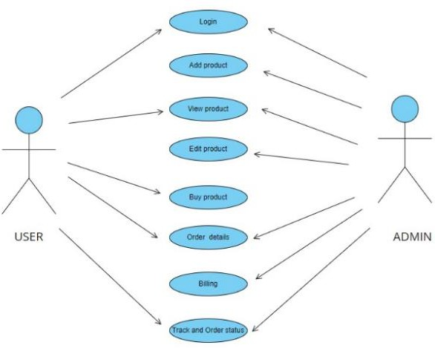

- DATA FLOW DIAGRAM Level 0

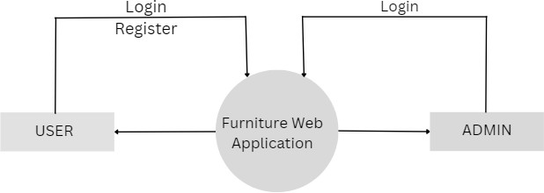

Fig 1
Level 1
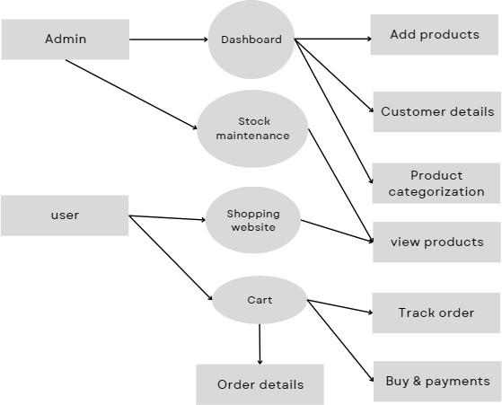

Fig 2

Level 2
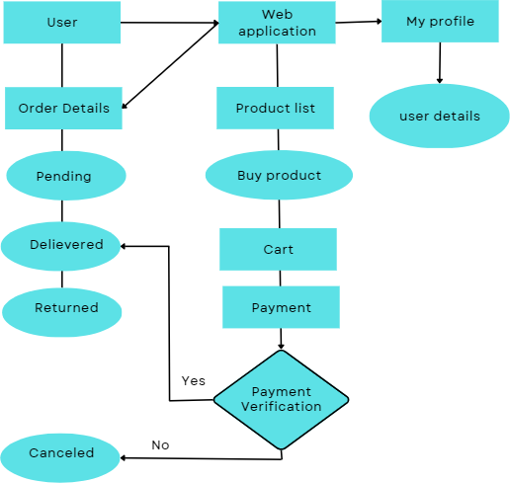

Fig 3.1
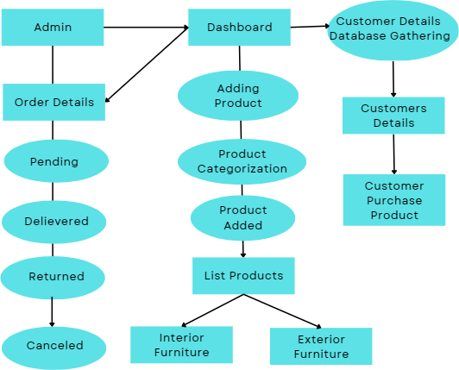

Fig 3.2

- METHODOLOGY
Methodology denotes the overarching strategy and rationale of the paper. It consists of methods that are used in the field of theories and principles which are used behind them. This paper embraces of two sections which are Executive and Consumer, developed using PHP, HTML/CSS. The Executive division consists of Order Management, Product Management and User Management. Each segment consists of various description, such as the Order Management holds the information of the products that ordered by the customers. Product Management comprises of various classification which is mainly focused on the product setup, brand segregation, product attributes, appending the products, seller products details etc., User Management holds information of the customer details like their name, mail id, address and contact number. The admin block is setup in a that every actions that are performed in the website can be monitored by them. They
have the authority to access the sales report and also add or remove product from the site depending upon the availability of that particular product. The landing page of the consumer block features various categories from which user can chose their desirable product, this action can also be done by alternative search filters which are available. It composes of a cart section where the order of products can be placed and shipment is proceeded along payment options. The consumer side also have a separate page for tracking of order where it also comprises of information such as exchange and cancel order.

- IMPLEMENTATION
- Order Management
Order management maintains the details of all information’s such as delivery of products, confirmation, product package, cancellation, returned etc., It manages the overall status of product delivery system. Here the admin can see to the details of product shipments and they can also track the order details. This setup is very helpful for the executive team to look in the order details so that if any problem is raised during the order placed it can stored quickly as soon as possible by the admin side.
- Product Management
Product management has a huge arrangement such as category setup, raw materials, In house products, promotion management and system setting. The category setup is made so that various types such as interior and exterior, along with their sub categories can be added by the admin. Raw material part maintains a list of materials that are been used to make the furniture products. Admin can modify them. In house products is field where the products are added based upon their categories and sub categories. The pricing of the products, offer details and the number of available products is denoted here. Promotion management deals in attracting the customers like displaying the most liked products, sending an notification to the user whenever there is an offer or if the price of the products are reduced. It also deals with the branding of the furniture shop by displaying their name and contact details. This segmentation maintains a separate file manager holds the images of the products that are sold in the website.
- User Management
This segment completely looks into the customers list, containing their details such as name, mail id, contact number and address. It also maintains a record of reviews that are given by users about the products so that they can know about the areas where it can be improved. The payment that are made by the users is also monitored in this part, where the transaction id, credit and debit card details are note. The customers will be given a notification if their desired product is back on stock using their mail id.
- Online Shopping Website
The customer who is new to the web page can register through mail id or phone number. The existing user can login to the web page. The home page has an variety of options for viewing products by category, search products using various types of filter options, searching using raw materials,

discounted and top selling products will be given first preference among the other products. A notification will be given to the user via message or mail whenever each new product is added to the website. User can add the products to wish list if they like it. The cart section has the details of products which are ordered and ready for shipment. This page holds information of the shipping method i.e., via which transport. The address to which the product should be delivered is given in this part of web page. Once the ordered is placed, next is the payment method and bill generation. Only after the bill is generated the order is confirmed. The bill generation will be taken care by the admin. The user can track his/her order details using this part of the site, it consists of package details, shipment and delivery details. The customer can also cancel their order any time before the shipment. Exchange option is also available if there is a need on the client side.
Shopping Website

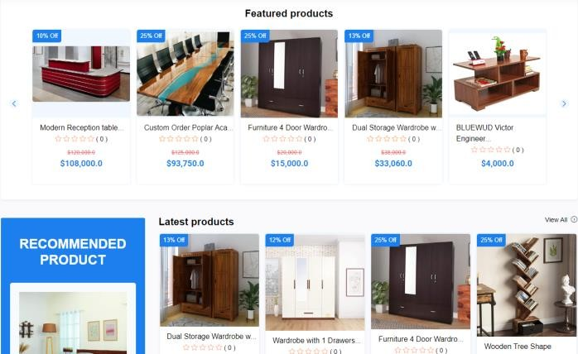
VII. FUTURE SCOPE

VI. RESULT ANALYSIS
Our paper represents the admin management system and user shopping website. It helps to manage products and analysing the sales report. User can buy products from anywhere through this website.
Order Management
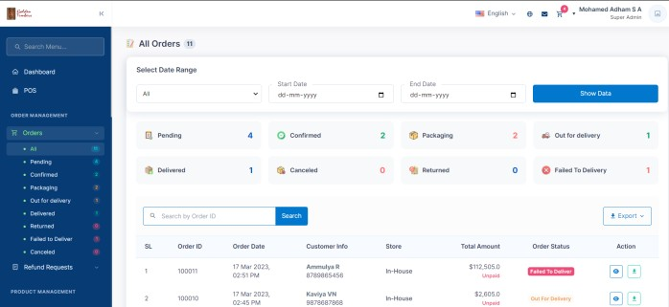

User Management
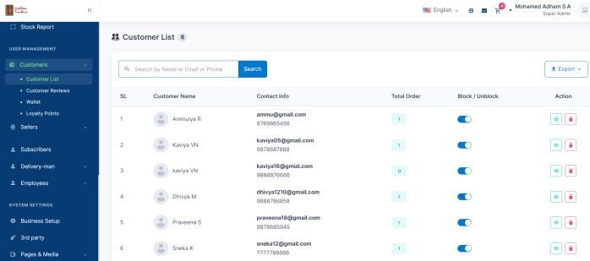

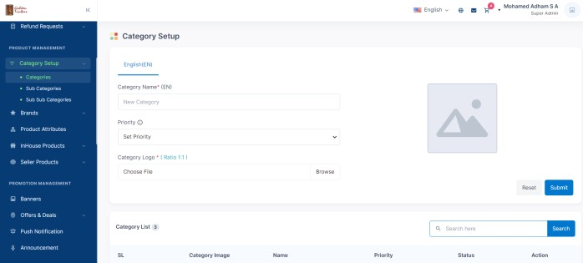
Product Management
There are several potential areas of future development for a furniture web application, including:
Personalization: Another area of potential development for furniture web applications is increased personalization options. By using data analysis and machine learning algorithms, web applications could provide personalized recommendations based on a user's preferences, past purchases, and browsing history.
Sustainability: As more consumers become environmentally conscious, there is a growing demand for sustainable and eco- friendly furniture. A furniture web application that emphasizes sustainable materials and practices could be well-positioned to capture this market.
Social Media Integration: Many consumers turn to social media platforms like Instagram and Pinterest for inspiration when it comes to home decor. Integrating social media sharing and tagging functionality into a furniture web application could help to drive engagement and increase brand awareness.
Virtual Showrooms: As e-commerce continues to grow, there is a need for innovative ways to recreate the in-store shopping experience. A virtual showroom could allow users to virtually browse and explore different furniture collections, providing a more immersive and interactive experience than traditional e- commerce platforms.
VIII. CONCLUSION
In conclusion, online furniture store management is an easy-to- use platform that simplifies the process of purchasing furniture products. Admin can easily manage and add new furniture varieties into the web application. Order and payment details of the product purchased by the customer can be easily viewed by the admin with the help of order management. User management offers a range of features, including customer recommendation, real-time stock updates and fast delivery options, which enhance the user experience and streamline sales. This web application is designed to be responsive and ensures that customers can access and purchase products from anywhere. Our system has demonstrated the importance of leveraging technology to meet customer needs and improve the overall efficiency of the business.

VII. REFERENCE
- Chuanmei Wang, Hengqing Tong “Research on Psychological Dimensions of E-Commerce Customer Satisfaction” IEEE publication, 30 September 2010
- Guangshu Chang “The deployment of customer requirements of e-commerce website” IEEE publication, 08 August 2008
- Haiying Ma, Dong Gang “Customer segmentation for B2C e-commerce websites based on the generalized association rules and decision tree” IEEE publication, 05 September 2011
- Hongyun Xiong, Surong Sun, “ A Method of Experienced Furniture Customization for Pervasive Computing” IEEE publication, 13 February 2009
- Minwoo Lee, Hye Young Lee, Moon-Gil Yoon “Website development strategy for e-Commerce success” IEEE publication, 13 December 2010
- Rongrong Gong, Shijian Luo, Ji He “ Use case based innovative design of E-commerce website” IEEE publication, 08 January 2010
- Sudiana, Yakob Utama Chandra, Lydia Angela “Key Success Factors for a Better User Experience in E-Commerce Website” IEEE publication, 14 September 2021
- Tong Liu “Research on the Design of E-commerce Data Analysis Platform” IEEE publication, 21 April 2021
- Wuwei Li, Yueru Wei “Evaluation of E-Commerce Website Based on Grey Multipurpose Decision System” IEEE publication, 07 September 2010
- Xu Hao, Liu Duo-lin, Lu Zhi-jie “The Research on E- commerce Website Success Mode” IEEE publication, 07 June 2010

