Paraphrasing Tool For Marathi Text
Anupam Teli¹, Prof.Trupti Patil², Shubham Hande³, Yashodhan Joglekar⁴, Deepak Manney⁵
¹ Dept of Information Technology, Student of Bharati Vidyapeeth Deemed To Be University, DET Navi Mimbai, India.
²Dept. of Computer Science and Business Systems, Faculty of Bharati Vidyapeeth Deemed To Be University, DET Navi Mumbai, India
³ Dept of Information Technology, Student of Bharati Vidyapeeth Deemed To Be University, DET Navi Mimbai, India.
³ Dept of Information Technology, Student of Bharati Vidyapeeth Deemed To Be University, DET Navi Mimbai, India.
³ Dept of Information Technology, Student of Bharati Vidyapeeth Deemed To Be University, DET Navi Mimbai, India
³ Dept of Information Technology, Student of Bharati Vidyapeeth Deemed To Be University, DET Navi Mimbai, India

---------------------------------------------------------------------***---------------------------------------------------------------------
Abstract - Paraphrasing refers to writing that either differs in its textual content or is dissimilar in rearrangement of words but conveys the same meaning. Identifying a paraphrase is exceptionally important in various real life applications such as Information Retrieval, Plagiarism Detection, Text Summarization and Question Answering. A large amount of work in Paraphrase Detection has been done in English and many Indian Languages. However, there is no existing system to identify paraphrases in Marathi. This is the first such endeavor in the Marathi Language. Paraphrase is a process of computing the semantic similarity between sentences, which are not lexicographically similar. It relates to the writing a sentence in another form. Though a number of metrics for English language have been proposed in literature, to quantify textual similarity; but none for Devanagari language. Existing system for Indian language paraphrase detection uses lexical similarity are supervised and requires large scale tagged corpus. The proposed method employs SVM learning metrics, based on lexicography similarity with producing output as +1 for paraphrased, -1 for not paraphrased, takes a sentence as input and produces another sentence without changing its semantic. In particular, the system addresses the problem for detection of monolingual text to text similarity for fusion language like Hindi and Marathi, which has complex morphology.
Key Words: Corpus, Morphology, Monolingual text, Paraphrasing.

1.INTRODUCTION ( Size 11, Times New roman)

Human beings have been communicating using natural language since ancient times. Communication is a powerful tool to advance human society. Communication helps people share their opinions and understand the feelings and thoughts of others. With the invention and advancement of technology, communication between computers and humans through various commands or codes has become easier. Computers require special training to understand natural language. Paraphrase implies extracting a sentence in another type of sentence that implies the changing nature of one sentence by the equivalent words corporating the expression to the word or adding points of interest to another word. The given content having similar importance to another sentence is recognized by paraphrase recognition[1]. The synonyms of the token matching and token matching of the text can be resolved by paraphrase detection. In Natural Language Processing, paraphrasection has the role of determining the similarity of sentences by analyzing the -word-by-word between two sentences. In the paraphrase, detection includes the occurrences of tokens in the texts, equivalent words of the tokens in the content, and coordinating the tokens of one sentence with the other sentence. Furthermore, produce the output as binary with the assistance of the classifier.

Marathi is recognized as a scheduled language of India according to the 8th schedule of the Indian Constitution. Marathi is derived from Sanskrit and is a major literary language of India that includes many writings. The Marathi language is a part of the Indo-Aryan family of the Indo-European language family.Marathi is the official language of the state of Maharashtra since 1966. It is the secondary language of Daman Diu, Dadra and Nagar Haveli, and Goa. Marathi is spoken by 83 million native speakers, approximately 6.86% of India’s total population, and ranks third in India after Hindi and Bengali. Out of Aroundillion speakers live in Maharashtra, and the rest in border states and union territories (UT)[2].

2. LITERATURE SURVEY

- Detection of paraphrases for Devanagari languages using support Vector Machine:

Paraphrase detection is challenging task for Devanagari Languages like Hindi and Marathi. Paraphrase word up to 40 words[3].
- Detecting Paraphrases in Indian Languages
based on Gradient Tree Boosting
The described approach to the Detecting Paraphrase problem in India Language that makes used of the Gradient Tree Boosting. In this paper, it is developed system for Malayalam and Hindi Language[4].
3. Paraphrase Detection in Hindi Language using
Syntactic Features of Phrase
The international languages uses to check the semantic similarity and lexical matching of the two sentences with the help of Word Net. This methodology saves time and aids in student monitoring when compared to the conventional method of recording attendance. Its provides an paraphrasing sentences in two form only [5].
4. A Novel approach to Paraphrase Hindi Sentences using NLP
Creating paraphrase by applying synonyms and antonym replacement.Synonyms are not properly applied for paraphrasing [6].
5. Language Independent Paraphrases Detection
In this paper, we presented our NLP-NITMZ system used for DPIL shared task. Overall, our approach looks promising, but needs some improvement [7].
6. Phrase Composing Tool using Natural Language Processing
Grammatical Error Correction and Detection by using Transformer Model have evolved into existence. As research is continuously in process, the need of development of the most optimal model is required. It makes an grammatical mistakes after paraphrase of words[8].
7. An Eccentric Approach for Paraphrase Detection using Semantic Matching and Support Vector Machine
Relates to computing the semantic similarity between the sentences which are not lexicographically similar. The proposed method uses the estimating result after detecting the paraphrasing pairs by defining the various cophenetic of the words [9].
8. Paraphrase Detection in Hindi Language using Syntactic Features of Phrase
State the lexical similarity metrics for the statistical analysis of paraphrase detectors. The Support Vector Machines and Naive Bayes classifier for classification purpose and the performance calculated in terms of precision recall f-measure and AUC. It claims the performance significantly better in SVM as compared to the Naive Bayes [10].
9. Paraphrase Identification on the Basis of Supervised Machine Learning Techniques
Presented the combination of rule based and supervised learning approach to recognize the paraphrases. The method uses the classification of the paraphrases and different approaches to recognize the paraphrasing as they type belongs. [11].
10. Paraphrase Detection Based on Identical Phrase and Similar Word Matching
uses the hierarchical clustering technique for WSD for Hindi Word Net. They have used Hindi Word Net for finding the sense of given word in a context. Performance depends on the number of input words and from which domain corpus [12].

- PROPOSED SYSTEM

A proposed system for a paraphrasing tool for Marathi text could involve the following components:
1)User Interface: The system should have a user-friendly interface where the user can input Marathi text to be paraphrased. The interface could also have options for the user to specify the level of paraphrasing required, such as basic or advanced paraphrasing.
2)Pre-processing Module: The input text would then be pre-processed to remove any unnecessary information such as numbers, symbols, and punctuation marks. The pre-processing module could also involve identifying and correcting any spelling or grammatical errors in the input text[13].
3)Paraphrasing Model: The pre-processed text would then be fed into a paraphrasing model that has been trained on a large dataset of Marathi text. The model would generate one or more alternative versions of the input text that retain the original meaning but use different words and phrasing.
4)Post-processing Module: The output of the paraphrasing model would then be post-processed to ensure that the resulting text is grammatically correct and coherent. This could involve checking for correct verb tenses, subject-verb agreement, and overall readability[14].
5)Output Module: The final step would be to display the paraphrased text to the user through the user interface. The user could then choose to accept the paraphrased text or request further paraphrasing until the desired level of paraphrasing has been achieved.
6)Feedback Module: The system could also include a feedback module where users can provide feedback on the quality of the paraphrasing, which can be used to improve the paraphrasing model over time[15].

- IMPLEMENTATION

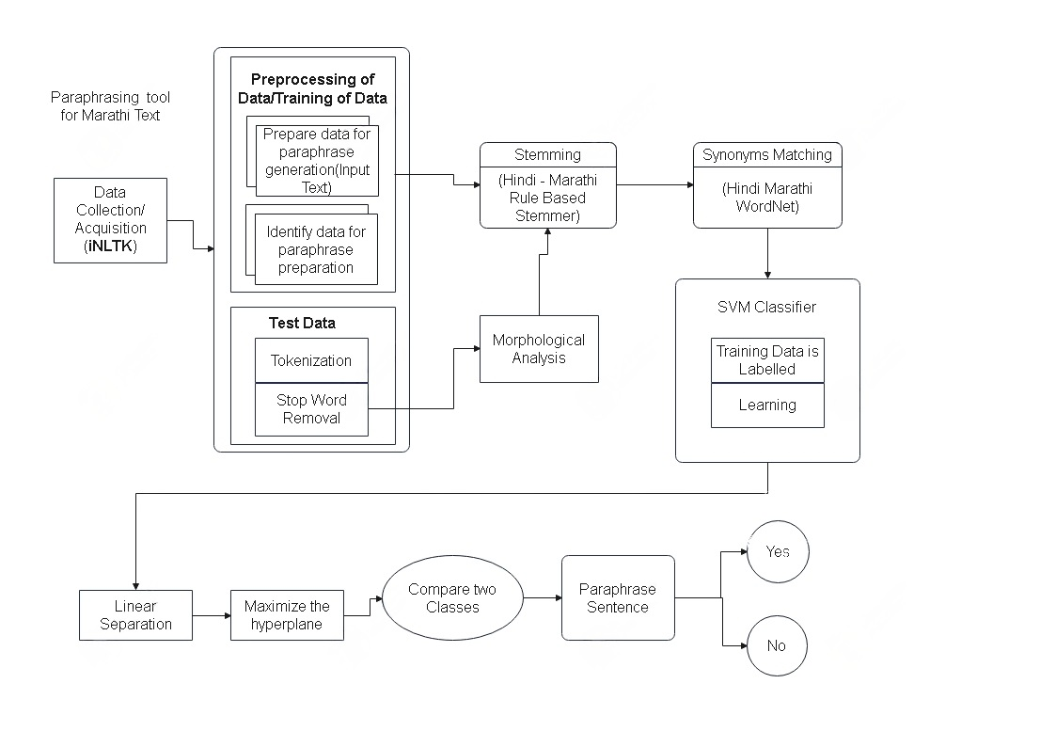

The implementation process of a paraphrasing tool for Marathi text would involve several steps:
1.Data collection: The first step would be to gather a large amount of Marathi text data from various sources such as books, articles, and websites. This data would be used to train the paraphrasing model[16].
2.Pre-processing: The collected data would then be pre-processed to remove any unnecessary information such as numbers, symbols, and punctuation marks.
3.Text representation: The text data would then be converted into a numerical representation that can be used as input to the paraphrasing model. This can be done using techniques such as one-hot encoding or word embedding.
4.Model training: Once the data has been pre-processed and represented numerically, the paraphrasing model can be trained using techniques such as neural machine translation or sequence-to-sequence models[17].
5.Evaluation: After the model has been trained, it would need to be evaluated to determine its performance. This can be done by comparing the output of the paraphrasing model with human-generated paraphrases.
6.Deployment: Finally, the paraphrasing tool can be deployed as a web application or a standalone software that users can access and use to paraphrase Marathi text[18].

5. CONCLUSIONS

In summary, the purpose of paraphrasing is not just to change a few words. Rather, it's about taking an idea and explaining it with a completely different sentence structure and word choice. It serves a greater purpose. Show that you have read the literature on the topic and can explain itclearlyto the reader.
In other words, correct paraphrasing shows that you understand the concepts in the field and allows in-text. citations to.support,your/own research.
When to paraphrase or cite Knowing how to improve the strength of research presentations and arguments. Asking for help with paraphrasing before inadvertently plagiarizing shows that you understand.the..importance.of/academic honesty.
Editing and proofreading services are available if you need assistance.

6.REFERENCES

[1] Darshana S.Bhole, Sandip S.Patil, “Detection of paraphrases for Devanagari languages using support Vector Machine”, 2018 International Conference on Communication, Information & Computing Technology(ICCICT), Feb.2-3, Mumbai, India.
[2] Ashwini Gadag, Sagar B M, “Paraphrase Generator Using Dictionary Lookup For Kannada Language”, International Conference on Next Generation Computing Technologies (NGCT-2018) Dehradun, India 14-16 October 2018.
[3]Rupal Bhargava , Anushka Baoni, Harshit Jain, Yashvardhan Sharma, “Paraphrase Detection in Hindi Language using Syntactic Features of Phrase”, 2019 International conference on Communication, Information & Computing Technology(ICCICT), May. 4-5, Hyderabad, India.
[4] Swati Meshram, “Review on NLP Paraphrase Detection Approaches”, International Journal of Innovative Science and Research Technology (IJISRT), November-2019.
[5]Mayur Ahirrao, Yash Joshi, Atharva Gandhe, Sumeet Kotgire, Prof. Rohini G. Deshmukh, “Phrase Composing Tool using Natural Language Processing”, International Conference on Intelligent Technologies (CONIT), Karnataka, India. June 25-27, 2021.

[6] Nandini Sethi, Prateek Agrawal, Vishu Madaan and Sanjay Kumar Singh, A Novel Approach to Paraphrase Hindi Sentences using Natural Language Processing, Indian Journal of Science and Technology, Vol 9(28), July 2019.
[7] Bharati, Akshar, Rajeev Sangal, and Dipti M. Sharma. 2007. "Ssf: Shakti standard format guide." Language Technologies Research Centre, International Institute of Information Technology, Hyderabad, India 2018.
[8] Begum, Rafiya, Samar Husain, Lakshmi Bai, and Dipti Misra Sharma. 2008 "Developing Verb Frames for Hindi." In LREC. LREC 2018.
[9] Ghosh, Sanjukta. 2014. "Making Verb Frames for Bangla Vector Verbs" ICON 2019.
[10] P. Vigneshvaran, E. Jayabalan, and A. V. Kathiravan, “An Eccentric Approach for Paraphrase Detection using Semantic Matching and Support Vector Machine," in International Conference on Intelligent Computing Applications (ICICA), 2020. IEEE, pp. 431-434.
[11]H. J. Y. S. Rupal Bhargava, Anushka Baoni, “Paraphrase Detection in Hindi Language using Syntactic Features of Phrase," in BITS PILANI @ DPIL FIRE, 2018, pp. Pilani-333 031.
[12]Z. Kozareva and A. Montoyo, “Paraphrase Identification on the Basis of Supervised Machine Learning Techniques." Springer, 2019.
[13] H.-Q. Nguyen-Son, Y. Miyao, and I. Echizen, “Paraphrase Detection Based on Identical Phrase and Similar Word Matching." in PACLIC Pacific Asia Conference on Language, Information and Computation, 2018.
[14] D Bhole and S Patil,” The Study and Review of Paraphrase Detection Techniques in Machine Learning “International Conference on Recent Trends in Engineering and Science, ICRTES January 2020
[15] Kamal Sarkar “KS_JU@DPIL-FIRE2016: Detecting Paraphrases in Indian Languages using Multinomial Logistic Regression Model”, DPIL 2019.
[16]SLIDESHARE[Online]:Available:https://www.slideshare.net/Almondhawk/detecting-paraphrases-in-marathi-language[Accessed : 02 December 2022]
[17]AboutSecureRF.https://paraphrasetool.com/langs/paraphrasing-tool-marathi . [Accessed: 08 January 2023]
[18]SEMANTICSCHOLAR[Online]:Available: https://www.semanticscholar.org/paper/Detecting-Paraphrases-in-Marathi-Language-Srivastava-Govilkar/e470a08b0c4d3499d9d794ea4aeff67e3eab339f [Accessed: 10 February 2023]

