Research on electric moped technology and its viability in India.

Baisakhi D
Assistant Professor
Center for Management Studies, Jain Deemed-to-be University
baisakhi_2015@cms.ac.in

Accamma CG
Assistant Professor
Center for Management Studies, Jain Deemed-to-be University
accamma_cg@cms.ac.in

Sankalp. C
Rohan. Jain
Chelsi. A
Danish. H
Danial. M
Abstract
In India, electric mopeds are quickly becoming a viable alternative to traditional petrol-powered mopeds due to their many benefits, including cheaper running costs, fewer pollutants, and more urban convenience. The promise of electric moped technology in India has not yet been completely realised, so more research is necessary to determine the best ways to encourage market dissemination and adoption.
Our research paper attempts to signify the importance, need, and growth of electric mobility technology, and compact mobility technology like mopeds in general to ascertain mobility problems throughout the world in the 21st century. We have reviewed multiple articles, case studies, and research papers which signify the ever-growing electric moped industry in India and the impact it will have on mobility as a whole in India. Our major findings suggest that many problems equipped with using battery-powered vehicles and their limitations can be tackled by acquiring and improving moped technology due to their versatility.
Keywords:
Electric Moped, Vehicles, Scooters, Mobility, Technology, Batteries, Range

Introduction
Electric motorcycles and scooters are pluggable electric vehicles with two or three wheels. Power is provided by a rechargeable battery to run one or more generators. The difference between an electric scooter and a motorcycle is that it has a straddle frame instead of a straddle type. Electric bicycles are similar vehicles with a special feature that the rider's pedals can be made in addition to battery propulsion.
Electric vehicles are becoming more common around the world. Given the rapid growth of the automotive industry, the penetration of electric vehicles may be high. Electric vehicles are also developing rapidly in India. However, there are other challenges for electric cars in India.
But automakers are moving rapidly in this direction. More EVs will be launched in India in the coming months.
In India, electric mopeds are quickly becoming a viable alternative to traditional petrol-powered mopeds due to their many benefits, including cheaper running costs, fewer pollutants, and more urban convenience. The promise of electric moped technology in India has not yet been completely realised, so more research is necessary to determine the best ways to encourage market dissemination and adoption.
By offering a thorough study of the state of electric moped technology in India as well as prospective prospects and difficulties for upcoming producers in this industry, this research paper seeks to fill this gap. The topic of electric moped technology will be examined from a variety of angles in this essay, including its technological characteristics, customer behaviour, market demand, governmental regulations, and business structures.
Overall, this study article aims to support the initiatives of manufacturers and policymakers in encouraging sustainable and effective means of transportation in the nation while also adding to the body of knowledge on electric moped technology in India.

Review of Literature:
In India, electric mopeds are becoming more and more popular as an affordable and environmentally friendly method of transportation, particularly in cities where traffic congestion is a big problem. Several studies have been carried out recently to examine the possibilities of electric mopeds as a substitute for traditional petrol-powered mopeds.

Dey et al.'s study from 2021 compared a commercially accessible electric moped to a traditional petrol-powered moped in order to assess performance and pollutants. According to the findings, the electric moped outperformed the petrol-powered moped in terms of range, cost of operation, and pollutants.

Jain and Sharma (2021) conducted another study to examine the viability of employing electric mopeds for last-mile deliveries in urban settings. Due to their cheaper running costs, lower maintenance costs, and lower pollutants, the study determined that electric mopeds were an effective option for last-mile delivery.

Singh and Tyagi (2020) conducted study on the effects of several variables on the performance of electric mopeds, including battery size, charging time, and weight. The investigation came to the conclusion that an increase in battery capacity and a decrease in weight might greatly increase the range and efficiency of electric mopeds.

According to a survey by Bhardwaj et al. (2019), people were open to buying electric mopeds as long as they had a respectable range and were reasonably priced. The report also emphasised the necessity of the government providing infrastructure and incentives to encourage the widespread use of electric mopeds.

Additionally, a study by Kulkarni et al. (2021) compared the environmental effects of electric mopeds to mopeds that are powered by traditional petrol engines. According to the study, electric mopeds may dramatically lessen air pollution in cities and have a lower carbon impact.

Overall, the research points to electric mopeds as a viable option for eco-friendly and economical transportation in India. However, the government's assistance, including incentives and infrastructure development, is necessary for their widespread adoption. The performance and design of electric mopeds need to be optimised, and further study is required to determine the best ways to encourage their adoption in India.

Research Gap:
Overview of electric mopeds: Immediately after entering the Indian market, car models aroused great interest. According to the Energy Storage Association of India (IESA), the expansion of the EV market is expected to register a 36% CAGR and the EV battery market is expected to register a 30% CAGR. According to reports, 75% of travelers in India travel less than 55 miles a day, normally on an electric scooter. Therefore, the e-scooter market in India comes from the micro-mobility e-scooter market.
The majority of motorbikes and scooters on the Indian market are 100cc utilitarian vehicles. While gearless scooters have a sizable following in metropolitan areas, motorbikes are more common in tier-3 cities and rural areas.The automatic/gearless scooters, powered by tiny 100-125cc motors, are seen as a significant possibility for makers of electric scooter motorcycles.

The introduction of BS 6 rules has led to an increase in scooter pricing across the nation, and rising fuel costs aren't helping their situation either. Due to the country-wide decline in revenue that followed COVID 19, vehicle maintenance and operating costs will be rigorously examined, favouring electric two-wheelers, but the initial cost and range anxiety remain obstacles.

Hero Electric and Okinawa now hold a combined market share of more than 65% in India. Only Hero Electric, TVS, and Bajaj, who are well-known two-wheeler manufacturers, have made a significant effort to introduce electric cars.In 2020, Hero Electric dominated the market and held the top spot, while Bajaj Cheetak could only sell 1,200 units.

There are 32 OEMs, including a number of start-ups like Tork, Emflux, Ultraviolette, etc., as well as OEMs that buy kits from China and put them together in India. Only 12 OEMs in India will have triple-digit and above sales in 2020.

Methodology
The study was done using the Mixed Method. Secondary Data was collected in the form of Case studies to have an in depth understanding on the innovation and functioning of emoped and Primary data was collected to have a comprehensive understanding of the experiences of the companies trying to enter the EV market The sample size of the study was 172 participants and Purposive Sampling was done to collect the data
To acquire the secondary data, variety of reports, research papers, articles, and case studies were analyzed and assessed that proved to us the potential of electric moped technology.

Research Objectives
Here are a few objectives of our research paper:

- To evaluate the current market demand and consumer behavior towards electric mopeds as a mode of transportation in India.
- To investigate the challenges and opportunities faced by manufacturers, distributors, and retailers of electric mopeds in the Indian market, including supply chain issues, customer support, and after-sales services.
- To develop a business model and marketing strategy for introducing and promoting electric mopeds in India, taking into account the local market conditions, cultural factors, and regulatory frameworks.
- To explore the potential for innovation and collaboration among different stakeholders, such as manufacturers, policymakers, academia, and civil society, to advance the development and adoption of electric mopeds in India.

Research Questions
- To identify the key technological and design features required for electric mopeds to be competitive with conventional petrol-powered mopeds in terms of performance, affordability, and convenience?
- To assess the impact of government policies and incentives on the adoption and diffusion of electric mopeds in India?
- To analyze the environmental and social benefits of electric mopeds compared to petrol-powered mopeds and other modes of transportation, and their potential contribution to sustainable urban mobility?

Analysis & Findings

The following are the findings from various individuals:

Have you ever heard of Electric Moped technology before?

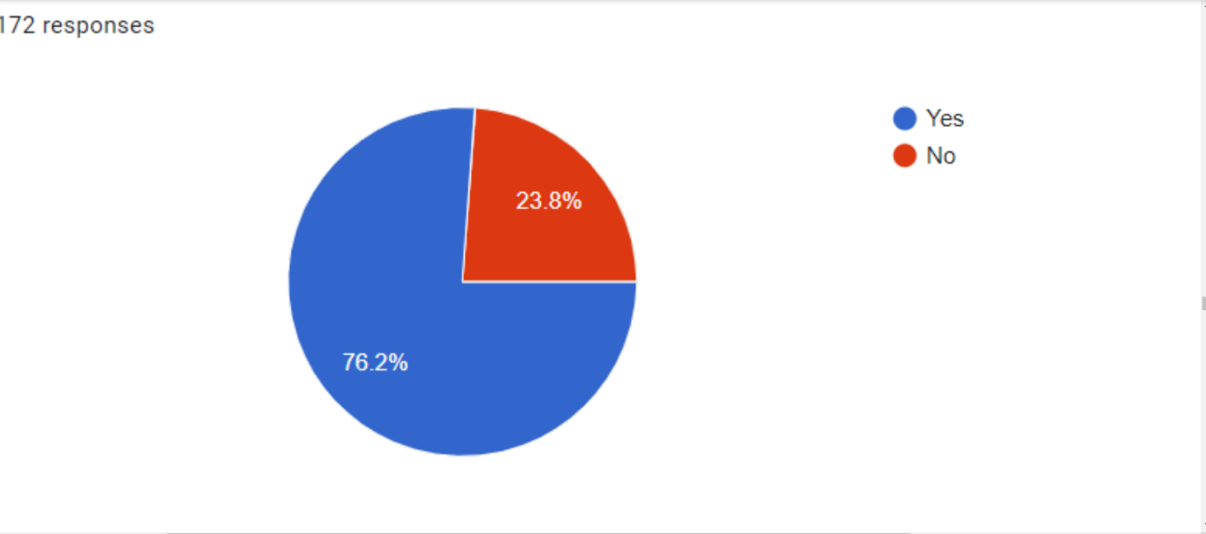
Electric mopeds were mentioned as a potential alternate means of transportation by 72% of the respondents. This result implies that the Indian people has a comparatively high level of awareness and interest in electric mopeds.
The fact that 72% of respondents knew about electric mopeds overall shows that India has a sizable potential market for this technology. Manufacturers and policymakers will need to overcome adoption constraints and create methods to encourage greater knowledge and understanding of the advantages of electric mopeds among the Indian populace in order to fully realise this potential.

How often have you encountered Electric Moped technology in your life before? 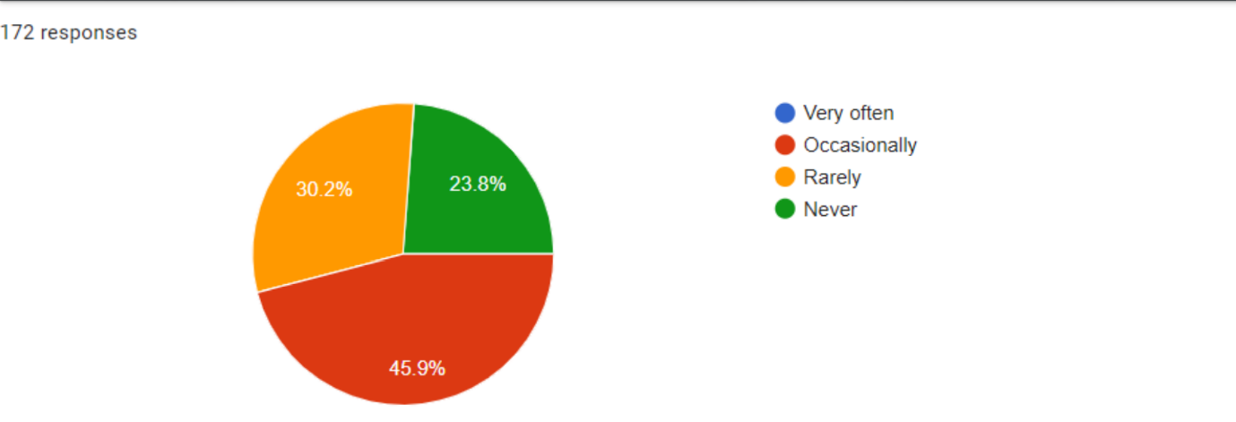

In their lives, 45% of respondents said they have sporadically run into electric mopeds. According to this finding, the Indian populace has a moderate amount of exposure to electric mopeds.

Do you think Electric Moped technology is a smart way of transportation in India?

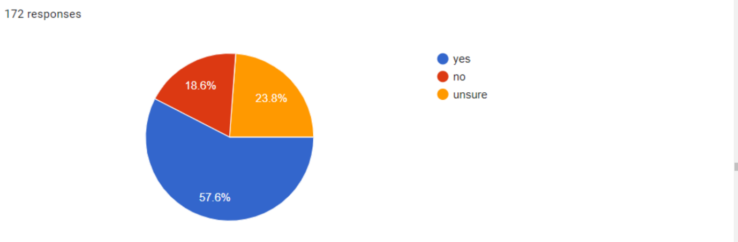

Among the respondents, 57% said electric mopeds were a wise choice. This result implies that a sizable fraction of Indians is aware of the advantages of electric mopeds over conventional petrol-powered mopeds.

Which one of the following terms is not synonymous with the words “Electric Mopeds?

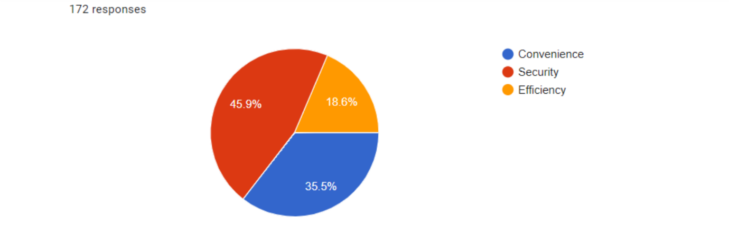
According to 45% of respondents, electric mopeds are secure. According to this research, the Indian people has a somewhat high level of confidence in the security of electric mopeds.

How comfortable do you think compact Electric Moped technology will be?

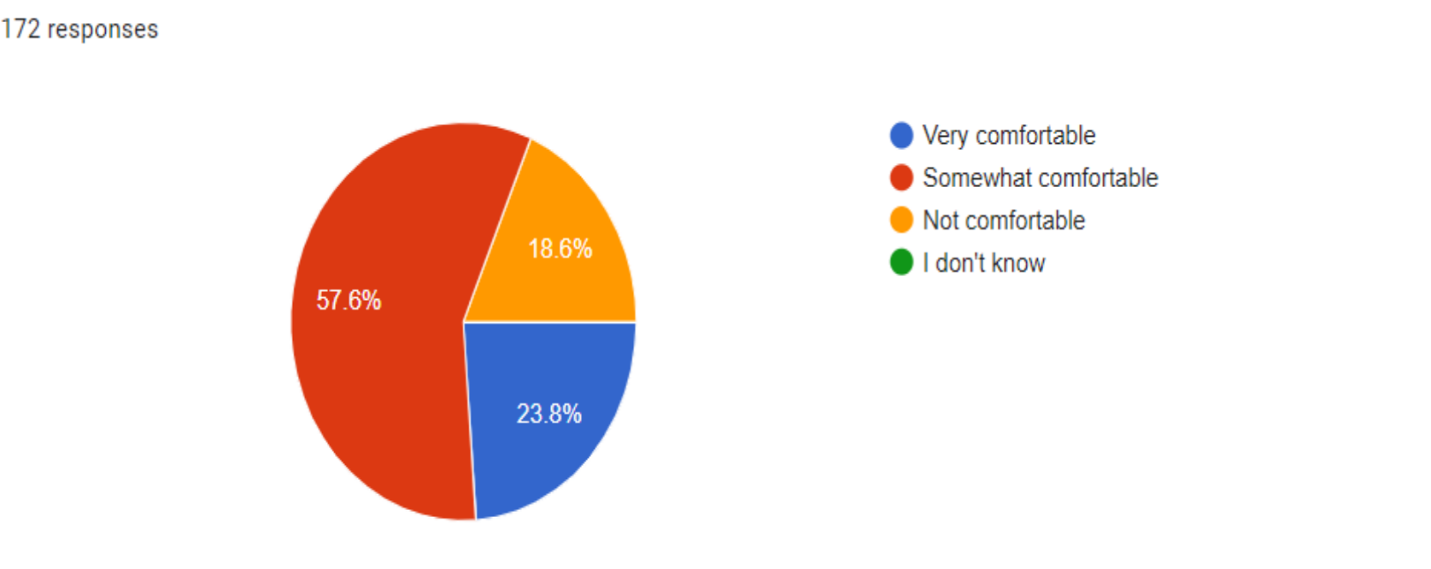

57% of those surveyed said they felt at ease riding electric mopeds. This result implies that a sizeable majority of Indians are amenable to the notion of riding electric mopeds as a form of transportation.

Would you recommend using Electric Mopeds for commercial and public use in India?

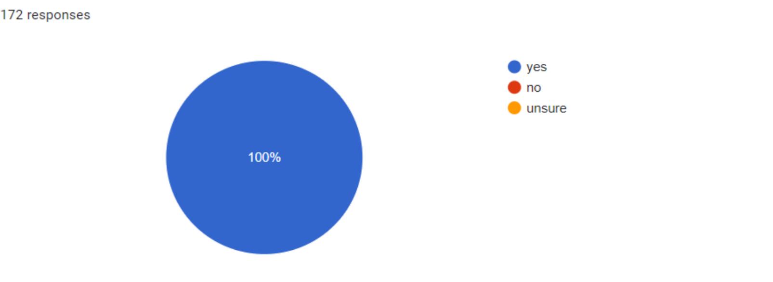

It is a very encouraging outcome for this technology that all respondents in an Indian study on electric moped technology agreed that employing electric mopeds for both public and commercial use is a good idea. It shows that there is a lot of confidence in and support for using electric mopeds as a form of public and commercial transportation.

In the context of electric mopeds, correlation analysis can be used to determine the relationship between various factors such as battery capacity, charging time, range, speed, acceleration, and price. For example, there may be a correlation between battery capacity and range, suggesting that a larger battery leads to a longer range. Similarly, there may be a negative correlation between charging time and driving, suggesting that longer charging times lead to shorter driving times.
• Relationship analysis can help companies and consumers understand the relationships between various factors and make informed decisions. However, it is important to remember that correlation does not imply causation and other factors may also affect the relationship between variables.

E. Quality Review: -
• Electric mopeds are popular for their cost-effectiveness, environmental friendliness, and versatility. A good evaluation of electric mopeds includes many factors such as battery life, operating range, speed and speed, maintenance, and cost.
• Battery Life: One of the most important aspects of Moped is battery life.
The battery must be strong enough to provide long-term reliable performance before being recharged. A good battery should last 40-50 miles or more depending on location and driving.
• Many operations: electric mopeds have many functions, depending on the design and model. A good moped should be able to go at least 40-50 kilometers in one go.
• Speed ​​and Acceleration: Electric mopeds provide superior speed and acceleration over conventional mopeds.
A good generator should be able to reach at least 30 mph.
• Correction: Electric mopeds are easier to control than gas mopeds. They require less maintenance and do not involve engine complexity. A good moped requires minimal maintenance.
• Cost: Electric mopeds are generally less expensive than conventional electric mopeds, but can offer significant savings in operating costs in the long run.

They also help reduce reliance on fossil fuels and promote sustainability because they run on electricity. This is having a positive impact on the environment, as more and more people choose electric mopeds over petrol-powered cars.
• Another advantage is cost-effectiveness. Electric mopeds require less maintenance and are less expensive than petrol-powered motorcycles. They tend to last longer and retain their resale value better than petrol mopeds.
• However, there are some disadvantages to consider when using moped. One is limited within limits. Depending on the size and quality of the battery, electric mopeds will have a shorter range than petrol mopeds. In addition, the prolongation of the payment period also affects the comfort of owning a generator.
• Another consideration is security.
While mopeds are generally slower than petrol mopeds and motorcycles, they do require drivers to take safety precautions such as wearing a helmet and obeying traffic rules.
• Overall, results for electric mopeds show that they can be more efficient and environmentally friendly than other gas mopeds. However, many factors and payment terms should be carefully considered before making the change.

Summary of Findings
To accurately understand the state of the transportation industry and to determine if India is ready for its EV revolution mainly under the pretext of Electric mopeds, we compiled a combination of a few major companies’ case studies digging deep into what the companies had to face in order to get their products rolling into the Indian market, as well as getting to know what the public thinks about the mopeds.

• Here are some case studies of electric moped applications:

• Vmoto: Vmoto is an Australian electric moped company specializing in electric mopeds. In 2020, the company joined the Italian motorcycle manufacturer Ducati to develop and manufacture a new line of electric mopeds. The partnership is designed to offer customers a high-performance and environmentally friendly alternative to gasoline-powered mopeds.

• Eko Cars: Eko Cars is an Indian startup that manufactures electric mopeds and scooters.
The company aims to provide cost-effective and efficient transportation options to customers in India, where pollution and congestion are major concerns. Eco Vehicles also operates a network of charging stations in the city of Derry to promote the use of electric mopeds.

• GOVECS: GOVECS is a German electronics manufacturer that produces a variety of electric mopeds and scooters. The company has deployed a fleet of e-mopeds in several European cities, including Berlin and Paris, as part of a joint campaign. Mopeds can be rented with a mobile phone and users can pick up and drop off the vehicle from the charging station.

• Muving: Muving is a Spanish electric moped company operating in several cities in Europe and South America. The company provides electric moped services with mobile phones, and users can pick up and drop off electric mopeds from charging stations. Muving aims to provide a safe and affordable alternative to gas-powered mopeds and cars.

• Ather Energy: Ather Energy is an Indian electric vehicle startup that produces electric scooters and mopeds. The company, which operates a network of charging points in the cities where its vehicles are sold, also offers users subscription models for maintenance and other services.
Ather Energy aims to promote the adoption of electric vehicles in India, where the climate is a major issue.

Implication
The research report on electric moped technology in India has important ramifications. The article offers insightful analysis and suggestions for upcoming producers and decision-makers who want to create and support sustainable means of transportation in the nation.

The study first emphasises the potential of electric mopeds as an economical and environmentally beneficial means of transportation, particularly in urban areas where air pollution and traffic congestion are important problems. This discovery may spur additional manufacturers to enter the Indian market for electric mopeds and create cutting-edge solutions that meet the unique requirements and preferences of Indian consumers.
electric scooters (e-scooters) are an advanced form of urban transport. While research on this topic focuses on injuries, e-scooter-sharing programs can affect health in several ways. This study aims to investigate the health behaviors of e-scooter users and discuss their effects on public health. Data was collected through an online e-mail survey for e-scooter users. A total of 1070 users completed the survey.
Descriptive statistics of variance and chi-square analysis were performed to determine the difference between the variances and the equality of the ratios. The most advertised places are 'just go', home, and dining/shopping places. Two modes of transportation in which e-scooters cannot be used are walking (43.5%) and using a private vehicle (28.5%).
On the road, on the pavement, and equally between the two, the behavior is balanced. Advantages (e.g., air pollution) and disadvantages (e.g. air pollution) of electric scooters from Provo.

Limitations
There are some limitations that should be acknowledged. Here are some potential limitations of a research study on electric moped technology in India:
- Limited scope: The study may only concentrate on a certain region or demographic group, which could prevent the results from being generalised to other situations.

- Data accessibility: Secondary data sources or survey data, which could have limits in terms of correctness and reliability, may be used in this study.

- Time restrictions: The study may have had little time to gather and analyse data, which could have constrained the analysis's breadth and depth.

- Personal biases or presumptions of the researcher may have an impact on the study and have an impact on how the results are interpreted.

- The electric moped market in India is continually changing, therefore the study's conclusions could fast become out of date.

- Regulatory changes: The regulatory landscape in India is dynamic, and new laws or incentives may be passed that have an impact on the study's conclusions and suggestions.

Conclusion
Recommendations for future research - Impact of micro-mobility on first and last-mile journeys in cities. Due to the situation caused by the COVID-19 pandemic, it is clear that the urban transport plan needs to be adjusted to reduce the use of public transport and transport, and to avoid traffic, among others, by encouraging people in the city to stop using it. engine. car.
From this point of view, the redevelopment of the city (such as Milan) is recommended to take into account both unforeseen environmental sustainability requirements and new needs promoting bicycles and PLEVs (such as electric scooters) [3].
PLEV is a phenomenon that is now seen in cities and aims to be a safe transportation route. The analysis shows that the growth of PLEVs in cities will increase the demand for electricity distribution, which should be considered by cities as the eight owners of sustainable development

Recommendations for policymakers - All electric scooters must be Regional Transport Office (RTO) registered. The registration process includes the manufacturer's certificate of origin, invoice of sale and verification, etc. includes the submission of necessary documents such as
• Passengers must hold a valid driver's license, two-wheeled vehicle license, or light vehicle license.
It is mandatory to wear a helmet when driving electric scooters in India. Helmets must comply with Indian safety standards set by the Bureau of Indian Standards. Electric scooters must be insured under a third-party insurance policy. This policy covers personal damage and another personal injury to third parties. Electric scooters should not exceed 25 km/h.
• Electric scooters may only be used on public roads. They are not allowed on the curb unless specifically indicated for their use.

References
Sankaran, G., & Venkatesan, S. (2021). Standardization of electric vehicle battery pack geometry form factors for passenger car segments in India. Journal of Power Sources, 502, 230008.
Alam, M. S., Moeller, T., & Maly, A. (2006, December). Conversion of an Indian Three wheeler Scooter into Hybrid Fuel Cell Ni-MH battery vehicle and validation of the vehicle model for the Bajaj Three wheeler Scooter. In 2006 IEEE Conference on Electric and Hybrid Vehicles (pp. 1-6). IEEE.
Alam, M. S., Moeller, T., & Maly, A. (2006, December). Conversion of an Indian Three wheeler Scooter into Hybrid Fuel Cell Ni-MH battery vehicle and validation of the vehicle model for the Bajaj Three wheeler Scooter. In 2006 IEEE Conference on Electric and Hybrid Vehicles (pp. 1-6). IEEE.
Bhardwaj, A., & Bhardwaj, T. (2019). Future prospects of electric vehicles in Indian market: marketing opportunities and challenges. International Journal of Management Research and Reviews, 9(3), 17-25.
Bhat, S., Antony, J., EV, G., Koul, R., Cudney, E. A., & Chakraborty, A. (2022). A study on critical failure factors of Design for Six Sigma in Indian companies: results from a pilot survey. The TQM Journal.
Bhosale, A. P., Gholap, A., Mastud, S. A., & Bhosale, D. G. (2019). A research on market status and purchasing decision influencing parameters for electric vehicles: Indian context. Int. J. Recent Technol. Eng., 8, 2700-2706.
Digalwar, A. K., Thomas, R. G., & Rastogi, A. (2021). Evaluation of factors for sustainable manufacturing of electric vehicles in India. Procedia CIRP, 98, 505-510.
Dixit, S. K., & Singh, A. K. (2022). Predicting Electric Vehicle (EV) Buyers in India: A Machine Learning Approach. The Review of Socionetwork Strategies, 16(2), 221-238.
Goel, S., Sharma, R., & Rathore, A. K. (2021). A review on barrier and challenges of electric vehicle in India and vehicle to grid optimisation. Transportation engineering, 4, 100057.
Gupta, S., Khanna, R., Kohli, P., Agnihotri, S., Soni, U., & Asjad, M. (2023). Risk evaluation of electric vehicle charging infrastructure using Fuzzy AHP–a case study in India. Operations Management Research, 16(1), 245-258.
Joshi, N., Malhotra, M., & Singh, J. (2022). Assessing adoption intention of electric vehicles in India: The mediating role of government policies. European Journal of Transport and Infrastructure Research, 22(1), 1-16.
Kesari, J. P., Sharma, Y., & Goel, C. (2019). Opportunities and scope for electric vehicles in India. SSRG International Journal of Mechanical Engineering, 6(5), 1-8.
Kore, H. H., & Koul, S. (2022). Electric vehicle charging infrastructure: positioning in India. Management of Environmental Quality: An International Journal.
Kumar, P., & Chakrabarty, S. (2020). Total cost of ownership analysis of the impact of vehicle usage on the economic viability of electric vehicles in India. Transportation Research Record, 2674(11), 563-572.
Mishra, S., Verma, S., Chowdhury, S., Gaur, A., Mohapatra, S., Dwivedi, G., & Verma, P. (2021). A comprehensive review on developments in electric vehicle charging station infrastructure and present scenario of India. Sustainability, 13(4), 2396.
Nama, T., Gogoi, A. K., & Tripathy, P. (2018, December). Low power electric two-wheelers for hilly region. In 2018 IEEE International Conference on Power Electronics, Drives and Energy Systems (PEDES) (pp. 1-6). IEEE.
Ramasamy, D. R. (2020). Enchanted improvements in air quality across India-A study from COVID-19 lockdown perspective. Adalya Journal, 9(5).
Saxena, S., Gopal, A., & Phadke, A. (2014). Electrical consumption of two-, three-and four-wheel light-duty electric vehicles in India. Applied energy, 115, 582-590.
Schelte, N., Severengiz, S., Schünemann, J., Finke, S., Bauer, O., & Metzen, M. (2021). Life cycle assessment on electric moped scooter sharing. Sustainability, 13(15), 8297.
Singh, V., Singh, V., & Vaibhav, S. (2021). Analysis of electric vehicle trends, development and policies in India. Case Studies on Transport Policy, 9(3), 1180-1197.

