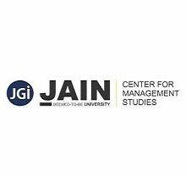
Project Centric Learning
Title of the project
Impact of Economic and Political Policies in Event Management Industry
Authors :

Name of the students | Semester | Reg.No.
Utkarsa Ramesh | VI H | 20BBAR0186
Varun B Reddy | VI F | 20BBAR0157
Almash Ashraf | VI H | 20BBAR0175
Jeevan Samrudh | VI I | 20BBAR0558
Aadhya Jayaram Reddy | VI E | 20BBAR0705

Co-authors :Dr. Priya Makhija And Ms. Megha Kukreja
Date:27 /3 /2023

ACKNOWLEDGEMENT
We would like to thank our director – Dr. Dinesh Neelkanth for giving us this opportunity to do this paper. We would also like to express our gratitude to Dr. Priya Makhija and Dr. Megha Kukhreja for their constant guidance and support. We would also like to convey our gratitude to the entire faculty and fellow teams for their consistent help and support.

ABSTRACT

Event management has become a booming industry in recent years. From sports and corporate events to intimate gatherings there is a constant demand and necessity for efficient event planning and management. Macro environmental factors such as savings rate , inflation rate, interest rate, economic cycle and foreign exchange rate determine the aggregate demand and aggregate investment in this sector , whereas competitive advantage of the firm is determined by microenvironmental factors such as competitive norms.
The aim of our research paper is to determine the various political and economical factors that affect the event management industry and further identify the recent trends and risks that is faced by this sector due to the economy and political stability. The nature of study is descriptive and the source of data is primary. The data is obtained directly from the subjects and Likert scale was used to answer the questions.
Through our study we have found that majority people believe that political and economical factors influence the event management industry and it affects the quality of services provided to consumers. People also believe that COVID 19 negatively impacted this sector. It was found that employment opportunities are created due to the development of this industry, thus having a positive impact on the economy. The results regarding the policies and regulations of the government that have an effect on event management was found that, event management businesses must abide by a variety of government regulations in order to operate legally and successfully.
Overall, this topic provides opportunities to study how varying economic and political factors can influence outcomes event management, as numerous real-world examples. Equipped with focused analysis and research highlighting causal relationships between policy implementations versus observed results including insights into secondary impacts will help execute informed recommendations going forward.

Key words: - economic, political , event , management, Covid , policies

INTRODUCTION

Events are an important motivator of tourism, and figure prominently in the development and marketing plans of most destinations. The roles and impacts of planned events within tourism have been well documented, and are of increasing importance for destination competitiveness. There have been rapid changes that have redefined event management and its characteristics in the modern world today. (Dearn, 2006; Marginson, 2006; Marginson & Considine, 2000; Marginson & Rhoades, 2002). The rise of a global marketplace, the introduction of new trends as well as the changing demands of mass markets have all created a different playing field to the one that existed three decades ago (Australian Government, 2006; Coady, 2002). The growth of event management industry is creative and regularly innovating. It is adapting continuously to new technology and has the potential to survive adverse economic and political circumstances as seen over the last 18 months or so.
Event management associations provide newcomers and existing practitioners with the necessary skills to ensure the continued growth and success of event management professional (Charles Arcodia & Sacha Reid,2008). A range of factors and forces are responsible for decision making in event management. Macro factors include economy and political factors which have an impact on event management. However, at the micro level are the sociological as well as environmental factors producing a unique effect on event management.
The analysis of literature reveals a substantial number of articles that have partially or indirectly addressed the issue both theoretically and empirically. The literature studying event and impact by political and economic policies builds on the early work in the area of event tourism, in which Getz (1997), Ritchie (1984) and Hall (1992) are the most often cited authors. The economic impacts may differ depending on each event and the longevity of each event. Subsequent to this, hosting such events of varying scale falls to stakeholders such as local authorities and event organizers. These stakeholders tend to focus purely on eco- nomic impacts and often overlook important social and environmental issues (Derry & Jago, 2010).
In the recent studies around the globe, it has reported that maximum loss of about more than $666 million till April is noted in event industry, due to cancellation of events worldwide and have 85.9 million jobs at stake.( Sergio Correia, Stephan Luck, and Emil Verner ,2020).The businesses are suffering for huge capital shortage to sustain in long run through use of technology and measures like live chat, webinars, online discussion shows, podcasts etc. are being used by companies to continue their services but they cannot replace the revenue from big fat events or events at large scale in terms of money and people inducement. The daily wage workers associated with the industry, the small and medium event companies who do not have the platform or the target customers to provide such services are suffering more harshness of this pandemic.
There was a study to show how the impacts on business performance of festival and event industry in the period of global economic recession from 2007 to 2009. (Joe J Goldblatt, Seung-won Lee,2012). It depicts that during economic crisis in the world, the event industry is also affected dramatically and it takes solid strategies to overcome after recession. During this period, the industry had suffered decrease in profit margins caused by decrease in sponsorship, high cost of products and services and recession on all sources of revenue. The strategies that lead to survival and a conservative growth pace after recession were to increase marketing efforts, control overall expenses and the use of technology in different ways to get sponsorships and target customers accordingly.
In this paper, we have analysed the data obtained to descriptively explain the impact of economic and social policies on event management, considering the challenges and opportunities it presents to the event management industry.

LITERATURE REVIEW

Due to the variety of events that are held all over the world, event management is a thriving industry with a significant growth trajectory. An activity that has a common interest and accomplishes a particular objective is called an event. As a result, event management encompasses event design, planning, coordination, and execution. The concept design, quality, timely delivery, and attendance satisfaction of an event are all critical to its success. The significance of event management, the political & economic factors affecting event management and some other difficulties encountered in the event management industry will all be the subject of this literature review.

(Thomas and Wood, 2004) The impact that event management has on education, business, and communications demonstrates its significance. Businesses can gain a competitive advantage in the market, promote their goods and services, and improve their brand image through events. In addition, events foster relationships between businesses and their customers by promoting direct engagement. Even in non-profit organizations and government institutions, events are effective communication tools. Rallies, fundraising galas, and protests, for instance, assist in conveying a particular message that has the potential to bring about social change. In addition, educational events provide venues for academic discussion, student activities, and community involvement.

(Parmesh Dutt, Mr Mahesh Dutt, Abhishek Chander ;2018) The COVID-19 pandemic has had a significant impact on the event management industry. The industry has been severely disrupted due to restrictions on large gatherings and social distancing protocols. As a result, many events have been cancelled, postponed, or transitioned to virtual formats. Overall, the COVID-19 pandemic has forced the event management industry to adapt and be innovative to survive. While the industry may continue to face challenges, there are opportunities to grow and reinvent the industry to meet the needs of consumers in the post-pandemic world.

Impact of Economic policies on Event Management:

(Kwiatkowski G., Oklevik O. (2015)) Rates of inflation, fluctuations in the value of currencies, and global economic instability are examples of economic policies that have an effect on event management. The expense of coordinating occasions is likely to changes in expansion rates and money vacillations. For instance, if the rate of inflation is high, suppliers might raise their prices, which will have an effect on how much it costs to put on events. The cost of importing event materials will also rise if currency fluctuations continue, which could have an impact on the organization of events. As it may result in the postponement or cancellation of events, global economic instability can also have an effect on event management.
Event management can also be significantly impacted by local government economic policies. A government's tax policies, for instance, can make organizing events more expensive, and licensing regulations can make it harder for event organizers to run events.

Impact of Political Policies on Event Management:

(Maguire,2019) Event management can also be affected by political policies. The kinds of events that an organization can host can be affected by the government's current policies. Concerts that contain content that is perceived as sexually explicit or that promotes drugs may, for instance, be outlawed in nations where conservative policies are in place.
Event management can also be affected by security policies. When making plans for events, event organizers must take into account the current state of security. For instance, concerts and sporting events held in areas with a high rate of terror attacks may require additional security personnel, which may result in an increase in the event's overall cost.
Events can get permits from governments, and they often do so based on political considerations like public safety, cultural expectations, and political affiliations. Events have sometimes been postponed as a result of political policies.

RESEARCH GAP

While there has been significant research on the impact of economic and political policies on various industries, the literature on their influence on event management remains relatively scarce. This research gap presents an opportunity to explore the interplay between these policies and the event management industry, particularly in the context of a rapidly globalizing world.

Event management is a multifaceted industry that encompasses the planning, organization, and execution of events ranging from small gatherings to large-scale conferences and festivals. As such, it is sensitive to a wide range of economic and political factors. For instance, economic policies such as taxation, financial regulation, and trade policies can have a direct impact on the resources available for event management, the cost of organizing events, and the overall profitability of the industry. Similarly, political policies, including those related to security, visa and travel regulations, and environmental concerns, can also shape the landscape of event management.

One area where the research gap is particularly evident is in the analysis of how economic policies affect the financial sustainability of event management companies. While some studies have touched upon the general impact of economic policies on businesses, there is a lack of research specifically focused on the event management industry. Investigating this relationship could provide valuable insights into the challenges faced by event organizers in various economic environments and help inform future policy decisions.

Another underexplored area is the influence of political policies on the internationalization of event management. Globalization has led to an increase in cross-border events, and political policies can either facilitate or hinder this process. For example, visa and travel policies can affect the ease with which event organizers, attendees, and suppliers can participate in international events. Furthermore, security policies can impact the attractiveness of certain destinations for events. Examining the role of political policies in shaping the global event management landscape can help identify best practices and areas for improvement.

The research gap also extends to the analysis of the interplay between economic and political policies and the environmental sustainability of event management. As concerns about climate change and resource depletion grow, there is a need to understand how policies can encourage or discourage environmentally responsible event management practices. For instance, research could explore the effectiveness of tax incentives or regulations in promoting the use of sustainable materials, waste reduction, and energy efficiency in event management.

Lastly, there is a need to investigate the impact of economic and political policies on the social and cultural aspects of event management. Events can serve as platforms for cultural exchange, community building, and social cohesion, and policies can either support or hinder these functions. For example, funding for cultural events may be influenced by political priorities, while economic policies can affect the affordability and accessibility of events for different segments of society. Understanding these dynamics can contribute to the development of more inclusive and culturally diverse events.

In conclusion, there is a significant research gap in understanding the impact of economic and political policies on the event management industry. Addressing this gap can provide valuable insights into the financial sustainability, internationalization, environmental responsibility, and social and cultural aspects of event management. By exploring these areas, researchers can contribute to the development of effective policies and best practices that support the growth and resilience of the event management industry in an increasingly interconnected world.

OBJECTIVES OF THE STUDY
The primary aim of this study is to evaluate the impact of economic and political stability on the quality of event management. The study seeks to investigate the economic and political factors that influence decision-making processes and ensure the smooth operation of management activities in the event industry. While it is acknowledged that events can generate positive economic impacts, the success of an event must also be evaluated in the context of the stability of the economy. Event leadership must be accountable and transparent, subject to greater democratic accountability, to prevent an increase in the number of events being organized physically and virtually. Additionally, advancements in technology have led to a desire for more "high touch" experiences, with events remaining the most effective means of providing such an experience.
Historically, economic impact measurements have focused on visitor spending and multipliers that extend this spending to other sectors of the economy. However, due to inconsistencies in reporting and data collection, economic impact studies continue to be misleading and should be viewed in proper balance with other impact assessments. Economic impacts of events can be difficult to measure, and they often have a differential effect on different members of the community. For this reason, economic impacts are frequently examined through investigation of residents' perceptions of the impacts.
The study aims to analyze the impact of the condition of the economy on the quality of event management and the activities of event management. Furthermore, the study aims to analyze the impact of political stability and its direct and indirect factors affecting event management quality. To cope with such impacts, the event management industry players must redirect their aims and strategies. To achieve this, the study aims to create new strategies and tools that can deal with any instabilities affecting the smooth functioning of event management. Areas such as the use of technologies, event tools, risk assessment and mitigation, global presence for company image branding purposes, and cost-effective financial planning need to be enhanced for the industry to dynamically grow in the future.

The following are some specific objectives of the study because these factors have a significant impact on the quality of event management:
To examine how the state of the economy affects the activities of event management and the quality of event management.
To examine the effect of political security and its jobs, the variables that influence occasion the executive’s quality straightforwardly or in a roundabout way.
To reorient the objectives and strategies of the event management company in order to deal with and manage these effects.
To develop new strategies and tools to deal with any instability that hinders event management's smooth operation.
To upgrade regions, for example, the utilization of innovations, occasion's apparatuses, making risk evaluation and alleviation, expanding the worldwide presence for the organization picture marking purposes, investigating the practical monetary preparation, and so on.

FINDINGS OF THE STUDY

In light of our exploration questions, the discoveries are on business, Coronavirus, estimating, innovation, nature of administration, worldwide economy, government rules and guidelines influence, political steadiness.
According to the employment result, Event Management needs competent employees to provide high-quality service to its clients. 20.7% disagree with this statement, while 79.3% are in agreement.
According to the Covid-19 result, it had a negative impact on the event management industry during its peak, resulting in the cancellation of numerous events due to social distance and gathering restrictions. Based on this, approximately 63.3 percent of respondents concur, 26.7 percent are neutral, and 10 percent disagree.
According to the pricing results, the Event Management company charges a high price. This indicates that 66.7 percent of respondents concur, 26.7 percent are neutral, and 6.6% disagree.
According to the findings regarding technology, Evet Management has benefited, with 76.6% of respondents agreeing and 23.3 percent being neutral.
76.6 percent of respondents believe that Metaverse is a viable option for Event Management in the future, while 23.3% of respondents disagree.
The outcomes on there being a decrease in quality help in Occasion The executives Business are 58.1% of individuals concurring, 19.4% of individuals being impartial and 22.6% of individuals clashing.
The outcomes on the worldwide economy affecting Occasion Arranging and the board are around 77.4% concur, 19.4% nonpartisan and 3.2% of individuals clash.
The results regarding the policies and regulations of the government that have an effect on event management are as follows: In general, event management businesses in India must abide by a variety of government regulations in order to operate legally and successfully. Based on this, roughly 51.5 percent of people concur, 36.4% are neutral, and 12.1% disagree.
The outcome of Event Management firms enhancing an event through efficient planning and budgeting, inventiveness and creativity, attention to detail, event marketing and promotion, effective communication and coordination, and post-event evaluation Approximately 81.8 percent of respondents are in agreement, while 18.2 percent are not.
the result of political stability having an effect on events in particular locations because it can have an effect on safety and security, the economy, infrastructure and logistics, government regulations, and how people see things. 72.7 percent of people concur, 24.2 percent are neutral, and 3.1% disagree.
The aftereffect of current expansion rates influencing shoppers spending on recreation occasions, in light of this around 75.8% concur, 15.2% nonpartisan and 9% of individuals clash.
Improved planning and execution, personalization and customization, automation of repetitive tasks, real-time analytics, enhanced event security, and cost savings are all potential outcomes of AI's viable integration into Event Management. 54.6 percent of people concur, 36.4 percent are neutral, and 9% disagree.
The consequence of Occasion The executives giving a lift to neighbourhood the travel industry bringing about expanded guest numbers, a lift in nearby organizations, positive openness, a better objective picture, and local area commitment. Around 72.7% concur, 24.2% impartial and 3.1% clash.

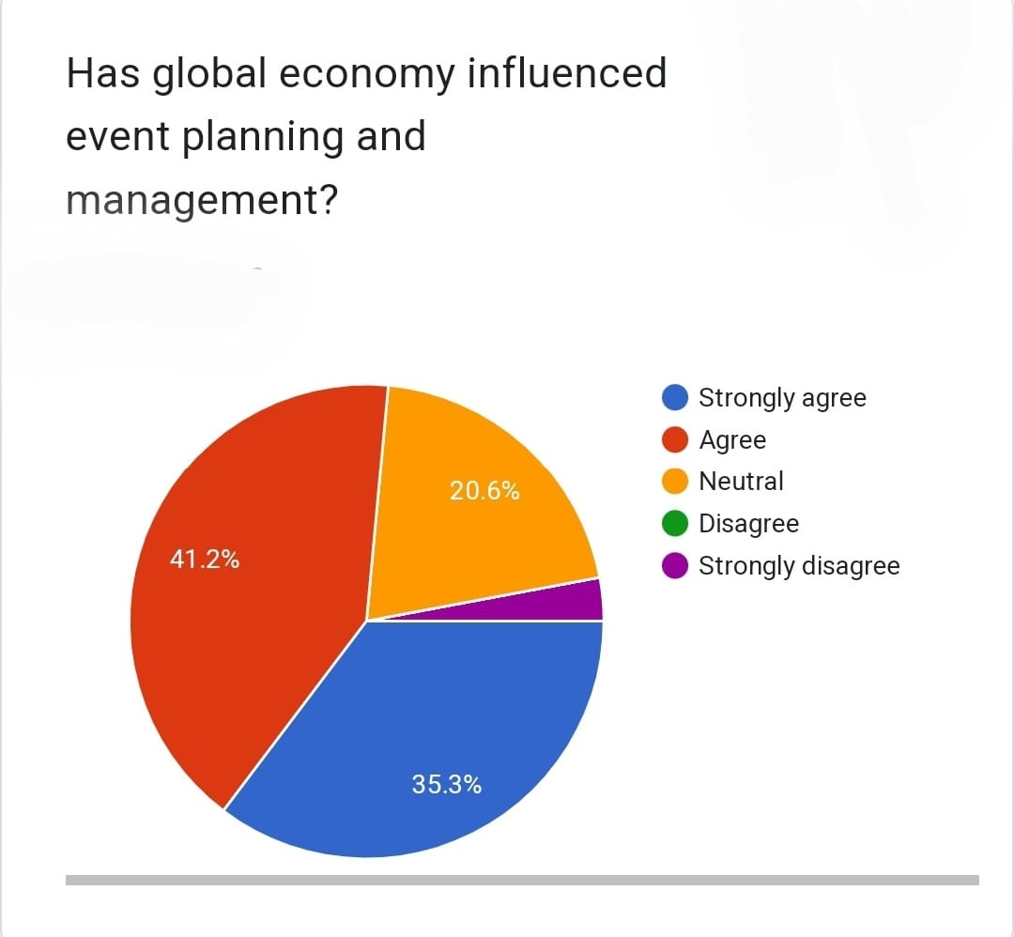
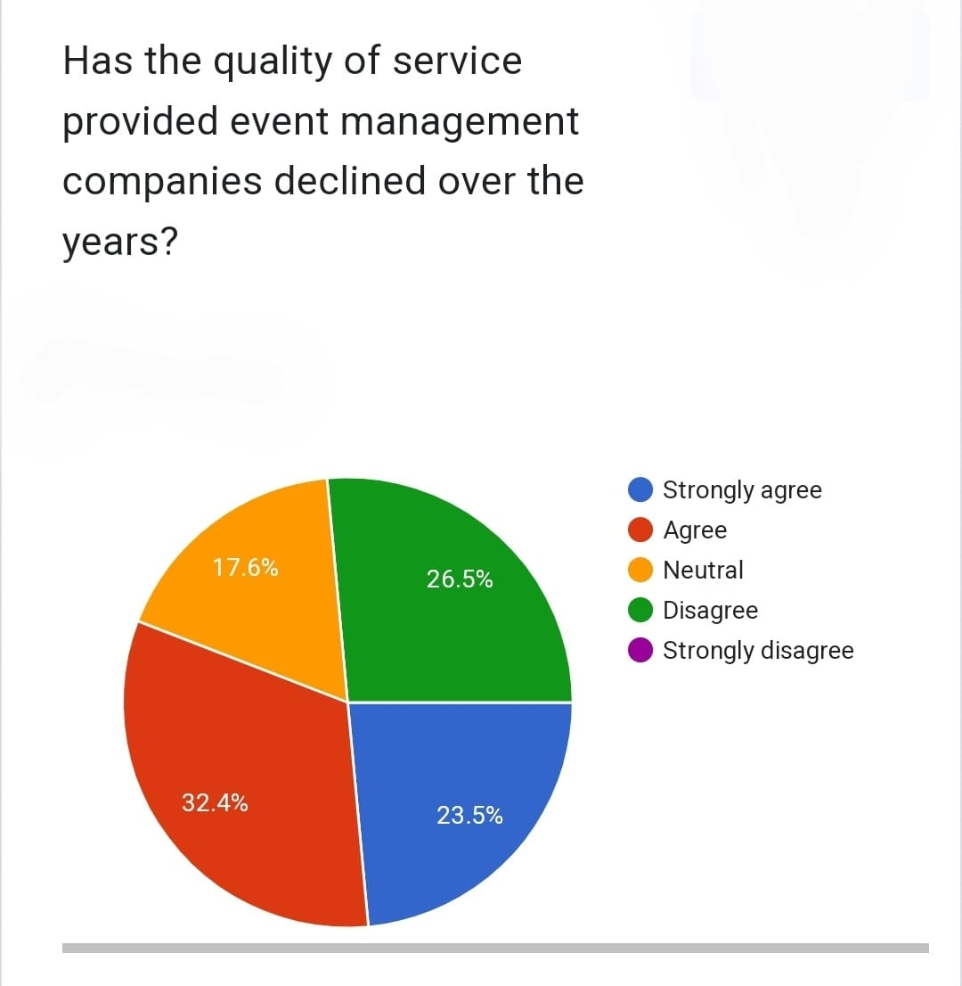
SUGGESTIONS AND SCOPE OF STUDY
1. Identifying the specific policies to examine: Economic and political policies can encompass a wide range of topics, so it's important to hone in on what specific policies to study. For example, you might choose to look at how changes in tax policy or government regulation affect events in a certain industry (e.g., music festivals).
2.: To make the research more concrete and compelling, selecting real-world examples of events that were impacted by economic or political factors. This will allow to analyse specific situations in detail and draw insights from them that would be harder to obtain through purely theoretical analysis.
3. Considering different methodological approaches: Depending on the study and the data available, there may be several different ways to approach and analyse these issues? Quantitative methods such as regression analysis etc can provide practical results while qualitative approaches such interviews with stakeholders involved can help gain information specific cases analysed.
4.Defining key metrics: Establishing key metrics will add value, defining metrics associated with increased revenue generation from an event combined other hard measures like social media impressions all contribute a better understanding if they match up against related policy implementations.
5.Assessing secondary impacts: It would also be wise gaining insight into adjacent sectors; evaluating the spill over effects of both economic and political policies could have a significant impact on areas like food, hospitality, logistics etc.
Evaluating adjacent sectors' spill over effects stemming from both economic and political policies could have significant consequences for areas such as food, hospitality logistics among others. And focused analysis anchored by grounded research methodologies aimed at highlighting causal relationships between observed results versus tackled policy interventions will allow informed recommendations going forward. Overall, this topic provides opportunities to study how varying economic and political factors can influence outcomes event management, as numerous real-world examples. Equipped with focused analysis and research highlighting causal relationships between policy implementations versus observed results including insights into secondary impacts will help execute informed recommendations going forward.

CONCLUSION

This research paper comes to a conclusion that the event management industry has experienced significant growth and is driven by economic and political factors that influence its success. The study shows that macro and micro environmental factors affect aggregate demand, investment, and the competitive advantage of event management companies. Economic stability and political stability are essential for event success, and the political risks of corruption, bureaucracy, and legal frameworks pose challenges to the industry. Data collection sources were gathered through Google form questionnaire. The collection of data was done in order to understand views of people on event management companies and economic and political factors affecting event management.

Economic impact studies are crucial in garnering support and resources for leisure, sport, and cultural events, and policymakers and event management companies must work together to improve efficiency post-COVID, event management companies should embrace technology, prioritize safety, streamline processes, focus on sustainability, improve communication and build a strong team. This can be achieved through the use of event management software, virtual event platforms, checklists and delegation, and training and development. By adopting these strategies, event management companies can deliver successful events in a challenging environment.

The event management industry in India was severely impacted by the COVID-19 pandemic. The government has taken some steps to support the industry, such as providing financial aid and reducing taxes. Event management companies are adapting to the new normal by incorporating technology and digital platforms into their services, such as live streaming, webinars, and virtual networking sessions. This has enabled them to reach a broader audience and expand their services beyond traditional events However, with the right support from the government and innovative solutions from event management companies, the industry can recover and continue to contribute to the country’s economic growth.

REFRENCES
1. Murphy, P. E., & Jago, L. K. (2004). Event management and event tourism (2nd ed.). CABI Publishing.

2. Ali-Knight, J., Robertson, M., Fyall, A., & Ladkin, A. (2012). International perspectives of festivity and events: Paradigms of analysis. Routledge.

3. Matheson V.A.; Baade P.D. (2004) Mega-Sporting Events in Developing Nations: Playing the Way to Prosperity? Journal of Economic Perspectives Volume 18

4.Jago, L.K(2018), Festival and Special Event Management, ‘John Wiley & Sons'

5. Getz D. (2019) Political Risk Management for Meetings and Events In Global Meeting and Event Planning Strategy: From Start to Finish.

6. Yeoman, I; Robertson, M.H; Ali-Knight J (Eds) (2019), Festival Impacts: Intellectual, Social and Cultural

7.https://www.academia.edu/431441/The_Political_Analysis_and_Political_Economy_of_Events

8.https://www.researchgate.net/publication/307839650_Economic_Impact_of_Events_and_Festivals_on_Host_Regions_-_Methods_in_Practice

9.https://www.irjmets.com/uploadedfiles/paper//issue_10_october_2022/30853/final/fin_irjmets1666882974.pdf

10. Maguire, K and Hanrahan, J (2017) Assessing the Economic Impact of Event Management in Ireland: A Local Authority Perspective. Event Management: an international journal, 21 (3). pp. 333-346. ISSN 1525-9951

11.Joe J Goldblatt, Seung-won Lee (2012) The current and future impacts of the 2007-2009 economic recession on the festival and event industry, https://doi.org/10.1108/17582951211229690

12. W. Qui; S. Rutherford; A. Mao; C. Chu (2017), The Pandemic and its Impacts, https://doi.org/10.5195/hcs.2017.221

13.FICCI (2020), Impact of Covid-19 on Indian Economy, India. 2. Gade J. and Ankathi (2016), R. Tourism Management Philosophies, Principles and Practices. Hyderabad, India: Zenon Academic Publishing, pp 402.

14. http://ficci.in/spdocument/23195/Impact-of-COVID-19-on-Indian-Economy-FICCI-2003.pdf
http://www.msruas.ac.in/pdf_files/Publications/MCJournals/August2018/Paper5.pdf
Adams, K.M. (2006).

15.AIEST (1987). Editions AIEST Vol. 28, The Role and Impact of Mega-Events and
Attractions on Regional and National Tourism. St. Gallen, Switzerland.

16.2010 Legacies Now (2012) Social sustainability. Available at http://www.2010legaciesnow.com/socialsustainability/. Accessed on March 29, 2012.

17.Andranovich, G., Burbank, M., & Heying, C. (2001). Olympic Cities: Lessons learned from MegaEvent Politics, Journal of Urban Affairs, 23 (2), 113131.

18Birkland, T. A. (1997). After Disaster. Agenda Setting, Public Policy, and Focusing Events Washington, Georgetown University Press.

19.Bob, U., & Swart, K. (2009). Resident perceptions of the 2010 FIFA Soccer World Cup stadia development in Cape Town, Urban Forum, 20 (1), 4759.

