TEAM 7

COMPARARITIVE STUDY OF CAB AGGREGATORS

Sara Elias – Assistant professor Center for management studies (Jain - Deemed to be University), Sunil Hegde– Assistant professor Center for management studies (Jain - Deemed to be University),
Preksha Thakkar- BBA student Center for management studies (Jain - Deemed to be University),
Rashi Agrawal BBA student Center for management studies (Jain - Deemed to be University)
Praneetha- BBA student Center for management studies (Jain - Deemed to be University),
Rishabh Keswani- BBA student Center for management studies (Jain - Deemed to be University)
Rahat Mannat - BBA student Center for management studies (Jain - Deemed to be University)

ABSTRACT

In the research paper we have covered various aspects related to car Aggregators. Our main objects were to analyse and understand the various aspects that are consider by the car Aggregators in the course of enhancing the quality of the service they provide and that of the customers that opt for the cabs. Along with this a comparative study is conducted between Ola and Uber to understand the level of competition they possess.
Car Aggregators is one of the growing markets where there are two major players - Ola and Uber.
We conducted the research in order to understand the level of competition and conduct a comparative study.

Keywords - Car, aggregator, pricing, comparative, market, study, cab, available.

INTRODUCTION

When compared to other countries, India's taxi transportation sector is distinctive and diverse. It is a rapidly growing sector with enormous potential that is enticing many start-ups to join. This industry has historically been divided into two eras: pre-aggregator and post-aggregator. The Cab Aggregators primarily handled all of the significant underlying problems, such as timely cab supply, driver behaviour, and vehicle security via technology-assisted monitoring.
Cab Aggregators essentially don't own the cars; all they do is coordinate between the passengers and drivers utilising GPS and GPRS (Global Positioning System and General Packet Radio Service) technology.
The taxi industry is split into organised and unorganised operations.
Since only 5% of the projected $9 billion Indian cab market is controlled by organised operators, the cab aggregation sector is still regarded to be in its infancy. The market still has a tremendous amount of untapped potential, as evidenced by the growth forecast to rise by 30% per month. The growth of the cab aggregation sector not only provided a solution from the standpoint of the consumer, but it also assisted the drivers in increasing their take-home pay.

Impact of cab aggregators
Newspapers, exclusive television programmes, live blogs, and the numerous stories that publish practically daily all demonstrate the impact that the cab aggregators had on the industry.
If we attempt to remember how we used to book a cab, the pre-aggregator era brings back recollections of phoning each cab company anxiously on a busy day.
We have to wait until the cab arrives without appropriate notice of the estimated arrival time, and there are problems with the drivers' conduct, higher prices, incorrect billing, and finally, we always saw they selected the most expensive routes to maximise their earnings. All of the archaic problems seemed to be resolved with the introduction of Uber and Ola, but as we talk further, it appears that they all resurfaced in new ways.
However, the new business model also provides the end user with peace of mind and a little luxury, particularly for the Indian middle class who have always wished to own a car but also can afford a cab ride.
Business Model
What makes a taxi aggregator business model exceptional is its convenience and choice. Passengers can choose from a range of options, such as different car types, prices, and providers. Taxi aggregators also offer opportunities for drivers, such as flexible working hours and the ability to earn more money during peak times.

- Passenger App
Users can easily sign up using their mobile numbers, e-mail addresses, or social media profiles.
Driver Rating: Customers can provide feedback and reviews for each driver individually.
Track payments: If users prefer quick transactions, they can pay for their fares and securely save their credit or debit card information under the payment section.
Scheduled rides: The user has the option of booking now or later. Ride Scheduling allows the user to book a ride at a specific time or later.

- Driver App
Drivers receive an alert when someone books a ride, and they can toggle their availability status on or off by toggling on the screen.
Route optimisation: Assists drivers in locating the location of the customer.
Payment Tracking: Allow drivers to view their payment information on a single screen.
Accept/Decline Ride Request: Based on availability, drivers can accept or decline the booking request.

- Admin Panel
Passenger Management: This tab allows the admin to view and manage all of the activity of registered customers.
Booking Management: The admin is responsible for overseeing the number of bookings, the rider’s information, and the driver of the specific booking.
Scheduled Requests: All scheduled requests, their details, and the payment method used by the riders are viewable to the admins.
Push Notifications: Admin can configure mass push notifications to send to users to keep them up to date about the necessary details.

Market study
ANI Technologies Private Limited (Ola Cabs) and Uber India Systems Private Limited dominate the Indian online taxi services market (Uber India). In FY 2020, Ola Cabs accounted for nearly 74.6% of the total revenue generated by India's online taxi services market, while Uber India held a 20.07% market share. Meru Mobility Tech Private Limited, Mega Cabs Private Limited, and Carzonrent (India) Private Limited are among the other market participants. As of 2020, Ola Cabs operates in approximately 130 Indian cities, whereas Uber India operates in approximately 55 cities.

COMPARITIVE STUDY

In many Indian cities, taxis are a popular form of transportation for many people. One needs taxis or cabs for a variety of reasons, including getting from work to home or vice versa, transporting family members out when they do not want to drive after drinking, and a number of other situations.
The fact that this industry is still unorganised, and that demand is increasing is crucial. Cab aggregators developed as a reliable answer because it demonstrates that there is a significant business possibility from an entrepreneur's standpoint while at the same time not raising the expectation of service from a consumer perspective.
This research paper looks at how OLA and Uber have affected the Indian vehicle industry, the current situation, the difficulties the sector is now facing, initiatives taken by Ola and Uber, and the 2019 Motor Vehicles Bill. In addition to comparing a personal vehicle and a taxi, it also discusses the problems from the perspective of the consumer.

Ola, one of a few Indian unicorns (start-ups worth more than $1 billion), has emerged as a key player in the broader anti-Uber coalition. It's now part of a larger campaign to counter Uber's growing global dominance. Uber is the world's most valuable start-up, valued at $68 billion.
Ola Cabs is a multinational taxi service company based in Bangalore, India. It is one of the best taxi services that began in 2010. The application's service is provided by the ola app. Because of its advanced and diverse features, the ola app has experienced rapid market growth.
In the competitive taxi industry, the Ola app is thriving.
The Ola app is constantly re-inventing and strategizing new ways to keep users interested. Let's take a closer look at Ola's business model to see how the company makes money. On trips booked through its platform, Ola charges a percentage of the total commission. Customers are fares are charged based on a number of factors, including:
The first flat fare is the base fare.
- Distance Per Kilometre Fare varies by car and is charged based on geographical location.
- Ride Time Fare - charged based on total time from pick-up to drop-off.
- The ride time fare is based on the amount of time it takes to travel in minutes.
- Wait Time Fare - charged if the driver is required to wait.
- Peak Pricing - charged when cabs are in high demand.
- Advance Booking Fees - The user will be charged an advance booking fee if they book their cab in advance.
- Access Fees - This is a charge for car rides.
In some cases, a cancellation fee may be assessed for cancelled rides.
• A service tax of 5% is added to the total trip fare.
Ola's estimated commission per trip - • New driver introduction promotion - 7.5%
• In India, ola charges the driver a 20% commission.

Other features include: Ola Money - Promotions in Cabs, Car Rental
Uber Technologies, Inc. is an American provider of mobility services. It is headquartered in San Francisco and operates in nearly 73 countries and 10,500 cities in the world.
Let's look at Uber's business model to see how the company makes money. The Uber trip includes:
- Booking fees range between $1 and $3, depending on location.
- Fare per mile - Customers are charged a fee per mile travelled.
- Travel Time Fare - A travel time fare is charged based on the length of the trip.
- Taxes - A tax is charged based on the location.
Additional sources: Uber Eats
OLA VS UBER
FEATURE | OLA | UBER
Service Availability | Approximately 60 countries | Approximately 70 countries
Car Types | Sedans, SUV, Luxury Sedans | Sedans, SUV, Accessible Vehicles, Premium Cars
Payment Method | Cash Credit Card, Debit Card, Mobile Wallets | Cash Credit Card, Debit Card, Mobile Wallets
GPS Facility | For both Rider and Driver | For both Rider and Driver
Feedback | Only available for Riders | Available for both Rider and Driver
Sign Up Discounts | $15 Referral Available | No Sign up offers available

REVIEW OF LITERATURE

Mr. Sai Kalyan Kumar Sarvepalli (2016), This paper aims to present an overview of the Car Aggregation industry in India, the current scenario, issues, and finally looks at the possibilities of consolidation based on recent industry developments. Finally, the paper offers recommendations for improving services that will benefit ride-hailing companies like Uber and Ola, as well as customers who use the services and drivers.
SHREY NIGOTIYA (2020), This article focuses on, studies, and discusses how OLA and Uber have impacted the Indian automobile industry, the current scenario, the industry's challenges, and the initiatives taken by Ola and Uber. Along with this, it compares a personal car and a cab, but it also describes the issues from the consumer's standpoint. The paper also provides extensive information about the 2019 Motor Vehicles Bill.
Vedant Jalan (2018) The purpose of this paper is to provide relevant data about the Cab Aggregator industry in India and to establish a link between cab aggregator network optimization and various Operations Research concepts. It also provides data concerning the present state of the Indian cab industry.
Robin Singh (2020) This article analyzes the business model challenges that cag aggregator platform models face in developing countries. To present the key features of Ola's model, the paper evaluates the situation and business model. The paper additionally highlights the inherent challenges in this model and highlights the importance of continuous business model innovation and service quality.
G. Venkatesh and George Easaw (2015) This paper attempts to study the technique by which performance of these aggregator services can be measured. The paper has identified the criteria and measures of performance that can help cab aggregator services to improve customer satisfaction and quality of service.
Dr. Rupali Rajesh (2021) The study's goal is to identify the factors that influence Uber cab service usage. Learn about the demographics of customers in Mumbai. It also investigated the customer experience aspects of online uber cab services. They conducted their research using the survey, sampling, and questionnaire methods, and the results will assist marketers in developing marketing strategies for customers.
RASHI SACHAN, the paper attempts to investigate the current state of the taxi market in India in an attempt to understand the impact of various factors such as new advancements, safety, price, comfort, and ease of availability. The research mainly focuses on the impact of these parameters on radio cabs and public transportation, as well as how it affects the public transportation market..

Utsav Pandya (2017) The primary goal of this research was to examine the influence of private taxi companies on the public taxi market. We carried out the study by utilising specific variables that will explain the effect of the private taxi market on the public market place. To get an in-depth knowledge of the taxi industry's strategic overview and the impact Ola had on black and yellow taxis. The collected and analysed data was closely researched and explained in the paper.
C. Anirvinna (2017) From an economic standpoint, the article evaluates the pricing strategy used by Ola and Uber in India. It emphasises the importance of surge pricing as a strategic business tool. It also considers the alternative, as well as the impact of such selective pricing on actual demand and supply of cabs on the road, as well as driver incentives.
Sarvesh Mathi (2022) The article mainly talks about a market study conducted into cab aggregators like Ola and Uber wherein they have analysed and discussed their pricing and transparency after considerations of numerous factors and facts they have made certain recommendations as well.
News editorial (2021) The article talks about various cab aggregators that are leading the transport industry that are mainly app based. They also talk about the potential in the same field. As per reports there are many other creative cab aggregators that are coming into the business.
Vinod Kumar Bishnoi (2019) The objective of the paper us to gain insights on about the present scenarios of the cab industry in India to examine and compare them to giants like Ola and Uber. The article uses various existing database for the research and analysis.
Randhir Kumar (2021) The paper discusses drivers who work on a digital platform of cab aggregators and have a unique employment relationship. It discusses the cab aggregator strategy used in cities such as Mumbai. In general, it seeks to theorise the relationship between cab aggregators and driver partners.
Nafisa Khatoon An article that discusses the driver partner importance in the Cab industry keeping in mind the two giants Ola and Uber. The article analysis lies in locating and studying the socio – economic standing of the driver partners and discuss on the same.

OBJECTIVES
The main objective of this study is to examine the kind of impact the car aggregators have on an individual. Through this study we have conducted a comparative study on the 2 major players in the market that is Uber and Ola.
Here the main focus is to understand to understand:
- Difference in features of the two aggregators.
- Understand the difference in services offered.
Along with this we attempt to understand the customer reviews and understand their point of view on various aspects.

LIMITATIONS:

Limited responses collected:
For our research the responses collected by us were limited to our convenience and to a number that we felt might be enough for us to conduct research. Normally the higher the number of samples the more in-depth is the study conducted. We might have missed out on a few points of views through the study and may not have reached out a diverse audience.
Time Constraint:
As a student the amount of time invested in the research paper may have differed. If in case we managed to invest in time to go into the minor details of the research topic that we selected we might have had a better and more in depth understanding of the topic.
Lack of previous experience:
As the first paper that we present as students, we might not have the experience talk more. Being new to the idea may have resulted in us not conveying the information the in the right manner, missing out of certain details etc.

RESEARCH METHODOLOGY

For our questionnaire we have used a set of 12 questions that mainly focusses on the collecting information from the respondents about their experience and opinion with reference to Ola and Uber:
The questions are as follows:
- Which Cab aggregator do you prefer.
- What type of vehicle do you prefer for transportation.
- You preferred cab aggregator ensures safety and security of the passengers.
- What is the average response time for booking a ride.
- The pricing structure is a suitable for the service provided.
- Offer and discounts offered are offered to frequent customers.
- The customer issues and complaint are resolved at the earliest.
- Cab aggregators offer comfort and conveniences to passengers.
- Booking a cab at peak hours and busy periods takes longer than expected.
- How often do you use your preferred cab aggregator.
- Ratings and Reviews helps the cab aggregator improve the quality of service provided.

Attached below is the Google form link:
https://forms.gle/KMumWjmXSUCAEw637
TYPE OF RESEARCH
The type of research that we have used in our research paper is that of Descriptive research. Descriptive research mainly focusses on comprehending the characteristics of a situation of a specific event. In case of our study this method of research helps us in understanding the customers point of view on various takes of the company’s methods of carrying out their services. With references to the questions asked, we have been able to cover various aspects that influence the customers as well as the car aggregator. For example, we have tried to understand the respondent’s opinion
- On the safety provided by the car aggregators
- Pricing structure
- Customer service
- And many more aspects.
This method of research also helps us understand the kind of expectations the customers might have from the car aggregators in terms of the kind of services, discounts and many other factors.
To conclude the benefits of descriptive research it offers useful information of the comparison of the two giants Ola and Uber and explains the business model.
TYPE OF SAMPLING
The study of a comparative study on cab aggregators was carried out on a small scale. The method of sampling used was convenience sampling. This method of sampling is used when the samples used in the study are as per the researcher’s convenience. The research was carried out by reaching out to potential respondents who were interested in taking up the questionnaire. The objective of the questionnaire was to have a in depth analysis in the customers review and past experiences with their choice of cab aggregators.
The findings of the questions asked in the questionnaire showed us a critical as well as appreciative opinion on various aspects. They helped us understand the benefits and drawbacks of the cab industry. It also threw light on many methods or areas where the industry should take into consideration the customer reviews and feedbacks.

Population Sampling:
Through out the course of our study we have only considered the Urban Bangalore Population. As mentioned earlier we have only considered a fixed number of samples that we have used to generalise the populations opinion. In the study we have considered individuals who are currently studying, those who are going to pursue their studies as well as those who are currently working.

Data Collection:
In our research we have opted for using questionnaires to collect information about the cab aggregators that have become a part of many people’s lives in today’s world. Included under this method were interviews, survey’s, focus groups and many more. We used Primary method of data collection which helped us draw conclusions based on the responses we received through the course of our study. This method helped us learn as well as gave us an insight into how we came to a conclusion with the help of a few samples, to be specific 30 samples.

ANALYSIS AND FINDINGS

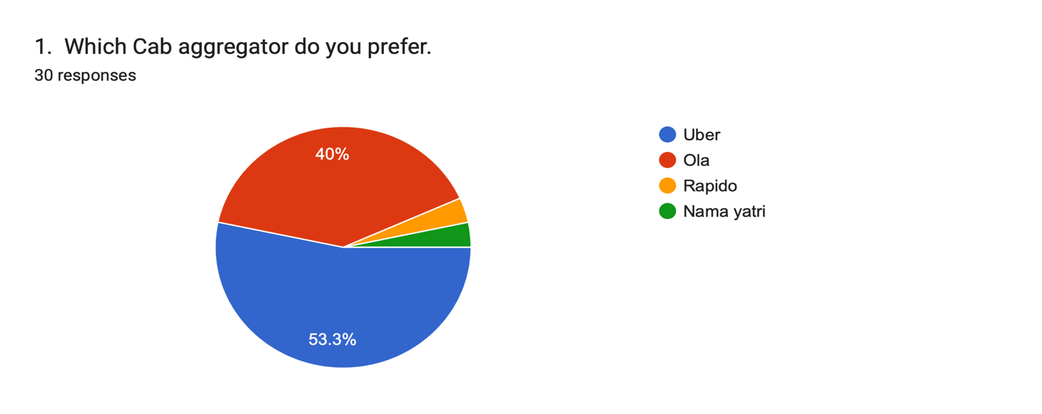
Among the 30 respondents majority of them (53.3%) prefer to commute via Uber a San Francisco based company.

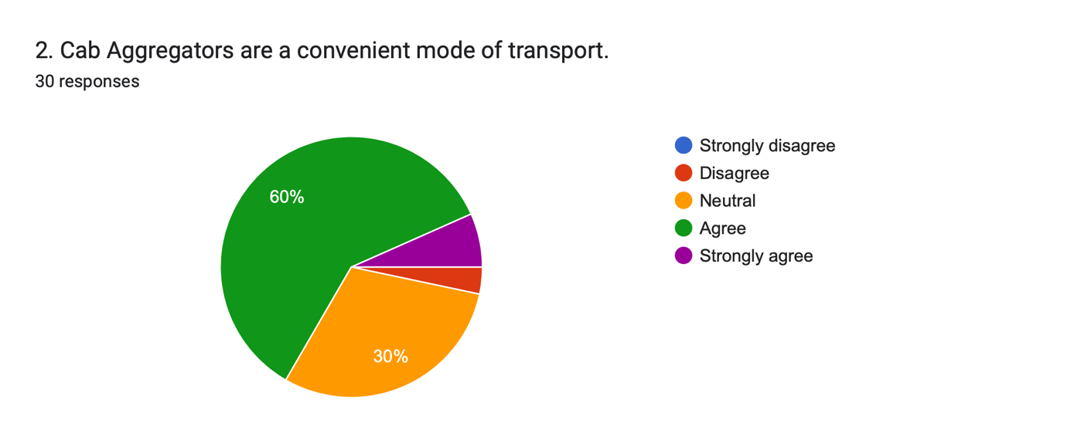
While a total of 60% strongly agree that the cab aggregators provide a convenient mode of transport there is still 30% of population that have opted to go for neutral decision based on their experience and other variable factors.

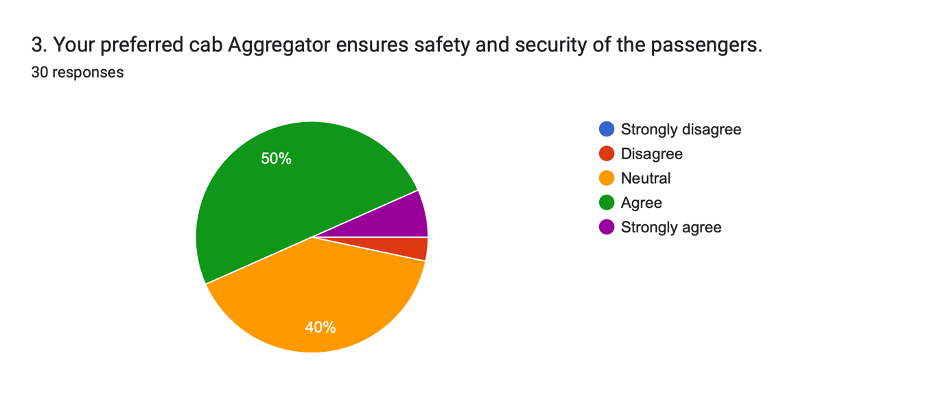
Almost half of the population (50%) of the selected respondents feel absolutely safe to use cab aggregators services safely. While the rest 40% have had mixed experiences and some still seek for redressal.

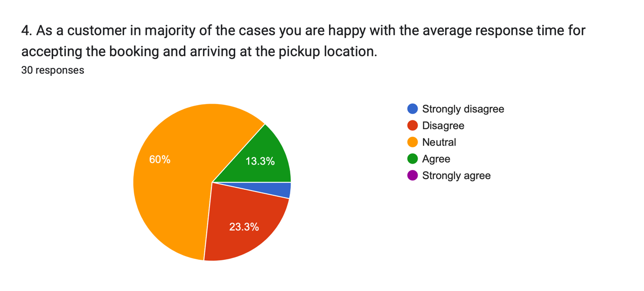
There is still a huge population who still do not clearly happy with the responding time when it comes to services provide by the cab aggregators. The rest of the respondents are also not quite satisfied with these service hence, requires update as per the chart shown above.

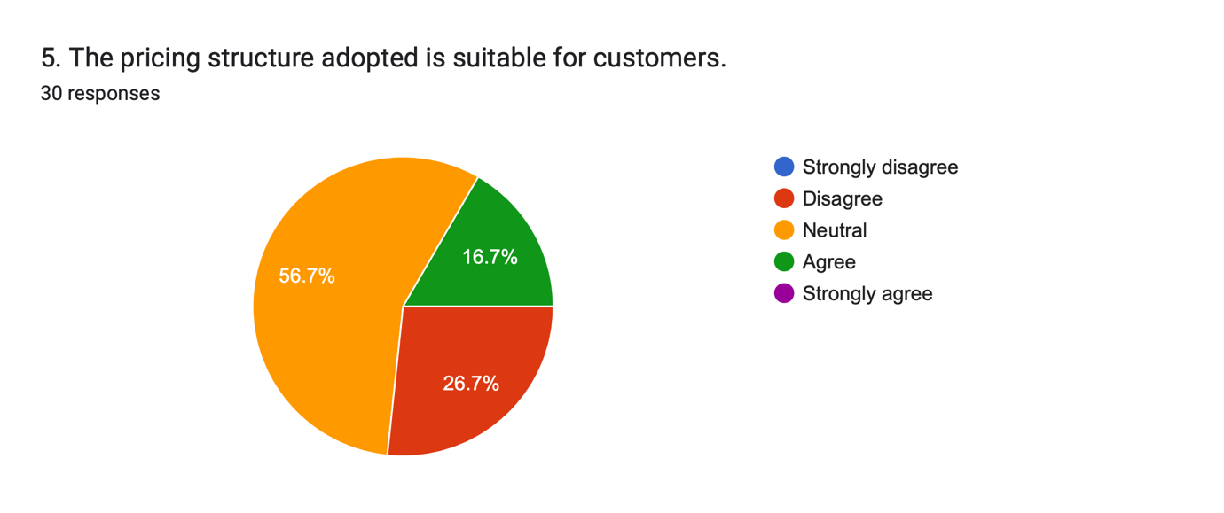
More than half of the respondents (56.7%) have opted to go for neutral answers. This might vary with the current gas prices and various government policies. Although 16.7% population still agree with the pricing structure as far as the service is top notch.

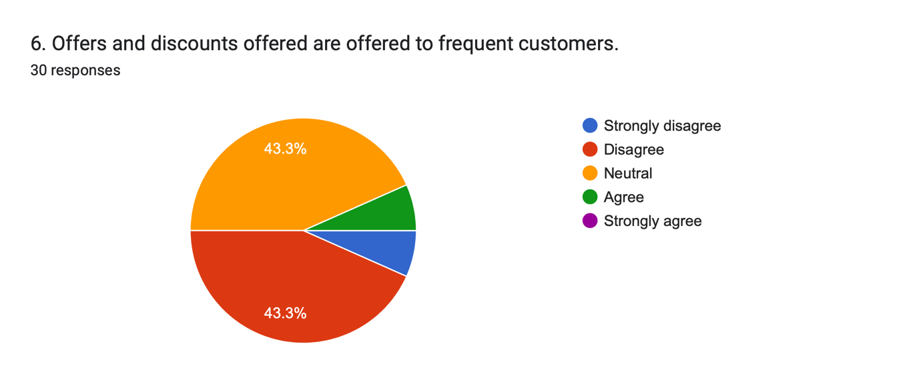
The responses here are mix. While the gift cards and cab passes provide users with notable discounts, majority of them go waste because of lack of service.

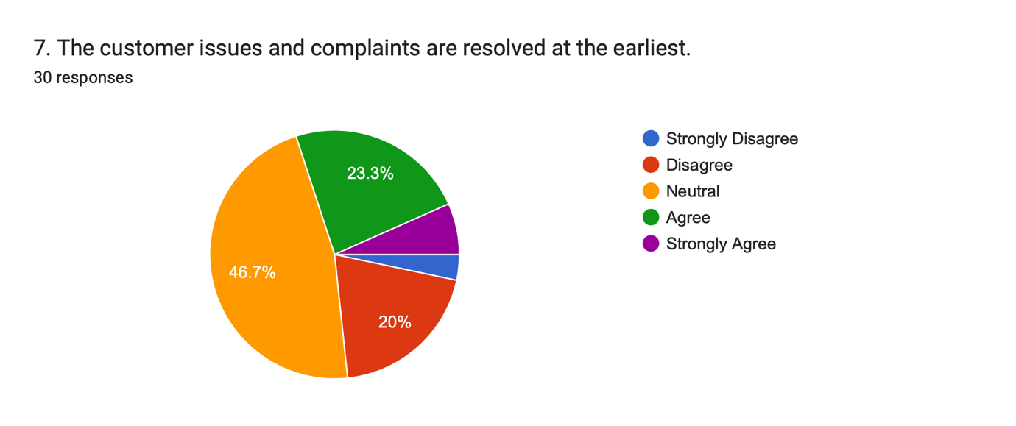
As per the yellow portion on the chart (46.7%) majority of the respondents have a neutral feeling i.e. not in the favour but also for it. While in most of the cases the issues are taken seriously there are majority of them that goes unsolved. The customers also complain that the entire process is tedious and there’s hardly anyone to look at the matter closely.

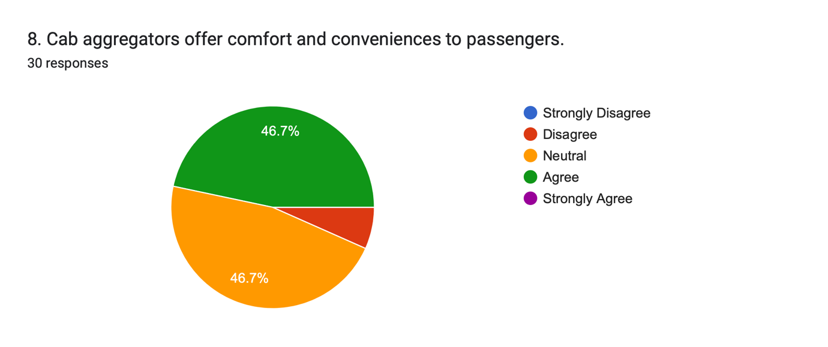
Yet again the customers have almost voted out to be neutral and agree to the concept. When it comes to comfort majority of them found the trip mesmerising with the behaviour, driving pattern and safety to be a no issue, while few of them have extremely bad experience over the time.

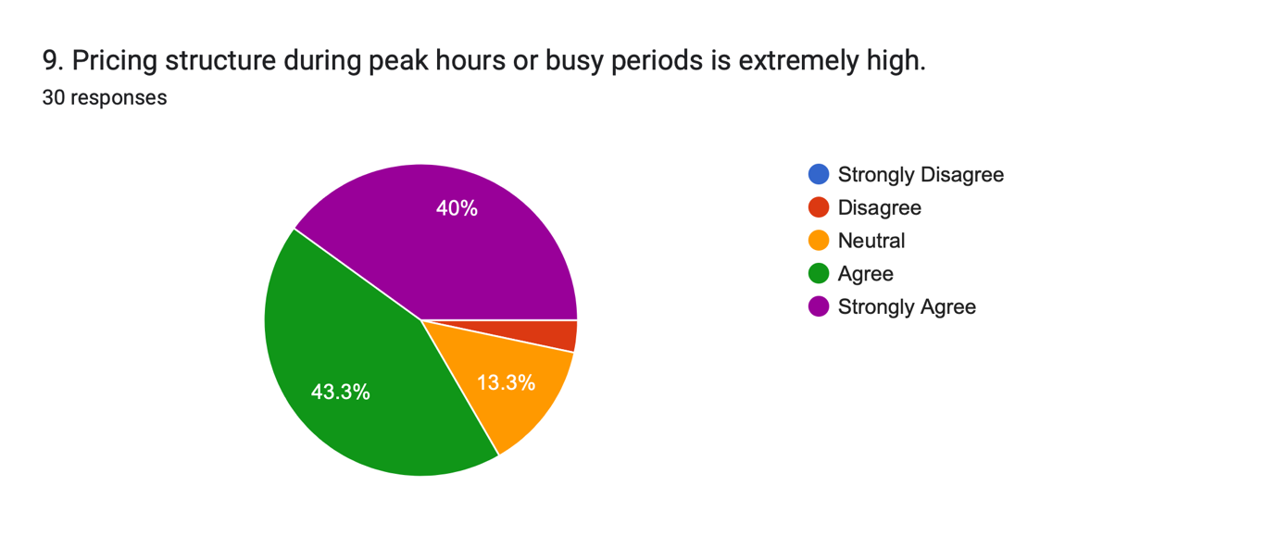
Here a total of 43% people agree that the companies are charging way high specially during the peak hours.

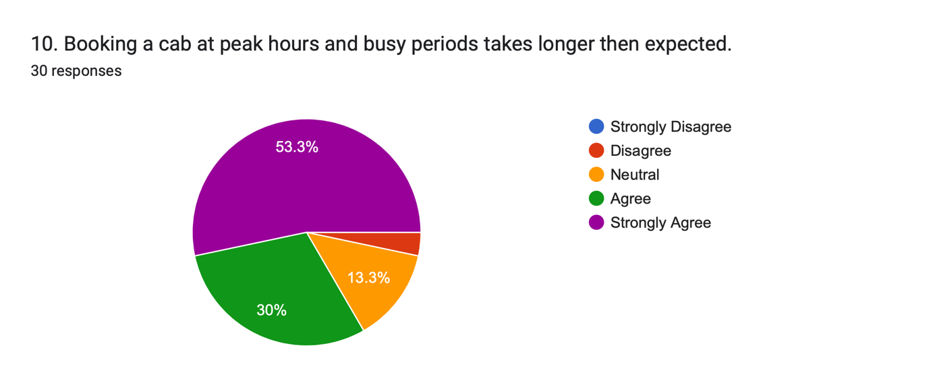
This is the root cause of almost most of the problem. Booking a cab during busy hours is extremely tough as per 53% of the respondents that came up to take part in the survey.

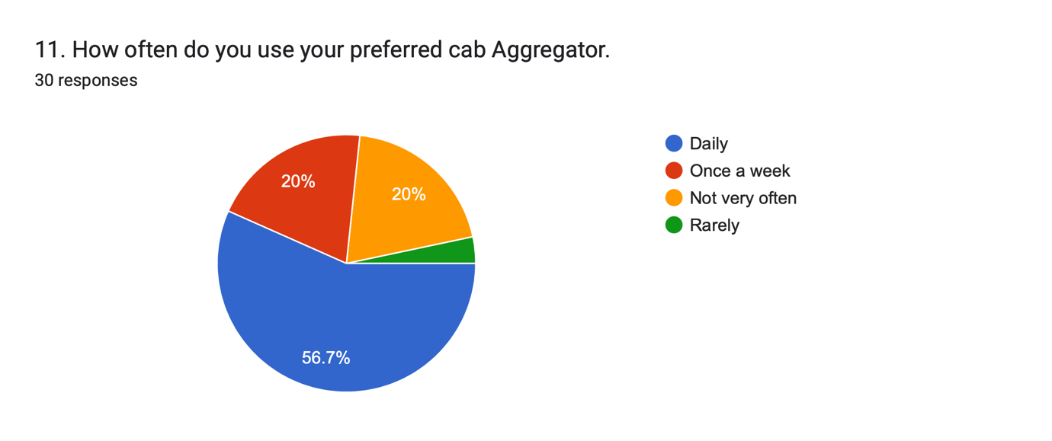
People, especially in metropolitan cities hit the busy road via cabs. More than half of the respondents as per the chart in blue colour (56.7%) often avail these services to cover their destination.

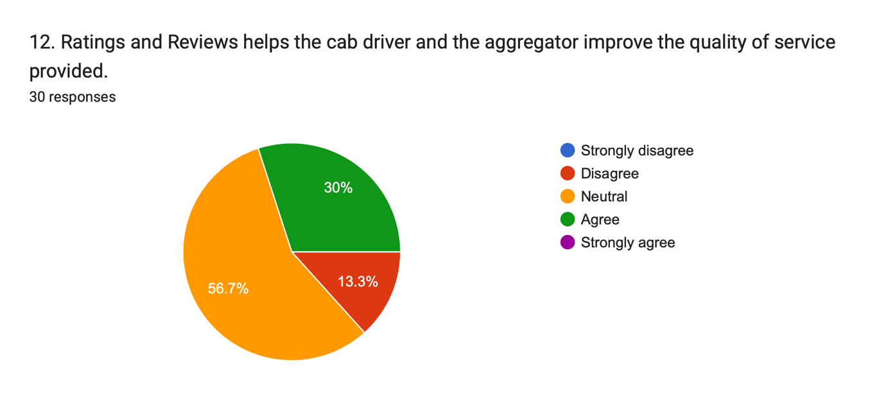
With 56.7% of the population have had mixed experiences and believe that after reaching the profit point while most of the cab aggregators run after numbers and hardly look after customer satisfaction there are still many that take this in to account seriously.

FINDINGS

As per the study we conducted on the topic of car aggregators. Our main aim was to compare and analyse the difference in services provided, various aspects involved in the business model and what plans they should undertake to develop their services.
According to the analysis that we conducted we narrowed down to a few conclusions which include
- A lot of the responses were neutral to the questions we asked related to the services provided.
- A few people agreed to many questions and put across their opinions about the kind of services provided by their preferred
- However, some had a different opinion and they felt that the services provided. The pricing structures were not suitable etc. A majority of the respondents felt that the pricing structure, wait time and peak hours business model is not suitable as per consumer preferences.

Through our research we also understood the different methods adopted by the companies to earn money and the way they structure their service. How the growth of cab aggregators has effected the local taxi’s along with which the convenience that customers experience due the faster availability of cabs at their required location.

CONCLUSION

Our objective was to compare and analyse the cab aggregator industry. Understanding the consumer point of view in terms of the services provided, the pricing structure and facilities provided by their preferred cab aggregator. In order to do so we circulated a questionnaire that contained 12 questions on similar topics mentioned above. The answers given by the respondents helped us understand
- Which cab aggregator was most preferred
- What kind of pricing do consumers prefer
- Whether they are happy with the services
- Whether the facilities provided are as per the customer preference

Through this we were able to compare the two giants in the business i.e., Uber and Ola.
We did experience certain hiccups through the course of our research which might have resulted in us missing out on certain details however we overcame them and did achieve our objectives.

