

AUTHOR - Dr. Roopa KV
Assistant Professor, Centre for Management Studies
Jain Deemed to be University- Bangalore, India
Dr.roopa_kv@cms.ac.in

Co- Author - Prof. Sunitha B K
HOD, Centre for Management Studies
Jain Deemed to be University- Bangalore, India
sunitha@cms.ac.in

Co- Authors-

NAMES | REGISTRATION NUMBERS
PRACHI SHAHDEO ( Student )  prachi_shahdeo2021@cms.ac.in | 21BBAR0486
PRABHLEEN KAUR ( Student ) | 21BBAR0482
PARUL BANSAL (Student ) | 21BBAR0465
PRISHITA AGRAWAL ( Student ) | 21BBAR0507
PARIDHEE AGARWAL (Student) | 21BBAR0462

RESEARCH PROJECT REPORT

“A STUDY ON NEW PRODUCT DEVELOPMENT TOWARDS READY TO EAT FOOD”

ABSTRACT

There is a tremendous problem in various cities with respect to time and traffic. At the same time, both men and women are working in a variety of households. From this point of view, they spend most of their time working either in the office or at home and have very little time to prepare meals. They also don't prefer to go out for food, which is why the ready-to-eat food has become popular. The research is conducted in Pune city. Pune is the second-largest city in Maharashtra, India. The benefits of ready-to-eat foods have led to an increase in the market for ready-to-eat food products. From college students to bachelors to people at the workplace, ready-to-eat food is easy to make and preferred as a quick fix to hunger. The main aim of this study is to identify consumer perception towards Ready-to-eat food in Pune city. Also, this study helps to identify the factors that influence the buying behaviour of Ready-to-eat food. The consumer perception and brand choice of Ready-to-Eat food were measured by the response of various people living in Pune City. A survey was conducted and various secondary sources were referred to derive the niche expertise of findings.

INTRODUCTION

MARKETING
Marketing is the process of exploring, creating, and delivering value to meet the needs of a target market in terms of goods and services; potentially including selection of a target audience; selection of certain attributes or themes to emphasize in advertising; operation of advertising campaigns; attendance at trade shows and public events; design of products and packaging attractive to buyers; defining the terms of sale, such as price, discounts, warranty, and rectum policy; product placement in media or with people believed to influence the buying habits of others; agreements with retailers, wholesale distributors, or resellers; and attempts to create awareness of, loyalty to, and positive feelings about a brand. Marketing is typically done by the seller, typically a retailer or manufacturer.

Sometimes tasks are contracted to a dedicated marketing firm or advertising agency. More rarely, a trade association or government agency (such as the Agricultural Marketing Service) Advertises on behalf of an entire industry or locality, often a specific type of food (e.g. Got Milk?), food from a specific area, or a city or region as a tourism destination.

It is one of the primary components of business management and commerce. Marketers can direct their product to other businesses (B2B marketing) Or directly to consumers (B2C marketing). Regardless of who is being marketed to, several factors apply, including the perspective the marketers will use. Known as market orientations, they determine how marketers approach the planning stage of marketing.
The marketing mix, which outlines the specifics of the product and how it will be sold, is affected by the environment surrounding the product, the results of marketing research and market research, and the characteristics of the product's target market. Once these factors are determined, marketers must then decide what methods of promoting the product, including use of coupons and other price inducements.

MARKETING OBJECTIVES
Marketing objectives are actionable goals that provide overall directions to a specific campaign.
Think of your marketing plan as a target that your team is looking to reach within a particular timeframe. Also, it comes with a metric that serves as a symbolic finish line. For example, a marketing objective might entail increasing your social media post's conversion rates by 30 percent. Objectives extend beyond picking an arbitrary number. You also have to specify how you intend to reach your goal and measure that endpoint.

Objectives of marketing management:
The objectives of each business are pre-set which is led by objectives of marketing management.
The basic and important objectives of marketing management are:

1-Attracting new customers
The important objective of marketing management is to attract new customers to increase the sales of products. Different strategies are set to make sure that maximum customers get attracted to the company's products like displaying ads on TV channels or social media, pamphlets, and arranging a sales team that demonstrates the products.

2-Satisfying the demands of customers
.Another important objective of marketing management is to keep satisfied the customer who is associated with the company's products for a long period. For this purpose, the quality matters a lot but apart from this good service is also concerned like an on-time supply of products and without damage, the products are supplied.

3-Profitability
Without earning profit a company could not survive longer. Earning profit is the backbone of a company. It is necessary to ear profit for growing, diversifying a business, and its maintenance as well. For this purpose, a company must know what is market management? And how to achieve these market targets? A company's management team keeps the marketing on track by entertaining their old and reliable customers and attracting the new customer to make maximum profit for maximum growth.

4-Maximizing the market share
Another objective of marketing management is to make maximum marketing share. For this purpose, companies use different tools to get maximum market sales of their products by having comparison with a market economy. Sometimes, companies offer discounts to attract customers.
Sometimes, they do attractive and unique packaging and offer promotions.

5-Creating a good public reputation
Public reputation plays an important role in the growth of a company. If the company has stood as a good public figure it means it has more chances to grow and diversify but if stands with a bad reputation, it will no longer survive. By marketing, the reputation of a company can be made good and trustworthy for the consumers.

IMPORTANCE OF MARKETING MANAGEMENT
Marketing management is of importance as it helps to stand competent in highly thriving competition in the market. This also helps to develop strategies to improve profits and reduce the cost of products. Marketing management has become the major source of exchange and transfer of goods.
It helps to maintain the company's reputation.

A good company is recognized by its reputation in the market. The marketing includes selling. buying, exchanging, transporting goods which build its reputation. If a company falls well on these parameters, it stands firm and gains a clear and good reputation among the public which is the sole of a business and cannot be denied.

If a good reputation is built, it will be beneficial for the company for its growth and promotion.
When it comes to reputation, good and reputable companies do not compromise for this at all and try. Companies with a good reputation get more opportunities to grow and get more tenders to make them market competent and economically strong. It helps to boost the economy of the company.

Marketing management decides the ways to beat the market competition and make good sales.
They develop plans to advertise their products in an affected way and when the products are advertised, they are on the radar to be viewed and known by the public.

Advertisements help to spread the product description to a great level through friends and family.
Suppose when a girl came to know about the flat 50 percent sale on the clothing brands she will tell her friends and family, spreading the advertisement of that brand's products lively. It promotes the new ideas.

The marketing management helps to promote new ideas which are depending upon the benefits and offers for the public to be grabbed quickly. These ideas keep nourishing and diversifying the companies by keeping them distinctive from other companies' presence in the market.

NEW PRODUCT DEVELOPMENT

New product development (NPD) is the process of generating a new idea, turning that idea into a new & usable product, and introducing it to the market. Usually, NPD follows a series of steps before introducing the new product to the market that satisfies the market need and want.

What is the new product?
A new product is seen understood differently by people and business organizations. Generally, the innovative product in the eyes of people which is first time developed and introduced in the marketplace is called the new product.

Getting the product right is the single most important activity of marketing. If the product is not what the market wants, no amount of price adjustment, dependable delivery, or brilliant promotion will encourage consumers to buy it - or at least, not more than once, and very few companies produce products which are 'once-in-a-lifetime' buys.

On the other hand, if the product produced does satisfy the consumer, the purchase is likely to be repeated. The purchaser may buy other products offered by the same company and recommend its products to other consumers.

Management's decisions about the products to be offered among the most important of those affecting a company's future. Product decisions are more basic than decisions about other marketing variables.

After segmenting the market, a particular company, choosing its target customer groups, identifying their needs, and determining its desired market positioning, is ready to develop and launch new products desired by its consumers.

The marketing department should actively participate with other departments in each stage of the new product development process rather than leave it to the Research and Development department.

Developing a new product begins with thoroughly evaluating the marketplace to determine consumer needs and wants. Based on that evaluation, the marketing executive starts planning strategies that will best fit those needs and yield a reasonable profit.

Challenges in New-Product Development

Considering the extreme competition in contemporary business, companies are exposed to greater risks than fail to develop new products.
Changing needs and tastes of consumers, new technologies, shorter product life cycles, and increased competition at home and abroad have made existing products vulnerable. Side-by-side new-product development can be very risky.
It was found in a study that the new-product failure rate was 40% for consumer goods, 20% for industrial goods, and 18% for service products.
Several reasons are responsible for this high rate of failure.

They may be as follows:

- If a high-level executive pushes a favourite idea through disregarding negative research findings of the marketing department.
- If there is an overestimation of the market size of a good product idea.
- If the actual product is not designed appropriately.
- If it is overpriced, not positioned correctly, or advertised ineffectively.
- If development costs go beyond the expected costs.
- If competition is found stronger than anticipated.

REVIEW OF LITERATURE

1. New insights into consumer-led food product development
A.1.A. Costa'W.M.E.Jongen
This paper builds upon a review of relevant marketing, consumer science and innovation management literature to introduce the concept of consumer-led new product development and describe its main implementation stages. The potential shortcomings of this concept's application in European food industry are described. Contrary to previous optimistic views, it is put forward that without significant changes taking place in the mindset of the organizations involved in Europe's food R&D, the way forward for consumer-led innovation strategies in the agri-business sector will be long and hard.

2. "A Study on New Product Development in Indian Manufacturing
Industries"
Authors:
Sumit Shandilya
BML MUNJAL UNIVERSITY
Surendra P Tiwari
Gyanabrata Lahkar
Amity University
Based on the role of New Product Development process (ND) in the Indian Manufacturing Industries and the importance of various stages that make up the process. New Product Development deals with the whole practice of creating a new product (or process) or improvements in existing products and the commercialization of existing products-a means to attain competitive advantage. New Product Development has a very vast literature discussing its history and its stages and can be considered as a practice related to both the fields of Business and Engineering and has gained a lot of incentive as being a crucial part of Industry 4.0-along with practices such as Six Sigma, Change Management, Lean Manufacturing, Supply Chain Management and more. The Manufacturing Sector is considered the backbone of economic growth in many developing countries. The recent boom in start-ups and the promise of a bright future for MSMEs (Micro, Small and Medium Enterprises) in India has gained a lot of focus.
Various incentives had been introduced to promote the Manufacturing Sector. A survey questionnaire was prepared that considered the various stages of New Product Development processes, the challenges that the Indian Manufacturing Industries face and the views of industry professionals, academics and students regarding the above topics were collected and analysed.
Discussions and conclusions were derived from the questionnaire data.

3. Managing the New Product Development Project Portfolio: A Review of the Literature and Empirical Evidence
Catherine P Killen; Robert A Hunt; Elko J. Kleinschmidt
Literature on project portfolio management (PPM) has been escalating as interest has intensified.
The surge of interest has been attributed to the increased importance of technological innovation and the recognition that successful innovation depends upon effective selection and management of the new product development (NPD) project portfolio. PPM processes are responsible for the alignment of projects with the innovation strategy, maintaining a balance of project types, and ensuring that the project portfolio fits with resource capability so that the organization can gain the maximum value from the investment in NPD. This is the first comprehensive review of the literature on ND PPM to be published and reveals a wide range of considerations from a variety of sources across several disciplines. The growing importance of NPD PPM is highlighted, and interest in PPM is shown to have stimulated a field of research that is beginning to offer empirical findings to help clarify the relationships between PPM methods and NPD outcomes.
Findings reported in the empirical literature are compared with the common beliefs and assertions presented in other published sources. The empirical findings show support for some assertions, and challenge others, while some proposed relationships remain untested.

- New product development practices in consumer versus business products organizations
Nessim Hanna, Douglas J. Ayers, Rick E. Ridnour, Geoffrey L. Gordon
Most recent work in the area of new product development has been of a theoretically prescriptive basis, ignoring, to a large degree, the current state of affairs in US corporations. The study examines, on a comparative basis, consumer and business products organizations, practices being utilized to guide the development process and key factors influencing the success/failure of the process. Results from an empirical study reveal that:
(1) there is no one best means to structure the process;
(2) top management commitment to and support of the process is a critical factor;
(3) knowledge of markets and customers remains elusive; and
(4) more similarities than differences exist between the practices undertaken by and the factors influencing success/failure in consumer versus business products organizations.

5. Top Management Involvement in New Product Development: A Review and Synthesis
Burcu Felekoglu, James Moultrie
Established literature on new product development (NPD) management recognizes top management involvement (TMI) as one of the most critical success factors. With increasing pressure to sustain competitive advantage and growth, NPD activities remain the focus of close interest from top management in many organizations. TMI in the NPD domain is receiving increasing academic attention. Despite its criticality, there is no systematic review of the existing literature to inform and stimulate researchers in the field for further investigation. This paper introduces the current state of literature on TMI in NPD, synthesizes important findings, and identifies the gaps and deficiencies in this research stream. The contents of the selected articles. which investigated TMI in NPD, are anayzed based on the type of the study, level of analysis, research methodology, operationalization of TMI, and main findings. Additionally, other studies, which did not directly investigate TMI and support in NPD, but were sufficiently related, are briefly summarized. As a result of this detailed literature review, it can be stated that both exploratory and relational studies provide rich evidence on the critical role of top management in NPD. However, the identified gaps and deficiencies in this research stream call for a better theoretical understanding and well-defined constructs of TMI in the NPD domain for different levels of analysis for future studies.

6. A Survey of New Product Evaluation Models
Muammer Ozer
New product development is a dynamic and lengthy process ranging from idea generation through product launch. It is quite important that product managers evaluate the viability of a new product at every stage of its development. Previous literature provides a large number of models that can be used to evaluate new products at different stages of the new product development process. These models vary with respect to their objectives, applicability to different products, data requirements, suitable environments and time frames, and diagnostics.
This article presents a critical review of the models with an emphasis on these factors. The article also outlines other emerging methods that companies are using today. It concludes with managerial and research implications.

7. An exploration of organizational factors in new product development success
Destan Kandemir, Roger Calantone, Rosanna Garcia
Purpose
This study surveys a broad spectrum of new product development (NPD) projects from the biochemistry industry in the USA, Canada, Germany, the UK, and Belgium with the purpose of exploring the role of the organizational activity factors in the ND success.
Design/methodology/approach
Drawing on the resource-based view of the firm, the authors present a set of hypotheses concerning the relationship between the people resources, development resources, letting resources, and launch resources committed to NPD projects and their financial success. In addition, the effect of the firm's international market involvement on the NPD project success is considered. In this study, testing of the hypothesized relationship is accomplished through linear probability model, binary probit model, and binary logit model.

Findings
Empirical results generally support the predictions from the theory. Specifically, the findings of this study show that: the involvement of a strong champion, use of a multi-disciplinary team, and focus of a dedicated team are key factors for NPD project success among the people resources; the detailed market research has a significant impact on the project success in the development phase of the NPD process; the allocation of resources to the testing of the product with the final customer, market testing, and production start-up positively influences the NPD project success; advertising quality plays a key role in the NPD project success during its launch; and the NPD project success is positively associated with the degree of a firm's diversification into international markets.

Originality/value
This study provides several guidelines for product managers seeking to launch new products. It offers critical insights into the identification of firm resources that influence the NPD project success. This study also has important implications for firms that consider diversifying or have already diversified into international markets. Understanding the role of market diversification in the NPD project success advances the ability of managers to direct their efforts in international market involvement.

STATEMENT OF PROBLEM

The product & the quality represent the company and create an identity. The product branding and cost placement shows, the competitors that the product has value for money. The product draws the customers towards the brand and brand loyalty is created, this is proved time over time with various big brands. As the brand plays an important role the products have to be developed with quality and high standard to satisfy. As all companies use 80% of their funds or financial resources towards product development & research development to find the right product to be released into the market for the customers.

SCOPE OF STUDY

This study will benefit various companies to etc a better understanding for their R&D and also
will protect their companies funds & financial resources is not overspending on R&D this will
give them an insight for their product development.
This would help the companies bring standardized policies for research and development of products.
The research would be helpful for companies' future references as it could serve as a
source of literature review

OBJECTIVES OF STUDY

To Understand Various Business Conditions Of New Product.
To Identify Market Opportunities & New Product Placement
To Understand the Competitive Environment of Products.
To know the factor influencing product designing.

HYPOTHESIS

- There is no significant impact of target market on product designing.
- There is significant impact of target market on product designing.
- There is no significant impact of different age groups on product designing.
- 'There is significant impact of different age groups on product designing.
- There is no significant difference between different age groups
- There is significant difference between different age groups and their level of acceptance.

RESEARCH METHODOLOGY

Research approach just alludes to the useful "how" of some random piece of examination. All the more explicitly, it's about how a scientist efficiently plans a review to guarantee substantial and dependable outcomes that address the exploration points and targets.

For instance, how has everything turned out about choosing:

- What information to gather (and what information to disregard)
- Who to gather it from (in research, this is classified "testing plan"
- Instructions to gather it (this is classified "information assortment strategies")
- Instructions to break down it (this is designated "information investigation strategies")

In an exposition, proposal, scholastic diary article (or any proper piece of examination), you will track down an exploration strategy part (or segment) which covers the viewpoints referenced previously. Critically, a decent technique part in an exposition or postulation makes sense of what systemic decisions were made, yet in addition makes sense of why they were made.

Overall, the approach section ought to legitimize the plan decisions, by showing that the picked strategies and procedures are the best fit for the examination points and targets and will give legitimate and solid outcomes. A decent exploration system gives deductively sound discoveries, though an unfortunate philosophy does not.

There are many different research instruments you could use in amassing data in your studies.
They may be grouped as follows:

Interviews (either as a group or one-on-one)-
You can carry out interviews in lots of unique approaches. For example, your interview may be established, semi-dependent, or unstructured. The difference between them is how formal the set of questions is this is asked of the interviewee. In a group interview, you may pick out to ask the interviewees to offer you their opinions or perceptions on positive topics.
In survey studies, you are posing questions in that you ask for a response from the person taking the survey. You might also want to have both unfastened-solution questions inclusive of essay fashion questions, or you can want to use closed questions consisting of more than one choice.
You may additionally even want to make the survey a aggregate of both.

Focus Groups-
Similar to the organization interview above, you could want to invite a focal point organization to discuss a specific subject matter or opinion while you're making a word of the solutions given.

Observations-
This is a good research instrument to use if you are looking into human behaviour. Different ways of researching this encompass analyzing the spontaneous conduct of members in their everyday existence, or something greater dependent. A structured observation is research carried out at a hard and fast time and location wherein researchers look at behaviour as deliberate and agreed upon with members.

DATA ANALYSIS
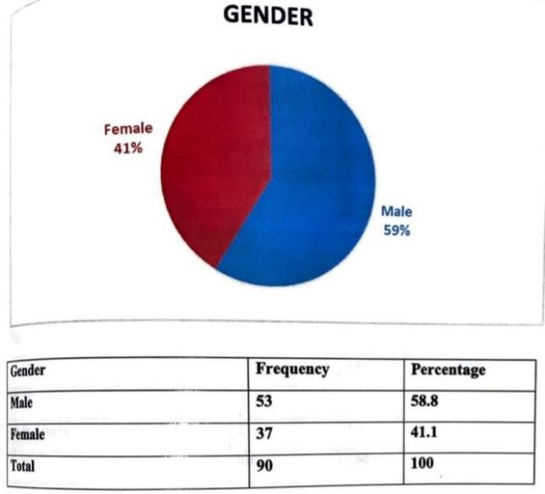
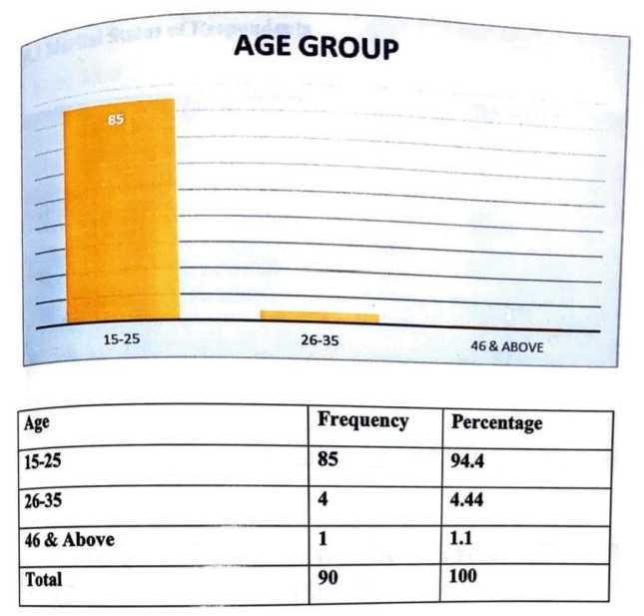

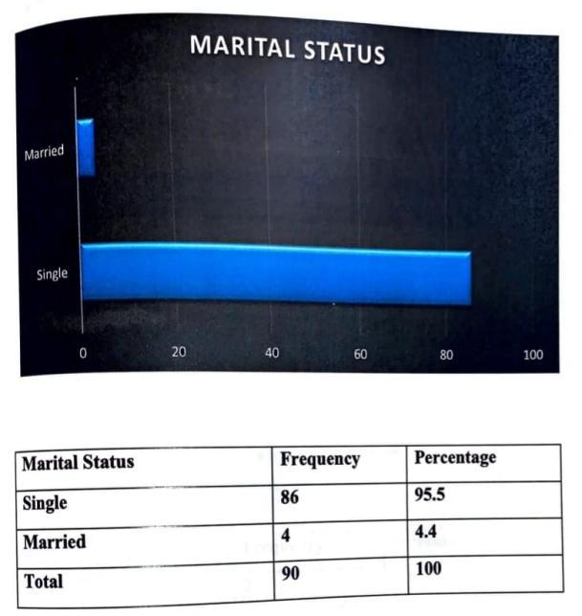
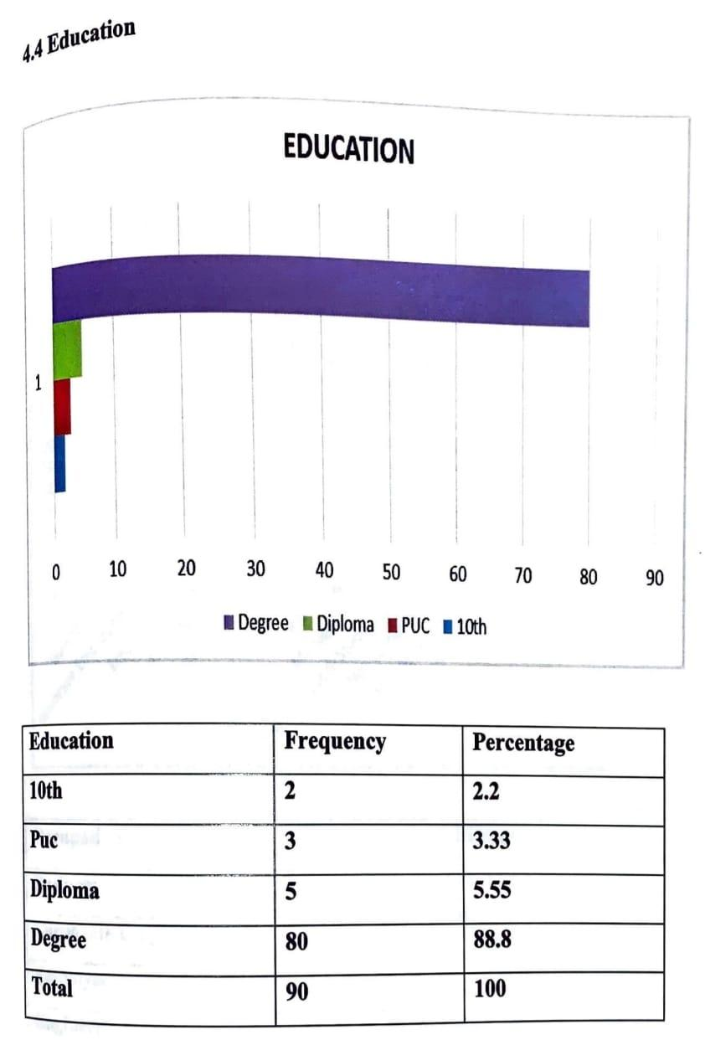

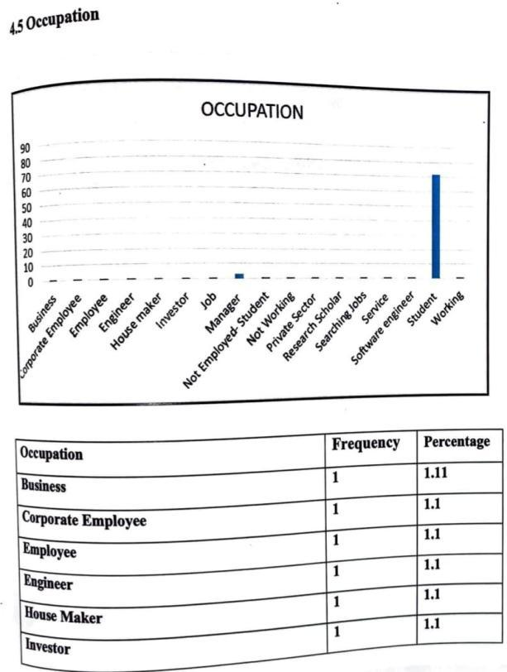
.

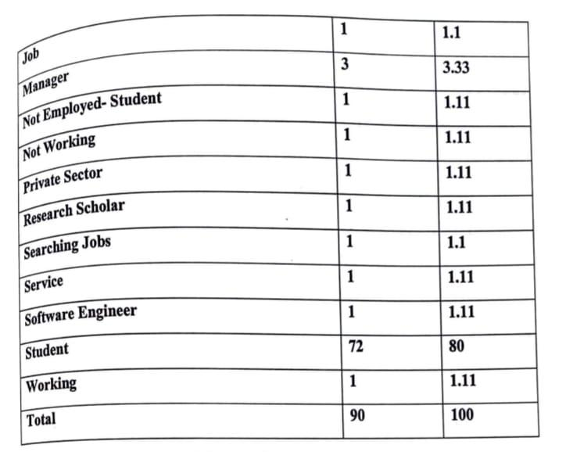

- What kind of food do you prefer for your morning breakfast?

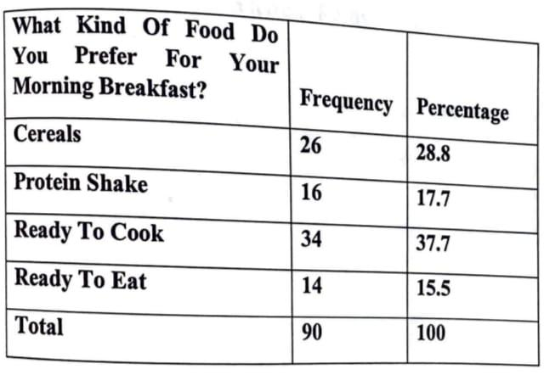
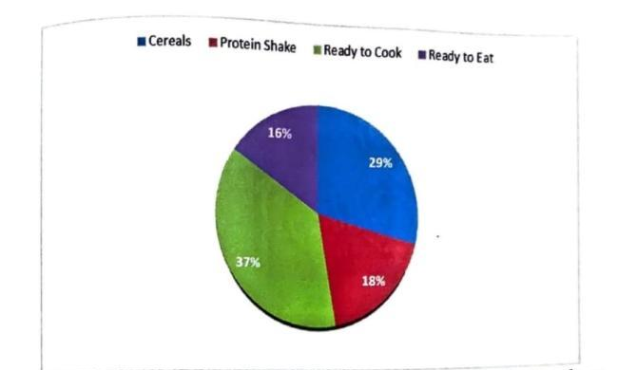

Q Are you aware of ready to eat food?

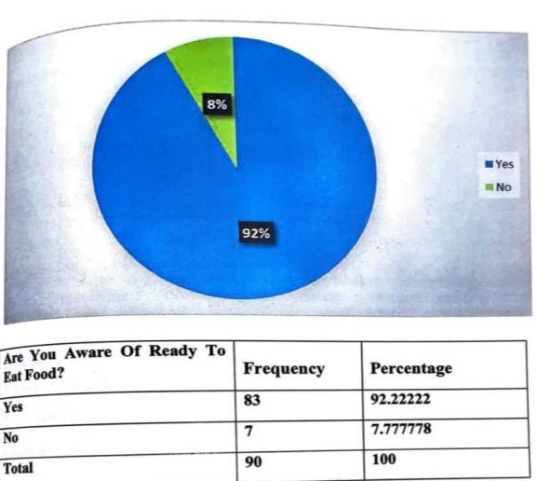

Q How did you come to know about ready to eat packs?

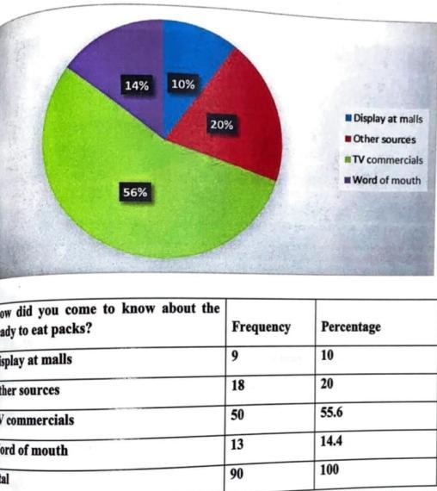

Q Factors considered while buying ready to eat products:

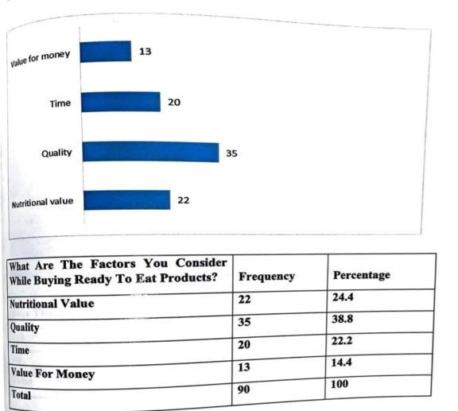

FINDINGS

1.Majority of the respondents were male.
2.Maximum number of respondents were youngster.
3.Most of the respondents were unmarried.
4.The education status of the respondents where majority of the respondents were graduate.
5. The large number of respondents where Students.
6. The type of food preferred by respondents where people preferred healthy cereals.
7. Consuming of breakfast by respondents where the people preferred alternative days.
8. Large number of respondents was aware about ready to eat product.
9. Maximum respondents were aware about the ready to eat pack from TV Commercial, and from word of mouth in displays in malls.
10. Most of the respondent thinks ready to eat product save time.
11. The important factors to decide while buying the product and the respondents buy for its price.
12. The respondents who ever purchased ready to eat product of where in good numbers.
13. The convenience level of the ready to eat product where maximum find in neutral convenient.
14. There's no significant relationship between marital status and awareness of ready to eat food. It is weak negative correlation exists. It's very nominal and weak. And fail to reject null hypothesis.
15. Since the P value is greater than 0.05, H1 is rejected. Therefore, we accept the null hypothesis HO. This implies that there is no significant relationship between what kind of food is consumed in the morning and how frequently morning breakfast to be consumed.

CONCLUSION

Many organizations these days understand that advancements are essential for their endurance Subsequently, they genuinely must track down a harmony between expanding the advantages of gisting items and bringing new and better items into the market that keep up with its market file simultaneously drawing in new ones.

Bringing another item into the market includes; thinking of thought, doing investigate available, breaking down the outcomes, genuine planning and fostering the item and testing the item.
New Product Development includes recognizing and assessing new item amazing open doors, fostering the item and afterward at long last testing its attractiveness. The thoughts for new items are created from the association's statistical surveying, innovative gauging and from innovative work projects.

Improving and refreshing product offerings is significant for the accomplishment for any association. Disappointment for an association to change could bring about a decrease in deals and with contenders hustling ahead. The course of NPD is critical inside an association. Items go through the phases of their life-cycle and will ultimately must be supplanted There are eight phases of new item advancement.

BIBLIOGRAPHY

1. https://www.sciencedirect.com/science/article/abs/pii/S0924224406000549

2. https://www.sciencedirect.com/science/article/abs/pii/S0923474803000079

3. https://pubsonline.informs.org/doi/abs/10.1287/mnsc.47.1.1.10668

4. https://www.sciencedirect.com/science/article/abs/pii/S0309174011001604

5. https://www.sciencedirect.com/science/article/abs/pii/S0950329304000886

6. https://pubsonline.informs.org/doi/abs/10.1287/mnsc.48.7.938.2818

- https://paperpile.com/g/what-is-research-methodology/

