Body Monitoring System For Critical Patients

Mr,.Raju Rathod Project guide
JSPM’s Rajarshi Shahu College of Engineering
Pune, India Rathodraju5983@gmail.com
Abhishek Ganesh Wani Dept of Electronics and
Telecommunications Engineering JSPM’s Rajarshi Shahu College of Engineering
Pune, India Abhishekwani213@gmail.com

Vaishnavi Narsingh Tundare
Dept of Electronics and Telecommunications Engineering JSPM’s Rajarshi Shahu College of Engineering
Pune, India Tundarevn78@gmail.com
Neha Rajendra Patil Dept of Electronics and
Telecommunications Engineering JSPM’s Rajarshi Shahu College of Engineering
Pune,India Patil2neha2@gmail.com

Abstract— Detection of changes due to movement in a real-time video is a very important tool. Patient movement & monitoring system is a system that is used to detect movement changes in the patient. Those changes may be either abnormal behavior or unusual changes made by the patient in the absence of a doctor. This paper presents the method of patient movement monitoring system for those patients that are taking medical treatment in both local and foreign hospitals with the help of frames comparison approach. In this project, FLUX sensors are fixed in two hands of the patient when there is any movement in hands the sensor sends information to the doctors by wireless communication.
GLASS SETUP with EYEBALL sensor is fixed in the patient’s eye when any motions in the eye the sensor sense the value and send information to the doctor. MEMS is used to find the patient's leg movement and all the information is wirelessly transferred through IOT module and monitored in PC HEARTBEAT and the TEMPERATURE sensors are used to find the heart rate and the temperature of the patient.

INTRODUCTION
As seen everywhere the quantum of the accident happens very high, if there is an accident, the patients are admitted in ICU (Intensive Care Unit), In such condition, the patient may go in a coma state. Coma is a state of unconsciousness in which a person cannot be awakened; fails to respond normally to painful stimuli, light, or sound; lacks a normal wakesleep cycle, and does not initiate voluntary actions. Coma may occur for various reasons, such as intoxication, a disease or infection that affects the central nervous system (CNS), a serious injury, and hypoxia, or oxygen deprivation. Doctors will check the affected person's movements and reflexes, response to painful stimuli, and pupil size. Doctors will observe breathing patterns
to help diagnose the cause of the coma. They also check the skin for signs of any bruises due to trauma.
To determine the affected person's level of consciousness, doctors may speak loudly or press on the angle of the jaw or nail bed. Doctors will watch for signs of arousal, such as vocal noises, eyes opening or movement. And also will test reflexive eye movements. These tests can help determine the cause of the coma and the location of brain damage.
For monitoring the patient physically it is usually happening in hospitals where two or three hospital staff needed to monitor the patient 24*7 for watching if there is movement or not, but this is not efficient method to get maximum efficiency. So this project helps to monitor the patient physically for every moment. The system developed based on Flex sensor, Eyeball sensor, MEMS body sensor, Heartbeat sensor, Temperature sensor and the Pressure sensor which is used to design a system which monitors the movement of the person at coma stage and alerts automatically by sending a message to the concerned person using IOT.

A. LITERATURE SURVEY
SURVEY 1 : “Analysis and Monitoring of Coma Patients using
Wearable Motion Sensor System”.
  - DESCRIPITION:
- AUTHOR:Sneha Chowdary Koganti, Dr. H N Suma, Appaji M. Abhishek.
- Publication: INTERNATIONAL JOURNAL OF SCIENCE AND RESEARCH (IJSR) ISSN (ONLINE): 2319-7064,VOLUME 4 ISSUE 9, SEPTEMBER 2015.

- Concept: In this paper, Wearable Motion sensor system is used to monitor the body movements such as eye blink movement and hand movement to detect the conscious state of an individual. This system will be helpful in assisting the doctor about the health condition of the unconscious patient and alerting the doctor whenever care is required. This system will assist the doctor by giving an alarm about the health condition of the patient, when the set of vital signals recorded are out of the normal range. These results are displayed on the computer and on the Liquid crystal display(LCD).
- Technique: Wearable Motion Sensor System.
- Drawbacks: Sometimes due to the critical condition of the patient there will be a difficult in measuringthe pulse at the finger.

SURVEY 2:“Emergency Fall Incidents Detection in Assisted Living Environments Utilizing Motion,Sound and Visual Perceptual Components”.
1. DESCRIPITION: a)AUTHOR:CharalamposN.Doukas,Ilias
Maglogiannis.
- Publication:IEEE TRANSACTIONS ON INFORMATION TECHNOLOGY IN BIOMEDICINE, VOL. 15, NO. 2, MARCH 2011.
- Concept: The main objective of this paper utilizes video, audio, and motion data captured from the patient’s body using appropriate body sensors and the surrounding environment, using overhead cameras and microphone arrays. Appropriate tracking techniques are applied to the visual perceptual component enabling the trajectory tracking of persons, while proper audio data processing and sound directionality analysis in conjunction to motion information and subject’s visual location can verify fall and indicate an emergency event.
- Technique: Motion and Sound Data Acquisition, Human Body Visual Tracking and Sound Processing and Event Detection
Drawbacks: The body sensor networks are still considered as invasive technology and require special treatment by users (e.g., proper body placement, battery replacement, etc.)

SURVEY 3: “A wearable device for measuring eye dynamics in real-world conditions”.
  - DESCRIPITION:
- AUTHOR:Simon Knopp, Philip Bones, Stephen Weddell, Carrie Innes, and Richard Jones.
- Publication:35TH ANNUAL INTERNATIONAL CONFERENCE OF THE IEEE EMBS OSAKA, JAPAN, 3 - 7 JULY, 2013.
- Concept: Drowsiness and lapses of responsiveness have the potential to cause fatalities in many occupations. One subsystem of a prototype device which aims to detect these lapses as they occur is described.A head-mounted camera measures
several features of the eye that are known to correlate with drowsiness. The system was tested with eight combinations of eye colour, ambient lighting, and eye glasses to simulate typical real-world input conditions. A task was completed for each set of conditions to simulate a range of eye movement—saccades, tracking, and eye closure.
- Technique: Image processing. (Omni Vision OV77351 image sensor).
- Drawbacks: The camera module uses an Omni Vision OV77351 image sensor.

SURVEY 4:“A Model-Driven Methodology for the Design of Autonomic and Cognitive IoT-Based Systems:
Application to Healthcare”.
1. DESCRIPITION:
- AUTHOR:Emna Mezghani, Ernesto Exposito, and Khalil Drira.
- Publication:IEEE TRANSACTIONS ON EMERGING TOPICS IN COMPUTATIONAL INTELLIGENCE, VOL. 1, NO. 3, JUNE 2017.
- Concept: The ultimate goal of these patterns is providing generic and reusable solutions for elaborating flexible smart IoT-based systems able to perceive the collected data and provide decisions. These patterns are articulated within a model driven methodology a set of patterns for developing a flexible cognitive monitoring system to manage patients’ health based on heterogeneous wearable devices. The proposed model describes the sensors measurements and protocols, identifies simple and complex filters to process the received data and detects symptoms to enable the adaptation.
- Technique: Model driven methodology. e)Drawbacks:Insufficient analysis. Expense implementing prototyping.

BLOCK DIAGRAM

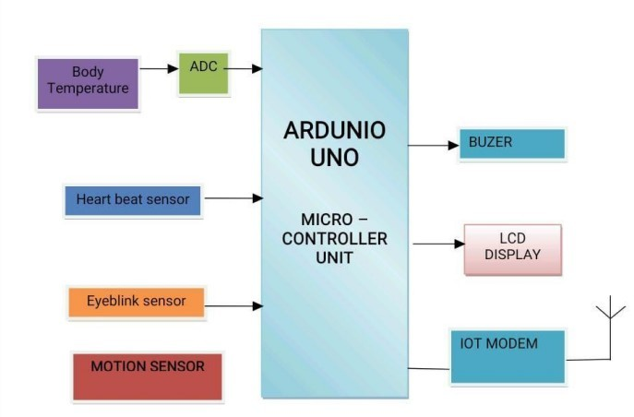
Simplified block diagram of MICRO-CONTROLLER based temperature and respiration display system is shown in figure. With this system the parameters of our body can be mentioned and it is viewed by various doctors where ever required. The signals from the patients are picked up by the sensors.

OBJECTIVES
1. To work on Literature Survey. 2.To detect eyeblink.
- To measure heartrate.
- To detect body movement.
- To measure body temperature using temperature sensor.

ACKNOWLEDGEMENT

We wish to express our sincere thanks to Dr. R.K. Jain, Principal, Rajarshi Shahu College of Engineering, Tathawade, for providing us all the necessary facilities.
We would like to place on record our deep sense of gratitude to Dr. S.C. Wagaj, HOD, Department of Electronics & Telecommunication Engineering, for his stimulating guidance and continuous encouragement.
We also wish to extend our thanks to Mrs. C.V. Rane, Project coordinator for her supervision throughout the course of present work.
We are extremely thankful to Mrs. Lata More for her insightful comments and constructive suggestions to improve the quality of project work.
Lastly we are thankful to Teaching and non-teaching faculty of the Department for their continuous co- operation.

CONCLUSION
To conclude that our project used for monitoring the health related parameters of comatose patient such as eye movement, pulse rate, temperature, hand, and leg movements.The system is designed for unconscious patients who need continuous care.

REFERENCES

- R. Archana, S. Indira, “Soldier Monitoring and Health Indication System”, International Journal of Science and Research (IJSR) ISSN.

- Ping Wang, Xinfeng BA, “Design of Soldier Status Monitoring and Command and Control System Based on Beidou System”, 2012 2nd International Conference on Computer Science and Network Technology.

- Richard B. Marth, Robert Levi, Dr.I.Newton Durboraw, Kenneth Beam, “The Integrated Navigation Capability for the Force XXI Land Warrior”.

- Shruti Nikam, Supriya Patil, Prajkta Powar, V.S. Bendre, “GPS based soldier tracking and health indication system”.

- Vongsagon Boonsawat,Jurarat Ekchamanonta,Kulwadee Bumrungkhet, and Somsak Kittipiyakul, “XBee Wireless Sensor Networks for Temperature Monitoring”, Sirindhorn International Institute of Technology, Thammasat University, Pathum-Thani,Thailand.

