Brain Tumor Detection & Classification using Deep Learning
__________________________________________________________

Dhiyanesh R Sankalp Padhi Harshit Kumar
Dept. Of Electronics Dept. Of Electronics Dept. Of Electronics
SRM University, SRM University, SRM University,
Kattankalathur,Chennai Kattankalathur,Chennai Kattankalathur,Chennai rd5744@srmist.edu.in sp5215@srmist.edu.in hk2539@srmist.edu.in

_____________________________________________________________________________________

Abstract: There are many different image processing methods, and the majority of them lose essential information in the process of enhancing images. The body's abnormal cell growth is what leads to diseases. It is challenging for radiologists to diagnose these fatal disorders. Due to the variety and complexity of the lesions, the majority of these diseases are misdiagnosed, which lowers patient survival. It is challenging to diagnose certain conditions using computer vision algorithms, such as brain tumors. Conventional methods for detecting brain tumors need labor-intensive and error-prone manual feature extraction or segmentation, which reduces the effectiveness of the image processing methodology. This project examines machine learning and deep learning approaches for multi-grade brain tumor categorization (ML). Machine learning can be used to diagnose brain tumors and masses using magnetic resonance imaging as technology develops (MRI). This project proposes a newly built deep learning model for the early diagnosis of brain cancers in various subclasses, including pituitary, meningitis, and glioma, as well as when there is no tumor (4 types). Brain MRI scans were also used to test the established transfer-learned model, confirming its adaptability, generality, and dependability for real-time use in the future. The outcomes demonstrated that the suggested model has high accuracy for hidden brain MRI data.
Therefore, the suggested deep framework can aid in the early diagnosis of brain cancers by physicians and radiologists.

Index Terms – Medical Image Processing, Deep Learning, Brain Tumors.

I. Introduction
Image processing is a technique for manipulating images, including operations like text extraction, image edge detection, and image enhancement. We take an image and convert it into several forms during the image processing process. An image processing system, in general, involves applying proven signal processing techniques to images to transform them into two-dimensional signals. The methods and procedures used to acquire images of the human body for clinical or medical purposes are referred to as medical imaging. Ultrasound (US), computed tomography (CT), and magnetic resonance imaging are common medical imaging modalities (MRI). Medical imaging is typically utilized in diagnosis and therapy planning to gather scientific data on illnesses and their impact on anatomical structures. Restoring an image by removing or reducing the damage in the images. These deteriorations can take the form of noise, which are inaccuracies in pixel values, or optical effects like blurring or camera movement-induced blurring. One of the most serious tumors in both children and adults is the brain tumor. For the tumor to be treated effectively, early brain tumor diagnosis, investigation, and classification are crucial. Most classification techniques for brain tumors would rely on segmentation. The issue with feature extraction and categorization, which is not only the most crucial phase but can also enhance the effectiveness of computer-aided medical diagnosis, is less significant. Researches use deep learning methods to concentrate on categorization tasks. Deep learning has recently been employed in several research to enhance the accuracy of computerised medical diagnosis in brain tumor cancer investigations. Deep learning techniques are widely used in medicine and have shown to be effective tools for treating many serious illnesses, including breast cancer image analysis and lung cancer diagnosis.

II. Literature Survey
- Roza Dastres et al. (2021) present recent developments and some of the applications in image processing systems such as the enhancements and image extraction to advance research by reviewing and analyzing recent achievements in published papers. Thanks to this, advanced image processing systems can be developed in various applications and new methods can be introduced in image processing systems.
- Mihaela Constantin Daniel et al. (2021), proposed an optimal framework for best pre-training and transfer learning. The main goal is to classify BT into glioma, meningioma, pituitary and no tumor. The separation of functions performed by a network depends on their architecture. CNNs (Convolutional Neural Network) are a class of deep neural networks and consist of neurons with weights and biases. Each neuron receives information from some input, then computes a scalar output and uses it freely in a non-linear fashion. CNN architectures take images as inputs. This network design best solves the task of image classification. Compared to other pretrained networks, Dense Net required a maximum training time of 21 hours 47 minutes 40 seconds using the Respro optimization program. It uses larger datasets to improve accuracy. More Advanced CPUs, GPUs and cloud computing are needed to reduce network training.
- Lavanyadevi. R et al. (2017) suggested using the PNN (probabilistic Neural Network) method to classify brain tumors. Feature extraction is performed using a gray-level co-occurrence matrix (GLCM). PCA successfully decreases the data's dimensionality. In the segmentation process, K-means clustering algorithm is used to identify the scattered area. Since PNN has fast learning, it can adapt its learning in real time. The proposed method involves the mechanical detection of semantically important regions in an image. The PNN algorithm could not classify when the test image is different from the training image. PNN requires more memory to store the model.
- Shaveta Arora et al. (2021) proposed an approach that involves mapping data features to specific MRI images. Features are selected using a popular texture-based selection technique using a gray-level co-occurrence matrix. The images are pre-processed with various feature selection, cleaning, standardization and normalization techniques. Deep learning models provide better classification accuracy than basic machine learning techniques. Inception_V3 seems to be overfit, but it can be checked by adding an exit. VGG16 performs the best among all models in classifying the given data set. Accuracy can be improved by optimization algorithms as well as classification techniques and hyperparameter tuning.
- Michael Christopher Xenya et al. (2021), this paper implemented a two-stage or scene-recognition model where regional features of the images were applied to distinguish the brain tumor from the background and further visualized using MatLab Gill. The classification models were developed and tested on the Google Collaboratory platform, that uses python. It focuses on segmentation or classification for brain tumor diagnosis only. The segmentation model performed well in most of the sample, but poorly in the sample where noise contributed to false tumor detection. This work proposes a framework for brain tumor segmentation and classification with an accuracy of 98.11%, which is robust because the multilevel ensemble did not necessarily depend on a single base classifier with better accuracy, mitigating the effects of brain tumor bias and variance.
TABLE I

COMPARISON OF EXISTING BRAIN TUMOR
CLASSIFICATION SYSTEMS

Reference | Year | DL Technique | Dataset | Accuracy%
Cinar et al. | 2020 | ResNet-50 | Kaggle | 97
Swati et al. | 2019 | VGG (16,19), AlexNet | Figshare | 94
Anarkari et al. | 2019 | Custom CNN | Figshare | 94
Naser et al. | 2020 | U-Net, VGG- 16 | TCIA | 92
Sharma et al. | 2020 | ResNet | SICAS Local | 93
Hashemzehi et al. | 2020 | AlexNet, ConvNADE | Figshare | 96

III. METHODOLOGY
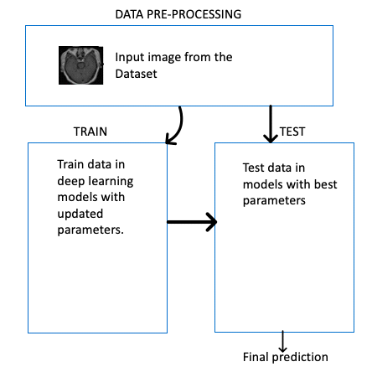
FIGURE:1- UML diagram
For this project, CNN models are proposed for comparison to get an optimal model that can deliver the output with minimal loss. State of the Art is used and combined with a custom model. There is something called an ensemble. Where we take the mean/average of the output of two models and make that value as our result. 4 levels of Convolutional layers: Each has got one conv2d network, pooling layer and an activation layer. We use a dropout layer before the last layer and are using the dense layer for output.

- Conv2d network - Makes feature maps(according to size of image) Example: If 1080x720, then matrix of same size
- Activation layer - Based on If - Else conditions.
- Dropout layer - Avoid overfitting.
- Dense Layer - Classify the data.
Using the ADAM Optimizer, Parameters are reduced but no compromise in accuracy. To start off with, first we collect a data set from Kaggle. It includes 4 types of classification categories i.e., Pituitary, Glioma, Meningioma, No tumor. Then we split it into training and testing. Names are extracted from folders and an array is made of it. Extracting the features of these images using Kera’s, a Deep learning framework & storing it in an array. Data Augmentation is done to normalize the data.
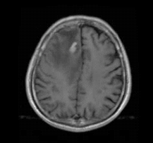
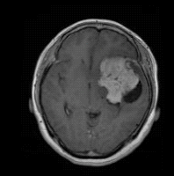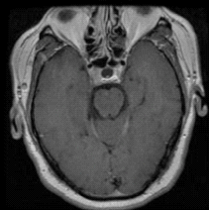
FIGURE:2-Example of the input images

Rotating the image clockwise (45 deg) and zooming it to get an equal number of training images for each class. Trying a different orientation of the same image.
The image is converted into RGB. It has 256 representations, from 0 to 255. Then scaling follows which helps to get better input and increase accuracy. Then we will construct the final model using state of the art model and custom model using ensembling and give the hyperparameters. Finally, we will run the model for output.
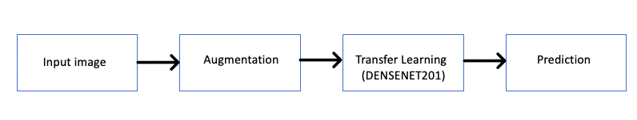
FIGURE:3- Overview of the proposed model
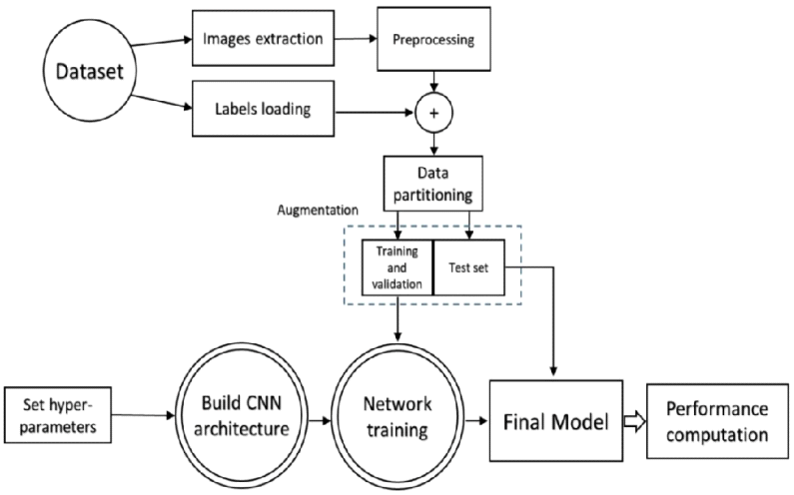
A. Data Preprocessing of DenseNet model
- We collect a data set from Kaggle. It includes 4 types of classification categories i.e Pituitary, Glioma, Meningioma, No tumor. Then we split it into training and testing. Names are extracted from folders and an array is made out of it. Extracting the features of these images using Keras, a Deep learning framework & storing it in an array.
- Data Augmentation is done to normalize the data
- Rotating the image clockwise (45 deg) and zooming it to get equal number of training images for each class. Trying a different orientation of the same image.
- The image is converted into RGB. It has 256 representations, from 0 to 255. Then scaling follows which helps to get better input and increase accuracy.
B. Training and Testing

- This module is based on the evaluation of the sample input data with the DenseNet201 Model to know the accuracy of the model which we have to overcome. Starting off the process, first we convert the labels in the form of vector which is easier to process and
- train the model using to categorical. Then we move on to convert the image matrix or the scaled images into a mathematical form of array i.e. np array.
- First process after acquiring the given labels and images in desirable format is to do flattening. It involves the conversion of a multi-dimensional array to 1-D array for training and testing images using reshaping functions.
- Then comes Validation, a process which involves limited input data, to check the working of the model. It is done by splitting the training and testing data in the form of 80:20 ratio which is a global convention as to avoid overfitting or underfitting. We will also shuffle the images to break the monotonous cycle. Validation is done before testing the model. The split x_train, y_train, x_test, y_test is printed afterwards.
- Next comes Data Augmentation. It is a very useful feature as it helps to attain more images by increasing/decreasing the size, length, zooming, etc, of the images. It is also useful for balancing the model so that it doesn’t lean towards training or testing due to the difference in the number of input images. This is achieved by using functions such as shear_range, fill_mode, vertical_flip, etc.
- Then, we use the DenseNet201 model and run it with our input data instead of the Imagenet dataset by giving desired conditions i.e., 150x150 matrix size, setting pooling condition. We are not training our model on the basis of our model that’s why we will put model1.trainable as false. This will be the input for our model.
- The output will be two layers i.e. Hidden and Classification layer which are user defined and which uses activation functions ReLu and Softmax respectively. The model is then compiled to check for any errors.
- After successful compilation, we define the no. of set epochs and run the code. The output gives the accuracy of the DenseNet model. Finally, the classification report is printed which shows the difference in the levels of ground values and predicted values based on parameters like precision, recall, f1-score, support for each label.
C. Custom Model
- To run the custom model, we first installed the keras_tuner program, which helps us choose the optimal set of hyperparameters for Tensorflow. To select the correct set of hyperparameters for an ML application, hypertuning must be performed. Afterwards, we start off by designing the architecture of our custom model by setting the different types of CNN layers that would be required like Conv2D, MaxPooling2D, Dense, Flatten, Activation.
- A very interesting function known as Early stopping is used in the framework as it helps to save resources and time by restricting the running of epochs after a set value is obtained.
- Model building function is defined using hp, we cannot change this naming convention as it is a globally adopted hyperparameter name. The number of nodes for Conv layer is defined from 32 to 64 and the kernel value is from 3 to 5.
- The learning rate is a tuning parameter in an optimization method that is used in machine learning and statistics which then chooses a step size in each iteration and tries to minimize the loss function. The learning rate is a hyperparameter that determines how much the model must change each time the model weights are updated according to the predicted error. Choosing the learning rate can be difficult, because too small a number can lead to a long training process that can get stuck, but too high a value can lead to unstable training. Once all the levels are correctly defined, we build the model using the ADAM optimizer and categorical_crossentropy and then return the model.
D. Creating User Interface
- Identify the target audience: Determine who will be using the system, such as healthcare professionals, researchers, or patients, and what their needs and expectations are. This will help you design a UI that is tailored to their specific requirements.

- Choose a UI framework: Select a UI framework or library that fits the project requirements and the skillset of the development team. Examples include React, Angular, Vue.js, or Bootstrap.

- Design the layout: Sketch out the layout of the UI, including the placement of the input and output elements, the navigation menu, the settings and options, and the feedback messages. Consider using wireframes or mockups to visualize the design and get feedback from stakeholders.

- Implement the UI components: Create the UI components using HTML, CSS, and JavaScript or the chosen programming language. Use responsive design principles to ensure that the UI adapts to different screen sizes and devices.

- Integrate the deep learning model: Connect the UI to the deep learning model using an API or a backend server. Define the input and output format of the model and handle any errors or exceptions that may occur during the prediction or analysis.

- Test the UI: Test the UI for usability, functionality, and performance. Use tools such as automated testing frameworks, user testing sessions, or accessibility checkers to identify and fix any issues or bugs.

- Deploy the UI: Deploy the UI to a production environment, such as a web server, a cloud platform, or a mobile app store. Monitor the performance and usage of the UI and gather feedback from users to improve the design and functionality over time.

IV. RESULTS
The deep learning model you provided earlier, there are a total of 12 layers, including 4 convolutional layers, 2 dense layers, 2 flatten layers, 2 pooling layers, and 2 dropout layers.
The deep learning model we used Convolutional Neural Networks (CNNs) for feature extraction. CNNs are a type of neural network that are specifically designed for image recognition tasks.. The output of the final convolutional layer is then fed into a fully connected neural network for classification.
In our model, we used a pre-trained CNN called VGG16 as the base of our model. We froze the convolutional layers of the VGG16 model and added a few dense layers on top of it to create our own custom classifier. This approach is called transfer learning and is commonly used in deep learning for image recognition tasks.

The advantage of using a pre-trained CNN for feature extraction is that the lower layers of the network have already learned to detect low-level features such as edges and corners, which can be reused in other tasks. This allows us to train our model on a smaller dataset and still achieve good performance. Additionally, since the VGG16 model has been trained on a large dataset of millions of images, it has already learned to recognize many common features and patterns that are useful for image recognition tasks.
The validation of the performance of this proposed model is done by calculating the accuracy, precision, recall, and F1 score parameters:
Accuracy= TP+TN / TP+FN+FP+TN… (1)
Precision= TP / TP+FP……………...…(2)
Recall= TP / TP+FN……………...…… (3)
F1 score= 2 x ( (Precision x Recall) / (Precision + Recall))…….(4)
Here, TP- True Positive, TN- True Negative, FP- False Positive, FN- False Negative. The accuracy of this model is approximately 90%, and the proposed CNN model outperforms previously reported networks in accuracy, precision, and recall, despite being less computationally complex.

RESULTS:
Classes | Precision | Recall | F!-Score
Glioma | 0.88 | 0.75 | 0.81
Meningioma | 0.97 | 0.97 | 0.97
Pituitary | 0.83 | 0.91 | 0.87

V. CONCLUSION
One of the most common types of cancer in the world, brain tumors claim many lives each year as a result of inadequate or late detection. For timely and reliable disease detection, computer-aided automatic diagnosis has emerged as the solution. In this paper, classification accuracy of multiple isolated-CNN models was examined using a variety of brain MRI datasets. The suggested model is trained and tested on 3264 MRI brain pictures under the four labels of glioma, meningioma, pituitary, and no tumor which is a publicly available dataset (Kaggle). The proposed framework is useful for real-time diagnostic applications in the future due to its flexibility, adaptability, generalizability and high accuracy. In the future, we hope to build on this research by expanding the types of brain tumors used to train our proposed model on larger datasets. In addition, we reduce online training time by using advanced CPUs, GPUs and cloud computing.
VI. References
[1] H. T. Zaw, N. Maneerat and K. Y. Win, "Brain tumor detection based on Naïve Bayes Classification," 2019 5th International Conference on Engineering, Applied Sciences and Technology (ICEAST), 2019, pp. 1-4, doi: 10.1109/ICEAST.2019.8802562.
[2] M. Constantin Daniel and L. Mihaela Ruxandra, "Brain Tumor Classification Using Pretrained Convolutional Neural Networks," 2021 16th International Conference on Engineering of Modern Electric Systems (EMES), 2021, pp. 1-4, doi: 10.1109/EMES52337.2021.9484102.
[3] R. Lavanyadevi, M. Machakowsalya, J. Nivethitha and A. N. Kumar, "Brain tumor classification and segmentation in MRI images using PNN," 2017 IEEE International Conference on Electrical, Instrumentation and Communication Engineering (ICEICE), 2017, pp. 1-6, doi: 10.1109/ICEICE.2017.8191888.
[4] S. Arora and M. Sharma, "Deep Learning for Brain Tumor Classification from MRI Images," 2021 Sixth International
[5] M. C. Xenya and Z. Wang, "Brain Tumor Detection and Classification using Multi-level Ensemble Transfer Learning in MRI Dataset," 2021 International Conference on Artificial Intelligence, Big Data, Computing and Data Communication Systems (icABCD), 2021, pp. 1-7, doi: 10.1109/icABCD51485.2021.9519361.
[6] M. A. Hafeez, C. B. Kayasandik and M. Y. Dogan, "Brain Tumor Classification Using MRI Images and Convolutional Neural Networks," 2022 30th Signal Processing and Communications Applications Conference (SIU), 2022, pp. 1-4, doi: 10.1109/SIU55565.2022.9864962.
[7] Gökalp Çınarer, Bulent Gursel Emiroglu,“Classification of Brain Tumors by Machine Learning Algorithms”
October 2019 3rd International Symposium on Multidisciplinary Studies and Innovative Technologies (ISMSIT), doi:10.1109/ISMSIT.2019.8932878.
[8] S. Kumar, A. Negi, J. N. Singh and A. Gaurav, "Brain Tumor Segmentation and Classification Using MRI Images via Fully Convolution Neural Networks," 2018 International Conference on Advances in Computing, Communication Control and Networking (ICACCCN), 2018, pp. 1178-1181, doi: 10.1109/ICACCCN.2018.8748614.
[9] R. M. Prakash and R. S. S. Kumari, "Classification of MR Brain Images for Detection of Tumor with Transfer Learning from Pre-trained CNN Models," 2019 International Conference on Wireless Communications Signal Processing and Networking (WiSPNET), 2019, pp. 508-511, doi: 10.1109/WiSPNET45539.2019.9032811.
[10] H. Kibriya, M. Masood, M. Nawaz, R. Rafique and S. Rehman, "Multiclass Brain Tumor Classification Using Convolutional Neural Network and Support Vector Machine," 2021 Mohammad Ali Jinnah University International Conference on Computing (MAJICC), 2021, pp. 1-4, doi: 10.1109/MAJICC53071.2021.9526262.
[11] Shaik Naseera, Jasmine Pemeena Priyadarsini, “A Review on Image Processing applications in Medical filed.”, Research Journal of Pharmacy and Technology, ISSN 0974-3618, October 2017
[12] Abidin Çalışkan, U. Çevik, “3D Medical Image Processing using Filtering methods.”, International Engineering, Science and Education Conference, 01-03 December 2016.
_______________________________________

