Product Authentication using Blockchain

Yashkumar Gupta
Dept. of Information technology
Shree L.R. Tiwari College of Engineering
Thane, India
yashguptace@gmail.com
Ishan Malavia
Dept. of Information technology
Shree L.R. Tiwari College of Engineering
Thane, India
ishan.malavia@gmail.com
Chanchal Kothari
Dept. of Information technology
Shree L.R. Tiwari College of Engineering
Thane, India jainchanchal1405@gmail.com

Preeti Chauhan
Dept. of Information technology
Shree L.R. Tiwari College of Engineering
Thane, India
chauhanpreeti72he1@gmail.com

Surekha Mali
Dept. of Information technology
Shree L.R. Tiwari College of Engineering
Thane, India
surekha.mali@slrtce.in

Product Authentication using Blockchain

Abstract—Our objective is to employ a decentralized blockchain-based solution to ensure that consumers do not just rely on merchants to evaluate whether things are original or not. Customers should be able to figure out whether the product is original or not using our software proposed. The method for identifying fake products using blockchain technology involves the use of unique product identifiers for the products registered on the blockchain network. These identifiers are encoded as QR tags which are assigned to each legitimate product during the manufacturing process. Smart contracts are built by using solidity. When a consumer purchases a product, they could scan the identifier using a smartphone or RFID reader to access information about the product's authenticity and supply chain history on the blockchain. This would allow consumers to easily verify that a product is legitimate and has not been tampered with, while also providing manufacturers with a tamper-proof record of their product’s supply chain. Additionally, the use of blockchain technology would enable real-time tracking of products, making it easier to identify and remove counterfeit products from circulation. We have proposed a novel blockchain-based product ownership management system (POMS) for the post-supply chain, which makes the efforts of counterfeiters to clone genuine tags redundant since they cannot prove the possession of products on this system. Thus blockchain, helped us to overcome problems in the supply chain like unauthorized products.
Keywords—blockchain, consumer, solidity, authenticity, supply chain, ownership, counterfeiters

I. Introduction
Blockchain technology has emerged as a potential solution to a wide variety of problems in various industries. Its decentralized and tamper-proof nature makes it an ideal solution for securing transactions and information. Blockchain uses cryptography to create a common distributed ledger, enabling secure and transparent transactions without the need for intermediaries or centralized control. The use of blockchain technology is gaining traction in the supply chain industry and can improve the transparency and security of the movement of goods and services.
The main goal of this project is to deploy a decentralized blockchain-based solution to ensure product security and prevent the circulation of counterfeit goods. By using unique product identifiers encoded as QR codes, we aim to create a tamper-proof record of each product's supply chain history. These identifiers are assigned to each legitimate product during the manufacturing process and registered on the blockchain network, ensuring that only genuine products are included in the ledger.
Built on top of the Solidity programming language, smart contracts enable consumers with an easy way to verify product authenticity. When a customer buys a product, they can scan the QR code with their smartphone to access information about the chain history of the product's supply on the blockchain. This allows consumers to have greater confidence in the products they purchase and provides manufacturers with a tamper-proof record of their product's supply chain. This project proposes a blockchain-based Product Ownership Management System (POMS) for post-supply chains. The use of blockchain technology eliminates efforts to duplicate authentic tags, as counterfeiters cannot prove their ownership of the product in this system. Blockchain-based product authentication can be used to overcome supply chain issues such as fraudulent products and create a secure and transparent product verification system. The project is expected to have a significant impact on the supply chain industry by providing a safe and efficient means of product authentication, increasing consumer confidence and reducing the spread of counterfeit goods.
II. Background
  - Blockchain
Blockchain technology has received considerable attention in recent years due to its potential to address various supply chain issues. The idea of ​​a decentralized peer-to-peer ledger was first introduced in 2008 by Bitcoin creator Satoshi Nakamoto. Blockchain refers to the collective maintenance of technical solutions that maintain a continuous file as a trusted database through decentralization. Originally widely used in Bitcoin transactions, the block generation method collects and verifies data to generate new blocks. Blockchain's consensus mechanism, similar to the Proof of Work (POW) algorithm used in Bitcoin, allows nodes to compete against each other based on their computing power, solving difficult-to-solve but easy-to-verify problems. The first node that can solve this problem gets the accounting right for the new block.
Blockchain data is stored in each node, and nodes share information with each other through the network. Each node holds complete blockchain data. Received transactions are validated by nodes, included in new blocks based on their own blockchain data, and attempt to acquire settlement rights for new blocks in the manner described above.
In recent years, blockchain has been widely used in transactions as it provides a tamper-proof, decentralized system for storing transaction records. Businesses benefit from low transaction fees and are protected from counterfeit goods. No central authority is required to validate transactions, so any participating entity can see the transaction on the network. The project uses blockchain technology to allow retailers and end-users to verify the authenticity of a product by scanning a product's unique QR code and verifying its authenticity on a decentralized blockchain network.
  - Ethereum

Ethereum is a decentralized blockchain platform created by Vitalik Buterin in 2013 with the aim of building decentralized applications (dApps) on his blockchain network. Ethereum is built on the public blockchain, managed by a decentralized network of nodes that validate transactions and execute smart contracts.
A smart contract is a self-executing contract in which the terms and conditions between a buyer and a seller are written directly in lines of code. Smart contracts allow you to build decentralized applications on the Ethereum network, including those focused on product authentication.
One of the key features of Ethereum is that it can create and manage custom tokens, known as ERC-20 tokens, on the blockchain network. These tokens can be used to represent assets, digital identities, and other types of information such as product ownership and supply chain information.
Using smart contracts and ERC-20 tokens, companies can create product authentication systems based on the Ethereum network. By creating a unique token to represent each product, manufacturers can track each product's supply chain on the blockchain and verify each product's authenticity.
In recent years, Ethereum has become one of the most widely adopted blockchain platforms, and more and more companies and developers are building decentralized applications on its network. The ability to create custom tokens and execute smart contracts has made it a popular choice for building blockchain-based solutions for product authentication and supply chain management.
  - POMS
Product Ownership Management System (POMS) is a new concept related to blockchain technology for establishing product ownership at a later stage of the supply chain. This aims to prevent counterfeit goods and ensure supply chain safety and reliability. The system is based on blockchain technology, a distributed ledger system that is tamper-proof, transparent and secure.
The use of blockchain technology in POMS provides a tamper-proof and immutable record of product history from manufacturing to distribution to final sale. Each product is assigned a unique identifier encoded as a QR code or RFID tag and registered on the blockchain network. Smart contracts written using the Solidity programming language are used to enforce POMS rules and regulations.
Once a product is registered on the blockchain, ownership of the product is established and all subsequent transactions related to the product are recorded on the blockchain network. This means that the full history of the product, including location, ownership and other relevant details, is available on the blockchain, making it easy to track the product's movement throughout the supply chain.
Using blockchain technology with POMS has several advantages. It eliminates the possibility of counterfeit products, as product ownership is established on the blockchain network and attempts to duplicate products are identified and prevented. All relevant information about the product is recorded on the blockchain network, ensuring transparency and reliability of the supply chain. This helps prevent fraud and improve supply chain efficiency.
The use of blockchain technology in POMS provides a safe and efficient way to establish product ownership and prevent counterfeit goods. The transparency and immutability of blockchain networks provide a tamper-proof record of product history that can be used to track movements within the supply chain and establish ownership. As blockchain technology evolves, we can expect more innovative applications of this technology in various industries, such as product authentication and supply chain management.

III. Literature survey

The case study outlines the implementation of a product traceability system called origin Chain, which utilizes Blockchain technology as a data storage solution instead of traditional centralized databases. The system aims to enable the tracking of product samples and their associated testing results conducted in a lab, by recording and storing this information on the Blockchain. In essence, the system seeks to enhance product traceability by leveraging the benefits of distributed ledger technology (Q. Lu and X. Xu 2017) [1].
A framework combining blockchain smart contracts and IoT sensors leads to various benefits. The framework will aim to establish a secure and transparent distributed ledger that can record various types of information related to supply chain quality management. This includes quality information, asset information, and transaction information (Si Chen and Rui Shi 2017) [2].
The design principles for supply chain management on Blockchain need to be indicated. Counterfeit products are an important issue that modern brands with multinational supply chain networks always need to acknowledge. By applying Blockchain in the supply chain data record, the flow of the products can be strictly monitored. (S. Matthew English and E. Nezhadian 2017) [3].
In today's market, consumers are often unable to determine whether the product they are purchasing is genuine or counterfeit, which poses a significant challenge. To address this issue, blockchain technology can be implemented to provide a secure and immutable record of the product's authenticity. To accomplish this, a unique QR code can be generated for each product, which can be scanned by both the manufacturer and the customer to verify the product's authenticity (Prabhu Shankar and R. Jayavadivel 2019) [4].
The utilization of social media as a primary medium for journalists to share news content with their audience has gained significant momentum in recent times. However, the emergence of fake news as a critical issue in the global discourse has raised concerns about the credibility of news content disseminated through these platforms. To address this challenge, the implementation of a blockchain-based framework presents a viable solution for detecting fake news with enhanced efficiency and effectiveness (A.D. Waghmare and G. Patnaik 2021) [5]. Through the integration of blockchain technology, the authenticity and reliability of news sources can be verified while ensuring the prevention of manipulation of news content.
The implementation of Ethereum was utilized to issue holding certificates for consumers, and the RFID technology was combined to assign a unique identity to each product stored in the blockchain. However, the proposed system may not be able to ensure that the product purchased by the consumer from the seller is genuine, leaving the issue of product counterfeiting unresolved (K. Toyoda, P. T. Mathiopoulos, I. Sasase, and T. Ohtsuki 2107) [6].
The wine industry has been plagued by the sale of substandard quality wines in retail stores, which can pose health risks to consumers. In order to mitigate this problem, the utilization of blockchain technology presents a promising solution. Specifically, each bottle of wine can be equipped with smart tags featuring a QR code, as well as a label printed with functional inks, all managed through a cloud platform (Steven Marwi 2018) [7]. Through the implementation of these measures, the authenticity and quality of each bottle of wine can be verified, ensuring that consumers are purchasing genuine, high-quality products. Blockchain technology can provide a secure and tamper-proof database for tracking the entire supply chain of the wine, from production to distribution, thus reducing the risks of counterfeiting and fraud.

IV. SYSTEM DESIGN
Our proposed anti-counterfeiting system is based on the decentralized and immutable properties of blockchain technology. Leveraging this technology provides manufacturers with a way to securely and transparently store and manage product information while allowing consumers to verify the authenticity of their products. Each product will be assigned a unique digital identifier linked to the information stored on the blockchain. This identifier can be easily scanned or entered by the consumer to verify the authenticity of the product. The system verifies the authenticity of the product by comparing the identifier with the information stored on the blockchain and provides a tamper-proof method to prevent counterfeiting. Additionally, the system ensures transparency for both manufacturers and consumers, as anyone can access the product information stored on the blockchain. Our proposed system provides an innovative solution to the counterfeiting problem by using blockchain technology to store and manage product information in a safe, transparent and tamper-proof manner.

A. Working
The proposed system flow aims to utilize the advantages of blockchain technology to establish a transparent and secure method for verifying the authenticity of products. The product authentication system consists of three key sections, namely the manufacturer, seller, and consumer. These sections share a common wallet, facilitating seamless interaction among them. In the manufacturer section, manufacturers can add their products to the supply chain, generating a unique QR code for each product. Additionally, they can provide seller details and sell their products to the registered sellers on the seller list. By assigning distinct product identifiers to each legitimate product during the manufacturing process and registering them on the blockchain network, only authentic products are included in the supply chain. This process eliminates the circulation of counterfeit goods.
In the seller section, the seller can view the list of available products in their inventory, check their availability and sell them to the consumers. The seller can also view the purchase history of the product and verify the product's supply chain.
In the consumer section, consumers can verify the authenticity of the product using the QR code. By scanning the QR code, the consumer can confirm if the product is genuine or counterfeit.
The system's security and tamper-proof feature are attributed to the use of blockchain technology, where each transaction is recorded and validated by the network. This approach ensures that the system flow reduces the circulation of counterfeit goods, benefiting both brands and consumers alike.
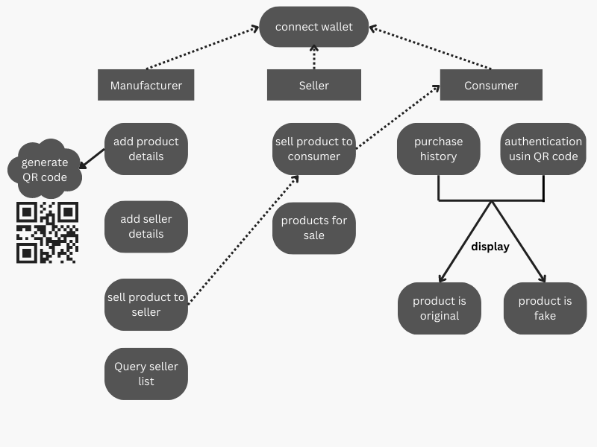
Figure 1. Working of the proposed system

B. Flow
Our supply chain management system is a comprehensive solution that enables end-to-end tracking and authentication of your products. The system uses blockchain technology to create a secure and transparent platform where manufacturers, sellers and consumers can verify the authenticity of their products at every stage of the supply chain.
Figure 2. Flow of the proposed system
Our supply chain management system is a comprehensive solution that enables end-to-end tracking and authentication of your products. The system uses blockchain technology to create a secure and transparent platform where manufacturers, sellers and consumers can verify the authenticity of their products at every stage of the supply chain.
The process begins with the manufacturer's adding product details such as product name, model and batch number to the system. The system will generate a unique QR code linked to the product information. This QR code is printed on the product so one can scan the code to access the product information. When a product is added to the system, the manufacturer sells it to the seller, who becomes the new owner of the product. The seller can scan the QR code on the package to verify product ownership. The system compares the QR code with the product information stored in the system to check the authenticity of the product. If the product is genuine, the seller can proceed with the sale.
After the seller purchases the product, it can be sold to the consumer. Consumers can scan the product's QR code to verify the product's authenticity before purchasing. Check the product information stored in the system to see if it is genuine or fake. If the product is genuine, the consumer can proceed with the purchase.
Once the purchase is confirmed, the system will update the product information to reflect the new ownership and transaction history. This information is stored on the blockchain, providing a secure and tamper-proof way to track and authenticate products at every stage of the supply chain. Our supply chain management system offers many benefits to manufacturers, sellers and consumers. For manufacturers, it helps protect their products from counterfeiting and protects their brand reputation. For sellers, it provides a way to verify product ownership and helps prevent fraud. For consumers, it helps ensure that they are buying genuine products, contributing to safety and satisfaction.
Our supply chain management system is a comprehensive solution that uses blockchain technology to enable end-to-end tracking and authentication of products. Providing manufacturers, sellers and consumers with a secure and transparent platform can reduce the risk of counterfeiting and improve supply chain efficiency.

C. Implementation
Implementing a private blockchain network for supply chain management involves multiple components working together to ensure a secure, transparent, and efficient system.
First, create a private blockchain network using ganache. This is an Ethereum emulator that can simulate a blockchain network. Ganache provides an easy way to test smart contracts in a controlled environment, allowing you to debug and test your code before deploying it to your live network.
Next, we will use Solidity, the programming language used to create smart contracts on the Ethereum network. A smart contract is a self-executing agreement that contains agreed terms between the parties involved in the transaction. Our smart contracts define the rules and conditions of our supply chain management system, including the roles and responsibilities of each party such as manufacturers, distributors and retailers.
We use Truffle to deploy smart contracts on our private blockchain network. It is a development framework for Ethereum that provides a set of tools for compiling, migrating, and testing smart contracts. Truffle simplifies the deployment process by automating many of the manual steps involved in deploying smart contracts, such as compiling the code and deploying it to the network.
We also use Metamask, a digital wallet that allows users to interact with the Ethereum network and connect to smart contracts. Metamask allows users to store and manage their Ethereum accounts and provides a secure way to sign and send transactions to the network. Use the User Interface (UI) to set up your project and perform supply chain management transactions. The user interface provides a user-friendly platform where users can interact with smart contracts to perform various actions such as adding products and verifying Product Authenticity. The interface also allows users to view transaction history, including details of each transaction and the parties involved.
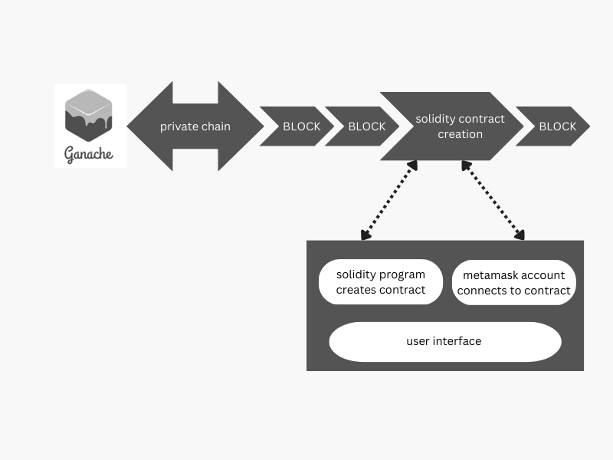
Figure 3. Implementation of the proposed system
  - Algorithm used

Consensus algorithms are a key component of blockchain technology that ensures that all nodes in the network agree on the state of the ledger. In decentralized networks with no central authority, consensus algorithms provide a mechanism for maintaining network integrity and security.

Various consensus algorithms are used in blockchain technology, such as Proof of Work (PoW), Proof of Stake (PoS), Delegated Proof of Stake (DPoS), and Practical Byzantine Fault Tolerance (PBFT). Each algorithm has its own strengths and weaknesses, making them suitable for different kinds of blockchain applications.

We have used the PoW consensus algorithm in our blockchain-based product authentication system. PoW is the original consensus algorithm used in Bitcoin and other early blockchain systems. In this algorithm, miners compete against each other to solve a mathematical puzzle, and the first miner to solve it receives a cryptocurrency reward. Solved puzzles are also used to add new blocks to the blockchain.

Using the PoW consensus algorithm ensures network security and resilience to attacks. The computational cost of solving the puzzle makes it difficult for attackers to control the network and alter transaction history. Furthermore, the consensus algorithm makes our system more transparent and immutable, making it an ideal solution for product authentication.

The benefits of using consensus algorithms in blockchain-based product authentication systems are numerous. It provides a mechanism to achieve network consensus and maintain ledger integrity. It ensures that transactions are handled in a decentralized and secure manner. It also creates a transparent and immutable record of product ownership and supply chain history. additionally, it ensures that your network is resistant to attacks and offers a high level of security.

Consensus algorithms are a fundamental part of blockchain technology. By using consensus algorithms in blockchain-based product authentication systems, it is possible to achieve network consensus, maintain ledger integrity, and create a transparent and immutable record of product ownership and supply chain history. Using a consensus algorithm has many advantages, making the system more secure, transparent and efficient.

V. future work
Counterfeiting is a serious problem affecting various industries such as fashion, electronics and pharmaceuticals. To address this issue, applications based on blockchain technology can revolutionize the anti-counterfeiting process and give consumers confidence and assurance that they are buying genuine goods. The system can integrate various functions such as proof of code simplicity, API integration, secure graphical QR codes, copy detection patterns, etc. to ensure product authenticity. Proving code simplicity is an important feature that ensures that the code used in the system is simple and easy to understand, increasing consumer confidence. This feature indirectly enhances the security of distributed applications and makes the system more efficient and effective. API integration is another feature that makes the system more efficient and user-friendly. Instead of manually entering product details, manufacturers can use APIs to extract information, saving time and reducing the potential for error.
A secure graphic QR code is a key component of an anti-counterfeiting system. These codes ensure that the information is lost when copied and that the product is genuine. In addition, we can incorporate a copier detection pattern, which is an optimally designed digital image that loses information when irreversibly copied. These features make it difficult for counterfeiters to copy the product. If a customer finds a counterfeit product, the system can show the same product, but the original product from another of her websites with a price difference. This improves the usability, efficiency and effectiveness of the system and gives consumers access to authentic products.
Blockchain-based anti-counterfeiting systems can be used in various fields such as pharmaceuticals, luxury goods, and electronics. The system can track products using tamper-resistant labels to ensure that they have not been tampered with. In addition, products can be tracked in real-time using dynamics (reading and writing NFC tags) to ensure authenticity and prevent counterfeiting. The system can also include a tracking system to monitor details of the product's processing from manufacturing to distribution. This feature ensures product authenticity and prevents counterfeiting. You can also implement real-time monitoring of your products to ensure that there is no tampering or counterfeiting. Future work on the system will include the integration of additional features such as real-time monitoring and display of original products.

VI. conclusion
Our proposed product authentication solution using blockchain technology has the potential to revolutionize the way products are secured and counterfeit goods are prevented from being distributed. We have created a tamper-proof record of each product's supply chain history by using a unique product ID encoded as a QR code. This record is assigned to each legitimate product during the manufacturing process and registered on the blockchain network, ensuring that only legitimate products are added to the ledger.
Additionally, our system is based on the Solidity programming language, enabling smart contracts for real-time tracking of products and providing consumers with an easy way to verify the authenticity of their products using blockchain technology.
This brings several benefits to product authentication, such as low transaction fees, secure and trustworthy systems, and tamper-proof records. The transparency and immutability of blockchain networks make them a trusted solution for preventing fraud in the product supply chain.
The solution we propose is to provide a safe and reliable system to ensure product authenticity, reduce the risk of fraudulent products, and ultimately protect the health and safety of consumers, which benefits both brands and consumers. By eliminating counterfeits, our system ensures that only genuine products are sold, improving customer satisfaction and brand reputation.
The proposed blockchain-based product authentication solution offers significant advantages over traditional methods to ensure product safety and prevent product counterfeiting. It is an effective and efficient solution that offers a safe and reliable system that has the potential to revolutionize the product authentication process and prevent the proliferation of counterfeit goods.

References
[1]. Lu and X. Xu, ‘‘Adaptable blockchain-based systems: A case study for product traceability,’’ IEEE Softw., vol. 34, no. 6, pp. 21–27, Nov./Dec. 2017.

[2]. S. Chen, R. Shi, Z. Ren, J. Yan, Y. Shi and J. Zhang, "A Blockchain-Based Supply Chain Quality Management Framework," 2017 IEEE 14th International Conference on e-Business Engineering (ICEBE), Shanghai, China, 2017, pp. 172-176, doi: 10.1109/ICEBE.2017.34.

[3]. S. Matthew English and E. Nezhadian, ‘‘Application of bitcoin data- structures & design principles to supply chain management,’’ 2017, arXiv:1703.04206. [Online]. Available: http://arxiv.org/abs/1703. 04206

[4]. Prabhu Shankar, R. Jayavadivel, “A survey of counterfeit product detection”, 2019, INTERNATIONAL JOURNAL OF SCIENTIFIC & TECHNOLOGY RESEARCH VOLUME 8, ISSUE 12, DECEMBER 2019.

[5]. Waghmare, Akash D. and Girish Kumar Patnaik. “FAKE NEWS DETECTION OF SOCIAL MEDIA NEWS IN BLOCKCHAIN FRAMEWORK.” Indian Journal of Computer Science and Engineering (2021)

[6]. K. Toyoda, P. T. Mathiopoulos, I. Sasase, and T. Ohtsuki, ‘‘A novel blockchain-based product ownership management system (POMS) for anti-counterfeits in the post supply chain,’’ IEEE Access, vol. 5, pp. 17465–17477, 2017.
[7]. Sandi, S., Radonjić, S., Drobnjak, J., Simeunović, M., Stamatovic, B., & Popovic, T. (2018). Smart tags for brand protection and anti-counterfeiting in wine industry. 2018 23rd International Scientific-Professional Conference on Information Technology (IT).

