Study of chest X-rays to Analyse thorax diseases using Deep Learning Framework

Sudarshan Adhav¹, Rohit Borse², Riya Gujarathi³, Madhuri Kubade⁴, Prof. Priyanka Khalate⁵
¹²³⁴⁵Department of Computer Engineering, Smt. Kashibai Navale College of Engineering Vadgaon(Bk.), Pune
Affiliated to Savitribai Phule Pune University

Abstract— When a patient's doctor suspects they have a lung ailment, one of the first tests they frequently have is a chest X-ray. Sometimes vital information regarding the sickness is missed by radiologists or restorative inspectors. It takes a lot of time to find the sickness' manifestations when these x-beams are reexamined. In this study, we demonstrate how to diagnose thoracic problems using a deep convolutional neural network (CNN). We begin by matching the interest points on the photos to align them. The dataset is then expanded using the theory of Gaussian scale space. The larger dataset is then used to train a deep CNN model in the following step. The larger dataset is then used to train a deep CNN model in the following step. Then, more recent test data that we have are diagnosed using the model. Our research demonstrates how effective our strategy is at producing quality outcomes.

Keywords–image classification, machine learning, imageprocessing, neural network.

- Introduction

The top portion of the trunk is also referred to as the thorax, or chest. It is mostly protected by the rib cage, spine, and shoulder girdle. The lungs, heart, and mediastinum organs that make up the rib cage collaborate to provide food, oxygen, and blood to every area of the body. The lungs, heart, and mediastinum organs are contained within the rib cage.

The most frequent reason for seeking medical attention and visiting the emergency room is chest pain. One of the most popular radiology tests used to determine what's wrong with the thorax is chest radiography, often known as a chest X-ray (CXR). However, because radiology is a field of medicine that deals with making choices under unclear circumstances, it is not always able to provide accurate interpretations or reports. This is the basis for computer-aided diagnosis (CAD). It enhances patient care and enables radiologists to make accurate diagnosis quickly. They are used as a "second opinion" to support the work of a radiologist, who can see within the body, and are not intended to replace or compete with doctors.

Over the past few years, numerous efforts have been made to improve computer-aided design (CAD) systems. This has been accomplished using computer vision and AI approaches. The classification of medical photographs is one of the major issues and a frequent activity. Based on their content, medical images can be categorised into one or more diagnostic outcomes. This is what the classification process aims to achieve. There has been a lot of work done to develop new classification schemes that are more precise in this regard.
The problem of image classification was initially solved in two steps. In the first stage, feature descriptors are used to find manually created features in an image, and in the second stage, the features are fed to a classifier that can be trained [2]. However, the technique utilised to extract characteristics in the initial stage, which is crucial, heavily influences how accurate this method will be. Deep learning was investigated in relation to picture classification for this reason. It enables automatic feature extraction and classification by modelling data through numerous nonlinear processing layers.

Convolutional Neural Networks (CNNs) are the most often used and favoured models for classifying images using deep learning. This is due to the fact that, when compared to other models, they offer excellent accuracy and impressive results. It can be used with two-dimensional data, such as pictures and videos, for which it was designed. The initial CNN model was put forth in the late 1990s, and its fundamental premise is based on how humans see and identify objects. The LeNet architecture, which was used to read zip codes, numbers, and other information from phones, is the most well-known of them.

This study describes how we employed multi-label problem transformation techniques and transfer learning to assist us identify thoracic illnesses from chest X-ray images.The fundamental idea is to use a pre-trained CNN to identify critical CXR features before using multi-label problem transformation techniques to reduce the multi-label problem to a single-label classification problem.

Motivation

In order to identify and treat illnesses, health care providers need to use dependable and durable computers. Such a technique is necessary to deal with the categorization challenge of thoracic disease in order to focus on potential lesion locations and reduce the noise supplied by irrelevant regions. Investigating the innate connections between various diseases is also helpful for improving the performance of the computer-aided system.
It could be challenging to classify chest X-ray pictures because so many areas are disease-inrelevant. In the majority of cases, healthy tissues may be observed in pictures.

- Literature Review

In this paper, authors propose a novel multi-atlas DLP method for brain parcellation. Our method is based on fully convolutional networks (FCN) and squeeze-and-excitation (SE) modules. It can automatically and adaptively select features from the most relevant brain atlases to guide parcellation. Moreover, our method is trained via a generative adversarial network (GAN), where a convolutional neural network (CNN) with multi-scale l1 loss is used as the discriminator. Benefiting from brain atlases, our method outperforms MAP and state-of-the-art DLP methods on two public image datasets (LPBA40 and NIREP-NA0) [1].
In this study, authors claim that skip connections are not sufficient to reliably find hazy borders in medical images. A novel encoder-decoder network with multiple scales of dense connections (HMEDN) is therefore proposed in order to finely exploit semantic information at multiple scales with high precision. Besides skip connections, high-resolution high-depth supervised pathways (composed of densely linked dilated convolutions) are combined to capture high-resolution semantic information for precise localisation of boundary boundaries (see figure). A cross-entropy loss function and a contour regression task are used in conjunction with these routes to improve border detection quality [2].
Using a new Hidden Markov Random Field (HMRF) model and a new hybrid metaheuristic method based on Cuckoo search (CS) and Particle swarm optimization algorithms, authors present a new segmentation method (PSO). The new model employs adaptive parameters to ensure that the model's segmented components are balanced. In addition, the hybrid metaheuristic algorithm is implemented to increase the quality of seeking solutions in the MAP estimate of the HMRF model [3].
To begin, authors offer a deep regression model that utilises the correlations in the intermediate semantic layer of word vectors to accurately predict labels for the visual features. Authors then use Ranking SVM to find the only multi-label correlations in the embedding space and formulate the label prediction problem as a pairwise problem. A multi-label zero-shot prediction strategy based on the testing data manifold structure is also shown [4].
It is possible to identify and locate disease at the same time using the same underlying model for all photos. Using both class information and limited location annotation, our technique beats the comparable reference baseline in both classification and localization tests [5].
A three-branch attention-guided convolution neural network (AG-CNN) that combines global and local information is what authors propose to use to identify disorders of the chest. The global branch can benefit from an attention-guided mask inference-based cropping method that reduces noise and improves alignment. While local branch cues may have been lost, AG-CNN also uses global cues to compensate for them. Images from throughout the world are used to teach us about CNN's global branch. Authors next infer a mask to clip a discriminative region from the global image using the attention heatmap provided by the global branch. A local CNN branch receives training in the surrounding area. Final pooling layers of both global and local branches are combined to fine-tune the fusion branch [6].
"ChestX-ray8" contains 108,948 images of frontal chest X-rays from 32,717 distinct patients with text mined eight illness image labels (where each image might have multiple labels) from the corresponding radiological reports, which authors describe in this study as a novel chest X-ray database. Using suggested dataset, authors demonstrate that a unified weakly supervised multi-label image classification and disease localization framework can detect and even locate these prevalent thoracic disorders [7].
Category-wise residual attention learning (CRAL) is a methodology proposed by the authors in this research to address the aforementioned issue. A class-specific attentive interpretation of CRAL predicts numerous diseases. Endowing feature representations with minimal weights tries to reduce the impact of irrelevant classes. In addition, the weights assigned to the most important traits would be increased. It is made up of two modules: the feature embedding module and the attention learning module. Features are learned using a convolutional neural network (CNN) in the feature embedding module while attention learning is focused on discovering how different categories are assigned [8].
It is proposed in this paper that a new hybrid fusion network, referred to as Hi-Net, can be used to synthesise multi-modal magnetic resonance imaging (MR) images by learning an image mapping from multi-modal source data, which includes both existing and previously unidentified modalities of imaging data. Authors use a modality-specific network to learn representations for each modality, and a fusion network to learn the common latent representation of multi-modal input in our Hi-Net model. Using a multi-modal synthesis network, the latent representation is combined with hierarchical characteristics from each modality and used as a generator to produce the target images. To make use of the correlations between various modalities, a Mixed Fusion Block (MFB) is developed to adaptively weight alternative fusion procedures [9].
In this study, Authors developed and validated a deep learning algorithm that classified clinically important abnormalities in chest radiographs at a performance level comparable to practicing radiologists. Once tested prospectively in clinical settings, the algorithm could have the potential to expand patient access to chest radiograph diagnostics [10].

- Existing System:-

This field has seen a lot of effort because of how widely used and applied it is. Some of the methods that have been used to accomplish the same goal are listed in this section. The methods for Thorax disease classification systems are what set these studies apart most.
The top portion of the trunk is also referred to as the thorax, or chest. It is mostly protected by the rib cage, spine, and shoulder girdle. The lungs, heart, and mediastinum organs that make up the rib cage collaborate to provide food, oxygen, and blood to every area of the body. The lungs, heart, and mediastinum organs are contained within the rib cage.

- Proposed System:-

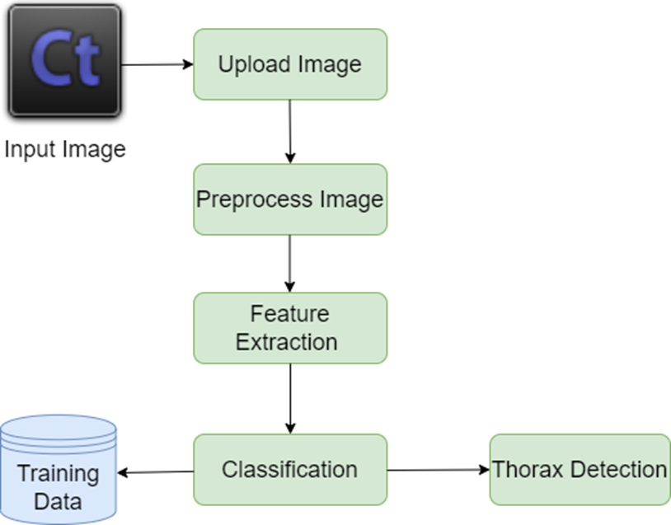

Figure 1. System Architecture

We focus on the difficulty of detecting saliency, which is related to the problem of identifying disease-critical features for categorization. However, "disease-critical" discriminative feature learning, which is distinct from saliency detection, is not mentioned in this study. Following the provision of some annotated ground-truth of the lesion region, we investigate how to handle the problem of disease recognition by utilising some saliency detection approaches. We want to make use of it in the future.

Conclusion

In this study, we propose ConsultNet, a two-branch architecture, to train discriminative features and simultaneously achieve both of these objectives. ConsultNet consists of two components. The first step is to retrieve important disease-specific features using a feature selector constrained by an information bottleneck based on their relevance. Second, the latent semantic dependencies in the feature space are enhanced by a feature integrator based on spatial and channel encoding. ConsultNet uses these unique traits to enhance CXR classification of thoracic illnesses. The effectiveness of the suggested approach has been tested using the ChestX-ray14 and CheXpert datasets. In the future, we might suggest adding some ground truth annotations to the lesion region in order to address the illness recognition difficulty using saliency detection techniques.

REFERENCES
References

- Z. Tang, X. Liu, Y. Li, P.-T. Yap, and D. Shen, “Multi-atlas brain parcellation using squeeze-and-excitation fully convolutional networks,” IEEE Trans. Image Process., vol. 29, pp. 6864–6872, 2020.

- S. Zhou, D. Nie, E. Adeli, J. Yin, J. Lian, and D. Shen, “Highresolution Encoder–Decoder networks for low-contrast medical image segmentation,” IEEE Trans. Image Process., vol. 29, pp. 461–475, 2020.

- T. X. Pham, P. Siarry, and H. Oulhadj, “Segmentation of MR brain images through hidden Markov random field and hybrid metaheuristic algorithm,” IEEE Trans. Image Process., vol. 29, pp. 6507–6522, 2020.

- Z. Ji et al., “Deep ranking for image zero-shot multi-label classification,” IEEE Trans. Image Process., vol. 29, pp. 6549–6560, 2020.

- Z. Li et al., “Thoracic disease identification and localization with limited supervision,” in Proc. IEEE/CVF Conf. Comput. Vis. Pattern Recognit., Jun. 2018, pp. 8290–8299.

- Q. Guan, Y. Huang, Z. Zhong, Z. Zheng, L. Zheng, and Y. Yang, “Thorax disease classification with attention guided convolutional neuralnetwork,” Pattern Recognit. Lett., vol. 131, pp. 38–45, Mar. 2020.

- X. Wang, Y. Peng, L. Lu, Z. Lu, M. Bagheri, and R. M. Summers, “ChestX-ray8: Hospital-scale chest X-ray database and benchmarks on weakly-supervised classification and localization of common thorax diseases,” in Proc. IEEE Conf. Comput. Vis. Pattern Recognit. (CVPR), Jul. 2017, pp. 3462–3471.

- Q. Guan and Y. Huang, “Multi-label chest X-ray image classification via category-wise residual attention learning,” Pattern Recognit. Lett., vol. 130, pp. 259–266, Feb. 2020.

- T. Zhou, H. Fu, G. Chen, J. Shen, and L. Shao, “Hi-Net: Hybrid-fusion network for multi-modal MR image synthesis,” IEEE Trans. Med. Imag., vol. 39, no. 9, pp. 2772–2781, Sep. 2020.

- P. Rajpurkar et al., “Deep learning for chest radiograph diagnosis: A retrospective comparison of the CheXNeXt algorithm to practicing radiologists,” PLoS Med., vol. 15, no. 11, Nov. 2018, Art. no. e1002686.

