Government Polytechnic Nanded,
Electrical Engineering,
AI In Speed Control of 3 phase I.M. by Pole Changing Method

Vilas Sarwadnya, Kasarpethkar Govind, Rathod Roshan, Khandapure
Rohan, Kasbe Jatin

Abstract:
A 3-phase induction motor can be used for different applications with various speed and load requirements. Electric motors can be found in almost every production process today. Getting the most out of our application is becoming more and more important in order to ensure cost-effective operations.
In this project we control the speed of the induction motor using pole changing method. Pole Changing Method is one of the main methods of the speed control of an induction motor. This method of controlling the speed by pole changing is used mainly for cage motor only because the cage rotor automatically develops a number of poles, which is equal to the poles of the stator winding. The number of stator poles can be changed by the following three methods. They are known as multiple stator windings, method of consequent poles and pole amplitude modulation (PAM).
Introduction:
In modern industrialized countries,
more than half the total electrical Energy used is converted to mechanical energy through induction motors. Induction motors are extensively used in industrial and household appliances and consume more than 50% of the total generated electrical energy. Single-phase induction

motors are widely used in home appliances and industrial control. During
the last few years, the concept of speed and torque control of asynchronous motor drives has
gained significant popularity. This way, it has been possible to combine the induction-motor structural robustness with the control simplicity and efficiency of a
direct current motor. This evolution resulted to the 14

- Multiple Stator Winding
In the multiple stator winding method, two windings are provided on the stator, wounded on two different numbers of poles. One winding is energized at a time. Let us consider that the motor has two windings for 6 and 4 poles. For the frequency of 50 hertz, the synchronous speeds will be 1000 and 1500 revolutions per minute respectively. This method of speed control is less efficient and more costly.
- Method of Consequent Pole

In the method of consequent poles, a single stator winding is divided into few coil groups. The terminals of all these groups are brought out. By simply changing the coil connections, the number of poles can be changed. In practice, the stator windings are divided only into two coil groups. The number of poles can be changed in the ratio of 2:1. The flux of the pole group should be passed through the given space between the pole group to complete the magnetic path. Thus, a magnetic pole of opposite polarity (S pole) is induced. These induced poles are known as Consequent Poles.
- Pole Amplitude Modulation (PAM) Technique
Pole amplitude modulation is a flexible method of pole changing that can be used in applications where speed ratios other than 2:1 are required. The motors designed for speed changing based on the pole amplitude modulation scheme are known as PAM motors.

Keywords: Three Phase Induction
Motor, Speed Control, Pole Changing

Literature Survey:
There are a lot researches that have worked on Speed control of three phase induction motor.
Mr. Ankit Agrawal, Mr. Rakesh, Singh Lodhi, Rd. Pragya Nama proposed the A Review of Speed Control Methods of Induction Motor.
Abstract: Induction motors do not run at synchronous speed; they are generally fixed speed motors. In Industries mechanical loads should not only be driven but should also be driven at desired speed. Therefore, the need of speed control methods for induction motor arises. There are various methods of speed control for an induction Motor. In this paper literature reviews on different speed control methods and their performance based on SPWM Inverter, harmonics reduction and speed-torque characteristics so as to analyse the most effective techniques among them considering the presence of harmonics as well as minimization of odd harmonics through Inverter.
SVS Phanie Kumar Ch, Venu Santi,
Sachin Jain proposed the Gradual Pole
Changing Technique for Elimination of
Circulating Current in Pole-Phase Modulated Induction Motor Drive during Transition.
Abstract: This paper proposes a methodology for the smooth pole phase change in induction motor drive (IMD) for electrical vehicle applications. The pole phase modulation technique improves the performance of IMD by extending its speed-torque ranges. However, during the pole-phase transition in IMD from low pole to high pole mode or vice-versa, there exist a circulating current in IMD. These circulating currents are due to the flux of stator periphery tries to change its nature suddenly during pole change. Nevertheless, this change of flux can't be carried suddenly. Thus, this results in flux distortion in IMD in-turn effecting performance of the IMD by creating abrupt torque and subsequent speed disturbances. The paper proposes a control strategy that provides a solution based on gradual pole change approach. In the given approach, the winding of IMD is excited by both 3-p and 9-p voltages, with one gradually decreasing and other gradually ramping up during pole transition. The proposed gradual pole changing technique emends the above issues and further improves performance in the pole phase- modulated induction motor (IM). This proposed method ofpole changing technique is implemented on a

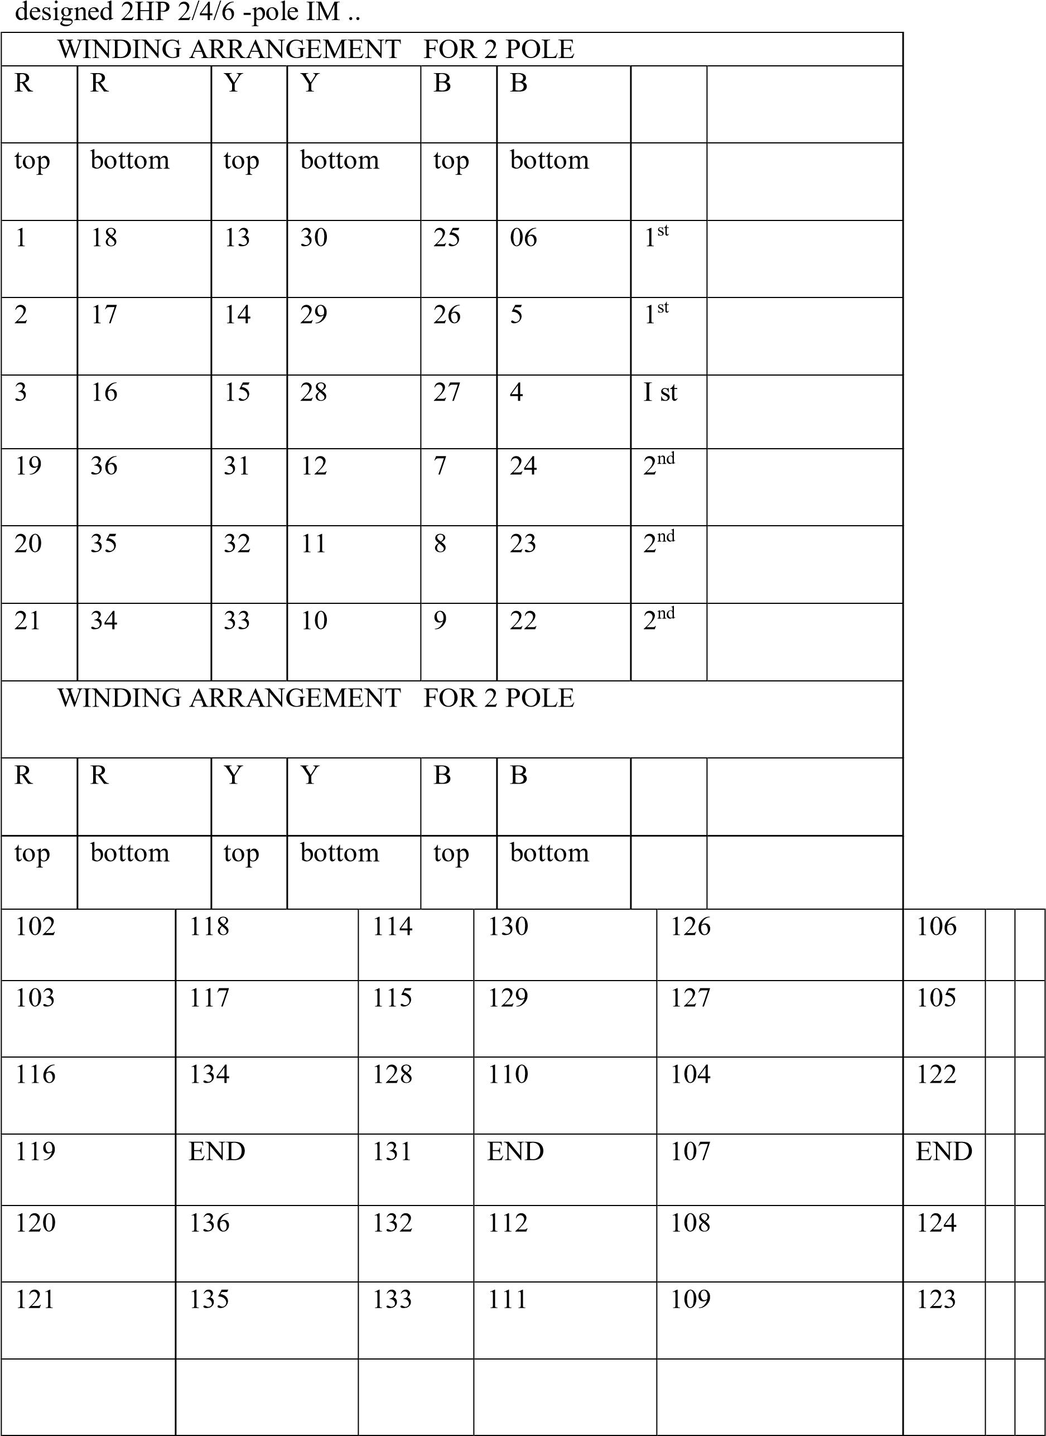

WINDING ARRANGEMENT FOR 6 POLE
R | R | Y | Y | B | B
top | bottom | top | bottom | top | bottom
1 | 6 | 5 | 10 | 9 | 14 | 1ST
7 | 12 | 11 | 16 | 15 | 20 | 2ND
13 | 18 | 17 | 22 | 21 | 26 | 3RD
19 | 24 | 23 | 28 | 27 | 32 | 4TH
25 | 30 | 29 | 34 | 33 | 2 | 5TH
31 | 36 | 35 | 4 | 3 | 8 | 6TH
WINDING ARRANGEMENT FOR 6 POLE
R | R | Y | Y | B | B
top | bottom | top | bottom | top | bottom
106 | 114 | 110 | 116 | 114 | 120
107 | 113 | 111 | 117 | 115 | 121
118 | 124 | 122 | 128 | 126 | 132
119 | 125 | 123 | 129 | 127 | 133
130 | 136 | 134 | 4 | 102 | 108
131 | END | 135 | END | 103 | END

Working:
The Arrangement is as per above given diagram works. The arrangement consists of a Stepper motor rotated by the Arduino. Generally Arduino receives the command by observing the position of selector switch. For making all the switches ON Firstly Arduino Uno is operated and send the command to the stepper motor for its operation. In between the stepper motor and Arduino uno one Driver is connected for operating the stepper motor.
When command is given to the Arduino it operates the stepper motor by using a motor driver. After that by rotation of stepper motor the wooden plate which is connected to the S.M. that is also rotated and goes to downward position. And by this setup all the switches are turned ON at the same time and motor will operate in respective pole speed like 2 Pole, 4 Pole, 6 Pole.

Components:
1. Arduino UNO
Arduino UNO is a microcontroller board based on the ATmega328P. It has 14 digital input/output pins (of which 6 can be used as PWM outputs), 6 analog inputs, a 16 MHz ceramic resonator, a USB connection, a power jack, an ICSP header and a reset button. It contains everything needed to support the microcontroller; simply connect it to a computer with a USB cable or power it with a AC-to-DC adapter or battery to get started. You can tinker with your UNO without worrying too much about doing something wrong, worst case scenario you can replace the chip for a few dollars and start over again.
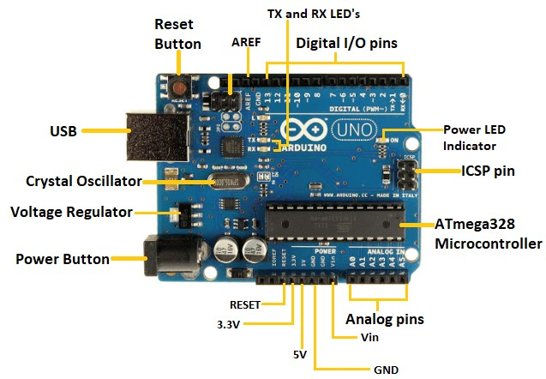

Motor Driver:
A motor driver IC is an integrated circuit chip that controls motors in autonomous robots and embedded circuits. L293D and ULN2003 are the most commonly used motor Driver IC that is used in simple robots and RC cars. A motor driver is unquestionably something that causes the motor to move in accordance with the given instructions or inputs (high and low). It listens to the low voltage from the controller/processor and controls an actual motor that needs high input voltage A motor driver IC, in simple terms, controls the direction of the motor based on the commands or instructions received from the controller. Many motor drivers follow different topologies, in this article, we will focus on the popular H-bridge topology which is used in the L293D motor driver IC.
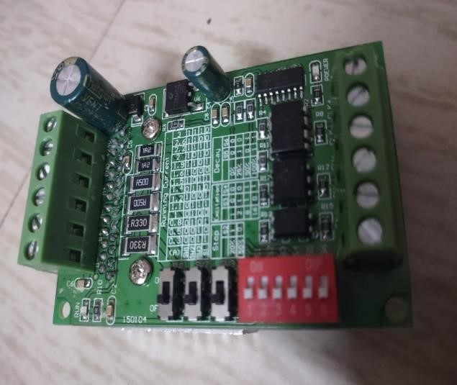
Stepper Motor:
A _{4.}stepper motor is an electric motor whose main feature is that its shaft rotates by performing steps, that is, by moving by a fixed amount of degrees. This feature is obtained thanks to the internal structure of the motor, and allows to know the exact angular position of the shaft by simply counting how may steps have been performed, with no need for a sensor. This feature also makes it fit for a wide range of applications
The instrument which measures the voltage or potential difference in volts is known as the voltmeter. It works on the principle that the torque is generated by the current which induces because of measurand voltage and this torque deflects the pointer of the instrument. The deflection of the pointer is directly proportional to the potential difference between the points. The voltmeter is always connected in parallel with the circuit.

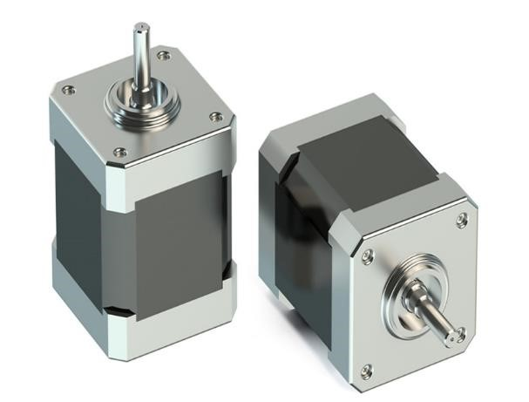

5. Ammeter:
Ammeter is a device used to measure either alternating or direct current. We know that ampere is the unit of current. Since this device measures the value in amperes, it’s known as ammeter.

Working Principle:
When a 3-phase supply is given to the stator winding it sets up a rotating magnetic field in space. This rotating magnetic field has a speed which is known as the synchronous speed. This rotating magnetic field induces the voltage in rotor bars and hence shortcircuit currents start flowing in the rotor bars. These rotor currents generate their self-magnetic field which will interact with the field of the stator. Now the rotor field will try to oppose its cause, and hence rotor starts following the rotating magnetic field. The moment rotor catches the rotating magnetic field the rotor current drops to zero as there is no more relative motion between the rotating magnetic field and rotor. Hence, at that moment the rotor experiences zero tangential force hence the rotor decelerates for the moment. After
deceleration of the rotor, the relative motion between the rotor and the rotating magnetic field re-establishes hence rotor current again being induced. So again, the tangential force for rotation of the rotor is restored, and therefore again the rotor starts following rotating magnetic field, and in this way, the rotor maintains a constant speed which is just less than the speed of rotating magnetic field or synchronous speed. Slip is a measure of the difference between the speed of the rotating magnetic field and rotor speed. The frequency of the rotor current = slip supply frequency.

Advantages:
There are different methods of speed control of 3 phase Induction Motor;
i. Variable Frequency Drive (VFD)
Method ii. Rotor Resistance Method
iii. Stator Resistance Method iv. Pole Changing Method.

- While above methods, Some methods such as requires Rotor Resistance Method this method is only applicable for slip ring induction motor.
- While the VFD drive is some what costly and produces harmonics and losses also.
➢
If pole changing method is used, it requires different connections only without any additional requirement, so the cost reduces.
In order to prepare low cost arrangement simple bell switches which requires only applications of force to switch on all the switches for making switches ON.

Actual photo of Motor and Arrangement:

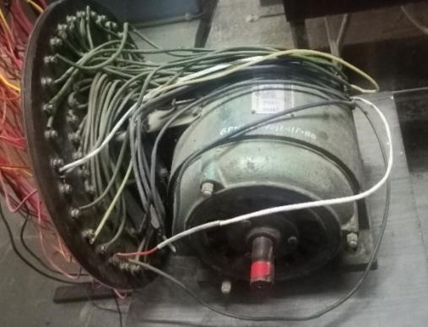

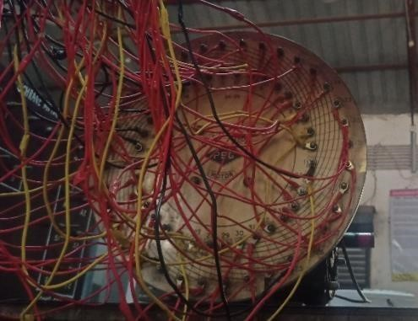
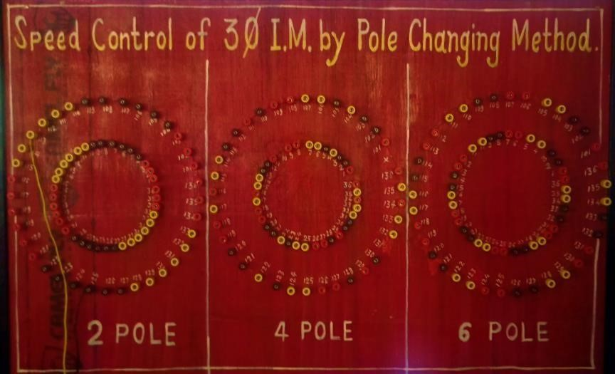

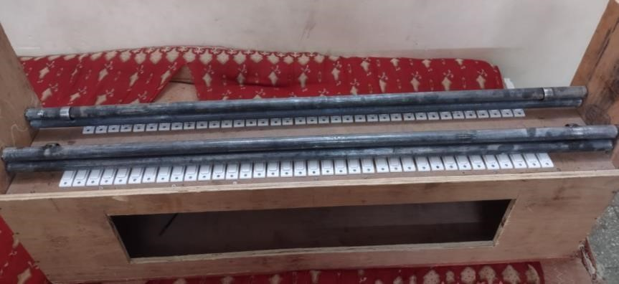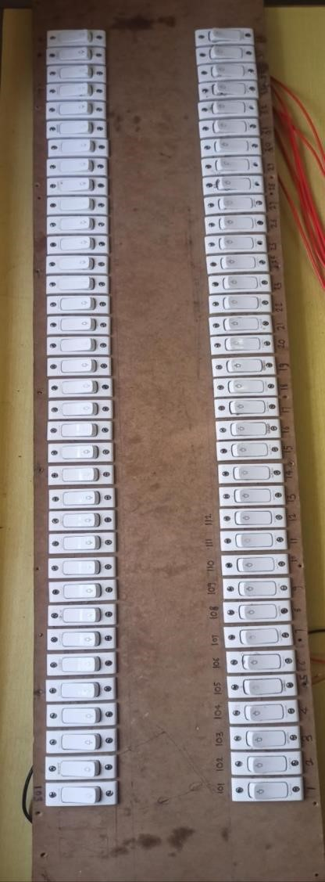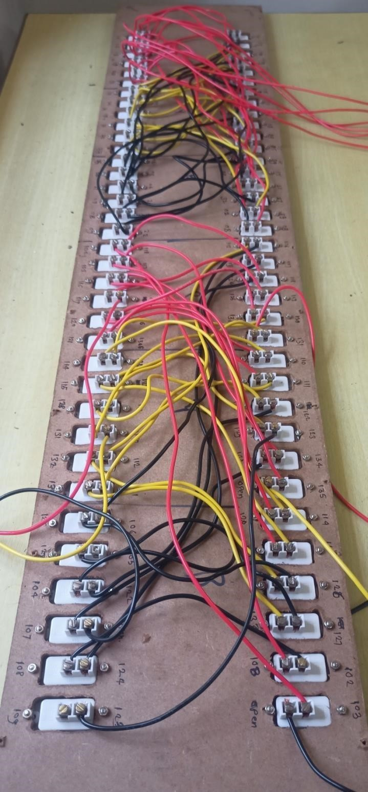

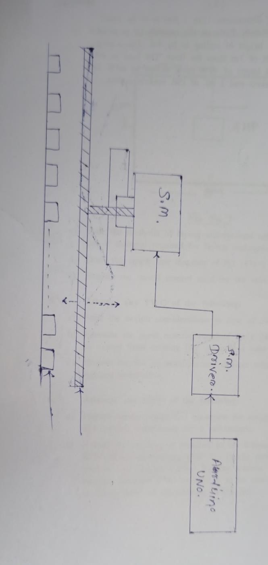




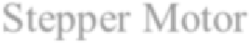
Arduino Uno

Driver

Stepper Motor

Results:
- Speed control is achieve easily with safety precautions.
- Reduces time needed to control the Speed.
- Reduces extra components/accessories require to vary the speed of I.M such as VFD etc.
- Easy To operate.
Conclusion:
A speed variation can be achieved by pole changing method using advanced technology. The method of pole changing is done with the help of consequent pole changing technique. As we are varying the pole by connecting winding coils with the help of wire externally, energy consumption can also be controlled by controlling speed of motor. Thus due it's lack of advantage's such as,(Speed control is achieve easily with safety precautions, Reduces time needed to control the Speed, Reduces extra components/accessories require to vary the speed of I.M such as VFD etc., Easy to operate, etc.) Proves to be easy to use & user friendly.
References:
https://ieeexplore.ieee.org/document/9634
401
https://ieeexplore.ieee.org/document/8707
677
https://ieeexplore.ieee.org/document/1211
265
https://ieeexplore.ieee.org/document/9484
995
https://ieeexplore.ieee.org/document/8521
626
https://www.researchgate.net/publication/4 022826_Control_of_a_continuously_ope rated pole-changing induction machine
https://www.researchgate.net/publication/3
34697159_A_Review_of_Speed_Contro
I_Methods_of_Induction_Motor

