RAILWAY TRACK MONITORING SYSTEM
MR. NIKAM APPASAHEB D, MS. KHOKALE VAISHNAVI S, MR. AHER RAHUL D.
PROF.KALE G. P, PROF.WAGH.K. B, MS. KOKATE M.C.
SANTOSH N DARADE POLYTECHNIC, YEOLA
DEPARTMENT OF ELECTRICAL ENGINEERING.

---------------------------------------------------------------------***---------------------------------------------------------------------
Abstract –
In India rail transport occupies a prominent position in providing the necessary transport infrastructure to sustain. needs of a rapidly growing economy. Today, India possesses the fourth largest railway network in the world. However, in terms of the reliability and safety parameters, we have not yet reached truly global standards. The main problem about a railway analysis is detection of cracks in the structure. If these deficiencies are not controlled at early stages, they might lead to a number of derailments resulting in a heavy loss of life and property. This system proposes a cost-effective solution to the problem of railway track crack detection utilizing IR (Slot sensor) assembly tracks the exact location of faulty track which then mended immediately so that many lives will be saved

Key Words: Slot sensor, IR Transmitter and IR Receiver, light, lasers,

1.INTRODUCTION
The Indian railways are the largest railway passenger transport in today’s world and it is the backbone of countries transport infrastructure. In India most of the commercial is being carried out by the railway network because it is being cheapest mode of transportation preferred over all other means of transportation. The rapidly developing economy of India has resulted in an exponentially increasing demand for transportation in recent years and this has resulted into an enormous rise in the volume of traffic in the Indian railway network. In railway bridges any time the bridge it’s striking due to weather condition floods earthquake cyclone etc. Now days system has some limitations if the bridge or track damaged that information goes to railway authority people they notify and informs to the corresponding trains it will takes more time informing that information. These problems with the rails generally go unobserved due to lack of proper maintenance and the currently irregular and manual track line monitoring that is being carried out in the current situation. Therefore, more efforts are necessary for improving safety. Railway safety is the crucial aspect of rail operation the world over. So to avoid delays our proposed system will immediately notify and informs the current train comes on the track through wireless medium a vast majority of the work done in the field of crack detection uses the infrared sensing technique and It is a well understood technique so much so that it was initially thought to be the best solution to the problem of crack detection but later it was found to be prone to external disturbances and hence came to be considered inaccurate. Techniques that employ ultrasonic and tide over some of the problems mentioned earlier but they can only inspect the core of the track that is it cannot check for surface and near surface cracking where most faults are usually located. IR sensor Used for Crack Detection on Railway Track. It is work in pairs of Transmitter and Receiver. Limit sensor which we used it measure Distance i.e. At what distance fault is present from starting Point to fault location. In it we used 2 pairs of Slot Sensor at Right and Left side i.e., IR Transmitter and IR Receiver. This Sensor detect Obstacle present in tracks.
from the opposite direction of each other on the same track. We actually think over this matter and motivated to do so. Moreover, natural disaster can throw any object on the rail track which cannot be removed very quickly in the remote area. We thought if our system can detect those object or barrier and inform to the control room then they can take necessary steps 3 to avoid accident. Figure 1 depicts the crack on track. The Rail transport is growing at a rapid pace in India. It is one of the major modes of transport but still our facilities are not that accurate, safer as compared to international standards. A survey on the internet states that about 60% of all the railway accidents is due to derailments, recent measurements shows that about 90% are due to cracks on the rails. Hence, it is not safer for Human Life. This needs to be at the utmost attention. These goes unnoticed and the properly maintenance of tracks is not done.
In previously existing system, the work is to be done manually, but the proposed system has a robot which will run automatically on the tracks. System having LED and LDR sensor assembly, but the main disadvantage is that the LED and LDR must be placed opposite to each other and also the environment needs to be perfect to detect the track. To overcome this disadvantage, here sensors are used, which will detect the crack accurately. The existing system is slow, tedious and time consuming. This system has GSM and GPS module which will give the real time location or coordinates in the form of Short Message Service (SMS) to the nearest railway station.
These types of incidents motivate us to think over the above-mentioned issue and take necessary steps to protect those lives. Through our proposed system, we need to establish more modern and secure railway system. Besides this, there is no such type of technology or system in our country which can stop the collision between two trains coming
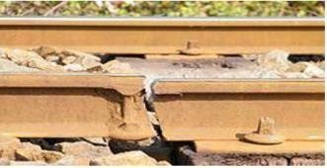
Figure. 1. Railway crack on track
2. LITERATURE SURVEY
India has fourth largest rail network in the world comprising 115,000 km of railway tracks. Approximately, 60% of rail accidents are due to derailments, of which, 90% are due to cracks problems [1]. The Indian Railway Safety Act, which came into effect in January 1989, was designed to improve rail safety by managing rail safety regulatory frame work, together with streamlined regulation development and process, and providing railway companies with greater freedom. Since 2002, there has been an increase in railway accidents mainly due to train derailments. Accordingly, in December 2006, the government announced the Railway Safety Act Review to further improve railway safety in India and to promote a safety culture within the railway industry while preserving and strengthening the vital role this industry plays in the Indian economy. Long range ultrasonic techniques along with radiography technique are the methods used for crack detection
The body of the broadside consists of add up to sections that present the main outcomes. These sectors should be organized to best existent the material.
It is often central to refer back (or forward) to vague sections. Such locations are made by designating the slice number, for case, “In Sec. 2 we exposed…” or “Section 2.1 contained a portrayal….” If the word Segment, Reference, Equation, or Figure starts a judgment, it is implied out. When occurring in the intermediate of a sentence, these disputes are abbreviated Sec., Ref., Eq., and Fig.
At the first manifestation of an contraction, spell it out followed by the acronym in additions, e.g., charge-coupled diode (CCD).
Wireless sensor network method [3] and electromagnetic system [4] are also used in detecting rail cracks. Ultrasonic rail flow detection is carried out with two different types of equipment’s viz. single rail tester and double rail tester. Long range ultrasonic testing technique is proposed as a complementary inspection technique to examine the foot of rails, especially in track regions where corrosion and associated fatigue cracks are likely to happen. A suitable array of transducers is developed that is able to generate selected guided wave modes in rails which allow a reliable long-range inspection of the rail. The characteristics of ultrasonic guided waves in the rail complex geometrical profile have been identified
Digital X-ray radiography offers new possibilities and advantages in rail-wield evaluation over traditional film radiography based on gamma rays. Rail wields have been traditionally weak link in the rail network which has always been very difficult to evaluate accurately. Portable digital X-ray equipment can give information regarding the actual state of suspect rail wields [6].
In wireless sensor networks method, the detection of cracks can be identified using infrared rays with the IR transmitter & receiver. IR receiver is connected to the signal lamp or electrified lamp with the IR sensor. Control Area Network (CAN) controller is connected to the main node and it sends the information via global system for mobile communications and transmit the message to railway engine and to the nearest railway station [3]. An electromagnetic system for rail detection and traction enhancement comprises, in a preferred embodiment, wheel axles, wiring coils around the wheel axles, respectively. It also consists of a power source coupled to the wiring coils for supplying power to produce electromagnetic flux. The wiring coils produce opposite magnetic north and south pole pairs on the axles [4]. The system also has provision for monitoring the flow pattern for locating the position where the crack pattern is detected as open. The flaws related to missing bolts or loosening of the fixtures at the railway track are inspected
The existing systems are more complicated and time consuming. Hence, this paper proposes a more reliable and less time-consuming mode of crack detection in the railway tracks. This is a real time application which can be performed easily.

3.SYSTEM DEVELOPMENT
3.1BLOCK DIAGRAM
Ultrasonic
Sensor 1
Power
Supply
Ultrasonic
Sensor 2
LCD Display
Left Motor
Microcontr
oller
GPS
Motor
Driver IC
Right
Motor
GSM

3.2 BLOCK DIAGRAM DESCRIPTION:
Above diagram shows the block diagram of the proposed work “railway track crack identification system”. In this system we are using Arduino Uno microcontroller, which acts as a brain of the system. This microcontroller controls the circuit function. Various components are interfaced with this microcontroller to perform desired operation of the system. The hardware components used in this system requires regulated power supply for the operation. This power is provided by the rechargeable battery connected in the system. Ultrasonic sensor is used to detect the cracks on tracks and IR sensor is used to detect the obstacle over the track, GPS and GSM systems are used to locate the fault and send information. RF transmitter is sending track status. IR sensors with the microcontroller for the distance and detection of the crack present in the track of the railway line. To communicate the received information, we make use of a GSM modem. The GSM module is being used to send the current latitude and longitude data to the relevant authority as an SMS. This GSM module is interfaced with the microcontroller through a matching circuit MAX232. A GPS receiver is also interfaced with the microcontroller to determine the exact location of the crack on the railway track. This GPS receiver will provide the longitude and latitude parameter values to the controller. Two DC motors are used to move the robot in forward direction. These motors are interfaced and controlled through the microcontroller. To operate these motors through a microcontroller a driver circuit is required for interfacing between microcontroller and motors. A wireless camera is also used in this system. This camera is interfaced in the system for live streaming of the status of the railway track. This camera provides the live video to the device in which the application of that camera is installed. The architecture of the proposed system also consists of a 16x2 LCD display, interfaced with the microcontroller for the display purpose. This LCD display will display the longitude and latitude values of the crack detected by the system.
3.3 PROCESS OF THE RAIL TRACK SYSTEM
The project block diagram is shown in Figure 4, which contains following process: Initially the tracks are being continuously monitored with the help of sensor, which is used to detect the crack in the track.
- This monitoring is done with the help of ultrasonic sensor in order to sense the minor changes also which can be quite difficult with other sensors.
- Whenever the crack gets detected with the help of ultrasonic sensor it passes the alert of crack found to the Arduino microcontroller.
- The Arduino microcontroller will perform the process assigned to it accordingly.
- The process mainly includes positioning, sending and alerting through the help of GPS module.
- As the message gets delivered to the Railway Authority, the alert is to be taken into account and important measures must be taken by them in order to avoid future incidents and miss happenings which can lead to loss of human life and also to major injuries.
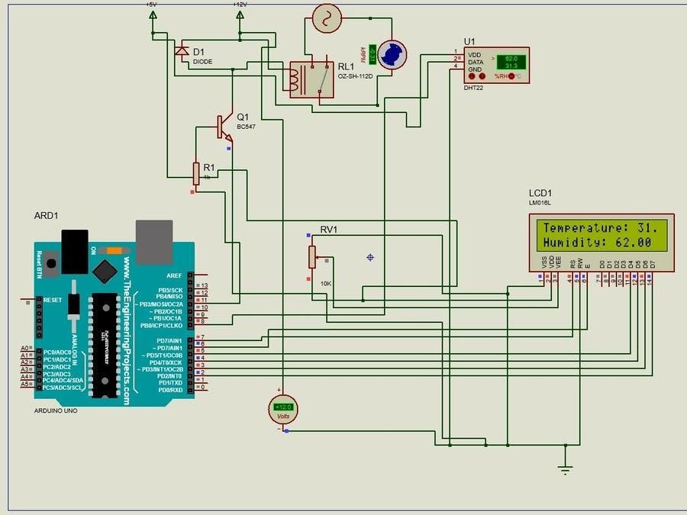
3.4 CIRCUIT DAIGRAME

Figure 3. CIRCUIT DIAGRAM
The main objective is to define any railway track fault using this system, which is implemented in effective and will also function efficiently. This method will be helpful in regular track checking as it is more convenient than the handheld checking system. The current system has a railway labor walking on the railway tracks and detecting the fault manually. In Figure 3 here we are using Arduino for control action to make system we are connecting Ultrasonic sensors and IR sensors to detect the obstacle and we are connecting dc motors; GPS module is used. This requires a lot of time and labor. So, we are using a Ultrasonic sensors and IR sensors for railway track crack detection. The testing vehicle consists of motors driven by a motor driver. The IR, and Ultrasonic sensor which is connected to the Arduino. Message is generated using GSM and GPS and will be sent to the nearby station.
Arduino is an open-source programmable circuit board based on top of easy-to-use hardware and software. The above Figure 7 depicts Arduino uno. It is tough in nature and can support the peripherals efficiently. It is centered on ATmega328. It has 14 digital input/output pins 6 analog inputs, a USB connection, a power jack, an ICSP header, and a reset button. The power essential to run the board can supply through connecting it to the laptop using a USB cable or plugging an ACDC power supply.
4. WORKING:
In our project, there are two set of IR sensor units fitted to the two sides of the vehicle. This unit is used to activate/deactivate GSM transmitter unit when there is any cracks in the track. The IR transmitter and IR receiver circuit is used to sense the cracks. It is fixed to the front sides of the vehicle with a suitable arrangement. When the vehicle is Powered On, it moves along the model track. The IR sensors monitor the condition of the tracks. In normal condition the motor, LDR, Serial transmission is in initial stage. When the battery power supply supplies the microcontroller then it’s starting the motor in forward direction and serial transmission is used to send the messages to the microcontroller. When a crack is detected by the IR sensor the vehicle stops at once, and the GPS receiver triangulates the position of the vehicle to receive the Latitude and Longitude coordinates of the vehicle position, from satellites. The Latitude and Longitude coordinates received by GPS are converted into a text message which is done by microcontroller. The GSM module sends the text message to the predefined number with the help of SIM card that is inserted into the module.
At Normal Condition:
The IR transmitter sensor is transmitting the infrared rays. These infrared rays are received by the IR receiver sensor. The Transistors are used as an amplifier section. At normal condition Transistor is OFF condition. At that time relay is OFF, so that the vehicle running continuously
At Crack Condition:
At crack detection conditions the IR transmitter and IR receiver, the resistance across the Transmitter and receiver is high due to the non-conductivity of the IR waves. When the track is in continuous without any cracks then output of IR LED and Photodiode will be high. As soon as the crack detected by the system the ultrasonic sensor reflection will be equal to zero and the robot will be stopped automatically. Another ultrasonic sensor is used to monitor the pit on the way of the railway track. When this output is high then it is concluded that there is no pit in the track. But if any pit is detected by the sensor the output of the sensor given to the microcontroller will be zero and again the microcontroller will stop the robot. When a crack is detected by the IR sensor the vehicle stops at once, and the GPS receiver triangulates the position of the vehicle to receive the Latitude and Longitude coordinates of the vehicle position, from satellites. The Latitude and Longitude coordinates received by GPS are converted into a text message which is done by microcontroller. The GSM module sends the text message to the predefined number with the help of SIM card that is inserted into the module to send the SMS.
5. ADVANTAGES & DISADVANTAGES
ADVANTAGES
Introduction of automation for Indian railway.
The project saves human effort and time.
Easy to use.
It is cost effective.
It will also increase the security for both rails and passenger.
Reduce accident on railway.
Quick response is achieved.
The signal transmission is wireless transmission.
DISADVANTAGES
Recharge to SIM.
Range problem.

6.CONCLUSION & FUTURE SCOPE
6.1. CONCLUSION
The Indian railways are the largest rail passenger transport in today’s world and it is the backbone of the country transport infrastructure. This system makes an attempt in providing a visible solution in making the railway tracks crack free with GSM based railway detection scheme. The proposed broken rail detection system automatically detects the faulty rail track without any human intervention, It means proposed system detects crack present in railway track as well as it also detect any obstacle i.e. living and non-living thing. There are many advantages with the proposed system when compared with the traditional detection techniques. By this proposed system the exact location of the faulty rail track can easily be located and we will easily avoid the accidents occurs by the faulty track which will help us for saving many lives.
As per the study the existing systems are time consuming as well as uneconomical. The proposed system is not only overcome these problems but also improve accuracy and crack detection in rails. It is the most economical solution provided in order to achieve good results of railways of our country in order to minimize the stats of accidents caused. There by possible to save precious lives of passengers and loss of economy. It also saves the time and money for identification of crack.
6.2. FUTURE SCOPE
- In future we can also use in the CCTV system with IP based camera for monitoring the visual videos captured from the track.
- In future a more advanced accelerometer sensor with more compatible technology can be used.
- By using Wireless sensor network techniques. we can develop more and more reliable security system applications in which continuously monitors the railway track through the sensor and detects any abnormality in the track. The sensor nodes are equipped with the sensors that can sense the vibration in the railway track due to coming train. The geographical positioning sensors are placed on the trains.
- In future we expand our project for a long distance.

6.3. REFERENCES
- Selvamraju Somalraju, Vigneshwar Muruli, Gourav Saha, Dr V Vaidehi,” Robust railway crack detection scheme (RRCDS) using LED LDR assembly”, ICRTIT-2012
- Reenu George, Divya Jose, Gokul T G, Varun A G “Automatic broken track detection using IR transmitter and receiver” ISSN 2320-3765 International Journal of Advanced Research in Electrical Electronics and Instrumentation Engineering volume 4, Issue 4, April- 2015
- Sandhya Solunke and Supriya Nimunkar and Yogita Survase, Crack Detection System for Railway Track by using Ultrasonic and PIR Sensor, International Journal of Advanced Research and Innovative Ideas in Education,07, 2017,5229-5235
- Muralitharan 1, Dinesh *2, Manikandan, An Enhanced Crack Detection System for Railway Track, International Journal of Engineering Trends and Technology (IJETT), 03, Issue 6, March 2015, 296-298
- S. Srivastava, R. Chourasia, S. Abbas, P. Sharma and N. Singh, "Railway Track Crack Detection Vehicle", International Advanced Research Journal in Science, Engineering and Technology, vol. 4, no. 2, pp. 145-148, 2017.
- “Detecting Cracks and Obstacles in Railway Tracks” P.V.V.N.D.P. Sunil, Y.N.V.V.L. Prasanna, M.L. Prasanna, P. Sravani Gayathri, P. Pavani Komali. Vol. 8, Issue 3, March 2019
- Volume 15, Issue 6 Ser. I (Nov. – Dec. 2020), “Automated Crack Detection of Railway Track” Aniket Chakraborty, Shyam Sundar Banerjee, Soutrik Karmakar, Koushik Das, Susmita Das

