Space Efficiency in Multi-Use Tall Building


ARCHITECTURE

By Student RAM SHARMA
Registration Number 0809AR191064

Under the Guidance of Ar. Prateek Ahirwar

School of Architecture IPS Academy, Indore

School of Architecture, IPS Academy, Rajendra Nagar, Indore, 452012

Space Efficiency in Multi-Use Tall Building

Abstract
This study aims to contribute to the development of design strategies for multi-use tall buildings in terms
of building space efficiency for architects, engineers, and developers throughout the early stages of the
design process. The complexity of a design development process driven by vertically stacked
functionalities is described in this study. This study discusses the critical design characteristics for multi-
use tall buildings and their relationship to space efficiency. Functions, lease span, floor-to-floor height,
vertical transportation, site area, FAR (Floor Area Ratio), building height, number of storeys, building
size at the base and top, aspect ratio, and structural system were among the parameters examined.

Ten multi-use buildings were carefully studied and investigated using case studies. A thorough data base was created in order to conduct this comparison research. A set of statistical analysis was done based on the case study data to demonstrate the relationship between design factors. This study will aid decision-making during the initial design stage, increasing the overall feasibility of multi-use tall buildings. It will provide a better knowledge of the complexities of multi-use buildings as well as ideas for efficient building design.

Introduction
This research is focused to understand space issues that are generated by stacked functions in multi-use tall building. Even though this type of building has much potential to provide advantages over the single-use building, not many such buildings have been constructed around the world. The main reason for this situation is that multi-use building have been considered as difficult buildings to design efficient space and an efficient structural system.
This building design must be a successful answer to the space challenges that arise when dealing with large numbers of commercial, office, hotel, and residential space before it can be considered for investment in urban areas. Because space efficiency is closely linked to functional distribution ratio, which indicates percentage of functions in a building, the combination of function components must be carefully analyzed. To achieve higher space efficiency in the early stages of design, the ratio of core, which results from the arrangement of functions in a building, must be given special consideration. A multi-use tall building's core is typically more complex and larger than a single-use building's core.
Space efficiency can be increased by reorganizing the function components, core components, and structural system. Lease span, core planning, vertical transportation, floor-to-floor height, and structural system are examples of these. These are linked to functional distribution, space efficiency, and the structural system. Because of the interconnected functional requirements of a multi-use tall structure, a single change can have a major impact on many other factors that must be considered while developing a project.

Types of Multi-Use Tall Building
Office, hotel, and residential functions are regarded as main functions among the common functional elements of multi-use tall buildings because of their various architectural and structural needs. The "Net-to-Gross" area ratio, which measures space efficiency, could be impacted by the combinations of various services, which typically call for a complex building core and user circulation.

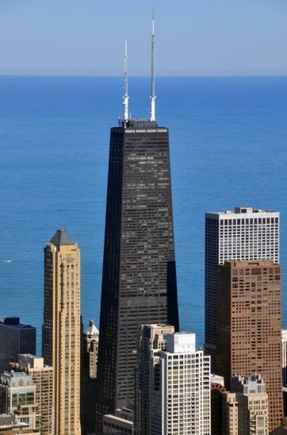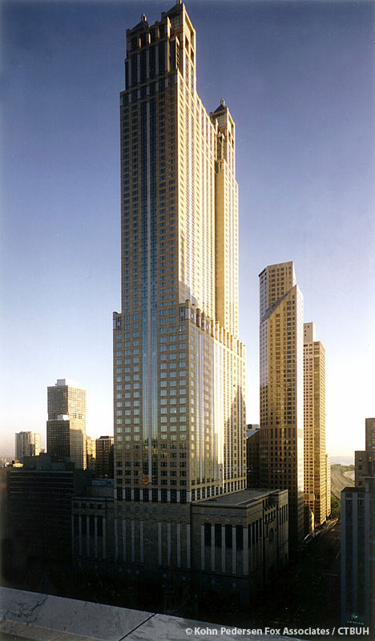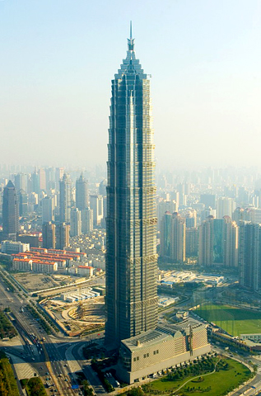

a. John Hancock Center | b. 900 N. Michigan | c. Jinmao building
Office + Residential | Off ice + Hotel + Residential | Office + Hotel
Added purposes include parking, commercial, and an observatory. Although those will provide marginal benefits, there is no such unique architectural planning issue as in the actual multi-use tall structure. Depending on their complexity, multi-use tall buildings can be divided into a few different categories.

- Office with Hotel
- Office with Residential
- Office, Hotel and Residential

Different Aspects of Multi-Use Building over Single-Use Building
Multi-use tall buildings integrate living, working, and service activities all within one structure, in contrast to single-use structures. In these situations, a single structure has a variety of uses, each with its own entry and circulation, including commercial, office, hotel, residential, and occasionally parking.
Developers in the city centre are drawn to multi-use buildings because of its marketing and financial benefits. The most flexibility of space division within a very wide structural grid is offered by the multi-use building. When compared to the typical single use building and multi-use building, these uses might be thought of as more notable. Research into each function is required to provide the best design possible. When considering the vertical location of multi-use functions from the perspective of tenant preference and rentability, the first level above grade should be used for commercial use, the next level for office space, the next for hotel, and the topmost level for residential function. However, for structural efficiency and to avoid specific considerations in transferring loads, the smallest column space, which is hotel or residential function, should always be situated at the bottom of the building. The goal is to find a balance between these two issues.
Space Efficiency in Multi-Use Tall Building
Maximizing the gross and net areas permissible on the site allows for the possibility of multi-use tall buildings. To allow the developer and owner to make the maximum oreturns from the high cost of land, the project must contain enough functional space to raise land value over total net rentable space. The space efficiency is simply the ratio of rentable area to gross area, and it is determined by the building's core area. Because the core of a multi-use building is generally more complex than that of a single-use building, reasonable combination of functional distribution is critical. Each function's distribution will have an impact on the core planning. The resulting space efficiency will vary depending on the ratio of distributed functions in the building volume.
2) Methods
Ten multi-use buildings are closely analysed and case studies are conducted. All measurements are based on architectural blueprints that have been collected.
Format of Case Study
- Function and Area Analysis
- Vertical Transportation Analysis
- Core Location

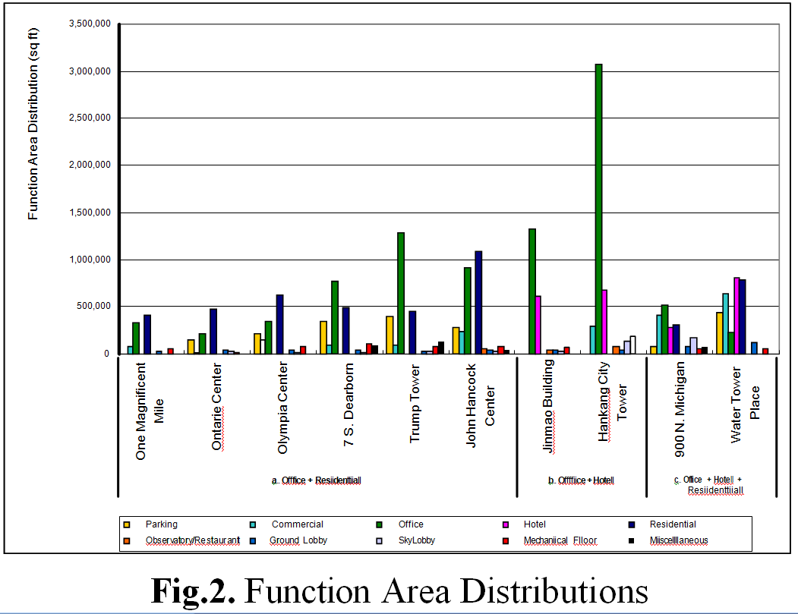
Fig.2 shows the area distribution of functions in each building.
Buildings with multiple uses always have two or more dominant purposes. The major services are evenly distributed in Water Tower Place and 900
N. Michigan, however the other buildings are mainly dedicated towards either office or residential use. Commercial use appears to be a major function for these two buildings.
Water Tower Place has three principal functions: commercial (21.4%), hotel (26.9%), and residential (25.8%), with the office function accounting for only 7.3% of the gross area.
900 N. Michigan is another example of a building with multiple functions instead of just one main function: office (25.7%), hotel (13.9%), and residential (15.3%). This building's commercial area is around 20%, which is higher than the percentage of hotel and residential space within a structure. Hankang City and Jin Mao Building provide greater office space than a hotel.
They both have offices that are larger than 60% of the total space. One Magnificent Mile and Ontario Centre are more residentially oriented structures. The residential area at John Hancock Centre is slightly larger than the office area, with 39.5% being residential and 33% being office.
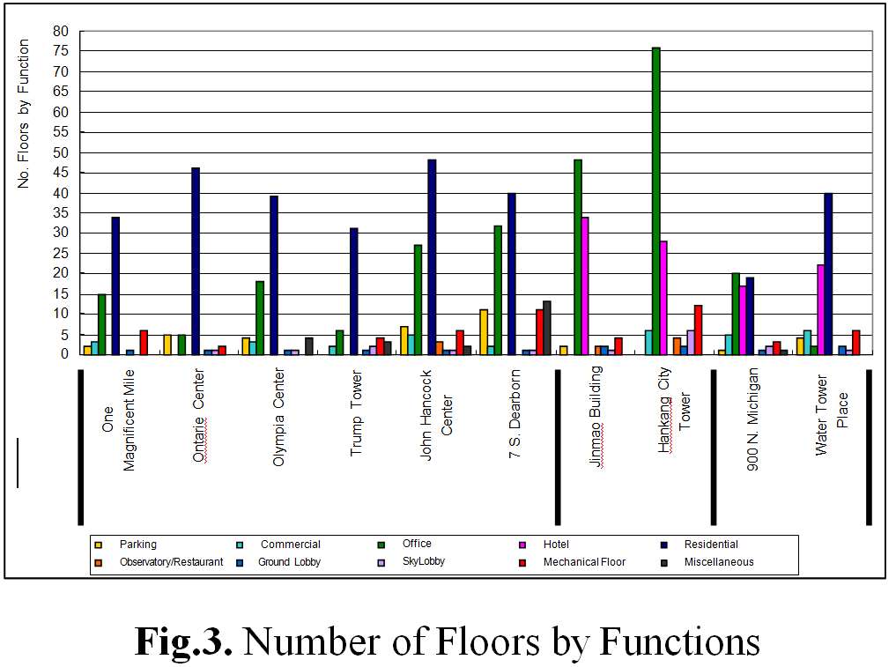
When compared to a single-use building, the height of a multi-use building is not always related to the number of storeys. Because of the variance in floor-to-floor heights for each function, the tallest structure does not always have the most floors. The 88-story Jin Mao Building towers over the 100-story John Hancock Centre. This explains why multi-use buildings should be identified not just by their height or number of levels, but also by their architectural programme and purposes.

Fig.3 displays a breakdown of each function based on the number of floors. The John Hancock Centre includes 27 office levels and 48 residential stories. The actual height of the 27 office floors is 344 feet, and the height of the 48 residential floors is 449 feet.

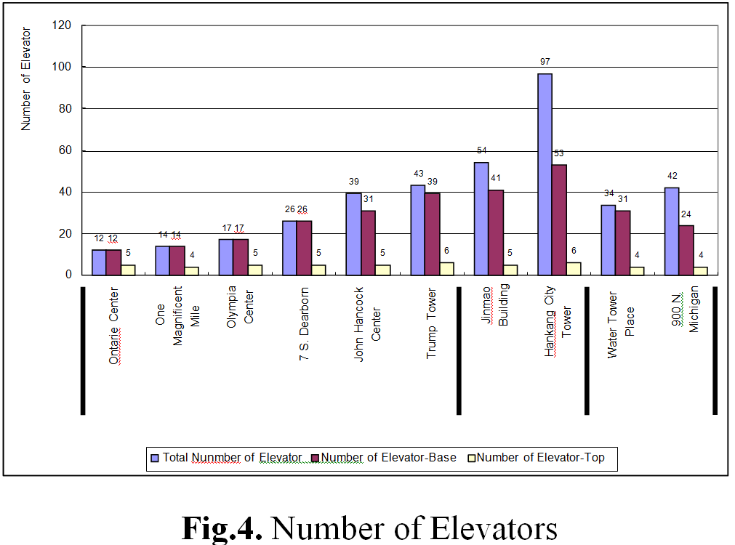
Fig.4 shows the total number of lifts for the buildings, as well as the number of lifts at the bottom and top of the building. Buildings often have more lifts at the ground level, but the number reduces as the building rises in height. A large number of office space in a structure, such as Honkong City Tower, implies that some functions demand more lifts than others. If it is an office function, lifts will decrease after the office zone ends, resulting in a lesser number of lifts at the building's upper levels.

Fig.5 shows Analysis of Elevators by Functions.
The office function displays the number of lifts in a building. In John Hancock Centre, 19 lifts are allotted for office, whereas 9 lifts (3 express, 6 local) are assigned for residential, despite the fact that it is larger in gross area than office. (See Figures 2 and 10)
Elevators are necessary for special functions such as the observatory and the sky café. Only three lifts are assigned to the John Hancock Center's top three floors (1.7% of gross space). Hankang City is another example of this type of structure. It has two stories for the observatory and two floors for the sky restaurant (also 1.7% of the total gross area), however these required two express lifts for the restaurant and three express lifts for the observatory.
Because lifts must run across the entire structure without stopping, extra thought should be given when the building uses these operations at the top of the building.

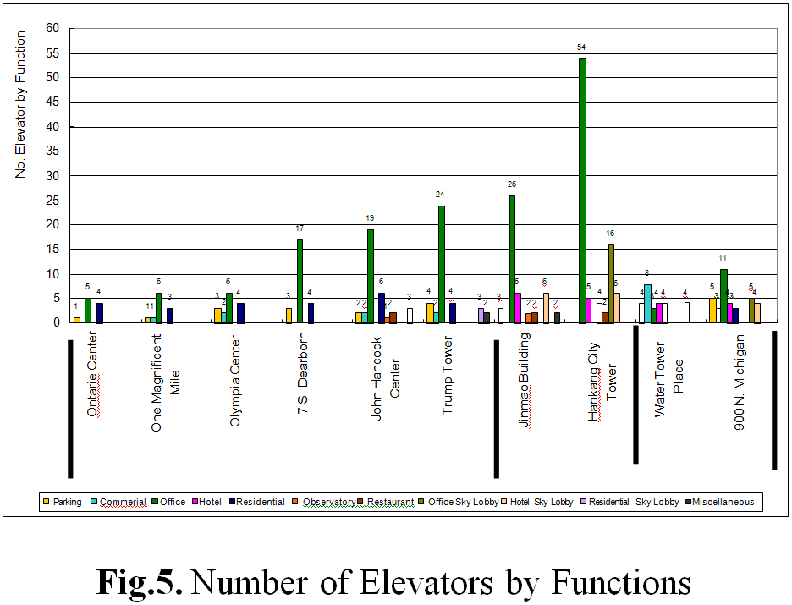

Building core design and its effects on space efficiency

The average floor plate of a normal multi-use construction has the following elements:

•Vertical Circulation Core
•Open Lease Space
•Optional public corridor.

Core location

The Building Core can take any of basic locations relative to the floor plate.

•Central Core

•Off- set Core

•Exterior Core

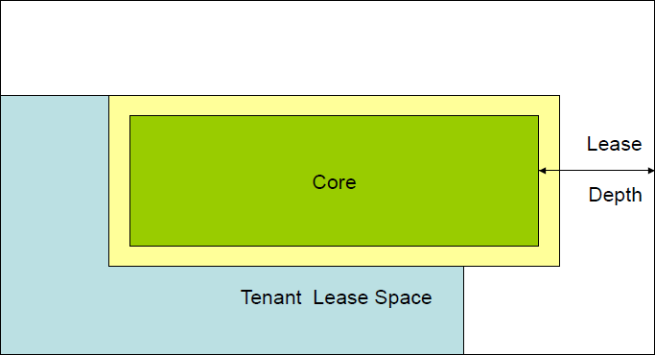
•Split Core

Central Core

The central core is present when the core is in the geometrical centre of the floor plate. The lease depth is approximately equal around the centre of the building in the central core. The tenant has the option of leasing the complete floor plate or a section of the floor plate.

Central core advantages and disadvantages
•Ensures equal circulation of users and services
•Provides equal amounts of rented space.
•All four sides provide natural light.
•Provides column-free and flexible spaces throughout the full floor plate.
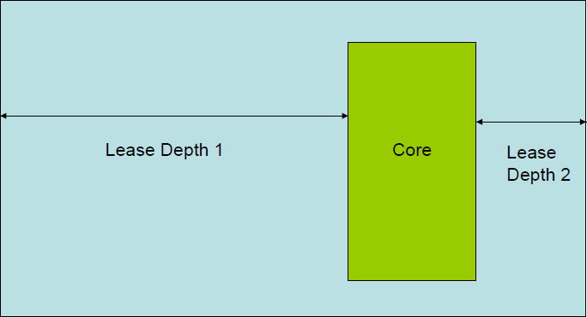
Off- Set Core
The off Set-Core places the core off center resulting in varying lease depths. This provides more but unequal leasing options.

Offset core advantages and disadvantages:
•Do not provide equidistant circulation for consumers and services
•Provides unequal modules of lease space.
•All four sides offer natural light.
•Provides a broader variety of leasing choices.
•The portion with the greater leasing depth does not provide column free spaces, depending on the leasing depth and structural system.
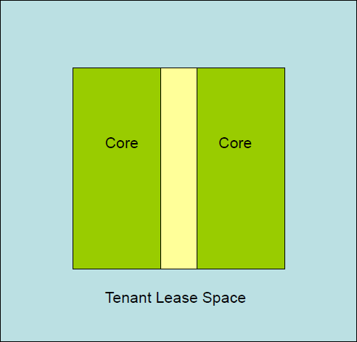

Split Core
The Split core divides the core with a central zone, from which all core components can be accessed. This eliminates the requirement for a peripheral access corridor, and lease space can extend all the way up to the core elements' walls. The Split Core can be split in any amount of ways. It should be noted that this increases the depth of the core which increases the floor plate size. The leasing area can also be divided here, but in case of fire there must be two means of exits should be maintained.
Column free areas may be available depending on the leasing depth and structural system. The demand for services increases two or more cores are added. Two cores require two numbers of fire escape staircases.
Split core has the following advantages and disadvantages:
• Provides equidistant circulation for users and services
• Provides equal amounts of rented space.
• All four sides provide natural light..
• Provides column-free and flexible spaces throughout the full floor plate.

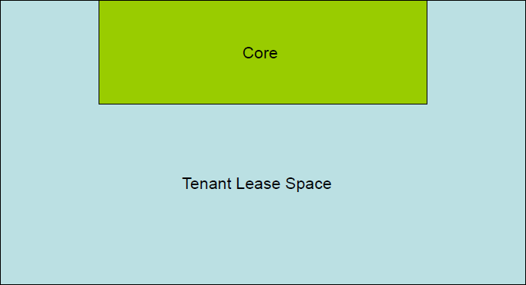
Exterior core
In the configuration of the Exterior Core The core is pushed to one side or edge. If the core is pushed to one side, a 'dead wall' is formed, which can be used to advantage if bad views or party walls are an issue. The Core can alternatively be separated from the lease floor plate as a separate mass element.

Example of the office
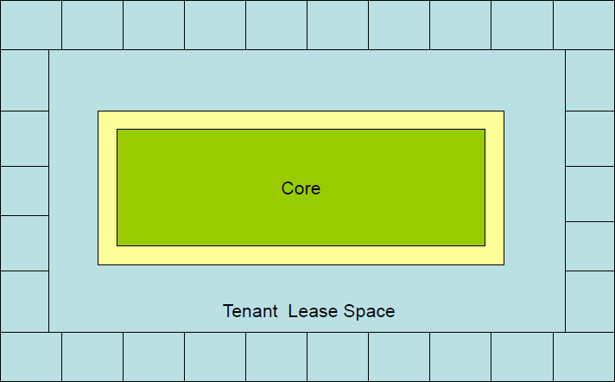
Private authority offices line the outside wall of the building. Their views make them prime locations. The building's corners are then the most desired. These are often designated for the most senior categories of employees. Corner offices can be achieved by effectively utilising the building's corners.

Preferred geometry for the building
We concluded that buildings with regular geometric shapes such as squares, rectangles, circles, and triangles use the least amount of area. The floor slab's shape is derived from an equilateral triangle.
The triangle's corners have been curved to prepare for wind loads, as rounded corners perform better against wind loads than sharp edges.

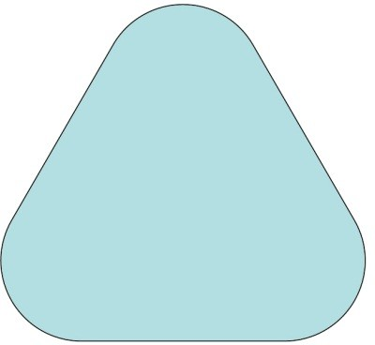
Core configuration
Central core is used in the design for the number of benefits mentioned earlier. The shape of the core is adjusted to get equal and right angles for better planning of the core.
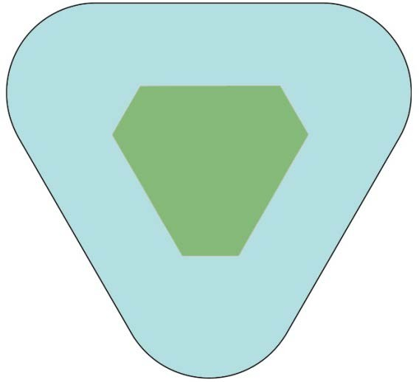
The central core is then split into three following the three sides of the triangular shape. The split central core does not require any circulation corridor around the core and provides equidistant circulation of users as well as services.

Conclusions
This research presents important parameters for the design of multi-use tall buildings and their relationship to the space efficiency. Due to the limited number of existing buildings, the focus of this study cannot be expected to contribute quantitative results. Efforts have been made to present visual analysis that explains the significance of space efficiency and the relations of parameters that impact the space efficiency.
Because multi-use buildings have distinct architectural and functional design than single-use buildings, the primary principle is to define space efficiency as a measure to evaluate buildings other than heights of structures.
When considering well-planned buildings, efficiency is a crucial consideration. Space efficiency is just one of many efficiencies, including structural efficiency, building efficiency, energy efficiency, and operating efficiency.
Maybe a well-designed building can function well. It should deliver a high level of serviceability to users while making maximum profit to developer. These topics are interconnected and have an impact on one another. Space efficiency cannot be considered without considering these parameters.
- Space efficiency in multi-use tall buildings is determined by the distribution of functions.
- Because of the additional gross area required for stacked functions, space efficiency may be reduced.
- Space efficiency could be lower if building includes special functions at the top of the building.
- Space efficiency in single-use buildings may be higher than in multi-use buildings.
- With efforts to improve serviceability, space efficiency may be reduced.
- Space efficiency may be increased if desired structural systems and resultedbuilding forms are designed together.
- Space efficiency could be increased if the building sacrifices its serviceability, such as reducing the number of lifts to have a smaller core space.

Space efficiency is just a figure that results from a series of interconnected decisions made throughout the project's early planning and development. Higher space efficiency alone cannot define a well-designed building. A multi-use building with great space efficiency has a better chance of becoming a good building.

References
- Abdelrazaq A, Wind Engineering Considerations for High-Rise Building, SOM, 1998
- City of Chicago, Report of Committee, Trump Tower Chicago, July 31 2002
- College of Architecture, Illinois Institute of Technology, Hankang City Project, Research Report, 1997
- CTBUH (Council on Tall buildings and Urban Habitat)., Architecture of Tall Buildings, McGraw-Hill Inc., N.Y., 1995.
- CTBUH., Structure System for Tall Buildings, Council on Tall Buildings and Urban Habitat, Bethlehem, PA., 1995
- Han-soo Kim, Structural patterns of setbacks in tall buildings, 7th International conference on computing in Civil and Building Engineering 1997
- Pauline A. Saliga, The Sky the Limit, A Century of Chicago Skyscraper, 1990, Rizzoli
- Robert M Lau, Economic Considerations for Tall Multi-Use Buildings, CTBUH Review Volume 1, Feb, 2001
- SAE & IIT, Development & Planning of Tall building, Research project, 1997, unpublished.
- Taranath, Bungale S., Steel, Concrete, and Composite Design of Tall Buildings, McGraw-Hill, New York, 1998.

