USING NEURAL NETWORK FOR PREDICTING SURFACE FINISH AND OPTIMIZATION OF
PROCESS PARAMETERS IN ADDITIVE MANUFACTURING

ME19811 PROJECT PHASE-2 REPORT

Submitted by

ASHOK KUMAR V (2116191101016)
ASHWIN BALAJI K (2116191101017)
BALAJI B (2116191101021)
in partial fulfillment for the award of the degree of

BACHELOR OF ENGINEERING

IN

MECHANICAL ENGINEERING



DEPARTMENT OF MECHANICAL ENGINEERING RAJALAKSHMI ENGINEERING COLLEGE (AUTONOMOUS),

CHENNAI-602 105

APRIL 2023

RAJALAKSHMI ENGINEERING COLLEGE
(An Autonomous Institution Affiliated to Anna University Chennai)

BONAFIDE CERTIFICATE

Certified that this Phase-2 Thesis title “USING NEURAL NETWORK FOR PREDICTING SURFACE FINISH AND OPTIMIZATION OF PROCESS PARAMETERS IN ADDITIVE MANUFACTURING” is the Bonafide work of ASHOK KUMAR V (2116191101016), ASHWIN BALAJI K (2116191101017), BALAJI B (2116191101021) who carried out the work under my supervision. Certified further that to the best of my knowledge the work reported here in does not form part of any other thesis or dissertation on the basis of which a degree or award was conferred on an earlier occasion on this or any other candidate.

Dr. S.P. Srinivasan Mr. S. Panneer Selvan
Professor and Head Associate Professor
Department of Mechanical Engineering Department of Mechanical Engineering Rajalakshmi Engineering College Rajalakshmi Engineering College Chennai- 602 105 Chennai- 602 105

Certified that the candidate was examined in the “VIVA-VOCE” Examination held on …………………….

INTERNAL EXAMINER EXTERNAL EXAMINER

ME19811 PROJECT PHASE-2 REPORT

DEPARTMENT VISION
To provide a world class education in mechanical engineering through innovation, excellence in teaching and research

DEPARTMENT MISSION
M1. To impart high quality technical education and prepare Mechanical Engineers with all round knowledge of multi-disciplinary branches of Engineering and Technology.
M2. To foster skill sets required to be a global professional for industry, research and technology management.
M3. To provide consultancy to the neighbourhood industries. M4. To cultivate the spirit of entrepreneurship

PROGRAMME EDUCATIONAL OBJECTIVES

PEO I
To provide students with a sound foundation in the mathematical, scientific and engineering fundamentals necessary to formulate, analyze and solve engineering problems and to prepare them for graduate studies and for successful careers in industry.

PEO II
To impart students with skills for design, improvement and installation of Mechanical and allied integrated systems of men and material

PEO III
To educate the students on designing the modern mechanical systems and expose them to industrial practices for better employability and adaptability.

PEO IV
To install the values, skills, leadership and team spirit for comprehensive and wholesome personality, to promote entrepreneurial interest among students and to create a fervor for use of Engineering in addressing societal concerns.

PROGRAM OUTCOMES (POs)

Engineering Graduates will be able to:

- Engineering knowledge: Apply the knowledge of mathematics, science, engineering fundamentals, and an engineering specialisation to the solution of complex engineering problems.
- Problem analysis: Identify, formulate, review research literature, and analyse complex engineering problems reaching substantiated conclusions using first principles of mathematics, natural sciences, and engineering sciences.
- Design/development of solutions: Design solutions for complex engineering problems and design system components or processes that meet the specified needs with appropriate consideration for the public health and safety, and the cultural, societal, and environmental considerations.
- Conduct investigations of complex problems: Use research-based knowledge and research methods including design of experiments, analysis and interpretation of data, and synthesis of the information to provide valid conclusions.
- Modern tool usage: Create, select, and apply appropriate techniques, resources, and modern engineering and IT tools including prediction and modelling too complex engineering activities with and understanding of the limitations.
- The engineer and society: Apply reasoning informed by the contextual knowledge to assess societal, health, safety, legal and cultural issues and the consequent responsibilities relevant to the professional engineering practice.

- Environment and sustainability: Understand the impact of the professional engineering solutions in societal and environmental contexts, and demonstrate the knowledge of, and need for sustainable development.
- Ethics: Apply ethical principles and commit to professional ethics and responsibilities and norms of the engineering practice.
- Individual and team work: Function effectively as an individual, and as a member or leader in diverse teams, and in multidisciplinary settings.
- Communication: Communicate effectively on complex engineering activities with the engineering community and with society at large, such as, being able to comprehend and write effective reports and design documentation, make effective presentations, and give and receive clear instructions.
- Project management and finance: Demonstrate knowledge and understanding of the engineering and management principles and apply these to one’s own work, as a member and leader in a team, to manage projects and in multidisciplinary environment
- Life-long learning: Recognize the need for and have the preparation and ability to engage in independent and life-long learning in the broadest context of technological change.

PROGRAM SPECIFIC OUTCOMES (PSOs)

- To innovate a Mechanical System which meets the desired specifications and requirements using CAE tools.
- To explore alternate materials for automobile, manufacturing and process industries
- To lead a professional career in industries or an entrepreneur by applying Engineering and Management principles and practices.

COURSE OBJECTIVE

- To develop the ability to solve a specific problem right from its identification and literature review till the successful solution of the same.
- To train the students in preparing project reports and to face reviews and viva voce examination.

COURSE OUTCOME

- On completion the students can able to execute the proposed plan and identify and overcome the bottlenecks during each stage.
- On Completion of the project work students will be in a position to take up any challenging practical problems and find solution by formulating proper methodology.
- Students will obtain a hands-on experience in converting a small novel idea / technique into a working model / prototype involving multi-disciplinary skills and / or knowledge and working in at team.
- Students will be able to interpret the outcome of their project.
- Students will take on the challenges of teamwork, prepare a presentation in a professional manner, and document all aspects of design work.

ABSTRACT

Additive Manufacturing (AM) has the potential to revolutionize the production of complex and customized parts. However, achieving desired surface finish and optimizing process parameters to ensure adequate tensile strength in AM remains a challenging task. In this project, we propose the use of Neural Networks (NN) for predicting surface finish and tensile strength, as well as optimizing process parameters in AM. The NN model will be trained using data obtained from AM experiments and will be used to predict the surface finish and tensile strength, as well as identify optimal process parameters. The proposed methodology can help in reducing the time and cost associated with AM by providing accurate predictions of surface finish and tensile strength, while optimizing process parameters. The results obtained from this study can be used to improve the quality of AM parts and increase the efficiency of the AM process.

ACKNOWLEDGEMENT

We thank Mr. S. MEGANANTHAN, B.E., FIE., Founder & Chairman,

Dr.THANGAM MEGANATHAN., M.A., M.Phil., Ph.D., Chairperson, and Mr. ABHAY

SHANKAR M, B.E., M.S., Vice Chairman of Rajalakshmi Institution for providing a pleasant environment.
It’s our pleasure to express my sincere gratitude to our respected Principal

Dr. S.N MURUGESAN, Ph.D., for allowing us to do project work. We gratefully acknowledge and thank Dr. S.P. SRINIVASAN Ph.D., Professor & Head, Department of Mechanical Engineering for giving his constant Encouragement.
We thank our project coordinators Dr. A. RAJKUMAR, Ph.D., Professor,

Department of Mechanical Engineering and Dr. S. SENTHILMURUGAN, Ph.D., Assistant Professor (SG), Department of Mechanical Engineering for their valuable suggestion throughout the phase of the project.
We thank our project guide Mr. S. PANNEER SELVAN, M.E., Associate Professor, Department of Mechanical Engineering for his valuable guidance throughout this phase of the project. We also express our proud thanks to all the faculty members and lab technicians of the Mechanical Department who helped us to make this project work successfully.
By

ASHOK KUMAR V ASHWIN BALAJI K
BALAJI B

TABLE OF CONTENTS

CHAPTER NO  1 | TITLE PAGE NO  ABSTRACT viii  LIST OF FIGURES xi  LIST OF TABLE xiii  INTRODUCTION 1  1.1 Additive Manufacturing 1  1.2 Fused Deposition Modeling 2  1.3 Neural Network 2  1.4 Problem Identification 3 |  | PAGE-NO
2 | LITRETURE REVIEW 5
3  4  5 | 2.1 Literature Survey 5  METHODOLOGY OF WORK 7  MATERIALS AND METHOD 8  4.1 Material Used 8  4.1.1 Properties Of PLA 8  4.2 Printer Used 9  4.3 ASTM STANDARD 10  4.4 Neural Networking Algorithm 11  4.5 Process Parameter Selection 12  4.5.1 Infill Density 13  4.5.2 Layer Thickness 13  4.5.3 Printing Speed 13  4.6 Parameter and Levels 14  4.7 Process Parameter With Printing  Details 14  4.8 Neural Network Program(PYTHON) 16  TESTING RESULT AND DISCUSSION 19
` | 5.1 Surface Roughness Test 19  5.1.1 Skidded Surface Roughness Tester 19  5.1.2 Surface Roughness Rest Result 20  5.1.2.1 Surface Roughness Test Data 21  5.2 Tensile Strength Test 22  5.2.1 Universal Testing Machine-Tec Sol India 22  5.2.2 Tensile Strength Test Result 23  5.2.2.1Tensile Test Result Data 24  5.3 Taguchi’s Design Of Experiment 25  5.31 Tensile Strength 25  5.3.2 Surface Roughness 26  5.4 Prediction Using Neural Network 27  5.4.1 Surface Finish 28  5.4.2 Tensile Strength 29
6 CONCLUSION 30

REFERENCE 31

LIST OF FIGURES

FIG | CONTENT | PAGE NO
1.1 | Illustration of AM | 1
1.2 | Fused Deposition Modeling | 2
1.3 | Illustration of Neural Network | 3
3.1 | Work Flow Chart | 6
4.1 | PLA Filament | 7
4.2 | PLA Chemical Formula | 7
4.3 | Ender 3 With Brass Nozzle | 8
4.4 | ASTM D638 Type-IV For Tensile Test | 9
4.5 | Algorithm Flow Chart Of The Neural Network | 10
4.6 | Fishbone Diagram | 11
5.1 | Skidded Surface Roughness Tester | 19
5.2a&b | Surface Roughness Testing | 20
5.3 | Surface Roughness Test Result Value | 20
5.4 | Graphical Representation of Result | 20
5.5 | UTM TEC SOL INDIA | 22
5.6  5.7  5.8  5.9  5.10  5.11  5.12  5.13  5.14  5.15 | Tensile Test Fixtures  Fixing of the component in fixture of UTM  Fracture of the component  Tensile strength result of sample 1 (0.28mm-60%-60mm/s)  Mean effect plot for SN ratios  Mean effect plot for SN ratios  Neural Network Prediction for surface finish  Actual value of the surface finish  Neural Network Prediction for tensile strength  Actual value of Tensile Strength | 22  23  23  23  26  27  28  28  29  29
SI NO  4.1  4.2  5.1  5.2  5.3  5.4 | LIST OF TABLES  TITLE  Levels of Process Parameters  Printing Details  Surface Roughness Test Data  Tensile Strength Result Data  Response Table for Tensile Strength  Response Table for Surface Roughness | PAGE NO  13  13  21  24  25  26

CHAPTER-1 INTRODUCTION
  - ADDITIVE MANUFACTURING

Additive Manufacturing (AM), also known as 3D printing, is a revolutionary technology that has the potential to transform the way we manufacture parts and products. Unlike traditional manufacturing methods that involve subtractive processes, such as cutting or drilling, AM builds up parts layer by layer from digital models, using materials ranging from plastics to metals. This approach offers numerous advantages, including the ability to produce highly complex and customized parts that would be difficult or impossible to make with conventional techniques. The potential applications of AM are vast, including aerospace, healthcare, automotive, and consumer goods.
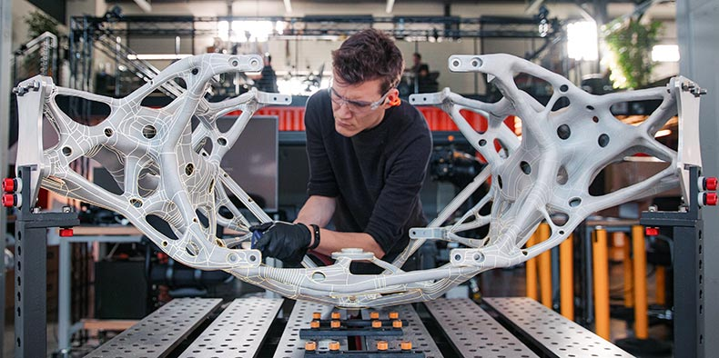

Fig 1.1 Illustration of AM
There are several types of Additive Manufacturing (AM) technologies, each with its own unique advantages and limitations. Here are some of the most common types of AM:

- Fused Deposition Modeling (FDM)

- Stereolithography (SLA)

- Selective Laser Sintering (SLS)

- Digital Light Processing (DLP)

- Binder Jetting (BJ)

1.2 FUSED DEPOSITION MODELING

Fused Deposition Modeling (FDM) is a popular Additive Manufacturing (AM) technology that involves the layer-by-layer extrusion of a thermoplastic material. FDM is one of the most widely used AM techniques due to its relative simplicity, low cost, and ease of use. FDM can be used to produce functional parts and prototypes for various applications, including aerospace, automotive, healthcare, and consumer products. The FDM process begins with a 3D computer-aided design (CAD) model, which is sliced into thin layers by software. The FDM printer then deposits a continuous filament of thermoplastic material, usually in the form of a spool of wire, onto a build platform. The filament is melted in the printer's extruder, and the melted material is extruded through a nozzle that moves in the x and y directions, creating each layer of the 3D object. As each layer is deposited, it fuses with the previous layer to form a solid part. The FDM process is highly customizable, and various parameters can be adjusted to achieve the desired part properties, including layer thickness, printing speed, and temperature. Different types of thermoplastic materials, such as ABS, PLA, and Nylon, can be used with FDM printers, depending on the specific application and part requirements.

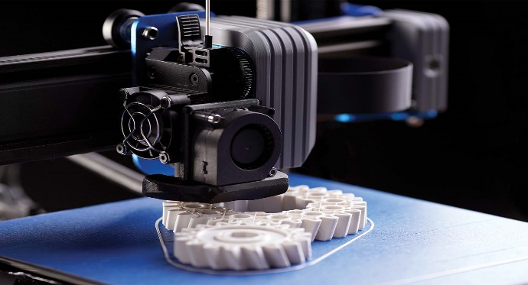
Fig 1.2 Fused Deposition Modeling (FDM)

1.3 NEURAL NETWORK

Neural Networks (NNs) are a class of machine learning models inspired by the structure and function of the human brain. NNs are widely used for pattern recognition, classification, and prediction tasks in various fields, including computer vision, natural language processing, and financial forecasting. At their core, NNs are composed of layers of interconnected nodes, called neurons, that process input data and produce output. Each neuron takes in one or more inputs, multiplies them by a weight, adds a bias, and passes the result through an activation function, such as a sigmoid or ReLU function, to produce an output. The output of one neuron can serve as the input to another neuron, creating a network of interconnected neurons. The weights and biases of the neurons in the NN are learned during a training process, in which the model is presented with a set of input-output pairs, called training data. The model adjusts its weights and biases to minimize the difference between its predicted output and the actual output in the training data, using an optimization algorithm such as backpropagation. There are many types of NN architectures, including feedforward, recurrent, convolutional, and deep neural networks, each with their own strengths and limitations. The choice of NN architecture depends on the specific task and data at hand.
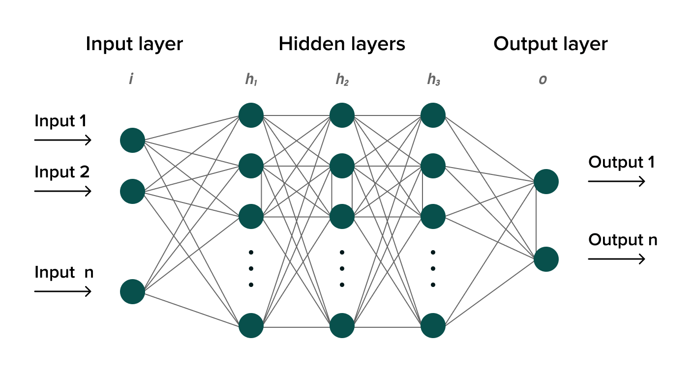
Fig 1.3 Illustration of Neural Network

1.4 PROBLEM IDENTIFICATION
- Achieving desired surface finish and optimizing process parameters for adequate tensile strength in Additive Manufacturing (AM) remains a challenging task, leading to increased time and cost associated with the production of parts.
- Traditional methods for predicting surface finish and tensile strength in AM may not be accurate enough, leading to inconsistencies and defects in the final product.
- The complex and highly nonlinear relationship between process parameters and surface finish/tensile strength in AM makes it difficult to optimize the manufacturing process using conventional methods.
- The lack of a reliable and efficient predictive model for surface finish and tensile strength in AM makes it difficult to produce high-quality parts with consistent properties.
- The current lack of a comprehensive understanding of the relationship between process parameters, surface finish, and tensile strength in AM makes it difficult to optimize the process for different types of materials and part geometries

CHAPTER 2 LITRETURE REVIEW

2.1 LITERATURE SURVEY
XINBO QI- Guofeng Chen et al [1] It is found that the different materials and neural networking models used. Prediction was made by determining the error value between the tested value and the values obtained by NN. Material used is milled carbon fibres and models used in NN are 1-4-1, 1-4-8-1, 1-4-12-8-1. This paper overviews the progress of applying the NN algorithm to several aspects of the AM whole chain, including model design, in situ monitoring, and quality evaluation. Current challenges in applying NNs to AM and potential solutions for these problems are then outlined.

Salman Pervaiz - Taimur Ali Qureshi et al [2] It gives a detailed review on how Fused Deposition Modeling (FDM) Works and the different types of composite materials like fibre reinforced polymers that are manufactured using FDM and their industrial significance. Various mechanical properties like Elastic modulus, creep strength, fatigue strength of FRP that are manufactured using FDM are discussed.

Nishata Royan Rajendran Royan - Jie Sheng Leong et al [3] It is discovered that difficulties that are faced by using Natural fibre reinforced polymer composites (NRFC) and their effect on mechanical properties. This also shows the various process parameters like filament diameter, melting temperature of different polymers, raster angle and its effects on the end product. It shows how increasing the fibre content in the polymer matrix increases the tensile strength.

Mahsa Valizadeh - Sarah Jeannette Wolff et al [4] It gives the idea of how a convolutional neural network has its application in additive manufacturing and in quality control. This also provides an idea on the different types of activation functions that are used in CNN. It Also tells us the challenges in applying CNN in AM were also addressed.

Cézar B. Lemos - Paulo C. M. A. Farias et al [5] This paper shows us how an CNN model can be trained and feeeded with data for object detection. Three deep learning based object detection architectures (SSD300, SSD512 and Faster R-CNN) are applied for detection of parts manufactured on a 3D printer. The object detection information is used to feed a vision-based robotic grasping task, as part of a robotic assisted additive manufacturing system. Transfer learning is applied and a high detection efficiency is achieved for the considered dataset.

Yosep Oh - Michael Sharp et al [6] The paper discusses ecent studies that have provided the possibility of neural network (NN)-based build time estimation. In particular, traditional artificial NN (ANN)- and convolutional NN (CNN)-based methods have been demonstrated. With experimental results for a variety of cases, this paper shows that how much the convolutional neural network (CNN)-based build time estimation is more accurate than the artificial neural network-based estimation. Based on a statistical result, this article presents that the size of three-dimensional models is critical in the CNN-based estimation while the amount of support structure is less significant.

CHAPTER 3

METHODOLOGY OF WORK
Printing of component
Neural Network Model Development
Material and process parameters selection
Data Collection and Pre-processing
Project finalization
Literature survey
Problem Identification
Fig 3.1 Work Flow Chart
Testing of Components
Conclusion
Analysis of Results
Training and Validation of NN

CHAPTER 4
MATERIALS AND METHOD
4.1 MATERIAL USED
PLA stands for Polylactic Acid, which is a thermoplastic polymer made from renewable resources such as corn starch, sugarcane, or cassava roots. PLA is a biodegradable and compostable material that can break down into water, carbon dioxide, and organic compounds in industrial composting facilities.
4.1.1 PROPERTIES OF PLA:
- Biodegradable: PLA is a biodegradable material, which means it can be decomposed by natural processes without leaving behind any harmful residue.
- Renewable: PLA is made from renewable resources, such as corn starch, sugarcane, or cassava roots, which makes it an environmentally friendly material.
- Low toxicity: PLA is considered safe and non-toxic, making it suitable for use in food packaging and medical devices.
- Easy to print: PLA is easy to 3D print due to its low melting temperature and high flowability, which makes it a popular choice for hobbyists and professionals alike.
- Good mechanical properties: PLA has good mechanical properties, such as strength and stiffness, which make it suitable for a wide range of applications, including packaging, textiles, and 3D printing.
- Limited heat resistance: PLA has a low heat resistance compared to other thermoplastics, which means it can deform or melt when exposed to high temperatures

. 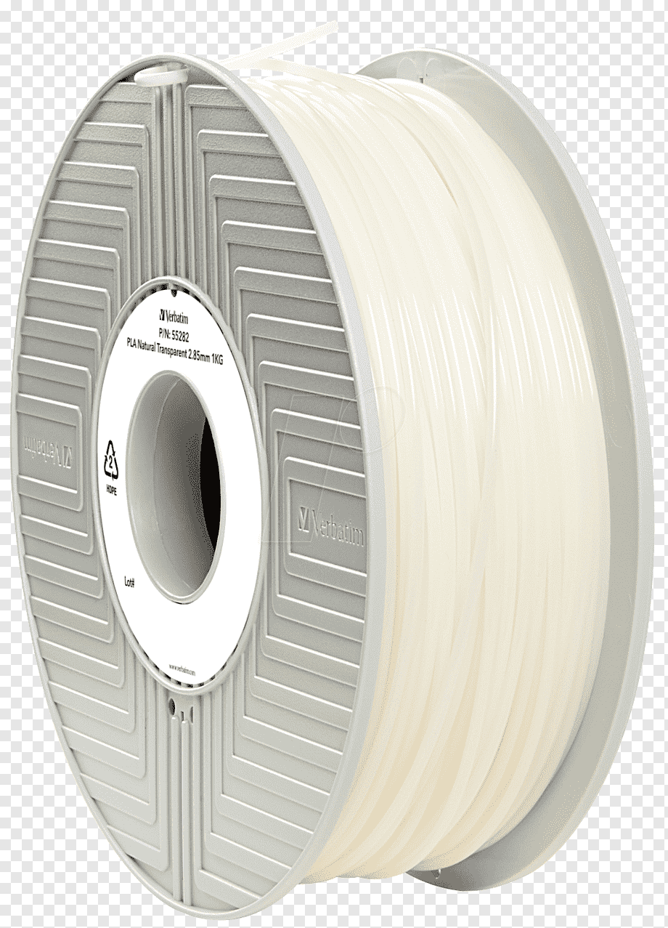 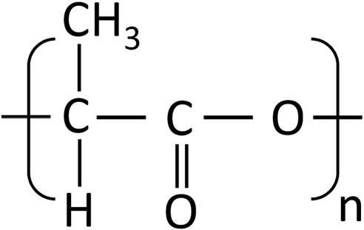

Fig 4.1 PLA Filament Fig 4.2 PLA Chemical Formula

4.2 PRINTER USED
Ender 3 with brass nozzle -0.4 mm
The Ender 3 is a popular and affordable 3D printer produced by Creality. It has a build volume of 220 x 220 x 250 mm, making it suitable for a wide range of 3D printing projects. The brass nozzle that comes with the printer has a diameter of 0.4 mm, which is a common size for 3D printers.
A brass nozzle is a good choice for 3D printing because it is relatively inexpensive and has good thermal conductivity, which helps to ensure that the filament melts consistently and flows smoothly through the nozzle. The 0.4 mm diameter is also a popular choice for 3D printing because it allows for a good balance between detail and speed. Overall, the Ender 3 with a brass nozzle of 0.4 mm is a great option for anyone looking to get started with 3D printing or for those who need a reliable and affordable printer for their projects.

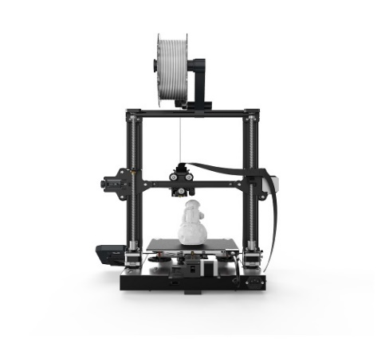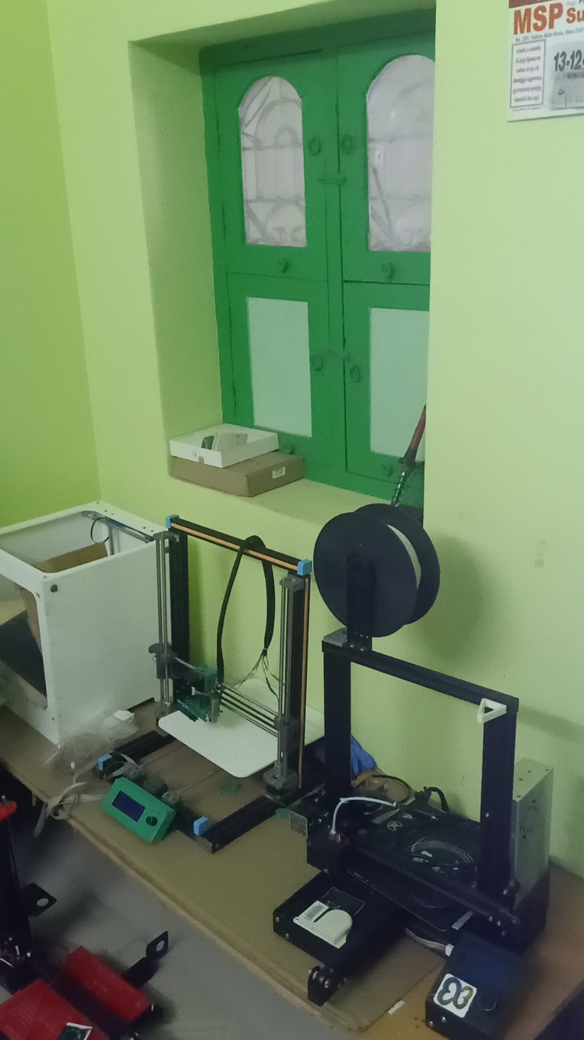
Fig 4.3 Ender 3 with brass nozzle
Our Components are printed in:
- Company name : iNZANEONE 3D
- Address: 3/195-1, road street Ramanthapuram, Arcot, Tamil Nadu 632509.
- Contact: 094869 22527
- Website: https://inzaneone.com

4.3 ASTM STANDARD

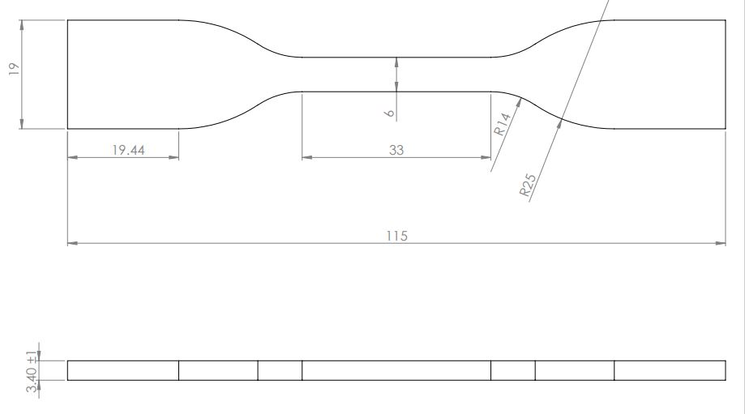
Fig 4.4 ASTM D638 TYPE-IV for Tensile test
The components are printed as per the ASTM D638 TYPE-IV standard.

4.4 NEURAL NETWORK ALGORITHM

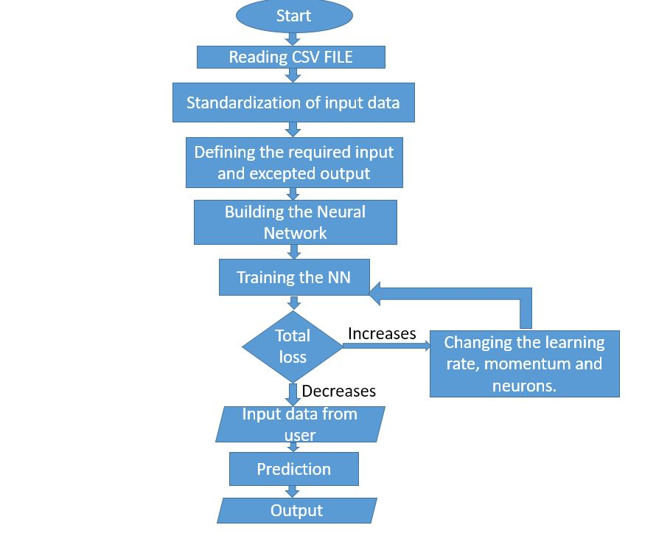
Fig 4.5 Algorithm Flow chart of the Neural Network

4.5 PROCESS PARAMETER SELECTION
Some important process parameters in Fused Deposition Modeling (FDM) 3D printing include:
- Nozzle temperature
- Bed temperature
- Layer height or thickness
- Printing speed
- Infill density
- Cooling fan
- Retraction
- Raster Angle
- Air Gap
- Extrusion Temperature
This parameter can impact the quality and accuracy of the final print. Overall, these process parameters must be carefully controlled and adjusted to achieve the desired results for a particular FDM 3D printing project.

Arup Dey and Nita Yodo et al., [7] a systematic survey of FDM process parameter optimization and their influence on part characteristics addresses the effect of process parameters on the FDM parts using a fishbone diagram.

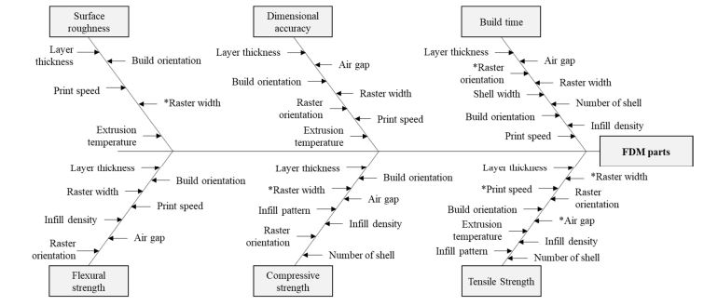
Fig 4.6 Fishbone Diagram

From the above Fishbone diagram, these process parameters have major impact on the surface roughness and tensile strength:

4.5.1 INFILL DENSITY
Infill density is an important parameter in Fused Deposition Modeling (FDM) 3D printing. It refers to the amount of material that is used to fill the interior of a printed object, which can impact the strength, weight, and overall quality of the final print. The infill density can be set during the slicing process, where the 3D model is divided into layers and instructions are generated for the 3D printer to follow. In most slicing software, infill density is specified as a percentage, with 0% meaning that no material is used to fill the interior of the object, and 100% meaning that the object is completely solid.

4.5.2 LAYER THICKNESS
It refers to the thickness of each layer of material that is deposited by the 3D printer during the printing process. In general, a layer thickness of 0.1-0.3 mm is considered to be a good starting point for most FDM 3D printing applications. However, this may vary depending on the specific printer, material, and geometry of the print. It is also important to note that the layer thickness should be less than or equal to the nozzle diameter of the 3D printer, as using a layer thickness greater than the nozzle diameter can result in poor print quality and clogs in the printer.

4.5.3 PRINTING SPEED
It refers to the speed at which the printer's extruder moves along the X, Y, and Z axes to deposit the material. The printing speed can be set during the slicing process, where the 3D model is divided into layers and instructions are generated for the 3D printer to follow. In most slicing software, printing speed is specified in millimeters per second (mm/s). The optimal printing speed depends on the specific requirements of the print, such as the desired level of detail, the printing material, and the geometry of the object. As a general guideline, a printing speed of 30-80 mm/s is recommended for most FDM 3D printing applications.

4.6 PARAMETERS AND LEVELS
From the fig 4.6 Fishbone diagram, these process parameters have major impact on the surface roughness and tensile strength,

Table 4.1 Levels of process parameters
Parameters | P1 | P2 | P3
Level | Infill density (%) | Printing speed(mm/s) | Layer Thickness(mm)
1 | 20 | 40 | 0.16
2 | 40 | 60 | 0.20
3 | 60 | 80 | 0.28

4.7 PROCESS PARAMETER WITH PRINTING DETAILS
Table 4.2 Printing Details
PRINTING SPEED (mm/s) | INFILL  DENSITY  (%) | LAYER THICKNESS  (mm) | TOTAL MATERIAL  (gms) | TOTAL TIME (min) | PRICE  (inc GST)
40 | 20 | 0.2 | 15 | 113 | 211
60 | 20 | 0.2 | 15 | 83 | 171
80 | 20 | 0.2 | 15 | 69 | 152
40 | 40 | 0.2 | 17 | 122 | 231
60 | 40 | 0.2 | 17 | 90 | 188
80 | 40 | 0.2 | 17 | 75 | 168
40 | 60 | 0.2 | 19 | 131 | 251
60 | 60 | 0.2 | 19 | 98 | 207
80 | 60 | 0.2 | 19 | 82 | 185
40 | 20 | 0.16 | 12 | 85 | 161
60 | 20 | 0.16 | 12 | 64 | 133
80 | 20 | 0.16 | 12 | 54 | 120
40 | 40 | 0.16 | 15 | 96 | 188
60 | 40 | 0.16 | 15 | 75 | 160
80 | 40 | 0.16 | 15 | 64 | 145
40 | 60 | 0.16 | 18 | 111 | 220
60 | 60 | 0.16 | 18 | 84 | 184
80 | 60 | 0.16 | 18 | 72 | 168
40 | 20 | 0.28 | 14 | 76 | 157
60 | 20 | 0.28 | 14 | 57 | 132
80 | 20 | 0.28 | 14 | 49 | 121
40 | 40 | 0.28 | 17 | 83 | 179
60 | 40 | 0.28 | 17 | 63 | 152
80 | 40 | 0.28 | 17 | 54 | 140
40 | 60 | 0.28 | 19 | 90 | 196
60 | 60 | 0.28 | 19 | 69 | 168
80 | 60 | 0.28 | 19 | 59 | 155

The above table gives the printing details of each of the sample products including Printing time and Weight of each sample component.

Total Weight of printed sample components=438 grams
Total Printing Time=2168 mins.

4.8 NEURAL NETWORK PROGRAM (PYTHON)
# Import PyTorch libraries
import torch
from torch import nn

# Import visualization library
import matplotlib.pyplot as plt

# Verify PyTorch version
torch.__version__
# Check to see if we have a GPU to use for training
device = 'cuda' if torch.cuda.is_available() else 'cpu'
print('A {} device was detected.'.format(device))

# Print the name of the cuda device, if detected
if device=='cuda':
print (torch.cuda.get_device_name(device=device))
import pandas as pd
url = 'https://raw.githubusercontent.com/Balaji3690/durden/main/DATA%20CRCT.csv'
df = pd.read_csv(url)
# Calculate the mean and standard deviation of price
# Standardize numSold
infillmean=df['Infill'].mean()
infillStd =df['Infill'].std()
df['Infill'] = (df['Infill']-infillmean)/infillStd
# Calculate the mean and standard deviation of numSold
# Standardize numSold
speedmean=df['Speed'].mean()
speedStd =df['Speed'].std()
df['Speed'] = (df['Speed']-speedmean)/speedStd
layermean=df['Layerthickness'].mean()
layerStd =df['Layerthickness'].std()
df['Layerthickness'] = (df['Layerthickness']-layermean)/layerStd
Sr1mean=df['Sr1'].mean()
Sr1Std =df['Sr1'].std()
df['Sr1'] = (df['Sr1']-Sr1mean)/Sr1Std
Sr2mean=df['Sr2'].mean()
Sr2Std =df['Sr2'].std()
df['Sr2'] = (df['Sr2']-Sr2mean)/Sr2Std
Sr3mean=df['Sr3'].mean()
Sr3Std =df['Sr3'].std()
df['Sr3'] = (df['Sr3']-Sr3mean)/Sr3Std
Sr4mean=df['Sr4'].mean()
Sr4Std =df['Sr4'].std()
df['Sr4'] = (df['Sr4']-Sr4mean)/Sr4Std
Sr5mean=df['Sr5'].mean()
Sr5Std =df['Sr5'].std()
df['Sr5'] = (df['Sr5']-Sr5mean)/Sr5Std
meanmean=df['mean'].mean()
meanStd =df['mean'].std()
df['mean'] = (df['mean']-meanmean)/meanStd
# Create our PyTorch tensors and move to CPU or GPU if available
# Extract the inputs and create a PyTorch tensor x (inputs)
inputs = ['Infill','Speed','Layerthickness']
x = torch.tensor(df[inputs].values, dtype=torch.float, device=device)
# Extract the outputs and create a PyTorch tensor y (outputs)
outputs = ['mean']
y = torch.tensor(df[outputs].values,dtype=torch.float, device=device)
model = nn.Sequential(
nn.Linear(3,60),
nn.ReLU(),
nn.Linear(60,1)
)

# Move it to either the CPU or GPU depending on what we have available
model.to(device)
import torch.optim as optim

# Meausure our neural network by mean square error
criterion = torch.nn.MSELoss()

# Train our network with a simple SGD approach
optimizer = optim.SGD(model.parameters(),lr=0.01,momentum=0.01)

# Train our network a using the entire dataset 5 times
for epoch in range(5):
totalLoss = 0
for i in range(len(x)):

# Single Forward Pass
ypred = model(x[i])

# Measure how well the model predicted vs actual
loss = criterion(ypred,y[i])

# Track how well the model predicted
totalLoss+=loss.item()

# Update the neural network
optimizer.zero_grad()
loss.backward()
optimizer.step()

# Print out our loss after each training iteration
print ("Total Loss: ", totalLoss)
# Below we use the synthetic data generator forumla to
# determine what the actual result should have been.
def datasetGenerator(Infill,Speed,Layerthickness):
meanactual= 0
if Infill:
meanactual = (Speed*0.3 + int(0.1//Layerthickness))
meanactual = int(meanactual)
return meanactual
Infill=20
Speed=40
Layerthickness=0.16

# Calculate what would have been the actual result using
# the synthetic dataset's algorithm
actual = datasetGenerator(Infill,Speed,Layerthickness)

# Use the CPU as we just need to do a single pass
model.to('cpu')

# Normalize our inputs using the same values for our training
Infill=(Infill-infillmean)/infillStd
Speed=(Speed-speedmean)/speedStd
Layerthickness=(Layerthickness-layermean)/layerStd

# Create our input tensor
x1 = torch.tensor([Infill,Speed,Layerthickness],dtype=float)

# Pass the input into the neural network
y1 = model(x1.float())

# Un-normalize our output y1
y1 = y1*meanStd+meanmean

# Compare what your network predicted to the actual
print ("Neural Network Predicts: ", y1.item())

CHAPTER 5
TESTING RESULTS AND DISCUSSION
5.1 SURFACE ROUGHNESS TEST
Surface roughness test is a procedure used to measure the deviations in the surface texture of an object from its ideal form. The measurement of surface roughness is important in manufacturing and engineering industries as it affects the performance and quality of the product. In general, the surface roughness test involves moving a probe or sensor along the surface of the object and measuring the deviations from the ideal form. The result is expressed in terms of parameters such as Ra (average roughness), Rz (average maximum height of the profile), Rq (root mean square roughness), and others. These parameters provide information about the texture, finish, and quality of the surface, which can be used to improve the manufacturing process or to evaluate the fitness for a particular application.

5.1.1 SKIDDED SURFACE ROUGHNESS TESTER
The Skidded Surface Roughness Tester with a 360μm measuring range is an accessory designed for use with the Surftest SJ-210 surface roughness tester. The SJ-210 is a portable, easy-to-use instrument that is widely used in manufacturing, production, and quality control environments to measure the roughness of a variety of surfaces. The Skidded Surface Roughness Tester attaches to the Surftest SJ-210, allowing it to measure surface roughness in a wider range of applications. The instrument uses a skid stylus to measure the roughness of a surface, which makes it ideal for measuring surfaces that are not perfectly flat, such as those with grooves or ridges.

Fig 5.1 Skidded Surface Roughness Tester

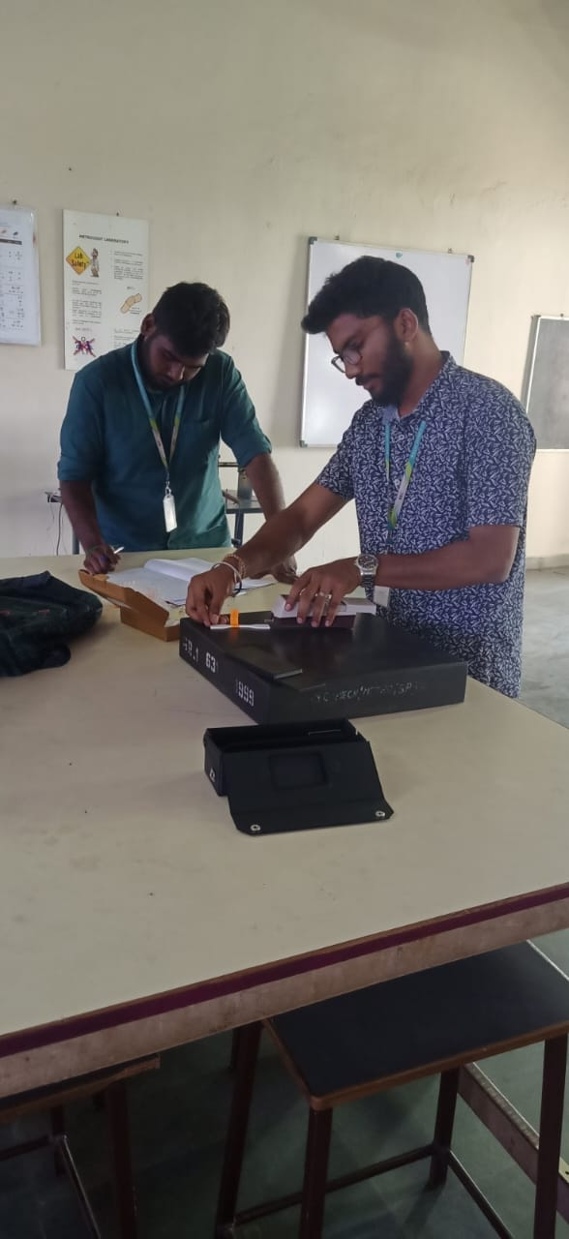
Fig 5.2 (a) & (b) Surface Roughness Testing

5.1.2 SURFACE ROUGHNESS TEST RESULTS
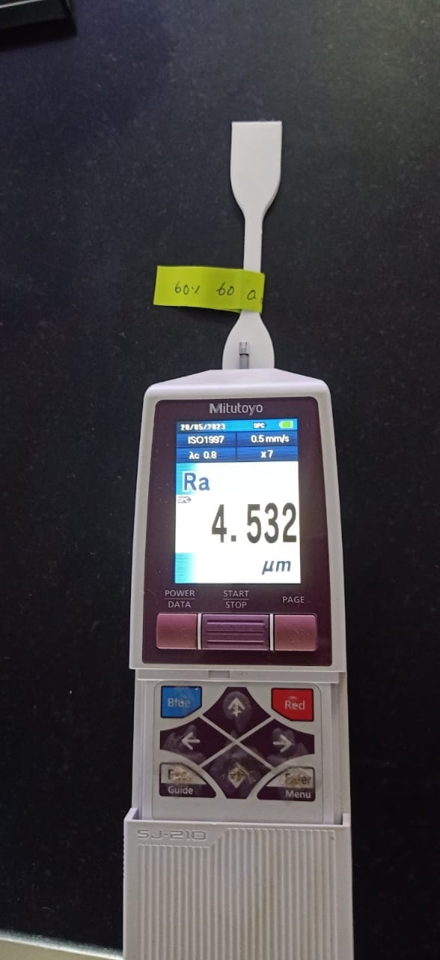
Fig 5.3 Surface Roughness test result value Fig 5.4 Graphical representation of result
The above figure gives us a real time result of the component. Fig 5.3 Addresses the Average roughness (Ra) of the sample component and Fig 5.4 gives us the graphical representation of surface roughness of the sample component.

5.1.2.1 SURFACE ROUGHNESS TEST DATA
Table 5.1 Surface Roughness Test Data
SI.NO | INFILL DENSITY (%) | PRINTING SPEED (mm/s) | LAYER THICKNESS (mm) | SURFACE ROUGHNESS (μm)
1 | 20 | 40 | 0.2 | 5.1684
2 | 20 | 60 | 0.2 | 4.8998
3 | 20 | 80 | 0.2 | 5.2326
4 | 40 | 40 | 0.2 | 4.8258
5 | 40 | 60 | 0.2 | 4.3868
6 | 40 | 80 | 0.2 | 5.0006
7 | 60 | 40 | 0.2 | 4.8316
8 | 60 | 60 | 0.2 | 3.5252
9 | 60 | 80 | 0.2 | 2.309
10 | 20 | 40 | 0.16 | 3.6708
11 | 20 | 60 | 0.16 | 5.468
12 | 20 | 80 | 0.16 | 5.0996
13 | 40 | 40 | 0.16 | 4.9818
14 | 40 | 60 | 0.16 | 5.305
15 | 40 | 80 | 0.16 | 3.6432
16 | 60 | 40 | 0.16 | 2.9532
17 | 60 | 60 | 0.16 | 4.4472
18 | 60 | 80 | 0.16 | 2.091
19 | 20 | 40 | 0.28 | 15.366
20 | 20 | 60 | 0.28 | 10.4024
21 | 20 | 80 | 0.28 | 10.818
22 | 40 | 40 | 0.28 | 15.9762
23 | 40 | 60 | 0.28 | 4.6362
24 | 40 | 80 | 0.28 | 12.8004
25 | 60 | 40 | 0.28 | 16.1928
26 | 60 | 60 | 0.28 | 3.4464
27 | 60 | 80 | 0.28 | 4.8676

5.2 TENSILE STRENGTH TEST
Tensile strength test is a mechanical test used to determine the maximum load or force that a material can withstand before breaking or rupturing. It is one of the most common tests used to evaluate the mechanical properties of materials, including metals, plastics, composites, and textiles. The tensile strength test is performed by applying a gradually increasing tensile force to a sample of the material until it breaks. During the test, the deformation and strain of the material are also measured, which can be used to calculate other mechanical properties such as modulus of elasticity, yield strength, and elongation.

5.2.1 UNIVERSAL TESTING MACHINE-TEC SOL INDIA
The Universal Testing Machine (UTM) is a testing instrument designed to measure the mechanical properties of materials, including tension, compression, bending, and shear. TEC SOL INDIA is a company based in India that specializes in the design and manufacturing of advanced testing equipment, including Universal Testing Machines. TEC SOL INDIA's Universal Testing Machine is a highly accurate and reliable testing instrument that is designed to meet the diverse testing requirements of various industries, including aerospace, automotive, construction, and materials science. The machine is equipped with a high-precision load cell and a robust frame that can withstand high loads, ensuring accurate and repeatable test results.. Overall, TEC SOL INDIA's Universal Testing Machine is a highly advanced and versatile instrument that can be used to measure the mechanical properties of materials accurately and reliably, making it an essential tool for research and development, quality control, and materials testing applications.
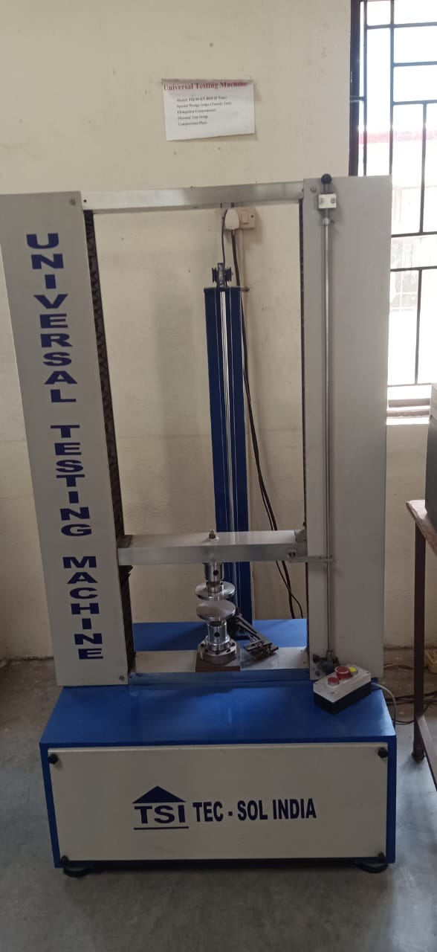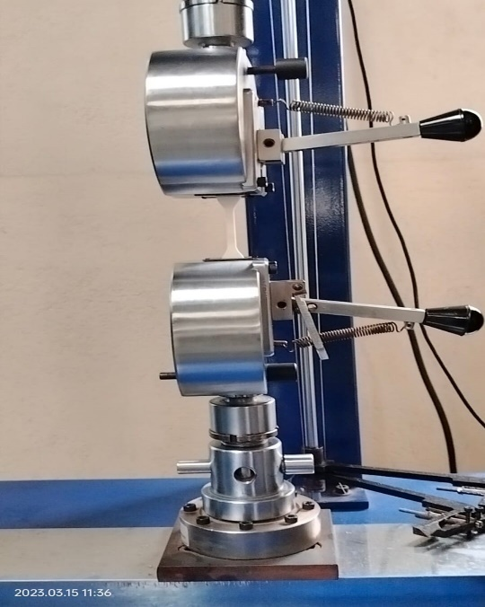
Fig 5.5 UTM TEC SOL INDIA Fig 5.6 Tensile Test Fixtures 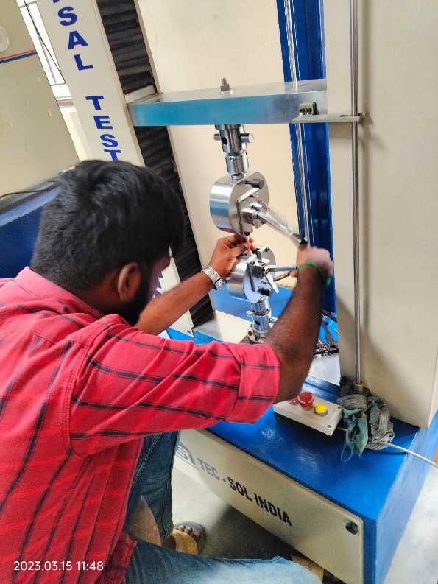 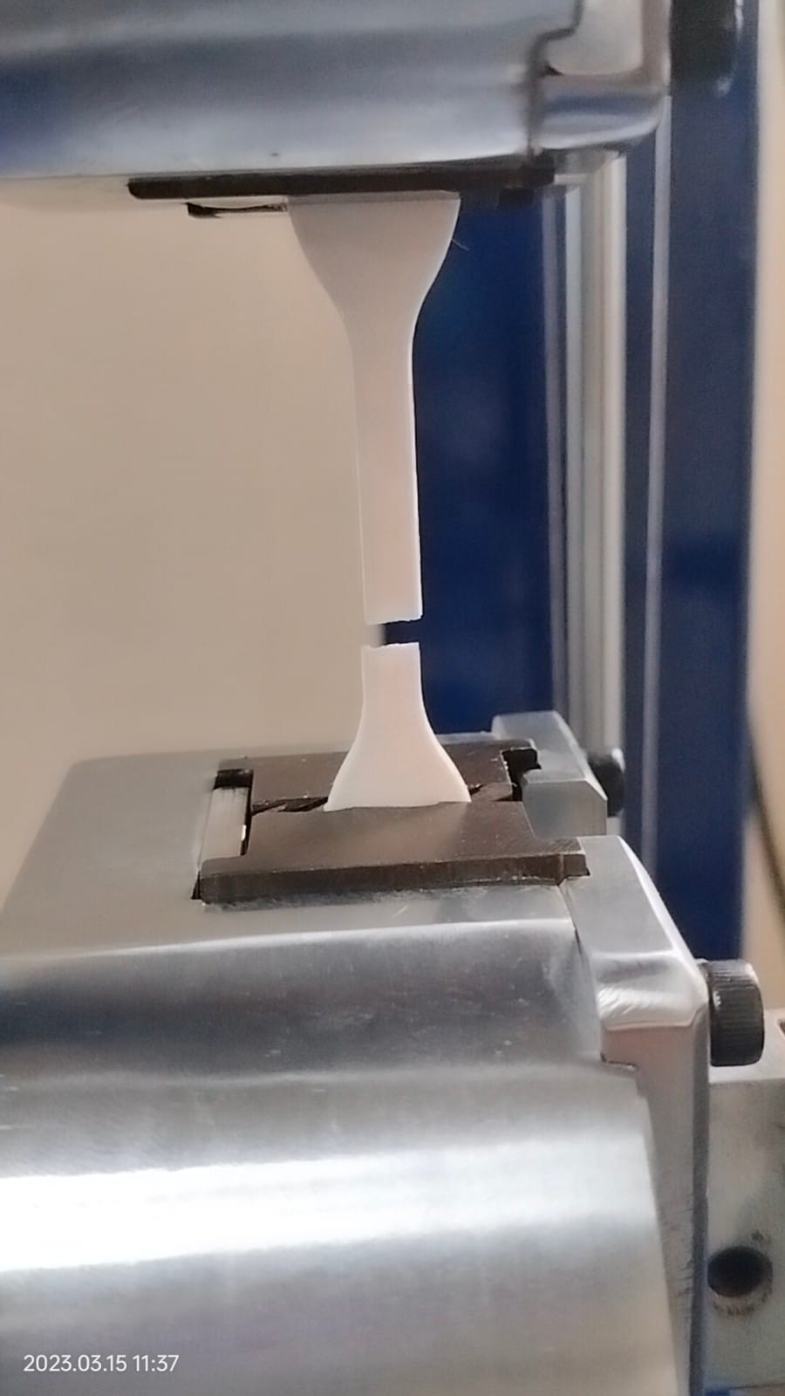
Fig 5.7 Fixing of the component in fixture of UTM Fig 5.8 Fracture of the component

5.2.2 TENSILE STTRENGTH TEST RESULTS
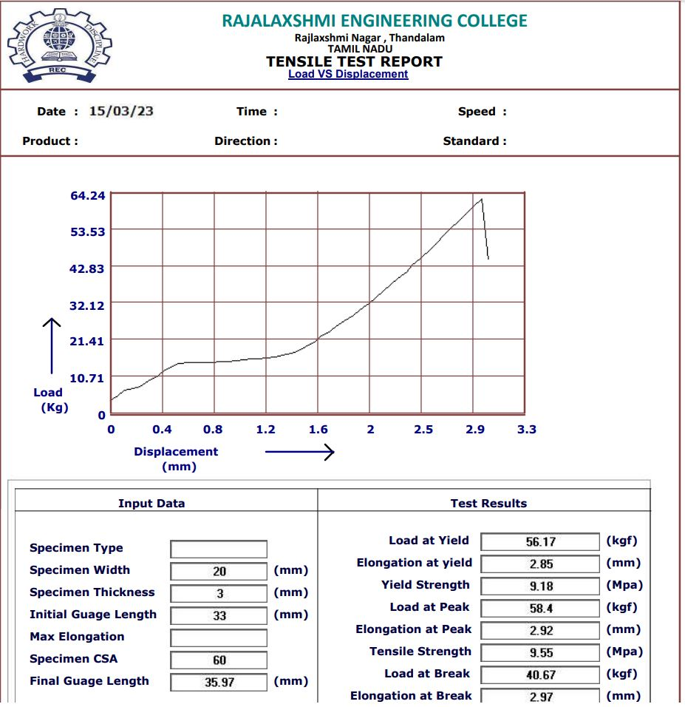
Fig 5.9 Tensile strength result of sample 1 (0.28mm-60%-60mm/s)

5.2.2.1 TENSILE TEST RESULT DATA
Table 5.2 Tensile Strength result data
SI.NO | INFILL DENSITY (%) | PRINTING SPEED (mm/s) | Layer Thickness(mm) | TENSILE STRENGTH (kgf)
1 | 20 | 40 | 0.2 | 8.69
2 | 20 | 60 | 0.2 | 6.71
3 | 20 | 80 | 0.2 | 5.36
4 | 40 | 40 | 0.2 | 4.55
5 | 40 | 60 | 0.2 | 6.09
6 | 40 | 80 | 0.2 | 5.42
7 | 60 | 40 | 0.2 | 6.74
8 | 60 | 60 | 0.2 | 6.82
9 | 60 | 80 | 0.2 | 5.76
10 | 20 | 40 | 0.16 | 8.83
11 | 20 | 60 | 0.16 | 6.99
12 | 20 | 80 | 0.16 | 5.74
13 | 40 | 40 | 0.16 | 8.55
14 | 40 | 60 | 0.16 | 6.49
15 | 40 | 80 | 0.16 | 4.95
16 | 60 | 40 | 0.16 | 9.36
17 | 60 | 60 | 0.16 | 6.02
18 | 60 | 80 | 0.16 | 4.98
19 | 20 | 40 | 0.28 | 8.95
20 | 20 | 60 | 0.28 | 9.56
21 | 20 | 80 | 0.28 | 8.19
22 | 40 | 40 | 0.28 | 9.55
23 | 40 | 60 | 0.28 | 7.92
24 | 40 | 80 | 0.28 | 5.98
25 | 60 | 40 | 0.28 | 9.46
26 | 60 | 60 | 0.28 | 7.96
27 | 60 | 80 | 0.28 | 8.76

5.3 TAGUCHI’S DESIGN OF EXPERIMENT
Taguchi design of experiment is a statistical method used in quality engineering to optimize product or process design. It was developed by Genichi Taguchi, a Japanese engineer who aimed to improve the quality of manufactured goods while reducing the cost of production. The Taguchi method involves the use of an orthogonal array, which is a matrix that represents a set of experiments. By varying the levels of the design factors (also known as variables or parameters) in the orthogonal array, it is possible to identify the optimal combination of factors that result in the desired outcome. The Taguchi method also uses the concept of signal-to-noise ratio (SNR), which measures the quality of a product or process by comparing the magnitude of the signal (desired outcome) to the level of noise (unwanted variation). The goal is to maximize the SNR to achieve the best possible quality. The Taguchi method has several advantages over traditional experimental design methods, including its ability to reduce the number of experiments required, its robustness to variations in the input factors, and its focus on optimizing the performance of a system rather than individual components. Overall, the Taguchi method can be a powerful tool for improving product or process design, particularly in manufacturing and engineering applications. MINITAB version 16 is used to optimize the process parameters with help of response table and SN curve.

5.3.1 TENSILE STRENGTH
Tensile strength is a measure of a material's ability to resist deformation or breaking under tension. In the context of Taguchi's design of experiments, tensile strength can be used as a response variable to evaluate the performance of a product or process.
Response Table for Signal to Noise Ratios using Taguchi’s design of experiment is shown below. It shows that larger delta value of a process parameter has better results.
Table 5.3 Taguchi’s Response table for Tensile Strength
LEVEL | INFILL DENSITY (%) | PRINT SPEED (mm/s) | LAYER THICKNESS (mm)
1 | 15.57 | 17.09 | 16.53
2 | 17.03 | 16.16 | 15.77
3 | 18.18 | 17.53 | 18.49
DELTA | 2.61 | 1.38 | 2.72
RANK | 2 | 3 | 1

From Table 5.3, it is clearly seen that the Layer thickness has a major impact on the tensile strength according to the rank obtained from Taguchi’s Response table.
Fig 5.10 Mean effect plot for SN ratios
From the fig 5.10, it can be concluded for achieving better tensile strength the mean value of the SN ratio should be maximum. So, the optimum process parameters for tensile strength are Infill Density=60%, Print speed =80mm/s, Layer Thickness = 0.28mm

5.3.2 SURFACE ROUGHNESS
Surface roughness is a measure of the texture of a material's surface, and it is an important quality characteristic in many manufacturing applications. In Taguchi's design of experiments, surface roughness can be used as a response variable to evaluate the performance of a product or process.
Response Table for Signal to Noise Ratios using Taguchi’s design of experiment is shown below. It shows that smaller delta value of a process parameter has better results.
Table 5.4 Taguchi’ Response Table for Surface Roughness
LEVEL | INFILL DENSITY (%) | PRINT SPEED  (mm/s) | LAYER THICKNESS (mm)
1 | -13.78 | -12.15 | -12.07
2 | -13.80 | -15.52 | -12.76
3 | -16.47 | -16.38 | -19.22
DELTA | 2.70 | 4.23 | 7.15
RANK | 3 | 2 | 1

From Table 5.4, it is clearly seen that the Layer thickness has a major impact on the Surface Roughness according to the rank obtained from Taguchi’s Response table.

Fig 5.11 Mean effect plot for SN ratios
From the fig 5.11, it can be concluded for achieving better surface roughness, the mean value of the SN ratio should be minimum. So, the optimum process parameters for surface roughness are Infill Density=20 %, Print speed =40mm/s, Layer Thickness = 0.16mm.

5.4 PREDICTION USING NEURAL NETWORK
In our project, prediction using neural networks involves using a trained neural network model to predict the surface finish and tensile strength of 3D printed components based on process parameters used during printing. The neural network model would learn to recognize patterns and relationships between the input process parameters and the output surface finish & tensile strength, which uses that information to make predictions on new data.

5.4.1 SURFACE FINISH
Predicted value by neural network
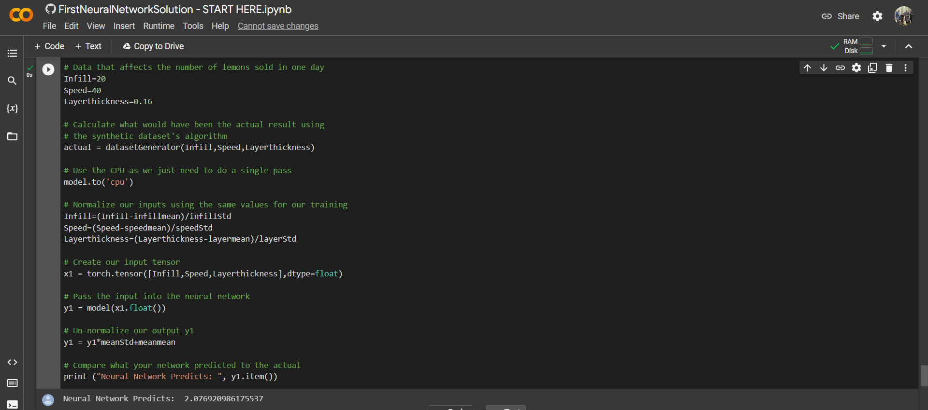
Fig 5.12 Neural Network Prediction for surface finish
The above Fig 5.12 is the last block of code in our neural network and the neural network model predicts the surface finish for the given inputs as 2.076 micrometers.
Actual value of the surface finish

Fig 5.13 Actual value of the surface finish
Figure 5.13 gives the target data about the surface roughness, it is clearly shows that the target value for surface roughness of the sample is 2.091 micrometers, which is close to the neural network prediction value with the error percentage of 0.71.

5.4.2 TENSILE STRENGTH
Predicted value by neural network
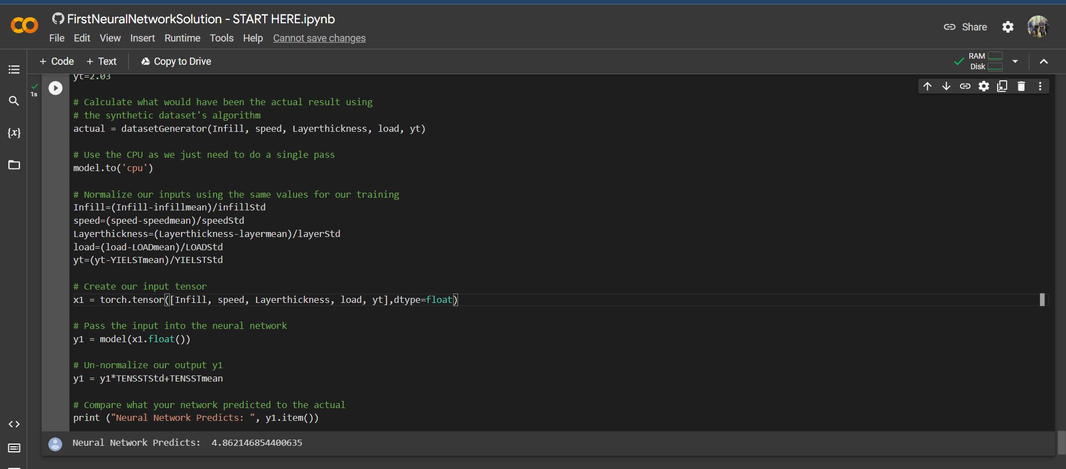
Fig 5.14 Neural Network Prediction for Tensile strength
The above Fig 5.14 is the last block of code in our neural network and the neural network model predicts the tensile strength value for the given inputs as 4.862 kgf.
Actual value of tensile strength

Fig 5.15 Actual value of Tensile Strength
Figure 5.15 gives the target data about the tensile strength it is clearly seen that the actual value for tensile strength of the sample is 4.95 kgf which is close to the neural network prediction value with the error percentage of 1.77.

CHAPTER 6
CONCLUSION
- The use of neural networks for predicting surface finish and optimizing process parameters in additive manufacturing has shown significant potential for improving the quality and efficiency of additive manufacturing processes.
- By analyzing large amounts of data and identifying patterns, neural networks can accurately predict surface finish and tensile strength reducing the need for time-consuming trial and error experiments.
- The use of neural networks can lead to cost savings by reducing material waste and improving productivity. However, it is important to note that neural networks are only as accurate as the data they are trained on, and ongoing monitoring and refinement of the system is necessary to ensure reliable and accurate results.
- The use of neural networks in additive manufacturing is a promising area of research that has the potential to revolutionize the field and improve the quality and efficiency of manufacturing processes.
- Optimization of process parameters is achieved by Taguchi’s design of experiment:
- From the Responsible table using Taguchi’s design of experiment, it is concluded that the Layer Thickness has major impact on both Surface roughness and Tensile Strength.
- Signal to Noise Ratios using Taguchi’s design of experiment for Surface Roughness test shows that Smaller the mean value of a process parameter has better results. So, the optimum process parameters for surface roughness are Infill Density=20%, Printing Speed=40 mm/s, Layer Thickness=0.16mm.
- Signal to Noise Ratios using Taguchi’s design of experiment for Tensile test shows that Larger the mean value of a process parameter has better results. So, the optimum process parameters for tensile Strength are Infill Density=60%, Printing Speed=80 mm/s, Layer Thickness=0.28mm.

REFERANCES
- Zhang, H., Zhang, Y., & Liao, W. (2018). Prediction of surface roughness in CNC end milling process using a hybrid model of genetic algorithm and neural network. Journal of Intelligent Manufacturing, 29(6), 1297-1312.
- Gupta, N., & Vedula, V. (2019). Optimization of process parameters for wire electrical discharge machining of Al–Mg–Si alloy using artificial neural network and genetic algorithm. Materials Today: Proceedings, 16, 2157-2163.
- Liu, S., Shi, Y., Wang, X., & Xu, B. (2021). Prediction of surface roughness and tool wear in face milling based on machine learning. Journal of Intelligent Manufacturing, 32(4), 903-918.
- Li, H., Ding, H., Wang, J., & Wang, Y. (2020). A neural network-based approach to predict surface roughness in high-speed milling of Inconel 718. Journal of Manufacturing Processes, 56, 211-222.
- Venkatesan, S., Ganesan, S., & Dhanalakshmi, R. (2019). Optimization of process parameters in additive manufacturing using artificial neural network. Materials Today: Proceedings, 16, 1975-1981.
- Zhang, H., Zhang, Y., & Liao, W. (2018). Prediction of surface roughness in CNC end milling process using a hybrid model of genetic algorithm and neural network. Journal of Intelligent Manufacturing, 29(6), 1297-1312.
- Zhang, L., & Ding, L. (2021). Prediction of surface roughness in machining processes using artificial intelligence: A review. Journal of Intelligent Manufacturing, 32(3), 527-548.
- Zhou, J., Chen, X., Xu, Z., & Liu, J. (2021). A review of process parameters optimization in additive manufacturing. Journal of Intelligent Manufacturing, 32(3), 681-703.
- Yin, J., Zhang, L., Zhou, Y., & Chen, X. (2020). A review of machine learning-based process monitoring and optimization for additive manufacturing. Journal of Intelligent Manufacturing, 31(7), 1785-1805.
- Du, J., Zhu, Y., Liu, W., & Zhang, H. (2020). Prediction of surface roughness and tool wear in milling of TC4 alloy using artificial neural network optimized by particle swarm optimization. Journal of Intelligent Manufacturing, 31(5), 1245-1256.
- Song, Y., Lu, B., Zhang, Y., & Li, Y. (2020). A review of process parameter optimization for metal additive manufacturing. Journal of Intelligent Manufacturing, 31(2), 315-333.
- Li, Y., Li, H., Li, Y., & Wang, Y. (2021). A hybrid approach for optimizing process parameters in additive manufacturing of Inconel 718 using a deep belief network and genetic algorithm. Journal of Intelligent Manufacturing, 32(1), 47-59.
- Tang, K., Wei, P., Wang, Y., Wang, J., & Huang, J. (2021). Surface quality optimization of selective laser melting using an artificial neural network and genetic algorithm. Journal of Intelligent Manufacturing, 32(1), 95-107.
- Wu, S., He, F., & Xu, Z. (2020). Process parameter optimization of selective laser melting of AlSi10Mg alloy based on artificial neural network and genetic algorithm. Journal of Intelligent Manufacturing, 31(6), 1425-1438.
- Chen, H., Wu, S., & Wang, Q. (2019). Prediction of surface roughness in the additive manufacturing process of Inconel 718 by combining extreme learning machine and genetic algorithm. Journal of Intelligent Manufacturing, 30(7), 2319-2329.
- Miao, Y., Chen, M., Chen, X., & Huang, X. (2019). Prediction of surface roughness in milling process based on back propagation neural network optimized by genetic algorithm. Journal of Intelligent Manufacturing, 30(6), 2073-2087.
- Lin, H., Wu, Y., & Liao, W. (2020). Prediction of surface roughness and cutting force in the end milling process using an optimized neural network. Journal of Intelligent Manufacturing, 31(3), 633-648.
- Liu, W., & Tian, X. (2019). Optimization of process parameters for wire arc additive manufacturing based on response surface methodology and artificial neural network. Journal of Intelligent Manufacturing, 30(5), 1795-1809.
- Gao, M., Xie, X., Lin, X., Liu, H., & Xiong, Y. (2019). Prediction of surface roughness in ball-end milling of titanium alloy based on improved BP neural network optimized by hybrid genetic algorithm. Journal of Intelligent Manufacturing, 30(7), 2409-2425.
- Chen, X., Liu, S., & Xu, B. (2020). Prediction of surface roughness and tool wear in face milling using a hybrid model of deep belief network and particle swarm optimization. Journal of Intelligent Manufacturing, 31(6), 1579-1592.
- Yao, Y., Chen, X., Liu, J., & Zhou, J. (2021). Multi-objective optimization for selective laser melting of Inconel 718 using an adaptive artificial bee colony algorithm. Journal of Intelligent Manufacturing, 32(3), 605-621.
- Zhang, Q., Wang, X., Zhou, Z., & Gao, X. (2021). Adaptive population-based optimization algorithm for process parameter optimization in selective laser melting. Journal of Intelligent Manufacturing, 32(2), 453-466.
- Xu, X., Xu, Q., Yao, M., & Zhao, H. (2019). Multi-objective optimization for selective laser melting of stainless steel using an improved multi-objective differential evolution algorithm. Journal of Intelligent Manufacturing, 30(3), 1235-1252.

