A STUDY ON THE IMPACT OF OTT PLATFORMS AMONG YOUNGSTERS IN CHENNAI CITY
*Dr. P. MATHAN KUMAR, **MS.R. SAHANA & ***Mr. V. K. VENKATRUPESH
*Assistant Professor of Commerce, Loyola College (Autonomous), Chennai-34
**Assistant Professor of Commerce, Loyola College(Autonomous), Chennai-34
***III B.Com., Loyola College (Autonomous), Chennai-34.

ABSTRACT:
The phrase "over-the-top" (OTT) refers to television and movie programmes delivered through the Internet rather than through a cable or satellite provider. The purpose of this research on consumer preferences for OTT platforms is to discover and examine the factors that influence customers' watching decisions, as well as to understand the OTT market competitiveness. The research approach used to perform descriptive and convenience sample studies is known as the sampling procedure. A survey was conducted to determine whether or not individuals were aware of the OTT platform prior to the outbreak. The data clearly shows that two-thirds of respondents were aware of Ott Services before to Covid-19. Customer satisfaction is quite high on OTT platforms. Consumers are enticed to watch OTT since it can be accessible at any time and from any location.
Keywords: Over-the-top (OTT), Customer Preference, Consumer Satisfaction.

INTRODUCTION:
The Indian online entertainment industry has grown tremendously in recent years. All of this has been made possible by the changing lifestyles of Indian viewers, a dramatic shift in the sorts of media they consume, and the rise of several online video streaming platforms via which the material is distributed. With the development of faster and more affordable internet services in the form of mobile connections as well as the general availability of broadband services, there has been a significant increase in both the availability of online material and the amount of time spent viewing online videos. According to a poll, the average time spent watching online videos in India is eight hours and twenty-nine minutes, which is substantially greater than the global average of six hours and forty-five minutes. This demonstrates the recognition of internet Web series, episodes, movies, humorous videos, and other types dominate video content. The emergence of Netflix, Amazon Prime, Hot star, Sony LIV, aha, and other web- and app-based online video streaming services has resulted in tremendous development in the Indian entertainment business. YouTube, the popular video streaming site owned by Google, the industry leader in search, also has a big viewership. With the growing popularity of streaming, content creators now have the opportunity to make money from it, which has resulted in a rise in the volume of content being shared online. The younger generation, mostly comprised of teenagers and young people aged 18 to 30, is the major target audience for web series and other internet streaming content. People between the ages of 30 and 50 make up the audience. These online video streaming providers value binge-watching. The employment of this tactic by these platforms helps them attract young individuals looking for amusement.

REVIEW OF LITERATURE:
- Meghan McAdams conducted research on "What is OTT-Understanding the Modern Media Streaming Landscape" on April 18, 2019. According to the findings, the OTT app certainly represents India's future. The main finding of her research was that 50% of OTT subscribers are feeling "subscription fatigue." As a result of using so many platforms. It was also said that the rise of large-scale platforms such as Disney Plus may have an influence on the possibilities for smaller, specialist firms.
- Arturo Gutierrez conducted research on "Switching Culture in Streaming and TV Is Now a Thing" on February 12, 2018. In his research, he discovered that TV customers searched for special discounts and promotions to move from their present providers. "The market for streaming applications is steadily expanding.
- According to Chatterjee and Pal, 2020, in the work titled 'Globalisation pushed technology frequently ends up in its micro localization: Cinema viewing in the age of OTT,' According to this study of consumer behaviour in connection to OTT content and television and film consumption in light of technical improvements, consumers prefer OTT material owing to not only technology advancement but also socio-economic and behavioural changes influenced by globalisation.

- According to 'THE RISE OF OTT PLATFORM: CHANGING CONSUMER PREFERENCES' authored by Jain in 2021, the web has drastically impacted the operation of a huge section of the enterprises. Because of the growing usage of the internet among its target audience, media outlets have seen significant changes in their jobs. This situation is favourable for the development of OTT platforms from one side of the world to the other. Indeed, interest groups in India are familiar with the motion pictures, shows, music, and other types provided by several OTT stages.
- Research conducted by Dr. S. Anbumalar, Brina Antony, Aishwarya, Mithun P.M., and Ajeeth Kumar R. in 2021 demonstrates the influence played by the trend of OTT media consumption. According to this survey, the main advantage that kids appreciated was the seclusion that they couldn't receive through regular family television. They were able to choose the stuff they wanted to see based on their interests and preferences. The researcher has concentrated more on the various OTT platform types and a study of those platforms from the perspective of the users. It is fundamental analysis of customer preferences for the stated OTT platforms and other OTT platforms.

OBJECTIVES OF RESEARCH:
This study aims at analysing the impact of OTT platform on youth in Chennai. The following are its specific objectives.
- To study the impact of the OTT platform among youngsters in study area.
- To measure the usage of OTT platform.
- To analyse the challenges faced by the theatre owner’s due to OTT platforms.
- To find out the working system of OTT platforms.
- To comprehend the utilisation of OTT platforms in relation to the shift in pre and post COVID-19 pandemic.
- To comprehend what it's like to use OTT platforms.

RESEARCH GAP:
There are a variety of potential research gaps in the field of how OTT platforms effect young people's development, one of which is the need for more extensive studies that follow young people over time in order to understand more about how their usage of OTT platforms varies and matures as they get older. The long-term effects of OTT platform use on young people's development, including their mental health, interpersonal connections, and academic and career results, require further study. The immediate impacts of OTT platform usage have been the subject of a number of recent research. Finally, more study is needed to determine the benefits of OTT platform use for youth development, including the chances for entertainment, self-expression, and relaxation. It is crucial to understand how OTT platforms could contribute to young people's lives positively, even if the majority of past study has focused on the negative consequences of OTT platform use.

STATEMENT OF PROBLEM:
The project's focus is on a study of young people's use of OTT platforms. The study's objective is to examine the several widely used OTT platforms now available and determine how frequently the younger generation utilises them as well as their thoughts and experiences with them. The study would also be useful for focusing on the many variables that could have influenced how these platforms were adopted. Additionally, the degree of satisfaction with these platforms is evaluated, as well as any new suggestions and peer usage.

METHODOLOGY OF STUDY:
The survey is being undertaken among youngsters aged 18-24, usually students, to determine their use of various OTT platforms. The study was carried out by distributing questionnaires online, and a total of 100 replies were gathered. The study made use of both primary and secondary data.
Data from primary sources: A questionnaire that was made available online was used to obtain the primary data from the sample respondents using random sampling and a timetable.
Secondary data sources: Secondary data was gathered from conventional reference books and numerous sources.
Analysis methods and tools: Tables, graphs, and pie charts are examples of data analysis tools.

RESEARCH LIMITATIONS:

This study examines how OTT platforms have impacted adolescent development in Chennai. 100 respondents make up the sample group for this study. The respondents were chosen from Chennai-area colleges and schools, and the study was carried out in March 2023. This study is constrained by the following factors:
- This research has a cap of 100 participants, all of whom are teenagers. As a result, conclusions and recommendations based on the study cannot be extended to the full population.
- The initial data gathered may be skewed. This study has flaws due to all of the aforementioned restrictions.

SAMPLE SPACE:
AGE GROUP OF THE RESPONDENTS
TABLE NO: 1
AGE | NUMBER OF RESPONDENTS | PERCENTAGE
Below 20 years | 26 | 25.5
20-30 years | 69 | 67.6
30-40 years | 5 | 4.9
40-50 years | 2 | 2
Above 50 years | 0 | 0
Total | 102 | 100

INTERPRETATION:
According to the above data, 67.6% of respondents are between the ages of 20 and 30, 25.5% are under the age of 20, 4.9% are between the ages of 30 and 40, and 2% are between the ages of 40 and 50.
It is determined that the majority (67.6%) of responders are in the 20–30 age range.

CHART: 1
RESPONDENTS' AGES

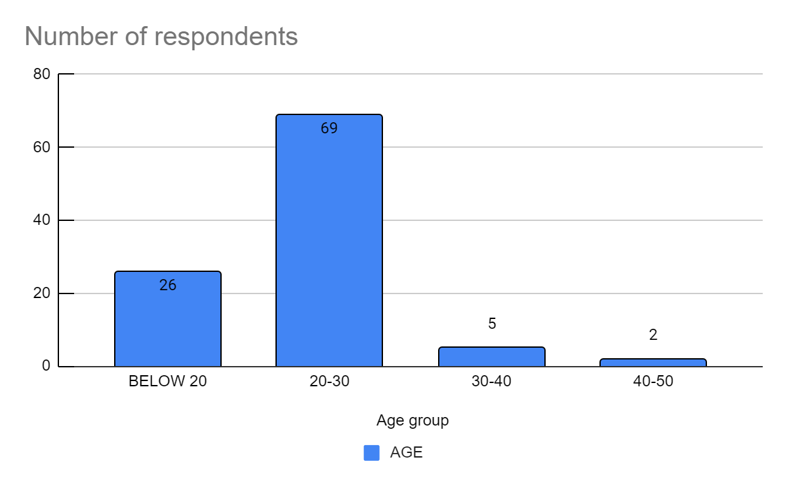
USAGE AFTER POST PANDEMIC
TABLE NO: 2
USAGE | NUMBER OF RESPONDENTS | PERCENTAGE
Highly increased | 46 | 45.1
Increased | 29 | 28.4
Neutral | 19 | 18.6
Decreased | 6 | 5.9
Highly decreased | 2 | 2
Total | 102 | 100

INTERPRETATION:
The preceding table reveals that 45.1% of those polled are highly increased their usage after post pandemic, 28.4% of the respondents are increased their usage after post pandemic, 18.6% of the respondents are neutral their usage after post pandemic, 5.9% of the respondents are decreased their usage after post pandemic and 2% of the respondents are highly decreased their usage after post pandemic.
It concluded that most (45.1%) of the respondents are highly increased their usage after post pandemic.
CHART NO: 2
USAGE AFTER POST PANDEMIC
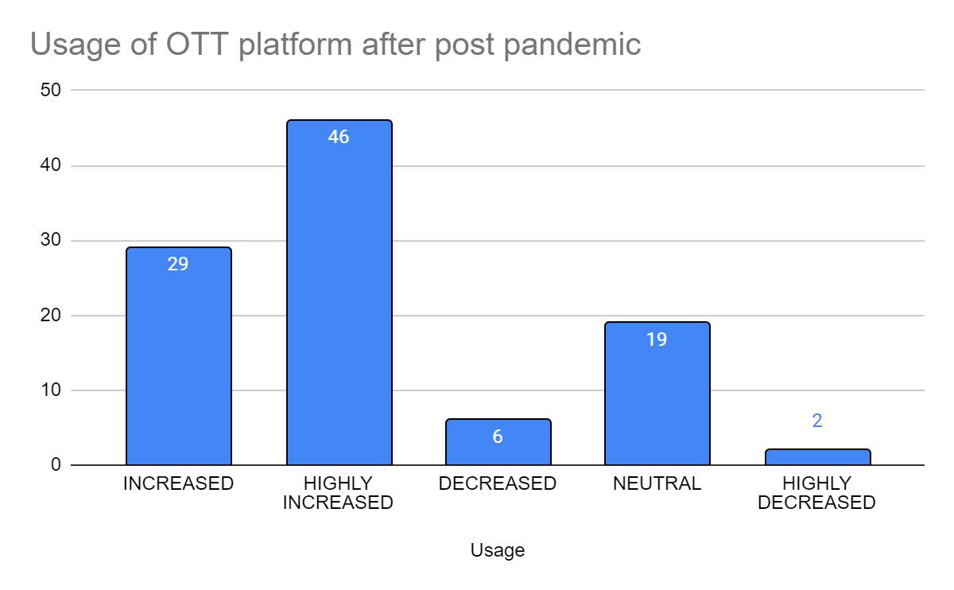

INFLUENCERS OF OTT PLATFORM
TABLE NO: 3
INFLUENCERS | NUMBER OF RESPONDENTS | PERCENTAGE
Own interest | 32 | 31.4
Social media | 38 | 37.3
Peer influences | 8 | 7.8
Advertisement | 18 | 17.6
Others | 6 | 5.9
Total | 102 | 100

INTERPRETATION:
According to the aforementioned statistics, 37.3% of responders influenced their social media, 31.4% of the respondents influenced by their own interest, 17.6% of the respondents influenced by advertisement, 7.8% of the respondents influenced by peer influences and 5.9% of the respondents influenced by others.
It concluded that most (37.3%) of the respondents influenced by social media.
CHART NO: 3

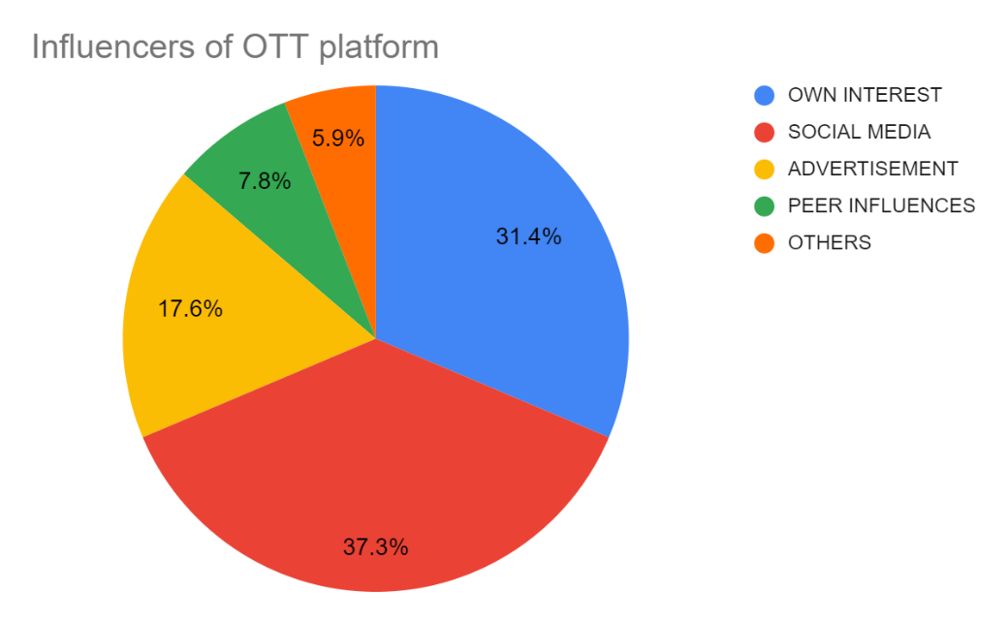
PREFERENCE OF OTT PLATFORM ON GENERAL
TABLE NO: 4
PREFERNCE ON GENERAL | NUMBER OF RESPONDENTS | PERCENTAGE
Netflix | 55 | 53.9
Amazon prime | 20 | 19.6
Hot star | 25 | 24.5
Sony LIV | 2 | 2
AHA | 0 | 0
Total | 102 | 100

INTERPRETATION:
According to the following statistics, 53.9% of respondents favour Netflix on general, 24.5% of the respondents prefer Hot star on general, 19.6% of the respondents prefer Amazon prime on general and 2% of the respondents prefer Sony LIV on general.
It concluded that most (53.9%) of the respondents prefer Netflix on general.
CHART NO: 4
PREFERENCE OF OTT PLATFORM ON GENERAL

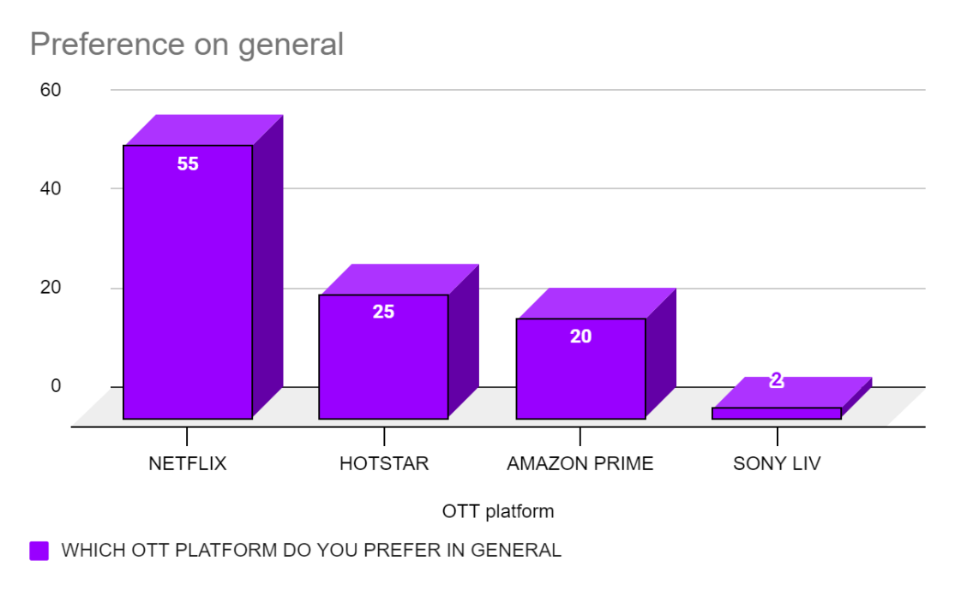
RATING OF OTT EXPERIENCE
TABLE NO: 5
RATING OF OTT PLATFORMS | NUMBER OF RESPONDENTS | PECENTAGE
Highly satisfied | 23 | 22.5
Satisfied | 54 | 52.9
Neutral | 24 | 23.5
Dissatisfied | 1 | 1
Highly dissatisfied | 0 | 0
Total | 102 | 100

INTERPRETATION:
The above table reveals that 52.9% of the respondent’s rates satisfied, 23.5% of the rates of the respondents neutral, 22.5% of the rates of the respondents highly satisfied and 1% of the respondent’s rates dissatisfied.
It concluded that most 52.9% of the respondent’s rates satisfied.
TABLE NO: 5
RATING OF OTT EXPERIENCE
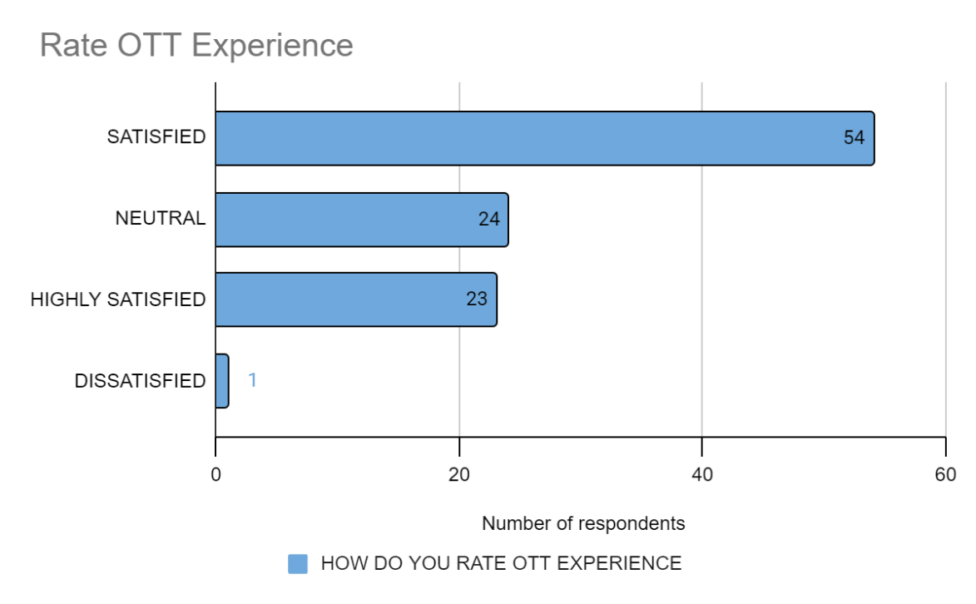
FINDINGS:
- The majority of the respondents belong to 20-30 years.
- The majority of the respondents are using OTT platforms for about 1-2 yrs. This is mostly the past 1-2 years which is the COVID period.
- The bulk of respondents are impacted by their social media in OTT platforms.
- The above table and charts show that the majority of the respondents prefer Netflix as it has all genre of contents.
- The majority of the respondents are satisfied with OTT experience.

SUGGESTIONS:
- Consumers should be made informed of the consequences of disclosing their connect to information to third parties and given instructions on how to avoid doing so.
- Since social media is one of the key determinants of young consumption, it is important to increase the advertising with marketing of OTT platform content there.
- There ought being more regional television and film broadcasting, which would result in more OTT users.
- Consumers should be free to choose their preferred language and content, as well as the language they will use.

CONCLUSION:
A major a rise in entry brand-new OTT firms into the market and quick changes in the provision of customised content take advantage of the fact that India has the fastest-growing OTT market in the world. Even the tiniest OTT sites are getting funding from foreign having investors and having a big market influence. The COVID-19 pandemic's entrance is clearly helping OTT platforms, as seen by the rise in usage among young people and OTT's status as their preferred medium. The main advantages of OTT platforms include their adaptability, accessibility to cross-cultural and international entertainment, and subscriptions to their user-friendly endless material. Additionally crucial are elements like the growing usage of mobile devices and availability of data on the internet. The most popular OTT material among young people is films and web series, which they favour since it is available and uncensored original content. Censorship of OTT platform material by the government would have a significant impact because most users prefer to watch original content, which is not available in cinemas or on other platforms. The majority of young people are likewise opposed to censorship.

REFERENCES:

- https://arro.anglia.ac.uk/id/eprint/705647/
- https://www.isme.in/impact-of-ott-media-on-the-family-and-the-individual/
- https://community.nasscom.in/communities/digital-transformation/telecom-media-communities/sustaining-the-ott-phenomenon-with-technology.html
- https://www.uscreen.tv/blog/ott-business-models/
- https://insights.daffodilsw.com/blog/top-5-industries-that-can-benefit-from-ott-apps-with-examples#:~:text=Media%20%26%20Entertainment,and%20video%20streaming%20OTT%20apps.
- https://www.businessinsider.in/careers/news/netflix-hotstar-amazon-prime-here-are-the-latest-job-openings-in-the-ott-space/articleshow/74294775.cms
- https://www.thefastmode.com/expert-opinion/22684-the-future-of-ott-what-lies-ahead-for-the-industry

