Design and implementation of RF Transmitter and Receiver
Prof. C. R. Kuwar, Vishwajeet V. Deshmukh, Vaibhav L. Jamdade, Raghavendra R. Mirji
(Electronics and Telecommunication Department, Sinhgad College of Engineering/Savitribai Phule Pune University, India)

Abstract:
The objective of this project is to create a wireless transmitter and receiver system operating at 433MHz frequency, utilizing HT12E and HT12D integrated circuits (ICs) and monopole and dipole antennas. The monopole antenna is implemented as a re- ceiver to receive the wireless signals transmitted by the dipole antenna. The system is designed using printed circuit boards (PCBs) and soldering to assemble the transmitter and receiver modules, with the ICs integrated with microcontrollers to enable wireless communication. The performance of the system is evaluated through experiments to test the signal quality and communication range. The results demonstrate that the system can achieve reliable wireless communication over a reasonable distance. This project aims to provide a practical guide for individuals who wish to build their own RF trans- mitter and receiver systems using the HT12E and HT12D ICs and monopole and dipole antennas, with applications such as wireless sensing, remote control, and telemetry.
Introduction
The RF transmitter and receiver are an easy way to communicate (one way) two devices by radio frequency. The corresponding range varies between 30 kHz and 300 GHz, in the RF communication system, the digital data is represented as variations in the ampli- tude of carrier wave. Wireless communication has become an essential part of modern life. The ability to transmit and receive information wirelessly has enabled a wide range of applications, from remote control systems to wireless sensors. Radio frequency (RF) communication is one of the most common methods for wireless communication, with frequencies ranging from a few kilohertz to several gigahertz. In this project, we focus on designing and implementing an RF transmitter and receiver system operating at a frequency of 433MHz. The project uses the HT12E and HT12D ICs, which are popular choices for encoding and decoding RF signals. Two types of antennas will be used, a monopole and a dipole antenna, to evaluate the performance of the system. The project aims to explore the different design choices involved in the development of RF systems and the methods for testing and validating their performance. The final deliverables will include a fully functional RF transmitter and receiver system using both types of antennas, along with detailed documentation on the design, implementation, and testing process. The outcomes of this project will contribute to the advancement of wireless communication technology and enable the development of new applications in various fields.

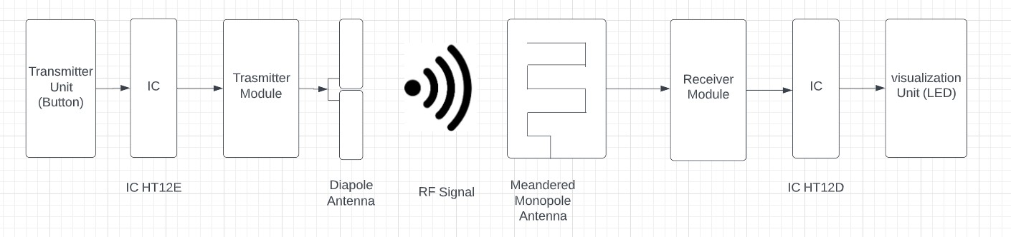

Block Diagram of RF System

Antenna Design

Dipole Antenna

Introduction
Antennas play a crucial role in wireless communication systems by transmitting and receiving signals. The design of an antenna can significantly impact the performance of a wireless communication system, including range, signal quality, and reliability. This chapter focuses on the design of monopole and dipole antennas for transmitting and re- ceiving signals in the 433MHz frequency band, which is widely used in various wireless communication applications. The chapter provides a detailed overview of the design process, including antenna structure, dimensions, and materials used. It also discusses the simulation and testing process for evaluating the performance of each antenna de- sign in terms of radiation pattern, impedance matching, and efficiency. The chapter aims to provide details of the design principles and considerations for monopole and dipole antennas for 433MHz RF transmission, and calculations by which the dimentions were calculated.

What is a Dipole Antenna?
A dipole antenna (also known as a doublet or dipole aerial) is defined as a type of RF (Radio Frequency) antenna, consisting of two conductive elements such as rods or wires. The dipole is any one of the varieties of antenna that produce a radiation pattern approximating that of an elementary electric dipole. Dipole antennas are the simplest and most widely used type of antenna. A ‘dipole’ means ‘two poles’ hence the dipole antenna consists of two identical conductive elements such as rods or metal wires. The length of the metal wires is approximately half of the maximum wavelength (i.e.λ/2)in free space at the frequency of operation.

This wire or rod is split at the center, and the two sections are separated by an insu- lator, these sections are known as an antenna section.

These two antenna sections are connected to a feeder or coaxial cable at the end closest to the center of the antenna. The basic dipole antenna with the center feed point is shown in the figure below.
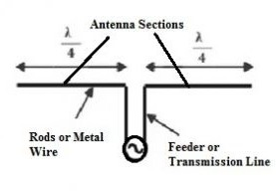

Basic Dipole Antenna with Centre Feed Point

The radio-frequency (RF) voltage source is applied to the center between the two sections of the dipole antenna. This voltage and a current flowing through the two conductive elements produce a radio signal or an electromagnetic wave to be radiated outwards from the antenna.

The current is maximum and voltage is minimum at the center of the dipole antenna. Conversely, the current is minimum and voltage is maximum at the ends of the dipole antenna.

The radiation pattern of the basic dipole antenna is shown in the figure below. It is perpendicular to the axis of the antenna. Note that the radiation pattern is the graphical representation of the radiation properties of the antennas as a function of space i.e., the radiation pattern of the antenna describes how the antenna radiates energy out into space

Antenna Calculations
Dipole antenna specification Frequency = 433 MHz =33x10-6 Antenna Length Calculation

c 3 ∗ 10⁸
λ = f = 433 ∗ 106 = 69.28Cm

69.28
L =
4
= 17.32cm

λ L_{g} = √ξ

4
69.28
= √2.167

Overall L_{g} = 11.7cm

CPWG

60π
Z = √ξϵff ∗
1

K(k) + K(k1)

Kk′ Kk1′S

Where

ω
K =
ω + S

K′ = √1 − k2

tan ^{πω} K1 = 4h
tanh π(ω+S)
4h

CPWG Impedance

Z₀ = 53Ω 50 Ω

For

ω = 1cm h = 0.5cm
S = 1mm ϵr = 3.78

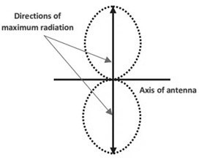

Radiation Pattern of a Basic Dipole Antenna
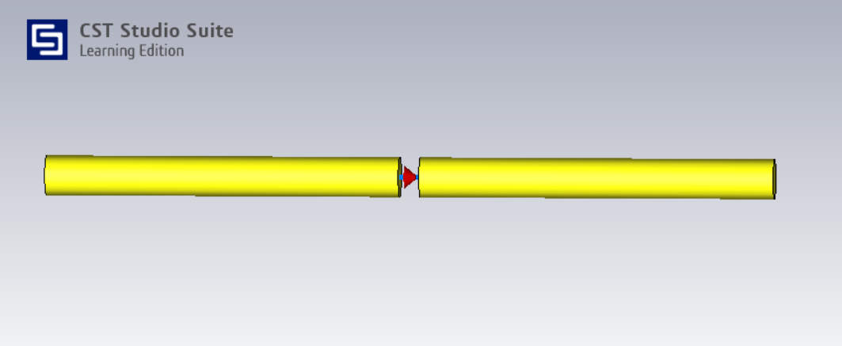

Dipole antenna simulation (CST Studio)
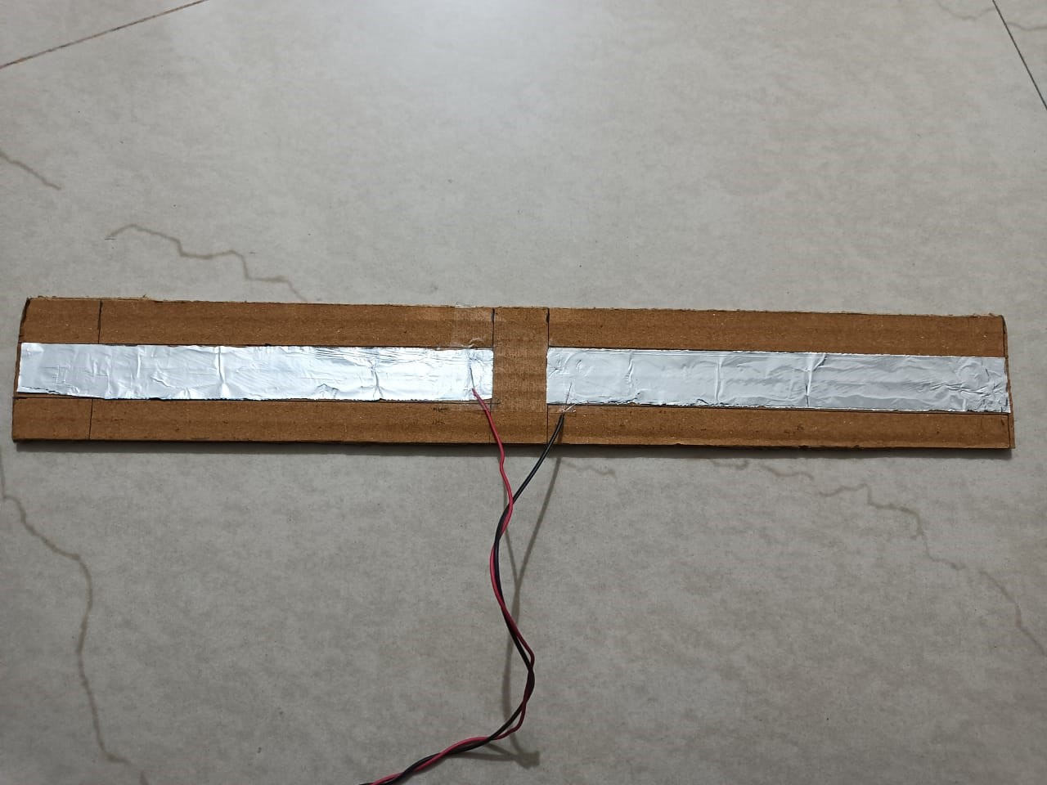
23

Dipole Antenna Implementation

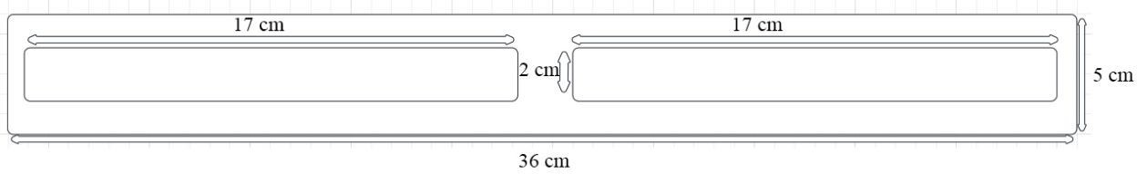

dipole dim

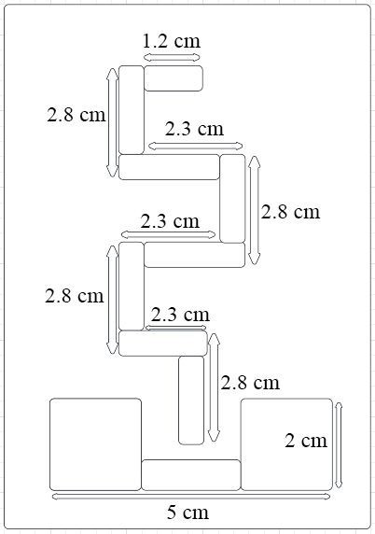

monopole dim

Transmission Unit
Transmission Unit Flow Chart
Step 1: Data generation when buttons are pressed
Step 2: Data transmission to IC HT12E data pins 10,11,12,13
Step 3: IC HT12E sends data to transmission module on DATA port. Step 4: Module converts square wave data into sine waves.
Step 5: Through Antenna port, data is sent to Dipole antenna

Transmitter Unit Circuit Description
The HT12E encoder IC VSS pin is connected to the power supply Ground (-) and the VDD is connected to the power supply VCC (+). IC A0 – A7 pins (pin 1 – 8) are connected to the Ground (-) to set the address at 0b00000000. The Switch 1 (S1), Switch 2 (S2), Switch 3 (S3), and Switch 4 (S4) are respectively connected to the AD11 (13), AD10 (12), AD9 (11), and AD8 (10). The 1M ohm resistor is connected between the pin 15 and 16, which provides the external resistance for the operation of the internal

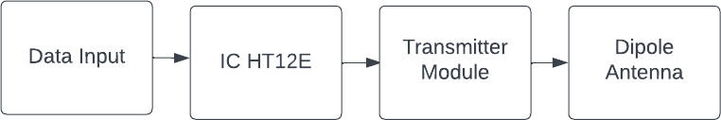

Transmission Circuit Flowchart

oscillator of the HT12E IC. The RF Transmitter module GND pin is connected to the power supply Ground (-) and the VCC is connected to the power supply VCC (+). The Data pin is connected to the DOUT (pin 17) of the IC.

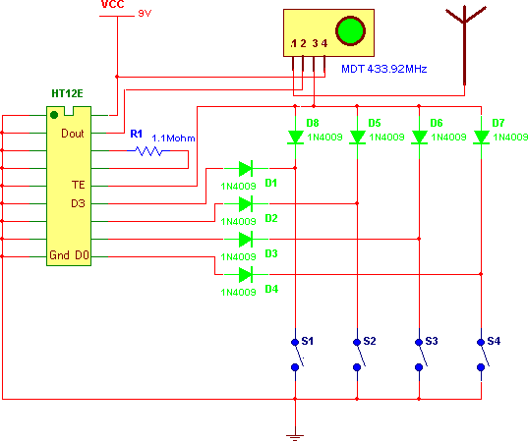

Transmission Circuit Diagram

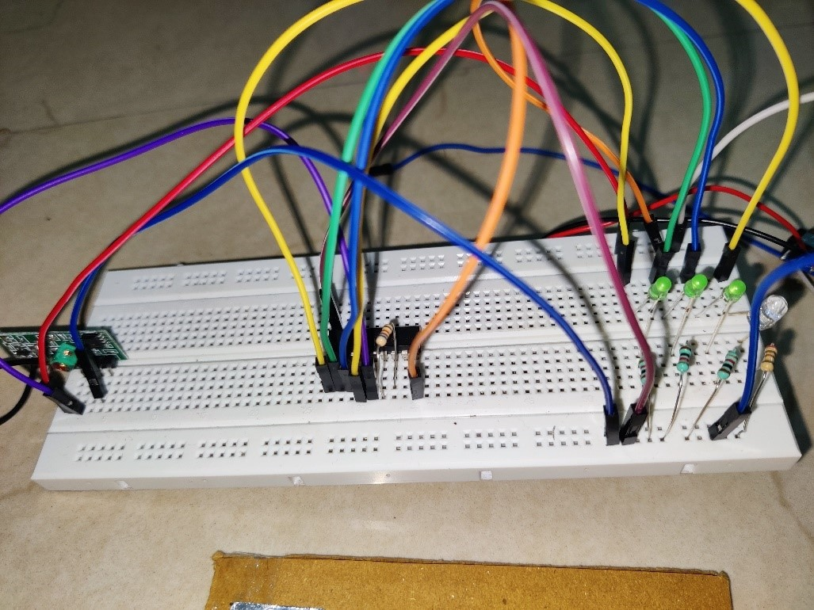

Transmission Circuit Implementation in first phase
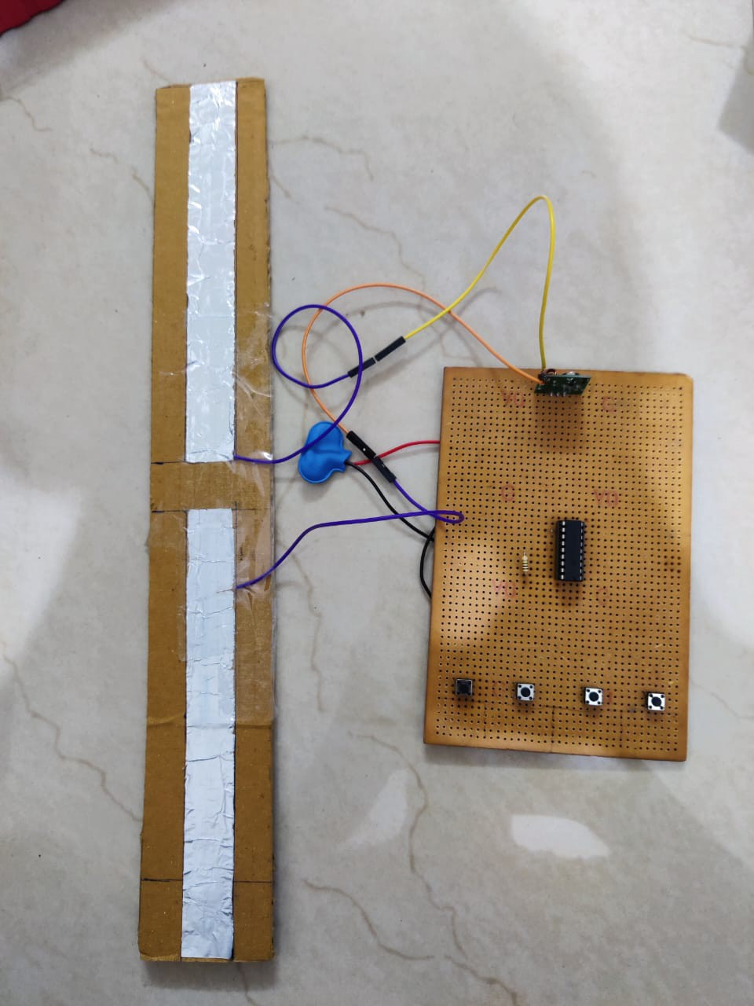
Transmission Circuit Implementation in second phase

Transmission Unit IC Connections
      - VCC - Interface with the positive stockpile voltage (Normally 5V).

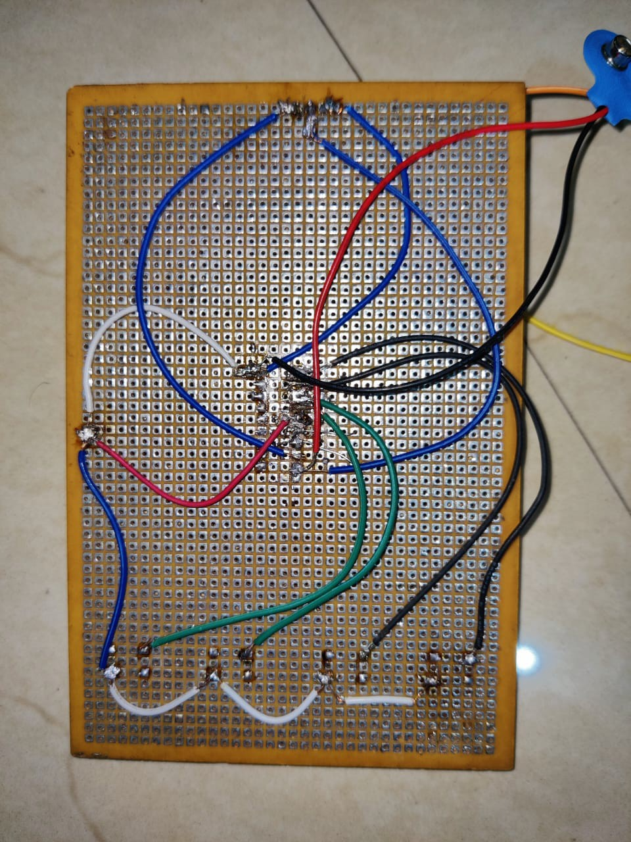

Transmission Circuit Implementation in second phase connection

      - Address Pins (A0-A7) - These are the information pins for setting the location code. Associate them to either VCC or GND to set the location.
      - AD8 - This pin is utilized to send an extra piece of information alongside the location bits. Interface it to either VCC or GND.
      - TE - Transmission empower pin. This pin is utilized to empower transmission. Interface it to the positive inventory voltage.
      - D8-D11 - These are the information input pins. Interface them to the information source (normally a microcontroller or sensor).
      - Oscillator pins (OSC1 and OSC2) - These pins are utilized to associate an outer resistor and capacitor to set the oscillator recurrence.
      - Ground (GND) - Interface with the ground.

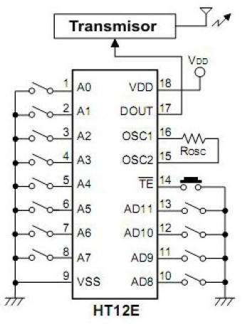

IC HT12E Pin Connections

Transmission Unit Hardware Description
The HT12E is an encoder IC (Integrated Circuit) that is commonly used in remote con- trol applications. It is designed to be used with a matching decoder IC, such as the HT12D, to create a wireless RF (Radio Frequency) communication system.

The HT12E IC is manufactured by Holtek Semiconductor, a Taiwanese semiconduc- tor company, and is part of their HT12x series of remote control encoder/decoder ICs. The HT12E is a 18-pin DIP (Dual In-line Package) IC that operates with a supply volt- age of 2.4V to 12V DC.

The purpose of the HT12E is to convert parallel data into a serial RF signal that can be transmitted wirelessly. It encodes the data inputs from its 8 data pins (D0 to D7) along with 4 address pins (A0 to A3) and a transmission enable (TE) pin to generate a 4-bit serial output (DOUT) that represents the input data.

The HT12E has several important features that make it useful for remote control ap- plications, including:

      - Low power consumption - The IC has a low standby current and can operate in a power-down mode when not in use.
      - High noise immunity - The IC uses a Manchester encoding scheme that provides high noise immunity and reduces the chance of errors in transmission.
      - Simple interface - The IC has a simple parallel data input interface that makes it easy to connect to a microcontroller or other digital circuit.
      - operating voltage range - The IC can operate with a wide range of supply voltages, making it versatile and suitable for use in a variety of applications.

Receiver Unit

Receiver Unit Flow Chart
Step 1: Data is received by Monopole antenna.
Step 2: Data is sent to receiver module at antenna port. Step 3: Module converts sine wave data square wave. Step 4: Data is sent to pin 14 of IC HT12D.
Step 5: IC HT12D processes this data and sends it to pin 10,11,12,13
Step 6: Output is attached to these pins and gets activated according to input buttons.

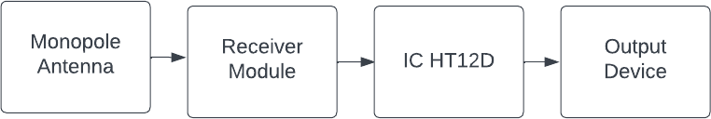

Receiver Circuit Flowchart

Receiver Unit Circuit Description
Receiver CircuitThe HT12D decoder IC VSS pin is connected to the power supply Ground (-) and the VDD is connected to the power supply Vout (+) of the 7805 5v Re- ceiver CircuitThe HT12D decoder IC VSS pin is connected to the power supply Ground (-) and the VDD is connected to the power supply Vout (+) of the 7805 5v 00000. The LED2, LED3, LED4, and LED5 are respectively connected to the D11 (13), D10 (12), AD9 (11), and D8 (10). The 33K ohm resistor is connected between pin 15 and 16, which provides the external resistance for the operation of the internal oscillator of the HT12D IC. The RF Receiver module GND pins are connected to the power supply Ground (-) and the VCC is connected to the power supply VCC (+). The Data pin is connected to the DIN (pin 14) of the IC.

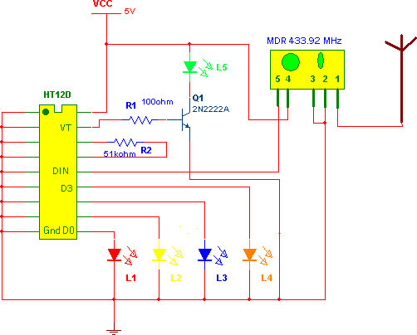

Receiver Circuit Diagram
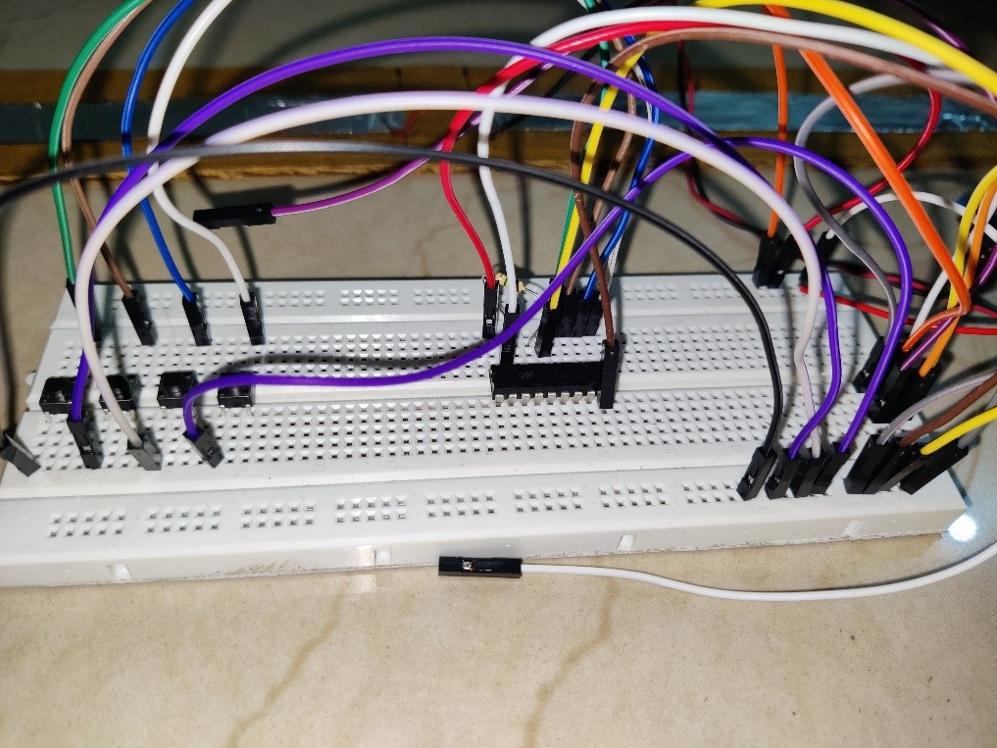
Receiver Circuit Implementation

Receiver Unit Hardware Description
The HT12D is a 12-bit decoder IC that is designed to receive the encoded data transmit- ted by the HT12E encoder IC. The encoded data is transmitted wirelessly using an RF (Radio Frequency) transmitter, and the HT12D receives the data using an RF receiver.

The HT12D has 8 data output pins (D0-D7), 4 address input pins (A0-A3), and a trans- mission enable (TE) input pin. The decoder decodes the 12-bit serial data input and

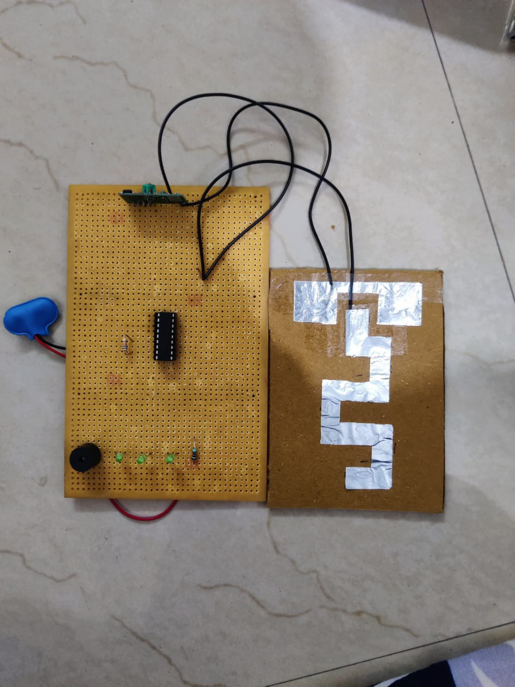

Receiver Circuit Implementation in second phase
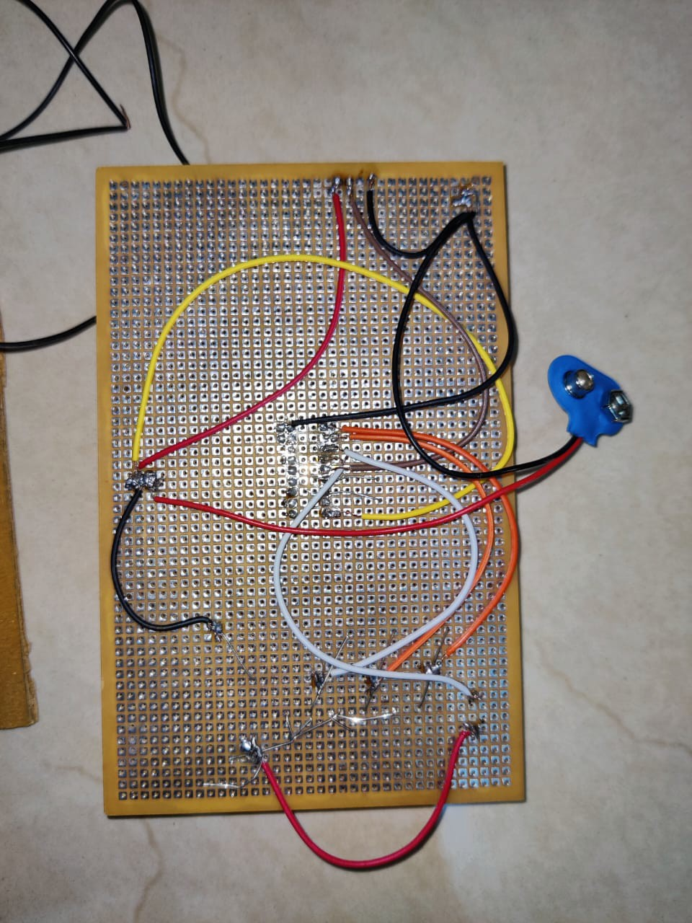
Receiver Circuit Implementation in second phase connection

outputs the corresponding parallel data on the data output pins.

The address input pins are used to set the address of the decoder, allowing it to re- ceive only the data that matches its address. This feature is useful in multi-channel applications where multiple transmitters are used, each with its own unique address.

The transmission enable (TE) input pin is used to enable or disable the decoder. When the TE pin is high, the decoder is enabled and can receive data. When the TE pin is low, the decoder is disabled and will not respond to any incoming data.

The HT12D uses a Manchester decoding scheme, which provides high noise immunity and reduces the chance of errors in reception. The IC also has a low standby current and can operate in a power-down mode when not in use, making it ideal for battery-powered applications.

In addition to remote control applications, the HT12D can also be used in other wireless data transmission systems where simple, low-cost data decoding is required.

Receiver Unit IC Connections
      - VCC - Associate with the positive stockpile voltage (Commonly 5V).
      - Address Pins (A0-A7) - These are the info pins for setting the location code. Interface them to similar qualities as those set in the HT12E encoder IC.
      - AD8 - This pin is utilized to get an extra piece of information alongside the loca- tion bits. Interface it to either VCC or GND.
      - VT - Legitimate Transmission pin. This pin goes high when a legitimate trans- mission is gotten. Interface it to a microcontroller or other computerized rationale to show that information is accessible.
      - D8-D11 - These are the result pins for the decoded information. Interface them to the information contribution of a microcontroller or other computerized rationale.
      - Oscillator pins (OSC1 and OSC2) - These pins are utilized to interface an outside resistor and capacitor to set the oscillator recurrence.
      - Ground (GND) - Associate with the ground.

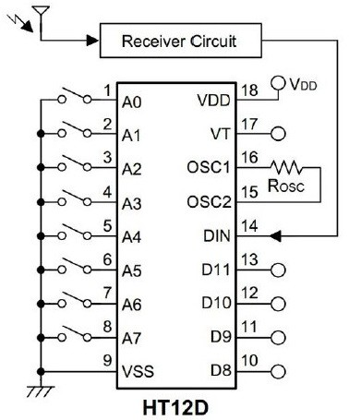

IC HT12D Pin Connections

