A STUDY ON FINANCIAL TECHNOLOGY & CYBERSECURITY IN INDIA

Authors:

Dr. Supriya Rai, Associate Professor, Jain (Deemed-to-be University) - Center for Management Studies - Bangalore, INDIA
Gyanesh R, J Chiru Karthik, Kruthika Mahesh, Saumya Jain, Vridhi Palrecha – Students - BBA, Jain (Deemed-to-be University) - Center for Management Studies - Bangalore, INDIA

ABSTRACT
Financial technology, or fintech, is a rapidly growing industry that has revolutionized the financial services sector in recent years. With the rise of fintech, traditional banking practices have been challenged, and new and innovative solutions have emerged. Cybersecurity threats have increased in frequency and sophistication, and the financial sector is one of the prime targets of cyber attackers. Fintech companies, in particular, face unique cybersecurity challenges due to the large amounts of sensitive data they handle. The potential consequences of a cybersecurity breach can be severe, including financial losses, reputational damage, and loss of customer trust.
This research paper examines the relationship between financial technology - fintech and cybersecurity. Fintech is an emerging industry that has revolutionized the financial services sector, providing innovative and convenient solutions to customers. However, with the increasing reliance on technology, there are growing concerns over cybersecurity risks and threats. The study reviews the evolution of Fintech and its growing importance in the financial industry, as well as the need for effective cybersecurity measures to ensure the confidentiality, integrity, and availability of financial data. It also aims to explore the intersection between fintech and cybersecurity, focusing on the challenges and opportunities that arise when using fintech services.
The paper investigates the vulnerabilities and risks associated with fintech, including data breaches, fraud, and cyber-attacks. It examines the various technologies and tools used by fintech companies to mitigate these risks, such as encryption, firewalls, and biometrics.
The findings of this research will contribute to the understanding of the current state of cybersecurity in the fintech industry and the measures that can be taken to enhance cybersecurity. Moreover, the research analyzes the regulatory landscape of the fintech industry and the measures taken by regulators to ensure the security and privacy of customer data. It discusses the role of government agencies in regulating the fintech industry and safeguarding against cyber threats.
Finally, the paper provides insights into the global view and future of fintech and cybersecurity, including the potential for emerging technologies such as blockchain and artificial intelligence to enhance security measure

KETWORDS: Fintech, Cybersecurity, Blockchain, Finance, Stakeholders

FINTECH IN PRACTICE
The most well-known fintech firms all have one thing in common: they aim to challenge and ultimately unseat established traditional financial services providers by being nimbler, catering to underrepresented populations, or offering faster and/or better service.
By providing a mechanism for customers to get quick, short-term loans for purchases, for instance, affirm aims to eliminate the role of credit card companies in the online purchasing process. Affirm claims to provide a solution for people with bad or no credit to both acquire loans and build their credit histories, even though its charges might be expensive. Similar to this, Better Mortgage uses a digital-only product that may provide users with a verified pre-approval letter within 24 hours of applying to expedite the home mortgage application process (and do away with traditional mortgage brokers). GreenSky aims to connect banks with home improvement borrowers by assisting customers in avoiding obstinate lenders and saving money on interest by providing 0% promotional periods.
Tala provides micro-loans to customers in the developing world who have no credit or bad credit by thoroughly analyzing the data on their smartphones, including their purchase history and seemingly unrelated information like the mobile games they play. In comparison to regional banks, unregulated lenders, and other microfinance organizations, Tala aims to provide these customers with better options.

TYPES OF FINTECH
From personal to corporate finance management, there are many different categories of financial technology available. Through the use of specialized, high-quality tools and FinTech software solutions, private enterprises can compete with traditional financial services, such as those provided by big U.S. banks.

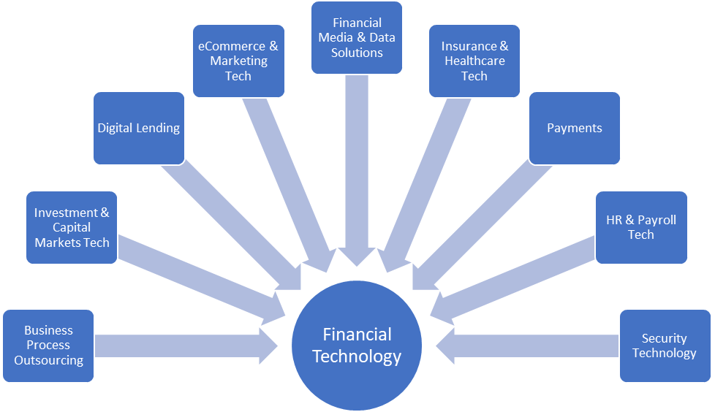

Fintech Landscape
Since the middle of 2010, the fintech industry has flourished, with established financial institutions either picking up new companies or developing their fintech solutions, as well as start-ups obtaining billions in venture capital.
The majority of financial businesses are still created in North America, with Asia coming in alternate place and Europe in third. The ensuring areas, among others, are some of the more active ones for fintech innovation:
- Cryptocurrency - Bitcoin, Ethereum, and other forms of cryptocurrency, as well as digital tokens like NFTs and digital money. These frequently rely on blockchain technology, a distributed ledger technology (DLT) that doesn't have a central ledger but instead keeps records on a network of computers. Smart contracts, which use code to automatically carry out agreements between parties like buyers and sellers, are another feature of the Blockchain
- Open Banking - A concept called "open banking" contends that everyone should have access to bank information in order to develop apps that link together a network of financial institutions and other service providers. Mint, an all-in-one money management solution, serves as an illustration.
- Insurtech - aims to modernize and streamline the insurance sector through the use of technology.
- Regtech - aims to assist financial services companies in adhering to compliance regulations, particularly those about money laundering and ow-your-customer procedures that combat fraud.
- Unbanked/underbanked services aim to assist low-income or underprivileged people who are neglected or underserved by conventional banks or financial services providers. These programmers encourage monetary inclusion.
- Cybersecurity - Cybersecurity and finance are related because of the rise in cybercrime decentralized data storage.

History of Fintech in India
The fintech industry in India has grown enormously in recent years. The development and growth of the fintech industry in the nation have been significantly influenced by the high internet and smartphone penetration rates. 40% of all digital transactions worldwide, according to a report from the ministry of trade and industry, take place in India. This is made feasible by the nation's fintech sector. Any contemporary economy must have strong financial services. Millions of underprivileged Americans now have access to financial services because to fintech.
The demonetization of the 500 and 1000 rupee notes in 2016 marked the beginning of the genuine Fintech saga in India. Even though there were few fintech businesses in the nation before to 2016, the economy was dominated by cash. The demonetization brought several new players into India's fintech market. Most consumers were first hesitant to use digital payment methods and other forms of commerce. People were driven to use digital payment methods since the economy was lacking in cash. But soon after, the majority of people understood how flexible, safe, and convenient digital transactions are. The country's fintech industry underwent yet another change with the introduce on of Unique Payment Interphase (UPI).
In less than 5 years, new fintech services such as digital lending, online KYC, digital insurance, digital microfinance, buy-now-pay-later, and banks without physical branches have arisen. India's fintech market was worth $50 billion in 2021, and it is anticipated to grow to $150 billion by the year 20251. Currently, the nation is home to more than 6000 fintech startups providing a wide range of services. India is thought to have a fintech adoption rate of 87%, which is much higher than the global average of 65%. The fact that even the traditional banking sector, which is resistant to change, is being compelled to incorporate digital technology to survive speaks volumes about the fintech industry's influence. To stay competitive, several conventional banks are forming alliances with fintech startups.
PURPOSE OF STUDY
Financial technology, often referred to as FinTech, is the technology and innovation that seeks to compete with traditional financial, financial services, whereas, it is considered an emerging industry that uses technology to improve financial activities. Many current financial institutions apply financial technology solutions and technologies to improve and develop their services, and to improve their competitive position. In recent years, a new generation of financial technology start-ups supporting financial institutions and providers of digital solutions has emerged, resulting in a reversal of financial market conditions around the world by leveraging technology innovations in finance. Due to this rapid development, it is necessary to adopt methods that guarantee the utilization of the financial technology revolution for the benefit of society and the economy, considering consumer protection and the financial system.
Hence, we find that financial technology innovations work hard to improve the efficiency of the financial system for all public and private sectors as well as companies and consumers, which in turn makes financial technology more vulnerable to financial risks and losses.

DESCRIPTION OF THE SERVICE
Technologies Involved in Fintech
The Internet of Things, AI, Machine Learning, Robotics, Cloud Computing, and automatic Assistants are just a few of the developing technologies being utilized to improve financial sector solutions and products. FinTech has revolutionized and can continue to influence the business models offered to consumers.
FinTech applications are numerous and expanding, with developments in fields like Blockchain, lending platforms, insurance technology, digital banks. Financial goods are now available to consumers in additional efficient and useful ways because of advances in technology.
FinTech, although commonly referred to as a new industry, has a long history that can be divided into three phases. The development of mainframe computers, SWIFTS, ATMs etc. is considered as a part of FinTech 1.0. The next era of FinTech, comprised of Internet and Internet of Things, and it was called FinTech 2.0. Now, we are in a transitional phase from FinTech 2.0 to FinTech 3.0, in which more and more technologies are expected to be developed. Finance combines Finance, Technology Management and Innovation Management. When explained, we can say that, we use technological solutions in innovative ways to make financial processes more effective.
Finance is a domain that is extremely significant for growth. But most financial services are consistently expensive and there are not many innovations in the financial sector that are practically delivered to customers with vital benefits. This doesn’t mean that finance lacks innovation, but the existing innovations have not improved the overall effectiveness of the domain. The high cost, slower pace, strict regulations and uneasiness of procedures of financial industry can be highlighted as major reasons why FinTech emerged. Similar to many other industries, FinTech companies initiate disruptive innovations for certain services.

By the time analysts just take a look at income statements, AI technologies can produce high quality interpretations and results. The present sentiment of general public on a stock can be figured out in just seconds by sentiment analysis firms. The merge of FinTech with IoT and AI is currently challenging the very existence of banks. The risks of making blunders in the progression of technological change is much lesser that the risk of not moving with the change.

As opposed to FinTech which is finance firms making use of technology, TechFin is another domain which refers to a technological firm that delivers financial services and products. The potential of such large techno firms to dominate financial services delivery is not just an idea;

Traditional Finance | FinTech
Delivering of financial services and products traditionally without the use of technology. | Begins with financial services and products and incorporates technological and data into it.
Starts with purely financial relationship. | Customer relationship is for financial purposes and aims to use technology to improve it.
Not data driven or technologically equipped. | Data driven and technologically equipped to specialize in finance.
Not potential disruptive and is likely to be replaced. | Disruptive in nature.
Regulations are strict and broad, making it inaccessible to many. | Regulations are comparatively lesser and developing.
Relative lack of innovation. | Highly innovative, enabling easier access at cheaper cost

Mobile payments are considered to be one of the strongest areas of FinTech. The paper has also summarized why FinTech is swiftly emerging by comparing it with the financial services industry. The comparatively greater expense associated with traditional financial services and their lesser reach as well as the stricter regulations means that not all customers can access it with ease. The integration of IOT with FinTech is recognized today as a novel technology, which is known to disrupt the way financial services are delivered and challenging the very existence of banks.
FinTech incorporates the usage of huge amount of data, even more than what traditional financial institutions uses, and hence data and information of users need to be protected from breaches and various attacks. The final section analyses the gaps in current literature.

DIFFERENT FORMS OF FINTECH PLATFORMS

1. Blockchain and Cryptocurrency
With the supply of smart contracts, Proof-of-Work, Peer-to-Peer transactions, blockchain-powered trading platforms, decentralized ledgers, and immutable records, FinTech and
Blok chain are good samples of how FinTech is affecting the growth of financial services.
Blockchain technology enables more private, secure, and transparent tracking of monetary transactions over their entire lifespan. The decentralized and distributed character of cryptocurrencies enabled by Blockchain technology contributes to their acceptance and confidence among business models and consumers alike.
Blockchain technology remains in its early stages, with further advances and breakthroughs being explored through additional study. Various systems leverage Blockchain technology, including Ethereum, Bitcoin, Chain, Blog, Wirex, and lots of others.
2. Insurance (InsurTech)
With the event of digital financial ecosystems, insurance solutions of high value are developed within the insurance business to improve the client experience. Insurers are integrating smartphone applications, drones, the web of Things (IoT), AI (AI), machine learning, and other techniques to offer greater effect through their services to customers and other entities that use them.
InsurTech is steadily transforming the way clients see insurance products, with several perks like online markets, less difficult and tailored ways, customized profiting, and lots of more.
Rapid expansion and progress within the insurance sector have been enabled by the use of technology in areas where traditional methods of operating would appear difficult.
3. Regulatory (RegTech)
The Financial Conduct Authority defined RegTech in 2015 as “a subset of FinTech that focuses on technology which will support the delivery of regulatory obligations more efficiently and effectively than existing capabilities.” RegTech refers to the utilization of cutting-edge technology to improve compliance and the implementation of simple, secure, and cost-effective regulations.
In a world where finance is being taken over by different technological applications, new regulatory frameworks are required to stay up with the innovations. RegTech is primarily employed to standardize and promote transparent regulatory processes that automate the full compliance system.
4. Lending (LendTech)
This industry employs technology to supply customers with financing options through more accurate and quicker procedures. to supply error-free outcomes, smart systems employing AI and Machine Learning algorithms are employed to process and validate identify credentials.
The use of technology in loan procedures makes it easier to forecast income expectations, evaluate the borrower’s diary, appraise collateral value, and foresee changes.
5. Payments (PayTech)
With the event and integration of digital processing applications and different processing networks, FinTech is transforming the payments sector. Wearable technology and smart gadgets are being created for patrons to improve digital connectivity and secure consumer identity.
Payment Technology secures and simplifies asset management and therefore the processing of various payment transactions (PayTech). PayPal and GPay are among the payment platforms that use PayTech.
6. Mobile Payements
Mobile wallets and other integrated payment solutions are frequently employed by business models and individuals to facilitate and perform payment operations via technology. this is often a significant topic of FinTech since every transaction done by any customer includes the payment process.
Most transactions would seem difficult to make and finish if mobile payment systems were not available to overcome the constraints created by traditional methods. Consumers all across the planet are using digital wallets such as Apple Pay, and Google Wallet. These platforms are simple to use, safe and enhance the whole customer experience.
7. Trading (TradeTech)
TradeTech is the application of information technology to reduce the information costs of global trade, simplify trade financing, and encourage transparency in trading practices for both business models and consumers. Realizing its full potential and benefits need international cooperation. TradeTech facilitates and supports international trade by utilizing IT platforms for supply chain finance and asset distribution.
8. Robo-Advising and Stock-Trading Apps
Apps for Robo-Advising and Stock Trading Diversified investment portfolios could also be developed and made available to customers using technology, eliminating the necessity for an investment professional or adviser. Robo Advisors may be a system designed for novice investors to assist with risk management as well as professional investment management.
9. Personal Finance (WealthTech)
This branch of FinTech focuses on improving wealth management and retail investment services by leveraging technology to reinforce and provide operations in a more efficient and automated manner. These digital solutions are utilized to enhance existing solutions and develop new ones to make them available to new groups of investors.
WealthTech makes it easier for investors to manage their investment portfolios by streamlining the investing process. By the use of Micro-Investment, Robo-retirement, Portfolio management systems, and other technology, WealthTech is being introduced into the financial sector.
10. International Money Transfers
Through the mixing of technology into payment channels that may be utilized to enable international money transfers, barriers are removed. Traditional methods of payment are less efficient and effective during this field of FinTech, since newer and simpler methods of payment exist now, making the whole process more streamlined, secure, quicker, and simpler for patrons and business models.
11. Equity Financing
Selling stock in a company to the general public, financial institutions, or investors is one way to raise money or capital. The money obtained is then used to expand already existing businesses or to launch new ones. By employing technology, crowdfunding could reach a larger audience of potential investors. Participants on crowdsourcing websites like Kickstarter, Pebble, and others can win prizes.
12. Accounting
Machine Learning, AI, Cloud Computing, Digitized Tax Platforms, and other technological breakthroughs are being utilized to enhance accounting automation and transparency. Through the utilization of software and tools, the utilization of technology in this field of finance has improved data access and analysis. The introduction of monetary technology and software has lowered the number of time accountants need to execute tasks such as invoice management, income forecasting, and other accounting services.
13. Consumer Banking (BankTech)
Many financial institutions are using digital technology to deliver services during a more streamlined and efficient manner. BankTech is that the use of digitized platforms to provide banking solutions and products to consumers. BankTech has several advantages over traditional banking methods, including improved user experience, lower costs, and fewer operational friction.

RECENT DEVELOPMENTS
- Open banking: Open API, or open banking, works on the principle of providing bank client data to third parties with the consent of the owner. This is beneficial for the bank user.
- The internet of things: FinTech companies are increasingly using connected devices to gather business-friendly customer insights and make more informed decisions. Connected wearables perform many useful tasks in FinTech such as through mobile banking applications, financial institutions monitor customer behavior to decide what relevant services to offer systems replace traditional Point of Sales (POS) systems.
- RegTech: The use of technology to improve the efficiency of business processes is called "digital transformation". The use of regulatory technology identifies problems that don't follow the rules and makes them work with the system.
- Biometric authentication: In comparison to traditional passwords and PINS, biometric authentication is thought to be more secure. users like biometric authentication to be the finest. Even if your laptop or smartphone is taken, confidential information will still be secure.
- Potential of Artificial Intelligence (AI): With Al being introduced in all market segments, this technology with a combination of machine learning has brought tremendous changes in cybersecurity. Although, it is being used to develop smart malware and attacks to bypass the latest security protocols in controlling data, AI enabled threat detection systems can predict cyber-attacks and notify admins for any data breach or threat instantly.
- Cloud is Also Potentially Vulnerable: With more and more organizations now established on clouds, security measures need to be continuously monitored and updated to safeguard the data from leaks. Although cloud applications such as Google or Microsoft are well equipped with security from their end still, it's the user end that acts as a significant source for erroneous errors and malicious software.
- Automation and Integration: With the size of data multiplying every day, it is eminent that automation is integrated to give more sophisticated control over the information. Security measurements are incorporated during the process to build more secure software in every aspect. Large and complex web applications are difficult to safeguard making automation as well as cyber security to be a key concept of the software development process.

FUTURE OF FINTECH
It's a little challenging to peer into a crystal ball and forecast the future as the world is now recovering from a serious pandemic. Venture Capital fintech funding decreased by $6.1 billion as of May 2020, reaching its lowest level since the first quarter of 2019.
Blockchain and open banking, the underlying technologies that propelled the Fintech 3.5/3.5 era, will continue to propel innovation in the years to come.
The way we engage with banks and insurance firms is about to change as a result of machine learning, which is intended to improve client relationships by creating "segments of one." Financial institutions can target people in this way to offer them tailored support and offers that are tailored to their behavior and will improve their experience.
This development is not merely applicable to the financial industry. Machine learning will be used by insurance companies to expedite the processing of insurance claims. Insurer Ping and has developed a system that automatically resolves claims using an algorithm that determines the type of automobile involved and the extent of the damage before sending over an offer to pay the claim right away. This is already happening in China.
Through a surge of integrated payment providers, fintech is poised to transform how money is collected and managed for both online and offline businesses, whether they be retailers, gyms, or plumbers. To provide these industries with a completely integrated system on which to operate their business.
While new digital banks can give customers a distinctive perspective on their finances, these integrated platforms can add payments as an additional component to an already robust system of business administration. You may handle bookings, stock levels, and payments using one system, which can provide insightful reporting that gives business owners crucial knowledge about how their enterprise is operating.
These providers can control a market by creating industry-specific solutions to address the particular problems faced by their clients by adding payments on top of a broader base of sector-specific tools.
The technologies we use to manage our finances are likely to be supported in the future by personalization and automation of systems that enhance the customer experience and promote the concept of the "segment of one."

LITERATURE REVIEW

THE ESSENCE OF CYBERSECURITY THROUGH FINTECH 3.5 IN PREVENTING AND DETECTING FINANCIAL FRAUD
Nagasundari A/P Selvaraj
2021
The Emergence of Fintech
As globalization and digitalization began to take center stage, financial services were revolutionized, by which various start-ups and large organizations launched online platforms to perform financial transactions. The stereotype boundaries for regulated financial institutions were defeated with the emergence of Fintech, which was the foundation for the emergence of Fintech. The deviation from traditional banking system and the introduction of modern technologies such as Bitcoin and digital wallets had paved a way to an improved industry of Fintech. The major difference between both the eras lies in the state of economy the users are experiencing. Developed countries with greater level of banking infrastructure and network distribution have adopted Fintech. On the other hand, developing countries in the Asia-Pacific region, which have lagged infrastructure development and less competitive market have leveraged on the alternative solutions for their financial needs, thus, have an extensive reliance on technology, prompting the evolution of Fintech. The innovation in Fintech extends beyond the usage and application of technologies, as it incorporates the element of cybersecurity into its service platforms. Among the most popular examples of cybersecurity technologies under Fintech includes blockchain, which functions to provide information in a decentralized encrypted platform that flows between specific desired members to uphold data integrity.

Cybercrime Platforms of Financial Fraud
Delving further into deep web, there lies dark web which is anonymous and intentionally concealed through sophisticated encryption and decentralized nodes to hide IP addresses of the users. The deep web and dark web constitute 96% of the Internet. Although financial fraud occurs in both platforms of surface web and dark web, the additional features of being less regulated and anonymity makes cybercrime activities to be conducted in a greater extend through dark web. A study conducted on the differences in malicious activities of surface web and dark web revealed that leaked honey webmail accounts through paste sites were accessed in a greater scale in Dark Web as compared to Surface Web.

Conclusion
With the evolution in technology, abundance of task is conducted virtually, from mobile banking, crowdfunding, InsurTech to robo-advising, affecting the individuals, organizations and governments at all levels. However, some setbacks come along with this advancement if technology is used by fraudsters with malicious intent. This paper has reviewed the aspect of cybersecurity in protecting and providing a safer virtual environment for transactions and negotiations to occur more securely. The platforms of which cybercriminals often utilize to intrude into organization’s systems have been explored. Dark web has a greater extend of usage and are relied more by fraudsters, as opposed to surface web, due to the concept of anonymity and less regulations. With regards to that, cybersecurity tools and algorithms such as neural networks, deep learning, data analysis, genetic algorithm and special tools used by government agencies were also discussed and associated with the function of preventing and detecting financial fraud. To understand the usage of technology, which includes cybersecurity innovations, regulatory sandboxes were adopted to benefit both Fintech companies and regulators in facilitating the innovations, to determine if the solutions provide positive impacts to the organizations and the market. However, considering that many countries are still yet to adopt this regulation, it is tough for these companies to be on a par with other countries that have established regulatory sandboxes, in terms of the growth and innovation of Fintech technologies, including cybersecurity solutions. Lack of stringent and comprehensive set of uniform cyber laws also pose hindrance to the efficiency of businesses and organizations. The prominent element of ethics also becomes a huge question in the application of cybersecurity tools by special government agencies, such as the FBI by the stipulation of law. Cybersecurity solutions also pose challenges, in terms of the matter of cost, legal frameworks and laws, inadequate awareness, and the burden of being vigilant to continuously update systems.

FINTECH CYBERSECURITY: AN ASEAN OUTLOOK
PAYPAL
2021
Financial service providers may now serve more clients at a reduced cost and with more efficiency thanks to technological improvements. New kinds of goods, services, and platforms have been created as a result of the digitization of financial services. through granting access to international markets and financing. The use of FinTech is fast increasing in economies that were primarily cash-based only a few years ago, from mobile digital wallets to automated insurance advisors and the supply of microloans to small and medium companies (SMEs).
The fintech industry has grown incredibly across ASEAN. New competitors frequently enter the pitch, motivated by their success and drawn by the commercial potential of the area. There is a lot of opportunity in this developing FinTech market. Despite residing in distant rural areas, more than half of the adult population in the ASEAN region still lacks a bank account. As a result, the area still has to do more to ensure financial inclusion. Technology can solve a lot of the access problems brought on by the geographic dispersion of the area.
The fintech industry in Southeast Asia is expanding rapidly. The region's digital financial services alone brought in USD 11 billion in income in 2019; by 2024, that amount is projected to more than triple to USD 38 billion. By 2030, Southeast Asia's unbanked population may contribute an additional USD 35 billion to the global economy. With the rest of the world, the ASEAN region is concentrating on economic recovery in the wake of COVID-19. 3 Negative growth rates have been observed in economies around the region as a result of the dependency of the ASEAN countries on trade with other economies that are also experiencing severely declining domestic demand. 4 Thus, it is now more crucial than ever for technology and digitalization solution providers to support the local economy. The ten ASEAN Member States' small and medium-sized firm (SME) sector, which makes up between 89% and 99% of all establishments and between 52% and 97% of all employment, is the foundation of the regional economy. 5 FinTechs offer a wide range of technology-enabled solutions to the burgeoning SME sector in the region, including cutting-edge payment methods, credit products, fraud detection tools, and financial risk assessment tools that use data. Transnational payment service providers like PayPal make it possible for SMEs in the region to increase their consumer base and sell globally. Also, the region's FinTechs serve as engines of innovation for the financial, technological, and SME sectors. Global players' interest in these FinTechs also fosters the development of international networks for cooperation and joint venture. Because of its expansion and the region's newly digitalized people, the FinTech sector is becoming an increasingly important part of the ASEAN region's economy, making it a tempting target for cybercriminals. No ASEAN nation or organization is immune to the threat posed by rapidly developing cybercrime, according to Interpol's 2020 ASEAN Cyber Threat Assessment Report. ASEAN members are among the nations with the fastest-growing digital economies, making them an ideal target for cyberattacks. Innovative products and services may actually serve as the very means by which criminal actors are successful in deceiving their victims in the absence of cyber resilience and proper safeguards. Online scams carried out during the COVID-19 outbreak served as a harsh reminder of how vulnerable the recently digitalized and financially integrated are to such attacks. Regulators in the area have therefore given cybersecurity a high priority, and recent years have seen a number of initiatives to increase resilience.
They discovered through a survey that the size and scope of FinTech enterprises in the area are varied. While these companies are very concerned about cybersecurity, they are spending an excessive amount of money on compliance without necessarily getting a return on their investment in terms of cyber resilience. Also, it was discovered that there is an urgent need for improved public-private interaction platforms where FinTech companies and governments may work together on risk-related concerns.

CONCEPTUALISING CYBERSECURITY RISK OF FINTECH FIRMS AND BANKS SUSTAINABILITY
From Sheffield Hallam University Research Archive
Cybersecurity risks for fintech companies
In recent years, cooperation between traditional financial institutions and fintech companies has improved significantly. The reason for the cooperation is to improve service quality, agility, innovative thinking and digital infrastructure. Controversially, the partnership makes traditional banks more vulnerable to cybersecurity risks due to embedded malware attacks, data breaches, and data integrity issues from fintech companies. Fintech cybersecurity risks are a current foundational research topic, and deeper analysis is needed to learn more about the different dynamics of emerging cybersecurity issues. Cyberattacks by fintech companies have increased the level of traditional banking vulnerabilities and fraud vulnerabilities. Fintech companies should therefore ensure cybersecurity requirements in each country in which they operate. The financial involvement of fintech companies has increased the number of cybercrimes. It is also difficult to estimate the economic damage faced by financial institutions because cyberattacks affect their operations in many ways. This means that cybercrime is not only a financial loss for financial institutions, but also a reputational risk.

The list of cyber-attacks of fintech partner banks.

Equity Year Of Amount Lost (USD) Reported Reason Cyber-Crime
JP Morgan Chase 2014 76,000,000 financial Hacked
Central Coast Credit Union 2016 60,000 financial Hacked
Capital One 2019 106,000,000 financial Hacked
Desjardins 2019 2,900,000 financial Inside job
Westpac 2019 98,000 financial Hacked
First American Corporation 2019 885,000,000 financial Poor cybersecurity

While the above cybercrimes are only attacks reported by banks, there have been many cyberattacks due to the banks' reputations and the severity of the incidents. Nonetheless, these incidents demonstrate a clear cybersecurity risk associated with fintech firms, which are having a negative impact on partner banks. Cybersecurity risks not only lead to significant financial losses, but also undermine investor confidence in fintech companies and their affiliates (financial institutions). Financial institutions also contribute significantly to gross domestic product (GDP) around the world. Therefore, cybersecurity risks are not only technical problems for Fintech companies or their partners, but they can also cause financial instability around the world. Observe the consequences of fintech cybersecurity failures.
Conclusion
This article examines the impact of fintech firms on financial institutions and financial inclusion, as well as the risks inherent in cybersecurity. Working with fintech companies has many benefits, such as lower operating costs, lower costs for customers, and faster service. Despite the advantages of FinTechs, this article highlights some of the challenges FinTechs face along with their partners. Like every year, the rate of cybercrime is increasing so far. Moreover, cybersecurity is a top concern for Fintech companies. As such, traditional banks serving fintech companies have become more vulnerable to cyberattacks in recent years. One of the reasons for the increase in cybersecurity incidents is the incompatibility of fintech services with financial institutions. Theoretical evidence indicates that financial institutions report cyber-attack problems shortly after fintech collaborations. This happens because fintech companies transfer their inherent cyber risk to partner financial institutions. The current study has several limitations that should be addressed by future studies. First, financial institutions keep all cybersecurity issues private and undisclosed, making them difficult to access. Second, future research will seek to explore the impact of fintech cybersecurity issues on the stability of fintech partner banks.

Fintech firms and banks sustainability: Why cybersecurity risk matters?
Khakan Najaf Sunway University,
Md Imtiaz Mostafiz Sheffield Hallam University,
Rabia Naja Taylor’s University
In the developing and digitized new world, cybersecurity threats are constantly putting the assets and information of businesses, institutions, governments and individuals at risk. Banks are no exception. Offering low interest rates is becoming a fundamental strategic move for banks to keep it going. Due to the high demand for customized portfolios of financial products, the availability of sophisticated communication and advanced trading mechanisms has created a new class of competitors known as financial technology (i.e. fintech) services. is appearing. Collaborations between these fintech organizations and banks have increased recently to provide consumers with finely tuned services and meet the needs of emerging markets. However, the cooperation between the bank and fintech companies poses significant cybersecurity risks. The dilemma is, therefore, whether banks should embrace such cooperation to revitalize their profit margins or be hesitant to be realistic and eliminate sustainability risks.
Components of cybersecurity risk
The research explored the literature on fintech cybersecurity issues and their implications for partner financial institutions. So far, it can be argued that cybersecurity attacks escalate after partnering with fintech firms, thereby affecting the financial stability of banks. are vulnerable to vulnerabilities in fintech cybersecurity systems. Among all institutions, banking institutions are more vulnerable to cybersecurity than all other financial institutions. Therefore, industry experts and academic researchers agree that banking institution operational risk is positively related to the financial prevalence of cyber incidents. A team of fintech experts and academic researchers are trying to study why cyber incidents are more frequent after fintech partnerships with financial institutions and how to mitigate the severity of cyber-attacks.
Malware Attacks
The Society for World Interbank Financial Telecommunication (SWIFT) system is commonly targeted by hackers around the world. Most financial institutions use the SWIFT system to protect financial transfer information. Hackers have shown sophistication in recent malware attacks against SWIFT systems, according to the latest cyberattack report from India's second largest bank. As such, vulnerabilities to malware attacks have increased in recent years after banks have ventured into fintech partnerships, and according to McAfee experts, the cumulative number of malware attacks was higher than his year-end 2020, just after the joint venture with fintech. By then he is expected to reach over 700 million views. Fintech companies have weak cybersecurity, making them a target for hackers.
Data leakages
In addition to malware attacks, another cybersecurity issue facing banks is data breaches. It has documented an increase in the number of data breach attacks so far after partnering with fintech companies. Financial data includes user credentials and payment card information. Data breaches are a common and recurring problem facing fintech companies. Clearly, fintech service providers are relatively more vulnerable to data breaches than other financial institutions because all their services are digital.

RESEARCH METHODOLOGY
Secondary research
A study technique called secondary research, sometimes known as desk research, uses data that has previously been collected. To improve the overall effectiveness of research, existing data is compiled and summarized.
Research that has been published in research reports and other comparable papers is included. These materials may be made available through online resources, public libraries, surveys that have previously been completed, etc. Various governmental and non-governmental organizations also keep data that can be obtained and used for research. It is far more affordable than primary research since it uses data that is already available, as opposed to primary research, which collects data directly from organizations or enterprises or allows them to hire a third party to do so.
It's worth noting that: an openness questionnaire survey was issued in the form of web-based distribution in a total of 300 copies, of which 256 were valid questionnaires. The questions are -
- The basic information on respondents, including gender, age, occupation, education, etc.
- The basic content of Fintech. This part of the questions was designed to see if the respondents know about Fintech and how well they know it, covered relevant.
- Application fields, application scenarios of Fintech, as well as the opportunities and challenges arising from Fintech, and the organizations that respondents believed will be the most disruptive in the future.
- The new changes that Fintech will bring to relevant industry in the future, including the flow of involved services and input of concerned technologies.
- Few questions were designed to understand the main factors that currently impede the innovation of Fintech and financial institutions, as well as the factors that hinder the cooperation between the two sides.

Research Question
Research question is the starting point of methodology for academic research in natural science and social sciences. Based on the application trend and present situation of financial technology globally and financial industry, the main research questions in this paper focused on the impacts brought by Fintech when it applied to the financial industry and main challenges in the Fintech supervision process. The research question is are followers:
1. Which parts of the financial sector are likely to be the most disrupted by Fintech over the next 5 years globally if they cannot catch up with the trend of financial technology development?
2. Which entities are likely to be the most disruptive driven by financial technology in the next 5 years globally?
3. Based on the current application of financial technology in the financial industry, what benefits financial technology brings to the financial sector.
4. Based on the development of financial technology, what kind of challenges can it bring to the financial industry?
5. Since the increasing application of financial technology in the financial industry, what are the problems in the process of cooperation between financial technology companies and financial institutions?
Above research questions will be analyzed in detail later. It is worth noting that since the questionnaire survey covers a wide range of issues and the degree of openness of the questionnaire is relatively large, thereby, during the subsequent analysis of the questionnaire results, samples with more than 50% support will be selected for conducting the analysis.

Research Design
The descriptive research followed a non-causal investigation, and the purpose of this paper was trying to clearly identify segments of Fintech, found out how technologies-related applied in the financial industry globally, how it worked, and the problems encountered in the process. Here, a phenomenological approach of qualitative research would be applied in the paper which relies on the participant’s own perspectives to provide insight their motivations and the researcher was partial interference to the objects. Then, study settings as non-contrived. In the whole study, secondary data of Fintech and financial filed since 2008-2018, and primary data from questionnaire results were both utilized, and units of analysis were individual, on the side, several case studies were also conducted. Finally, the time horizon of the study was cross-sectional and total research time lasts for six months.
Data Collection
Data collection is the process of systematically collecting and measuring information on target variables and then enabling people to answer relevant questions and evaluate results. As a descriptive research paper, a questionnaire survey was conducted to supporting the entire researching, thereby, the data collections in the whole paper were directly come from the questionnaire results and also contained individual data from various types of annual reports. Also included data summarized from existing secondary data. Since the wide range of technologies involved in the application of Fintech, the above-mentioned data sources are derived from the development and application of the financial sector of Global and Fintech industry, including the third payment data, and market data of related technologies, such as cloud computing.

INTERPRETATION OF DATA

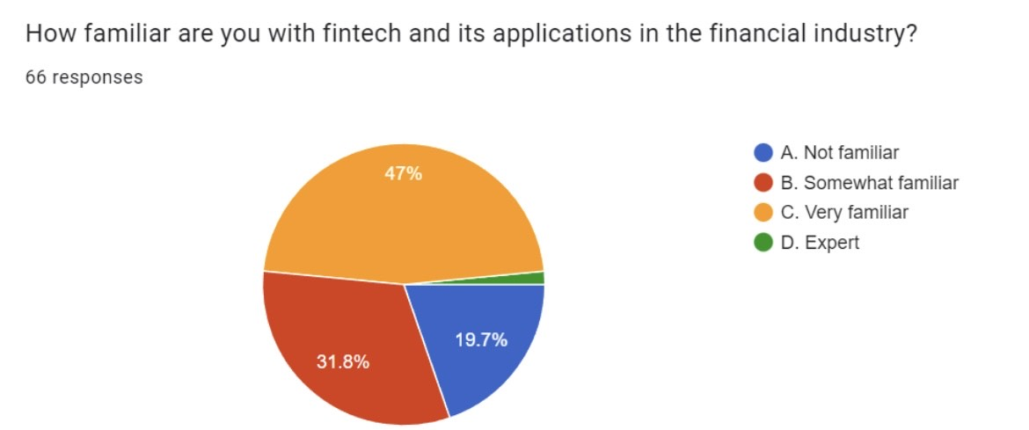
From this data we can conclude that a larger section of people (47%) are familiar with fintech and its application. And only about 19.7% not familiar and 31.8% are somewhat familiar. They know but aren’t sure. Very small percentage of people are expert in it.

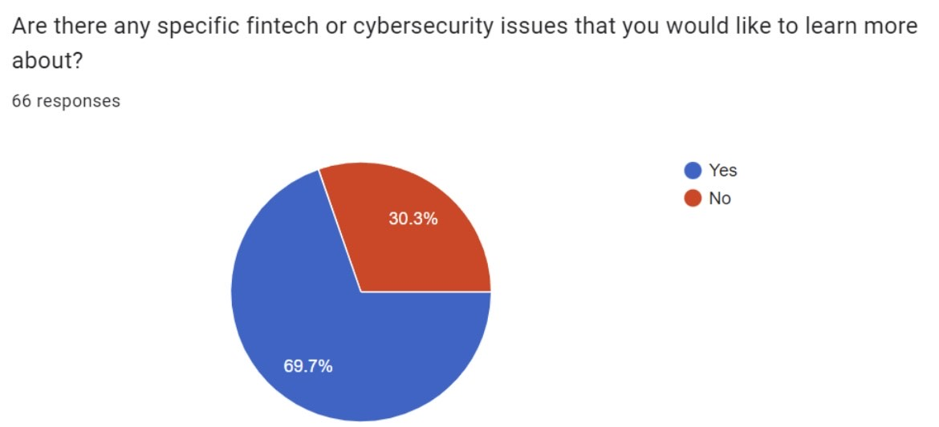
This data shows that a larger group of people (69.7%) people are keen on learning about fintech or cyber security and 30.3% of people aren’t keen on learning.
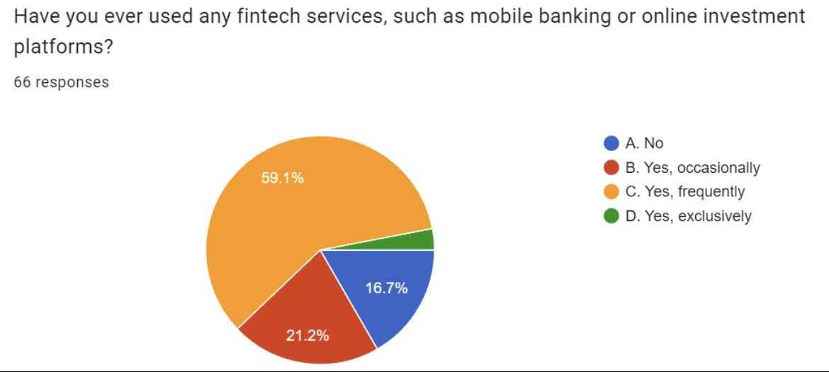
The responses show us that good number of people (59.1%) use fintech services like mobile banking or investment platforms on a regular basis whereas regularly it yet and 21.2% people use it occasionally and a very small percentage of people use it on regular basis.

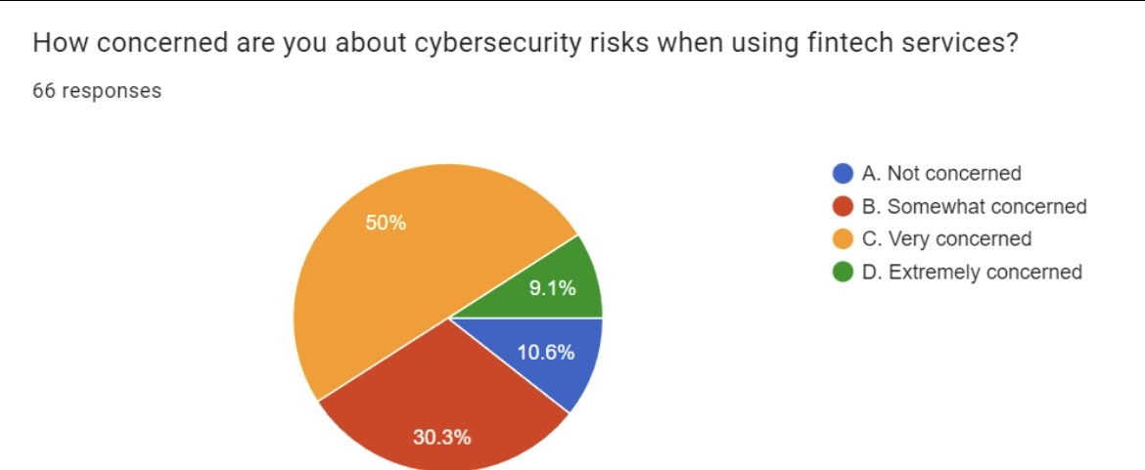
When people were asked about their concern while using fintech the study showed us that half (50%) of the people were concerned while using cyber security risk. And 30.3% were somewhat concerned, around 10.6% were not at all concerned and 9.1% were extremely concerned.
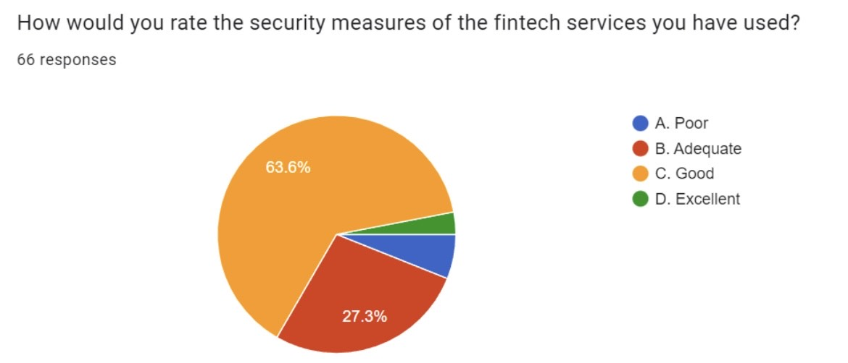
63.6% of people rated the security measures of fintech service as good and 27.3% as adequate. A smaller section of people think security is poor and few think it’s an excellent service.
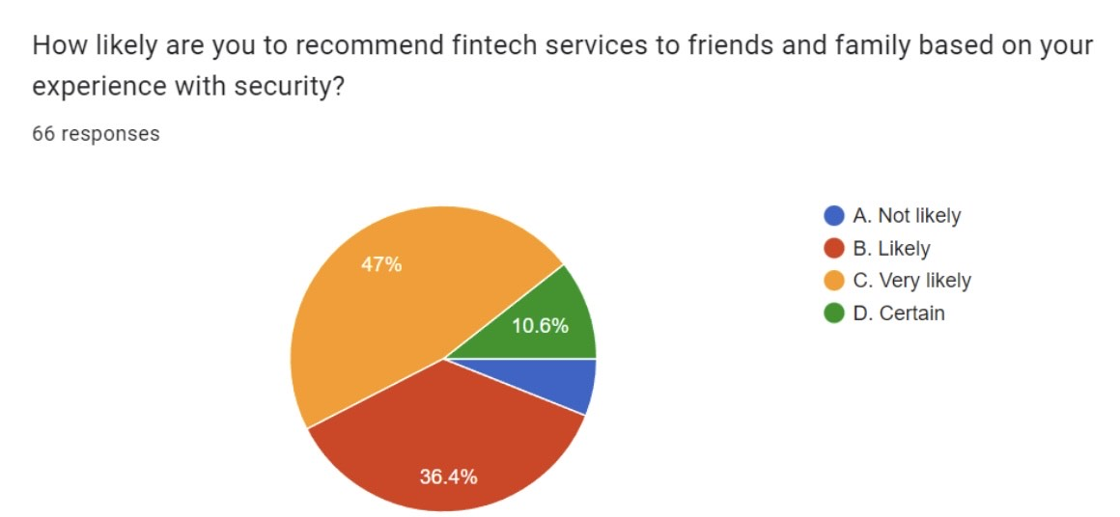
From this we can interpret that 47% of people are very likely to recommend fintech services to their friends/ family, 10.6% are certain of recommending and 36.4% are likely to recommend where as a smaller section are not likely to recommend due to their own reasons.

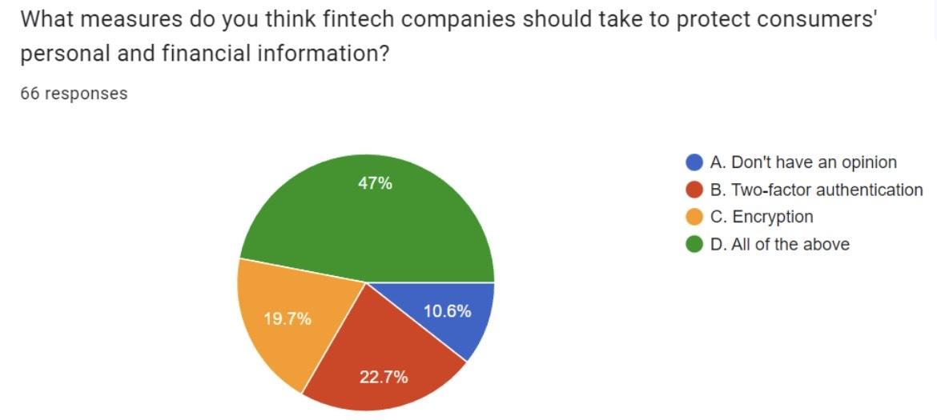

2 measures that fintech company should take are –
- 22.7% - think two factor authentication.
- 19.7% - think encryption
- 47% - think both
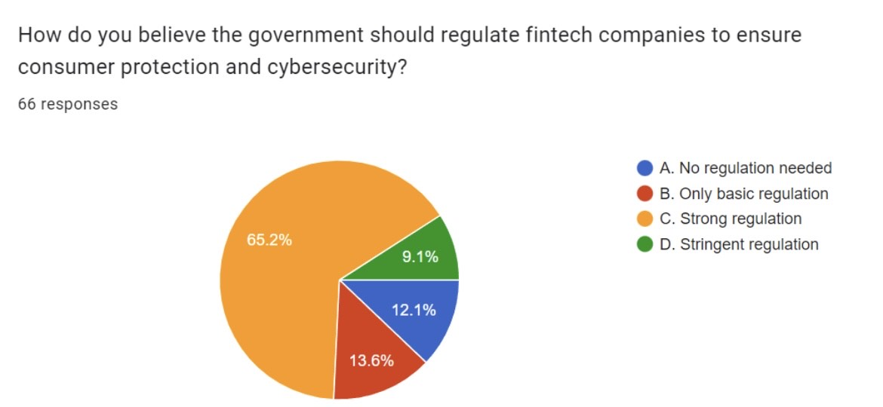
Around 65.2% think that the govt. Should strongly regulate fintech companies to ensure consumer protection and cyber security, 13.6% believe there should be only basic regulations, 9.1% believe in stringent regulations where as 22.2% thinks there’s no need of any kind of regulations.
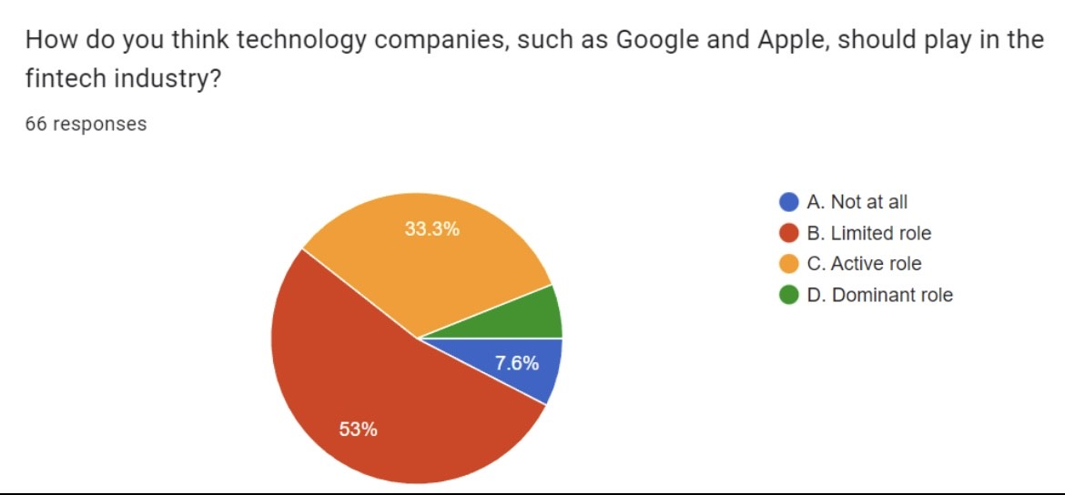

Around 53% people think there should be a limited role of tech. Companies such as google and apple to play in the fintech industry.
33.3% - active role
7.6% - people think these companies shouldn’t have any role in fintech industry.

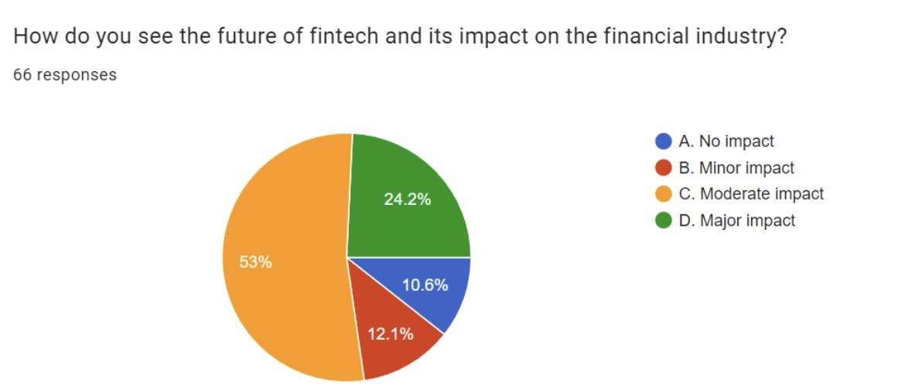

Around 53% people think there’s a moderate impact of future of fintech and its impact on the financial industry. 24.2% think there’s major impact, 10.6% think there’s no impact at all whereas 12.1% people see a minor impact.

Therefore, we can conclude this from all of the responses recorded that half of the people have an idea about fintech and even the cyber securities. Many people would like to know more about this. More than half have been using these services and something should be done as many are even concerned about the risk while using these services. They have even been rating the security system of these services as good and that should be maintained. A larger section of people would like to recommend these services to their friends and family. Fintech companies should provide both of these measures – 2 factor authentication and encryption to protect the consumers personal and financial information.

FINDINGS

The findings of fintech and cybersecurity have implications for various stakeholders, including government, business organizations, and the general public. Here are some potential benefits for each of these groups:
Government: The government can benefit from fintech and cybersecurity by promoting innovation in the financial sector while ensuring the security of financial systems. Governments can implement regulations and guidelines to ensure that fintech companies comply with cybersecurity standards, which can reduce the risk of financial crimes and data breaches. Additionally, the government can support the development of cybersecurity talent and research to improve the nation's cybersecurity posture.
Business organizations: Business organizations can benefit from fintech and cybersecurity by leveraging fintech innovations to streamline financial operations and enhance customer experiences, while minimizing the risk of cyber-attacks. By implementing robust cybersecurity measures, such as data encryption and multi-factor authentication, businesses can protect customer data and prevent financial losses due to cyber-attacks.
General public: The general public can benefit from fintech and cybersecurity by enjoying more convenient and secure financial services. With the rise of digital payments, people can now easily and quickly make financial transactions from their smartphones or laptops. Additionally, by ensuring the security of financial systems, people can have greater trust in the financial services industry and avoid financial scams and fraud.
In summary, fintech and cybersecurity can benefit government, business organizations, and the general public by promoting financial innovation, protecting sensitive data, and enhancing financial security.

IMPLICATIONS
The implications of fintech and cybersecurity for government, business organizations, and the general public are significant, and understanding them is essential for making informed decisions about financial services and security. Here are some key implications:
Government: Governments need to be proactive in creating regulatory frameworks and guidelines to ensure that fintech companies comply with cybersecurity standards. They must also invest in cybersecurity research and technology to stay ahead of evolving threats.
Business organizations: Business organizations need to invest in cybersecurity measures to protect customer data and financial transactions, and ensure that they comply with applicable regulations. Fintech innovations can help streamline financial services, but companies must balance innovation with security to maintain the trust of customers.
General public: The general public needs to be aware of the risks and benefits of fintech and cybersecurity, and how to protect themselves from cyber-attacks and fraud. They should also look for financial services that prioritize security while still providing convenient and accessible services.
Overall, the implications of fintech and cybersecurity require a coordinated effort from government, business organizations, and the general public to ensure that financial services are safe, accessible, and innovative. With the right approach, fintech and cybersecurity can bring numerous benefits to the financial services industry, while minimizing risks to customers and businesses alike.

OUTCOME
In India, the fintech industry has been rapidly growing and transforming the financial services landscape. However, this growth has also brought about new cybersecurity challenges. Here are some key findings of fintech and cybersecurity in India:
- The use of digital payment systems has increased significantly, leading to an increase in cyber-attacks on these platforms.
- Many fintech companies in India have adopted advanced cybersecurity measures such as biometric authentication, encryption, and AI-based fraud detection systems.
- The Reserve Bank of India (RBI) has implemented various regulations and guidelines for fintech companies to ensure they maintain a robust cybersecurity posture.
- Despite these measures, there have been several high-profile data breaches in the Indian fintech industry, highlighting the need for continued vigilance and improvement in cybersecurity practices.
- Fintech companies are collaborating with cybersecurity experts and investing in cybersecurity technologies to better protect customer data and financial transactions.
- Overall, while fintech innovations have brought numerous benefits to India's financial services industry, ensuring cybersecurity is critical to maintaining trust in these systems and protecting against financial losses and reputational damage.

CONCLUSION
The outcome of this study demonstrates how the Fintech sector has changed financial services in India. and the world's fastest-growing fintech market is in India. According to NASSCOM, the Indian fintech software market is expected to grow from its current USD 1.2 billion to USD 2.4 billion by 2020. The historically cash-based Indian economy has reacted favorably to the fintech possibility, which was primarily brought on by an increase in e-commerce and widespread smartphone use. A five-year CAGR of 22% is expected to increase the transaction value for the Indian fintech sector from an estimated USD 33 billion in 2016 to USD 73 billion in 2020. The Indian government also emphasizes and supports the fintech sector, as well as innovative concepts and developments related to the sector. In the financial sector, fintech is a new idea. The Indian economy benefits more from financial technology innovation, and the fintech services are more user-friendly and secure. Their costs for financial services are reduced by the fintech services.
The study has demonstrated how changes in the production of financial services brought about by digital innovation have an impact on the financial sector's industrial structure and are economically significant. Connectivity and computing advancements may increase productivity and competition. Unbundling of various products and services has occurred frequently in the financial services industry. Financial factors and frictions that initially prompted the need for financial intermediation have also made a comeback. The market structure of the financial sector may be moving towards a barbell pattern, whereby giant multi-product institutions coexist with smaller, more specialized specialist institutions.
Tools for regulatory and supervisory policy will need to change. Existing regulatory perimeters may not adequately cover emerging providers of financial services, and new players may pose challenges to day-to-day financial supervision. It is increasingly tough to manage competition and stability, both among financial services providers and across various stakeholders in reconfiguring financial product value chains. It will be necessary to set the rules for data control and the types of data that are acceptable for different services. Ideally, these rules should provide individuals autonomy while balancing consumer protection, competition, and efficiency. There will be new forms of bias and discrimination that need to be understood and combated. It will be necessary to strike a new balance between consumer protection, privacy concerns, stability, and integrity while also taking into account public preferences in various jurisdictions worldwide and within various societies. Instruments for monetary policy, systemic stability, and consumer protection—all of which are entirely outside the purview of this paper—might also need to change. The difficulties include sustaining the viability of deposit insurance schemes where new players grow to be significant, stabilizing credit markets where non-bank companies become big lenders, and granting new providers access to lender-of-last resort programs.
With regard to market structure, government must be deliberate. It is necessary to reconsider previous beliefs regarding the trade-offs between stability and competition. Traditional beliefs about how to keep finance and commerce separate are already being challenged. Measures of pricing and concentration for one market or firm may have become less useful, and existing approaches to competition regulation and antitrust may not be well suited to digital financial services. With markets driven by rising returns to scale but also lowering entry barriers for specialized services, the nature of contestability needs to be reevaluated. A barbell market arrangement may or may not be desirable depending on consumer skills and behavior that affect switching costs in a particular market. Minimum capital requirements, licensing standards, and other factors are already influencing market forces
A number of authorities are implementing effective policy changes to reduce trade-offs. Current entity-based regulations for giant IT companies, such as those proposed in the EU, UK, US, and China, can address concerns more ex ante, prevent anticompetitive behavior, and thereby support a level playing field. Requirements for data mobility and data privacy can enhance consumer protection while also potentially fostering competition. Yet, there will need to be a public discussion about what kinds of data are appropriate for use in financial services and when privacy laws might be bent for the sake of stability.
Authorities will need to work together to navigate this new territory successfully and to balance the important policy objectives. Domestically, competition and data protection authorities, industry regulators, central banks, and other financial sector regulators must work together. Authorities are collaborating on a global scale to coordinate policies and share knowledge about financial regulation of both incumbents and new entrants. Given the international repercussions of antitrust and data governance rulings as well as the opportunity to increase service efficiency by standardization in areas like interoperability, data protection, and cybercrime prevention, this is becoming more and more crucial.
REFERENCES
1. Name- Hayder M .Kareem Alduhaidahawi, Mustafa Salam; Date- October 2020; Title- The Financial Technology (Fintech) and cybersecurity; Link- https://www.researchgate.net/publication/346508094_The_Financial_Technology_Fintech_and_cybersecurity
2. Name- Ziba Habibi Lashkari, Arash Habibi Lashkari; Date- August 2021; Title- Cybersecurity Vulnerabilities in FinTech; Link- https://www.researchgate.net/publication/353683338_Cybersecurity_Vulnerabilities_in_FinTech
3. Name- Gurdip Kaur; Date- May 2021; Title- Cybersecurity Policy and Strategy Management in FinTech; Link- https://www.researchgate.net/publication/353715822_Cybersecurity_Policy_and_Strategy_Management_in_FinTech
4.Name- Jing Zhang, Meriem Sebai; Date- October 2020; Title- The Financial Technology (Fintech) and cybersecurity; Link- https://www.researchgate.net/publication/346508094_The_Financial_Technology_Fintech_and_cybersecurity
5. Name- Artie Ng, Benny K.B. Kwok; Date- July 2017; Title- Emergence of Fintech and cybersecurity in a global financial centre: Strategic approach by a regulator; Link- https://www.researchgate.net/publication/318754690_Emergence_of_Fintech_and_cybersecurity_in_a_global_financial_centre_Strategic_approach_by_a_regulator
6. Name- Taylan Turan; Date- January 2022; Title- Building a future-ready bank; Link- https://www.fintechfutures.com/2023/01/building-a-future-ready-bank/
7. Name- Alex Pugh; Date- September 2022; Title- Solving the cybersecurity puzzle; Link- https://www.fintechfutures.com/2023/02/solving-the-cybersecurity-puzzle/
8. Name- Ouliana Smith; Date- January 2023; Title- Should digital banking platforms be fraud prevention solutions by design? Link- https://www.fintechfutures.com/2023/03/should-digital-banking-platforms-be-fraud-prevention-solutions-by-design/
9. Name- Nick Bilodeau; Date- February 2023; Title- Executive panel: key banking cybersecurity developments for 2023; Link- https://www.fintechfutures.com/2023/03/executive-panel-key-banking-cybersecurity-developments-for-2023/

10. Date- February 2023; Title- Cybersecurity in this era of polycrisis; Link- https://www.fintechnews.org/cybersecurity-in-this-era-of-polycrisis/
11. Date- February 2023; Title- 5 cybersecurity threats to the financial sector; Link- https://www.fintechnews.org/5-cybersecurity-threats-to-the-financial-sector/
12. Date- January 2023; Title- Account-to-account payments: MultiSafepay adds MyBank to its payment method mix; Link- https://www.fintechnews.org/account-to-account-payments-multisafepay-adds-mybank-to-its-payment-method-mix/
13. Date- December 2022; Title- Digital payments are being reported to the IRS, what this means for your 2022 taxes; Link- https://www.fintechnews.org/digital-payments-are-being-reported-to-the-irs-what-this-means-for-your-2022-taxes/
14- Date- December 2022; Title- Fintech cybersecurity: how to safely integrate products; Link- https://www.fintechnews.org/fintech-cybersecurity-how-to-safely-integrate-products/

------------------------------------------------------------------------------------------------------------------------------------

