Blockchain Based E-voting System
Prashant Govardhan, Payal Chandel, Anand Kankirad, Nirmiti Meshram, Shlok Mishra, Natasha Wanjari
Computer Science and Engineering Department,
Priyadarshini College of Engineering,
Hingna Rd, Digdoh Hills, Nagpur-440019,
Maharashtra, India.

E-mail-er.phgovardhan@gmail.com,Payallchandel@gmail.com,anandkankirad1@gmail.com,mishrashlok03@gmail.com, nirmitimeshram@gmail.com, natashawanjari11@gmail.com.

Abstract— Profoundly progressed security techniques are exceptionally important for presenting the successful web-based casting a ballot framework in the entire world. An electronic democratic has arisen as a choice to paper-based casting a ballot to diminish overt repetitiveness and irregularities over the long haul. The fundamental part of safety and straightforwardness is a danger from worldwide political decision with the regular framework. Blockchain could be an uneasy innovation of current period and certifications to upgrade the strength of e-casting a ballot framework. this method presents a shot to use edges of blockchain like cryptological establishments and straightforwardness to achieve a proficient subject for e-casting a ballot. The projected subject adjusts to the basic necessities for e-casting a ballot conspires and accomplishes start to finish undeniable nature. The framework presents top to bottom investigation of the subject that with progress shows its viability to accomplish Partner in Nursing start to finish certain e-casting a ballot topic. The Overall decisions are as yet utilizing a concentrated framework where one association that oversees it. A portion of the issues that can happen in conventional electing frameworks are with an association that has full command over the data set and situation, it is feasible to control with the data set. This paper presents a study on some past democratic framework that is utilized by various nations and associations. Blockchain could be an interesting innovation of current time and blockchain certifications to improve the strength of e-casting a ballot framework. this method presents a shot to use edges of blockchain like cryptological establishments and straightforwardness to accomplish a productive subject for e-casting a ballot. The projected subject adjusts to the natural necessities for e-casting a ballot conspires and accomplishes start to finish unquestionable status. The framework presents top to bottom investigation of the subject that with progress.

Keywords--- Ethereum, Voting, Decentralized, Blockchain, Nodes.

I. INTRODUCTION

These days the races are the vital conventions which assists individuals with developing. In past, During the Most common way of counting the votes it has been done physically and it was extremely tedious cycle so we concocted the elector machine so counting the quantity of votes without consuming time will be simple. Yet, there is one impediment of utilizing this machine that is during this interaction anyone can do fakes and can abuse the information of candidates.so to keep away from this abuse and cheats we concocted the blockchain innovation. Blockchain innovation is the security which will give security to the framework and it is one of the arising advancements with solid cryptographic establishments which is utilized to look like an information structure that keeps up with and shares every one of the exchanges being executed through its beginning. The democratic framework that utilizes electronic gadgets to deal with projecting and taking into account votes is named e-projecting a polling form structure. The paper considering projecting a voting form system is displaced by the e-projecting a voting form. Presently a day to diminish the heap of labour and defer in outcome statement of casting a ballot result e-casting a ballot framework is more popular by private or public associations. It likewise saves papers which are comprised of trees which will ultimately save the catastrophic events.
E-casting a ballot these days has turned into an extremely reasonable approach to casting a ballot. Electronic democratic enjoys numerous upper hands over the customary approach to casting a ballot. A portion of these benefits are lesser expense, quicker organization of results, more prominent exactness and lower the gamble of human and mechanical mistakes. blockchain innovation is hence considered by a few, along with America, to be the best device, to be acclimated produce the new stylish majority rule polling form strategy. This paper assesses the work of blockchain as a help to carry out partner degree electronic voting form (e voting) framework

II.BACKGOUND AND LITERATURE REVIEW

II.I Survey Existing system
Literature survey is one of the most important steps in any of kind of research. Before start developing the system, we need to study the previous papers of our domain which we are working and on the basis of study we can predict or generate the drawback and start working with the reference of previous papers.
.
Paper title VOTEETH: AN E-VOTING SYSTEM USING BLOCKCHAIN [2] They proposed an e-Casting voting system framework that used the blockchain. The framework is decentralized and doesn't depend on trust. Any enlisted citizen will can cast a ballot utilizing any gadget associated with the Web. The framework is totally straightforward for the elector use and the blockchain stores the logarithms of every one of the exchanges in an exceptionally safe way which gives the confirmation to the citizen that his vote has been effectively casted and he might check the same later anytime of time.

Paper title ‘E-VOTING SYSTEMS USING BLOCKCHAIN: A SYSTEMATIC REVIEW AND FUTURE RESEARCH DIRECTION [1] The Blockchain is another sort of innovation, an assortment of various blocks is, associated by hubs which is called as interconnected hubs that have their duplicate of the dispersed records that contains the historical backdrop, everything being equal. Information is handled and put away in the blocks with the assistance of information mining process. Each block in blockchain contains a record of the past block and thus it shapes a chain of blocks, with the primary block known as the beginning block. Subsequently, it shapes a connected rundown kind of Construction. Blockchain has various records where information must be affixed yet not erased or altered. It is unchanging. Blockchain has two access specifier it tends to be public or private, in open mode anybody can alter the data into the blockchain and in confidential mode just those individuals can alter the data whose are approved.

Paper title “Star-vote: A secure, transparent, auditable, and reliable voting system.”, in 2013 Electronic Voting Technology Workshop/Workshop on Trustworthy Elections (EVT/WOTE 13). Washington, D.C.: USENIX Association, 2013 [3] This paper describes the STAR-Vote design, that may preferably be the next-generation electoral system for Travis County and maybe elsewhere.

Paper title Blockchain Enabled E-Voting System [4] In this paper they are attempt to proposed framework includes a client server design coordinated with a block chain framework. The base prerequisites required by an elector is a cell phone or a PC. The targets of the reception of the Blockchain innovation in the arrangement are - To offer a help casting a ballot plot that is open, fair and freely unquestionable; To upgrade the constituent cycle that empowers secure, fast, financially savvy, straightforwardness and further developed character confirmation.

II.II Limitations of Existing system
Ongoing significant specialized difficulties connecting with e-casting a ballot framework typify, but not limited to get computerized character the board. Any potential resident should be enrolled to the discretionary framework before the decisions. Their information should be during a carefully processable organization. In addition, their personality information should be whole non-public in any including data. old E-casting a ballot framework could deal with following issues:
• Unknown vote-projecting
Each vote might contain any decision per competitor, ought to be unknown to everybody including the framework chairmen, after the vote is submitted through the framework.
• Individualized polling form processes
How a vote is depicted inside the including net applications or information bases keeps on being AN open conversation. while a straightforward instant message is that the most terrible arrangement, a hashed token is wont to offer lack of definition and respectability. In the meantime, the vote should be non-trustworthy, that can't be fortified by the symbolic goal.

III. RELATED WORK

In this part, we momentarily survey the connected work on Web based Casting a ballot Framework, First, SQL is utilized which contains the check information which is as of now put away. Second, the username and secret key are utilized to check regardless of whether the specific individual is login. Rather than this, we can likewise utilize Aadhaar card gave the authority data of the elector.
Online is more effective rather than disconnected mode and putting away the democratic information to get online server. Results can be shown by administrator in the wake of entering client id and secret key. The proposed technique is to construct a Shrewd democratic framework involving Blockchain for any elector in INDIA to make the choice to their separate supporters from anyplace in INDIA by going to their closest democratic stall in the spot of stay.
Likewise, to foster a safe shrewd democratic framework which Gives the citizen to cast a ballot from any district with in India to their Local location and it is additionally extremely successful for a not individual having a typical cell phone with him/her and for those to get to cast a ballot from the closest Democratic Corner with a protected democratic cycle without failing to cast a ballot. This framework gives security from all kind of assaults, when vote is heading out from casting a ballot client to casting a ballot server from their trial and error in light of the blockchain encryption strategy.
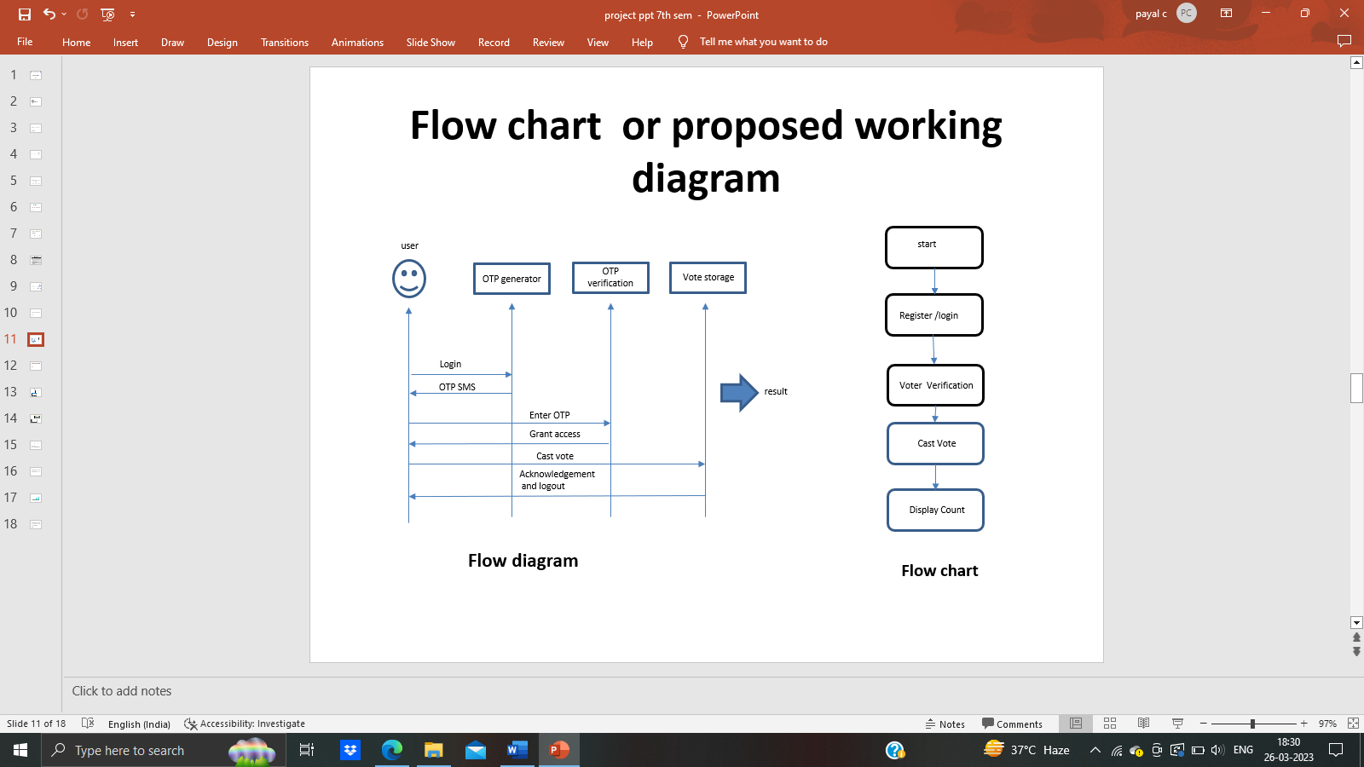
These assaults incorporate security dangers from inactive as well as dynamic interloper. For confirmation of citizen rather than USERNAME, on the off chance that we can utilize thumb impression or the OTP check of elector or catch photograph of his/her face and contrast it and photograph put away in our data set, it will turn out to be safer. Underneath given is the stream outline of the proposed technique.
In This paper has shown the chance of laying out E-Casting a ballot convention in view of public-key encryption. The security of the proposed E-Casting a ballot relies upon RSA public key encryption convention utilizing blockchain. It permits the elector to cast a ballot from his/her very own PC (PC) with next to no additional expense and exertion. This convention is proposed to supplant the untrustworthy past democratic framework, since electors feel reasonably certain that their votes will be counted and nobody will actually want to get to it without them.

The following is the stream graph given: -
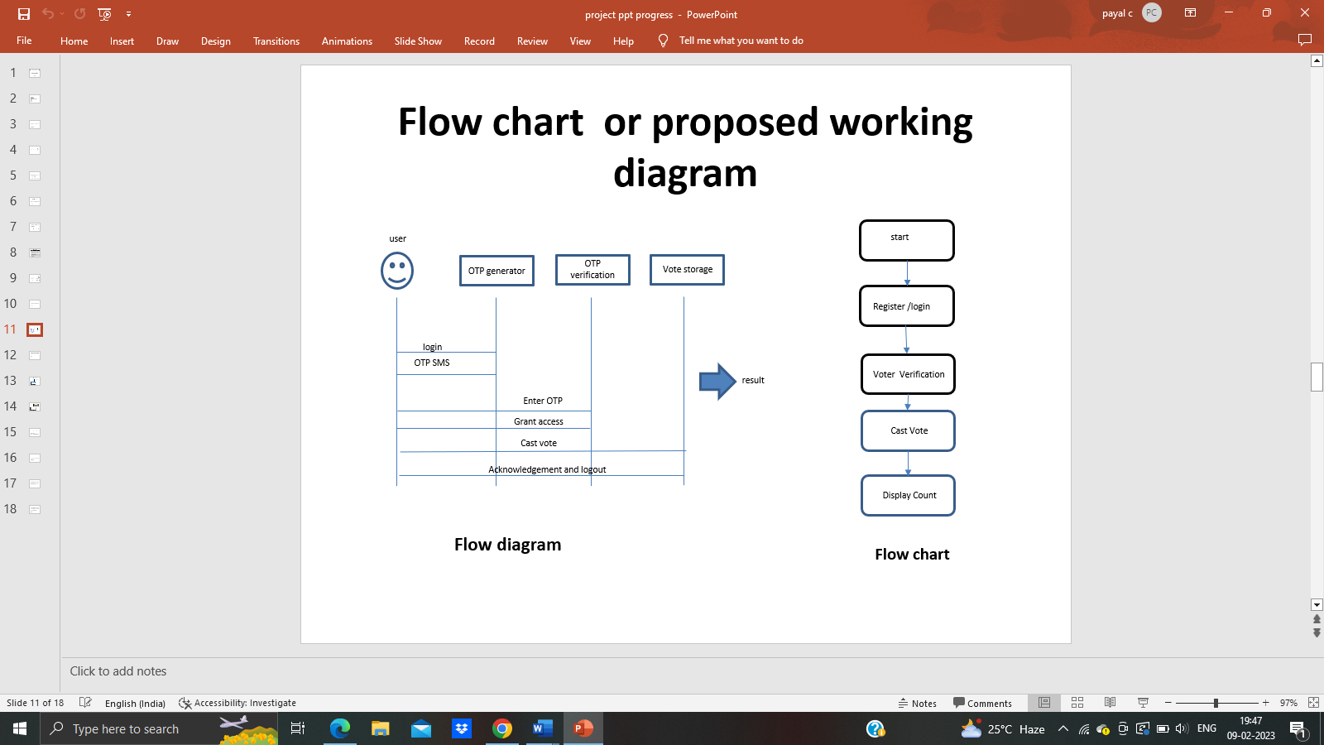

In this paper, a block-chain-based casting a ballot framework. It needs time to promote block-chain for a democratic framework as it is an original thought and casting a ballot itself is an urgent matter in a vote-based country.

IV. METHODOLOGY

The straightforward legitimization could be a 'chain' of blocks. A block is partner degree mass arrangement of data. information square measure gathered and method to suit in an extremely block through a cycle known as mining. each block might be known utilizing a science hash (likewise alluded to as a computerized finger impression). The block formed can contain a hash of the past block, so blocks will kind a grouping from the essential block ever (known on the grounds that the Beginning Block) to the molded block. during this strategy, all the data might be associated by means of an associated list structure.

IV.I Analysis/Framework/Algorithm

Working:

• The SHA-256 calculation takes a contribution of any irregular length and produces a result of a fixed length(256 bits).
• On account of SHA-256 calculation regardless of how enormous or little is the information, the result is of fixed length (256 bits).

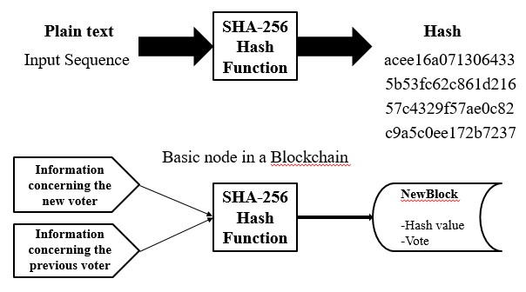

A cryptographic hash capability has the accompanying properties:

1. Deterministic: This implies that regardless of how frequently we enter similar info we will get the same result.

2. Quick Computation: This implies that the outcome is created rapidly and this prompts an expansion in the framework efficacy.

3. Pre-Picture resistance: Suppose we are rolling a dot (1-6) and on second thought of getting a particular number we get the hash value. Now we work out the hash worth of each number and afterward contrast it and the result. And for a bigger informational collection it is feasible to break pre-Picture obstruction by savage power strategy and this takes too lengthy that it doesn't make any difference.

4. Small changes in Info change the entire Result: A minor change in the info essentially changes the entire result.

5. Collision Resistant: Every information will have a novel hash esteem.

6. Puzzle friendly: The mix of two qualities gives the hash worth of new factor.

The need of hashing in blockchain:
• The blockchain is a succession of blocks that contain information.
• Each block has a hash pointer that contains past block's information.
• So, in the event that a programmer attempts to go after a specific block, the progressions will be reflected to the whole chain of blocks.
• Subsequently, the blockchain idea is so progressive.

IV.II Details of Hardware and Software

IV.II.I Software Requirements
• Operating system: Windows 10.
• System: Visual Studio.
• Server: Localhost.
• Database: MS-SQL Server 2012/2014.

IV.II.II Hardware Requirements
• Processor: Intel Quad centre 1.7 GHZ Processor
• HD: Least 10 GB of HD.
• Ram: Least 8 GB of Smash

IV.III Design details

The .NET System is Microsoft's Overseen Code programming model for building applications on Windows customers, servers, and versatile or installed gadgets. Microsoft's .NET Structure could be a PC code innovation that is available with numerous Microsoft Windows employable frameworks. inside the accompanying segments portrays the essentials of Microsoft .Net Casing work Innovation and its associated programming models.

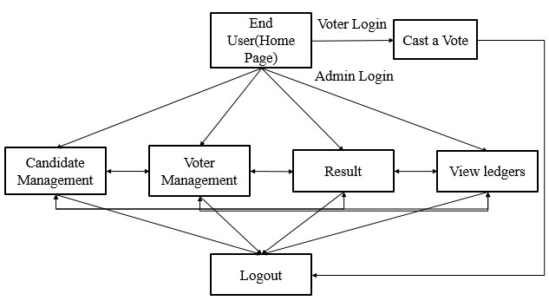

C# might be a language for talented programming. C# (articulated C sharp) might be a programming language intended for building a huge differ of big business applications that sudden spike in demand for the .NET Structure. The objective of C# is to deliver a direct, protected, current, object-situated, predominant and solid language.
.NET turn of events. conjointly it permits engineers to make answers for the broadest change of buyers, as well as net applications, Microsoft Windows Structures based applications, and merger and brilliant client devices.[4]

•Microsoft SQL Server 2008:

Business these days requests an extraordinary very information the executive’s goal. Execution quantifiability, and reliability are fundamental, but organizations as of now expect extra from their key IT venture.
SQL Server 2008 surpasses reliable Ness necessities and gives imaginative capacities that increment specialist adequacy, coordinate heterogeneous IT environments, and amplify capital and usable financial plans. SQL Server 2008 gives the endeavour information the executives stage your association needs to adjust rapidly in an extremely fast steadily evolving environmental factors.
Benchmarked for versatility, speed, and execution, SQL Server 2008 is a completely endeavour class data set item, giving centre help to Extensible Increase Language (XML) and Web queries.[3]

•Simple to-utilize Business Intelligence (BI) Apparatuses:

Through affluent data investigation and information handling capacities that incorporate with familiar applications like Microsoft work environment, SQL Server 2008 licenses you to deliver all of your staff with indispensable, ideal business information custom fitted to their particular information wants. each duplicate of SQL Server 2008 boats with an assortment of metallic component services.[4]

• Self-Tuning and the board Abilities:

Progressive self-tuning and dynamic self-config urging choices improve data execution, though man agreement apparatuses automatise standard exercises. Graphical apparatuses and execution, wizards change arrangement, data style, and execution watching, allowing data chiefs to target meeting vital business desires.[4]

Detailed Design
The following use case diagram explains the flow of the project from user end and backend.

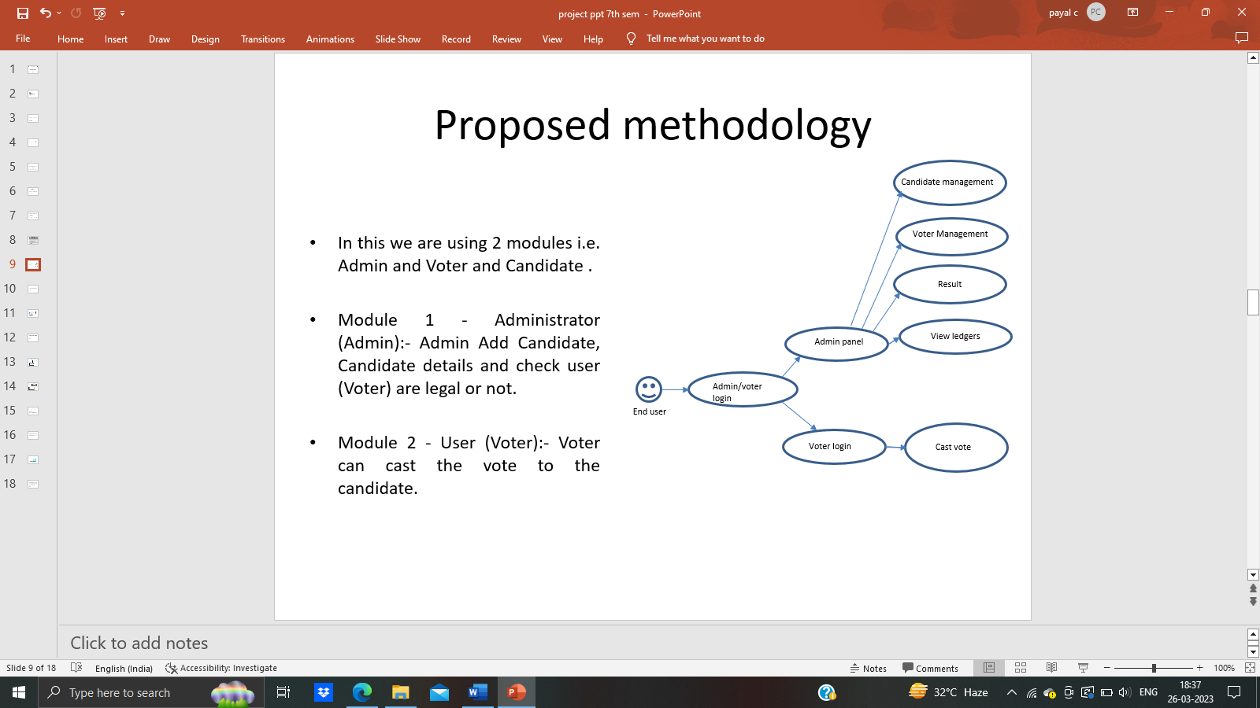

An elector at initial logs into the framework. He can accomplish this by either making another record or bringing in another one from the framework. On making the choice, he signs the exchange with its advanced mark or by checking it by the id secret key too. On marking the exchange, the exchange is distributed to the organization and is mined by the Boot likes. For the most part, the vote is public, consequently the data of vote isn't encoded yet because of the security reason we are keeping it scrambled.
The blockchain-based e-casting a ballot framework can be applied to various democratic circumstances and different applications. In this paper, we have introduced a proof-of-idea framework for fostering an e-casting a ballot framework that used the Ethereum blockchain. The framework is decentralized and doesn't depend on trust. Any enrolled citizen will can cast a ballot utilizing any gadget associated with the Web however they can cast a ballot just a single time after that the framework will be obstructed. The Blockchain will be openly evident and circulated such that nobody will actually want to ruin it and in future work, we will examine the chance of fostering an in-house agreement calculation to suit for the fluctuating requirements of safety.

V. DISSCUSSION

In this casting a ballot framework, the elector can make their choice to as it were one pioneer for each post. In the event that the elector can attempt to give their vote again then it would be confined by the democratic framework what's more, the message will be show on the citizen side window, it tends to be refreshed in future augmentation of this undertaking. The foundational layout has excluded from model of casting a ballot framework. We are carrying out it for giving greater security and straightforwardness. It help to choose the best contender for the advancement of region without doing any misbehaviour. The underlying model of casting a ballot framework can be updated in future by giving the IP locations to more clarity. This casting a ballot framework will diminish the likelihood phony. The framework can be straightforward for the average citizens and cost proficient. The framework has the capacity to trade and utilize data and has the possibility to make the democratic interaction simpler and that's only the tip of the iceberg effective for the citizens.
The designated benefits of casting a ballot framework are referenced underneath.
• Time effective
• Climate agreeable.
• Open from anyplace.

VI. CONCLUSION

This framework is likewise utilized for corporate organizations to lead their decisions for various posts, for example, the official political race, director political decision and so on. The advantages of picking e-casting a ballot arrangement ought to offset the downsides, not just when contrasted with other electronic democratic frameworks yet additionally when contrasted with paper casting a ballot. Any extra expense brought about by e-casting a ballot ought to be legitimate by the advantages that can be anticipated from the arrangement. Propose a blockchain-based e-casting a ballot conspire, which meets the fundamental necessities of e-casting a ballot cycle. All votes in the blockchain are cryptographically connected block by block. The block with a higher worth of mark is chosen over others when the others when they have the equivalent timestamp.

VII. REFERENCES

[1] See discussions, stats, and author profiles for this publication https://www.researchgate.net/publication/353731219 VOTEETH: AN E-VOTING SYSTEM USING BLOCKCHAIN Article · June 2019 DOI: 10.26562/IRJCS. 2019.JNCS10081
[2]E-VOTING SYSTEMS USING BLOCKCHAIN: A SYSTEMATIC REVIEW AND FUTURE RESEARCH DIRECTION Dhiraj Amrutkar*, Gaurav Dongare*, Sayog Sonune*, Archana Y. Chaudhari**
[3] Bell, S., Benaloh, J., Byrne, M. D., Debeauvoir, D., Eakin, B., Kortum, P., McBurnett, N., Pereira, O., Stark, P. B., Wallach, D. S., Fisher, G., Montoya, J., Parker, M. and Winn, M. (2013).“Star-vote: A secure, transparent, auditable, and reliable voting system.”, in 2013 Electronic Voting Technology Workshop/Workshop on Trustworthy Elections (EVT/WOTE 13). Washington, D.C.: USENIX Association, 2013

4] Vol. 8, Issue 4, April 2019Copyright to IJARCCE DOI 10.17148/IJARCCE.2019.8412 77 Blockchain Enabled E-Voting System Sri Raksha S Arun1, Shibani2, Spoorthi S3, Vaishnavi R Kamath4, Dr. C Vidya Raj5 Department
of Computer Science and Engineering, The National Institute
of Engineering Mananthavadi Road, Mysuru, India1,2,3,4,

[5] Blockchain technology based e-voting system. Prof. Anita A. Lahane1,∗, Junaid Patel1,∗∗ , Talif Pathan1,∗∗∗ and Prathmesh Potdar1,∗∗∗∗. 1Juhu Versova Link Rd, behind HDFC Bank, Gharkul Society, Bharat Nagar, Versova, Andheri West, Mumbai, Maharashtra 400053.
[6] Prathmesh Potdar1, ITM Web of Conferences 32, 03001 (2020) ICACC-2020

[7] Private, public, and consortium blockchains - what’s the difference? https://www.binance.vision/blockchain/ private-public-and-consortium-blockchains-what’s-the-difference. Accessed: 2020-01-24
[8] Ashish Singh, Akali Chatterjee, Sec EVS: Secure Electronic Voting System Using Blockchain Technology, International Conference on Computing, Power and Communication Technologies (GUCON)Galotti’s University, Greater Noida, UP, India. Sep 28-29, 2018.
[9] Private, public, and consortium blockchains - what’s the difference? https://www.binance.vision/blockchain/ private-public-and-consortium-blockchains-what’s-the-difference. Accessed: 2020-01-24 What is blockchain. https://www.investopedia.com/terms/b/blockchain. asp. Accessed: 2020-01-24.

.

