APPLICATION FOR SKIN DISEASE DIAGNOSIS SYSTEM USING CONVNET
Byreddy Harika Reddy¹, Dunaboina Sneha Nagu^{2,} Gooty Mohammed Nameera Fathima³, Appidi Uday Laxmi⁴, N. Ramya⁵
^{1,2,3,4}B.Tech. Student, Department of Computer Science and Engineering,
harikareddy2924@gmail.com, snehanagu0512@gmail.com, nameerafathima9266@gmail.com,
udaylaxmi0825@gmail.com, ramya.nellutla@gmail.com
⁵Assistant Professor, Department of Computer Science and Engineering,
Nalla Malla Reddy Engineering College, Hyderabad, India

Abstract— Skin disease among humans has been a common disease, millions of people are suffering from various kinds of skin diseases. Usually, these diseases have hidden dangers which lead to not only lack of self-confidence and psychological depression but also lead to a risk of skin cancer. Medical experts and high-level instruments are needed to diagnosis these skin diseases due to non-availability of visual resolution in skin disease images. The proposed framework includes deep learning techniques such as CNN architecture and three predefined models called Alex Net, ResNet, InceptionV3. A Dataset of images with seven diseases has been taken for the Classification of Skin diseases. They include diseases like Melanoma, Nevus, Seborrheic Keratosis etc. The dataset was extended by adding images having cuts and burns, which were classified as skin disease by most of the existing systems. The usage of Deep Learning algorithms has reduced the need for human labor, such as manual feature extraction and data reconstruction for classification purposes. In this project we develop a use doctor interaction portal to show skin disease prediction module with CNN and doctor appointment booking and user-friendly chat bot.

Keywords—Diagnosis, CNN, Alex Net, ResNet, InceptionV3, Deep learning Algorithms, Chatbot.

1. INTRODUCTION

Skin is one of the most important and quickest developing tissues of the human body. The burden of skin disease is regarded as a multidimensional concept that comprehends psychological, social and economic significance of the skin disease. It is a contamination that takes place in humans of all ages. Skin is regularly broken due to the fact it's far a touchy a part of the body. There are more than 3000 skin diseases. A cosmetically look spoiler disease will have a big effect and might reason extensive ache and everlasting injury. Most of the chronic skin conditions, along with Atopic eczema: a condition that causes dry, itchy and inflamed skin. It's common in young children but can occur at any age. Psoriasis:A skin disease that causes a rash with itchy, scaly patches, most commonly on the knees, elbows, trunk and scalp. Vitiligo:A chronic (long-lasting) autoimmune disorder that causes patches of skin to lose pigment or color. Leg ulcers:It is a simply a break in the skin of the leg, which allows air and bacteria to get into the underlying tissue., aren't right now deadly, they may be diagnosed as an extensive problem on fitness popularity which include physical, emotional and economic outcome. On the other hand, skin cancers are potentially lethal and their trouble is associated with the temporality that they carry. One of the most frequent ailments among people all over the world is skin disease. Basal cell carcinoma (BCC): It appears as a slightly transparent bump on the skin. It occurs most often on areas of the skin that are exposed to the sun, such as your head and neck. Melanoma:It is a form of skin cancer that begins in the cells (melanocytes) that control the pigment in your skin. Serous endometrial intraepithelial carcinoma (SEIC): It is a rare but highly aggressive form of uterine endometrial cancer. Squamous cell carcinoma: A common form of skin cancer that develops in the squamous cells that make up the middle and outer layers of the skin. are examples of skin cancers. The occurrence of skin cancer is currently greater than the occurrence of other new kinds of lung and breast cancer. Several skin illnesses have symptoms that can take a long time to treat since they can grow for months before being recognized. As a result, computer-based disease diagnosis comes into play since it can produce a result in a short period of time with more accuracy than human analysis utilizing laboratory procedures. Deep Learning is the most widely used technology for skin disease prediction. Deep learning models will use inferred data to identify and explore features in unexposed data patterns, resulting in significant efficiency even with low computational models. This study presents a robust mechanism for accurately identifying skin diseases using supervisory approaches that reduce diagnostic costs. This has prompted the researchers to consider using a deep learning model to categorize the skin disease based on the image of the affected region. We are going to propose a Skin disease Diagnosis System to detect the diseases type using ConvNet which is a fast, effective and user friendly.
2.LITERATURE REVIEW
Manual diagnosis of skin diseases by visiting and consulting dermatologists is time consuming. Most rural areas do not have this option. These rural people need to travel to a nearby city for advice and diagnosis. This takes a lot of human effort. Not to mention, it costs a lot just to see your doctor. This also includes human contact, which is an unnecessary evil in this pandemic crisis. Few diseases are contagious. In the existing system, body contact is unavoidable. The existing computer-aided diagnosis involves identifying burns and injuries as skin diseases. The accuracy of these methods is not as good as needed. Thus, there is a need to develop a computer-aided system that automatically diagnoses the skin disease problem and differentiates skin diseases with other skin issues. Quan Gan et.al [3] used image colour and Texture feature for the recognition of skin disease. Median filtering was used to pre-process the images. Denoise images are rotated to get the segments of the images. GLCM tool was used to extract text features and finally used SVM for classification of skin diseases herpes, dermatitis, and psoriasis. Md Nafiul Alam et al [4]., “Automatic Detection and Severity Measurement of Eczema Using Image Processing”, suggested an automatic eczema detection and severity measurement model using image processing and computer algorithm. The system identified and determine the severity of eczema by allowing patients to input an image of the affected skin area. This system used image segmentation, feature extraction, and statistical classification to recognize and differentiate between mild and severe eczema. Once the eczema type was identified, a severity index was assigned to that image. Later Researches used Deep learning techniques for classifying the skin diseases. Parvathaneni Naga Srinivasu et.al [5] used deep learning based MobileNet V2 and Long Short Term Memory for classifying skin diseases. A grey level co-occurrence matrix was used to estimate the progress of disease growth. The system has achieved an accuracy of 85% on the HAM10000 skin disease dataset. S.Malliga et.al [6], used the CNN algorithm for training and classifying all kind of clinical images. They have taken three types of skin diseases. They are Melanoma, Nevus, Seborrheic keratosis and achieved an accuracy of 71%.Nazia Hameed et.al [7] designed, implemented and tested to classify skin lesion image into one of five categories, i.e. healthy, acne, eczema, benign, or malignant melanoma using AlexNET, a pre-trained CNN model to extract the features. SVM classifier was used for classification and the overall accuracy achieved is 86.21%.
3.METHODOLOGY

Mechanism of ConvNet
Firstly we need to understand the CNN classfication model, how it is training the dataset and giving the prediction of diseases.
Steps Required:
STEP1: The first step to this project is to collect reliable data for training our deep learning model and we have preferred data about skin lesions that is provided in Kaggle data science web site.
STEP2: Preprocessing the acquired data for preventing future run time exceptions while training the model.
STEP3: Divide the data into training and testing part. Now augmentation of data has to done to increase the size of the training data as the obtained data from Kaggle is not enough for training the deep network model.
STEP4: Prepare a convolutional model to predict the required outputs. As this application is meant for commodity level devices, we preferred Mobile Net model to train on our dataset.
STEP5: Train the model and valuate it on the validation set and finally evaluate the model based on the learning curves obtained during training.
STEP6: Convert this model in TensorFlow is model to deploy it into the web application.
STEP7: Now finally, develop a web application that can take input as skin image and display disease probabilities using is model, we include in it.

Apply
(colorLayoutFilter)
Dataset size
Increase
Dataset
Image Filter

Splitting
Dataset
into
training (90%)
and testing (10%)
Attributes
Selection
Training Data

Test Data

Apply Classification Algorithms
Prediction of Classifying Diseases
Classification model

Fig 1: System Architecture

A system architecture or systems architecture is the conceptual model that defines the structure, behavior, and more views of a system. An architecture description is a formal description and representation of a system is organized in a way that supports reasoning about the structures and behaviors of the system.
In the methodology of this project, we have the following two modules in it.
User Module
Using this module user will register with application login with valid username and password and upload image to website and load trained CNN model and preprocess input image and give input to model and get predicted skin disease type as result. User can search for doctors and send request for appointment and get confirmation from doctor. User can use chat bot option to search for queries and get results from queries.
Doctor Module
Using this module doctor will register with application and view requests received from user and accept request.
Chat bot Module:
Dataset:
Text file with questions and answers are used as dataset in this project. Skin disease related queries with queries and answers are given in text file which is prepared by taking data from health care website. Data set can be increased by adding more records to the txt files.
Pre-processing:
In this step required chat bot libraries are initialized and text data is taken as input to NLP module and preprocessing is performed. Data set question and answers are stored in database. While application I executed preprocessing is performed.
Chat Bot Web APP:
Flask framework is used to develop chat bot application which has input option from user and question posted by user is processed and verified with the answer which is trained using NLP model and result is displayed to user based in input question.
Development Process:
ChatBot is a library in python which generates a response to user input. It used a number of machine learning algorithms to generates a variety of responses. It makes it easier for the user to make a chatbot using the chatbot library for more accurate responses. The design of the chatbot is such that it allows the bot to interact in many languages which include Spanish, German, English, and a lot of regional languages. The Machine Learning Algorithms also make it easier for the bot to improve on its own with the user input.
Five Steps for building a chatbot
Installation of chatbot and chatbot corpus

Import the installed modules

Provide a name for your chatbot

Use logic Adapters

Training, Communication and testing

Fig 2: Building a chatbot

3. RESULTS

Initially, the user upload the image of the affected area. To optimize the skin images, we apply some image processing method by removing the background. The result is based on a pre-trained CNN model. The image is fed into our model and predicted skin disease type is generated as a result as in the figure1 (a).
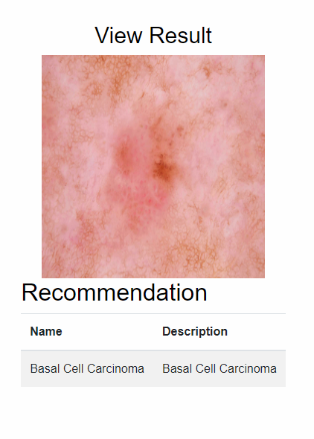Fig 3: Skin Disease Prediction

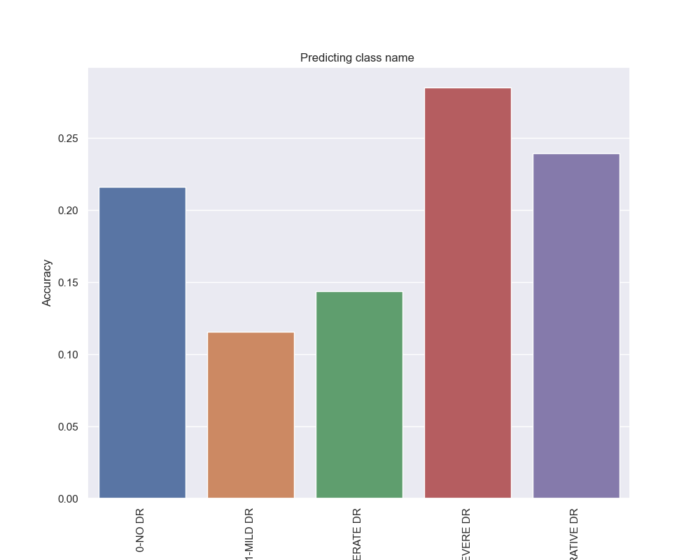
Fig 2: Accuracy

The graph shows the accuracy of the different skin diseases.The proposed system is able to classify the different types of skin disease with accuracy of about 90%.
The system consist of Chatbot where user can can get answers to the Skin disease related queries. The system also consists of Doctor module where users can book a doctor’s appointment in the nearby location.
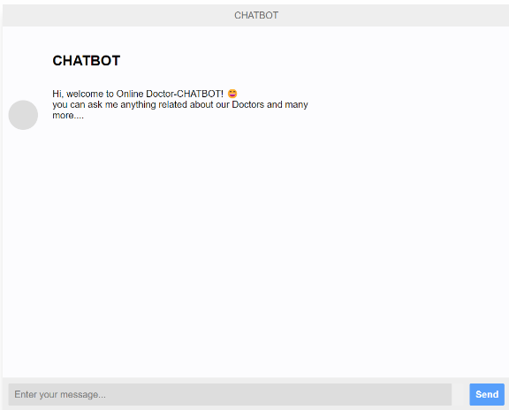

Fig 5: Chatbot

4. CONCLUSION

In this project, we design a doctor patient interaction portal for skin disease prediction and appointment booking with user friendly along with chat bot application. It can be used to help people from all over the world and can be used in doing some productive work. The tools used are free to use and are available for the user, hence, the system can be deployed free of cost. The application developed is light-weight and can be used in machines with low system specifications. It has also a simple user interface for the convenience of the user. The image processing and machine learning algorithms were successfully implemented.
The convolutional neural network-based system was implemented to classify the disease present in the input skin image (either from a dataset or Webcam). Skin image with different shape & size of the disease images has been fed at the input for training the system. The proposed system is able to classify the different types of skin disease with accuracy of about 90%.

5.ACKNOWLEDGEMENTS

Skin disease diagnosis system using ConvNet will have a lot of uses in the future. It is estimated that 90% of the search fields will be enabled with this system. It helps to diagnosis the skin without any instruments and help for the better treatment. Even from the doctor we can get the suggestions and take care about our skin.

6.REFERENCES
[1]R.J.Hay,N.E.Johns,H.C.Williams,I.W.Bolliger,R.P.Dellavalle,and D. J. Margolis, ``The global burden of skin disease in 2010: An analysis of the prevalence and impact of skin conditions,'' J. Investigative Dermatol- ogy, vol. 134, no. 6, pp. 1527_1534, 2014 .

[2].X. Huang, J. Zhang, J. Li, S. Zhao, Y. Xiao, Y. Huang, D. Jing, L. Chen, X. Zhang, J. Su,Y.Kuang,W. Zhu, M. Chen, X. Chen, and M. Shen, ``Daily intake of soft drinks and moderate-to-severe acne vulgaris in Chinese Adolescents,'' J. Pediatrics, vol. 204, pp. 256_262, Jan.2018.

[3].Y.Deng,Q.Peng,S.Yang,D.Jian,B.Wang,Y.Huang,H.Xie,andJ.Li, ``The rosacea-specific quality-of-life instrument (RosQol): Revision and validation among Chinese patients,'' PLoS ONE, vol. 13, no. 2, Feb. 2018, Art. no. e01924878

[4].C.Junchen,W.Zeng,W.Pan,C.Peng,J.Zhang,J.Su,W.Long,H.Zhao, X. Zuo, X. Xie, J. Wu, L. Nie, H.-Y. Zhao, H.-J. Wei, and X. Chen, ````Symptoms of systemic lupus erythematosus are diagnosed in leptin transgenic pigs,'' PLoS Biol., vol. 16, no. 8, Aug. 2018, Art. no. e2005354.

[5].X.Xiaoyun,H.Chaofei,Z.Weiqi,C.Chen,L.Lixia,L.Queping,P.Cong,Z. Shuang, S. Juan, and C. Xiang, ``Possible involvement of F1F0-ATP synthase and intracellular ATP in Keratinocyte differentiation in normal skin and skin lesions,'' Sci. Rep., vol. 7, Feb. 2017, Art. no.42672.

[6].W. Chen, X. Zhang, W. Zhang, C. Peng, W. Zhu, and X. Chen,``Polymorphisms of SLCO1B1 rs4149056 and SLC22A1 rs2282143 are associated with responsiveness to acitretin in psoriasis patients,'' Sci. Rep.. vol. 4, no. 1, 2018, Art. no. 13182. doi: 10.1038/s41598-018-31352-2

