GENERATION OF BIOELECTRICITY USING METAL OXIDE COMPOSITES TO ENHANCE POWER DENSITY IN MICROBIAL FUEL CELL

ABSTRACT
A Microbial Fuel Cell is a Bioelectrochemical device that expect the microorganism to produce electric power or electrical energy. Due to the continuous innovation from natural source to implicit the electric power leads to future ‘generous. In a microbial fuel cell (MFC), power can be generated at the anode from the oxidation process of organic matter by microorganism, with reduction of oxygen at the cathode. Proton exchange membranes used in MFCs are permeable to oxygen, resulting in the diffusion of oxygen into the anode chamber. A two-chamber MFC containing a proton exchange membrane was inoculated with a nanoparticle. The nanoparticle somehow produces more electron compared to the bare PEM. Depending on the operational parameters of the MFC, different metabolic pathways are used by the microorganism. This determines the selection and performance of specific organisms. Here we discuss how microbes use an anode as an electron acceptor and to what they experience to generate electrical output. The analytical output was carried out through CV and LSV. This show that the corresponding performance, advantages and disadvantages, and future potential applications of select electron acceptors (e.g., CuO and MnO nanoparticles) and mediators.

KEYWORDS: Microbial Fuel Cell, Nanoparticles, PEM, Electrodes, Electron acceptor, cyclic voltammetry, linear sweep voltammetry
1.INTRODUCTION
Nanotechnology is a mindset, even though the scientific community is fascinated with the field of nanoscience, most of the ongoing discussions, definitions, and attention is focused on nanotechnology. As such, it represents a broad term which demonstrates the apotheosis of man’s ceaseless urge for knowledge having practical potential. The meaning of the term nanotechnology is any technology operating on the nanoscale which has applications in the real world, that is, to employ single atoms and molecules to form functional structures. (Kaehler, 1994) The field of nanotechnology involves the creation and utilization of chemical, physical, and biological systems with structural features between single atoms or molecules to submicron dimensions, and also the assimilation of resultant nanostructures into larger systems. (Daniel, 2004) The simplest definition of nanotechnology is “technology on the nanoscale.” Subsequently, various definitions of nanotechnology have evolved. This original definition requires further development, such as a definition of what is meant by nanoscale. Thus, we cannot properly define nanotechnology unless we define “nanoscale,” that is, a scale covering 1–100 nm. A brief definition of nanotechnology is an “atomically precise technology” or “engineering with atomic precision” (Rao, 2001)
Nanotechnology can play a significant role in the extension of innovative methods used to create new products, to substitute present production equipment, to reformulate novel materials and chemicals toward improved performance resulting in reduced material and energy consumption, to reduce harm to the environment, and for environmental remediation (Lee, 2010).
MFCs are Bioelectrochemical cells having an anode chamber (containing microorganisms and anolyte under anaerobic conditions) and a cathode chamber (containing an electron acceptor and a catalyst under aerobic/anaerobic conditions), connected by the PEM (proton exchange membrane) e.g., Nafion. The microorganisms at the anode chamber are called Exoelectrogens which act as a biocatalyst. The electrons are produced at the anode and transferred to the cathode through an electrical connection. The electrons react with protons and oxygen to release water. The Exoelectrogen regulates the electrons in their outer membranes by themselves at the anode and transfers them to the cathode where they are reduced by the electron acceptors (oxygen). The most common use of MFC technology is electricity production. The electrons at the anode are produced by oxidation of organic matter which initiates a low redox potential and reduction at the electron acceptor of the cathode creates a high redox potential. The potential difference directs the electrons from the anode to the cathode to generate electricity. The MFCs are constructed in different ways. Some use the pure culture and others use mixed culture (primary wastewater) for the electric current generation. The anode chamber is modified with nanoparticles or microbial genes to enhance the MFC performances. For instance, N-doped carbon nanoparticles are used which raises the power density to three times. Nature Environment and Pollution Technology B. subtilis raised the power output to 13 times. This technology operates on the biodegradation of the organic compounds of the wastewater. Hydrogen is produced by the modification of MFC into microbial electrolysis cells (MEC). The voltage is supplied by MFC to the MEC for hydrogen production. In this review article, applications of MFCs and improvement techniques are analyzed critically. The applications of the MFC include electricity production, bioremediation, treatment of wastewater, biosensors, and production of hydrogen. (Maqsood, 2022)
2.MATERIALS AND METHODS
2.1 MATERIALS
2.1.1 CHEMICALS USED
Chemicals reagents employed in the present work were Copper II sulphate pentahydrate, Manganese chloride, Sodium hydroxide, potassium ferric cyanide purchased from NICE chemicals PVT Ltd, Kochin.
2.2 SYNTHESIS OF CuO NANOPARTICLE
The synthesis of CuO nanoparticle was carried out. The amount of 2.49g of CuSO₄.5H₂O taken in a beaker in 100ml of distilled water respectively. Afterward, 0.75 mol of NaOH solution (10 ml) was dropwise added to the resultant mixture under magnetic stirrer. The sample remained precipitated and settled down then filter the sample and further heated at 100°C for 24 h. The final product was obtained after certain period. Afterward, the final product was calcined at 550 °C for 4 h at muffle furnace with the help of crucible. A black-colored powder was obtained.
2.3. SYNTHESIS OF MnO NANOPARTICLE
The synthesis of MnO nanoparticle was carried out. The amount of 15.1g of Mn taken in a beaker in 100ml of distilled water respectively. Afterward, 0.75 mol of NaOH solution (10 ml) was dropwise added to the resultant mixture under magnetic stirrer. The sample remained precipitated and settled down then filter the sample and further heated at 100°C for 24 h. The final product was obtained after certain period. Mix the sample in a mortar to get fine powder. A black-colored powder was obtained.
2.4. FABRICATION OF CuO/MnO
The prepared CuO/MnO nanocomposite is taken 0.5g from each and grind it with the help of mortar for 20mins. Place the sample in a beaker with 50ml of distilled water. Then sonicate the sample for better mixing for 30mins.keep the sample in oven at 103°C. keep the sample in vial.
2.5 CHARACTERIZATION TECHNIQUES
The wide-range morphology of synthesized photocatalyst was examined by using Field emission scanning electron microscope (FE-SEM) (Hitachi (SU8010)). The elemental analysis of the as-fabricated photocatalyst was examined by using an energy dispersive X-ray spectrophotometer (EDX) attached to the FE-SEM. The detailed crystal structure of the photocatalysts was investigated by employing X-ray powder diffraction (XRD) pattern of photocatalysts recorded on Pan analytical X’ Pert Pro X-Ray Diffractometer with Cu Kα 138 radiation (λ = 1.54 Å). the functional groups are identified by the Fourier transform infrared spectroscopy.

2.5.1 X-RAY DIFFRACTION OF CuO/MnO
The detailed crystal of the photocatalyst was investigated by employing X-ray powder diffraction (XRD) pattern of photocatalyst recorded on pan analysis X’Pert Pro X-Ray diffraction with Cu K alpha 138 radiation. This analysis was performed at the Department of Chemical Engineering, SSN College of Engineering, Chennai.
2.5.2 FOURIER TRANSFORM INFRA-RED SPECTROSCOPY (FT-IR) OF CuO/MnO
Fourier Transform Infra-Red spectroscopy is a characterization method in which the presence of surface functional groups can be identified. The functional groups that Account for CuO/MnO nanoparticles can be identified. This analysis was performed at the Department of Chemical Engineering, SSN College of Engineering, Chennai. Thus, the analysis was performed in a range of 400 cm⁻¹To 4000 cm ⁻¹ with HappGenzel apodization, therefore the different peak values were obtained. The values were compared with the standard IR spectral chart and the corresponding functional groups were Identified. Thereby, the presence of functional groups corresponding to CuO/MnO.
2.5.3 SCANNING ELECTRON MICROSCOPY OF CuO/MnO
The wide-range morphology of synthesized photocatalyst was examined by using a Field emission scanning electron microscope. The elemental analysis of the fabricated photocatalyst was examined by using an energy dispersive X-ray spectrophotometer (EDX) attached to the SEM. These analyses were performed at the Department of Chemical Engineering, St Joseph’s college of engineering, Tiruchirappalli.
2.6. EXPERIMENTAL SETUP
2.6.1. THREE ELECTRODES SYSTEM
The three-electrode system consists of a working electrode, counter electrode and reference electrode. The reference electrode’s role is to act as reference in measuring and controlling the working electrode potential, without passing any current. Wash every time after the use of working electrode with the help of alumina powder. In between use ethanol and distilled water to sonicate the working electrode (GLASSY CARBON), Then coat the glassy carbon with metal oxides (copper pentahydrate, manganese chloride and their composites) to run the experiment. The electrolyte for the system is potassium chloride 0.1m. Analyze the cyclic voltammetry for the metal oxide coated in glassy carbon.
2.6.1. TWO ELECTRODES SYSTEM
A common electrochemical system consisting of two electrodes; namely, a working electrode and a counter electrode that also functions as the reference electrode. Some two-electrode systems, like batteries and fuel cells, may alternatively refer to the electrodes as anode and cathode. Firstly, load the sample on MFC (anode in broth, cathode in potassium ferric cyanide). Without adding microbes on anode run the Cyclic Voltammetry and chronopotentiometry, observe its graph. Add microbes to anode and take cyclic voltammetry and chronopotentiometry then compare the variation between them. Wash completely and then coat the PEM with copper pentahydrate and run the sample. After getting result run other two metal oxide (manganese chloride and composite of copper pentahydrate and manganese chloride). Wash every time after running the experiment. Compare all four results in a graph to check the potential of metal oxides by analyzing the cyclic voltammetry and chronopotentiometry.
3.RESULT AND DISCUSSION
3.1. XRD CHARACTERIZATION
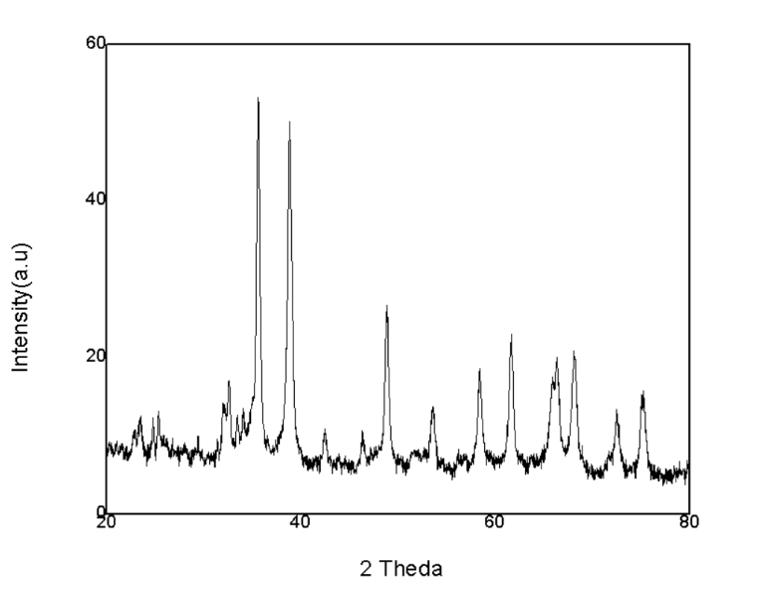
Figure (3.1.1) XRD pattern of CuO nanoparticles
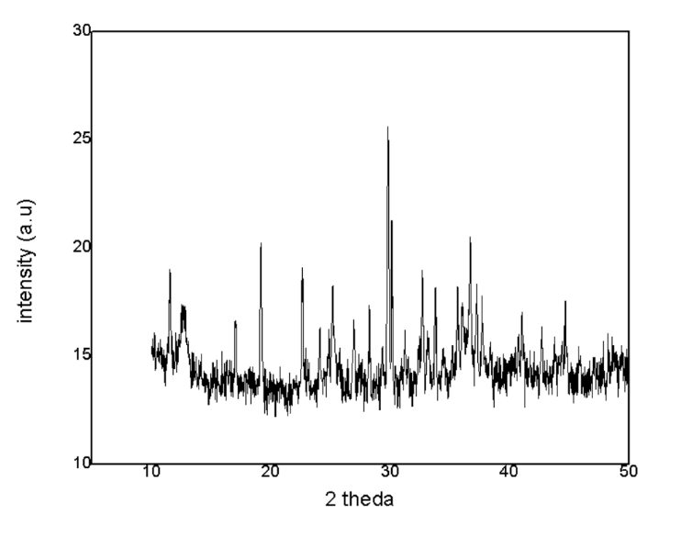
Figure (3.1.2) XRD pattern of MnO nanoparticles

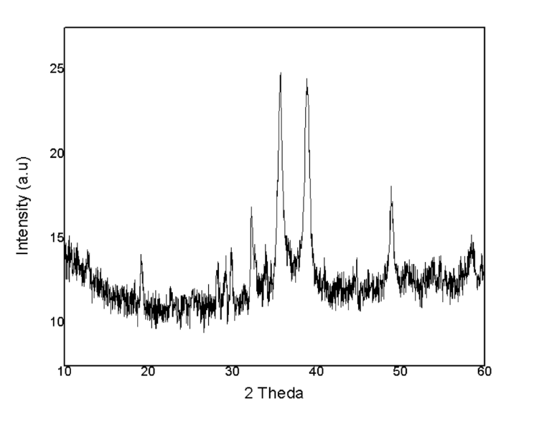
Figure (3.1.3) XRD pattern of CuO and MnO nanocomposite

3.2. FT-IR SPECTROSCOPIC ANALYSIS
The Fourier Transform Infra-Red (FT-IR) spectroscopy was performed to characterize the biologically synthesized photocatalyst. According to (Hassani et al., 2015) the Scanning was performed in an absorbance range of 500 cm ⁻¹ to 4000 cm ⁻¹ The Apodization used for FT-IR scanning was Happ-Genzel which is the most used optical filtering technique. Therefore, the functional groups present in the surface of the nanoparticles were identified at various transmittance peaks (fig 4.2)

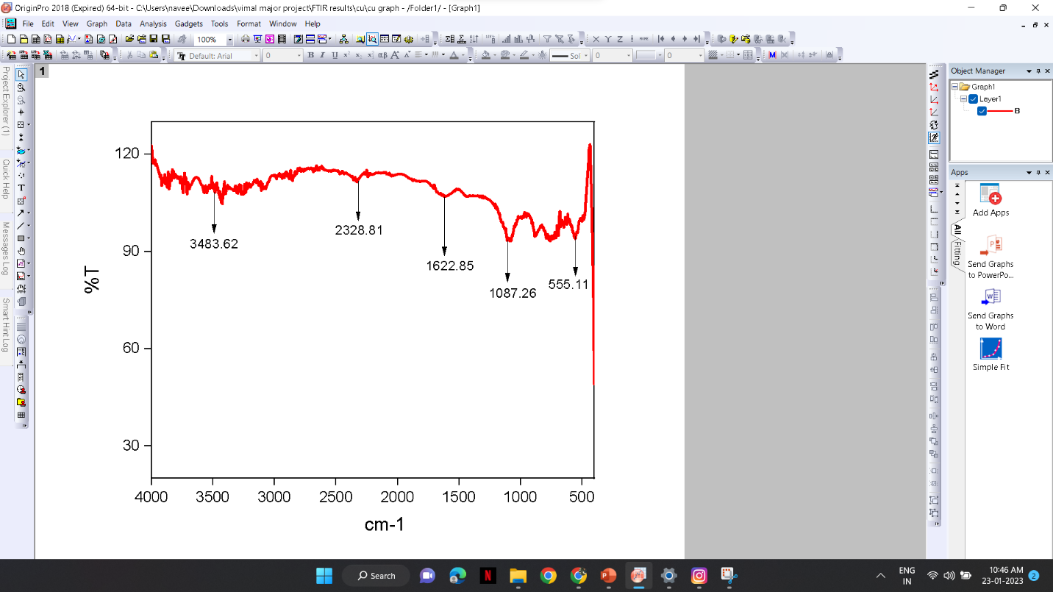
Figure (3.2.1) FTIR pattern of CuO nanoparticles

The peak values were compound with the standard IR chart and different functional group were identified.

Table (3.2.1) FT-IR Functional group present in CuO nanoparticles
Absorption group | Functional group | Compound class | Appearance
3484cm⁻¹ | O-H Stretching | Primary anime | Medium
2323cm⁻¹ | O=C=O Stretching | Carbon dioxide | Strong
1623cm⁻¹ | C=C Stretching | Unsaturated ketone | Strong
1087cm⁻¹ | C-O Stretching | Primary alcohol | Strong
555cm⁻¹ | C-I Stretching | Halo compound | Strong

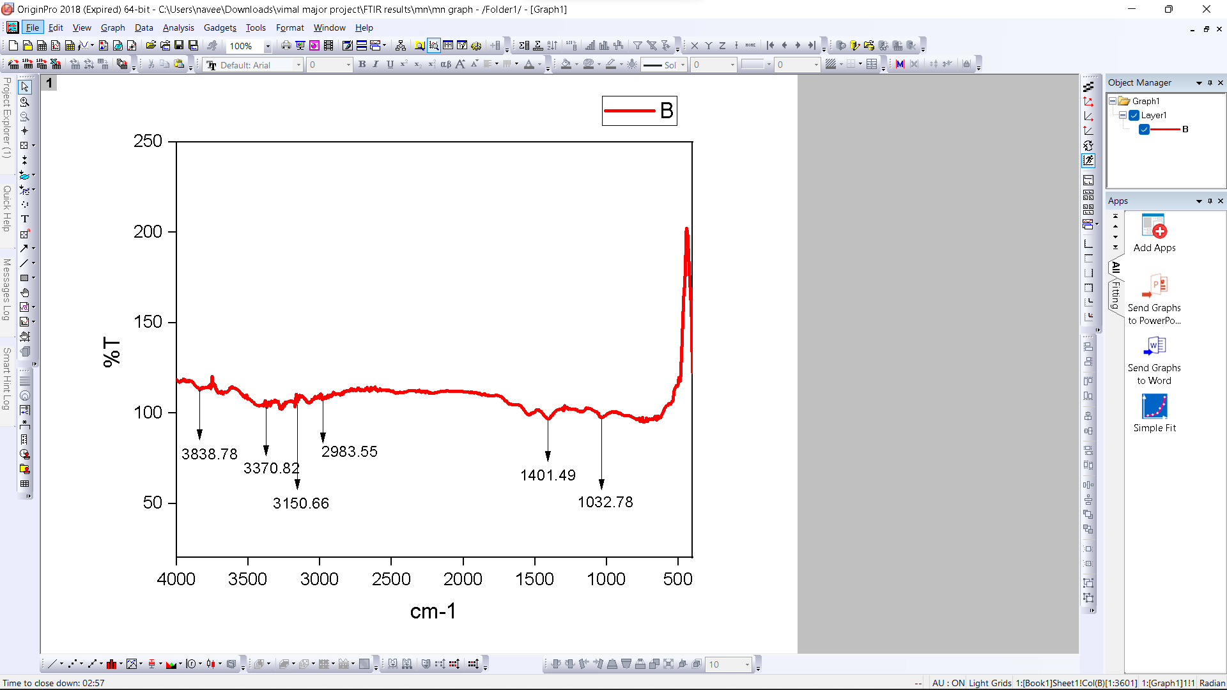

Figure (3.2.2) FTIR pattern of MnO nanoparticles

The peak values were compound with the standard IR chart and different functional group were identified.

Table (3.2.2) FT-IR Functional group present in MnO nanoparticles

Absorption group | Functional group | Compound class | Appearance
3839cm⁻¹ | O-H Stretching | Alcohol | Medium, sharp
3371cm⁻¹ | N-H Stretching | Secondary anime | Medium
3151cm⁻¹ | O-H Stretching | Alcohol | Weak
1401cm⁻¹ | C-H Stretching | Alcohol | Medium
1033cm⁻¹ | S=O Stretching | Sulfoxide | Strong

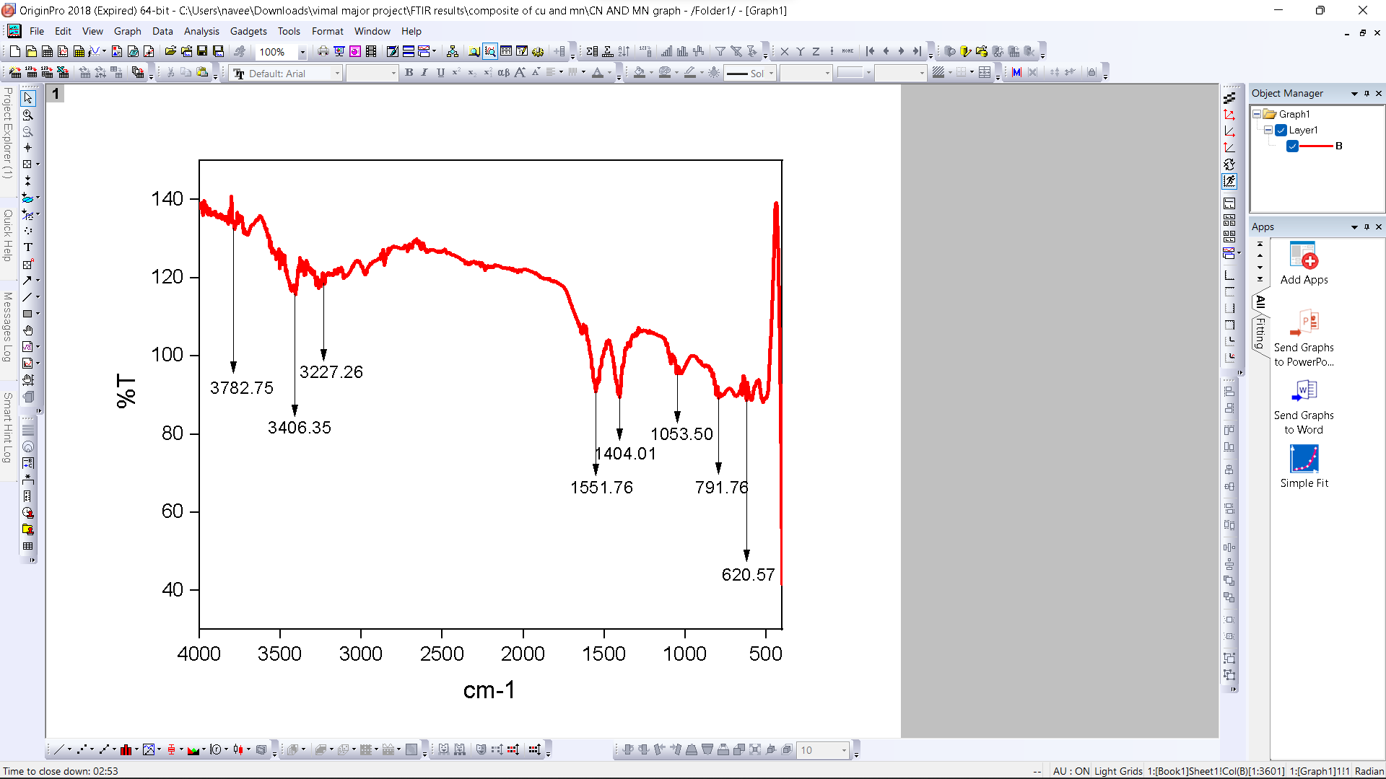
Figure (3.2.3) FTIR pattern of CuO and MnO nanocomposite

The peak values were compound with the standard IR chart and different functional group were identified.

Table (3.2.3) FT-IR Functional group present in CuO and MnO nanocomposite
Absorption group | Functional group | Compound class | Appearance
3783cm⁻¹ | O-H Stretching | Alcohol | Medium, sharp
3406cm⁻¹ | N-H Stretching | Aliphatic primary | Medium
3227cm⁻¹ | O-H Stretching | Alcohol | Weak, broad
552cm⁻¹ | N-O Stretching | Nitro compound | Strong
621cm⁻¹ | C-Br Stretching | Halo compound | Strong

3.3.SEM ANALYSIS WITH EDX ANALYSIS
The SEM analysis was carried out in St. Joseph’s College, Tiruchirappalli. The SEM image indicated that the CuO/MnO nanoparticles was suitable for photocatalytic applications. The nanoparticle sizes ranged between 92.41 and 98.84 nm and nano bar shaped.

Figure3.3(CuO nanoparticles) Figure 3.3(MnO nanoparticles)

Figure 3.3(CuO and MnO nanocomposite)

3.4.THREE ELECTRODE SYSTEM
The three-electrode system consists of a working electrode, counter electrode and reference electrode. The reference electrode’s role is to act as reference in measuring and controlling the working electrode potential, without passing any current. Wash every time after the use of working electrode with the help of alumina powder. In between use ethanol and distilled water to sonicate the working electrode (GLASSY CARBON), Then coat the glassy carbon with metal oxides (copper pentahydrate, manganese chloride and their composites) to run the experiment. The electrolyte for the system is potassium chloride 0.1m. Analyze the cyclic voltammetry for the metal oxide coated in glassy carbon.
Here the MnO and composite of both metal oxide gives more than 0.003 current.
3.4.1. CYCLIC VOLTAMMETRY
CYCLIC VOLTAMMETRY(CV) is a powerful electrochemical technique used to investigate the reduction and oxidation processes of molecular species. CV also provides study electron transfer-initiated chemical reactions, which includes catalysis.

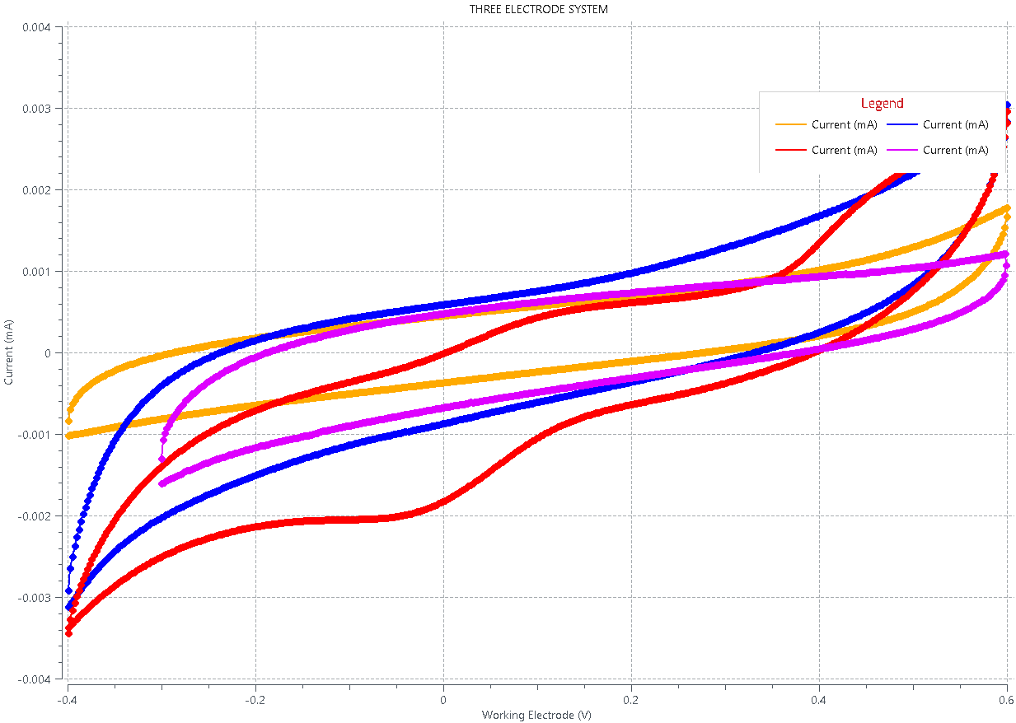
Figure 3.4.1
- YELLOW(CuSO₄.5H₂O)
- BLUE(MnCl₂)
- PURPLE(BARE)
- RED(COMPOSITE OF CuSO₄.5H₂O AND MnCl₂)

In three electrode system, the composite nanoparticle of CuO and MnO nanocomposite and MnO nanoparticles has high yielding electric current.

3.5.TWO ELECTRODE SYSTEM
A common electrochemical system consisting of two electrodes; namely, a counter electrode and a working electrode that also functions as the reference electrode. Some two-electrode systems of fuel cells may alternatively refer to the electrodes as cathode and anode. Firstly, load the sample on MFC (anode in broth, cathode in potassium ferric cyanide). Without adding microbes on anode run the Cyclic Voltammetry and chronopotentiometry, observe its graph. Add microbes to anode and take cyclic voltammetry and chronopotentiometry then compare the variation between them. Wash completely and then coat the PEM with copper pentahydrate and run the sample. After getting result run other two metal oxide (manganese chloride and composite of copper pentahydrate and manganese chloride). Wash every time after running the experiment. Compare all four results in a graph to check the potential of metal oxides by analyzing the cyclic voltammetry and chronopotentiometry.
3.5.1. CYCLIC VOLTAMMETRY


Figure 3.5.1
- PURPLE(CuSO₄.5H₂O)
- LIGHT BLUE(MnCl₂)
- YELLOW(BARE)
- RED (COMPOSITE OF CuSO₄.5H₂O AND MnCl₂)

In CV, the two-electrode system shows that the composite nanoparticle of CuO and MnO has high yielding electric current.

3.5.2. LINEAR SWEEP VOLTAMMETRY
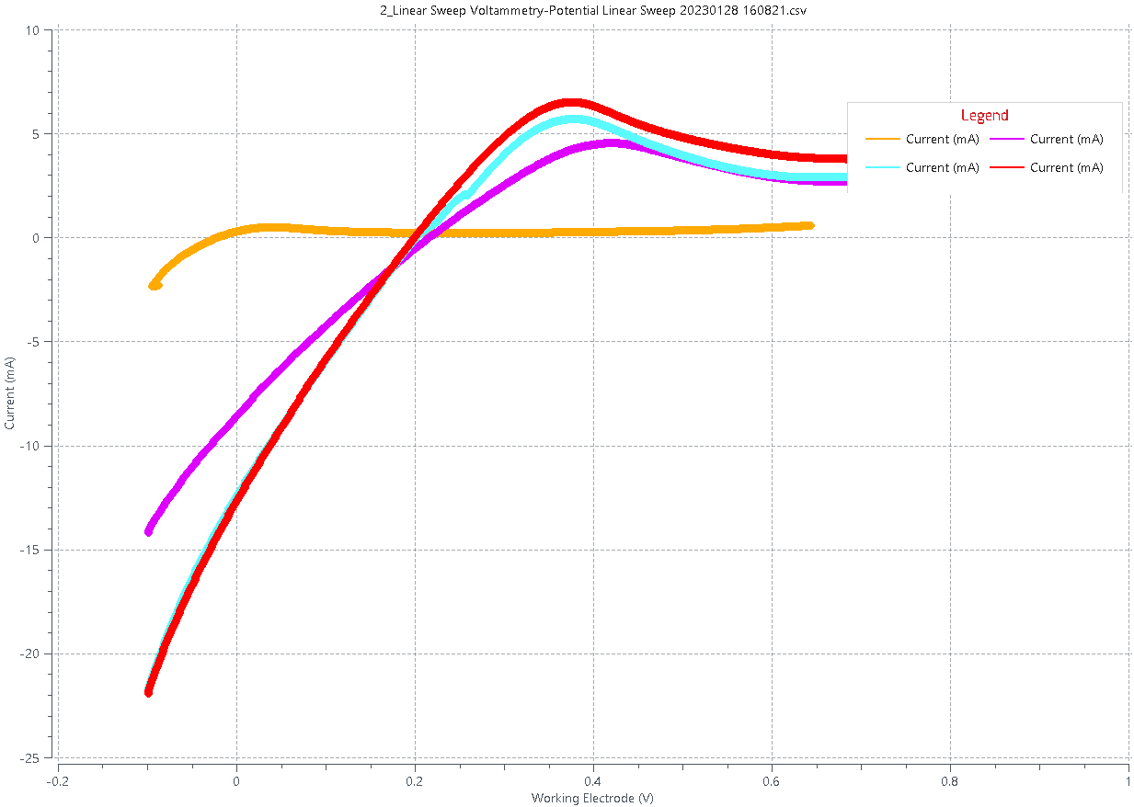
Figure 3.5.2

- PURPLE(CuSO₄.5H₂O)
- LIGHT BLUE(MnCl₂)
- YELLOW(BARE)
- RED (COMPOSITE OF CuSO₄.5H₂O AND MnCl₂)

Compared to the graph the composite nanoparticle of CuO and MnO has high yielding electric current in Linear sweep voltammetry.

4.CONCLUSION
The study of microbial fuel cell has proven that it could be the most preferred alternative source for the energy need of forthcoming generation. But much research is yet to be done over this technology which has the capacity to serve energy need of future generation. But gradually, researchers are seeking higher output from it which can be utilized at large scale level applications. Hence, microbial fuel cell technology has been emerging gradually and attaining solidarity in its stand in renewable world. (R.Pote, 2020)
In summary, the study explains that the mixture of copper and magnese nanocomposite produce excess electrons in MFC. By the CV analysis and LSW comparison we conclude that the power electron is maximum in composite of elements. Compared to all analysis the electrons production is mass in nanocomposite of MnO and CuO. Thus, it gives the good performance rather than other nanoparticles.

REFERENCES
- Quratulain maqsood*, esha ameen**, muhammada mahnoor***, aleena sumrin*, muhammad waseem akhtar***, riya bhattacharya**** and debajyoti bose****†, ‘applications of microbial fuel cell technology and strategies to boost bioreactor performance’, *centre for applied molecular biology, university of the Punjab, Lahore, Pakistan **department of molecular biology & molecular genetics, university of the Punjab, Lahore, Pakistan ***department of rehabilitation sciences, Akhtar saeed medical & dental college Lahore, Pakistan **** school of biotechnology, faculty of applied sciences & biotechnology, shoolini university of biotechnology and management sciences, solan, himachal pradesh, india,2022, vol. 21 ,pp. 1191-1199.
- Karthikeyan rengasamy, harsha uskaikar, sheela berchmans, electrochemically prepared manganese oxide as a cathode material for a microbial fuel cell, 2012, vol. 45:12, pp. 1645-1657.
- Daniel, M.C. and Astruc, D. (2004) ‘Gold nanoparticles: assembly, supramolecular chemistry, quantumsize-related properties, and applications toward biology, catalysis, and nanotechnology’, Chem Rev Vol.104, No.1, pp.293–346
- Kaehler, T. (1994) ‘Nanotechnology: basic concepts and definitions’, Clin Chem Vol.49, No.9, pp.1797–9.
- Rao, C.N.R. and Cheetham, A.K. (2001) ‘Science and technology of nanomaterials: current status and future prospects’, Journal of Mater Chem Vol.11, No.12, pp.2887–94
- Lee, J., Mahendra, S., and Alvarez, P.J.J. (2010) ‘Nanomaterials in the construction industry: a review of their applications and environmental health and safety considerations’, ACS Nano Vol.4, No.7, pp. 3580–90.
- Crowley, C.A. (2020) ‘Electric furnace’, Popular Mechanics Vol. 67, No. 6. pp. 941– 945.
- Deena, Titus., James Jebaseelan, S., And Selvaraj, M. (2019) ‘Nanoparticle characterization techniques’, Green Synthesis, Characterization and Applications of Nanoparticles Vol.298, pp.303-319
- Hassani, A., Khataee, A. and Karaca, S. (2015). ‘Photocatalytic degradation of ciprofloxacin by synthesized TiO2 nanoparticles on montmorillonite: Effect of operation parameters and artificial neural network modeling’, Journal of Molecular Catalyst Analytical Chemistry Vol.409, pp.149–161

