Analyzing 5G: Prospects of Future Technological Advancements in Mobile
Simran Sachdeva
Bhai Parmanand DSEU Shakarpur Campus 2, under Delhi Skill and Entrepreneurship University, Dwarka

Abstract: A new mobile network generation usually refers to a completely new architecture from Analog (1G) to GSM (2G) to CDMA (3G) and finally to LTE (4G). So, the next fundamental step beyond fourth-generation LTE networks is being referred to as “5G” by the industry. The term 5G is also known as World Wide Wireless Web (WWWW). The main purpose of the 5G is to design the best wireless world that is free from limitations and hindrance of the previous generations because wireless system designers have been facing the continuously increasing demand for high data rates. This paper throws light on the development of 5G technologies as a cornerstone for realizing breakthroughs in the transformation of mobile networking. This paper represents the introduction of 5G technology, evolution, need, hardware and software requirements, specifications, network architecture of 5G wireless technologies and its future scope.
Keywords - 5G, MIMO, WWWW, LTE, IoT,latency

Introduction
5G offers enormous potential for consumers and industry as well as the prospect of being considerably faster than existing technologies. 5G holds the promise of applications with high social and economic value in which mobile will play an ever more important role in people‟s lives leading to a „hyper-connected society‟. A significant role will be played by the Global System Mobile Association (GSMA) in shaping the strategic, commercial and regulatory development of the 5G ecosystem. Areas that will be included are the definition of roaming and interconnect in 5G, the identification and alignment of suitable spectrum bands. The technical requirements that necessitate a true generational shift for 5G are sub-1ms latency and >1 Gbps downlink speed. The 5G network is efficient and appealing as the billing interface is highly advanced. It offers huge quantity of broadcasting data in GB which can sustain more than 60,000 connections. It also offers huge bi-directional bandwidth [1].
Massive MIMO is a pre-5G technology that will make the network future ready for meeting the data demand coming from digital revolution. It provides faster data speeds on existing 4G mobile devices without any upgrades or plan change. Massive MIMO deployment uses green technology thereby reducing carbon footprint. It also creates 3D beams both on vertical and horizontal towards users that are located within its coverage footprint. The signal quality (SINR) is improved by 2-3dB due to the coverage and reducing interference across users in different beams. 5G uses data rate of 20 mbps and frequency band of 2-8 GHz which is enabled by OFDM and millimeter wireless. Recent technology constituents like high-speed packet access (HSPA) and long-term evolution (LTE) will be launched as a segment of the advancement of current wireless- based technologies. Overall, 5G will be aiming to reduce up to 90% of the power consumption in devices and network centers and strongly highlight itself as a greener technology[2].


- 5G OFFICIALLOGO
Fig. 1. 5G logo

EVOLUTION OFCELLULARGENERATIONS
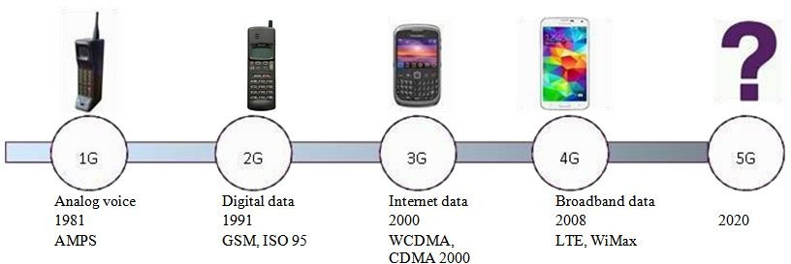
Fig. 2. Cellular Generations [2]

COMPARISONOFALLGENERATIONSOFMOBILETECHNOLOGIES
TABLE 1. COMPARISON OF ALL THE GENERATIONS [3][4]
Technology Features | 1G | 2G | 3G | 4G | 5G
Start/ Deployment | 1970 – 1980 | 1990 - 2004 | 2004-2010 | Now | probably 2020
Data Bandwidth | 2kbps | 64kbps | 2Mbps | 1 Gbps | Higher than 1Gbps
Technology | Analog Cellular Technology | Digital Cellular Technology | CDMA 2000, UMTS, EDGE | WiMax, LTE Wi-Fi | WWWW
Service | Mobile Telephony (Voice) | Digital voice,  SMS, Higher capacity packetized data | Integrated high-quality audio, video and data | Dynamic Information access,  Wearabledevices | Dynamic Informationaccess, Wearable devices with  AI Capabilities
Multiplexing | FDMA | TDMA, CDMA | CDMA | CDMA | CDMA
Switching | Circuit | Circuit, Packet | Packet | All Packet | All Packet
Core Network | PSTN | PSTN | Packet N/W | Internet | Internet
Key differentiator | Mobility | Secure, mass adoption | Better  internet experience | Fasterbroadband internet, lower  latency | Lower battery consumption
Drawbacks | Low capacity, unreliable handoff, Poor voice links,  less secure | Digital signals are reliant on location and proximity,  Requires strong digital signals, | Accommodates lower network capacity | Being deployed | Yet to be implemented

FEATURES OF5G:
- It has Ultra low latency which ranges between 1ms and10ms.
- It gives enough capacity for unlimited datatransfer.
- The 5G technology presents the high resolution and fast Internetaccess.
- It provides billing limits in advance which makes it more attractive andefficiency
- Theinformationfromthedatatransfer in5Gtechnologyorganizea moreaccurateandreliableresults.
- It also supports virtual privatenetwork.
- It has high peak bitrate
- Better connectivity irrespective of geographicregion
- Supports large number ofdevices
- Highcapacitytoallowmoreconnectivityofdevicesconcurrentlyandinstantaneously[5].

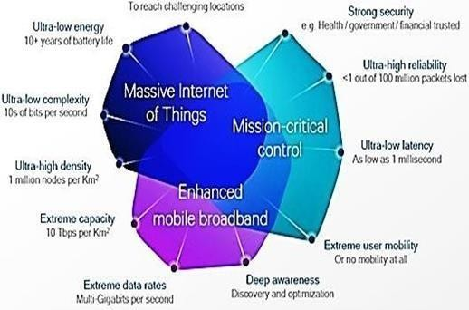
Fig. 3. Features of 5G

REQUIREMENTS OF5G:
Many of the industry initiatives that have progressed with works on 5G identify a set of eight requirements:
- 1-10Gbps connections to end points in thefield
- 1 millisecond end-to-end round-trip delay(latency)
- 1000x bandwidth per unitarea
- 10-100x number of connecteddevices
- (Estimation of) 100%coverage
- (Estimation of) 99.999% availability
- 90% reduction in network energyusage
- Up to ten years battery life for low power, machine-type devices[6].
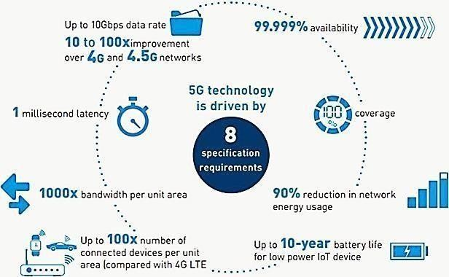
Fig. 4. Requirements of 5G [7]

WHY DO WE NEED5G?
- 5Gwilldeliversuperioruserexperienceandbetternetworkenergyefficiency,aswellasincreased operationalperformance
- Mostly due to video streaming, mobile data traffic is risingrapidly.
- Each user has a growing number of connections with multipledevices.
- TheemergenceoftheIoT(Internet ofThings) meansnetworksmust handlebillions of moredevices.
- Network operators are under pressure to reduce operationalexpenditure.
- Operatorsalsoneednewapplicationsformobiletechnology whichopensupnewrevenuestreams[8].

5GSPECIFICATIONS
Table 2. 5G SPECIFICATION TABLE [6]

PARAMETER | PERFORMANCE
Network capacity | 10000 times the capacity of the current network
Peak data rate | 20Gbps downlink and 10Gbps uplink
Cell edge data rate | 100 Mbps
Latency | < 1 ms
Bandwidth | Possibly 1-2 GHZ
Connection density | 1 million connected devices per square km (0.38 sq. miles)
5G mobility | 500km/h high speed
Spectral efficiency | 30bits/Hz downlink and 15 bits/Hz uplink

HARDWARE REQUIREMENTS OF 5GTECHNOLOGY

UWB Networks
5G network technology has higher bandwidth at low energy levels. In addition, UWB provides the needed cost- effective, power-efficient, high bandwidth solution for relaying data from host devices to devices in the immediate area

Bandwidth
5G has 4000 megabits per second, which is 400 times faster than today‟s wireless networks.

Smart antennas
Switched Beam Antennas support radio positioning via Angle of Arrival (AOA) information collected from nearby devices.
Adaptive Array Antennas: It provides improved capacity and safety for wireless systems. This kind of arrays can be used for interference rejection through spatial altering, position location through direction ending measurements, and developing improved channel models through angle of arrival channel sounding measurements.

Multiplexing
CDMA (Code Division Multiple Access) employs analog- to-digital conversion in combination with spread spectrum technology. Audio input is first digitized into binary elements. The frequency of the transmitted signal is then made to vary according to a particular pattern, so that it can be intercepted only by a receiver whose frequency response is programmed with the same code, so it follows exactly along with the transmitter frequency [1].

SOFTWARE REQUIREMENTS OF 5GTECHNOLOGY
5G network will be the single unified standard of different wireless networks, including wireless technologies (e.g. IEEE 802.11), LAN/WAN and WWWW, unified IP and combination of the broadband [9].
Other requirements are Software Defined Radio, Packet layer, implementation of packets, encryption, flexibility etc. [1].

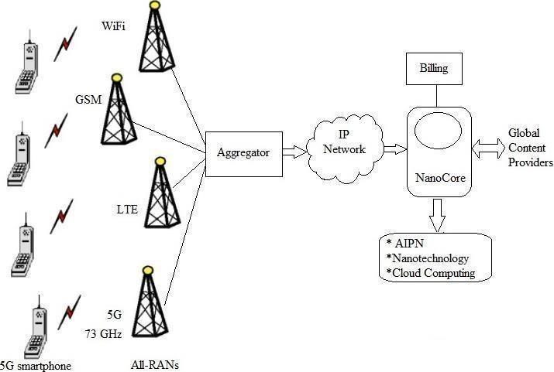
NETWORK ARCHITECTURE
Fig. 5. Network Architecture for 5G [10]
Fig. 5 shows 5G network architecture for mobile systems. It uses flat IP concept, so that different RANs (Radio Access Networks) can use the same single Nanocore for communication. RANs which are supported by 5G architecture are WiFi, WiFiMAX, GSM, LTE etc.

Aggregator
5G aggregator which is located at BSC/RNC place aggregates all the RAN traffics and routes it to gateway

IPnetwork
It reduces number of network elements in data path and hence reduces the cost.

5Gnanocore
It comprises of All IP network (AIPN), nanotechnology, cloud computing [11].

AIPN
Flat IP architecture is an important part of 5G network. The All-IP Network (AIPN) is an evolution of the 3GPP system to meet the increasing demands of the mobile communications market. AIPN provides a competitive edge in terms of both performance and cost.

Nanotechnology
It is the application of nanoscience to control process on nanometer scale between 0.1 and 100 nm. Core features like self-cleaning, self-powered, sensible to the environment with which it is been interacting, flexible and transparent will be loaded with the nano equipment in the 5G nanocore [12].

CloudComputing:
A Technology that uses the central remote server and internet for maintaining data and applications is called Cloud Computing.
The Cloud computing has three segments as follows:
    - Applications: It is based on software services ondemand.

    - Platform:Theproducts whichare usedtodeployinternetisreferredastheplatform.

    - Infrastructure: The infrastructure is the backbone of the entire concept. Itsvendorsallow users to build applications in this platform [7][13].

TECHNOLOGICALCHALLENGES

Inter-cellInterference
It is caused due to variations in size of traditional macro cells and concurrent small cells.

Efficient Medium AccessControl
The user throughput will be low, latency will be high, and hotspots will not be competent to cellular technology to provide high throughput where dense deployment of user terminals are required.

TrafficManagement
Compared to traditional human to human traffic in cellular networks, overload and congestion can be caused due system challenges i.e. RAN challenges when the number of Machine to Machine (M2M) devices in a cell increases [14].

FUTURE SCOPE
5G technologies have revealed a new era in mobile communication technology.5G technologies are likely to appear in the market by 2020. It is expected to significantly improve the Quality of Service in the context of increasing growth of data volume in mobile networks and wireless devices. The main aim of 5G is to design a Multi-Bandwidth data path by integrating the current and future networks for a new architecture of the 5G real wireless world. The user can simultaneously be connected with several wireless access technology and multiple data transfer path are possible. 5G technology offers high resolution for crazy cell phone users. TV channels can be watched at HD clarity on our mobile phones without any interruption. In 5G the network operators will be connected with one single core and have one single infrastructure which will be promoted by the concept of super-core.

CONCLUSION
In this paper, we have surveyed 5G technology for mobile communication. It is going to be a new revolution in wireless system market. The mobile network performance and capability requirements will be pushed to their extremes which will be given by the foundation of 5G. It is presenting many new challenges as well as opportunities for the test and monitoring industry 5G. Tremendous data capabilities, unrestricted call volumes and infinite data broadcast within the latest mobile operating system are offered by Fifth generation technologies. It should make an important difference and add more services and benefits to the world over 4G.

REFERENCES
Journal Papers:
- Ravalli Kolli, Shweta Malle, Shreya Shetty, Sunanda Dixit, “Review on 5G wireless technology”, International Journal of Advanced Research in Computer and Communication Engineering Vol. 5, Issue 12, December2016.
- Ms. Reshma S. Sapakal , Ms. Sonali S. Kadam, “5G Mobile technology” in International Journal of Advanced Research in Computer Engineering & Technology (IJARCET) Volume 2, Issue 2, February2013.
- Mrs. Sandhya Shinde, Amruta Nikam, Swati Joshi, ”An Overview of 5G Technology “ in International Research Journal of Engineering and Technology(IRJET).
- Mr. Ganesh. B. Khaire, Asst. Prof. V.S.Ubale , Ms. Anuradha. B. Banote, “5G Key Concepts And Wireless Network Architecture”, International Journal of Electronics and Communication Engineering and Technology(IJECET) Volume 4, Issue 1, January- February2013.
- Akhil Gupta, (Student Member, IEEE), Rakesh Kumar Jha, (Senior Member, IEEE), “A Survey of 5G Network: Architecture and Emerging Technologies”, IEEE Access, Volume 3,2015.
- M. Sathiya1, R. Gowthami, G. Karpagam3, B. Saranya, U. Suganya, “Cellular And Network Architecture For 5g Wireless Communication Networks In Mobile Technology”, International Journal of Technical Research and Applications, Volume 3, Issue 2 (Mar-Apr2015).
- VidhiVashist, “5th GENERATION TECHNOLOGY”, International Journal of Advanced Technology in Engineering and Science, Volume 3, Issue No. 12, Dec15.

Books:
- Mr. Sundeep Ranjan, “Understanding 5G standards”, Tandon School of Engineering, Dec 14,2016.

Websites:
- http://www.rfwireless-world.com/Terminology/Advantages-and-Disadvantages-of-5G.html
- https://www.gemalto.com/mobile/inspired/5G
- https://arstechnica.com/information-technology/2017/02/5g-imt-2020-specs/
- https://www.qualcomm.com/invention/5g/technologies
- http://in.pcmag.com/cell-phone-service-providers/104415/feature/what-is-5g
- https://www.cnet.com/news/t-mobile- will-deploy- blazing-5g- this-year- but-you- cant-use-it-yet/

