Design and Fabrication of Battery Operated 2-Wheeler Forklift

Prof. A.N. Madne¹, Abhishek Fating², Dhananjay Bhowate³, Ketan Deshpande⁴, Samruddha Luthade⁵, Atharva Ghuse⁶
¹Professor of Mech Engg., K.D.K. College of Engineering, Nagpur.
^{2,3,4,5,6}Student, Dept. Of Mech Engg., K.D.K. College of Engineering, Nagpur.

Abstract:
This journal presents the design and fabrication of a Battery Operated 2-Wheeler Forklift. In this project we investigate a forklift design that is new and different from existing design. The new design offers two features: One the forklift attached to the frame body end and the other feature is that the new lifting mechanism by lead screw where it is easy to lift and more compact compare to the existing design. And also, we do analysis and calculation work on the model to make sure it is stable and safe under different working condition.

INTRODUCTION
The product varieties in different shapes and different packaging of goods for loading and unloading has always been a heavy process during transportation by fork lifts were naturally inverted and became the solution to this problem they save time and space, if cargo’s are being organized properly for the use of forklifts with right attachment would be a best way to load and unload which would be make the whole process less time consuming the less labours intensive in addition forklifts optimize the use of storage space by eliminating the need for many people to handle the loading and unloading operation and enabling the stacks up to good the stacking the height of goods can be up 4-5m some even can be height as 10, which brings up the utilization of warehouse by least 40% now most of the transportation operation are using fork lifts. Mechanization reduces the human efforts and manpower, but need to be closer and complex human supervision. If consistency and close supervision is not provided, there might be costly process error will occur. So, automation process will eliminate the error and human interface by taking full control over the operations of the mechanize equipment and provides a consistency through the process control system and strong the instrumentation built in the system.

LIST OF COMPONENTS

Sr. No. | Name of Components | Quantity
1 | Gears (spur) | 4
2 | Pinion (spur) | 1
3 | Spanner Box (19mm) | 4
4 | Shaft | 4
5 | Base Plates or Base Rod | 2
6 | Key | 4
7 | L-Shaped Anchored Bolts | 6
8 | Cotter | 4
9 | Wheels | 2
10 | DC Motor | 2
11 | Battery (12v) | 2

METHODOLOGY
A fork elevate truck, conjointly referred to as a self-propelled vehicle and alternative names, may be a battery-powered industrial truck. Its main purpose is for material handling among facilities or compounds, particularly the potential to elevate masses to be positioned at height also on lower them pro re natal. Fitted with specific attachments, the fork elevate truck is also wonted to perform alternative connected functions like the transfer masses from slip sheets onto pallets, also on clamp them or to invert them.
The chassis is fictional from M.S sq. pipes. this can be finished easy fabrication, and to scale back the weight. The chassis was designed to require a static load of 3kg. The rear wheel that holds the motor and is fast to the chassis. so, the driving motors will simply accommodate below the chassis. The chassis incorporates hole for attaching front globe wheel, and for attaching the raise structure. It’s an oblong plate that is command between 2 vertical channels of M.S sq. pipe that area unit unengaged to slide up and right down to raise and lower the weight/load up to a desired limit with the assistance of hydraulic bottle jack that is operated on foot and it's placed between the fork. 3 wheels area unit employed in self-propelled vehicle and the two wheels area unit placed at front and the remaining wheel area unit placed at the rear.
The hydraulic device is employed for to raise the serious material by applying smaller force. it's place at the front of the self-propelled vehicle. The hydraulic jack could be a device used for lifting serious hundreds by the appliance of a lot of smaller force. it's supported Pascal’s law, that states that intensity of pressure is transmitted equally altogether directions through a mass of fluid at rest.
D.C. Motor is utilized in our project for moving fork carry from one location to a special. Our project has only one motors wish to run the rear wheel. whereas the lifting portion is completed by hydraulic jack & and it's connected to the controller. The accelerator is employed for to keep up the speed of the self-propelled vehicle. we tend to area unit mistreatment the accelerate of speed bike connected to regulate controller. It provides power to motor. The battery is placed at the rear aspect of frame. 12volt battery issued to provide power.

CAD MODEL

Front View Top View
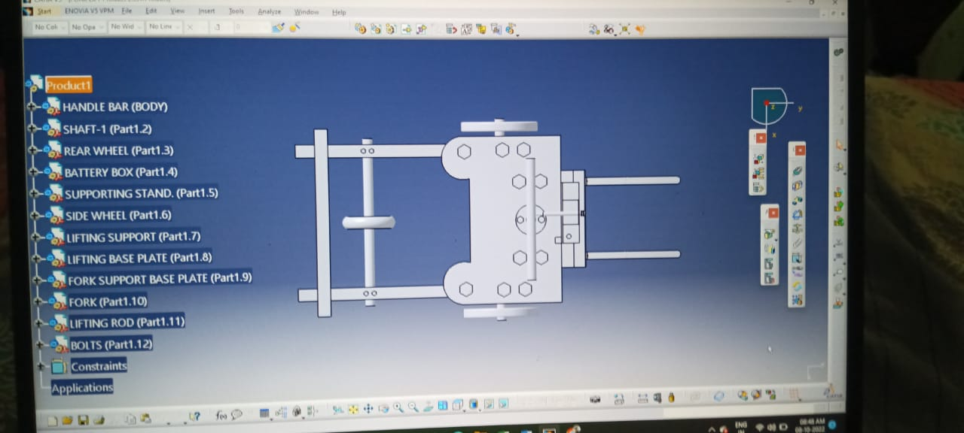
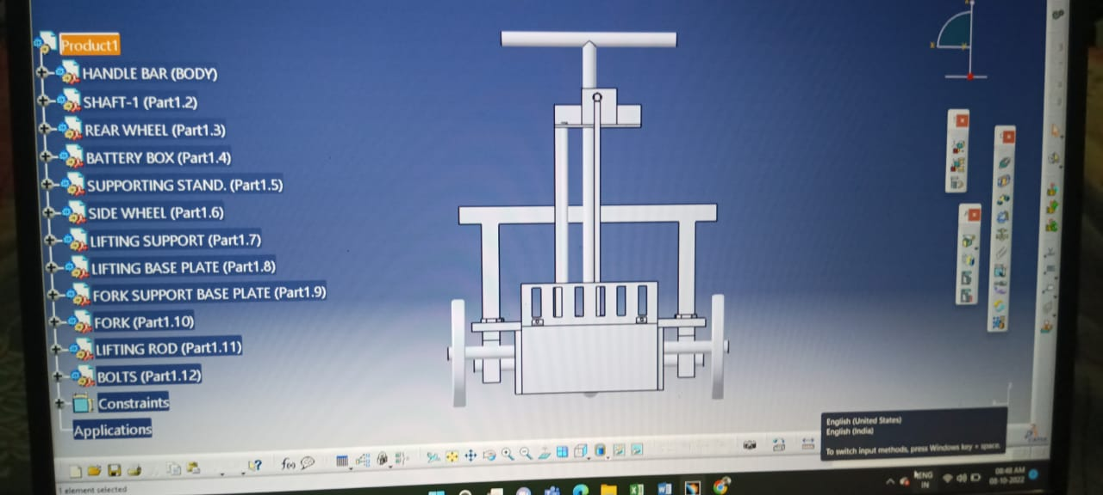

Side View Isometric View
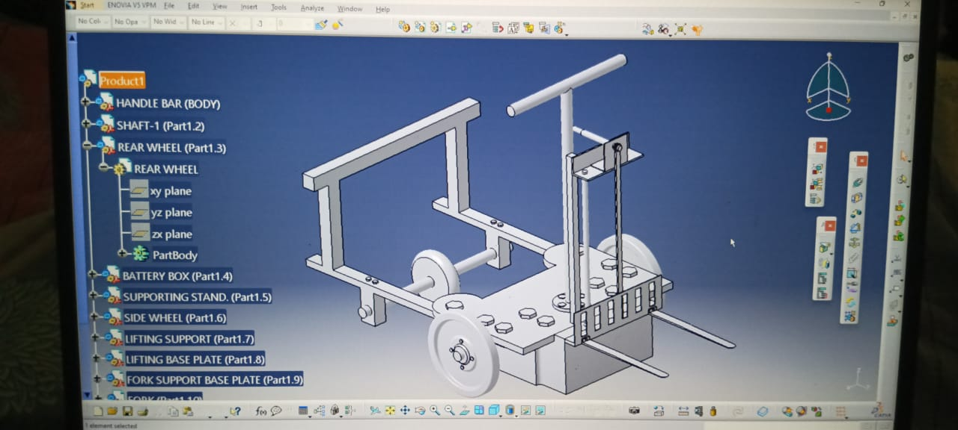
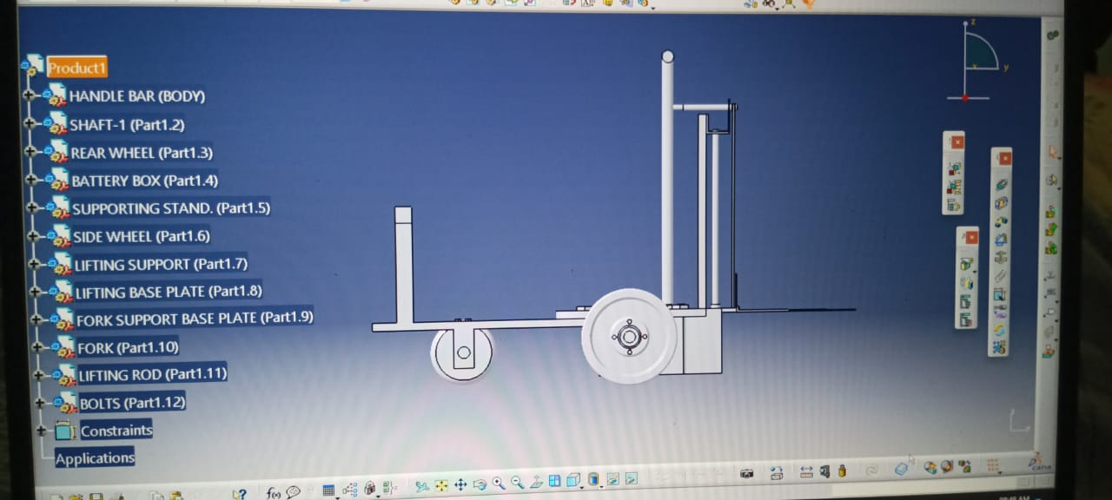

DESIGN ASPECT

Calculations
Motor: Rider Weight 80 kg
Required Speed 8 km/hr

- To find angular velocity we use,
V = 8 km/hr r = 250 mm$≅0.250 m$
$$V= r×ω$$
$$\frac{8*{10}^{3}}{3600}=0.250×ω$$

$$∴ ω= 0.55 rad/sec$$
- To find the motor rpm we take,
$$ω= \frac{2 πN}{60}$$
$$0.55= \frac{2πN}{60}$$
$∴ N = 5.25 rpm$
- Next Power transmission is equal to,
$$P = \frac{2πNT}{60}$$

$$T = r× R$$
= 0.125x 7.84

$$∴T = 0.98 N.m$$

$$P = \frac{2π×5.25×0.98}{60}$$
$$∴ P = 0.538 Watt$$

- In order to find battery backup, we use P = 24 watt @ 20 amp

$$P = V . I$$
$= 12 ×$2
Battery 12 V 8 amp
∴ P = 96 Watt @ 8 amp
Backup 8/2 = 4 hours

Lifting Motor:
Lifting Motor =$g×L$ (Load = 80 kg)
$$=80×9.81$$
$$= 784.8 N$$
Motor torque
T = F x R……. (Lifting pulley 100 mm)
= 784.8 x 0.050
∴T = 39.24 N-m
∴ T = 400 kg-cm

ADVANTAGES
- The loading and unloading process is easily done by this machine.
- This machine is faster as compared to existing machine.
- This machine is safe for worker during the material handling.
- Easy to maintenance.
- Cost effective.
- Easily Attachable & Detachable.
- Industrial Goods Transport.
- Warehouse Internal Transport.

CONCLUSION

The purpose of this paper was to focus on the solving problems at the warehouses using forklift to carry load of lighter weight and making it efficient n reduce the accident’s happening in warehouses due to large forklifts. The two-wheel aisle forklift is designed keeping the centre of idea to increase work efficiency, reducing power Consumption, smaller dimension and hence aisle for movement in narrow space of warehouses, high safety factor, time saving application, easy controlling from on board. At the closing of this report, it is evident that there are important areas which call for future research and analysis. The first of this is that completely autonomous working without any human assessment. This will enable more productivity and high reliability. Additionally, method of lifting forklift can be changed safety measures, power consumption can be reduced. For the next step in the design of this particular forklift, higher fidelity analysis method should be employed to ensure that lifting mechanism would to interesting and provide direction towards the application of this forklift.

REFERENCES
- . Seidl M, Dvo ák Z (2011) In-house transport as a part of business logistics. J Eng Manag Compet 1(1/2):1-5.
- Masztelarz M (2010) Methods for accounting of ancillary activities’ costs (Metody rozliczania kosztów działalności pomocniczej) [IN] Gabrusewicz W. (ed.) Audyt w systemie kontroli; Conference Proceedings, KIBR, Poznan, Poland 29.11.2010 pp. 131–142 ISBN: 978-83-61287- 45-2 http://www.pracownicy.ue.poznan.pl/ asztalerz/rozliczanie .pro duk cji .pomocniczej.pdf (in Polish) access: 5th November 2015.
- Michałowska K (2013) Logistics costs in a company (Znaczenie i sposoby rozliczania kosztów logistycznych); Zeszyty Naukowe Uniwersytetu Szczecińskiego nr 765, Finanse, Rynki Finansowe, Ubezpieczenia^ Wydawnictwo Naukowe Uniwersytetu Szczecińskiego. 61(2):325–334. In Polish.
- R S Khurmi, J.K Gupta (2005), a text book of Machine Design.
- S. S. Rattan (2009), Theory of Machines, Professor of Mechanical Engineering, National Institute of Technology, Kurukshetra.
- J B Gupta (2011), Basic Electrical & Electronics Engineering.
- B L Thareja, A K Thareja Revised by S G Tarnekar (2005), Electrical Technology, Former Professor & Head, Electrical Engineering Department.
- Visvesvaraya National Institute of Technology, Nagpur.
- Conte M (2010) Super capacitors technical requirements for new applications. Fuel Cells 10:806–818.
- Hyster-Yale Materials Handling, Inc. Retrieved 15 December 2013.
- Brindley, James (December 2005). "The History of the Fork Lift". Warehouse & Logistic News. Archived from the original on 2009-08-31. Retrieved 2008-01-25.
- Clark Material Handling Company. 2008. Retrieved 15December 2013.
- V B Bhandari (2010), Design of Machine Elements, Retired Professor and Head Department of Mechanical Engineering, Vishwakarma Institute of Technology, Pune.
- Atlantic Mutual Insurance Company (1999): Mechanics, Stability Triangle.

