Oil Skimmer With Solar Panel
MD GUDDU¹, DHIRAJ MULYA², TUSHAR GAIKWARD³, JEET PATKAR⁴, CHIRAJ GAWAI⁵,
PROF. SAGAR PATIL⁶
Department of mechanical engineering
Faculty of Mechanical Engineering
IETES Bharat Collage of Engineering Badlapur, Maharstra,India
---------------------------------------------------------------------***---------------------------------------------------------------------
Abstract - An oil skimmer is a device used to remove oil from the surface of water. It works by using a belt or drum that is rotated through the oil, which adheres to the surface of the belt or drum and is then scraped off and collected for disposal. Oil skimmers are commonly used in industrial settings, such as oil refineries and manufacturing plants, as well as in environmental cleanup efforts after oil spills. They are often considered a more efficient and cost-effective method of oil removal than other techniques, such as using absorbent materials or chemical dispersants.

Key Words: oil skimmer, worm gear with motor oil separator machine with solar panel,

1.INTRODUCTION An oil skimmer is a device that is designed to remove oil from the surface of water or other liquids. It works by using a series of mechanisms, such as belts, drums, or disks, to attract and collect oil floating on the surface of a liquid.
Oil skimmers are commonly used in industrial settings to remove oil from coolant tanks, wastewater treatment plants, and oil spills in bodies of water. They can be automated and integrated into existing systems, or used as standalone units that require manual operation.
There are different types of oil skimmers available, each with its own advantages and disadvantages. Factors such as the type and viscosity of the oil, the size of the liquid surface, and the desired rate of oil removal can affect the selection of the appropriate oil skimmer.
Overall, oil skimmers are an effective and environmentally friendly solution for removing oil from water or other liquids, and they play an important role in preventing pollution and protecting natural resources.

  - Problem Definition

While oil skimmers are effective devices for removing oil from water or other liquids, they can still encounter several problems that may affect their performance. Some common problems associated with oil skimmers include:
- Ineffective Removal: Depending on the type of oil and the nature of the liquid, some oil skimmers may not be effective in removing all the oil from the surface.
- Clogging: Oil skimmers can become clogged with debris or emulsified oil, which can reduce their efficiency or cause them to stop working altogether.
- Maintenance: Oil skimmers require regular maintenance, such as cleaning and replacing parts, to ensure that they continue to operate effectively.
- Environmental Impact: If not used properly, oil skimmers can have a negative impact on the environment, especially if they remove more than just oil from the surface.
- Cost: Oil skimmers can be expensive, and the cost can vary depending on the type and size of the skimmer required for the specific application.
Overall, the effectiveness of an oil skimmer depends on several factors, including the type of oil, the nature of the liquid, and the design and operation of the skimmer. It is important to carefully consider these factors when selecting an oil skimmer and to properly maintain and operate it to ensure that it functions effectively.
1.2 Objective

The primary objective of an oil skimmer is to remove oil from the surface of water or other liquids. This is typically done to prevent pollution, protect natural resources, and ensure compliance with environmental regulations. Some specific objectives of using an oil skimmer may include:
- Improving Water Quality: Removing oil from water can improve the overall quality of the water and make it safer for human use and consumption.
- Protecting Wildlife: Oil spills can have a devastating effect on wildlife, and oil skimmers can help prevent this by removing oil before it has a chance to spread and cause harm.
- Compliance with Regulations: Many industries are required to comply with environmental regulations that limit the amount of oil and other pollutants that can be discharged into water bodies. Oil skimmers can help these industries meet their regulatory obligations.
- Cost Savings: Removing oil from water can be an expensive and time-consuming process. Using an oil skimmer can reduce these costs by making the process more efficient and effective.
Overall, the objective of an oil skimmer is to remove oil from water or other liquids in a way that is effective, efficient, and environmentally responsible.

2.1 MAIN COMPONENTS

- Worm gear with motor (24v, 10w, 65rpm)
- Solar panel (Size60x66, weight 4kg,12v,40w,0
- Battery (24v,14Ah, lithium ion)
- Belt (100mm width x 5000mm length)
- Pipe (square MS pipe)

- Worm gear with motor

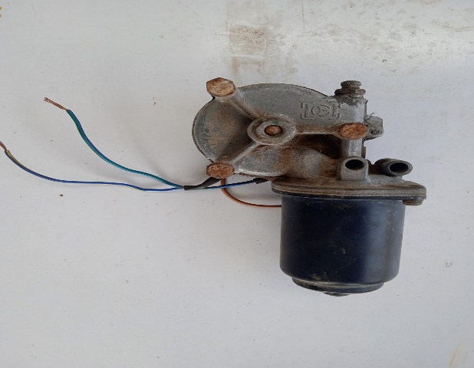

A worm gear with motor is a mechanical system that consists of a worm gear and an electric motor.
The worm gear is a type of gear that consists of a cylindrical screw-like shaft called the worm that meshes with a toothed wheel called the worm wheel. The worm gear is used to transmit motion and power between two perpendicular shafts that are not in line with each other. It provides a high reduction ratio, which means that it can reduce the speed of the input shaft and increase its torque output.
- Solar panel


A 40W solar panel is a photovoltaic module that is capable of producing up to 40 watts of power from sunlight. Solar panels are made up of several individual solar cells, which are connected together to form a panel. When sunlight falls on the solar cells, they generate electricity through the photovoltaic effect. The power output of a solar panel is measured in watts (W), which is a unit of electrical power. A 40W solar panel typically produces an output voltage of 12 volts DC, which is suitable for Battery,

- Battery

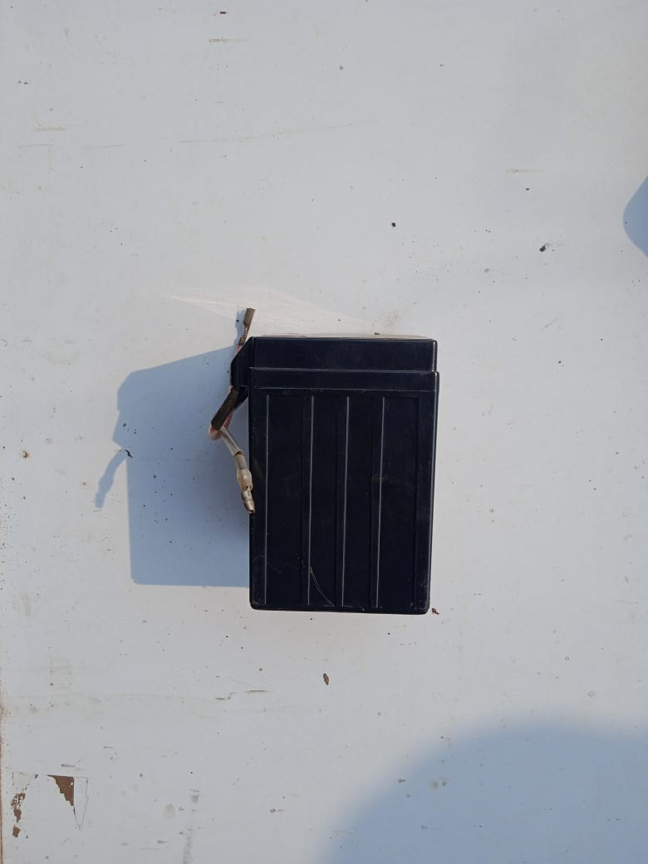

A 24V lithium-ion battery is a rechargeable battery that is commonly used in a variety of applications such as power tools, electric bikes, scooters, and other portable devices.
Lithium-ion batteries use lithium ions to generate electricity, which is stored in the battery's cells. The cells are connected in series to form a battery pack, which provides a nominal voltage of 24 volts.

- Belt

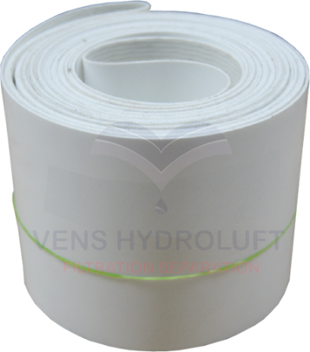

An oil skimmer belt is a device used for removing oil or other floating hydrocarbons from the surface of water or other liquids. The skimmer belt is made of a material that has a high affinity for oil, such as oleophilic (oil-attracting) material, and is designed to remove the oil from the surface of the liquid.

- Pipe


MS square pipe refers to a square-shaped hollow steel pipe made of mild steel (MS) material. The pipe is generally available in various sizes and thicknesses, depending on the intended use.
MS square pipes are widely used in the construction industry for various applications, including building frameworks, columns, sheds, fencing, gates, handrails, and other structural applications. They are also used in the fabrication of furniture, automotive components, and machinery.

3.1 Converting Technology
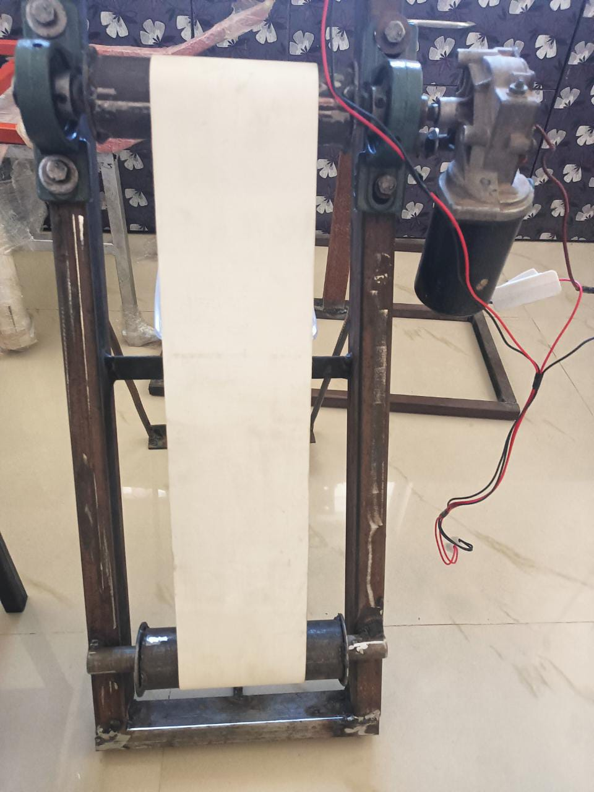

Oil skimmers are devices that are designed to remove floating oil and other hydrocarbons from the surface of water or other liquids. There are several types of oil skimmers available, each using a different technology to remove oil from the surface of the liquid.

In terms of converting technology of oil skimmers, advancements are being made in the development of more efficient and effective skimming technologies, including the use of nanotechnology, smart materials, and artificial intelligence. For example, nanotechnology-based skimmers have been developed that use a coating of nanoparticles to increase the surface area of the skimmer, improving its oil-attracting properties. Smart materials, such as shape-memory alloys, are also being explored for use in oil skimmers, as they can change shape in response to temperature or other stimuli, allowing them to collect oil more effectively. Artificial intelligence is also being used to develop smarter oil skimmers that can detect and respond to changes in oil levels and other environmental factors, improving their efficiency and effectiveness.
IRJET sample template format , Conclusion content comes here. Conclusion content comes here Conclusion content comes here Conclusion content comes here Conclusion content comes here Conclusion content comes here Conclusion content comes here Conclusion content comes here Conclusion content comes here Conclusion content comes here Conclusion content comes here Conclusion content comes here Conclusion content comes here.

3.2 Observation

Observation of an oil skimmer in action may include the following:
- The skimmer is usually seen floating on the water, with a hose or other collection system extending out from the platform.
- The collection system may use a belt or drum to remove the oil from the surface of the water. The belt or drum rotates, collecting the oil, which is then scraped off and collected in a tank or other storage system.
- Some skimmers use a suction system to draw the oil off the surface of the water. A hose or tube is used to suction the oil into a tank or storage system.
- The skimmer may be operated manually or with a remote control.

CONCLUSIONS

The effectiveness of oil skimmers depends on a variety of factors, including the type of skimmer used, the size and viscosity of the oil, and the weather conditions. Multiple skimmers may be used in tandem to increase efficiency and ensure that all of the oil is removed from the water.
While oil skimmers are an important part of the overall strategy for cleaning up oil spills, they are not a complete solution. Other methods, such as booms, dispersants, and bioremediation, may also be necessary to fully address the environmental impacts of an oil spill.
Overall, oil skimmers are an essential tool for protecting the environment and supporting a variety of industrial processes that involve the use of oil and other hydrocarbons.

ACKNOWLEDGEMENT

Oil skimmers are an important technology that has been developed and improved over the years by various individuals, organizations, and companies. We acknowledge their contributions and dedication to improving the effectiveness of oil spill response and pollution prevention.
We also acknowledge the efforts of government agencies, such as the United States Coast Guard and the Environmental Protection Agency, in regulating the use of oil skimmers and promoting their use in response to oil spills and other environmental emergencies.
Furthermore, we recognize the ongoing research and development efforts by scientists and engineers to improve the efficiency and effectiveness of oil skimmers, as well as to develop new technologies for cleaning up oil spills and preventing environmental damage.
Finally, we appreciate the efforts of individuals and organizations that work to promote public awareness of the importance of protecting our environment and preventing pollution, and the role that oil skimmers play in achieving these goals.

REFERENCES
- Annunciado, T. R., Sydenstricker, T. H. D., Amico, S. C., 2005. Experimental investigation of various vegetable fibers as sorbent materials for oil spills. Marine Pollution Bulletin, 50, 1340-1346, doi:10.1016/j.marpolbul.2005.04.043.
- Alexander, C., 17 December 2014. National Geographic Report.
- Ansell, D. V., Dicks, B., Guenette, C. C., Moller, T. H., Santne, R. S., White, I. C., 2001. Proceedings from ‘01: International Oil Spill Conference, The International Tanker Owners Pollution Federation Limited, March 20, Tampa, Florida, USA.
- Agnew, R. W., 1972. A free floating endless belt oil skimmer, EPA-R2-72-006.
- Behnood, R., Anvaripour, B., Fard, N. J. H., Farasati, M., 2013. Application of natural sorbents in crude oil adsorption. Iranian Journal of Oil & Gas Science and Technology, 2(4), 1-11.
- Broje, V., Keller, A. A., 2007. Interfacial interactions between hydrocarbon liquids and solid surfaces used in mechanical oil spill recovery. Journal of Colloid and Interface Science, 305, 286-292. doi: 10.1016/j.jcis.2006.09.078.
- Broje, V., Keller, A. A., 2007. Effect of operational parameters on the recovery rate of an oleophilic drum skimmer. Journal of Hazardous Materials, 148, 136–143. doi:10.1016/j.jhazmat.2007.02.017.
- Dave, D., Ghaly, A. E., 2011. Remediation technologies for marine oil spills: a critical review and comparative analysis. American Journal of Environmental Science, 7(5), 423-440.
- Encyclopædia Britannica News., 2010. Deepwater Horizon oil spill of 2010 (oil spill, Gulf of Mexico). Retrieved from https://global.britannica.com/event/Deepwater-Horizon-oil-spill-of-2010.
- Fingas, M., 2004. Weather windows for oil spill countermeasures for Prince William Sound Regional Citizens’ Advisory Council (PWSRCAC), Anchorage, Alaska, Environmental Technology Centre, Environment Canada.
- Government of Dubai, Technical Guideline Number-I., 2011. Oil Spill Preparedness and Response. Marine Environment & Wildlife Section, Environment Department.
- Gupta, U. S., Jain, S., Jain, H., Rathi, S. S., 2015. Experimental performance & evaluation of eco oil skimmer. International Journal of Research in Engineering Technology and Management, 2 (5), 1-10.
- Hammoud, A. H., 2001. Enhanced oil spill recovery rate using the weir skimmer, US EPA Archive Document.
- Husseien, M., Amer, A. A., El-Maghraby, A., Taha, N. A., 2009. Availability of barley straw application on oil spill clean-up. International Journal of Environmental Science and Technology, 6(1), 123-130.

.

