HealthCare Chatbot System Using Machine Learning

Sayali korake  Department of Computer Engineering: SMT.Kashibai Navle college of Engineering Pune, India Sayalikorake25@gmail.com  Rohit Madgundi Department of Comp Engg SMT.kashibai navle college of Engineering Pune, India.  rohitmadgundi@gmail.com | Shivkanya Mhetre  Department of Computer Engineering  Smt Kashibai Navale college of Engineering Pune India Mhetershivkanya@gmail.com  Dhanashri Nevase Department of Computer Engineering SMT.Kashibai Navle college of Engineering Pune, India Dhanashri.nevase@gmail.com | Vrushali Gaikwad Department of Computer Engg. SMT Kashibai Navale college of Engineering Pune, India 2001vrushaligaikwad@gmail.com

Abstract: Healthcare is a very important to led good life. However, it is very difficult to obtain consultation with the doctor for health problem. The idea is to create the medical chatbot using Artificial Intelligence that can diagnose the disease & provide basic details about disease before consulting the doctor. This will help us to decrease the healthcare costs and improve accessibility to medical knowledge through medical chatbot.
The chatbots are computer programs that use the natural language to interact with users. The healthcare chatbot stores all data in database to identify the disease. Ranking & sentence similarity calculation is performed using ngram, TFIDF & cosine similarity. The score will be obtained for the each sentence from the given input sentence & more similar sentences will be obtained for the query given. The 3rd party, expert program, handles question presented to a bot that is not understood or is not present in the database.

I . INTRODUCTION :
A chatbot is an automated program that simulates human conversation through text messages, voice chats, or both.
The chatbot is a computer programs that use natural language to interact with users.
It stores the data in database to identify the sentence keywords & to make a query decision and answer to question.
There are wide ranges of chatbots such as business, customer care, healthcare, recommendation systems, support system, accessory shopping, travel chatbots, banking chatbots etc.

- SCOPE OF SYSTEM
- Provided Solution to particular disease
- Introduced voice-based feature
- Provides daily reminders about health to the user
- Scheduling of doctor appointment
.

REQUIREMENT ANALAYSIS

  - SOFTWARE REQUIREMENT

  - DATABASE REQUIREMENT:
    - Database: SQLite

  - HARDWARE REQUIREMENT:

    - I5 Processor Based Computer or higher
    - Memory: 4 GB
    - Hard Drive: 1 TB
    - Monitor
    - Internet Connection

  - SOFTWARE REQUIREMENT:

- Windows 10
- Jupitar Notebook / Google colab
- React JS
- My SQL
- Python.

- FEASIBILITY STUDY

Risk:
7 AM hencethe promotional emails should be sent at 7 AM and determinewhich content is the best to get a highest open rate, click through rate.

Plan:
- We may not be suitable to
optimize itveritably easily.

- Any AI/ ML problem is veritably heavily data- driven so the entire thing depends on thedataset, Like what kind of dataset is used and how you'll ameliorate that dataset.( It can be answered using if we don't get Any clean datasets, we can use the shell datasets.)

- Tracking might be accurate with drive announcements, but again it isn't possible to integrate shadowing data with being CRM.

Proposed Solution:
Use traditional datasets to build an AI model which will determine which is the best content and time of delivery additional bonus would be which would be the best channel to communicate for the subset of users.

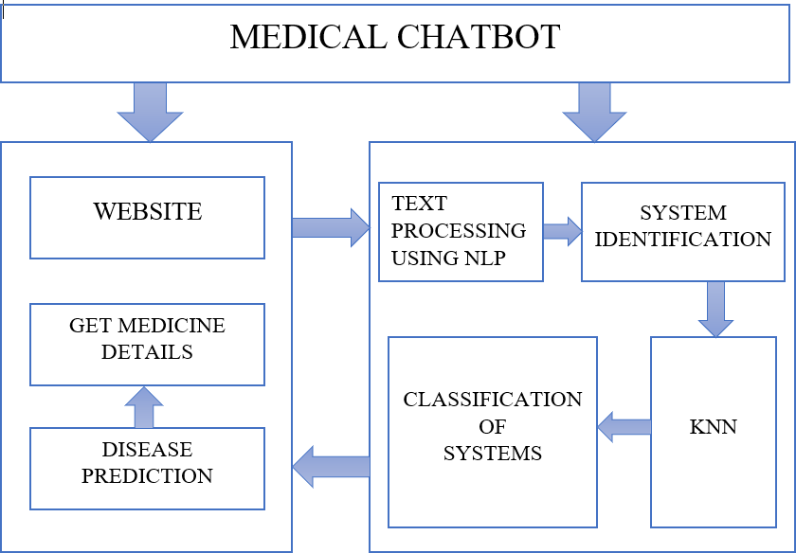
  - Use traditional datasets to build an AI model which will determine which is best content and time of delivery additional bonus would be which would be the best channel to communicate for the subset of users.

- GAP IDENTIFICATION IN EXISTING SYSTEMS

  - There is no specific solution of the disease rather they only elaborate the disease.
  - Text based input to system

- PROPOSED A SYSTEM

- Provided Solution to particular disease
- Introduced voice based feature
- Provides daily reminders about health to the user
- Scheduling of doctor appointment
- as a mode of communication and checks email at

User can interact with the system by following steps: 1) Client will be authenticated first by logging into the system if username and password are correct then client will be authenticated to enter into the system and start communication. 2) User enter his/her symptoms into chatbot 3) The system takes symptoms and apply NLP algorithm for text pre-processing 4) By applying KNN algorithm classification of symptoms are takes place 5) Then depending on symptoms, Chatbot gives Medicine details.

VIII . ALGORITHM

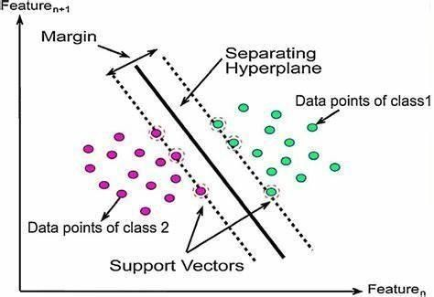
In this project Data Science, and Machine Learning Approachesand algorithm are used.

Support Vector Machine (SVM)

- A support vector machine is a machine literacy algorithm that analyzes data for bracket and retrogression analysis.
- SVM is a supervised literacy system that looks at data and feathers it into one of two orders. Support Vector Machine labors chart of sorted data with perimeters between two as far piecemeal as possible.
- SVMs are used in the text categorization, handwriting recognition and in the sciences.
- Support Vector Machine is one of the mostly used Supervised literacy algorithms, which is used for Bracket as well as Retrogression problems. still, primarily, it's used for Bracket problems in Machine literacy.

1. Datasets:
Linear Data
Linear data is data that can be represented on a liner graph. This means that there's a clear relationship between the variables and that the graph will be a straight line.

- ADVANTAGES

- Assistance with Medications
- Daily Medication Reminders
- Reduced Costs
- Scalable Customer Service
- Save Time

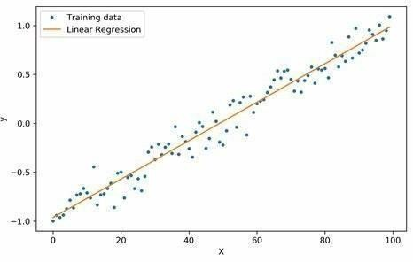

- APPLICATION

- Provide on-demand solution on health-related problems
- Offer instant support to the patients
- Remind people of medication
- Make appointments to doctors and save time in queues

- CONCLUSION

The user of this application can specify their symptoms to the chatbot and chatbot will specify the health measures to be taken. General information about symptoms and diseases are available in the dataset. After analyzing the symptoms of the different users, it finally predicts the disease to the user.

XII REFERENCES

- Chatbot for Disease Prediction and treatment Recommendation using Machine Learning, Rohit Binu Mathew, Sandra Varghese, Sera Elsa Joy, Swanthana Susan Alex.

- The Times of India, https://timesofindia.indiatimes.com/lifestyle/health-fitness

3 . Sameera A. Abdul-Kader, Dr. John Woods. Survey on the Chatbot Design Techniques in Speech Conversation Systems, School of Computer Science and Electronic Engineering/University of Essex Colchester/ UK

- Kuligowska, Karolina. (2015). Commercial Chatbot Performance Evaluation, Usability Metrics & Quality Standards Embodied Conversational Agents. Professionals Center for Business Research. 2. 1-16. 10.18483/PCBR.22

- Mrs. Rashmi Dharwadkar, Dr.Mrs. Neeta A. Deshpande "A Healthcare ChatBot"” in National Journal of Computer Trends and Technology (IJCTT) V60(1):41-45, June 2018.

- Shweta Taneja, Charu Gupta , Kratika Goyal , Dharna Gureja, “An Enhanced K-Nearest Neighbor Algorithm Using Information Gain and Clustering”, 2014 Fourth International Conference on Advanced Computing & Communication Technologies. doi:10.1109/acct.20

