Review on 8051 microcontroller trainer kit

Sneha Karadkhele, Smita Ambhore, Shrushti Kulkarni, Nidhi Rahegaonkar

Department of Electrical engineering, Government polytechnic Nanded

Abstract— The use of development board has become increasingly popular in the field of embedded systems. This project focuses on interfacing various peripheral like lads, LCD, seven segment and stepper motor with 8051 microcontroller development board. The objective of the project is to provide a platform for students and enthusiasts to learn and experiments with different hardware peripheral using a single development board. In this paper, we discussed the implementation of each these peripheral and the results obtained.
Keywords – microcontroller 8051; seven segment display; embedded system

I. INTRODUCTION

The 8051 microcontroller is a popular choice for embedded systems due to its simplicity, low Power consumption and ease of programming however working with various hardware peripheral can be daunting task for beginners. The use of development board has made it easier for students and enthusiastic to experiment with different hardware peripheral without the need for extension hardware knowledge. In this project we Focus on interfacing four different peripheral leds, LCD, stepper motors and seven segment display with 8051.

8051 Microcontroller is designed by Intel in 1981. It is an 8bit microcontroller. It is built with 40 pins DIP (dual inline package), 4kb of ROM storage and 128 bytes of RAM storage, 2 16-bit timers. It consists of four parallel 8- bit ports, which are programmable as well as addressable as per the requirement. An on-chip crystal oscillator is integrated in the microcontroller having crystal frequency of 12 MHz[1]. The 8051 architecture performs many functions (CPU), random access memory (RAM), input/output(I/0), interrupt logic, time etc) in one package.[2].
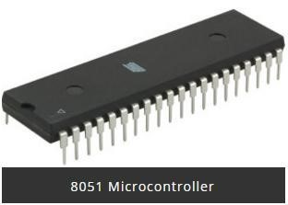

II. LITERATURE REVIEW

The interfacing of various display and microcontrollers has been an essential part of the embedded system design for many years. There is a considerable amount of literature available on interfacing seven segment displays,LEDs,LCDs and Stepper motor with microcontrollers like the 8051 .
Interfacing of seven segment displays: seven segment display are commonly used in digital electronics to display numerical information .They consist of seven LEDs arranged in the shape of number eight .There are two types of seven segment display -common cathode and common anode .There are many methods available for interfacing seven segment display with Microcontroller like 8051 , including direct interfacing and multiplexing.Some of the literature topic includes “ interfacing seven segment display with 8051 microcontroller “ by micro Digital.Ed.
Interfacing LEDs : LEDs are commonly used in digital electronics to indicate the status of circuit or to provide visual feedback .They are relatively easy to interface with microcontrollers like the 8051 .There are several methods available for interfacing LEDs , including direct interfacing and matrix interfacing.Some of the literature on this topic includes “interfacing LEDs with 8051 microcontroller “ by Robotics club and “interfacing LEDs with
8051microcontroller” by Tutorial point.
Interfacing LCDs : LCDs are commonly used in digital electronics to display alphanumeric information .They are more complicated to interface with microcontrollers then seven segment display or LEDs. There are several methods available for interfacing LCDs , including direct interfacing and using an LCD driver like the HD44780. Some of the literature on this topic includes “ interfacing LCD with 8051 microcontroller” by Edgefx Kits and “Interfacing LCD with
8051 microcontroller using apriteus Simulation” by Engineers Garage Interfacing stepper motor: Stepper motor are commonly used in digital electronics to control the movement of mechanical devices like robot ,CNC machines, and printers
.
They are complicated to interface with microcontrollers then simple display or LEDs .There are several methods available for interfacing stepper motors, including using a Stepper motor driver like the L293D. Some of the literature on this topic includes “ Interfacing stepper motor with 8051 microcontroller ” by using stepper motor driver like L293D .Some of the literature on this topic includes “ Interfacing stepper motor with 8051 Microcontroller using L293D” by circuit digest. In conclusion there is vast amount of literature available on interfacing various displays and motors with Microcontroller like the 8051. Direct interfacing and using appropriate drivers are the most common method for interfacing these devices.

III.COMPONENT SELECTION

1. STEPPER MOTOR

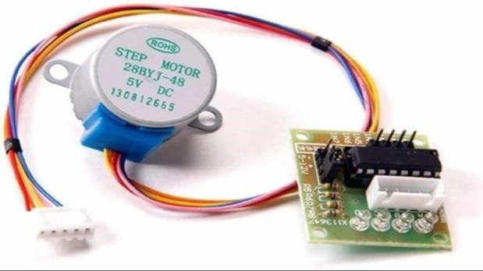

Stepper motor is a brushless motor which converts electrical pulses into mechanical rotation .As the names indicates it rotates insteps according to the input pulses .In some disk drive , dot matrix printers , and some other different palaces stepper motor are used.the main advantage of using stepper motor is the position control . stepper motors generally have permanent magnet shaft ( rotor ), and it is surrounded by a stator
Normal motor shaft can move freely but the stepper motor shaft move in fixed repeatable increments . Interfacing of Stepper motor with 8051 microcontroller
A Stepper motor driver is required to provide a sufficient power control to the motor common driver chip include the L293D,ULN2003, and A4988 Here we are using port Po of
8051 for connecting the stepper motor. Here AR- 5V+ STEPMTR 5V Stepper motor +ULN2003 driver chip is used that is compatible with the motor and 8051 microcontroller. This is basically high voltage, high current Darlington transistor array . Each ULN2003 has 7 NPN Darlington pairs . stepper motor is connected to the driver the motor has four wires which are connected to the four outputs of driver after that driver is connected to 8051microcontroller .The driver datasheet will indicate which pin used for different functionalities such as direction and speed control . write a software in assembly or C language to control stepper motor. The program should configure the ports and pins of the microcontroller to communicate with the driver and send the appropriate signal s to the driver to control speed and direction of the motor. Once the software is written test the system to ensure that motor moves as expected ,if there is any issues troubleshoot the system by checking connection and code to resolve any issues

Overall interfacing a Stepper motor with an 8051 microcontroller requires selecting a suitable motor and driver connecting the components together, writing the software and testing the system to ensure proper operation

2. LCD ( liquid crystal display)
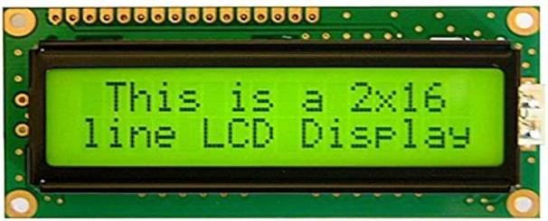

A 16×2 LCD ( Liquid crystal display) module is commonly used alphanumeric display in many electronic devices .It consists of 2 columns and 2 rows hence the name 16×2 .
The 16×2 LCD module typically uses the HD44780 controller chip , which allows for easy interfacing with microcontrollers. It has a built in character set that can display character and symbols
These LCD display usually driven by microcontroller of microprocessor Which is also present on development board.The microcontroller communicates with the LCD display via specific interface such as I2C ,SPI or parallel
interface
Interfacing of LCD with 8051 microcontroller Interfacing an LCD with 8051 in a development board involves the following steps .
- Hardware Connection: First you need to connect the LCD to the 8051 development board using the appropriate pins .The connections include data pins, control pins, and power supply pins.The data pins are used to transfer data to the LCD , while the control pins are used to send to send control signals to the LCD .The power pins are used to power the LCD .
- Write code for initialization : You need to write code to initialize the LCD before you can use it . This includes setting the mode of the LCD , such as 8-bit or 4-bit mode ,and setting the number bof lines and characters
- Write code for sending data and command: Once the LCD is initialized, you can write code to send data and commands to it .for example , you can send commands to clear the display, move the cursor to a specific position ,or turn on /off the display .
- Display the data : You can now display data on the LCD by sending the appropriate commands and data to it .for example , you can display character or strings on the LCD

3.SEVEN SEGMENT DISPLAY

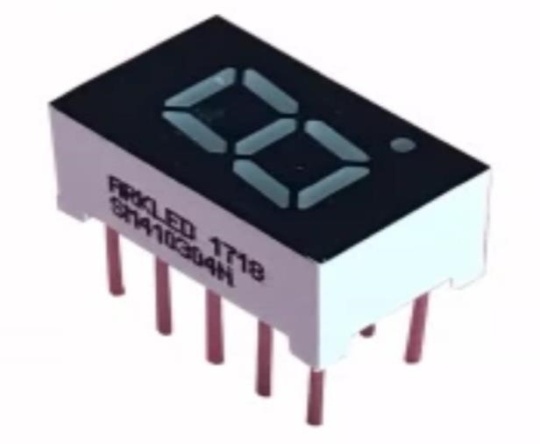

A seven segment display is a type of electronic display device that can show numerical digits and some letters by lightning up specific segments of the display .
In the context of a 8051 development board a seven-segment display is often used as an output device to display information to the user or to help with debugging code . Interfacing of seven segment display with 8051
Interfacing of seven segment display with 8051 Microcontroller development board requires the following steps :
- Choose a seven segment display : There are different types of seven segment display available in the market ,such as common anode and common cathode . Choose a suitable one according to your requirement.
- Understand the pin configuration : The seven segment display has eight pins , including seven segment pins (a to g) and a common pin (either anode or cathode) . Identify the pins of your display and understand their functionality [3] Connect the pins to the 8051 Microcontroller : Connect the seven segment pins to the I/O pins of the microcontroller and the common pin to a suitable voltage source. For example ,if you are using a common anode display , connect the common pin to VCC and if you are using common cathode display, connect it to GND
[4] write the code : Write the code in the programming language of your choice to display the desired characters to the seven segment display . The code should send the appropriate signal to the segment pins of the display to light up the desired segments .

III. METHODOLOGY

The development board used in this project is 89V51RD2. This board features an 8051 microcontroller with CMOS controller with PCA, Dual DPTR, WDT,32 I/O lines, 3 timers/ counters, seven interrupts/ 4 priority levels 64 kilo bytes ISP FLASH, 256 bytes in chip RAM , 768 bytes XRAw interface LED, LCD, stepper motor and seven segment display with the board using the appropriate interface things. We write code in embedded C language to control the peripheral and display the desired output. We test the functionality of each peripheral by turning on and off led, displaying character and numbers on the LCD, rotating the stepper motor in different directions, and displaying decimal numbers on seven segment display.
In this board, you can use any 40 pins 8051 microcontroller for interfacing and developing your own prototype. This board also contain RS232 driver for easy connection to pc or any other embedded hardware. Bridge rectifier on board allows it to power with both ac and DC power adaptor.
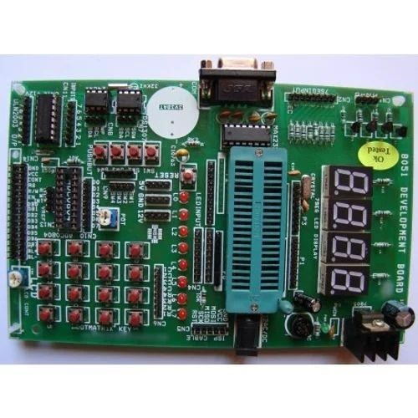
Features:

- 8051 Development board for intel 8051 architecture (EX – 89S52)
- 89v51RD2 flasher through RS232 using progisp software
- On board regulated power supply 5v, 12v supply
- Easy to test berg connection wires
- A serial port for ISP
- An RS232 serial ports
- 7 segment multiplexed display
- DC power supply connector
- Ready interface for LCD display 2 line x 16 character
- 24Cxx I2C EEPROM
- RTC DS1307
- 8 LED array
- Matrix keypad
- 4 interrupt switches

IV. SIMULATION DIGRAM
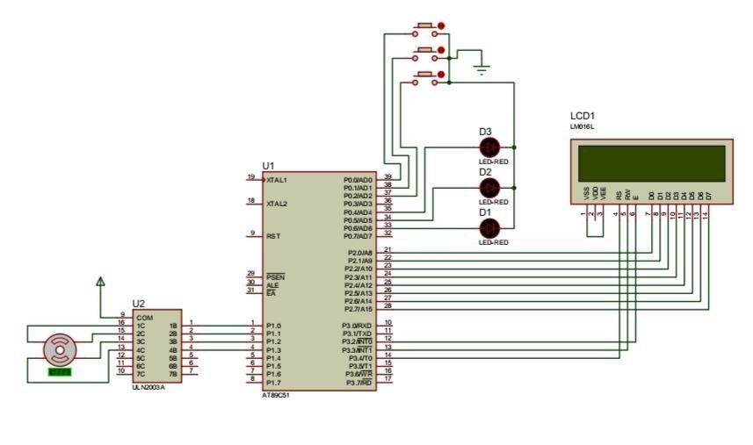

Fig .(a) To interface LED,LCD ,and Stepper motor with mounted on an 8051 development board

V. PRACTICAL SET-UP

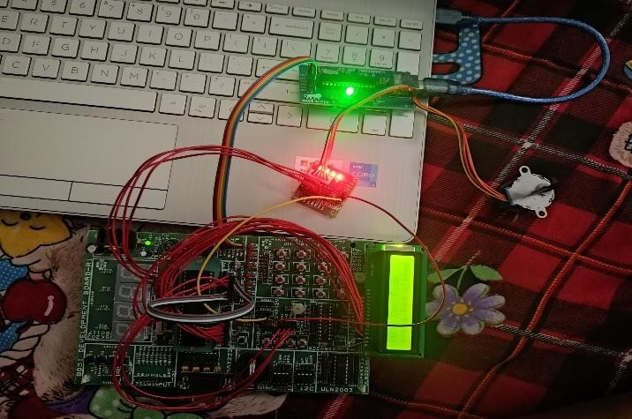

VI. RESULTS AND DISCUSSIONS

Gives students a greater understanding of their skills base. Students will be able to acquire new ideas and learn a deeper understanding of various concepts.
- Practical education helps one to think critically, analyze problems, and come up with appropriate solutions.
- To give support for students in their learning and to make a link between the domain of real objects and observable facts on one hand and the domain of ideas on the other
- The abilities that students acquire to perform their practical efficiency

VII. CONCLUSION AND FUTURE SCOPE

In this project, we successfully designed and implemented a development board that can be used to interface various hardware peripheral with the 8051 microcontroller. We demonstrated the functionality of four different peripheral LED, LCD, stepper motor and seven segment display and provided sample codes for each peripheral. This board provides a platform for students and enthusiasts to learn and experiment with different hardware peripheral using single development board. Further improvements could be made to the board to include additional peripheral or to enhance it’s functionality.
The 8051 microcontroller is a popular choice for embedded system development and development board based on this microcontroller can provide a powerful platform for experimenting with hardware and software. Here are the sone potential areas of future development for 8051 development board:
- Integration with internet of things (IoT)
- Real time operating system (RTOS)
- Machine learning
- Augmented reality (AR)
- Block chain technology

Overall the future potential scope of 8051 development board is vast, and new ideas and innovation are emerging every day. The key to success is to keep an open mind saty up to date with the latest trends and technology, and be willing to experiment and explore new possibilities.

VIII.REFFERNCE

[1] Yeralan and Ahluwalia. I programming and interfacing the 8051 microcontroller, Addison -Wesley 1995 [2] m ackcnzicScott , IThe 8051 Microcontroller , Prentice Hall, 3rd .Ed , l 1999.
- Donal Heffernan I8051 Microprocessor University of Limerick May 2002
- A Fasiku, Ayodeji Ireti B.Olawale, Jimoh Babatunde,
C.Abiola Oluwaroyin.B,”Comparison of Intel single Core and Intel Dual Core Processor performance”, International Journal of Scientific Reasearch in computer science and engineering, Vo1, Issue.1pp1-9 2013
- S Shaikh,S Rathi and P.janrao, “IRuSL: Image Recommendation using semantic Link ,”2016
- Tiwari R Sam and S Shaikh “Analysis and prediction of churn customer for telecommunication industry”, 2017
- Navadia P.Yadav. J Thomas and S. Shaikh “ whether prediction A novel approach for measuring and analysing weather data “ 2017
- International conference on I-SMAC (loT in Social Mobile Analystics and cloud )
[ 8] S Shaikh,S Rathi and P.Janrao , Recommendation System in E-commerce websites: A Graph Based Approached 2017 IEEE 7th International advance computing Conference (IACC) [9] Aurdino Embedded Technologies – An Encyclopedia Coverage of compiler’s Programmers and simulator’s for 8051 , PIC , AVR
- 8051 tutorial Information by Vault Information , services http://www.8051.com
- M.Sora , J.Talukdhar ,S.Majumder, P.H Talukdhar .U.S .Sarmah ,” Word level detection of Galo and Adi language using acoustical cues”.

