SIDHAARTH VISHNU.K.R. S
Department of computer science ,sri Krishna arts and science college, Coimbatore

ABSTRACT
Cloud computing is a type of computing that utilizes a network on the internet rather than a local server or a personal computer to store, manage, and process data,. It is a model of service delivery that allows businesses to access technology-enabled services over the internet. Cloud computing provides a range of benefits to users, including scalability, cost savings, increased collaboration and productivity, and improved disaster recovery and business continuity. Moreover, cloud computing offers businesses the opportunity to access enterprise-level applications and services without the need to invest in costly hardware and software. This abstract outlines the basics of cloud computing, its benefits, and the potential for businesses to leverage it for their own success. Cloud computing is a model of delivering on-demand computing resources, including servers, storage, and applications, over the internet. In this model, users can access these resources from anywhere and at any time without needing to manage or own the underlying infrastructure. Cloud computing offers several benefits, including scalability, cost efficiency, and flexibility. It enables businesses to easily scale their operations up or down based on changing demands, pay only for the resources they use, and access a range of services without needing to invest in their own hardware and software. Cloud computing has become increasingly popular in recent years, with public cloud providers like Amazon Web Services, Microsoft Azure, and Google Cloud Platform dominating the market. As more businesses move their operations to the cloud, the need for skilled cloud computing professionals is also increasing.
KEYWORDS
Cloud computing, services, businesses,storage ,data,storage,
Security.

Fig.1 cloud computing
INTRODUCTION
Cloud computing is a type of computing that relies on sharing computing resources to handle applications not by having local servers or personal devices . It is a model for enabling convenient, on-demand network access to a shared pool of configurable computing resources that can be quickly provisioned and released with small management effort or service provider interaction. Cloud computing services are offered in three main categories: Infrastructure-as-a-Service (IaaS), Platform-as-a-Service (PaaS) and Software-as-a-Service (SaaS).
Cloud computing offers organizations a variety of advantages, including cost savings, scalability, reliability, and flexibility. It also allows organizations to focus on their core competencies instead of managing IT infrastructure. Additionally, cloud computing can help organizations improve their agility, since they no longer need to wait for hardware to be provisioned and deployed. Furthermore, cloud computing enables organizations to access powerful applications and services that they may not have been able to afford on their own.
FUTURE OF CLOUD COMPUTING
Cloud computing is the future of computing. It offers the promise of ubiquitous access to computing resources, allowing organizations of all sizes to store and process data in the cloud and access it from anywhere in the world. We can expect to see cloud computing become a much bigger part of the tech landscape in the near future, as more businesses move towards cloud-based solutions and increased use of artificial intelligence and machine learning. Cloud infrastructure is expected to become even more scalable and powerful, making it easier and more cost-effective for organizations to access the resources they need. We can also expect to see the development of more sophisticated security technologies to protect data stored in the cloud, as well as the emergence of new cloud-based services that will help businesses maximize their efficiency. 
Fig.2 future of cloud computing
APPLICATIONS OF CLOUD COMPUTING
1. Data Storage: Cloud computing offers a central storage platform for businesses of all sizes. Companies can store their data in the cloud for easy access and sharing.
2. Big Data Analysis: Big data analysis can be done in the cloud without the need for physical infrastructure. This makes it easier for companies to process large amounts of data and make informed decisions.
3. Business Intelligence: Business intelligence tools can be used to gain insights from large datasets in the cloud. With cloud computing, businesses can quickly identify trends and patterns in their data.
4. Disaster Recovery: Cloud computing can help businesses back up their data and quickly get back up and running after a disaster. By storing data in the cloud, businesses can be sure their data is safe and secure.
5. Collaboration: Cloud computing makes it easy for teams to collaborate on projects. Files can be shared easily and securely in the cloud, so everyone has access to the same information.
PRIVACY AND SECURITY OF CLOUD COMPUTING
Cloud computing provides a high level of security and privacy due to the use of multi-level security protocols, encryption techniques, and authentication procedures. Cloud providers have invested in physical, technical, and administrative measures to protect data from unauthorized access, modification, and destruction. Cloud users have the ability to control access to their data with the use of authentication techniques, authorization methods, and data encryption. Furthermore, cloud providers are subject to government regulations and industry standards, which further ensures the security and privacy of cloud computing.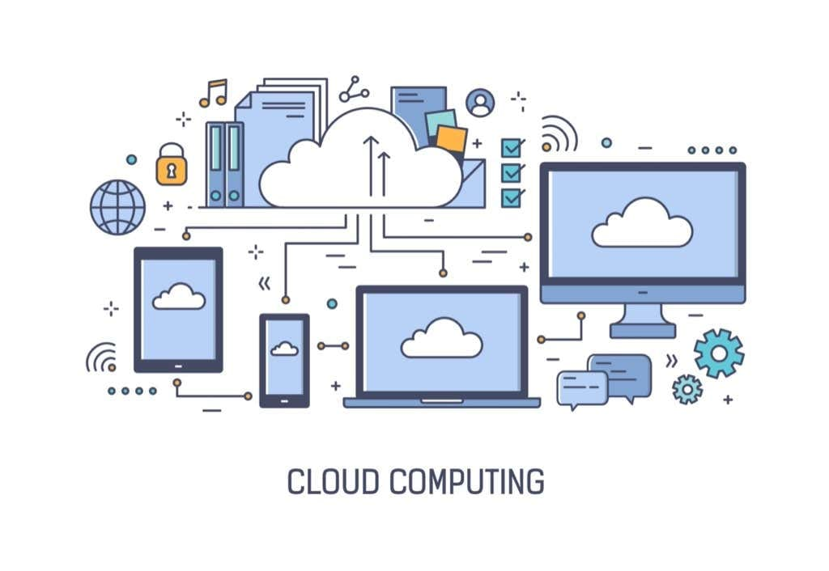
Fig.3 privacy and security
DEVELOPMENT OF CLOUD COMPUTING
Cloud computing is the delivery of computing services such as servers, storage, databases, networking, software, analytics, and more over the internet. This type of computing provides users and organizations with on-demand access to a shared pool of configurable resources, such as networks, servers, storage, applications, and services that can be rapidly provisioned and released with minimal effort or service provider interaction.
The development of cloud computing has been driven by the emergence of virtualization, service-oriented architecture, autonomic computing, and utility computing. Virtualization technology enables the abstraction and pooling of physical resources, including networks, servers, storage, and applications, into virtual resources, making it possible to provision and release these resources quickly and easily. Service-oriented architecture (SOA) enables the delivery of IT services as a combination of loosely coupled software components. Autonomic computing describes the ability of a computer system to manage itself, including self-healing, self-configuration, and self-optimization. Utility computing describes the delivery of computing resources as a metered service, similar to a utility such as electricity.
The development of cloud computing has enabled organizations to reduce capital and operational expenses, increase agility and scalability, and enable users to access computing services anywhere

CONCLUSION
Cloud computing is a powerful and cost-effective technology that can be used to drive digital transformation initiatives. It offers the scalability, flexibility, and security that modern businesses need to stay competitive. In addition, cloud computing provides a number of benefits such as increased collaboration, improved efficiency, and reduced costs. By taking advantage of the cloud, organizations can become more agile and better equipped to handle the ever-evolving needs of their customers. With the right cloud computing strategy, businesses can maximize their potential and remain ahead of the competition. In conclusion, ChatGPT is a powerful language model trained by OpenAI that can provide helpful assistance and answers to a wide range of questions. Whether you need help with a homework assignment, want to learn about a specific topic, or just want to engage in a conversation, ChatGPT is always ready and available to assist you.With its extensive knowledge base and advanced natural language processing capabilities, ChatGPT can understand complex questions and provide accurate and informative responses. It can also learn and adapt over time, improving its responses as it gains more experience interacting with users.Overall, ChatGPT represents a significant step forward in the field of artificial intelligence and has the potential to revolutionize the way we interact with machines and access information. Its ability tkes it a valuable resource for anyone looking . As an AI-powered conversational agent,


Fig_4-cloud computing

REFERENCE
[1]Bradford, C. (2019). 7 Most Infamous Cloud Security Breaches – StorageCraft. Retrieved from https://blog.storagecraft.com/7-infamous-cloud-security-breaches
[2]Mell, P., & Grance, T. (2011). The NIST Definition of Cloud Computing. Retrieved from https://csrc.nist.gov/publications/detail/sp/800-145/final
[3]Mimoso, M. (2013). Contractor Accesses 2 Million Vodafone Germany Customer Records. Retrieved from https://threatpost.com/contractor-accesses-2-million-vodafone-germany-customer-records/102286/
[4]Patrick, S. (2016). Security and the Cloud: Trends in Enterprise Cloud Computing Clutch.co. Retrieved from https://clutch.co/cloud/resources/security-trends-in-enterprise-cloud-computing
[5]Mell, P., & Grance, T. (2011). The NIST definition of cloud computing. National Institute of Standards and Technology, 53(6), 50.
[6]Armbrust, M., Fox, A., Griffith, R., Joseph, A. D., Katz, R., Konwinski, A., ... & Zaharia, M. (2010). A view of cloud computing. Communications of the ACM, 53(4), 50-58.
[7]Buyya, R., Yeo, C. S., Venugopal, S., Broberg, J., & Brandic, I. (2009). Cloud computing and emerging IT platforms: Vision, hype, and reality for delivering computing as the 5th utility. Future Generation Computer Systems, 25(6), 599-616.
[8]Marston, S., Li, Z., Bandyopadhyay, S., Zhang, J., & Ghalsasi, A. (2011). Cloud computing—The business perspective. Decision support systems, 51(1), 176-189.
[9]Kshetri, N. (2018). Blockchain’s roles in meeting key supply chain management objectives. International Journal of Information Management, 39, 80-89.
[10]Vaquero, L. M., Rodero-Merino, L., & Caceres, J. (2009). A break in the clouds: towards a cloud definition. ACM SIGCOMM Computer Communication Review, 39(1), 50-55.

