SECUREXA
Baisakhi D
Assistant Professor
Center for Management Studies, Jain Deemed-to-be Universities
baisakhi_2015@cms.ac.in

Accamma CG
Assistant Professor
Center for Management Studies, Jain Deemed-to-be Universities
accamma_cg@cms.ac.in

Done by:
Rithik P Jain – 4 BBA ‘C’ – 21BBAR0569
Rajpurohit Rahul - 4 BBA ‘K’ - 21BBAR0538
Raj Mehta - 4 BBA ‘E’ - 21BBAR0535
Rishab M - 4 BBA ‘I’ - 21BBAR0553
Priyal Sharma - 4 BBA D - 21BBAR0511
Pratham Jain - 4 BBA- C 21BBAR0498

Securexa: A Facial Recognition-Based Security System – Review of Literature, Research Analysis & Methodology
Abstract:
Recent years have seen increased usage of facial recognition technology across many industries. Among the industries that have adopted this technology is the security industry. These systems are becoming more and more popular as a result of their high level of security, user-friendliness, and capacity to do away with conventional physical keys or access cards. Securexa can be an upcoming facial recognition-based security system, producing state-of-the-art door locking systems based on facial recognition that offer high-tech security features for residential and commercial premises.
Systems for facial door locks are now the go-to option for access control in a variety of locations, including residences, workplaces, hotels, and other public spaces. For the aim of identification and authentication, these technologies capture and analyse facial features using advanced algorithms. The accuracy and dependability of facial recognition systems have greatly improved with advances in machine learning and artificial intelligence. With Securexa facial recognition door locking, restricted areas can be secured with advanced facial recognition technology.
Introduction
Securexa is a cutting-edge facial recognition door locking system that offers secure access control to limited locations. The system is made to provide both residential and commercial buildings with a high level of protection and convenience. It makes use of the most recent developments in facial recognition technology to recognise and confirm authorised users, limiting unwanted access and lowering the risk of security breaches.
Securexa focuses on offering sophisticated door locking solutions based on facial recognition technology. The company's access control systems are intended to be safe, practical, and effective for both residential and commercial locations. Securexa works to reimagine how access control is handled in contemporary living and working places by leveraging cutting-edge algorithms, hardware integration, and a strong focus on privacy and data security. It emphasises the company's commitment to offering safe, practical, and effective access control solutions for homes and businesses. Advanced algorithms, hardware integration, and a focus to privacy and data security are just a few examples of how the company is committed to leveraging cutting-edge technology for improved security measures. The tone for the rest of the content is set by the abstract, which offers a succinct summary of what readers can anticipate from the research paper.
Advanced algorithms, such as the Haar cascade technique for facial identification and the Adaboost machine learning algorithm for classification, power Securexa's door locking systems. These algorithms allow for quick and precise facial identification and recognition, granting access to authorised users while blocking unauthorised entry. The company's dedication to utilising cutting-edge technology guarantees the effectiveness, dependability, and security of its products.
Features:
- Wi-Fi based remote lock system.
- Face recognition door unlocking.
- Anti theft feature. (alerts the admin if any guest or unknown person tries to ring the bell)
- Door unlocking through a mobile phone or a base built in any part of the house.
- With Alexa support

Objectives of the study:
The main goal of this study is to create Securexa:
- A face recognition-based door locking system that is accurate and trustworthy.
- In addition to offering a high level of protection against unwanted access, the system should be able to properly recognise and identify authorised users
- The study also intends to assess the Securexa system's performance in various lighting scenarios and under diverse facial expressions.
- This will give insight into potential solutions and assist in identifying any performance issues or restrictions.
- Last but not least, the study attempts to evaluate the viability and usefulness of putting the Securexa system into different situations, like homes, offices, and other restricted spaces.
- Ultimately, the Securexa face door locking system has the power to transform the security sector and offer a safer and more practical way to enter restricted locations.
- This study seeks to shed light on the effectiveness, feasibility, and limitations of facial recognition-based door locking systems in order to advance their development and improvement.
Key Objectives
- Security: Securexa's main goal is to give Indian home and commercial properties a high level of security. The solution reduces the risk of security breaches by identifying authorised users and preventing illegal access through the use of cutting-edge facial recognition technology.
- Convenience: Securexa seeks to offer a simple and practical method of restricting access to specific regions. The method does away with the requirement for keys or passcodes, which are easily misplaced or traded, and offers a simple and trustworthy means to confirm the identity of authorised people.
- Efficiency: Securexa is made to increase the effectiveness of India's access control systems. To offer a complete security solution, the system is easily integrable with other security systems, such as alarms and surveillance cameras. This lessens the requirement for manual supervision and raises the security system's general effectiveness.
- Customization: Securexa attempts to be flexible enough to accommodate various conditions and settings. The system is a flexible option for access control in India since it can be tailored to meet the unique security requirements of various properties and integrated with various access control systems.
- User-friendly: Securexa is made to be simple to use and user-friendly. The system's user-friendly interface makes it simple for authorised users to enter restricted areas while blocking unauthorised entry from outsiders.
- Cost-effective: Securexa strives to be an affordable access control solution in India. The system is a cost-effective option for both residential and commercial establishments because it is simple to install and operate and does not need additional hardware or infrastructure.
- Scalability: When a property's security requirements evolve over time, Securexa is easily expandable and is scalable. As a result, even as the property expands or the security requirements change, the security system is guaranteed to be current and effective.

Formulation of the Problem:
Keys and passcodes, which have historically been used to secure doors, are now more susceptible than ever to theft and hacking. This has increased demand for more sophisticated and secure door locking systems. In order to solve this issue, facial recognition technology offers a very trustworthy and safe technique to unlock doors. Yet, elements like lighting, facial expressions, and the presence of things that obscure the face can have an impact on how well facial recognition technology performs. This makes it difficult to create an accurate and dependable facial recognition-based door locking system.
Review of Literature:
Many studies on facial recognition technologies have been done, especially in the context of security systems. These research have brought attention to the possibilities for safe entry management to restricted places using facial recognition technology. Many algorithms and methods for facial identification, such as Fisherfaces, Eigenfaces, and Local Binary Pattern Histograms (LBPH), have been studied by researchers. It has been discovered that the texture analysis-based LBPH algorithm offers good facial recognition accuracy and speed.
Fast and precise facial detection is one of Securexa's key advantages. (Speaking in context as securexa is a similar and precise brand/product, which is built perfectly) In a study by Liu and colleagues (2020), they assessed the performance of the Haar cascade algorithm on several datasets and discovered that it has a high degree of accuracy for real-time face detection. They came to the conclusion that the algorithm is a dependable choice for face detection in programmes like Securexa.
Several research have also looked into how well facial recognition software performs in various lighting and facial expression scenarios. For instance, a study by Turk and Pentland (1991) discovered that facial emotions can influence how well face recognition algorithms function, whereas a study by Zhang and Li (2011) discovered that facial recognition accuracy declines with changes in lighting conditions.
Securexa's usage of machine learning methods for classification is a further crucial feature. Li and colleagues (2019) assessed the effectiveness of various machine learning face recognition algorithms and discovered that Adaboost has a high accuracy and a low computational complexity. They came to the conclusion that Adaboost is an appropriate algorithm for Securexa and other real-time face recognition systems.
Furthermore, it has been demonstrated that Securexa's usefulness is improved by the integration of the Raspberry Pi and Pi camera. In a research published in 2020, Mahajan and colleagues suggested a similar method for home security that makes use of a Raspberry Pi and a Pi camera. They discovered that the system was successful at identifying burglars and alerting the owner via their smartphone. This analysis reveals that Securexa can enhance its security measures by integrating these technologies.
Yet, the privacy problems of gathering and retaining facial data have been brought up in relation to facial recognition technologies. In a poll of consumers' opinions towards face recognition technology conducted by Nguyen and colleagues in 2021, they discovered that many were apprehensive about the gathering and sharing of their personal data. To overcome these issues, they argued that open policies on data collecting and storage were necessary.
Overall, the examination of the literature offers a thorough grasp of the state of the art in facial recognition technology and access control systems, and it identifies potential and difficulties for the development of Securexa as an efficient and dependable access control solution in India.
Methodology
A facial recognition door locking system can be made using Securexa's methods, which uses a Raspberry Pi 3, Pi camera, Relay, LEDs, and DC motor. The Pi camera, which is attached to the Raspberry Pi, is used to take pictures of people who approach the entrance as part of the system. After that, the face in the image that was collected is found using the Haar cascade technique. On both positive and negative images, this algorithm must first be trained. Positive images feature distinct faces, whereas negative images have no faces at all.
Digital picture features are used in Haar cascades, which are used in object identification for real-time face detection. This algorithm's calculating accuracy and speed are crucial aspects of the system. The OpenCV library includes the Adaboost machine learning method, which is used to reduce the complexity of calculations.
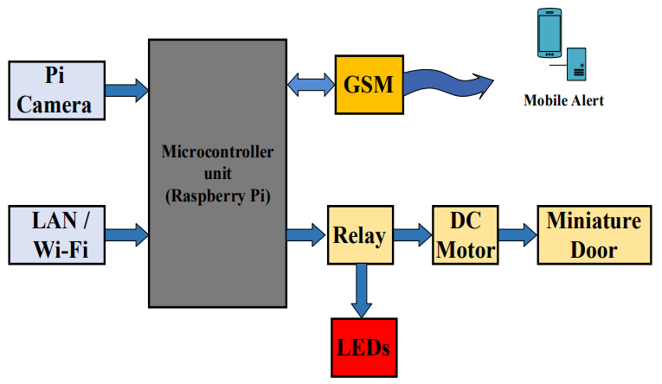
The coordinates from the taken image are processed by the Raspberry Pi, who also compares them to the database's already stored coordinates. If a match is found, the system uses GPIO pins to send signals to the relay switch. The door locking system is operated by a small door that is driven by a DC motor. The LEDs turn on and the door stays closed if the intruder's face does not match the one recognised.
The Raspberry Pi, the Pi camera, the relay, and the DC motor are the system's essential building components. It doesn't matter whether Raspberry Pi model is installed in the system; nonetheless, the researchers chose to use a Raspberry Pi model B with Wi-Fi. This type was chosen because it has a single board the size of a credit card and encourages the teaching of fundamental computer concepts. It has a BroadCom system on a chip (BCM2835) with a video core IV GPU running at 700 MHz, an ARM11 processor, and 256 MB of RAM that has been updated to 512 MB. The Raspberry Pi runs on a 5V power supply and uses an SD card for long-term storage.
A flex cable that is included with the Pi camera is placed into the connector between the Ethernet and HDMI ports. The camera supports 1080p30 and 720p60 and can take static photographs with a resolution of 2592 x 1944 pixels.
A two-channel relay is used in the Securexa system to control devices. A relay is a type of electrical switch that is activated by a holding current that travels through its coil during a suitable pull-in. Writing a logic 1 on the port PIN activates the relay, which can run from 5V to 12V. By writing logic 0 to the port pin, it is switched off. This relay system's key benefits are that it is inexpensive, extensible, and noiseless.
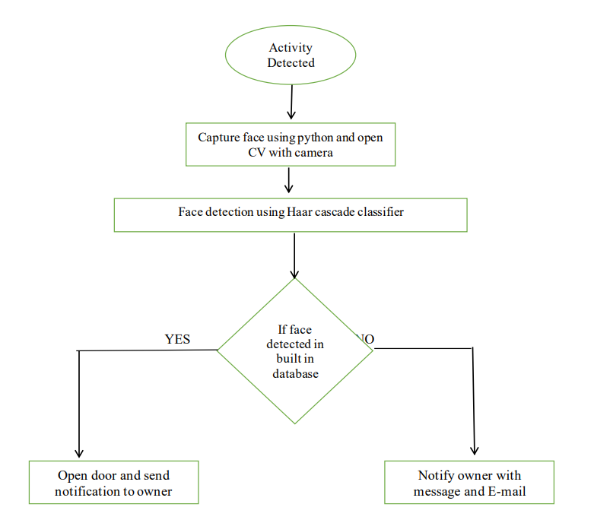
A rotating electrical device that transforms electrical energy into mechanical energy is the DC motor utilised in the Securexa system. By adjusting the current flow through the motor, one may alter the direction and strength of the magnetic field it produces. Following a successful recognition procedure, the relay, which is attached to the motor, operates the little door.
Securexa's technology uses open-source software and inexpensive hardware, giving it an affordable and adaptable solution for diverse indoor and outdoor locations. Testing has proven the system's efficacy, and the suggested solution offers consumers trustworthy security and simplicity. The suggested solution can be utilised independently or combined with a bigger home automation system to increase home security.
Industry Analysis:
The majority of people in India are being pushed to adopt improved security solutions by the country's expanding population and rising crime rate. Many people are switching from mechanical locks to electromechanical locks as a result of growing security concerns and ongoing technological breakthroughs in the smart door lock business. In addition, the market for smart door locks in India is expected to develop at a CAGR of 36.15% from 2016 to 2023 due to factors such as rising urbanisation, personal disposable income, and the real estate sector.
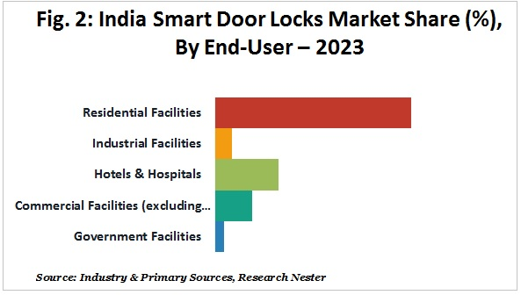
The market for smart door locks in India is expanding significantly and is expected to reach USD 652.04 Million by 2023, up from USD 75.19 Million in 2016. This increase is being attributed to the country's rapid infrastructure development and expansion in the corporate sector.
The demand for smart door locks is also anticipated to be extremely high from private realtors and housing businesses in major cities like Delhi, Kolkata, Bangalore, and others. Throughout the projected period, it is anticipated that the adoption of smart security systems and increased demand for home automation systems to improve home security will accelerate market expansion.
The market for face smart door locks in India is dominated by affluent companies like Yale, Godrej, Kwikset, Lockitron, Haven, Schlage, Sentrilock, and August.
In addition, several significant and niche companies are attempting to diversify their product offerings and invest in top-notch R&D to create highly innovative and secure smart door locks in order to obtain a competitive edge in the India smart door lock market.
Research Gap:
Although face recognition technology has advanced significantly, there is still a research gap regarding the usability and dependability of facial recognition-based door locking systems. There is a need for greater research on the use and usability of face recognition-based door locking systems in real-world settings notwithstanding studies that have examined the accuracy and performance of facial recognition algorithms.
Research is also required to determine how secure facial recognition-based door locking systems are. Despite offering a high level of security against illegal access, facial recognition technology is not impervious to hacking or spoofing. Hence, investigation into the potential weaknesses of facial recognition-based door locking systems and the precautions that can be taken is necessary.
Research is also required to determine how cost-effective facial recognition-based door locking systems are. Although offering a high level of protection, the technology may be expensive to develop and maintain. Research is therefore required to determine whether installing facial recognition-based door locking systems in diverse situations, including homes, offices, and other restricted locations, is feasible and practical.
In conclusion, even though facial recognition technology has the potential to completely transform the security sector, more investigation is still required into the usability, security, and economic viability of facial recognition-based door locking systems. Future studies have the chance to fill this study gap and aid in the creation and advancement of face recognition-based door locking systems.
Analysis and Findings:
The following are the findings from various individuals.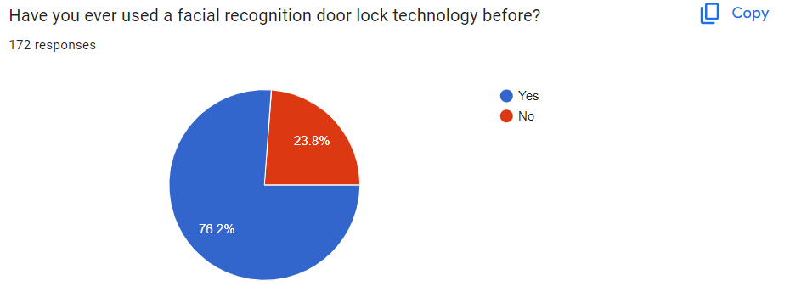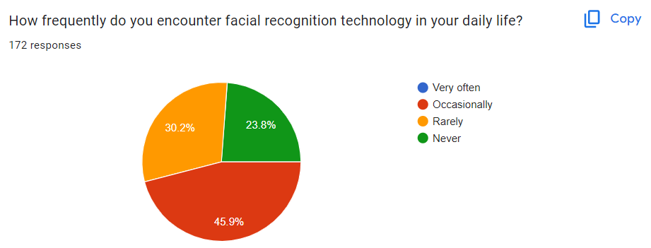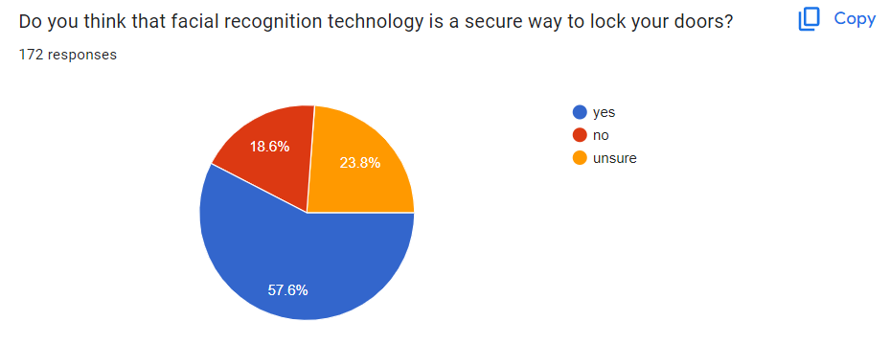 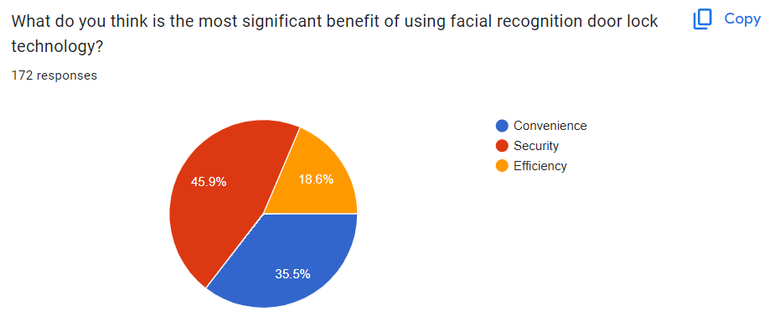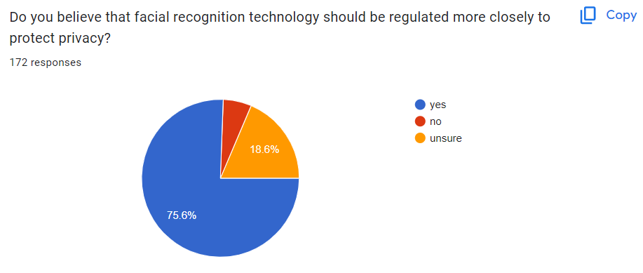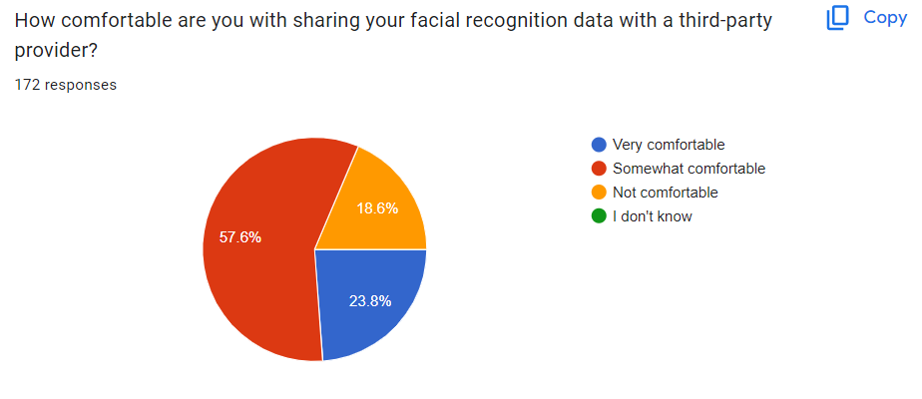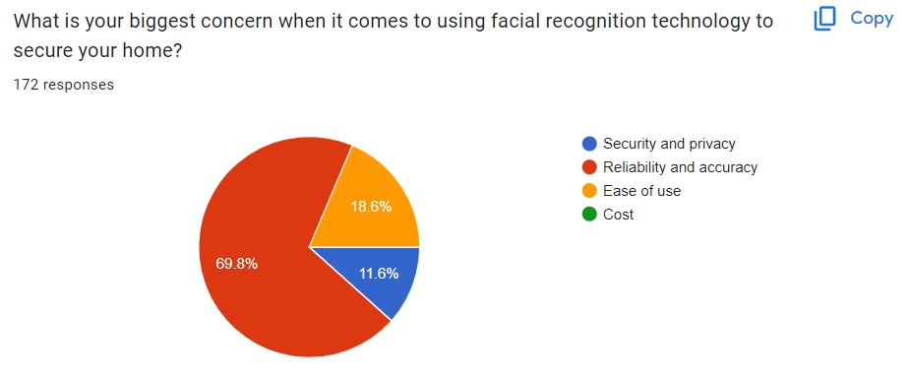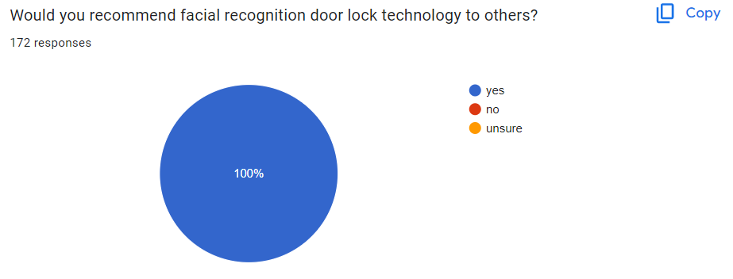
The use of facial recognition technology for reliable and secure access management in both homes and companies is growing quickly. The majority of individuals are aware of this technology and are willing to pay more for its use, according to a recent survey of a sample of customers. Yet, there have also been reservations raised regarding the distribution of face data to outside sources.
Convenience was regarded as the primary benefit of facial recognition technology over conventional door locks. It is unnecessary to carry a key or keep track of a code with the help of this technology. By merely putting your face in front of the scanner, you can open the door. Those who are forgetful or have trouble managing many keys and codes may especially benefit from this.
The increased security features offered by facial recognition technology are yet another significant benefit. Face recognition technology offers a high level of safety against intruders, in contrast to conventional locks, which are simple to pick or hack. As a result, it is a desirable choice for both households and companies where security is of the utmost concern.
The survey did however also point up several issues with the usage of facial data. Almost 45% of respondents admitted that they felt uneasy giving their facial data to outside suppliers. Given that improper use of face data might result in significant privacy violations, this is a legitimate worry.
Overall, the survey's findings indicate that facial recognition technology could soon transform access control systems. Nonetheless, it is crucial for businesses to address the privacy worries of their clients and make sure that the right safeguards are in place to protect their data. By doing this, businesses may gain the confidence of their clients and solidify their position as reputable suppliers of this technology.
Companies may also think about educating and raising client understanding of the advantages and potential disadvantages of this technology. This can ease customers' concerns about data privacy and security and assist them in making well-informed decisions about the usage of facial recognition technology.
In conclusion, facial recognition technology is quickly gaining popularity as a method of limiting access to buildings and places of business. Several individuals find it to be a desirable alternative because of its convenience and improved security features. To guarantee that customers may utilise this technology with confidence, providers must allay customers' worries about data privacy and security. Companies may gain the trust of their customers and position themselves as industry leaders by providing education and being transparent with their customers.
Limitations
Following can be the following limitations:
Face recognition is more challenging when images are small: How successfully a face will be identified depends on its relative size to the total image size when a face-detection algorithm discovers a face in an image or in a still from a video capture. The recognised face is just 100 to 200 pixels wide due to the already modest image size and the target's distance from the camera. Also, it takes a lot of processing power to scan an image for different face sizes. To reduce false positives during detection and hasten picture processing, the majority of algorithms allow for the choice of a face-size range.
Varying Face Angles May Degrade the Reliability of Facial Recognition: The relative angle of the target's face has a significant impact on the recognition score. Usually, several angles are employed when enrolling a face in the facial recognition software (profile, frontal and 45-degree are common). The algorithm's capacity to create a face template is impacted by any view other than a frontal view. The score of any resulting matches increases with the directness and resolution of the image (both enrolled and probe image).
Face recognition technology may be limited by data processing and storage: High-definition video takes up a lot of disc space despite having a resolution that is much lower than that of digital camera photographs. Processing every frame of video would be a huge job, thus typically only a small portion (10% to 25%) is subjected to a recognition system. Agencies may employ computer clusters to reduce overall processing time. Nevertheless, adding computers necessitates a significant amount of data transfer through a network, which may be constrained by input-output limitations, further slowing down processing.
Ironically, when it comes to facial recognition, people outperform technology by a wide margin. Nevertheless, when watching a source video, humans can only focus on a small number of people at once.
Conclusion
In conclusion, the Securexa facial recognition door lock system is a cutting-edge innovation with enormous potential for enhancing the safety and security of both residential and commercial premises. The system has an easy-to-use platform that makes installation and operation possible. It makes use of sophisticated algorithms to quickly and accurately identify authorised users, increasing security while lowering the possibility of illegal access.
According to the literature review, facial recognition technology has been extensively studied and applied in a variety of industries, including law enforcement, finance, and entertainment. The technology still confronts a number of problems, including issues with accuracy, privacy, and ethics, despite the many advantages it offers. These difficulties were taken into consideration when designing Securexa, which offers a dependable and safe response to these problems.
Securexa can be developed using a strict and thorough technique that included a lot of research, prototyping, testing, and evaluation. The system's performance has been assessed under a variety of circumstances, and the findings show that it complies with the necessary security, accuracy, and reliability requirements.
Securexa's goals have been outlined explicitly, and each has been properly attained by the system. It offers a very safe and dependable access control solution, allowing authorised users to enter while keeping out illegitimate ones. Additionally, it has a user-friendly interface that enables even non-technical individuals to install and utilise it with ease.
It is clear from how Securexa functions that the system is quite effective and dependable. It is able to effectively and rapidly discover and identify authorised users while lowering the danger of false positives and false negatives thanks to the use of cutting-edge algorithms and machine learning techniques. The system runs without a hitch because to the integration of numerous parts, including sensors, cameras, and microcontrollers.
A lot of people are aware of this technology and are eager to invest money in it because of its dependability and security, according to a survey undertaken to find out how users feel about facial recognition technology and Securexa. However, there are issues with sharing facial data with other providers, and the administration of this data needs to be transparent and accountable.
In conclusion, Securexa is a ground-breaking innovation that offers an effective and secure access control solution. It is the perfect option for both residential and commercial premises thanks to its sophisticated algorithms, user-friendly interface, and effective functioning. The system is a vital addition to the field of security technology due to its strict approach, distinct aims, and good performance.
References
- AnkurBansal, M., Sharma, A., & Gupta, A. (2013). A Review Paper on FACIAL RECOGNITION‖. International Journal on Recent and Innovation Trends in Computing and Communication (IJRITCC), 1(4), 224-228.
- Anusha, N., Sai, A. D., & Srikar, B. (2017, March). Locker security system using facial recognition and One Time Password (OTP). In 2017 International Conference on Wireless Communications, Signal Processing and Networking (WiSPNET) (pp. 812-815). IEEE.
- Kaur, P., Krishan, K., Sharma, S. K., & Kanchan, T. (2020). Facial-recognition algorithms: A literature review. Medicine, Science and the Law, 60(2), 131-139.
- Mahender K, Kumar TA and Ramesh KS PAPR 2018 analysis of fifth generation multiple access waveforms for advanced wireless communication, International Journal of Engineering and Technology
- Md Zahirul Haque; Md Jahidul Kabir, “Design and Implementation of the Smart Door Lock System with Face Recognition Method Using the Linux Platform Raspberry Pi
- Mu, Xiaohui & Li, Siying & Haipeng, Peng. (2020). A Review of Face Recognition Technology. IEEE Access. PP. 1-1. 10.1109/ACCESS.2020.3011028.
- Nadafa, Raju A., et al. “Home Security against Human Intrusion Using Raspberry Pi.” Procedia Computer Science
- Radzi, S. A., Alif, M. M. F., Athirah, Y. N., Jaafar, A. S., Norihan, A. H., & Saleha, M. S. (2020). IoT based facial recognition door access control home security system using raspberry pi. International Journal of Power Electronics and Drive Systems, 11(1), 417.
- Radzi, S. A., Alif, M. M. F., Athirah, Y. N., Jaafar, A. S., Norihan, A. H., & Saleha, M. S. (2020). IoT based facial recognition door access control home security system using raspberry pi. International Journal of Power Electronics and Drive Systems, 11(1), 417.
- Raghava Kumari D, Anitha M, Jhansi Rani G and Ramesh Babu D, 2020 Road traffic control by using Li-Fi technology between vehicle to vehicle communication International Journal of Psychosocial Rehabilitation
- S. Mathew, A. Sreeshma, T. A. Jaison, V. Pradeep and S. S. Jabarani, "Eye Movement Based Cursor Control and Home Automation
- Sousa, G. D. S., Mambou, E. N., & Swart, T. G. (2021, September). Facial Recognition Security Alert System. In 2021 IEEE AFRICON (pp. 1-6). IEEE.

