
Smart Canteen and Cafeteria Management System using RFID Technology

Siya Bhandari,
From Electronics Engineering Usha Mittal Institute and Technology
SNDT Women’s University siyabhandari2001@gmail.com

Harshada Menewar, From Electronics Engineering
Usha Mittal Institute and Technology SNDT Women’s University harshmena222@gmail.com

Abstract— The Internet of Things (IoT) has revolutionized various industries by connecting everyday objects and devices to the internet. IoT is a system that incorporates IoT-enabled devices, software, and sensors to automate canteen services. One of the latest applications of IoT is in the canteen industry. IoT canteen is an innovative approach to streamline the food ordering and delivery process in educational institutions, hospitals, and workplaces. The traditional system to manage meals in the canteen can be updated by using Internet of Things (IoT) involving RFID technology provides applications to gather information about a large number of the users by making it efficient to process the collected data and even encourages the use of e-cash. IoT provides transparency to admin by using the data effectively. This paper demonstrates how the system manages the canteen bills by introducing IoT in existing or traditional canteen management systems.
Keywords: RFID reader, RFID card, e-cash.

INTRODUCTION

A canteen installation is a auxiliary system which is provided by associations for their employees/students. Associations with large figures of employees cannot handle a canteen with manual processes. The being system is a cash and paper-based system. The payment and procedure take a lot of time as the client has to pay the exact amount and stay for the change. Functionalities delivered by our Canteen Management System are built on various factors Such as Canteen, Item and Sales. Manage the data of Canteen, & also Students/employees/Customers. Proper resource/stock management of Data will be done by editing, adding and modifying of records. Assimilation of all records of Sales. In colleges, schools, companies and various cafeterias this type of facilities can be provided. The users can be students, college staff or employees. Users will have to register themselves in order to be able to use this facility. Section II will be displaying the research papers we referred for this project.

Prajakta Mahajan, From Electronics Engineering
Usha Mittal Institute and Technology SNDT Women’s University ps.mahajan07@gmail.com

Professor Kiran Dange, From Electronics Engineering
Usha Mittal Institute of Technology SNDT Women’s University kiran.dange@umit.sndt.ac.in

Section III consists of the basic idea of the project, block diagram with the description of components and the flowchart. Section IV will be describing about the methodology and the working of the project. Section V which is Workflow depicts the idea about how the project would be working. Section VI will be displaying the expected results of the project. In Section VII we will be conclude and discussion about the future improvement.

LITERATURE SURVEY
“Smart Canteen Management System Using RFID” (2020) Rajath Bagre, Akshatha Y, J Hima Nanaiah, Mohammed Mehar Ali Sabri, Nihal S Karkera. The paper proposes a Smart Canteen Management System (SCMS) that uses Radio-Frequency Identification (RFID) technology to improve the efficiency of canteen operations. The system uses RFID tags attached to student ID cards to identify students and record their food purchases. It also includes a mobile application for students to pre-order their meals and track their expenses. The system allows canteen staff to manage inventory, track sales, and generate reports. The authors conducted a feasibility study and a user satisfaction survey to evaluate the system's effectiveness and found positive results. The SCMS is expected to reduce waiting times, eliminate errors, and increase customer satisfaction in the canteen.

“Canteen Management System” (2021)
Miss. Dhokane Vrushali Navnath , Miss.Devhare Vanita Adinath
The "Canteen Management System" is a project developed in 2021 by Miss.Devhare Vanita Adinath and Miss. Dhokane Vrushali Navnath. The system is designed to manage canteen operations, including menu management, order placement, billing, and inventory management. The project aims to simplify canteen operations, reduce errors, and improve efficiency.

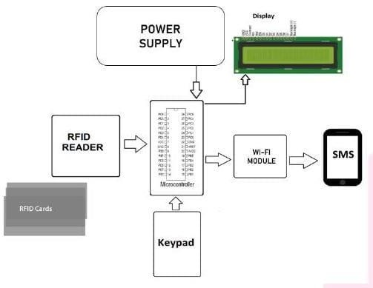
“Canteen Management System” (2022)
Bidesh Chanda, Ganadhish Navelkar, Atish Gracias, Vaibhav Sharma, Valerie Menezes, Basil Jose
The "Canteen Management System" is a project developed in 2022 by a team consisting of Ganadhish Navelkar, Bidesh Chanda, Vaibhav Sharma, Atish Gracias, Basil Jose, and Valerie Menezes. The system is designed to manage canteen operations, such as menu management, order placement, billing, and inventory management. It includes features such as online ordering, payment processing, and user management. The project aims to improve the efficiency of canteen operations, reduce errors, and enhance the overall customer experience. It is likely a software-based solution.

“Cashless Canteen Management System” (2020)
M. Ambika, Sandhya S Nair, Ranjith Kumar, S Saravana Kumar R
The "Cashless Canteen Management System" is a project developed in 2020 by M. Ambika, Saravana Kumar R, Sandhya S Nair, and Ranjith Kumar S. The system is designed to manage canteen operations without the use of cash transactions. It includes features such as user registration, order placement, and payment processing through a mobile application or smart card. The project aims to reduce the handling of cash, prevent errors, and improve the efficiency of canteen operations. It is likely a software-based solution integrated with hardware devices for payment processing.

ESP32

Fig.1. Block diagram

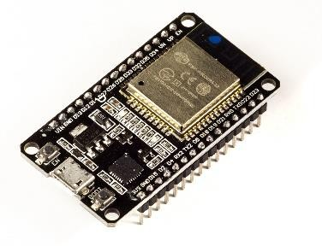
“Integrated Cafeteria Management System Using Rfid” Manali Chaudhari, Amol Shelke, Aayushi Vyawahare, The "Integrated Cafeteria Management System Using RFID" is a project developed by Amol Shelke, Aayushi Vyawahare, and Manali Chaudhari. The system is designed to manage cafeteria operations using RFID technology, including user registration, order placement, and payment processing. The RFID technology enables the system to identify customers, track their purchases, and deduct the cost of items from their accounts automatically. The project goal is to decrease the use of cash, prevent errors, and improve the efficiency of cafeteria operations. It is likely a software-based solution integrated with RFID hardware devices.

IMPLEMENTATION
The canteen management system (CMS) is a exclusive and latest solution connected to automation practices around the college canteen/company’s canteen.This benefis to verify and track employees reports within the canteen about food, daily and monthly consumption of food, employees order, etc.
As we know, various organizations provide eatery amenities to their employees to assist their food services. So, the CANTEEN MANAGEMENT SYSTEM USING RFID
helps to construct transparency among the firm, retailer, and employees as well as keeps a track of the amount of meals taken by the employees.

The SoC microcontroller is the ESP32. Popular low-power system-on-chip microcontrollers, such as the ESP32, include Wi-Fi and dual-mode Bluetooth.As a result, they are ideal for designing and developing Internet of Things (IoT) applications. It has a WiFi chip that operates at 2.4 to 2.5GHz and is compliant with 802.11 B, G, and N standards.

RFID Reader

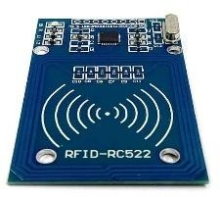

RFID stands for radio frequency identification devices (RFIDs) and is used for automatic identification and tracking. RFIDs are wireless, non-contact systems that transmit data from tags attached to objects using radio frequency electro magnetic fields. This technology enables contactless and line- of-sight data transmission from a data medium. A tag, an antenna, and a transceiver with a decoder form the components.

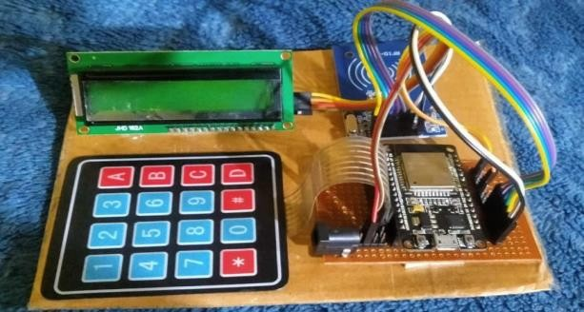
Matrix Keypad

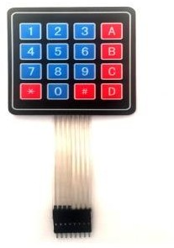
The matrix keypad is used to provide input to the system such as menu selection, billing, and so on. The Keypad 4x4 in matrix configuration has a total of 16 buttons. Matrix keypads with 4 rows and 4 columns imparts button states to the host

WORKFLOW
Fig.2. Final Setup

device, that is normally a microcontroller. It has an overlay with a telephone-style keypad and four additional useful buttons. It can be connected to your mirocontroller circuits via the included female 8-pin berg connection.

LCD Display
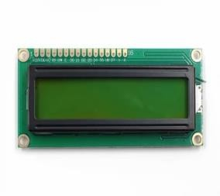
LCD stands for Liquid Crystal Display and is a 16*2 resolution type of flat panel display that operates primarily with liquid crystals. They have a wide range of applications for consumers and businesses, as they are commonly found in smartphones, televisions, computer monitors, and instrument panels. Backlight colours for the display LCD 16x4 series include blue, green, white, yellow-green, amber, red, and white LEDs.

RFID Card
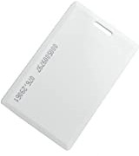

An RFID credit card is enabled with radio frequency identification technology. This enables your card to communicate with a payment terminal by using a radio frequency by replacing a magnetic strip. RFID cards allows you to simply tap or wave your RFID card near a card reader which provides much more security than any other credit cards.
Admins need to register first by signing up using Id and password for identification and authentication through the credentials presented.
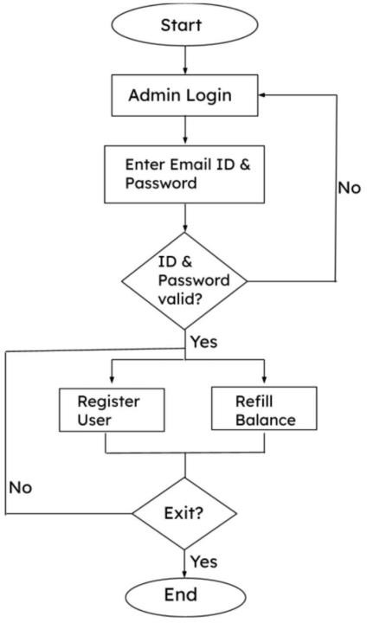

Fig.3. Flowchart for Admin Interface

If the password or any credentials appears to be incorrect then the admin will be redirected to the login page and if the admin forgets the password they can also create a new password and login again. When credentials are valid then admin will be able to look into the dashboard where he/she can view balance and refill the balance of the users.

RESULTS
As a result, the admin will be able to see the details of customers such as balance, email id, unique identification number and order details. Admin will also get the option to update or edit incase of any errors in the details of customers. Users will get the message via SMS or mail to check the balance and order details and will be able to refill the balance. Table 1.1 is shown below.

Table 1.1 Customer Details

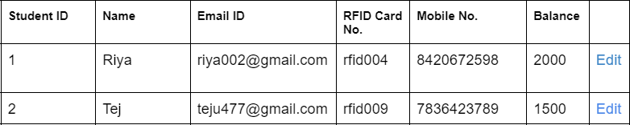

The canteen management has the benefit of avoiding paper usage, there is no need for extra manpower in the bill counter and they can manage the old data easily which will be useful for the future.

CONCLUSION
IoT based Canteen Management System involving RFID Technology can be used in cafeterias, food courts and canteen so that the operation for administrators becomes easy since the management of customers becomes easy. The main objective of keeping record of customer details such as balance, ,order details, ID number and contact information and use of electronic cash thereby increases the efficiency of management single-handedly. Also this system reduces the efforts for customers as they can recharge their accounts as they will be receiving SMS or Mails. IoT can enhance the profit in this type of service industry. This script studies the existing canteen’s difficulties and finally suggests an effective and implicit working solution for the same.

REFERENCES
- ”Smart Canteen Management System Using RFID”,International Journal for Research in Engineering Application & Management (IJREAM),ISSN : 2454-9150 Vol- 06, Issue-01, Apr 2020.Akshatha Y, Rajath Bagre, Mohammed Mehar Ali Sabri, Nihal S Karkera, J Hima Nanaiah,

- ”Canteen Management System”,International Research Journal of Engineering and Technology (IRJET) e-ISSN: 2395-0056,Volume: 09 Ganadhish Navelkar,Bidesh Chanda,Vaibhav Sharma, Atish Gracias,Basil Jose, Valerie Menezes,

- ”Cashless Canteen Management System”,International Journal of Innovative Technology and Exploring Engineering (IJITEE) ISSN: 2278-3075 May 2020. Ranjith Kumar S, M.
Ambika, Saravana Kumar R, Sandhya S Nair.

- ,”Integrated Cafeteria Management System Using Rfid”,IOSR Journal of Electronics and Communication Engineering.Amol Shelke, Aayushi Vyawahare, Manali Chaudhari

- “Automated Food Ordering System with Real-Time Customer Feedback”, Shidankar, Madhura M. Joshi Shweta Shashikant Tanpure, Priyanka R. International Journal of Advanced Research, Computer Science and Software Engineering, February 2013.

- “Design and Implementation of Ordering System for Restaurants” Swapna M., Firdouse Ali Khan, International Journal of Engineering Research Technology
- ”Canteen Food Ordering Android System” Chaitanya Parulekar, Abhishek Singh, Kunal Yadav, Amit Tanwar IT Department MUMBAI University, Journal on Recent and Innovation Trends in Computing and Communication.

- “IoT Smart Canteen Management System Using RFID” Akshatha , Rajath Bagre, Mohammed Mehar Ali Sabri, Nihal S Karkera, J Hima Nanaiah Assistant Professor,B.Tech Student, Computer Science and Engineering, Presidency University, Bangalore, India 2020.

“Cashless Canteen Management System”
M. Ambika, Ranjith Kumar S, Sandhya S Nair, Saravana Kumar R

- “Canteen Automation System with Payment Gateway” Prashant Avhad and Bhanushali, Harsh and Bhatt, Keval and Rathod, Mansing Rathod,

- “RFID Technology for IOT Based Meal Management System” Prof. P.B.Borole, Ms. Snehal Borole, Veermata Jijabai Technological Institute,, Electrical department, Mumbai, 2017.

- “Web based E- wallet Canteen Management System using RFID” by Giteshri Kale, Sharad Dube, International Research Journal of Engineering and Technology (IRJET),e-ISSN: 2395-0056,August 2020.

- “An Automated Management System for Student eServices” (2021) by Muhammad Sarfraz,, Dalal Alsoraya, Afrah AlBathali, and Ohoud Al-Mayyas.Department of Information Science, College of Life Sciences, Kuwait University, Sabah AlSalem University City, Kuwait

- “Computational Resources for mobile E-wallet System with observers” Muleravicius’, Eligijus Sa;alausas’, Jonas Inga Timofejeva Kaunas University of Technology, Department of Applied Mathematics.

- “Design and Implementation of a Web-Based Canteen Management System using PHP and MySQL”(2023) Sham Kumar Prajapathi, Niraj Pandey
,International Journal of Research Publication and Reviews, March 2023.

