Smart Dustbin-Garbage Segregation
And Trash Level Indicator Using IoT

AUTHORS:
A Sandhya Anjali N Dr. M Prabhakar
School of CSE School of CSE Associate Professor
REVA UNIVERSITY REVA UNIVERSITY REVA UNIVERSITY
r19cs002@cit.reva.edu.in r19cs031@cit.reva.edu.in prabhakar.m@reva.edu.in

ABSTRACT:
India ranks second in terms of population which is one of the causes for major production of waste. Due to an increase in urbanization, there is an equal upsurge in waste production. The problem here is with waste management. In most cities, overflowing garbage bins are creating an unhygienic environment which leads to the arise of different types of unnamed diseases. An efficient smart dustbin can be used for managing waste disposed of. Several design models were proposed with advantages as well as disadvantages. In this project, we have developed a model that first detects the waste, opens the lid automatically if the waste is brought near the dustbin, collects the waste, detects whether it is wet or dry, and segregates it into the two chambers of the bin. Once the bin reaches a certain level, it also gives an alarm that the dustbin is full, and the dustbin needs to be emptied. The major functions concentrated will be of level-check, waste collection and waste detection. All these data can be viewed in the Blynk app. The proposed model is cost-effective and energy efficient.

KEYWORDS: Smart Dustbin, alarm, Blynk app, level-check, collection and detection.

INTRODUCTION:
In recent times, garbage disposal has become a massive cause for concern worldwide. With rapid urbanization and industrialization waste, generation rates are increasing. Hence, new and innovative waste segregation technologies are required for effective waste management. A voluminous amount of waste that is generated is disposed of by means which harm the environment. The standard waste disposal method is unplanned and uncontrolled open dumping at landfill sites. This method is harmful to human health and plant and animal life. This destructive method of waste disposal can generate liquid leachate, which contaminates surface and ground waters and cause harbor disease vectors that spread harmful diseases and can degrade the aesthetic value of the natural environment, which is an unavailing use of land resources. These methods will harm the everyday life of human beings.
In India, rag pickers play an essential role in solid waste recycling. Dependency on the rag-pickers can be minimized if segregation occurs at the municipal waste generation source. The economic value of the waste generated is not realized unless it is recycled completely. When the trash is segregated into primary streams, such as wet and dry, the waste has a higher potential for recovery and is recycled and reused. The damp waste fraction is often converted into compost, methane gas, or both. Compost can reduce the demand for chemical fertilizers, and biogas can be used as a natural energy source. Although large-scale industrial waste segregation is present, segregating the waste at the start is always much better. This benefits with a higher quality of material for recycling. The occupational hazard for waste workers is reduced. Also, the segregated waste could be directly sent to the recycling and processing plant instead of to the segregation plant and then to the recycling plant.
By 2030, it is expected that around 40 percent of the population of India will be in urban areas. The steep increase in urbanization and population in India is one of the main reasons for producing massive waste from industries, commercial, domestic, and agriculture, etc. As the population increases, the country's waste generation also increases. In this paper, we have tried to upgrade the vital component of the waste management system. This smart dustbin we have developed separates the dry and wet waste without human involvement. There is an automatic opening and closing of the dustbin lid for which the threshold is set. There are various sensors to detect the moisture content in the waste, to show the status of the bin (full or empty), and whether the waste is dry or wet. The users can see the messages through the Blynk App.

LITERATURE REVIEW:
Improper monitoring of the waste being dumped in the localities leads to several threatening diseases which are often transmitted by flies, mosquitoes, and bees. The major sources of unhygienic surroundings are the overflowed dustbins. Rather than consuming more natural resources in the production of certain products, we can recycle them and use which also prevents pollution. The waste produced from medical uses such as PPE kits, face masks, and hand gloves is directly dumped into the dustbins which may cause the spreading of the virus to all front-line workers, especially municipality waste cleaners. Normally unhygienic conditions occur if there is an overload of waste
material in the dustbin. A waste management system is necessary to reduce unhygienic conditions in the city, society, home, college, or public areas. Dustbins are placed all over the city, and delivered with low-cost embedded methods to help in tracking the garbage bins. The Blynk app indicates through SMS as soon as the dustbin has reached its maximum level, to the unwanted management department. Immediate action would be taken by the alarmed authorities once the position of the bin is sent via the Internet. The proposed system is developed by using ultrasonic sensors, node MCU, servo motor, and Blynk app[8]. A survey has been conducted in various cities for efficient waste management systems for proposed garbage monitoring systems using IR sensors and web browsers. The proposed model is cost-effective and energy efficient. Also, with the incorporation of IoT (Internet of things) by using 802.11 Wi-Fi standard waste bin status can be monitored through mobile phones for domestic users and through servers for industrial purposes[5]. Intelligent waste monitoring and collecting systems have been developed based on radio frequency and GSM. A novel approach for a Garbage management system based on IoT and GSM with GUI representation using MATLAB has been proposed. An intelligent bin for smart cities based on IR sensors, GSM, and the internet has been proposed. The literature available for waste management systems has considered various IoT techniques and sensor technology to build a smart bin for efficient waste collection, tracking, and monitoring. The proposed model of the smart dustbin has a PIR sensor and ultrasonic sensor for human motion detection and to sense the level of garbage present in the bin respectively. An alert system based on GSM has been interfaced with Arduino which sends alert messages based on the level of the garbage at regular intervals. The proposed model work with very low power and increase the security for front-line workers from Covid-19[7]. The proposed system gathers the real-time garbage level of every bin with the help of ultrasonic sensors. This data is then used to generate dynamic routes for garbage trucks while considering several factors like the capacity of trucks and bins, the distance between bins, and the level of garbage[9].

IMPLEMENTATION METHODOLOGY:
The main idea of this project is to manage waste production by letting the users know
when the dustbin reaches the maximum level and also to segregate the waste efficiently. We have used a node MCU ESP8266 for transmitting the dustbin status through the wireless mode to the cloud and displayed it in the Blynk app.ESP8266 Wi-Fi module is a low-cost wireless transceiver that can be used for end-point IOT developments. ESP8266 Wi-Fi module enables internet connectivity to embedded applications. It uses TCP/UDP communication protocol to connect with the server or the client. ESP8266 detects the presence of the Wi-Fi, matches the ID and password, and tries to connect with the router or the Wi-Fi.
Two MG995 servo motors are used. One motor helps in the automatic opening of the lid when the waste is brought near the dustbin. And, the other motor fixed inside the bin helps in the rotation of the plate to dump the waste in either of the chambers of the bin. As per the design of the bin, the servo motor is around four hundred grams which can withstand the current of 1A current.
The battery is a very important component as it has to provide power to all other components and also the motor. In this project, an external power supply is used during the waste disposal.
Two ultrasonic sensors are used to carry out the process. One ultrasonic sensor is used to detect the distance between the user and the dustbin for automatically opening the lid(lid opens if the distance between the person and the dustbin is less than 10 cm). And, the other sensor is used to calculate the distance inside the dustbin to give an alarm not to dispose of any more waste in the dustbin.
A Raindrop sensor that is used as a wet sensor is used to detect the wet waste and the plate rotates 180 degrees. The infrared sensor doesn’t detect dry waste. It is used to detect if there is some waste on the plate. If the dustbin detects the waste and if it’s not characterized as wet waste, the plate rotates 0 degrees and classifies it as dry waste. If the infrared sensor detects no waste, then the message displaying “ No waste detected” appears in the app. If the wet waste is sensed by the raindrop sensor, then the message “Wet waste detected” displays in the app. Similarly, if the infrared sensor detects the waste, “Dry waste detected” appears on the screen.

PROPOSED MODEL:

Power supply
CLOUD

Ultrasonic sensor
NODMCU
ESP8266
WIFI
IR Sensor
Ultrasonic sensor

MG995 servo motor
Wet Sensor

Blynk app

MG995 servo motor

Fig(1) Block Diagram of Proposed System
Fig(1) shows that when the waste is dumped into the smart dustbin,the ultrasonic sensor identifies the level of garbage in the bin and indicates whether the bin is Full or Empty, activating the microcontroller. Generally, an ultrasonic sensor is used to sense specific characteristics of its surroundings by emitting and detecting infrared radiations.
The sensor’s coil receives retransmitted field and alerts the user by producing a target response. The next sensor connected is the moisture sensor which uses capacitance to measure the dielectric permittivity of the surrounding medium. Wet waste has a higher relative dielectric constant than dry waste because of moisture, oil, and fat. By this, we know whether the waste is wet or dry. Also, it displays different messages. Initializing all modules ensures that any environmental changes do not affect the sensing.
DATA FLOW DIAGRAM:

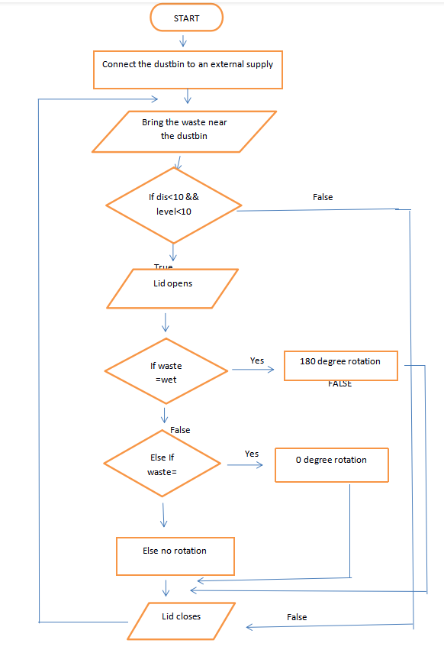
Fig(2). Data Flow Diagram of Proposed System

Fig(2) represents a Data Flow Diagram of our Proposed System. The model is connected to a power supply. When the person comes near the dustbin, the ultrasonic sensor placed in front of the bin detects the distance between the person and the bin.If the distance and level of the bin are less than 10 cm, the lid opens and the sensors placed on the plate are used for segregation.

SEQUENCE DIAGRAM:

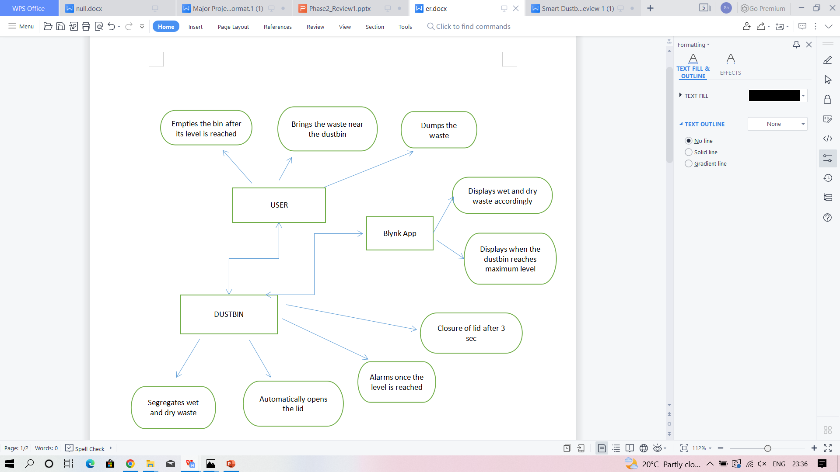

Fig(3).Sequence Diagram of Proposed System

Describes how the components are linked to each other and how the messages are passed between the objects.

CLASS DIAGRAM:

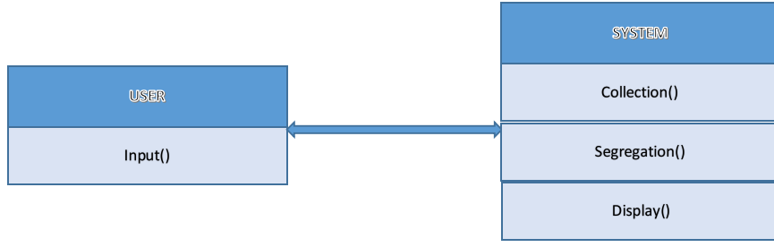
Fig(4).Class Diagram of Proposed Model

DESIGN OF THE PROPOSED SYSTEM:

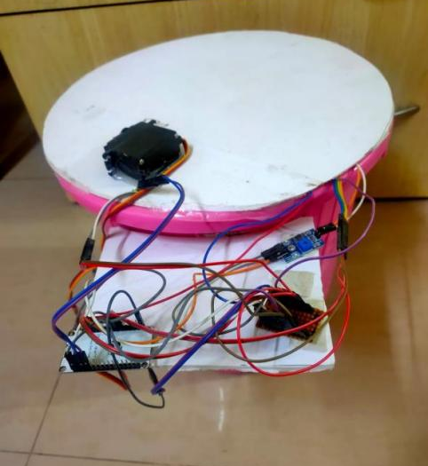
Fig(5). Connection of Proposed Model.
Fig(5) shows the structure of our model.It depicts how the connections are done among several components.

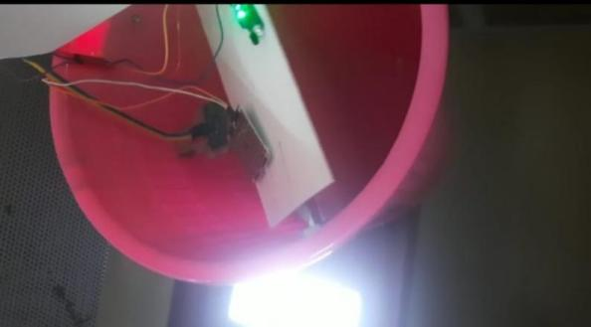
Fig(6).Working View 1
Fig(6) depicts the lid rotation of 180 degrees when the wet waste is dumped into the dustbin.

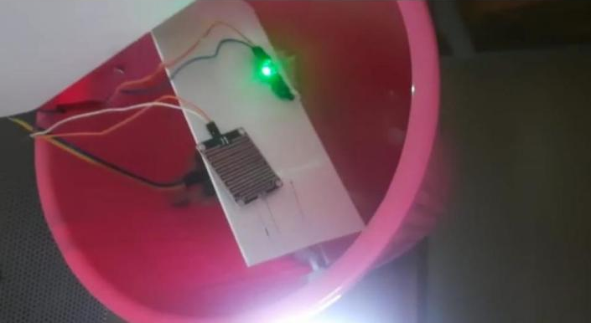

Fig(7).Working View 2
Fig(7) depicts the lid rotation of 0 degree when the dry waste is dumped into the dustbin.

OPERATION:
The whole system depends on the code implemented to carry out the task. The purpose of using ESP8266 is that it is cost-effective and the recurring cost can also be handled. Wi-Fi ESP8266 is programmed with embedded C to reach the goal of waste segregation. Once the Wi-Fi is connected, and the dustbin is not full, the bin detects and segregates the waste accordingly. These operations can only be performed until the dustbin reaches a certain level. The waste in the dustbin must be cleaned up and again can be used for waste management.

CONCLUSION:
The automatic Waste Segregator implemented here provides segregation of waste into wet, and dry at the entry level. Thus it eliminates the risk of segregation at higher levels or segregation when there is a huge amount of waste. This is cost-effective and also a very effective method of segregating waste which requires no human interaction. To reduce pollution and minimize the use of natural resources, recycling waste is very essential. Recycling becomes easier once the waste is segregated. Hence, the proposed model becomes the solution for the major problem in our environment.

REFERENCES

[1]. R Sundar Ram, Ajjai Ashok, Prem Savarinathan, Thenmozhi Karuppasamy, Avila Jayapalan, “Garbage Monitoring System Using IOT”, 2022 International Conference on Computer Communication and Informatics (ICCCI) , 2022.

[2]. G.V.V.S.L. Rupesh, Mopidevi Sai Advytha, Nammi Bhanu Prakash, Varsha Sahu, Amit Gupta, Shashi Kant Dargar, “A Smart-Dustbin and Integration of Waste Management System using IoT” , 2022 4th International Conference on Inventive Research in Computing Applications (ICIRCA), 2022.

[3]. Elam Cheren S, Sampriti G, Subasree T, Sumetha M, Swetha V, “IoT based Smart Dustbin for Waste Management”, 2022 4th International Conference on Inventive Research in Computing Applications (ICIRCA), 2022.

[4]. Dhiraj Sunehra, K. Pravalika, A. Sruthi, G. Rajasri , “Implementation of an Automatic Waste Segregator System using Arduino Uno” , 2021 6th International Conference for Convergence in Technology (I2CT) , 2021.

[5]. Alisha Das, A. Shukla, Roopa Manjunatha, Ejaz Aslam Lodhi , “IoT based Solid Waste Segregation using Relative Humidity Values” , 2021 Third International Conference on Intelligent Communication Technologies and Virtual Mobile Networks (ICICV), 2021.

[6]. S. Mohamed Azarudeen, B. Mohan, S. Pujita, P. Swapna, “AUTOMATIC SMART RECEPTACLE USING IOT AND MOBILE APPLICATION” , 2021 5th International Conference on Intelligent Computing and Control Systems (ICICCS) , 2021.

[7]. R Prem Chand, V Bavya Sri, P Maha Lakshmi, S Santosh Chakravathi, O D M Veerendra, Ch Venkateswara Rao, “Arduino Based Smart Dustbin for Waste Management during Covid-19”, (2021)5th International Conference on Electronics, Communication and Aerospace Technology (ICECA), 2021.

[8]. Venkateswara Rao, Abdul Azeez, Sasank Peri, Vaishnavi Kumar, R. Santhiya Devi, Amirtharajan Rengarajan, K. Thenmozhi, and Padmapriya Praveenkumar , “IoT based Waste Management for Smart Cities” , 2020 International Conference on Computer Communication and Informatics (ICCCI) , 2020.

[9]. Mohit Badve, Apoorva Chaudhari, Palak Davd, Vinal Bagaria, Dhananjay Kalbande, “Garbage Collection System using IoT for Smart City”, 2020 Fourth International Conference on I-SMAC (IoT in Social, Mobile, Analytics and Cloud) (I-SMAC), 2020.

