Smart Glasses for Multimeter

Pallavi Patil
Department of Electronics and Telecommunications Engineering, JSPM’s Rajarshi Shahu College of Engineering, Tathawade.
Pune, Maharashtra, India. .pshevale21@gmail.com
Vaishnavi Kharade
Department of Electronics and Telecommunications Engineering, JSPM’s Rajarshi Shahu College of Engineering, Tathawade.
Pune, Maharashtra, India. vaishnavikharade0871@gmail.com
Ravindra Kumbhar
Department of Electronics and Telecommunications Engineering, JSPM’s Rajarshi Shahu College of Engineering, Tathawade.
Pune, Maharashtra, India. .ravindra21122k@gmail.com

Abhijeet Swami
Department of Electronics and
Telecommunications Engineering,
JSPM’s Rajarshi Shahu College of
Engineering, Tathawade.
Pune, Maharashtra, India.
abhi1234swami@gmail.com

Abstract - Working in the surrounding of high voltage areas is very risky job that can lead to accidental death. One main reason for the accident occurred because of carelessness of the worker himself. For example, a worker requires to check whether the fuse is damaged or not while the voltage is applied, and he by mistake connect the phase wire to the neutral using multimeter. The outcome of such incidents is that short circuit can occur, and that worker will get a one big an arc flash in his entire body. Usually, the worker faces troubles while testing/troubleshooting electrical works/PCB while locating samples on 2 points and looking at the exact time of the multimeter. This also takes a lot of time and leads to incorrect or improper measurements. To solve this problem that occurred, this project will be focused on how to keep focus on hands-on job when observing important data such as voltage readings on the multimeter. The idea for solving this difficulty is to design and develop devices that can display output digitally in front of the user’s eyes so that he doesn’t have to look here and there and there is less chance of losing focus. After doing some research, the most suitable device for this problem is smart glasses using Bluetooth. Hence, this project will include designing and developing smart glasses by studying and gaining a good idea from the previous researchers that are also making smart glasses for multiple purposes. Lastly, this project will build a model which is simple and cheap and is suitable for every level of community to use it.

Keywords - Multimeter, Bluetooth HC05, Troubleshoot, Virtual, OLED, Lens, etc.

- INTRODUCTION

As the world is developing so fast and technologies are spreading rapidly smart glasses are presenting the brand-new concept in the technological field. In this paper a new system is projected called smart glasses for multimeter. The basic need of this system is to note down or see the readings of high voltage without losing the focus or the vision from the electrical appliances so that no damage will be bearable.

In the past few years, measuring electrical factors like voltage and current has been difficult and risky. Assessing high AC voltage by using convectional multimeter is risky as it could lead to an authentic accident like getting a shock. While measuring it, the one who is working looks at the samples and at the same time he has to look at the multimeter to see what the readings are displayed. During such measurements the probes can be disturbed also there is a chance of losing focus, due to this observer will take incorrect reading.

We are coming up with the solution for such a problem, that is a smart glass by which user can see readings and while using these glasses user doesn’t have to look at DMM since readings will appear on smart glasses i.e., in front of his eyes. Also, this system is safe to use. This system is depended on Arduino micro pro for handling and showing output. OLED display is used for showing the voltage reading we measured. This OLED display is interfaced to controller using SPI (Serial Peripheral Interface). By making use of Bluetooth, it is feasible to develop the glass which is wireless so that voltage or current which is measured will occur on OLED display. The system is assembled to fit effectively on the ears of an individual and authorizes the individual to see the hardware simultaneously with the measured voltage, current and resistor.

- BLOCK DIAGRAM

Arduino Pro Micro in this project is the brain for system which will control OLED display and Bluetooth HC05. And because of that, Arduino will require supply which is from LiPo battery. Next, based on the coding created, the Arduino has been programmed for receiving data at RX from BLE module. For this Project, the data receive is Voltage value from multimeter Bluetooth device. Next, Arduino will send the data to OLED display via SPI Bus in a way which users can easily read the data. Then, OLED will display the data which is Voltage value that also display at multimeter.

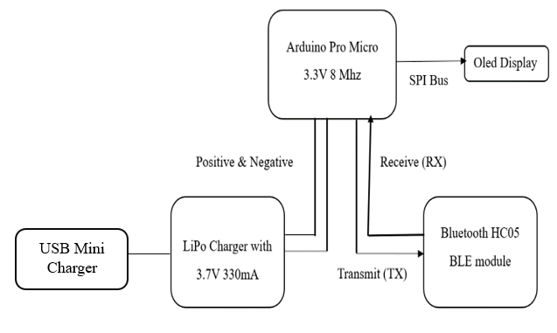
Figure 1: Block Diagram of Proposed System
The equipment and material used to develop the prototype of this project consists of Arduino Pro Micro, Bluetooth Module, Micro OLED, Mini USB Output Charger, LiPo Battery, Mini Slide Switch, Bluetooth Multimeter, Jumper Wire, Small Mirror, Safety Eyeglasses, and Small Fresnel Lens.

- Arduino Pro Micro

To lighten the weight for this project, getting the smallest Arduino is needed. Therefore, the most suitable Arduino for this case is Arduino Pro Micro which weighs less than 2 grams.

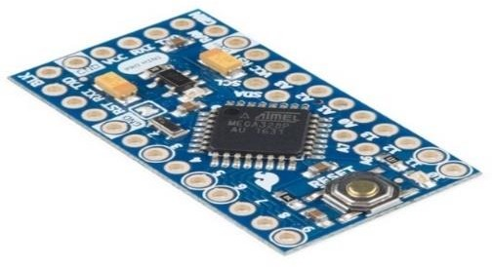

Figure 2. Arduino Pro Micro

- Bluetooth HC05
For Arduino to receive Data from Bluetooth Multimeter, this project requires a Bluetooth module which can communicate with the Arduino. The version module that will be used is HC05 BLE.
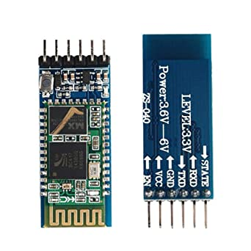

Figure 3. Bluetooth HC05

- OLED Display
OLED is the most suitable display tool for this project because of its small and light size. Besides that, Micro OLED offers high brightness which enables the image to reflect to user’s eye more clearly.
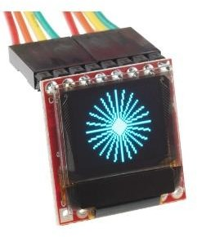

Figure 4. OLED Display

- LiPo Battery

Because of its small and light characteristics, this battery is ideal for this Smart Glasses project that requires convenience for users to move freely. Besides that, users do not need to change the new battery because this battery is allowed to recharge it back.

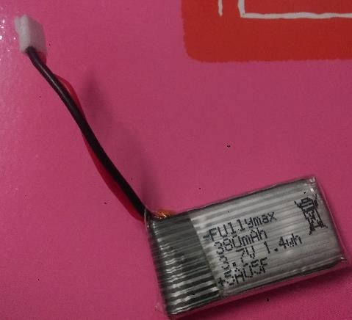

Figure 5. LiPo Battery

- USB Charger
This mini-USB charge will be used so that the battery of this project can be recharged unlike any other electronic device.
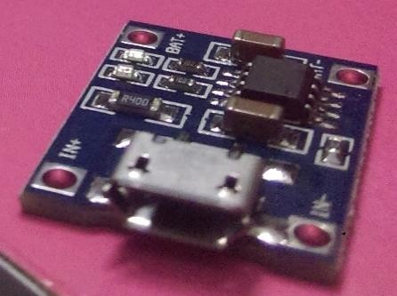

Figure 6. USB Charger
- Mini Switch

This type of switch is required to make it easier for users to turn on and off for this project.
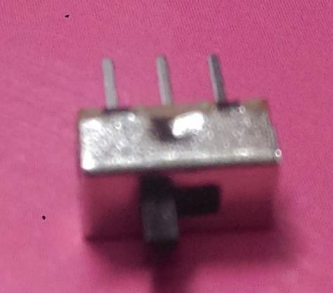

Figure 7. Mini Switch

- Jumper Wire
Jumper wire will be used in this project for making connection for each material such as Arduino Pro Micro, Bluetooth Module, Micro OLED, Mini USB Output Charger, LiPo Battery and Mini Slide Switch.

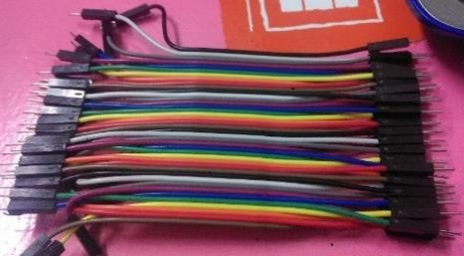

Figure 8. Mini Switch

The final design of the system will look like the following figure:

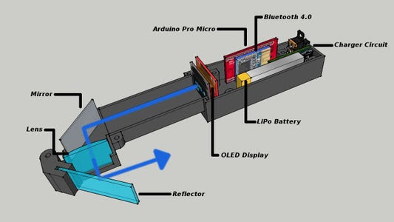

Figure 9. Final design of the system

Based on Figure 10, it shows the inside of our system. The Smart Glasses are developed by using Arduino pro micro along with combination of optical system. Arduino pro micro in this system will control the OLED display and Bluetooth HC05.
Next, Micro OLED will be used to display output data which has been set or programmed by Arduino. Bluetooth HC05 BLE Module was also to be used to enable connect between Arduino and multimeter via Bluetooth.
Mirror is used to reflect the output display of Micro OLED. Besides that, lens will be used to enlarge the data display from the mirror. Furthermore, LiPo battery was also used in this project as rechargeable battery.
How to use it? – Firstly, connect Bluetooth Multimeter to the device and after Bluetooth data is displayed on the OLED, it is then reflected over the mirror and will goes through the lens and users can see the picture in the little transparent glass.

- FLOW CHART

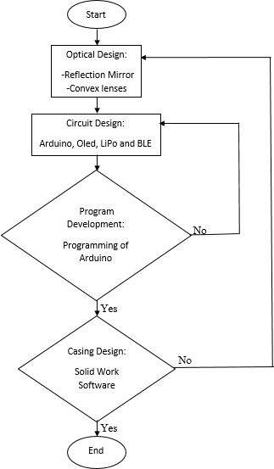

Figure 10. Flowchart of the proposed system

- CIRCUIT DIAGRAMS

- Arduino pro micro and Bluetooth HC05

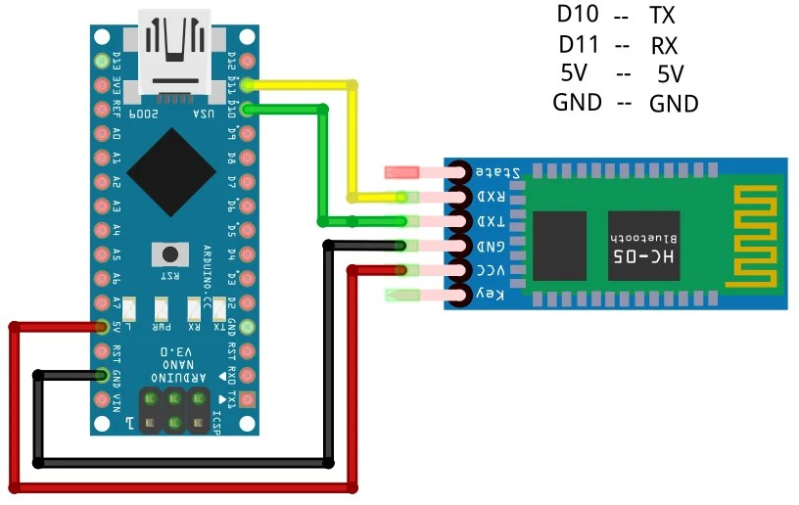

Figure 11. Connection between Arduino pro micro and Bluetooth HC05

- Connection between Battery, Arduino Pro Micro, OLED Display, HC05

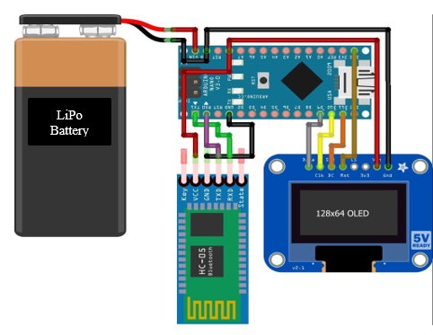

Figure 12. All Connections

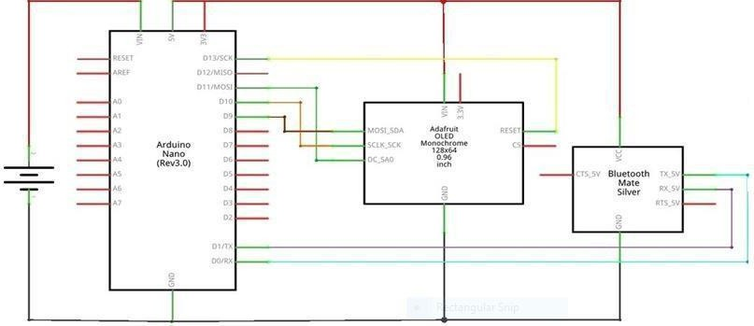
- Complete Circuit Diagram

Figure 13. Complete Circuit Diagram

- CODING

- Coding Program of TX:

#include <SoftwareSerial.h>
SoftwareSerial EEBlue(2, 3); // RX | TX
#define ANALOG_IN_PIN A0
// Floats for ADC voltage & Input voltage
float adc_voltage = 0.0;
float in_voltage = 0.0;
// Floats for resistor values in divider (in ohms)
float R1 = 30000.0;
float R2 = 7500.0;
// Float for Reference Voltage
float ref_voltage = 5.0;
// Integer for ADC value
int adc_value = 0;
void setup()
{
Serial.begin(9600);
EEBlue.begin(9600); //Default Baud for comm is 9600. if enable pin of HC05 is connected to 5v than baund rate is 38400
Serial.println("The bluetooth gates are open.\n Connect to HC-05 from any other bluetooth device with 1234 as pairing key!.");
}
void loop()
{
adc_value = analogRead(ANALOG_IN_PIN);
adc_voltage = (adc_value * ref_voltage) / 1024.0;
in_voltage = adc_voltage / (R2 / (R1 + R2)) ;
EEBlue.write(in_voltage);
Serial.print("in_voltage");
Serial.println(in_voltage);
//EEBlue.write("A");
delay(500);
}

- Coding Program of RX:

#include <SoftwareSerial.h>
SoftwareSerial EEBlue(2, 3); // RX | TX
#include <SPI.h>
#include <Wire.h>
#include <Adafruit_GFX.h>
#include <Adafruit_SSD1306.h>
#define SCREEN_WIDTH 128 // OLED display width, in pixels
#define SCREEN_HEIGHT 64 // OLED display height, in pixels
#define OLED_RESET 4 // Reset pin # (or -1 if sharing Arduino reset pin)
#define SCREEN_ADDRESS 0x3C ///< See datasheet for Address; 0x3D for 128x64, 0x3C for 128x32
Adafruit_SSD1306 display(SCREEN_WIDTH, SCREEN_HEIGHT, &Wire, OLED_RESET);
float a =0.00;
void setup()
{
Serial.begin(9600);
EEBlue.begin(9600); //Default Baud for comm is 9600. if enable pin of HC05 is connected to 5v than baund rate is 38400
Serial.println("The bluetooth gates are open.\n Connect to HC-05 from any other bluetooth device with 1234 as pairing key!.");
if (!display.begin(SSD1306_SWITCHCAPVCC, SCREEN_ADDRESS))
{
Serial.println(F("SSD1306 allocation failed"));
for (;;); // Don't proceed, loop forever
}
display.clearDisplay();
}

void loop ()
{
// Feed any data from bluetooth to Terminal.
if (EEBlue.available())
{
a= EEBlue.read();
Serial.println(a );
}
display.setCursor(20, 10); //oled display
display.setTextSize(2);
display.setTextColor(WHITE);
display.println("Voltage:");
display.setCursor(25, 40); //oled display
display.setTextSize(2);
display.setTextColor(WHITE);
display.print(a, 2);
display.println(" V");
display.display();
//delay(500);
display.clearDisplay();
//display.display();

}

- PROTOTYPE

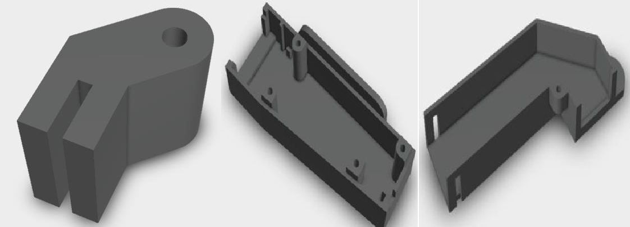

Figure 14. Prototype of Casing

For the first test in this project, firstly enclosed made from cardboard was used. Then for the final version, it will be used in 3D printer by using SolidWorks software. It described as solid modelling Computer-Aided Design (CAD) and Computer-Aided Engineering (CAE) computer program that proceeds on Microsoft windows. It was published by Dassault System. Thus, it is high performance software that is suitable for this project.

- HARDWARE

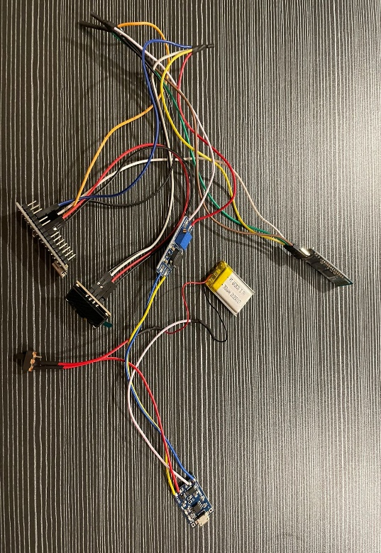

Figure 15. Hardware model when not connected to Multimeter.

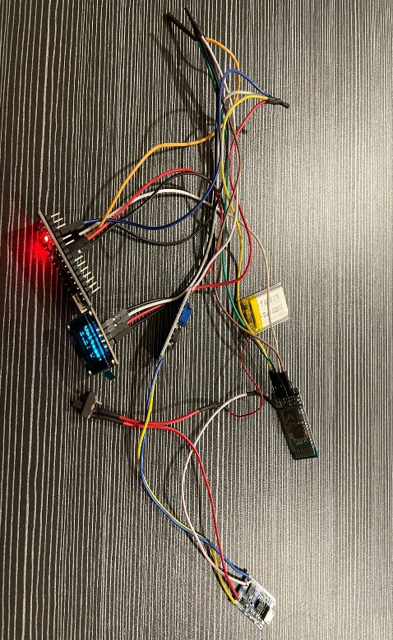

Figure 16. Hardware model when connected to Multimeter.
- ADVANTAGES
- This system is lighter than traditional systems Easy-to-use multimeter.
- It improves the mobility of this system. You can move it easily from here and there.
- This system is more convenient for observers.
- As simple and cheap as possible for suitable to every level of community to earn it.
- It is a user friendly which it can recharge back.
- It is safe as the user will able to read or see the output display of multimeter in front their eyes while doing their hands work especially in area of high voltage which is a very risky place.

- APPLICATIONS
- College Labs: In industries there is lot of use of multimeter, so by using this system it provides mobility to workers and it is also time saving with more precision/accurate results.
- Industries: It provides safe usability to the students and also faculties and it makes easier for them to take readings as compared to the convectional one.

- CONCLUSION
This project was developed to make devices that can display output digital in front of the user’s eyes. Several methods had been used in studying and earned a good idea from the others researcher that also making the Smart Glasses. Optical design and circuit design had been developing as the main body for this data glasses project. Reflection mirror and convex lens, which is the excellent method for the optical design had been made in use. Arduino Pro Micro was used as brain to control the circuit which is Bluetooth module HC05 and Micro OLED. Charger circuit and LiPo battery are included as source for the electronic circuit to make this project use as a long-lasting useful tool. Lastly, casing for this project is made by 3D printer.

- REFERENCES
- Marie-Christin Ostendorp, Jan Charles Lenk, Andreas Lüdtk (2015) “Smart Glasses to Support Maritime Pilots in Harbor Maneuvers,” Procedia Manufacturing, vol. 3, pp. 2840–2847.
- Junya Kawaia, Hiroyuki Mitsuharaa, Masami Shishiboria (2015) “Tsunami Evacuation Drill System Using Smart Glasses,” Procedia Computer Science, vol. 72, pp. 329–336.
- Charlotte Romarea,b, Ursula Hass c, Lisa Skar (2017) “Healthcare professionals’ views of smart glasses in intensive care: A qualitative study,” Intensive and Critical Care Nursing, vol. 45, pp.66-71.
- Ken Bowron. Electrical Incident Safety Report 2016-17, 2017, Department of Mines, Industry Regulation and Safety.
- Jessica G. Shih, MD, Shahriar Shahrokhi, MD, FACS, FRCSC, Marc G. Jeschke, MD, PhD, FACS, FRCSC (2016) “Review of Adult Electrical Burn Injury Outcomes Worldwide: An Analysis of Low-Voltage vs High-Voltage Electrical Injury,” . Journal of Burn Care & Research, vol. 38, no. 1, pp.e293-e298.
- Robert Holloway and Shreveport (2018) “Electrical distribution system” U.S. Patent 9,899,819. Robert J.Ward, Caleb R. Thompson, Brian L.Timmons (2018) “High Voltage Training Device and System and Method Thereof,” U.S. Patent Application 15/639,711.
- Giovanni Luca Amicucci, Maria Teresa Settino (2017) “Accidents with injuries or death during non-electrical work activities near overhead power lines,” In Environment and Electrical Engineering and IEEE Industrial and Commercial Power Systems Europe (EEEIC/I&CPS Europe), IEEE International Conference on, pp. 1-6.
- Shoichi Yamazaki, Kazutaka Inoguchi, Yoshihiro Saito, Hideki Morishima, Naosato Taniguchi (2012) “Thin wide-field-of-view HMD with free-form-surface prism and applications”, In Stereoscopic Displays and Virtual Reality Systems VI, Vol. 3639, pp. 453-463.
- R. Andrew Wall, Tuomas Vallius, Pietila Pasi, and Keita Oka (2017) “Waveguide-based displays with anti-reflective and highly-reflective coating,” U.S. Patent 9,891,436.
- KazukiOtao, Yuta Itoh, Kazuki Takazawa, Hiroyuki Osone, Yoichi Ochiai (2018) “Air Mounted Eye piece: Optical See-Through HMD Design with Aerial Optical Functions”, In Proceedings of the 9th Augmented Human International Conference, AH Vol.18, p.1.
- Hong-Zong Liao, Ying-Yueh Chang, Chih-Ming Yen (2017) “Diffractive optical element and laser diode-doe module” U.S. Patent Application 14/706,401.
- Milan Momcilo Popovich, Jonathan David Waldern, Alastair John Grant (2017) “Method and apparatus for generating input images for holographic waveguide displays”, U.S. Patent Application 15/512,500.
- Oscar A.Martinez, Ozan Cakmakei, James C. Dunphy (2018) “Curved eyepiece with color correction for head wearable display,” U.S. Patent 9,897,811.
- David Alan Smith, Gregory A. Harrison, Gary E. Wiese (2014) “Head-mounted display apparatus employing one or more reflective optical surfaces” U.S. Patent 8,625,200.
- Alan Transon, Adrien Verhulst, Jean-Marie Normand, Guillaume Moreau, Maki Sugimoto (2017) “Evaluation of Facial Expressions as an Interaction Mechanism and their Impact on Affect, Workload and Usability in an AR game,” In VSMM 2017-23rd International Conference on Virtual Systems and Multimedia, pp. 1-8.
- Kouji Takano, Naoki Hata and Kenji Kansaku (2011) “Towards intelligent environments: an augmented reality–brain–machine interface operated with a see-through head-mount display,” Frontiers in neuroscience, Vol. 5, p.60.
- Tomoki Kurahashi, Kazuki Suemitsu, Keiichi Zempo, Koichi Mizutani, Naoto Wakatsuki (2017) “Disposition of captioning interface using see-through head-mounted display for conversation support,” In Consumer Electronics (GCCE), 2017 IEEE 6th Global Conference on, pp. 1-4.
- Masayuki Miyasugi, Hideo Akaike, Yasuichi Nakayama and Hiroyasu Kakuda (2017) “Implementation and evaluation of multi-user mind map authoring system using virtual reality and hand gestures,” In Consumer Electronics (GCCE), 2017 IEEE 6th Global Conference on, pp. 1-5.
- Pietro Lungaro, Rickard Sj¨oberg, Alfredo Jos´e Fanghella Valero, Ashutosh Mittal and Konrad Tollmar (2018) “Gaze-aware streaming solutions for the next generation of mobile VR experiences,” IEEE transactions on visualization and computer graphics, Vol. 24, no. 4, pp.1535-1544.
- Ryota Horie and Ryotaro Nawa (2017) “A hands-on game by using a brain-computer interface, an immersive head mounted display, and a wearable gesture interface,” In Consumer Electronics (GCCE), 2017 IEEE 6th Global Conference on, pp. 1-5.
- Steven Feiner , Blair Maclntyre , Tobias Hollerer and Anthony Webster (1997) “A touring machine: Prototyping 3D mobile augmented reality systems for exploring the urban environment,” Personal Technologies, Vol. 1, no. 4, pp.208-217.
- Oliviu MATEI1, Ioan VLAD2, Robert HEB1, Alexandru MOGA1, Otto SZIKA1, Ovidiu COSMA3 (2016) “Comparison of Various Epson Smart Glasses In Terms Of Real Functionality and Capabilities,” Carpathian Journal of Electrical Engineering, Vol. 10, no. 1.
- Ryutaro Nambu, Tatsuya Kimoto, Takeshi Morita, Takahira Yamaguchia (2017) “Integrating Smart Glasses with Question-Answering Module in Assistant Work Environment,” Procedia Computer Science, vol. 11, no. 1, pp.1-16.
- Oliver Amft, Florian, Shoya Ishimaru and Kai Kunze (2015) “Making regular eyeglasses smart,” IEEE Pervasive Computing, vol. 14, no. 3, pp.32-43.
- Hiroyuki Mitsuhara1, Katsuhiko Moriya1, Kazumoto Tanaka2, Junko Kagawa1, Kazuhide Kanenishi1, and Yoneo Yano (2012) “Teacher Support for Theatrical Learning Support in Lectutainment.” In International Conference on Information Processing and Management of Uncertainty in Knowledge-Based Systems, pp. 405-414.
- Angel Suarez, Stefaan Ternier, Marco Kalz, Marcus Specht (2015) “Supporting inquiry- based learning with Google Glass (GPIM),” Interaction Design and Architecture (s) Journal (IxD&A), Vol. 24, pp.100-110.

