Starbucks’s Competitive Analysis
Research Question: To what extent has innovation and product development alleviated Starbucks’ position as a market leader against Dunkin Donuts?

Table of Contents
Introduction: 3
Methodology: 3
Tools: 4
Market Share 4
Porter's five forces 4
BCG Matrix 4
Ansoff Matrix 4
Main body: 4
Porter's five forces: 6
The secret to success? 8
What makes Starbucks different? 9
Collaborations 9
BCG Matrix: 9
Ansoff Matrix 14
Conclusion 14

Introduction:
Starbucks was founded by Jerry Baldwin, Gordon Bowker, and Zev Siegl in Seattle, Washington in 1971. Currently, Howard Schultz serves as the interim CEO until April 1, 2023 when he will be replaced by Laxman Narasimhan, who will then become an advisor to Narasimhan until the end of the fiscal year in 2023. Starbucks is now the largest coffee chain in the world with 15,337 stores in the US. The company was incorporated in 1985 and went public on June 26, 1992. Today, Starbucks is considered one of the leading coffee brands. As a coffee lover, I chose this topic because I was interested in exploring the impact of innovation and product development on competition in the coffee industry. I wanted to understand how Starbucks and Dunkin Donuts have responded to competition and how their strategies have resulted in their current market positions. I believe that by studying how these two companies have used innovation and product development to create competitive advantages and gain market share, I could gain valuable insights into how to succeed in a highly competitive industry. The research question posed is: “To what extent has innovation and product development alleviated Starbucks’ position as a market leader against Dunkin Donuts?”

While searching, it became apparent that Starbucks is the largest coffee company in the United States, with Dunkin Donuts providing constant rivalry. Despite such, Starbucks still remains to be the overall market leader. Therefore, Dunkin Donuts' business activity and nature, in comparison to Starbucks will also be researched. In conclusion, all factors that contribute to Starbucks as a market leader will be evaluated.

Methodology:
To conduct the analysis, I will be utilizing secondary sources such as online news articles for marketing-related information. These sources will provide insight into competitive pricing strategies and product plans used by the organizations to grow their business. Additionally, I will be using official websites of Starbucks and Dunkin Donuts to access articles about their operations, strategies, and promotional offers. Utilizing these authenticated sites will allow me to make a more accurate analysis and better answer the research question. Lastly, I will be referring to Paul Hoang’s Business Management to gain an understanding of business concepts, tools, theories, and techniques to perform competitive analysis.

Tools:

Market Share

Firm’s sales revenue

X 100 = Market Share
Industry’s sales revenue

Market share refers to “an organization's portion of the total value of sale revenue within a specific industry.” (359 Hoang). In Starbucks’s and Dunkin Donuts' case since they are the market leaders in the US market. As of 2021 Starbucks dominates the industry with a market share of 35.7%, and Dunkin Brands with 23.6%

Porter's five forces
A model that helps identify an industry's weaknesses and strengths by identifying and analyzing competitive forces that affect every industry.

BCG Matrix
This refers to which is a model used to analyze a business's products to aid with long-term strategic planning and “helps managers to plan for a balanced product portfolio.” (351 Hoang).

Ansoff Matrix
“An analytical tool that helps managers to devise their product and market growth strategies" (45 Hoang).

Main body:
Innovation and product development have played a crucial role in solidifying Starbucks' position as a market leader in the competitive coffee industry. While Dunkin' Donuts has long been a formidable rival, Starbucks' ability to consistently introduce new and exciting products has allowed the company to stay ahead of the game and maintain its dominance in the market. In the early days of the coffee industry, Dunkin' Donuts was the clear leader in the market, with a strong brand and a wide variety of options for customers. However, in the late 1990s, Starbucks made a strategic move to expand its product offerings and focus on innovation, which helped them quickly gain a foothold in the market and eventually surpass Dunkin' Donuts as the leading coffee chain. From the introduction of new drink options such as Frappuccinos and lattes to the development of new store designs and mobile ordering capabilities, Starbucks has consistently found ways to differentiate itself and appeal to a wider customer base. Overall, the essay aims to provide a comprehensive understanding of the role that innovation and product development have played in shaping the coffee industry and how it has impacted the relative positions of Starbucks and Dunkin' Donuts.

Below is the graph of the market shares of selected leading coffee chains in the US by the number of outlets in 2020 and it is clearly visible how Dunkin Donuts and Starbucks are the top runners among which Starbucks is the lead.

Figure 1: number of outlets
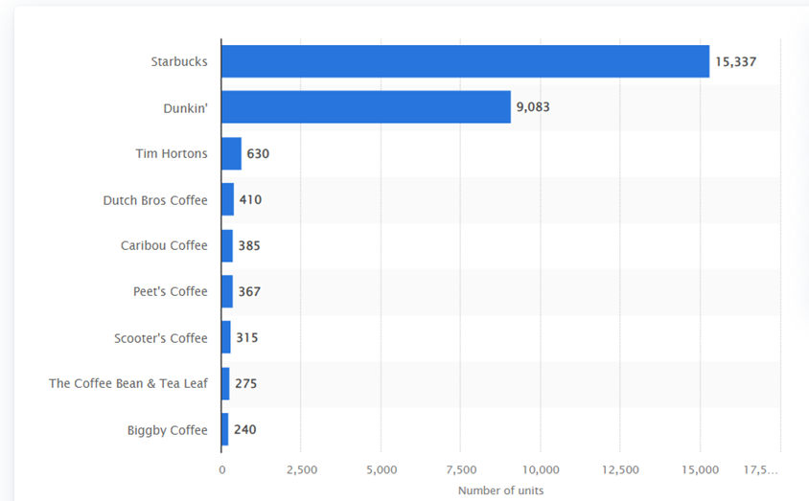

The graph shows the sales of different coffee stores in the US of the year 2022. This is the second evidence displaying how Starbucks and Dunkin Donuts have the highest sales and are the top runners.

Figure 2: sales of stores in the united states (in millions of $)
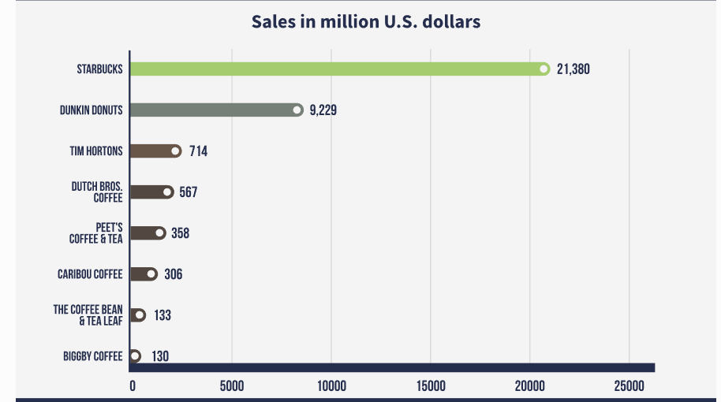

Porter's five forces:

Porter’s 5 Forces

Threats of new entrants
Industry Competitors
Threats of substitute
Bargaining power of suppliers
Bargaining power of buyers
Entrants
Rivals
Substitute
Supplier
Buyers
Power: medium-high to high
Power: Low
Power: High
High level of rivalry
Power: Low
Figure 3: Porter’s five forces

Porter's Five Forces industry study gives an overall view of an industry's competitive environment and the prospects for continuing profitability. An evaluation of this industry analysis enables a firm to discover the resources and competencies that enable it to push back against these pressures and stay competitive.

Starbucks and Dunkin Donuts as market leaders have several other competitors in the coffee market. Using Porter’s Five Forces will help analyze the competitive environment of the coffee industry and help to understand what they have to do to be competitive.

Bargaining Power of Buyers
The coffee industry is highly competitive, providing consumers with many choices and giving them considerable bargaining power. Customers have the freedom to switch between different brands and companies, making it difficult for any one company to maintain control over them. Although some customers may have a strong loyalty to a particular brand, the majority of buyers are able to shop around and make their purchasing decisions based on factors such as price and quality. Therefore, the bargaining power of buyers in the coffee industry is considered to be medium-high to high. As a result, with so many options for coffee and food available such as Costa coffee, McCafe, Tim Hortons etc buyers possess a significant amount of bargaining power when selecting where to buy their products.

Bargaining Power of Suppliers:
Starbucks does not cultivate any of its own raw materials, instead sourcing them from other farmers or suppliers according to strict standards. To ensure quality and sustainability, they use Coffee and Farmer Equity (C.A.F.E.) Practices for growing cocoa, tea, coffee and other raw materials. Similarly with dunkin donuts their supplier in US is Mid-Atlantic Distribution Center (MADC) MADC supplies the raw materials—flour, glaze, muffin mix, and other ingredients.
The cost of switching suppliers is relatively low, as there are numerous different farms and countries that produce coffee beans. This allows companies to find new suppliers if they are unhappy with the prices or services of their existing ones. In general, suppliers have low bargaining power in the coffee industry, because while the raw materials are not something unique due to the fact that both Dunkin' Donuts and Starbucks are large companies with strong buying power, which helps them to negotiate advantageous terms with their suppliers.

The threat of New Entrants:
The coffee industry is an ever-evolving market that continues to bring in new players each year. The barriers to entry are relatively low, as it is comparatively inexpensive and simple to make and customize coffee. However, the majority of newcomers to the market are smaller, specialized coffee shops such as DutchBros, CafeBustelo, Bewley’s Coffee and Tea. These chains take time to build loyalty and repute like the mega coffee companies and chains. Therefore, the threat of new entrants in the coffee industry is deemed to be medium-high to high. While it is not overly complicated to enter the market, it can be challenging for fresh companies to establish themselves and acquire a considerable market share. Due to being well-established labels with firm customer loyalty, Dunkin' Donuts and Starbucks make it difficult for entrants to gain a presence in the market.

The threat of Substitutes:
The threat of substitutes in the coffee industry is thought to be high, due to the existence of other available options for customers. Many people opt to make coffee, tea, and other beverages at home, which is an easy substitute for buying coffee from a shop. In addition, caffeine is widely accessible in other forms such as soda, energy drinks, and caffeine pills, which can be used as an alternative to coffee. Additionally, there are many other kinds of beverages that can be seen as substitutes for coffee, such as smoothies, juices, and milkshakes. Despite this, Dunkin' Donuts and Starbucks offer a wide selection of products, including a range of food, which makes it difficult for consumers to find replacements for their products. This increases their position in the market.

Industry Competitors (Rivalry):
The coffee industry is highly competitive, with an intense level of competition among businesses. There are numerous options for speedy coffee beverages accessible in the United States, and rivalry is fierce because the products being provided are similar. With minimal differentiation between rivals, customers often choose a brand based on its reputation or loyalty rather than the taste or quality of its items. This makes it simple for them to switch to a competitor if they are not pleased with their current selection. The competition in the sector is frequently decided by the balance between price and quality. Organizations must aim to offer a mix of both to be successful in the aggressive market.

The secret to success?

Starbucks’s marketing strategies is that it addresses all four Ps of the marketing mix: product, price, place, and promotion. Starbucks' product strategy is built on giving its consumers a distinct and premium coffee experience. The company obtains its coffee beans from the world's greatest farmers and roasts them to perfection. Starbucks baristas are taught to make each cup of coffee with precision and care as well as how to connect with customers. They are also known for its branded merchandise. Starbucks sets itself apart from other coffee shops by providing appealing lifestyle products. Their merchandise is almost as well-known as their coffee. It is most likely the only coffee business that offers such a wide range of lifestyle products.

Dunkin' Donuts, on the other hand, has a more limited product offering. The company focuses primarily on coffee and donuts and does not offer the same variety or quality of food and beverage options as Starbucks. As a result, Dunkin' Donuts has not been able to build the same level of brand equity as Starbucks.

In addition to its wide range of beverages, Starbucks also places a strong emphasis on the quality and sustainability of its coffee beans. The company sources its beans from several countries and works closely with farmers to ensure that its coffee is ethically and sustainably produced. This focus on quality and sustainability sets Starbucks apart from Dunkin' Donuts where Whereas Dunkin doughnuts' sustainability practices are rather limited and the company uses commodity-grade coffee beans sourced from several countries including Guatemala, Colombia and Brazil the company lacks any real sustainability focus or initiatives.
Both firms have quite different tactics in place to build brand loyalty. One significant technique is its loyalty program, which rewards clients with special discounts and offers for recurring business. The company also provides a variety of customized beverages, allowing clients to personalize their purchases to their own preferences. Customers will feel more connected and loyal as a result of this. In addition, Starbucks places a strong emphasis on customer service and creates a welcoming, inviting atmosphere in its stores. The company trains its baristas to be friendly and helpful, and it invests in-store design and ambiance to create a pleasant customer experience. All of these factors contribute to customer loyalty and help to keep customers coming back to Starbucks. In contrast, Dunkin' Donuts has a more limited loyalty program that primarily offers free drinks after a certain number of purchases, then Dunkin' Donuts has a more straightforward, no-frills approach and may not place as much emphasis on the overall customer experience.

What makes Starbucks different?
Starbucks regularly brings out new and innovative products, like seasonal drinks, different types of coffee beans, and food items, to keep customers coming back to try the latest offerings and to stay ahead of their competition. Additionally, Starbucks has introduced several significant innovations to their packaging, such as the “Nitro Lid” that enables customers to enjoy draft coffee on the go, and the “Perfect Cup”, a reusable container designed to combat waste. Such developments may provide Starbucks with an added competitive advantage in terms of convenience and sustainability.
Starbucks offers a number of value-added services in its stores, such as mobile ordering and payment through the Starbucks app, as well as a rewards program for frequent customers. These services make Starbucks different and give it a competitive edge over Dunkin' Donuts in terms of convenience and customer loyalty.

Collaborations
Collaborations between Starbucks and Dunkin' Donuts and other companies have been instrumental in the development of new and improved products. These collaborations have allowed the brands to reach a larger audience, as well as allowing them to benefit from the expertise of other companies. Additionally, these collaborations have increased the visibility of both Starbucks and Dunkin' Donuts, leading to increased sales and customer loyalty.Starbucks partnered with several companies to offer unique products and experiences. For instance, Starbucks has collaborated with music streaming services such as Spotify to give customers an in-store music experience and with Nestle to release packaged coffee and tea products in supermarkets. Furthermore, Starbucks has teamed up with Uber and Lyft to allow customers to order and pay for their coffee through the ride-hailing apps. These partnerships have enabled Starbucks to provide a more personalized and convenient experience to its customers.
Dunkin' Donuts has also collaborated with different companies to provide new products and services. For instance, the company has partnered with Baskin-Robbins and Togo to offer customers a broader variety of food and drinks. Additionally, Dunkin' Donuts has partnered with Grubhub and DoorDash to enable delivery services that let customers order and get their food and beverages without having to go to the store.
When it comes to how Starbucks has managed to stay ahead of Dunkin' Donuts, Starbucks has been more successful in leveraging collaborations to offer new products and services. The company has a wide range of partnerships with various companies and services which allow them to attract new customers and give them a more personalized and convenient experience. In comparison, Dunkin' Donuts' collaborations are more narrow and mainly focus on providing food and drink options, delivery services, and increasing the reach of their stores.

BCG Matrix:
Using the framework of the BCG Matrix (given in the tools section) it is possible to evaluate the relative positions of Starbucks and Dunkin' Donuts in the U.S. market.
MARKET SHARE
 | HIGH | LOW
H  I  G  H | STARS  COFFEE AND PACKAGED GOODS | QUESTION  MARK  MUGS, TUMBLERS, SCRUNCHIES, TSHIRTS, CUPS, EARRINGS, TEA
L  O  W | BEVERAGES  CASH  COWS | PACKAGED COFFEE BEANS  DOGS
Figure 5: BCG Matrix of Starbucks

Firstly, for Starbucks, the products of the company lie in all four quadrants of BCG: Stars, Cash cows, question marks, and the dog.
Star: Coffee and packaged foods are items with a significant market share in high-growth economies. They are goods that produce a lot of money for Starbucks and it is visible in the graph below that the ready-to-drink coffee of Starbucks has the largest market share as of 2022.. That is, the company will likely invest money in producing and marketing its coffee and packaged foods.
Figure 6: Market share of the leading ready-to-drink (RTD) coffee brands in the United States in 2022
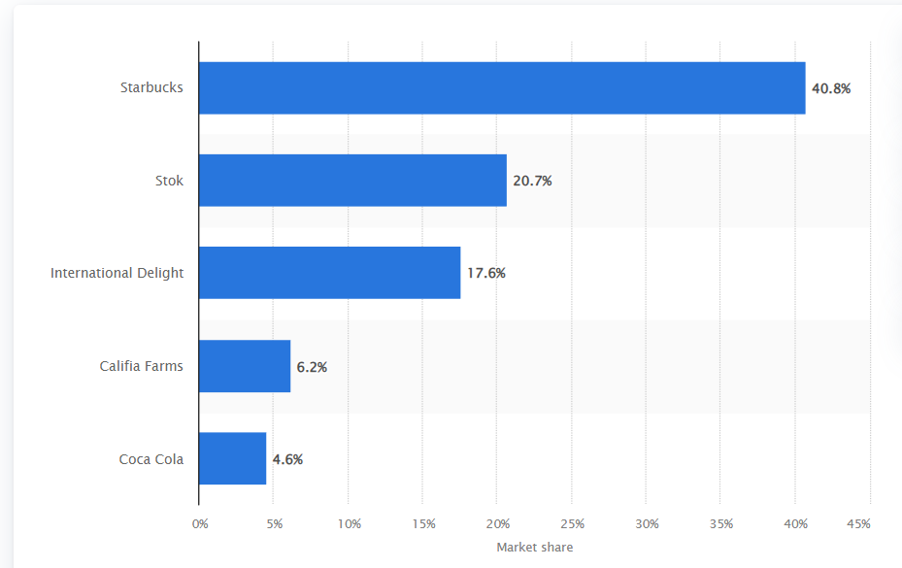
Despite operating in a high-growth market, tea has a small market share for Starbucks, as the company is mainly associated with coffee, which may indicate inferior product quality. Additionally, Starbucks provides customers with tumblers, mugs, t-shirts, scrun2chies, and other items, most of which are limited edition and seasonal, and tend to be sold out within days. Customers take pride in having Starbucks products because of the brand's unique and premium status; exclusive designs that are hard to get hold of have high demand and lie in the question mark quadrant.
Beverages other than coffee and tea are a major money-maker for Starbucks, despite the presence of cheap competitors. Beverages sold in-store accounted for a large majority (74%) of the company's revenue.

On the other hand, packaged coffee beans have a low market share and operate in a low-growth market, which does not bring in much income for Starbucks (only 4% of the revenue) since customers usually come for quick and good coffee and food service.²⁰

Therefore, Starbucks is classified as a star in the BCG matrix, due to its high market share in a rapidly expanding market, high growth potential, and large amount

MARKET SHARE
 | HIGH | LOW
H  I  G  H | STARS  ALL TYPES OF FLAVOURED DONUTS INCLUDING ORIGINAL DONUTS | QUESTION  MARK  SANDWICHES AND BREAKFAST SET
L  O  W | COFFEE  CASH COWS | COOKIES  DOGS
Figure 6: BCG Matrix of Dunkin Donuts

Star includes all varieties of flavored doughnuts, including original donuts. This is because North America is the largest region of donuts with a market share about 45% and Dunkin Donuts is one of the industry leader there. Their donuts account for a significant portion of both market share and market growth. The majority of Dunkin' Doughnuts customers come to buy donuts. This is the major reason why all doughnuts are classified as stars.

Sandwiches and breakfast come under question marks. Customers are more interested in local food, according to recent market trends. As a result, this market has a high growth rate. However, in Dunkin Donuts Growth Strategy, this segment has a low market share. This is because many customers are still hesitant to purchase the sandwiches and breakfast packages supplied by Dunkin Donuts.

In Dunkin Donuts' BCG matrix, coffee is a cash cow. This is because coffee has a low percentage of market growth but a high percentage of market share. Customers do not frequent Dunkin' Donuts since the firm has major competition, Starbucks. Starbucks is constantly concerned with selling premium and high-quality coffee.

Dunkin' Donuts cookies is a dog in the BCG matrix.

Thus Dunkin' Donuts is a Cash Cow. The company has a high market share in the coffee and donut category, but growth has been slow in recent years. While Dunkin' Donuts is not a star, it is a solid performer that generates a lot of cash for the company. Starbucks has a higher percentage of its products in the Stars category than Dunkin' Donuts. This means that Starbucks is investing more in products that have high growth potential and are generating a lot of revenue. Dunkin' Donuts, on the other hand, has a higher percentage of its products in the Cash Cows category. This means that Dunkin' Donuts is generating more revenue from its existing products than Starbucks.

These distinctions are due to a variety of reasons. One benefit is that Starbucks has been in business for a long time and has thus had more time to invest in new products. Another difference is that Starbucks prioritizes innovation over Dunkin' Donuts. Starbucks has made significant investments in new product development, such as the Frappuccino line and Seattle's Best Coffee brand. Dunkin' Donuts, on the other hand, has been more conservative in terms of innovation, preferring to focus on increasing its existing product line. The differences in the BCG matrixes of the two organizations reflect their varied approaches to business. Starbucks prioritizes expansion and innovation, whereas Dunkin' Donuts prioritizes profitability.

Ansoff Matrix

Starbucks and Dunkin' Donuts are two of the most popular coffee chains in the world. They both employ the Ansoff Matrix to inform their strategic decisions. The Ansoff Matrix is a tool that can be used to assess the risks associated with various growth strategies for a company, such as market penetration, product development, market development and diversification. This section will provide an overview of how Starbucks and Dunkin' Donuts use the Ansoff Matrix.
The Ansoff Matrix is a tool used to help businesses analyse and strategize their product development. When applied to Starbucks and Dunkin Donuts, it can be seen that both companies have adopted different strategies in order to remain competitive. Starbucks has focused on product development. On the other hand, Dunkin Donuts has focused more on market penetration.

Dunkin' Donuts' main strategy in the US market is still market penetration, which allows it to increase its market share by expanding its presence in the existing coffee and baked goods market through promotions and ads, as well as opening new stores in new locations in the US. This helps them to compete by connecting with more customers and gaining a larger market share. Furthermore, Dunkin' Donuts maintains a competitive edge by continuously innovating and updating its menu, enabling them to differentiate from competitors and maintain a strong brand reputation.

On the other hand, constant product innovation has always been the main factor of Starbucks, they utilize the other aspects of Ansoff matrix such as maintaining the customers with selling the existing products that everyone loves such as Frappuccinos, they were introduced in 1995 and till the date customers enjoy more than 36000 different combinations of Frappuccino. Diversification which means introducing new products in new markets which can be the merchandise that Starbucks launched such as tumblers, mugs, water bottles etc. And market development is selling existing products in new markets and Starbucks constantly keeps expanding to new cities and countries, and operates more than 33,000 stores around the world. Lastly the main aspect is the product development, Starbucks is the biggest coffee chain in US and in order to maintain it they do constant product development such as limited-edition seasonal drinks such as Peppermint Mocha and they also have a secret menu item for Christmas. This not only helps them stand out from their competitors but also creates a feeling of exclusivity and innovation, which helps attract new customers and retain existing ones.

All in all, both companies have employed different strategies to gain success in the US market. Dunkin' Donuts mainly focuses on market penetration, while Starbucks has implemented a combination of strategies such as market penetration, market development, and majorly product development.

Conclusion
This essay examined the research question, “To what extent has innovation and product development alleviated Starbucks’ position as a market leader against Dunkin Donuts?” However, this exploration had a few limitations: only a limited number of tools were used in the analysis, and a better result could have been achieved with the use of more tools; further, only the product aspect of both companies was examined, which is not sufficient to determine whether Starbucks should be at the top rank or not; there are multiple other factors that should be considered. Moreover, Porter’s Five Forces have their own limitations, as the model primarily focuses on industry competition and ignores the external environment.

Product strategy is essential for a business to succeed in today's highly competitive market. For Starbucks, product strategy has been an integral element in its capability to sustain a competitive edge over Dunkin' Donuts in the US. By strategically constructing its menu and customer experience, Starbucks has been able to set itself apart from other companies and draw in a bigger and more diverse customer base. As a result, Starbucks has been able to acquire a larger market share and generate higher profits.

In conclusion, it is evident that although Starbucks and Dunkin' Donuts offer a similar range of products, their quality and variety of coffee and food items, customization options, sustainability efforts, brand image, menu innovation, in-store experience, value-added services, innovation in packaging, international expansion, loyalty programs, investments in technologies, partnerships, and collaborations, as well as product innovation are all product strategies that to a moderate extent alleviate Starbuck’s position as a market leader against Dunkin Donuts in the U.S. Market.

Bibliography:
¹ 01, September. “Starbucks Names Laxman Narasimhan as Next Chief Executive Officer.” Starbucks Stories, stories.starbucks.com/press/2022/starbucks-names-laxman-narasimhan-as-next-chief-executive-officer/.
² Ian. “Starbucks Marketing Strategy - It's Genius!” Marketing Strategy, 28 Apr. 2021, www.marketingstrategy.com/marketing-strategy-studies/starbucks-marketing-strategy-its-genius/.
³ HOANG, PAUL. Business Management 4th Edition. IBID Press, 2018.
⁴ Published by Statista Research Department, and Jul 26. “U.S. Coffee Chains Market Share 2020.” Statista, 26 July 2022, www.statista.com/statistics/250166/market-share-of-major-us-coffee-shops/.
⁵ Collins, Author:Melissa. “90 Coffee Statistics You Should Know ☕ New Infographics.” Perfect Brew, 19 Oct. 2022, www.perfectbrew.com/blog/coffee-statistics-infographic/.
⁶ “US Coffee Market Analysis - Industry Report - Trends, Size & Share.” US Coffee Market Analysis - Industry Report - Trends, Size & Share, www.mordorintelligence.com/industry-reports/united-states-coffee-market.
⁷ Gupta, S.K. “Top 20 Starbucks Competitors & Alternatives.” Business Strategy Hub, 14 Nov. 2022, bstrategyhub.com/starbucks-competitors-alternatives/.
⁸ 28, February. “C.A.F.E. Practices: Starbucks Approach to Ethically Sourcing Coffee.” Starbucks Stories, stories.starbucks.com/press/2020/cafe-practices-starbucks-approach-to-ethically-sourcing-coffee/.
⁹ Name. “Time to Deliver the Donuts.” Inbound Logistics, 4 May 2022, www.inboundlogistics.com/articles/time-to-deliver-the-donuts/.
¹⁰ The Coffee Beans from Dunkin’ Donuts – Thecommonscafe. www.thecommonscafe.com/the-coffee-beans-from-dunkin-donuts/.
¹¹ water, Kirkland sparkling. “A Hot Serving of Empty Promises? Dunkin' Brands, the Enduring Foam Cups, and Sustainable Coffee.” Technology and Operations Management, d3.harvard.edu/platform-rctom/submission/a-hot-serving-of-empty-promises-dunkin-brands-the-enduring-foam-cups-and-sustainable-coffee/.
¹² 18, May. “Starbucks and Spotify to Partner on Music Streaming Service.” Starbucks Stories, stories.starbucks.com/stories/2015/starbucks-spotify-partnership/.
¹³ “Nestlé and Starbucks to Bring Ready-to-Drink Coffee Beverages to Southeast Asia, Oceania and Latin America.” Nestlé Global, www.nestle.com/media/pressreleases/allpressreleases/starbucks-rtd-coffee-beverages-southeast-asia-oceania-latin-america#:~:text=With%20its%20historical%20local%20footprint,International%20and%20Channel%20Development%2C%20Starbucks.
¹⁴ 23, July. “Starbucks Delivers to Be Available throughout the U.S. in Early 2020.” Starbucks Stories, stories.starbucks.com/press/2019/starbucks-delivers-to-be-available-throughout-the-u-s-in-early-2020/.
¹⁵ Retailers Take Note: Lyft & Starbucks Mixing up Customer Loyalty. www.annexcloud.com/blog/retailers-take-note-lyft-and-starbucks-are-mixing-up-the-customer-loyalty-world/.
¹⁶ Swain, Mark. “International Business – Swain.” Reading: Dunkin' Brands – Dunkin' Donuts and Baskin-Robbins – Making Local Global | International Business – Swain, courses.lumenlearning.com/suny-fmcc-internationalbusiness/chapter/reading-dunkin-donuts/#:~:text=One%20of%20the%20overall%20strategies,and%20expanding%20in%20different%20countries.
¹⁷ Dunkin'. “Dunkin' Expands Delivery Service with Grubhub to More Stores throughout the Metro New York Market.” PR Newswire: Press Release Distribution, Targeting, Monitoring and Marketing, 2 Mar. 2020, www.prnewswire.com/news-releases/dunkin-expands-delivery-service-with-grubhub-to-more-stores-throughout-the-metro-new-york-market-301014678.html.
¹⁸ Donuts, Dunkin'. “Dunkin' Donuts Partners with Doordash for Expanded Delivery Service in Select Areas of New York and New Jersey.” PR Newswire: Press Release Distribution, Targeting, Monitoring and Marketing, 26 June 2018, www.prnewswire.com/news-releases/dunkin-donuts-partners-with-doordash-for-expanded-delivery-service-in-select-areas-of-new-york-and-new-jersey-300551346.html#:~:text=Dunkin'%20Delivery%20will%20be%20offered,Dunkin'%20from%20morning%20to%20night.
¹⁹ Published by M. Ridder, and Dec 6. “Market Share: Leading Ready-to-Drink (Rtd) Coffee Brands U.S. 2022.” Statista, 6 Dec. 2022, www.statista.com/statistics/753258/market-share-rtd-coffee-brands/.
²⁰ Exhibit 99.1 Starbucks Reports Q1 Fiscal 2023 Results. s22.q4cdn.com/869488222/files/doc_financials/2023/q1/1Q23-Earnings-Release-Final-(2.2).pdf.

²¹ ByTheExpressWire. “Doughnuts Market Size in 2022 by Fastest Growing Companies - Dunkin' Brands, Daylight Donuts, Mister Donut with Top Countries Data: New Report Spreads in 140 Pages.” Digital Journal, 28 June 2022, www.digitaljournal.com/pr/doughnuts-market-size-in-2022-by-fastest-growing-companies-dunkin-brands-daylight-donuts-mister-donut-with-top-countries-data-new-report-spreads-in-140-pages.

https://stories.starbucks.com/press/2022/starbucks-names-laxman-narasimhan-as-next-chief-executive-officer/
https://www.marketingstrategy.com/marketing-strategy-studies/starbucks-marketing-strategy-its-genius/
Paul Hoang edition 4 Business Management
https://www.statista.com/statistics/250166/market-share-of-major-us-coffee-shops/
https://www.perfectbrew.com/blog/coffee-statistics-infographic/
https://www.mordorintelligence.com/industry-reports/united-states-coffee-market
https://bstrategyhub.com/starbucks-competitors-alternatives/
https://stories.starbucks.com/press/2020/cafe-practices-starbucks-approach-to-ethically-sourcing-coffee/
https://www.inboundlogistics.com/articles/time-to-deliver-the-donuts/#:~:text=Located%20in%20Easthampton%2C%20N.J.%2C%20MADC,in%20the%20eastern%20United%20States.
https://www.thecommonscafe.com/the-coffee-beans-from-dunkin-donuts/
https://d3.harvard.edu/platform-rctom/submission/a-hot-serving-of-empty-promises-dunkin-brands-the-enduring-foam-cups-and-sustainable-coffee/
https://stories.starbucks.com/stories/2015/starbucks-spotify-partnership/
https://www.nestle.com/media/pressreleases/allpressreleases/starbucks-rtd-coffee-beverages-southeast-asia-oceania-latin-america#:~:text=With%20its%20historical%20local%20footprint,International%20and%20Channel%20Development%2C%20Starbucks.
https://stories.starbucks.com/press/2019/starbucks-delivers-to-be-available-throughout-the-u-s-in-early-2020/
https://www.annexcloud.com/blog/retailers-take-note-lyft-and-starbucks-are-mixing-up-the-customer-loyalty-world/
https://courses.lumenlearning.com/suny-fmcc-internationalbusiness/chapter/reading-dunkin-donuts/#:~:text=One%20of%20the%20overall%20strategies,and%20 expanding%20in%20 different%20 countries.
https://www.prnewswire.com/news-releases/dunkin-expands-delivery-service-with-grubhub-to-more-stores-throughout-the-metro-new-york-market-301014678.html
https://www.prnewswire.com/news-releases/dunkin-donuts-partners-with-doordash-for-expanded-delivery-service-in-select-areas-of-new-york-and-new-jersey-300551346.html#:~:text=Dunkin'%20Delivery%20will%20be%20offered,Dunkin'%20from%20morning%20to%20night.
https://www.statista.com/statistics/753258/market-share-rtd-coffee-brands/
https://s22.q4cdn.com/869488222/files/doc_financials/2023/ar/Starbucks-FY22-Annual-Report.pdf
https://www.digitaljournal.com/pr/doughnuts-market-size-in-2022-by-fastest-growing-companies-dunkin-brands-daylight-donuts-mister-donut-with-top-countries-data-new-report-spreads-in-140-pages

