Research
on
Supplier selection using TOPSIS in Door and window industry
By

Abhay Pratap Pal

Abstract
In today’s highly competitive environment where industries growing too fast and their requirement also which increase in the suppliers who help in manufacturing process little faster. As we can see India is emerging market for Door and windows, Façade market and last one Decade its grown a lot and Bigger company involved in manufacturing of door and windows segment and even large no. start-up had been seen in this industry Which led to increase in supplier and vendor to . for such industries effective supplier selection process is very important to the success of any manufacturing organization. Supplier selection represents one of the most important functions to be performed by the companies’ respective departments. Supplier selection is a multi-criterion problem which includes both qualitative and quantitative factors. A number of models and techniques have been developed to deal with selecting and evaluating suppliers and to best possible supplier among them. The aim of this study is developing a methodology to evaluate suppliers and select best supplier among big list in supply chain cycle based on Technique for Order Preference by Similarity to Ideal Solution method (TOPSIS). The authors, with the help of going over expertise of experts and their relevant specialized literature, could recognize variables and effective criteria in supplier selection. Keywords: # Inventory Management, #Weightage Criteria, #Manufacturing industry, # Topsis Method, #Fenestration.

Table of Content
 | Abstract
1 | Introduction | 4
2 | Literature Review | 5
3 | Research Objective | 6
4  4.1  4.2 | Research Methodology  TOPSIS method  Data Collection | 6  6  7
5  5.1  5.1.1  5.2  5.3  5.4  5.5 | Analysis of Project  Stage 1  Entropy-Calculating Weightage  Stage2  Stage3  Stage4  Stage5 | 8  8  9-11  12  12  12-13  13
6 | Result and Conclusion | 15
7 | References | 16

1. Introduction
With technological advances, customer needs have changed, for demand for lower prices and higher quality at the same time is now on the increase. The start-up firm deals with manufacturing of UPVC and aluminium doors windows and having wide variety of customer base. As India is emerging market for UPVC and aluminium door industry so larger market cap and sales opportunities. So to survival Indian market is difficult, various factor play important role in sales of doors and windows Indian market like Price, Elegance of system, Authenticity of product, Different Style, ease of delivery etc. For the manufacturer like start-up need to take care more about price savings to survive in price concern market. They have to meet the demands from their customers in time, and adapt to rapid changes in this increasingly globalized world. It is also important to keep inventory levels at the appropriate point. need to reduce production costs and manage business processes well. Working with the right suppliers will reduce purchase costs, increase customer satisfaction, and improve competition capacity in a business. Supplier selection process is one of the most important for organizations .and evaluating and identifying supplier is a big issue. The role of the procurement function is often described as supplying raw material and equipment as well as other materials in sufficient quantity and quality, at an affordable price with appropriate delivery. Businesses in fenestration industry need to find the right suppliers to work with to get ahead of their competitors. The prime focus this paper is TOPSIS method, The acronym TOPSIS stands for Technique for Order Preference by Similarity to the Ideal Solution. In general, the process for the TOPSIS algorithm starts with forming the decision matrix representing the satisfaction value of each criterion with each alternative. Next, the matrix is normalized with a desired normalizing scheme, and the values are multiplied by the criteria weights. Subsequently, the positive-ideal and negative-ideal solutions are calculated, and the distance of each alternative to these solutions is calculated with a distance measure. Finally, the alternatives are ranked based on their relative closeness to the ideal solution. The TOPSIS technique is helpful for decision makers to structure the problems to be solved, conduct analyses, comparisons and ranking of the alternatives.

2. Literature Review
Organizations must work with good no. of suppliers to continue its activities. Selection of the suppliers in a group of candidate firms is a difficult decision problem. In these circumstances, supplier selection is vital for the firms. Determining the best supplier is the key for success to the companies with respect to strategic sense. The TOPSIS method was first developed by Hwang & Yoon and ranks the alternatives according to their distances from the positive ideal and the negative ideal solution, i.e. the best alternative solution has simultaneously the shortest distance from the ideal solution and the farthest distance from the negative ideal solution. The ideal solution is identified with a hypothetical alternative that has the best values for all considered criteria whereas the negative ideal solution is identified with a hypothetical alternative that has the worst criteria values. In practice, TOPSIS has been successfully applied to solve selection/evaluation problems with a finite number of alternatives because it is intuitive and easy to understand and implement. Furthermore, TOPSIS has a sound logic that represents the rationale of human choice and has been proved to be one of the best methods in addressing the issue of rank reversal. The TOPSIS method was developed for multi-criteria optimization of complex systems. This method focuses on ranking and selecting from a set of alternatives in the presence of conflicting criteria. Multi criteria optimization is the process of determining the best feasible solution according to the established criteria (representing different effects). Practical problems are often characterized by several non-commensurable and conflicting criteria and there may be no solution satisfying all criteria simultaneously. Selection the right supplier for a long-term relationship is a relevant procurement issue that demands judicious attention. According to Tahiri et al. (2008) "supplier selection problem has become one of the most important issues for establishing an effective supply chain system". Indeed, supplier selection and evaluation represent one of the significant roles of purchasing and supply management function. Tracey and Tan (2001) note that one of the key elements essential to supply chain success is effective purchasing function. Lee et al. (2001) and Kumara et al. (2003) emphasize that selection of the best supplier is an essential strategic issue imperative for supply chain effectiveness and efficiency. Kumara et al. (2003) contend that strategic partnership with the right supplier must be integrated within the supply chain to contain costs, improve quality and flexibility to meet end-customers' value and reduce lead time at different stages of the supply chain (Chris I., Bell-Hanyes, 2010). A study by Moynihan et al. (2006), states that about 60% of the manufacturer's sales dollars are paid to the supplier for purchased materials. Supplier selection decisions are complicated by the fact that various criteria must be considered in the decision-making process. The analysis of criteria for selection and measuring the performance of suppliers has been the focus of many academicians and purchasing practitioners since 1960s. (Weber, Current, Benton, 1991) Based on Dickson's (1966) empirical study, 23 criteria were identified which purchasing managers generally consider when selecting a supplier. Of the identified criteria, quality, on-time delivery, and supplier's performance history were found vital in supplier selection regardless of the type of purchasing environment. Dempsey (1978) identified quality, delivery capability, and technical capability as imperative in supplier selection. Ellram (1990) emphasized the need not only to base supplier selection decision on the traditional price and quality criteria but also on longer term and qualitative attributes such as strategic match and evaluation of future manufacturing capabilities (Chris I., Bell-Hanyes, 2010).
3. Research Objective:
- Evaluate multiple suppliers for purchasing upvc Door handle
- Selecting Best Alternative of supplier by using TOPSIS.

4. Research Methodology
4.1 TOPSIS Method:
A Multi-Criteria Decision Making (MCDM) technique helps the decision makers to evaluate the best alternative Out multiple alternatives, TOPSIS method is “Technique for Order Preference by Similarity to Ideal Solution (TOPSIS)” is a method of multi-criteria decision analysis and this method was introduced by Hwang and Yoon in 1981. TOPSIS logic is rational and understandable. It chooses the alternative which has the shortest geometric distance from the positive ideal solution and compares a set of alternatives by identifying weights for each criterion, normalizes the scores for each criterion and calculates the geometric distance between each alternative and the ideal alternative in order to give the best score for each criterion. TOPSIS method helps to choose the right suppliers with a various finite number of criteria.
Ideal alternative: One which has best attribute value (i.e max benefit attribute and min cost).
Negative ideal alternative: One which has worst attribute value (i.e. min benefit and cost attribute).
Step 1: The structure of matrix,
D=
A1 | X1 | X2 | ….. | Xj
A2 | X11 | X12 | ….. | X1j
. | X21 | X22 | ….. | X2j
. | . | . | ….. | .
. | . | . | ….. | .
Ai | Xi1 | Xi2 | ….. | Xij

Step 2: Calculate the Normalized the matrix D by using the following formula:
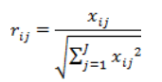

Step 3: Construct the weighted normalized decision matrix by multiplying:
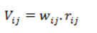

Step 4: Determine the positive ideal solution and negative ideal solution
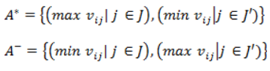
Step 5: Calculate the separation measure
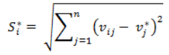
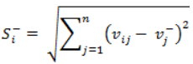
Step 6: Calculate the relative closeness to the ideal Solution
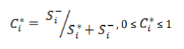
Step 7: Calculate the total score and select the alternative closest to 1.

4.2 Data Collection
- Primary data collection for Ecogreen fenestration technologies. Details below:
- Supplier Details and Parameter determining Handle Performance and demand.
- Secondary Data regarding TOPSIS implementations from various article, Journals, Books and Technical paper.

5 . Analysis of Project
For a Fenestration firm wants to select its supplier, suppose the following criteria and characteristic as the most important items to focus: price, Operation cycle, Aesthetic, Delivery, MOQ, After consideration following decision matrix is obtained.

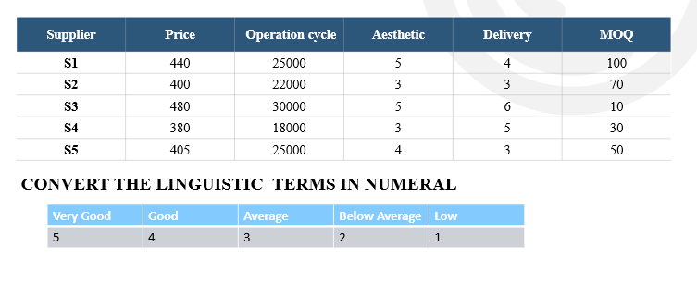
5.1 Stage 1-
Standardize the decision matrix
This step transforms various attribute dimensions into non-dimensional attributes, which allows comparison across criteria.
For standardizing, each column of decision matrix is divided by root of sum of square of respective
Calculate Normalized Matrix
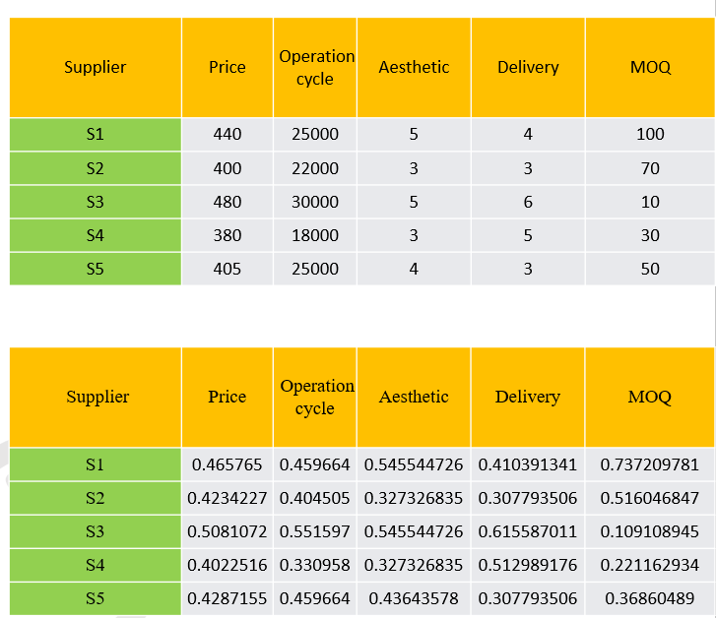

Normalization of matrix
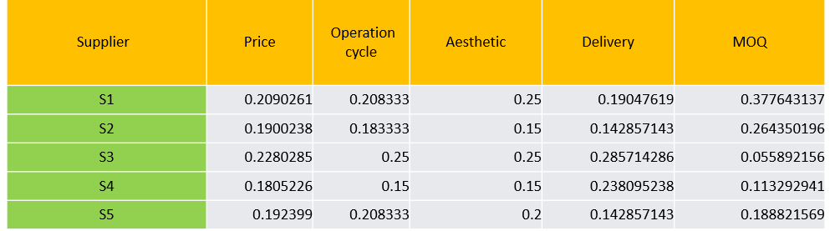
5.1.1 Entropy for calculating weightage
- Normalization of decision matrix
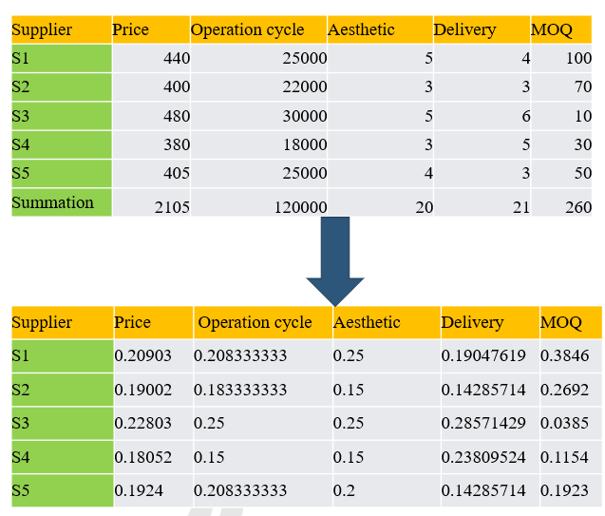
Compute entropy
- Ej=-h$∑_(i=1)^m▒〖(m¦i)rij〖ln⁡rij〗^ 〗$,
- j=1,2,3……,n
- h= 1/ln(m), m is no.of supplier
- h= 1/ln(5)=0.621335
- Summation –
- $∑_(i=1)^m▒〖(m¦i)rij〖ln⁡rij〗^ 〗$
Ej=-h$∑_(i=1)^m▒〖(m¦i)rij〖ln⁡rij〗^ 〗$
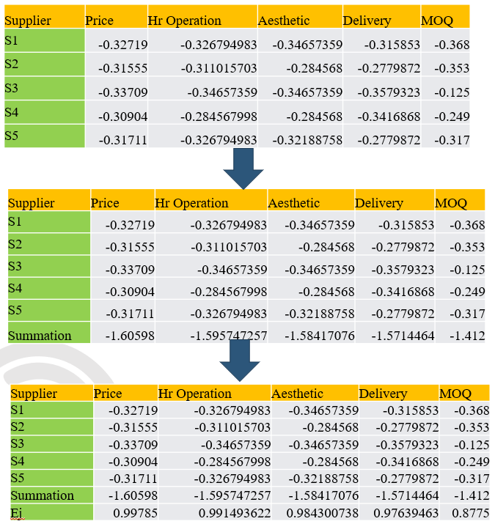

Compute weight vector
- wj$=1-ej/∑_(j=1)^n〖(1-ej)〗$ ,
- J=1,2,3….n
- $∑_(j=1)^n〖(1-ej)〗$
- wj$=1-ej/∑_(j=1)^n〖(1-ej)〗$ ,
- J=1,2,3….n
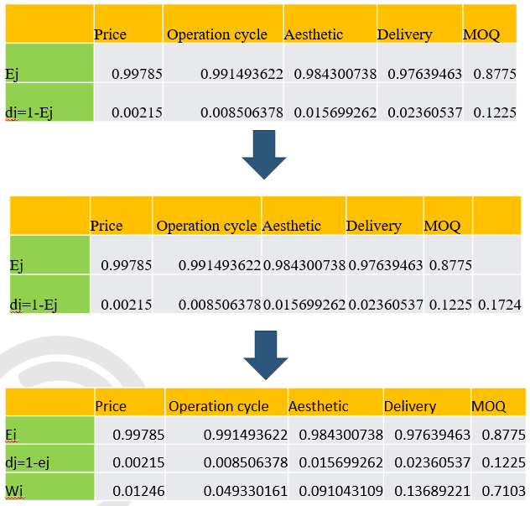

5.2 Stage-2
- Construct weighted standardized decision matrix by multiplying attributes weight to each.
- Calculate weighted Normalized Matrix
$$V_ij=X ̅_ij×W_j$$
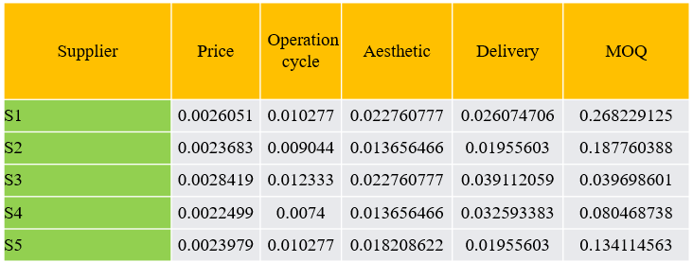

5.3 Stage 3-
- Calculate the ideal best and ideal worst value.
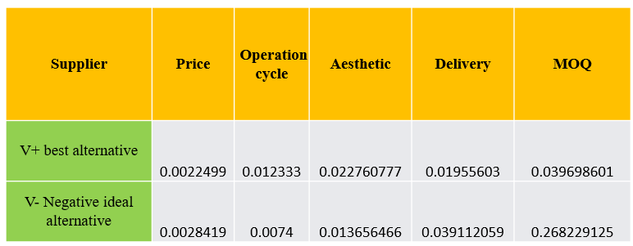

5.4 Stage 4-
- Calculate the Euclidean distance from the ideal best .
- Calculate the Euclidean distance from the ideal worst .
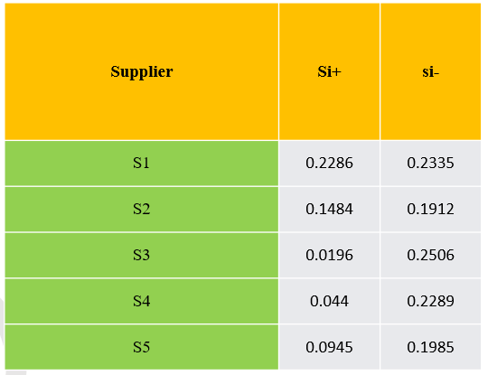
5.5 Stage 5-
Calculate Performance Score for rating the supplier.
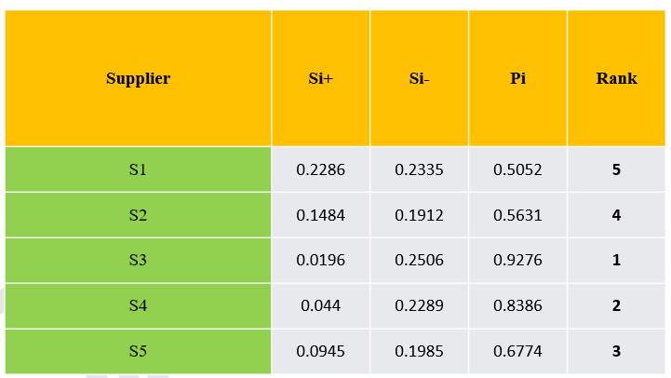

6. Result
The Five competing suppliers (Kinlong, Pulse, GU, Pego and DNV) were evaluated by the performance score of rating. When value of supplier performance score is nearer 1,then the supplier is most suitable for company for provide material over the facts of selected criteria’s(Price, Operation cycle, Aesthetic delivery,MOQ). According performance score GU secure 1st rank with score of 0.9276, Pego secure 2nd rank with score of 0.8386, DNV secure 3rd rank with score of 0.6774, Pulse secure 4th rank with score of 0.5631 and last kinlong secure 5th rank with score of 0.5052. so most preferred supplier would be GU.
7. Conclusion
In this paper, the calculation algorithm is done properly and the results were reached within the framework of the objectives set for the supplier. In this study GU hardware supplier was the most suitable supplier for further procurement process. The prime focus was how to select the best supplier in supplier selection problems when decision makers set the target value of each criterion. Although many approaches can solve the problem, the study proposed a method and a procedure to extend the TOPSIS method to solve the problem. The main advantages of using TOPSIS method are “TOPSIS logic is rational and understandable”, “The computation processes are straightforward”, “The concept permits the pursuit of best alternatives criterion depicted in a simple mathematical” and “The importance weights are incorporated comparison procedures”. Due to this, decision making for selection of suitable supplier is of special importance. Acquired results from numerical example determine that this model could be used for decision making optimization in supplier selection.

REFERENCE

Benyoucef, L., Ding, H., & Xie, X. (2003). Supplier selection problem: selection criteria and methods (Doctoral dissertation, INRIA).
Cengiz, A. E., Aytekin, O., Ozdemir, I., Kusan, H., & Çabuk, A. (2017). A multi-criteria decision model for construction material supplier selection. Procedia Engineering, 196, 294-301.
Cristea, C., & Cristea, M. (2017). A multi-criteria decision-making approach for supplier selection in the flexible packaging industry. In MATEC Web of Conferences (Vol. 94, p. 06002). EDP Sciences.

E.A. Frej, L.R.P. Roselli, J. Araújo de Almeida, A. Teixeira de Almeida. A Multicriteria Decision Model for Supplier Selection in Food Industry Based on Trade-off Method, Centre for Decision Systems and Information Development (CDSID) (2017)19 October

Faez, F., Ghodsypour, S. H., & O’Brien, C. (2009). Vendor selection and order allocation using an integrated fuzzy case-based reasoning and mathematical programming model. International Journal of production economics, 121(2), 395-408.

Kuo, R. J., Wang, Y. C., & Tien, F. C. (2010). Integration of artificial neural network and MADA methods for green supplier selection. Journal of cleaner production, 18(12), 1161-1170.

Taherdoost, H., & Brard, A. (2019). Analyzing the process of supplier selection criteria and methods. Procedia Manufacturing, 32, 1024-1034.

Tahriri, F., Osman, M. R., Ali, A., & Yusuff, R. M. (2008). A review of supplier selection methods in manufacturing industries.

Thiruchelvam, S., & Tookey, J. E. (2011). Evolving trends of supplier selection criteria and methods. International Journal of Automotive and Mechanical Engineering, 4(1), 437-454.

Wang, C. N., Viet, V. T. H., Ho, T. P., Nguyen, V. T., & Nguyen, V. T. (2020). Multi-criteria decision model for the selection of suppliers in the textile industry. Symmetry, 12(6), 979.

