Survey Paper on HealthCare Chatbot System Using Machine Learning

Sayali korake  Department of Computer Engineering: SMT.Kashibai Navle college of Engineering Pune, India Sayalikorake25@gmail.com  Rohit Madgundi Department of Comp Engg SMT.kashibai navle college of Engineering Pune, India.  rohitmadgundi@gmail.com | Shivkanya Mhetre  Department of Computer Engineering  Smt Kashibai Navale college of Engineering Pune India Mhetershivkanya@gmail.com  Dhanashri Nevase Department of Computer Engineering SMT.Kashibai Navle college of Engineering Pune, India Dhanashri.nevase@gmail.com | Vrushali Gaikwad Department of Computer Engg. SMT Kashibai Navale college of Engineering Pune, India 2001vrushaligaikwad@gmail.com

Abstract:
Healthcare is a very important to led good life. However, it is very difficult to obtain consultation with the doctor for health problem. The basic idea is to create the Healthcare chatbot
using Artificial Intelligence to diagnose disease and provide basic details and solution about disease before consulting the doctor. This will help us to decrease the healthcare costs and improve accessibility to medical knowledge through medical chatbot.
The chatbots are computer programs that use the natural language to interact with users. The healthcare chatbot stores all data in database to identify the disease. Ranking & sentence similarity calculation is performed using ngram, TFIDF & cosine similarity. The score will
be obtained for each sentence from the given input sentence & more similar sentences will be obtained for the query given. The 3rd party, expert program, handles question presented to a bot that is not understood or is not present in the database.

I . Introduction

A Healthcare chatbot is an automated program that simulates human conversation through text messages, voice chats, or both.
The chatbot is a computer programs that use natural language to interact with users.
It stores the data in database to identify the sentence keywords & to make a query decision and answer to question.
There are wide ranges of chatbots such as business, customer care, healthcare, recommendation systems, support system, accessory shopping, travel chatbots, banking chatbots etc.
Everything in this generation is getting related with web. It's extremely efficient to
Utilize approach to management of benefit everything at your doorstep. The chatbots are
sufficient to fool the users in believing that they are talking to a human being, they have a very limited knowledge base at runtime and have no means to keep track of all the conversations. Chatbots uses machine learning to reach Artificial Intelligence for helping them to understand the user queries and provide user with an appropriate Solution.

2 . Literature Review

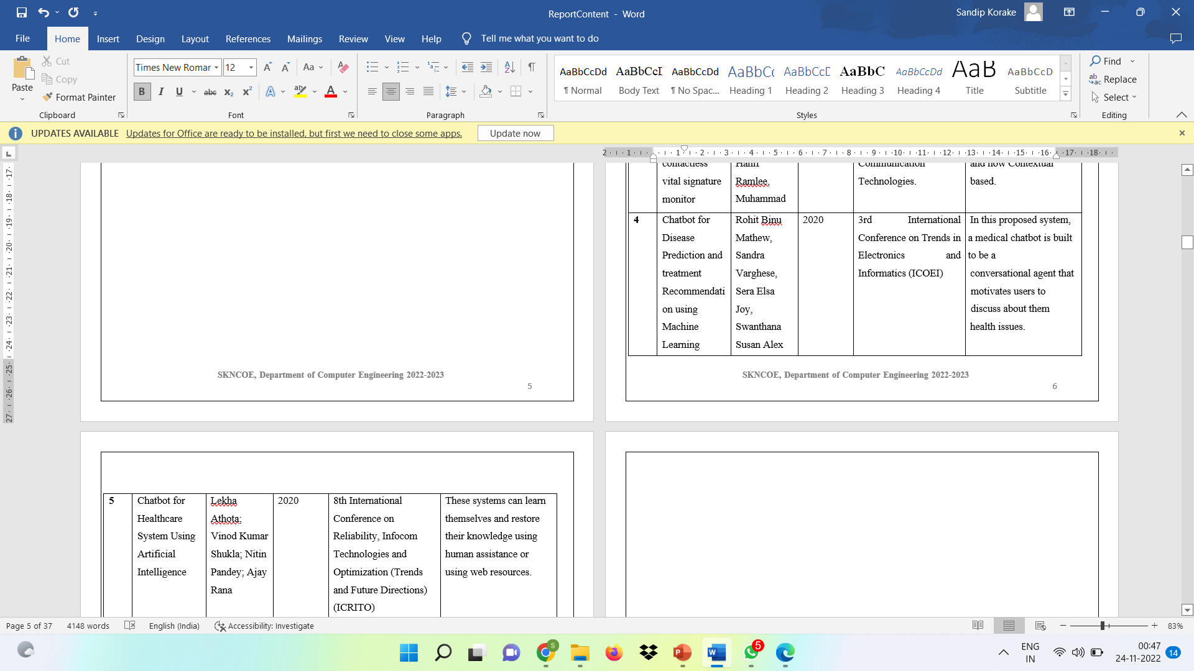
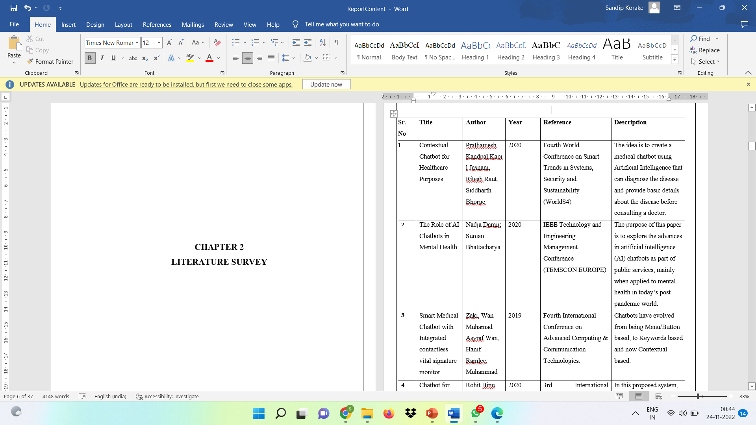

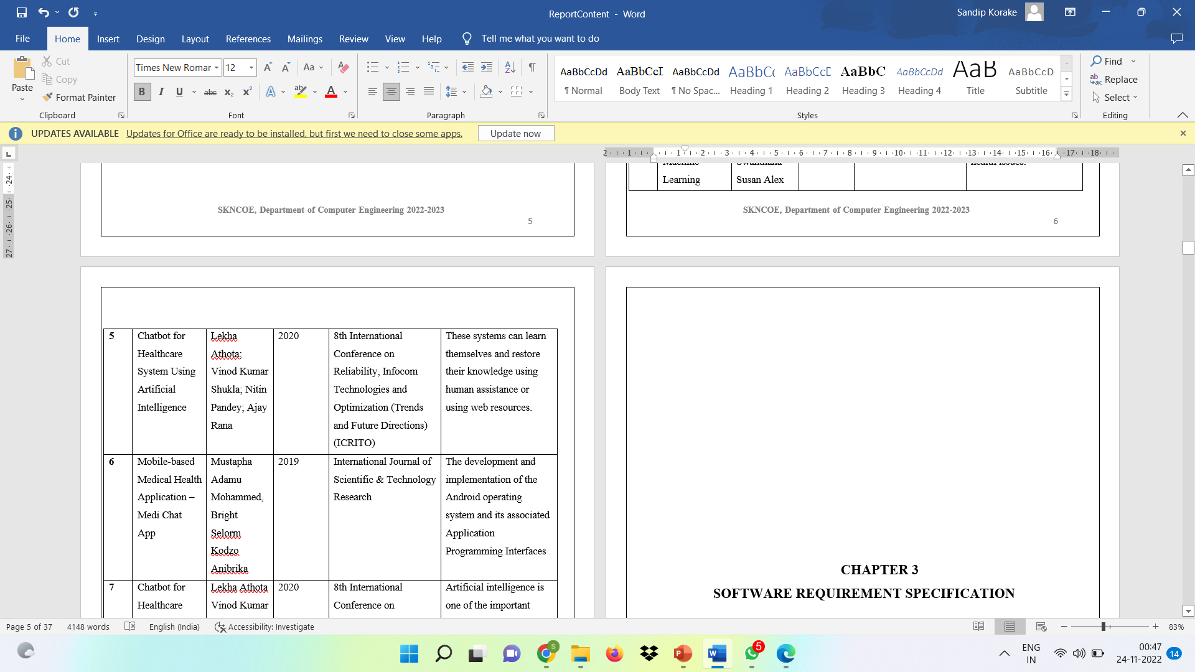
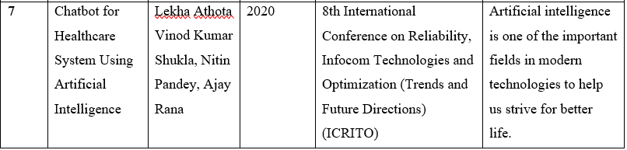

3. Conclusion :
The user of this application can specify their symptoms to the chatbot and chatbot will specify the health measures to be taken. General information about symptoms and diseases and the solution for that diseases are available in the dataset. After analyzing the symptoms of the different users, it finally predicts the disease to the user.

4.Reference :

1. Chatbot for Disease Prediction and treatment Recommendation, Rohit Binu Mathew, Sandra Varghese, Sera Elsa Joy, Swanthana Susan Alex.
2. The Times of India, https://timesofindia.indiatimes.com/lifestyle/health-fitness
3 . Sameera A. Abdul-Kader, Dr. John Woods. Survey on the Chatbot Design Techniques in Speech Conversation Systems, School of Computer Science and Electronic Engineering/University of Essex Colchester/ UK.
4. Kuligowska, Karolina. (2015). Commercial Chatbot Performance Evaluation, Embodied Conversational Agents. Professionals Center for Business Research. 2. 1-16. 10.18483/PCBR.22
5. Mrs. Rashmi Dharwadkar, Dr.Mrs. Neeta A. Deshpande "A Healthcare ChatBot"” in interNational Journal of Computer Trends V60(1):41-45, June 2018.
6. Shweta Taneja, Charu Gupta , Kratika Goyal , Dharna Gureja, “An Enhanced K-Nearest Neighbor Algorithm Using Information Gain and Clustering”, 2014 Fourth International Conference on Advanced Computing & Communication Technologies. doi:10.1109/acct.20

