SYSTEM SURVEILLANCE USING KEYLOGGER
Prof. S.M.Melasagare; Vinit V. Dalvi, 05; Prasad V. Patil, 36; Aftab N. sarguru, 46;
Sindhudurg Shikshan Prasarak Mandal’s College of Engineering, Department of Computer Science, Mumbai University.

Abstract—In many companies, data security and recovery is now the most important factor. In many cases where data recovery is required. For these kinds of problems, a keylogger is one of the best solutions, which is often referred to as keylogging or keyboard capture. Keycapping is the act of recording keystrokes on a keyboard, usually covertly so that the person using the keyboard does not know that their actions are being monitored. With the help of keylogger application, users can get the data when the working file is corrupted due to several reasons like power loss etc. This is a tracking application used to track the users which records the keystrokes; uses log files to retrieve information. Using this application, we can recall a forgotten email or URL. In this keylogger project, whenever the user types something on the keyboard, the keystrokes are captured and sent to the admin email address without the user’s knowledge within a set time.
Index Terms—Keylogger, system survillance, keystrokes, etc.

I. INTRODUCTION
I
N many IT infrastructure organizations now-a-days, data security and data recovery are the most important factors which is basically deployed in Computer Forensics. Computer forensics consists of the art of examining digital media to preserve, recover and analyze the data in an effective manner. There are many cases where data recovery is required essentially. So by using keylogger application users can retrieve data in the time of disaster and damaging of working file due to loss of power etc. This is a surveillance application used to track the users which log keystrokes, uses log files to retrieve information, capture a record of all typed keys. The collected information is saved on the system as a hidden file or emailed to the Admin or the forensic analyst.
Keylogger sometimes refers as a keystroke logger is a surveillance type of software or spyware that has the ability to s all the keystrokes pressed by the user.Generally, the keylogger is used for monitoring and malicious activity purposes. It is not a new device or software for the users. The first keylogger was installed in US embassy consulate buildings of various countries in 1970 for capturing the information to be used in a malicious manner by Petersburg. There are several types of keyloggers present in markets like hardware keyloggers and software keyloggers. In software, there are two main types of kernel mode keylogger and userspace.

II. LITERATURE REVIEW
In [1] we observe that To make recognizing keyloggers all the more conceivable, it is important for individuals to get a handle from top to bottom information about what keyloggers really are, how they work implement and understand a different approach to it. On answers to this kind of questions we will discuss about different the kind of algorithm that has been proposed so far to overcome the problem and also the disadvantages of the proposed system. Key recording is a stock trading practice that should be possible from multiple points of view. When the attacker gain physical access to your computing devices that may eavesdrop on physical hardware such as the keyboard to collect them valuable user data. This strategy is completely dependent on some real properties, either sound transmission created when the client composes or electromagnetic remote console propagation (Santripti Bhujel — Mrs. N. Priya 2022). In [2] we found out External keyloggers or hardware keyloggers are small an electronic device that is placed between the keyboard and motherboards, this procedure requires attackers to have a physical access to the system to which they are intended compromise. Keyloggers are performed on targeted machine for recording client keystrokes finally, the transfer of this private information to a third party (Kavya .C, Suganya.R 2021). In [3] we observed Keyloggers are used for both legal and illegal purposes. Attackers usually use keyloggers to obtain private information of an individual or an association. In the past a lot of credit card information has been misused attackers using keyloggers. Keyloggers from now on are one of the most dangerous types of spyware to date, ( Devashree Kataria , Manan Kalpesh Shah , S Bharath Raj , Priya G 2020). In [4] we discover Malicious programs using the keystroke logging feature an example of a real-time online banking system. Off the chance that some of the frame capacities were erroneously updated, may represent attacker to gain access to the www.ijcrt.org © 2022 IJCRT — Volume 10, Issue 11 November 2022 — ISSN: 2320-2882 IJCRT2211029 International Journal of Creative Research Thoughts (IJCRT) www.ijcrt.org a249 client ledger. The the loophole of these attacks can be easily removed if the gadget keeps asking for a brand new set characters or alphabets regardless of whether the login is successful (Disha H. Parekh, Nehal Adhvaryu, Vishal Dahiya 2020). In [5] we found out that As examination depends on individual positions and now not to the specific character styles that are allowed inside the verification code, allowing codes to contain a could not have a more distinctive assortment of characters remove the weakness, even though it would be possibly improve security in various ways. He too proposed an extension of the permissible lengths authentication codes could put the attack to sleep, but they could now do not change the straightforward situation. In total the central issue is the enemy of key logging frameworks done in that particular way will reasonably invalidate theirs entire consideration (Jia Wang, Brent Lagesse 2020).

III. PROBLEM STATEMENT
Hackers and other third parties are always looking for the vulnerabilities present inside the system. To gain knowledge about what they require from the organizations, they either gain access to the confidential data stored in the system and either cause harm to the integrity of data or may cause data loss. Another problem is that cyber crimes are increasing day by day. If we will have the chat logs or keystroke logs of the victim’s laptop then we can easily analyze the entire planning of the victim which will provide the best solution to eradicate or solve the problem.

IV. PROPOSED SYSTEM
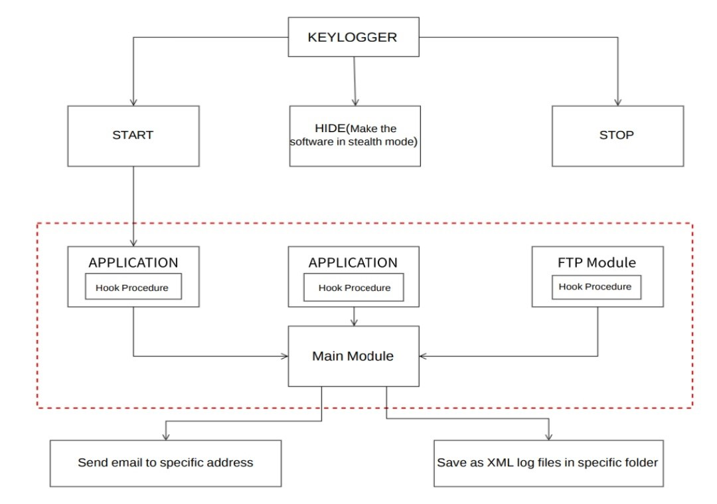
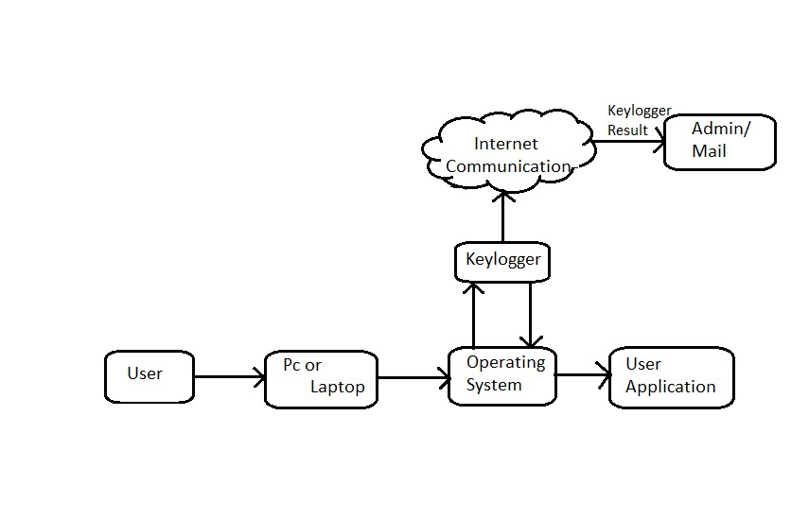
In this section, we are going to discuss the system that is suggested to work on those mentioned problems and discuss how the proposed system work to analyse the keylogger system also, which technologies are we going to use in this project. The solution to the above existing problem is that we can build software keyloggers instead of hardware keyloggers. The proposed model provides a solution that reduces the difficulties while installing the keylogger in the target system. Since software keylogger can be installed remotely and does not need any physical access to the target system. Proposed software is efficient enough to get installed in the targeted system by itself when the user for example clicks the malicious link sent to him through mail or any social media and finally captures all the keystrokes of the user while he is logged into the system, saves the logs in a folder or sends the log directly to the mail address of the third party. Create Software keyloggers instead of hardware keyloggers. It reduces trouble installing the keylogger to the target System. Keylogger software can be installed remotely. The designed software is powerful enough to be installed on the targeted system itself . Figure 2: Proposed System
Fig. 2. Il System Design.
VI. M
ETHODOLOGIES
Fig. 1. Logical data flow diagram.
In the above fig.2.1, these are the following steps
- Installation: The keylogger software is installed on the target device. This can be done manually by someone with physical access to the device or through malicious means such as email attachments, infected USB drives, or other forms of malware.
- Keystroke Capture: Once installed, the keylogger software captures and records keystrokes made on the target device. This can include text typed in documents, web browsers, chat applications, and other programs. Keylogger software can capture keystrokes by monitoring keyboard events or intercepting input/output operations.
- Data Logging:The captured keystrokes are typically stored in a log file or transmitted to a remote location for later retrieval. This may involve storing the data locally on the target device or sending it to a remote server or email address.
- Stealth and Persistence: Keylogger software may use techniques to remain hidden from the user and evade detection. For example, it may run in the background without displaying any visible signs or disguise itself as a legitimate process to avoid detection by antivirus software. It may also be configured to automatically start upon system boot or reinstall itself if removed.
- Remote Access and Control:Some keylogger software may provide remote access and control features, allowing the operator to view and manage the captured data from a remote location. This may involve accessing the data through a web-based interface or using other means of remote communication.

V. SYSTEM DESIGN
1. Smtplib:Simple Mail Transfer Protocol (SMTP) is a protocol.The module included in python defines an SMTP client session object that can be used to send mail to any internet machine with an SMTP listener daemon.
Here is the detail of the parameters:
host- This is the host running your SMTP server. You can specify IP address of the host or a domain name like keyloggers.com. This is optional argument.
port If you are providing host argument, then you need to specify a port, where SMTP server is listening. Usually this port would be 25.
local-hostname If your SMTP server is running on your local machine, then you can specify just localhost as of this option.
An SMTP object has an instance method called sendmail, which is typically used to do the work of mailing a message.
It takes three parameters
The sender A string with the address of the sender.
The receivers A list of strings, one for each recipient. The message A message as a string formatted as specified in the various RFCs.
2. Threading:It is one of the modules provided with python includes a simple-to-implement locking mechanism that allows you to synchronize threads.
A Thread or a Thread of Execution is defined in computer science as the smallest unit that can be scheduled in an operating system.
Threads are normally created by a fork of a computer script or program in two or more parallel (which is implemented on a single processor by multitasking) tasks.
Threads are usually contained in processes. More than one thread can exist within the same process. These threads share the memory and the state of the process. In other words: They share the code or instructions and the values of its variables.
3. Pynput:This library allows the users to control and monitor input devices.
The pynput library allows you to control and monitor/listen to your input devices such as they keyboard and mouse. The pynput.mouse allows you control and monitor the mouse, while the pynput.keyboard allows you to control and monitor the keyboard.we will be moving the cursor to a specific position, automate clicks, and simulate keystrokes from the keyboard.
e.g.; pynput.mouse, pynput.keyboard.
Exact string matching algorithm:
Exact string matching algorithm is used to match keyboard input variables with input received from the keyboard, and exact string matching is a method that can be done to match input string variable with string comparison variable, for testing of exact string matching algorithm on keylogger application can be assumed. Exact String Matching Algorithms (also known as Fuzzy String Searching) searches for substrings of the input string. More specifically, the approximate string matching approach is stated as follows: Suppose that we are given two strings, text T[1. . . n] and pattern P[1. . . m]. The task is to find all the occurrences of patterns in the text whose edit distance to the pattern is at most k. Some well-known edit distances are – Levenshtein edit distance and Hamming edit distance.
Database: In this Keylogger system the database is utilized the storage of our computer. The PC must contain At list 40GB of free space. It preserves all the keystrokes/Loggs in the backend.

VII. CONCLUSION
A Keylogger is a form of software that is used to track or log the all the keys that a user strikes on their keyboard. Usually in secret so that the user of the system doesn’t know that their actions are being monitored. It is otherwise known as a keyboard capturer. These are perfectly legal and useful. They can be installed by employers to oversee the use of their computers, meaning that the employees have to complete their tasks instead of procrastinating on social media. Keylogger applications designed by implementing the Exact String Matching algorithm can record all user activities related to the keyboard. Results are stored automatically in a dedicated database that can only be accessed by the keylogger owner.

VIII. ACKNOWLEDGE
We sincerely acknowledged with deep sense of gratitude to Prof. S.M. Melsagare and the project coordinator, Dr. N. M. Shivsharan for their valuable guidance, genuine suggestion and constant encouragement during preparation of project synopsis work without which completion of this task would be a difficult task. We are also thankful to all of our faculty members of Computer Engineering Department especially our head of the department Prof. D. P. Mhapasekar and our respected principal Dr. A. C. Ganagal who give us idea of significant cooperation during completion of this work. We are immensely grateful to all who involved in this project work because without their cooperation,inspiration, constant promoting and useful suggestion it would be impossible to complete this task and synopsis report within this allotted time. Project Members:
Dalvi Vinit Vilas
Patil Prasad Vijay
Sarguru Aftab Nijamuddin
11 Apr 2023
Sindhudurga Shikshan Prasrak Mandal’s College of Engineering

IX. REFERENCES
- Simon Heron. The rise and rise of the keyloggers. Network Security, 2007(6):4–6, 2007.
- Laurie A. Schintler and Connie L. McNeely, editors. Keylogger, pages 609–609. Springer International Publishing, Cham, 2022.
- A. Solairaj, S. C. Prabanand, J. Mathalairaj, C. Prathap, and L. S. Vignesh. Keyloggers software detection techniques. In 2016 10th International Conference on Intelligent Sys- tems and Control (ISCO), pages 1–6, 2016.
- Dave Waterson. How keyloggers work and how to defeat them. ITNOW, 63(1):40–41, 2021.
- Mohammad Wazid, Avita Katal, R.H. Goudar, D.P. Singh, Asit Tyagi, Robin Sharma, and Priyanka Bhakuni. A framework for detection and prevention of novel keylogger spyware attacks. In 2013 7th International Conference on Intelligent Systems and Control (ISCO), pages 433–438, 2013.
- Adrianna Kozierkiewicz-Hetma nska, Aleksander Marciniak, and Marcin Pietranik. User authentication through keystroke dynamics as the protection against keylogger attacks. pages 345–355, 2016.
- Seth Simms, Margot Maxwell, Sara Johnson, and Julian Rrushi. Keylogger detection using a decoy keyboard. pages 433–452, 2017.
- Ahsan Wajahat, Azhar Imran, Jahanzaib Latif, Ahsan Nazir, and Anas Bilal. A novel approach of unprivileged keylogger detection. pages 1–6, 2019.
- Akashdeep Bhardwaj and Sam Goundar.
- Huseyn Huseynov, Kenichi Kourai, Tarek Saadawi, and Obinna Igbe. Virtual machine introspection for anomalybased keylogger detection. pages 1–6, 2020.

