TACTICAL URBANISM
An approach to implement NMT-friendly neighborhoods in Indian cities.

A research paper submitted in partial fulfillment of the academic requirement of Graduation in Architecture

ARCHITECTURE
By Student
Rishabh Choudhary

Registration Number
0809AR191068

Under the Guidance of
Ar. Monika Saraf

School of Architecture
IPS Academy, Indore

School of Architecture, IPS Academy, Rajendra Nagar, Indore, 452012

ACKNOWLEDGEMENT

I would like to take this opportunity to express my heartily gratitude and acknowledge the contributions to all those who enabled me to complete and present this research paper.
First of all, I am grateful to my guide Ar. Monika Saraf for guiding me for the proper methodology of the research. I am thankful to our coordinators Ar. Nitya Durve for their valuable guidance.
I am also thankful to my other faculty members of our college who contributed to my dissertation by their advice. Moreover, I am thankful to my parents for their encouragement and financial support and friends for emotional support that leads me to the completion of this work.
I must express my deep gratitude towards our (Prof.) Dr. Manita Saxena for providing us proper guidance.

STATEMENT OF ORIGINALITY & ETHICS DECLARATION

I declare that the research entitled TACTICAL URBANISM-An approach to implement NMT-friendly neighborhoods in Indian cities is the bonafide work carried by me, under the guidance of Ar. MONIKA SARAF further declare that this has not been previously formed the basis of award of any degree. diploma, associateship or other similar degrees or diplomas and has not been submitted anywhere else. I hereby, give consent for my research paper, if accepted, to be available for photocopy and inter-library loan, and for the title and summary to be made available to other organizations

Name of student
RISHABH CHOUDHARY

Place: INDORE

Date: 01/04/2023

ABSTRACT
This research paper examines the idea of tactical urbanism. In order to create neighbourhoods that are welcoming to non-motorized transportation (NMT), Using brief, low-cost interventions, tactical urbanism seeks to improve the usability and pedestrian friendliness of urban areas. The importance of NMT in Indian cities, where there is a great need for environmentally friendly and reasonably priced transportation solutions, is highlighted at the outset of the article. The various difficulties of putting in place NMT infrastructure are then discussed, including the lack of finance and space.
The study contends that by empowering communities to take control of the transformation process and uniting various stakeholders behind a single objective, tactical urbanism can be a successful response to these problems. It gives examples of tactical urbanism projects that have been effective in Indian cities, such as turning parking lots into pedestrian-friendly areas and constructing bike lanes using bollards and signage. In order to secure the sustainability and scalability of these programmes, the report also highlights the necessity of long-term planning and governmental support.
Overall, this study emphasises tactical urbanism's potential as a strategy for developing NMT-friendly neighbourhoods in Indian cities. In order to make Indian cities more accessible, livable, and sustainable, it advocates for increased cooperation between communities, local government, and civil society organisations.
Keywords: participative design, public safety, tactical urbanism, economic development, community participation, sustainability, and equity.

INTRODUCTION
The idea of tactical urbanism has gained popularity recently, particularly since metropolitan regions all over the world confront more issues linked to sustainability, social equality, and economic development. A fresh kind of urban planning called tactical urbanism focuses on transforming city streets and public areas swiftly and affordably through small-scale, low-cost interventions. NMT is a crucial component of tactical urbanism since these interventions frequently aim to enhance pedestrian and bicycle infrastructure, lessen reliance on cars, and improve urban livability. In order to better understand how Tactical Urbanism may support NMT in cities, To promote more sustainable and livable urban settings through more non-motorized mobility, tactical urbanism has the ability to do just that.
The term "tactical urbanism" refers to a collection of methods for energising and reshaping public space via inexpensive, transient, and scalable interventions. These interventions are frequently carried out by residents, artists, activists, and designers who reinvent and revive underutilised or neglected urban locations using their inventiveness, creativity, and social networks. Tactical urbanism is the use of unusual and flexible design methods in architecture.
HISTORY OF TACTICAL URBANISM:
The idea of the "city lovely" first gained popularity in America in the early 20th century, which is when tactical urbanism first emerged. The city beautiful movement aimed to build impressive and aesthetically pleasing public areas, but it was attacked for its elitism and contempt for the wants and ambitions of common people. The urban renewal movement tried to tackle the issues of urban degradation and social injustice in the 1960s and 1970s with extensive deconstruction and redevelopment projects, but it also encountered opposition from local communities and preservationists.
Guerrilla urbanism is a phrase that was developed in the 1990s to characterise unlawful and unplanned interventions made in public areas by artists, activists, and everyday people. Guerrilla urbanism was viewed as a means of reclaiming public space from the powerful while also fostering new modes of urban expression and identity. As a more intentional and purposeful method of urban intervention that aspired to produce immediate and beneficial results for communities, tactical urbanism arose in the 2000s.
Tactical urbanism principles
Several important principles serve as a guide for tactical urbanism, including:
- Flexibility and adaptability: Tactical urbanism interventions should be made to be simple to put into place, change as needed, and take away.
- Cost-effectiveness and resourcefulness: Tactical urbanism interventions should be feasible, utilising locally accessible resources and labour as well as easily available and repurposed materials.
- Scalable and incremental: Tactical urbanism initiatives should begin modestly, gain momentum over time, and have the capacity to develop as support and demand rise.
- Participatory and collaborative: Local communities and stakeholders should be engaged in the planning, design, and implementation stages of tactical urbanism initiatives.
Tactical urbanism applications in architecture
Architectural tactical urbanism has been used in a variety of ways, including:
- Building and space adaptation: Tactical urbanism interventions can repurpose underutilised or abandoned structures for new purposes like community gardens, art exhibitions, or pop-up stores.
- Temporary installations and pop-ups: Tactical urbanism interventions can produce temporary installations and pop-ups that liven up public spaces and offer fresh chances for interactivity and involvement among residents.
- Public facilities and street furniture: Tactical urbanism interventions can create and construct public amenities and street furniture, including.
Why is it significant in the context of India?
We are currently coping with social, infrastructural, and geographical issues as a result of the growing urbanisation of Indian cities. This has led to a culture of adopting areas for convenience as a way to adapt and make do. The concepts of tactical urbanism are positioned in this area of flexible negotiation. Up until a few decades ago, the majority of Indian cities were composed of 15-minute communities, where residents could get to everything they needed on foot or by bicycle in under 30 minutes. There are methods to gradually recover it, even though we have gone too far to do so.
Promoting NMT will benefit greatly from the construction of basic pathway infrastructure, and TU might be used as a tool to test and realise 15-minute neighbourhoods.
TU methods differ according on the environment and circumstance, but a mix of top-down and bottom-up strategies is required to make it function in India. This summary will concentrate on analysing how this idea may strengthen inclusive and accessible sustainable transportation patterns in Indian cities. It seeks to cover three subjects:
One: To think about the advantages of tactical urbanism
Two: To consider the tactical urbanism's possibilities in the ephemeral urban settings of Indian neighbourhoods.
Three: To approach mobility as a service that may be shared rather than a product through various initiatives, and to comprehend how citizen involvement can be a propellant for change.
What strategies are used?
Cities all across the world today need to adapt to a vast and diversified population, shifting economic conditions, new technology, and climate change. Short-term community endeavours, like pop-up places and open street initiatives, are emerging as a powerful and flexible new catalyst for local campaigners, designers, and legislators looking to promote long-lasting advancements in their communities and beyond. These quick, inexpensive, and scalable actions form the basis of the tactical urbanism idea. They offer a method to energise public areas and encourage neighbourhood connections, whether it be by turning parking lots into social centres or a bustling plaza that hosts various events throughout the day.
One: A methodical, staged approach to bringing about change.
Two: Providing regional answers to regional planning issues.
Three: Temporary commitment and reasonable goals.
Four: Minimal risks and a potential for big rewards.
Five: Building organisational capacity for public-private organisations, non-profits, and their constituents. Building social capital between citizens.
There are four reasons to use tactical urbanism strategies in any situation:
1. Aids in comprehending each stakeholder's demands
2. It acts as a proof of concept, demonstrating the process's viability to other individuals.
3. It expedites the process of addressing issues and actively stepping in rather than letting them remain on paper.
4. It sparks discussion and increases public involvement.
Who are the tacticians.
The amazing thing about this approach is that it necessitates collaboration amongst many stakeholders in order to achieve any kind of change. It is actually guided by a spirit of cooperation. Even if one component of the partnership isn't doing its part, the endeavour won't probably proceed. The difficulty, of course, is in simplifying the procedure given the large number of participants and the limited time available for the project. Nonetheless, safety, coherence, and beauty serve as a catalyst6 to advance the cause, whether it is through increasing NMT usage, improved pedestrian movement, or the opening of the door for more significant reforms to the rules controlling mobility.
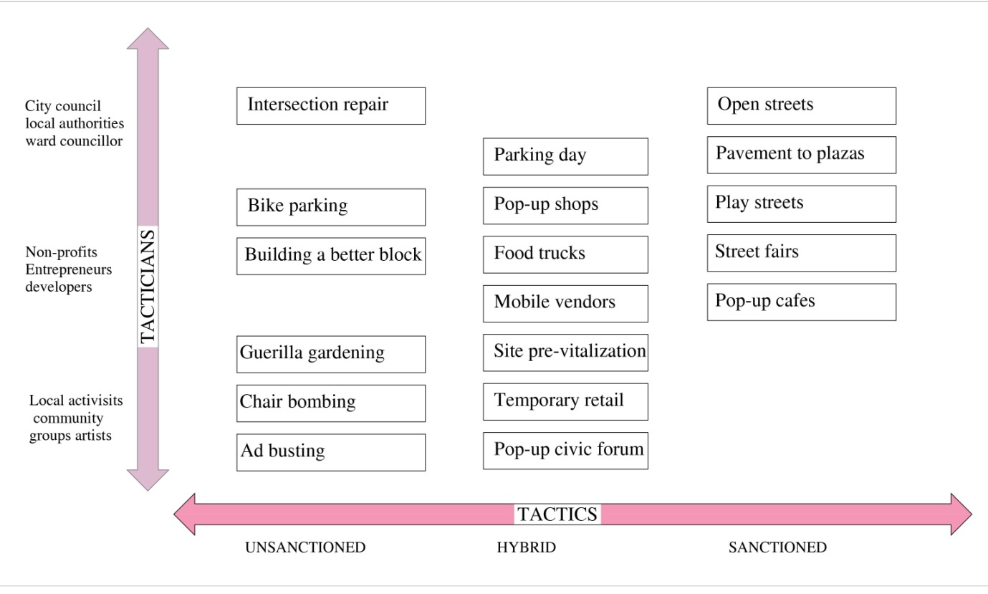

Ideas for a project in tactical urbanism
There are various considerations that must be made in order for a project to be successful and granted approval by local authorities for long-term transformation. Recently, TU has gained acceptance as a recognised framework with several.

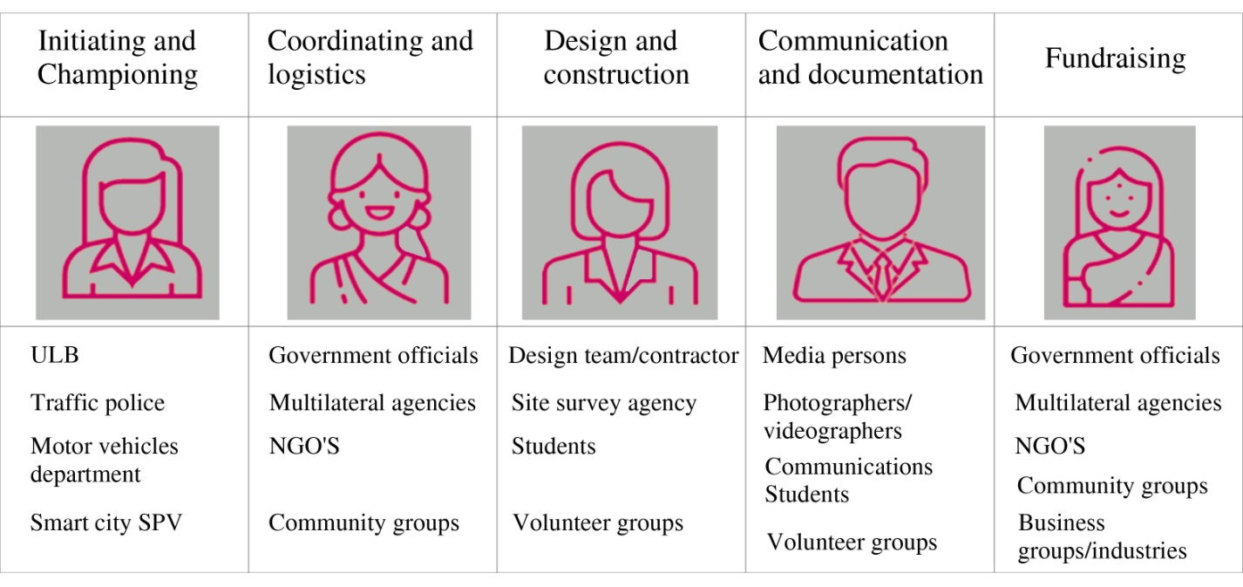

WHAT ARE THE PERKS AND LIMITATIONS OF IT?
Tactical urbanism may be used in a variety of intervention areas, including improving transit experiences, placemaking, navigation, and the mobility of people on foot and by bicycle.
As a strategy, tactical urbanism offers a number of advantages, including but not limited to the following:
1. With a quick evaluation of the current issues, possibilities, and restrictions, it assists in a deeper knowledge of the user's needs at the site for intervention.
2. It is used to demonstrate the viability of a proposal before making significant financial commitments in a project. Conversely, if the tactical urbanism project has gotten favourable feedback after execution, it also helps hasten project implementation knowing that there is a buy-in from all concerned parties.
3. Quickly addressing user experience issues in our streets with affordable solutions is helpful.
4. It promotes collaboration among citizens, non-profits, small enterprises, and governmental organisations while encouraging innovative system use. By giving the chance for more fruitful dialogues with residents, this aids in expanding public participation.
However, there are certain restrictions, and the following are some issues that initiatives focused on tactical urbanism can only partially solve:
• Absence of services, such as sewage lines, storm water lines, or other street infrastructure.
• Bad road conditions, such as water logging, uneven street levels, and broken or incomplete roadways.
CASE STUDY-
One: Choose places with high human traffic; loops are also preferred because they will see more foot traffic and are a part of a bigger network.
Two: Mixed-use streets are ideal for testing the intervention during the experiment.
Three: If there are senior citizens and kids who can be involved in the process, they can act as unofficial watchmen over the public area.

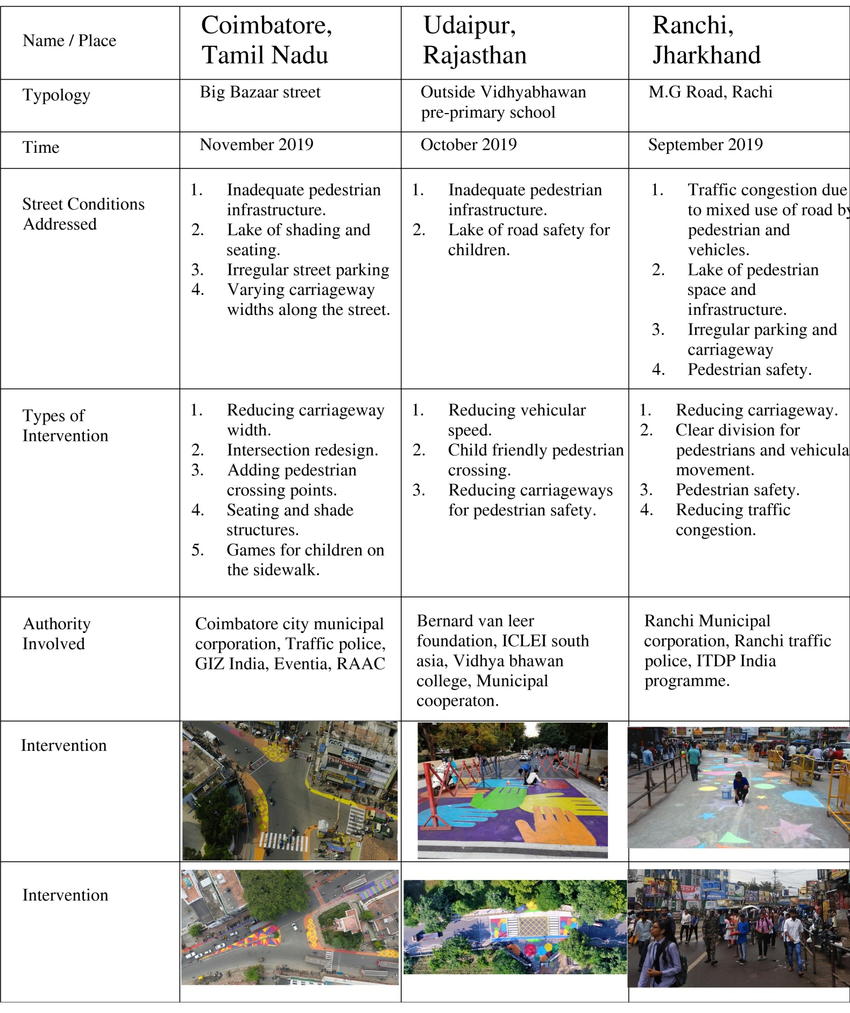
COMPARITIVE ANALYSIS MATRIX

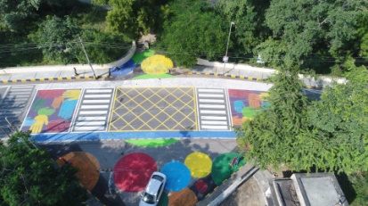

ACTION IN THE SHORT TERM TOWARDS LONG TERM CHANGE-
Each tactical urbanism project must be a contextually innovative solution to particular concerns on a street in a neighbourhood in order to be successful since they work as a catalyst for change that must eventually be made permanent. Cities must accept that long-term improvement in the livability of their public spaces requires persistent involvement.
CHALLENGES
- One typical pitfall that these projects frequently commit is to solely cosmetic improvement of the chosen property. If a TU project's utility is simply surface-level, it will fail.
- Another enormous job is persuading the public of the necessity of such an intervention and the effects it will have on their everyday lives. For others to completely understand the potential of the concept, this must be presented in the appropriate manner.
- The final obstacle is formalising the intervention with the assistance of the pertinent parties. It frequently takes a long time to close gaps and communicate with numerous authorities in order to receive permits and authorization. To build anything in a neighbourhood, one must be well-versed in the regional rules governing construction and transportation. If there are no established requirements or regulations, this may be difficult.
- If the intervention is not continued or is stopped after the testing phase, it might be embarrassing. Each project should include measures for assessing user reactions and post-implementation surveys. Transfer of ownership is also necessary to avoid abuse or deterioration of the tactical plug-in.
- Constant participation is necessary to provide individuals with the resources to maintain their social infrastructure. Since that behavioural change sometimes necessitates longer periods of engagement, this proves challenging to accomplish.

Recommendations
On the basis of the knowledge gained from this study, the following recommendations may be made:
• Since TU is highly contextual and site-specific, the government need to support projects that bring together local communities and designers to develop locally tailored solutions to locally tailored challenges.
•The processes for receiving approvals and fines from the relevant authorities for TU projects should be swift and simple.
• Using TU as a technique should be done with a long-term, permanent aim in mind. TU is only a way to achieve a design goal by exploring and testing various approaches with participants; the interventions used in this process are not ends in and of themselves.
• There is frequently a noticeable gap in stakeholders' participation. Those who support bike lanes and pedestrian-friendly streets typically come from wealthier origins and have access to vehicles and two-wheelers. Regrettably, the discussion frequently excludes a sizable portion of the population that really needs the bike lanes and pedestrian routes. All engagement platforms have to be inclusive and accessible because of this.
The following are some strategies that may be used for inclusive stakeholder management:
• During project planning, identifying and categorising stakeholders based on their demographics; identified stakeholders can then be contacted to see whether any other stakeholders were unintentionally left out.
• In-person encounters, such as interviews, focus group discussions, presentations, events, etc., are more important than social media campaigns for obtaining inclusive, actionable feedback.
• It is important to make conscious efforts to overcome linguistic and socioeconomic divides by holding meetings at locations that are convenient for all parties involved.
• After implementation, social, environmental, and project impact analyses should be performed to determine a TU intervention's genuine value before it is scaled up.
• Citizen participation is the best strategy for maintaining TU. As a result of being ingrained in empowering and involved communities, stronger and more responsible local institutions are best positioned to enable TU.
• Toolkits may be created to facilitate interactions between citizens, elected officials, and policymakers, and knowledge-exchange meetings can be used to scale up TU.
• Policymakers are encouraged to utilise TU as a design technique since it is a cheap, brief, and evidence-based experiment. In order to save time and resources, it is only sensible for policymakers, designers, and planners to choose TU.
Conclusion:
Tactical urbanism has, to date, been a significant factor in the implementation of non-motorized transportation options in many Indian neighbourhoods. Cost effectiveness, quick project turnaround times, long-term effects, and community engagement are the major drivers of its success. Since TU initiatives increase community ownership of public areas by enhancing involvement in design and decision-making, the government should support them.

