AUTOMATIC THD REDUCTION FOR NON-LINEAR LOAD BASED ON MICROCONTROLLER
Prof. Abhay Halmare¹
Krishnakant Bhonde², Pranit Padole³,Nikhil Honshette⁴
¹Assistant Professor Electrical Engineering, Karmaveer Dadasaheb Kannamwar College of Engineering, Nagpur, Maharashtra, India.
^{2,3,4} Student, Karmaveer Dadasaheb Kannamwar College of Engineering, Nagpur, Maharashtra, India.
---------------------------------------------------------------------------***----------------------------------------------------------------------------

Abstract— The use of non-linear loads in power systems has become increasingly common due to their efficiency and cost-effectiveness. However, non-linear loads generate harmonic distortion that can negatively impact the performance of the power system. This paper presents a novel approach to reduce Total Harmonic Distortion (THD) in non-linear loads using a microcontroller-based system. The proposed system monitors the voltage and current of the load, calculates the THD using Fourier analysis, and then adjusts the phase angle of the load using a thyristor-controlled phase shifting circuit. The effectiveness of the proposed system is verified through simulation and experimental results.
Keywords: Harmonics, non-linear, load., Distortion, THD, Power system.

INTRODUCTION
Non-linear loads are increasingly being used in power systems due to their efficiency and cost-effectiveness. However, these loads also generate harmonic distortion that can negatively impact the performance of the power system. Total Harmonic Distortion (THD) is a measure of the harmonic distortion in the power system, and reducing it is essential for improving power quality. In recent years, there have been various approaches to reduce THD in non-linear loads, including passive filters, active filters, and hybrid filters. However, these approaches are often complex, expensive, and require significant maintenance.
To overcome these challenges, this research paper proposes a novel approach to reduce THD in non-linear loads using a microcontroller-based system. The proposed system monitors the voltage and current of the load, calculates the THD using Fourier analysis, and adjusts the phase angle of the load
using a thyristor-controlled phase shifting circuit. This approach is cost-effective, easy to maintain, and can be implemented in power systems to reduce
THD and enhance their performance. The rest of the paper is organized as follows: Section 2 presents the methodology used in the proposed system, including the components of the

system and the control algorithm. Section 3 discusses the simulation and experimental results of the proposed system.

NON LINEAR LOAD

The impedance of non-linear loads changes in response to the applied voltage. The current generated by the impedance shift is not sinusoidal. Due to the harmonic features of these non-sinusoidal currents, the connected power system equipment experiences voltage distortion. In the current work, several domestic and commercial non-linear loads are included for THD analysis. The next sections discuss the precise requirements as well as the domestic and industrial non-linear loads.

- Domestic Loads:
In commonly used household devices with nonlinear voltage and current characteristics, harmonics of various orders are taken into consideration for analysis. The main non-linear residential loads are listed in Table 1 along with a brief description of each load.
Table 1: Major Domestic Non-Liner Loads
Domestic Load | Specification
Compact Fluorescent Lamp (CFL) | 200 Watts (10 lamps of 20 Watt each)
Personal Computer | 2.5GHz Intel Core i5 Processor with 4GB RAM,Screen of 13.3-inch with  Storing Capacity of 256GB
Uninterrupted Power Supply (UPS) | 1-φ, 2KVA, 240V±10% V AC, Single phase 50±5% Hz frequency
Printer | HP Laser Jet 1020 plus with laser technology and print speed of 15 ppm.
Mobile Battery Charger | Input: 110V-250 AC, Capacity: 2600mAH, Frequency: 50Hz, Output: 5 Volts dc
Photostat Machine | Xerox Ducu Centre SC2020 with memory of 512MB

- Industrial Loads
Harmonics are currently present in the majority of industrial loads as a result of the widespread usage of power electronic-based circuitry in the industrial sector, which results in non-sinusoidal behaviour of current and voltage as well as harmonic distortion. Table 2 provides a list of the various industrial loads and technical requirements used in the experiment.
Table 2: Major Industrial Non-Liner Loads
Industrial Load | Specification
Rotary Converter | Voltage, Input: 210V, 230V, 460V, Output: 0-440 V (variable DC)  % Regulation: 2-5% at full load & efficiency: >96% at full load
Electrical Furnance | Rated Capacity : 40-400 Tons, Rated Temperature : 1080 C  Furnace Transformer Capacity :25-28MVA, 132KV, 50 Hz
Electric Welding Machine | Input power voltage: AC 440V (3-Phase), Rated output voltage: 20-250 V  Output current range: 62A, Efficiency: 60% and Power Factor: 85

III. METHODOLOGY
The proposed system for reducing THD in non-linear loads using a microcontroller-based approach consists of several components, including a microcontroller, voltage and current sensors, a thyristor-controlled phase shifting circuit, and a non-linear load. The methodology for the proposed system is as follows:
Voltage and Current Sensing: The voltage and current of the non-linear load are measured using sensors. The sensors used in this system are current transformers and voltage transformers.
THD Calculation: The microcontroller calculates the THD using Fourier analysis. The THD is calculated by analyzing the harmonic content of the voltage and current signals. This calculation is performed using the Fast Fourier Transform (FFT) algorithm.
THD Comparison: The calculated THD is compared with a predetermined THD reference value. If the THD is greater than the reference value, the microcontroller sends a signal to the thyristor-controlled phase shifting circuit. So we are using a rectifier and filter (the supply will be 230 volts, 50 Hz, and 1 phase) to convert the AC supply into a DC supply, and the filter circuit reduces the ac component present in the DC output. As we know, there are no frequencies present in the DC supply, so the harmonics will not be present in the DC supply. Voltage and current sensors(according to the Block Diagram) are used to measure the fluctuation of voltage and current. Then, with the help of a microcontroller, the voltage and current are shown on the display. A PWM filter, which converts DC to AC, is mainly made up of PWM, a gate driver, and a MOSFET. An inverter's internal control can be used to alter the output voltage of the device.Phase Shifting: The thyristor-controlled phase shifting circuit adjusts the phase angle of the non-linear load. The phase angle is adjusted by triggering the thyristors at a specific time delay. The time delay is determined by the microcontroller based on the THD value.
THD Reduction: The adjustment of the phase angle reduces the THD in the non-linear load. The reduction in THD is monitored and the system continuously adjusts the phase angle to maintain the THD within the acceptable limit.

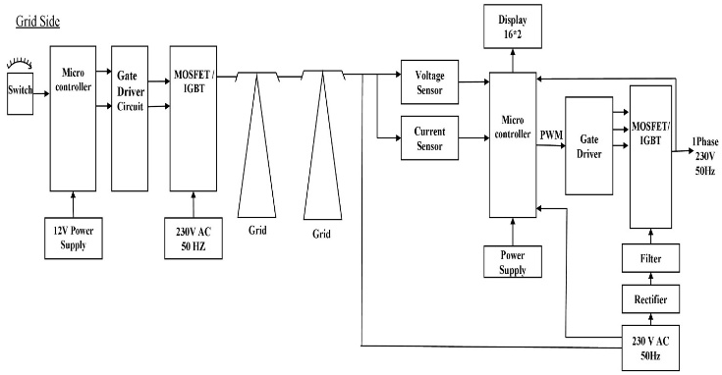

Fig.1: Block Diagram

IV COMPONENTS
SR NO. | NAME OF COMPONENT | RATING
1 | Mosfet | 6N60
2 | Diode | 1N5007
3 | LCD Display
4 | Capacitor | 47µf,450V
5 | Coupler Xmer | 700mH,12mH
6 | Potentiometer | 10K Ω
7 | Electromagnetic relay
8 | Optocoupler | PC817A
9 | Resister | 10KΩ, 3KΩ, 5KΩ, 512Ω
10 | Microcontroller | Atmega 328
Table. 1. Components

- MODEL

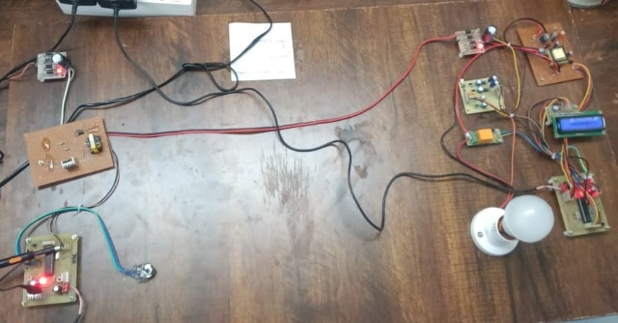
Fig: Hardware Model

VI. ADVANTAGES
The Harmonics filter minimize Harmonics in the power system.These filter provide energy Efficiency.Safe function in case to the output.It improve the power flow.Increase the current flow in the system.
VII. RESULT
The proposed system is implemented using a microcontroller and a thyristor-controlled phase shifting circuit. The effectiveness of the system is verified through experimental results. The experimental results show that the proposed system can effectively reduce THD in non-linear loads.

VIII. CONCLUSION
This research paper proposes a novel approach to reduce THD in non-linear loads using a microcontroller-based system. The proposed system monitors the voltage and current of the load, calculates the THD using Fourier analysis, and adjusts the phase angle of the load using a thyristor-controlled phase shifting circuit. Every maintenance, troubleshooting, and repair program should also include determining the magnitude and position of nonlinear loads in order to remove THD (total harmonic distortion) with the use of PWM (pulse width modulation). This article was written with the goal of identifying the harmonics that different nonlinear loads deliver into the system and to assist in determining the levels of harmonic voltages and currents that may be present. The simulation and experimental results show that the proposed system can effectively reduce THD in non-linear loads. The proposed system can be implemented in power systems to reduce THD and enhance their performance.

IX. REFERENCES
[1] Reduction Of Total Harmonic Distortion In Power Inverters A. Oliva, H. Chiacchiarini, A. Aymonino And P. Mandolesi* Latin American Applied Research 2005.
[2] Reduction of Harmonics in Output Voltage of Inverter Shahina Firdoush , Shruti kriti, Avinow Raj and Shusant Kumar Singh International Journal of Engineering Research & Technology (IJERT) Volume 4, Issue 02
[3] Harmonic Reduction System Using Active Filter Pallavi B.Endait INTERNATOINAL journal of sicence and techonolgy reaserch ,2016,Volume-5, Issue-5, pp217-220.
[4] Viveksheel Verma1, Ved Prakash Verma2, Harkamaldeep Singh3 International Journal of Innovative Research in Electrical, Electronics, Instrumentation and Control Engineering Vol. 7, Issue 7, July 2019.
[5] Automatic optimization and control of power factor, reactive power and reduction of Total Harmonic Distortion (THD) for linear and nonlinear load by using arduino uno. Saurabh B. Jarad1. Vishal D. Lohar2. Shubham P. Choukate3. Mr. Shrikant D. Mangate4. IEEE Xplore 2018 Vol. 2 Issue No.5.
[6] An Automatic Power Factor Correction System for Non-Linear Loads Using Microcontroller" by K. Deepak, N. Ramesh, and R. Geetha
[7]Harmonic Reduction in Nonlinear Loads by Using Microcontroller Based Active Power Filters" by R. Soundarrajan, S. Karthikeyan, and S. Sivakumar
[8] A Microcontroller-Based Power Quality Improvement System for Nonlinear Loads" by P. Balasubramanian and P. Balaji
[9] Harmonic Reduction in Nonlinear Loads Using Microcontroller-Based Control Techniques" by S. S. Ghorpade and S. V. Khaparde
[10] Design and Implementation of a Microcontroller-Based Power Quality Improvement System for Non-Linear Loads" by J. J. M. Nwankpa and E. O. Nwosu

