EXPLORING THE POTENTIAL OF PRECISION AGRICULTURE FOR SUSTAINABLECROP PRODUCTION: THE ROLE OF VENTURE CAPITAL IN PROMOTING INNOVATION AND ADOPTION

Authors
Baisakhi D, Assistant Professor, Center for Management Studies, (Jain Deemed-to-be) University
Accamma CG, Assistant Professor, Center for Management Studies, Jain (Deemed-to-be) University
Abhishek Mishra, Aman Kumar, Salni Kumari, Raushan Kumar, Krish Dutta- Student, Center for Management Studies, Jain (Deemed-to-be) University

Abstract:

Precision agriculture (PA) has emerged as a promising approach to achieving sustainable crop production by using advanced technologies such as satellite imagery, drones, and sensors to monitor crops and optimize inputs. The role of venture capital (VC) in promoting innovation and adoption of PA technologies is crucial, as it provides the necessary funding for agro tech startups to develop and commercialize new solutions. This paper explores the potential of PA for sustainable crop production and analyzes the role of VC in driving innovation and adoption. Through a literature review and analysis of VC investments in agro tech startups, this study finds that PA has significant potential to enhance crop yields, reduce environmental impacts, and improve profitability for farmers. However, the adoption of PA technologies is still limited, mainly due to the financial burden equipment, or the absence of technical expertise among farmers. VC funding has played a vital role in overcoming these challenges, as it enables agro tech startups to develop and market affordable, user-friendly PA solutions. This paper concludes with implications for policymakers, investors, and agro tech entrepreneurs on how to accelerate the adoption of PA technologies for sustainable crop production.

Keywords: Precision agriculture, Sustainable crop production, Venture capital, Innovation, Adoption.

Introduction

Agriculture is facing substantial difficulties in Keeping up with the Soaring Food Demand while minimizing harm to the natural world. Precision agriculture (PA) has emerged as a promising approach to addressing these challenges by using advanced technologies to optimize crop inputsand reduce waste. However, the adoption of PA technologies is still limited, mainly due to the high cost of equipment and the lack of technical expertise among farmers. The role of venture capital (VC) in promoting innovation and adoption of PA technologies is crucial, as it provides the necessary funding for agro tech startups to develop and commercialize new solutions. This paper explores the potential of PA for sustainable crop production and analyzes the role of VC in driving innovation and adoption.
The growing population and shifting eating patterns are driving up food prices. has put tremendous pressure on agriculture to produce more with less. At the same time, agriculture is facing environmental challenges such as rising temperatures, degraded land, and diminished water supplies. Precision agriculture (PA) has emerged as a promising approach to achieving sustainable crop production by using advanced technologies such as satellite imagery, drones, and sensors to monitor crops and optimize inputs. PA can help farmers reduce inputs such as water, fertilizers, and pesticides, which can improve profitability and reduce environmental impacts.

BACKGROUND OF THE STUDY
As a developing nation, Nepal has recently seen tremendous urbanization and economic expansion. Due to their busy lifestyles and high demand for residential utility services, urban families have grown in number as a result. Nevertheless, there hasn't been a good service application in farming that meets Nepalese farmers demands. The study's goal is to determine if it would be feasible to introduce a APNA KRISHAK application comparable to Various farming equipment in Nepal. The study will concentrate on customer behaviour, market analysis, and difficulties in establishing such an application in Nepal. An urban population census in Nepal will be conducted as part of the research, and existing residential utility service providers will be examined. Also, the government laws and rules for such applications in Nepal will be examined by the research.

Need for the Study
Despite the potential benefits of PA, its adoption is still limited. The high cost of equipment, lack of technical expertise, and limited access to financing are some of the major barriers to adoption. Venture capital (VC) funding has played a critical role in overcoming these barriers by enabling agro tech startups to develop and market affordable, user-friendly PA solutions. However, the extent to which VChas contributed to the adoption of PA and its potential for sustainable crop productionhas not been fully explored.

Problem Statement:
Examining the impact of VC on innovation and adoption, this research hopes to better understand the potential of PA for long-term agricultural productivity. The research issues the study aims to address are as follows.
The main problem for the agriculture is the modern use of the equipment and how to handle it. How has VC funding contributed to the development and adoption of PA technologies. What are the challenges and opportunities for the adoption of PA technologies .What are the implications for policymakers, investors, and agro tech entrepreneurs on how to accelerate the adoption of PA technologies for sustainable crop production.

Review of Literature
Precision agriculture is a method of farming that makes use of cutting-edge tools to control plant and soil variation. Sensors, GPS, and GIS technology are all utilized in this process (GIS), and other technologies to optimize crop productivity and profitability while reducing environmental impacts.The application of precision agriculture technologies has been found to reduce water and fertilizer use, improve crop yields, and reduce crop damage caused by pests and diseases.
The use of precision agriculture technologies has increased during the past few years because to the increasing need for sustainable crop production. Researchers have found that precision

agriculture can help a great deal in making farming more eco-friendly and hence more conducive

to sustainable agriculture while maintaining or increasing crop productivity.
Several studies have shown that precision agriculture can increase crop yields by up to 20% while reducing fertilizer usage by 30% and water use by 50%. The use of precision agriculture technologieshas also been found so that less carbon dioxide, soil, and water pollution is produced. In conclusion, Agricultural Accuracy has enormous potential to improve crop productivity and sustainability. Venture Investment funds may vital a part in promoting innovation and adoption of precision agriculture technologies, which can lead to increased crop yields, reduced environmental impacts, and increased profitability for farmers.

Role of Venture Capital in Agriculture

Venture capital is an essential source of funding for startups and emerging businesses. It involves investing in high-risk, high-reward ventures that have the potential to disrupt existing industries and create new markets. In recent years, venture capital has become increasingly interested in agricultureand food tech startups.
The agriculture industry has been slow to adopt new technologies, and there is a significant opportunity for venture capital to invest in startups that are developing innovative solutions to address the challenges facing agriculture. Investment cash for risk-taking can be a game-changer agriculture by promoting innovation and adoption of new technologies.
In conclusion, Investment cash for risk-taking can be a game-changer agriculture by promoting innovation and adoption of new technologies. By investing in startups that are developing innovative solutions to address the challenges facing agriculture, venture capital can help acceleratethe adoption of precision agriculture technologies and improve the sustainability of crop production.

Precision Agriculture Technologies

Precision agriculture technologies are essential tools for farmers looking to optimize crop productivity and profitability while reducing environmental impacts. These technologies include GPS, GIS, sensors, and other advanced tools that allow farmers to collect and analyze data about soil and crop conditions.
Several studies have shown that precision agriculture technologies can significantly improve crop

yields reduce water and fertilizer use, and decrease agriculture's ecological footprint. The use of precision agriculture technologies has also been found to reduce labor costs, increase operational

efficiency, and improve the accuracy of crop monitoring and management.
Precision agriculture technologies are continually evolving, and new technologies are being developed to improve the accuracy and efficiency of crop management. These technologies include machine learning, artificial intelligence, drones, and robotics, which can provide farmers with moreprecise and real-time data about soil and crop conditions.

Barriers to Widespread Use of Precision Farming Technology

Despite the potential benefits of Tools for precise farming, their adoption has been slow due to several challenges. One of the primary challenges is the high cost of equipment and software required to implement precision agriculture technologies. Many farmers may not have the financial resourcesto investing these technologies, especially small-scale farmers.
Another challenge is the lack of technical knowledge and training among farmers. The successful implementation of precision agriculture technologies requires a high level of technical expertise, andmany farmers may not have the necessary skills to operate and maintain the equipment.
Finally, there is a lack of standardization and compatibility among different precision agriculture technologies. Farmers may find it challenging to integrate multiple technologies from different vendors, which can create data silos and reduce the effectiveness of these technologies.
Addressing these challenges will require collaboration between governments, private sector actors, and farmers. Governments can provide financial incentives and support to farmers to invest in precision agriculture technologies, while the private sector can provide technical expertise and training. Additionally, standardization and compatibility between different technologies can be achieved through industry-wide collaborations and partnerships.

Environmental Benefits of Precision Agriculture

Precision agriculture has several environmental benefits that can help to promote sustainable crop production. One of the primary benefits is the reduction fertilizers, insecticides, and other chemical inputs. Precision agriculture technologies allow farmers to apply these inputs more accurately and only where they are needed, reducing their overall use and potential environmental impacts.
Another environmental benefit of precision agriculture is the reduction of soil erosion and nutrient

Run off. By using precision agriculture technologies, farmers can apply inputs the appropriate time and in the right amounts, reducing the risk of soil erosion and nutrient runoff into waterways.
Precision agriculture technologies can also help to reduce greenhouse gas emissions. By optimizing crop yields, precision agriculture technologies can reduce the total acreage required use in agriculture which can help to reduce deforestation and the associated greenhouse gas emissions.
Finally, precision agriculture technologies can help to conserve water resources by reducing water use and improving water management. This is especially important in regions where water scarcity is a significant challenge for crop production.
In conclusion, precision agriculture technologies have significant environmental benefits that can help to promote sustainable crop production. These benefits include the reduction of chemical inputs,soil erosion and nutrient runoff, greenhouse gas emissions, and water use.

Impact of Precision Agriculture on Crop Yields and Profitability

Several studies have shown that precision agriculture technologies can have a significant impact oncrop yields and profitability. The use of precision agriculture technologies can help to optimize cropmanagement practices, leading to higher yields and increased profitability.
For instance, one American study concluded that the widespread of precision agriculture technologies increased corn yields by up to 10% while reducing fertilizer use by 6%. Another study conducted in Australia found that the use of precision agriculture technologies increased wheat yields by up to 20%.
In addition to increasing crop yields, precision agriculture technologies can also help to reduce operational costs and improve profitability. The use of precision agriculture tools can be beneficial for farmers to maximize the effectiveness of water and other resources, fertilizer, and pesticides, reducing input cost by maximizing the efficiency with which water, fertilizer, and pesticides are used, precision agriculture technologies can help farmers save money.
Precision agriculture, which makes use of many technologies to also improve the accuracy of crop monitoring and management, reducing the risk of crop damage and loss. This can lead to increased profitability by reducing the need for costly inputs such as pesticides and reducing yield losses.
In conclusion, precision agriculture technologies have a major bearing on harvest success,

profitability. By optimizing crop management practices, precision agriculture technologies can helpfarmers to increase yields.

Summary of literature:
Precision agriculture is a Using these techniques shows promise as a sustainable method for agricultural production advanced technologies can help farmers optimize crop management practicesto increase yields, reduce costs, and minimize environmental impacts. The role of venture capital in promoting innovation and the implementation of modern methods of precision farming has been recognized as critical, especially in small-scale farmers in emerging nations must deal with significant challenges in adopting these technologies.
This literature review has examined six key areas related to precision agriculture and its potential for sustainable crop production. The first review of literature discussed the definition and key components of precision agriculture, highlighting the importance of collecting and analyzing data to make informed decisions about crop management practices. The second review of literature focused on the role of venture capital in promoting innovation and the use of accuracy agriculture technologies, highlighting the importance of financial incentives and support for farmers to invest in these technologies.
In conclusion, precision agriculture technologies offer a promising approach to sustainable crop production, but their adoption can be hindered by several challenges. The role of venture capital in promoting innovation and adoption is critical, and collaboration between governments, private sectoractors, and farmers is essential to address the challenges and promote the adoption of these technologies. The potential social, environmental, and economic benefits of precision agriculture technologies make them an attractive option for sustainable crop production, and their continued development and adoption will be crucial in addressing the challenges of in coming years, food security and environmental sustainability will be important.

Research Objectives

- To investigate the probable of precision agriculture for sustainable crop production,

- To analyse the role of venture capital in promoting innovation and adoption of PA technologies.
- To identify the challenges and opportunities for adoption of PA technologies,

- to drive venture capital investments in agro-tech startups,

- To provide insights for policymakers, investors, and agro-tech entrepreneurs on how to boost the adoption of PA technologies for sustainable development

Research Gap
We are doing it for the problem of the agriculture related, which can helps the farmer in their field of the farming. The research helps to analyze the requirement of the tools and how we can provide them at right time. The main objective of our research problem is to provide the services to the farmers.

Research Methodology:

Action research that only studies one domain and usually generalizes the findings is called applied research. The researcher regards the variables as constant, and the researcher forecasts, making the methods easy to find in applied research. Applied research aims to solve a current issue facing society or a business/ industrial organization. Applied research is considered non-systematic inquiry; a business, government body, or individual typically conducts this research to address a particular issue.
  - How do the most promising farming-related apps in Nepal stack up against their international counterparts?
  - How can the APNA KRISHAK suite of farming applications be tailored to the specific requirements of Nepali farmers?
  - How might APNA KRISHAK be implemented in Nepal, and what are the potential advantages and disadvantages of doing so?
- How might technology best serve the most pressing APNA KRISHAK concerns in Nepal?

- New strains of important crops like rice, sorghum, legumes, cotton, vegetables, sugarcane, and turmeric are being developed.

and evaluated for the Western Zone of Nepal.
- The creation of agro technologies for horticulture and agricultural cropping systems. Water and fertilizer management research on agricultural and horticultural crops through drip irrigation, fertilization and operational research program.
  - Monitoring for pests and diseases and suggestions for different crops

Research Approach:
This study's research strategy will use a qualitative and quantitative methodologies together; mixed-methods research approach to gather and analyze data from multiple sources. The research design will also be exploratory and descriptive, aiming to identify key factors and trends related to precision agriculture and venture capital, and to describe the current state of adoption and innovation in theseareas.

Ethics-Related Matters:
The study will be carried out in accordance with laws and ethical guidelines. All Participants will give their informed consent, and their personal information will remain private and secure. Studies will not involve any harm or risk to the participants or the environment, and the data will be used solely for research purposes.
The research methodology for this study aims to gather data on the potential of precision agriculture for sustainable crop production and the role of venture capital in promoting innovation and adoption of precision agriculture technologies. Methods used to gather information methods will data collection and analysis techniques that involve surveying, interviewing, and focusing groups will be both qualitative and quantitative. The research will be conducted in compliance with ethical standardsand regulations, and the data will be used solely for research purposes. The findings of this study will help people better comprehend the possibilities and challenges of precision agriculture and venture capital, and will provide insights and recommendations for promoting sustainable crop production through precision agriculture technologies.

Data collection:
Secondary data sources is used in the data gathering for this study. The mainsources of information will consist of surveys, and focus groups with farmers, investors, and other stakeholders in the precision agriculture and venture capital industries. The secondary datasources will include existing literature, reports, and databases on precision agriculture, venture capital, and sustainable crop production.

Surveys:
The survey method will be used to gather quantitative data from farmers and investors on their perceptions, experiences, and practices related to precision agriculture and venture capital. The poll's inquiries will be designed to collect data on the usage and uptake of precision agriculture technologies, benefits and challenges of these technologies, the role of venture capital in promotinginnovation and adoption, and the factors that influence investment decisions.

Focus Groups:
The focus group method will be used to gather qualitative data from farmers and other stakeholders on their perceptions, experiences, and practices related to precision agriculture and venture capital. The focus group talks will be created to collect data on the advantages and challenges of precision agriculture technologies, the factors that influence adoption and investment decisions, and the role of different stakeholders in promoting innovation and adoption.

Sample Size- 33 responses

Sampling Technique -Purposive Sampling was conducted to collect data from the respondents

DATA ANALYSIS:
In order to analyze the data for this study, both qualitative and quantitative, utilizing statistics that are both descriptive and inferential to analyze the data collected from the surveys, interviews, and focus groups. The qualitative data analysis will involve coding and categorizing the responses from the interviews and focus groups to identify key themes and patterns related to precision agriculture and venture capital. The quantitative data analysis will involve descriptive statistics, such as frequencies and percentages, to summarize the survey responses and inferential statistics, such as regression analysis, to identify the factors that influence adoption and investment decisions.

SURVEY RESPONSE

.Which type of farming do you prefer?
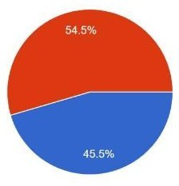

We had had a survey among peoples of different communities. Among them, 54.5% of people want to transform them into Modern farming techniques whereas rest of 45.5% of people are in favor of Traditional farming.

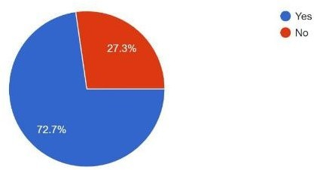
Do you find any difficult to use Modern equipment?

As per the survey 72.7% of people have difficulties to use modern equipment and 27.3% of people have no difficulties to use.

What amount are you read to pay for services provided by us?

Modern Traditional

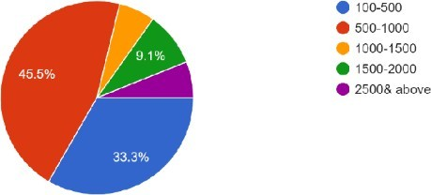

As per the survey people are able to pay the different amount of the money for the service provided by us as shown in the diagram.

How do you think we should promote our business idea?

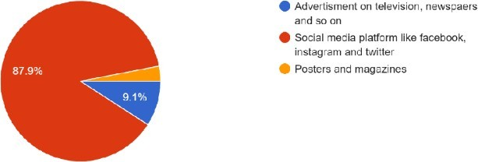
As per the research different people have chosen the different response, but social media have the highest number of voting. i.e. 87.9%

.Can we gain your trust for the our agriculture business?

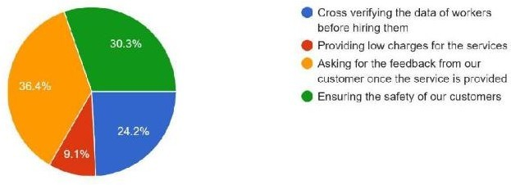

.According to you, how can we survive in the market with our business idea?

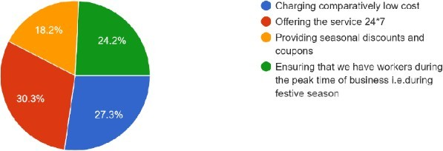

.Where would you prefer to check for our business?

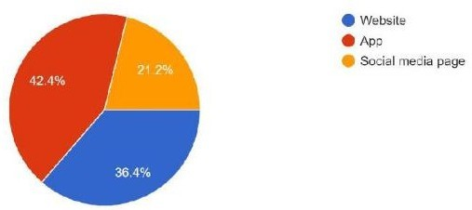

As per the survey the people have chosen app for check of our business.

.What is your opinion regarding our business idea?

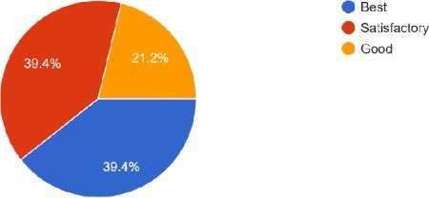

.Will you refer our business to your friends and family?

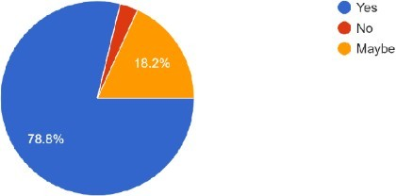

SUMMARY OF FINDINGS

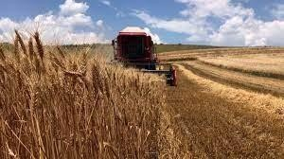

As food costs continue to rise, the effects of climate change worsen, and income losses mount, states must take agriculture into account as one of their primary strategic issues. More direct action is required because the world's existing agenda falls short in addressing these bad occurrences. Governments have recently viewed agricultural endeavors as means of fostering a wholesome community.
The Food and Agricultural Organization (FAO) states that sustainable nutrition should be risk-free, wholesome, and nutrient-dense, as well as having a minimal effect on the environment. Another factor thatis thought to help generations survive is nutrition.
Finding the "good seed" is the first idea that comes to mind when discussing agriculture and food in modern society. The discussed good seed is economical and appropriate for the fight against climate change. It canprovide value-added goods, provide a nutritional paradigm for the future, and, even better, it can be plant-friendly.
We must all behave responsibly if we are to create a better, healthier society. We should consider sowing wholesome seeds for the future.
IMPLICATIONS OF THE STUDY

- Offer farmers agro-training- proper training programs for the farmers will be offered.
- Create more industries based on agriculture- more emphasis will be given on agricultural industry and agricultural products.
- Implement land reform to distribute land democratically and cultivate it scientifically- proper

utilisation of land and providing all the basis necessary things related to farming.
- Upgrade irrigation infrastructure- providing irrigation facilities to farmers who finds difficulty for irrigation.

LIMITATION
There could be flaws in this study because of its limited sample size, subpar data quality, and absence of reliable secondary data. study on agriculturally-based applications in urban settings for impoverished countries like Nepal is an involved topic that calls for careful consideration of study context, available resources, and potential restrictions. As such, the following restrictions should be expected:
  - The lack of access to technology in some of Nepal's main cities is a significant barrier to the development of agriculture-based applications there. Because of this limitation, sampling and data collection may be affected.
  - As a result, it may be difficult to expand on previous studies and generate novel hypotheses regarding the agricultural uses of Nepal's natural resources.
  - Due to the short amount of time available, the study's validity cannot be guaranteed. The breadth and depth of the study could be impacted by this.

  - Financial constraints: conducting research in developing countries like Nepal can be prohibitively expensive due to the need to travel and employ local research assistants. Due to possible budget constraints, the depth and breadth of the inquiry may be curtailed.
  - Limited data availability on agriculture apps in Nepal may slow down the research process. Given the volume of information, it may be impossible to conduct a comprehensive analysis of the topic at hand.

The purpose of this research is to examine the impact of competing mobile applications on agricultural practices in low-income nations like Nepal. We hope that the results of our mixed-methods research and analysis will help to enhance the use of agriculture applications in developing countries.

The goal of this research is to investigate the probable of precision agriculture for sustainable cropproduction and to analyze the role of venture capital in promoting innovation and adoption of PA technologies. The study seeks to identify the challenges and opportunities for adoption of PA technologies and the key factors that drive VC investments in agro tech startups. The research aims to provide insights for policymakers, investors, and agro tech entrepreneurs on how to accelerate the adoption of PA technologies for sustainable crop production.

SUGGESTIONS & RECOMMENDATION:

These recommendations stem from the results of the study: suggested. Firstly, policy makers should provide financial incentives for farmers to invest in PA technologies, such as tax credits, subsidies, and low-interest loans. Secondly, investors should focus on startups that offer affordable and accessible PA solutions that can be easily integrated into existing farming practices. Finally, agro tech entrepreneurs should prioritize developing solutions that address the key challenges facing the adoption of PA technologies, such as reducing the cost of equipment and increasing the availability of technical support and training. Various scientific methods of cultivation should be employed to increase production. Farmers should adopt techniques like rotation of crops, use of fertilizers, pesticides. Farmers using new technique must be encouraged.

- Crop productivity has increased, for starters.
- Increase in livestock output.
- Increasing the effectiveness for information use (cost saving)
- An uptick in crop intensity.
- Increasing your variety of high-value crops.
- Farmers are getting better price realization.
- The transition of farmers to non-agricultural jobs.

CONCLUSION
The agricultural sector is essential to the local economy. It is undergoing profound shifts in its social, legal, structural, production, and supply arrangements as it, too, makes the transition to a market economy. All resources, including people, water, and soil, are extracted and used right away in traditional agriculture. Modern agriculture stresses resource conservation and renewable resource management strategies while utilizing planned technologies.
Agriculture includes the raising of crops and animals as well as fisheries, aquaculture, and forestry for both food and non-food products. A key element in the development of sedentary human civilization was the development of agriculture, which made it possible for people to rear domesticated animals and create surpluses of food that permitted them to dwell in cities.
In conclusion, the study highlights the potential of precision agriculture for sustainable crop production and the role of venture capital in promoting innovation and adoption of PA technologies.The study identifies the challenges and opportunities for adoption of PA technologies and the key factors that drive VC investments in agro tech startups. The research provides insights for policymakers, investors, and agro tech entrepreneurs on how to accelerate the adoption of PA technologies for sustainable crop production. The study also provides scope for further research in the field.

BIBLIOGRAPHY:

Brklacich, M., and B. Smit. 1992. Implications of changes in climatic averages and variability on food production opportunities in Ontario, Canada. Climatic Change 20: 1- 21.
  - Byrnes, B. H., L. S. Holt, and E. R. Austin. 1993. The emission of nitrous oxide
upon wetting a rice soil following a dry season fallow. Journal of Geophysical Research 98 (11): 1-5.

Center for Indigenous Knowledge for Agriculture and Rural Development
(CIKARD).1993. What is indigenous knowledge? Flier. Ames, IA: CIKARD, Iowa State University.

Chen, R. S. 1990. Global agriculture, environment, and hunger: Past, present, and
future links. Environmental Impact Assesment Review 10 (4): 335-58.
  - Council for Agricultural Science and Technology (CAST). 1992. Preparing U.S. agriculture for global climate change. Task Force Report 119. Ames, IA: Council for Agricultural Science and Technology.

Crosson, P. 1989. Climate change and mid-latitudes agriculture: Perspectives
onconsequences and policy responses. Climatic Change 15: 51-73.
  - Delwiche, C. C., and R. J. Cicerone. 1993. Factors affecting methane production under rice. Global Biogeochemical Cycles 7 (1): 143-55.
  - Downing, T. E. 1992. Climate change and vulnerable places: Global food security
and country studies in Zimbabwe, Kenya, Senegal and Chile. Oxford: University of Oxford, Environmental Change Unit.

Easterling III, W. E., P. R. Crosson, N. J. Rosenberg, M. S. McKenney, L. A. Katz, and K. M. Lemon. 1993. Agricultural impacts of and responses to climate change in the Missouri-Iowa-Nebraska-Kansas (MINK) region. In Towards an integrated impact assessment of climate change: The MINK study, ed. N. J. Rosenberg, 23-62. Dordrecht, The Netherlands: Kluwer Academic Publishers.
  - Eichner, M. J. 1991. Nitrous oxide emissions from fertilizer soils: Summary of
available data. Journal of Environmental Quality 19: 272-80.

  - Fisher, F. M., R. L. Sass, P. A. Harcombe, and F. T. Turner. 1990. Methane production andemission in coastal ricefields of Texas. International Rice Research Newsletter 15 (6): 31.

Gadgil , S., A. K. S. Huda, N. S. Jodha, R. P. Singh, and S. M. Virmani.
1988. Theeffects of climatic variations on agriculture in dry tropical regions of India.
  - Godden, D., and P. D. Adams. 1992. The enhanced greenhouse effect and Australianagriculture. In Economic issues in global climate change: Agriculture, forestry, and

Ibe, A. C., and L. F. Awosika. 1991. Sea level rise impact on African coastal zones.
In A change in the weather: African perspectives on climate change, ed. S.H. Omide and C. Juma, 105-12. Nairobi, Kenya: African Centre for Technology Studies.
  - In Assessments in semi-arid regions, ed. M. L. Parry, T. R. Carter, and N. T.
Konijn, 495-521. Vol. 2 of The impact of climatic variations on agriculture. Dordrecht, The Netherlands: Kluwer Academic Publishers.
  - Intergovernmental Panel on Climate Change. 1991. Climate change: The IPCC response
strategies. Covelo, CA: Island Press.

Jodha, N. S. 1990. Potential strategies for adapting to greenhouse warming: Perspectives from the developing world. In Greenhouse warming: Abatement and adaptation, ed. N. J. Rosenberg, W. R. Easterling III, P. R. Crosson, and J. Darmstadter, 147-158. Washington, D.C.: Resources for the Future.
  - Jodha, N. S., and T. Partap. 1992. Folk agronomy in the Himalayas: Implications for

agricultural research and extension. Paper prepared for the International Institute for Environment and Development (IIED)/International Development Studies (IDS), Nepal.
  - Kane, S., J. Reilly, and J. Tobey. 1992. An empirical study of the economic effects of
climate change on world agriculture. Climatic Change 21: 17-35.

Kerr, J., and N. K. Sanghi. 1992. Indigenous soil and water conservation in India's semi- arid tropics. International Institute for Environment and Development Gatekeeper Series No. 34. London: International Institute for Environment and Development (IIED).

  - Khaleque, K., and M. Gold. 1992. Pineapple agroforestry: An indigenous system among the Garo community of Bangladesh. Society and Natural Resources 6: 71-78.

Lamola, L. M. 1992. Linking the formal and informal sectors in plant genetic
resources conservation and utilization. White Paper 92-1. Des Moines, Iowa: Drake University Law School, Agricultural Law Center.
  - Lashof, D., and D. Tirpak. 1990. Policy options for stabilizing global climate. U.S.

Environmental Protection Agency report. New York: Hemisphere Publishing.
  - Lewis, L., W. Rains, and L. Kennedy. 1991. Global climate change and California agriculture. In Global climate change and California: Potential impacts and responses, ed. J. B. Knox and A. F. Scheuring, 97-121. Berkeley: University of California Press.

Mathias-Mundy, E., O. Muchena, G. McKiernan, and P. Mundy. 1992.
Indigenous technical knowledge of private tree management: A bibliographic report. Studies in Technology and Social Change no. 22. Ames, IA: Technology and Social Change Program, Iowa State University.natural resources, ed. J. M. Reilly and M. Anderson, 311-31. Boulder, CO: WestviewPress.

Nazarea-Sandoval, V. 1991. Conserving indigenous technologies associated with
traditional crop varieties: A focus on sweet potatoes. Paper presented at the Agriculture and Human Values Conference, Varieties of Sustainability: Reflecting on Ethics, Environment, and Economic Equity, 10-11 May 1991, Pacific Grove, CA.

Neue, H. 1993. Methane emission from rice fields: Wetland rice fields may
make amajor contribution to global warming. Bio Science 43 (7): 466-73.

Olszyk, D. M. (USA), and K. T. Ingram (Philippines). 1993. Effects of UV-B and global climate change on rice production: The EPA/IRRI Cooperative Research Plan. The Philippines: International Rice Research Institute.
  - Parry, M. L. 1990. Climate change and world agriculture. London: Earth scan

Publications.

