Transparent And Genuine NGO Management Application Based On Blockchain.
Sanchana Bhonde¹, Prasanna Wankhede², Anurag Ingole³ , Yash Waghmare⁴, Prof. A. R. Kale⁵
^{1,2,3,4} U.G Students, Department Of Computer Science And Engineering, P R Pote Patil College Of Engineering And Management, Amravati, Maharashtra, India.
⁵Assistant Professor, P R Pote Patil College Of Engineering And Management, Amravati, Maharashtra, India.

---------------------------------------------------------------------***---------------------------------------------------------------------
Abstract - The basic idea of “TRANSPARENT AND GENUINE NGO MANAGEMENT APPLICATION BAESD ON BLOCKCHAIN” is to providing the platform for small scales NGO’s organizations which are not familiar with the modern technologies and digital appliances , such small scale organization are facing the problem as they are unable to attract people which can help the organization with donations and funds required to run the NGO, for such organization it is always ease to just sign in on our website rather than hosting their own website, because for hosting the website it requires technical expert to do so, so we are not just providing the platforms for them but also help them to reach the interested people throughout the world. Now why user choose our website if they want to donate so the answer for this is we are providing the transparency and security to the data as they can view all the transactions made for the NGO in detail and there will be no scam of money. Donor always has a doubt that where their money has been utilizes, for the reason most of the people hesitate to donate Transparent and genuine NGO management application is a web application that provides a software solution to the problem of trusting traditional NGO management structure and ensuring a safe donation feeling to the donor. It is developed to provide transparency to the donor and minimizing the no. of threat from the NGO admin or NGO owner. It is also helpful for the donor as they will be notified about any manipulation done to their donation by the NGO. This is one of the ways to manage NGO in a much better way than traditional way.
Key Words: Transparency, NGO Organization, Blockchain, Donation.

1.INTRODUCTION
Transparent and genuine NGO management application based on blockchain, is the solution for regaining the trust of people in the process by increasing the transparency of funds using blockchain technology. Using conventional paper-based methods for managing the funds of an NGO’s increase the risk for embezzlement and fraud. This NGO management application based on blockchain uses blockchain so that both the donors as well as the organization can be rest assured that no malpractice is being conducted with the donation.
The system has three entities, on the homepage of application there are three login modules for Admin, donor, and organization. The donor can choose the NGO of their preference and make donation to them. NGO or organizations can use this system to add their project and view the history of all their transactions. Admin has access to monitor and manage the organization projects and their transaction history. And also, we have miner section in case of user after certain period of time wants to check if his transaction has been manipulated then all three can view for manipulation in data. So, if any user tries to tamper any information outside by system, all three comes to know about it.

2. Literature survey
The traditional paper-based system of NGO management application increases the risk for embezzlement and fraud. As manual document can easily get manipulated, and once the files are changes then there is no way of getting the right information back. One of the biggest drawback of paper-based Ngo organization is their limit such organization has limit themselves for only certain areas, which limit their purpose of human welfare, here are some more broader issues with paper-based Ngo organizations.
In paper [1], the author mentioned the benefits of technology over wing blockchain Conventional a System in different field.
Blockchain any can remove the necessity to depend upon third party for transaction.
This can even be employed in a case where there is requirement to track, verify and authenticate transaction. while developing which decentralized applications which might be banking applications, Charity, etc. Various characteristic Like decentralization, Anonymity
and Auditability some others related challenges are explained.

In paper [2], the author discusses the of the issue of trust between two Parties considering transaction. The issue is related to the dependency of verification on third party. So, to over come the issue of trust in transaction the author suggests a decentralize approach using blockchain. The benefits of using blockchain technology it eliminates the dependency on third party. Hence system become more trust worthy.
This can be use where a third party cannot be trusted and we need to establish trust. In this blockchain is use to crate a tamper prove record, transaction, system for charity. this will be more beneficial than tradition system.

In the article [3], the authors explore various cryptocurrency mining systems and discuss algorithms and mining methods used by various cryptocurrencies. Author
explains why mining is necessary because when
transactions occur, some coins are shared and transactions involve two parties Here, one of the miner's tasks is to check whether the currency used by the
payer is its own currency. The
author also explains the benefits and
discussions regarding different cryptocurrencies.
Bitcoin, Litecoin, Peercoin, Ethereum,
etc. Explain various
cryptocurrencies and different
mining algorithms. Explain in detail the effects of hash algorithms used by the
cryptosystem, such as SHA 256, Blake, X11.

3. Proposed System
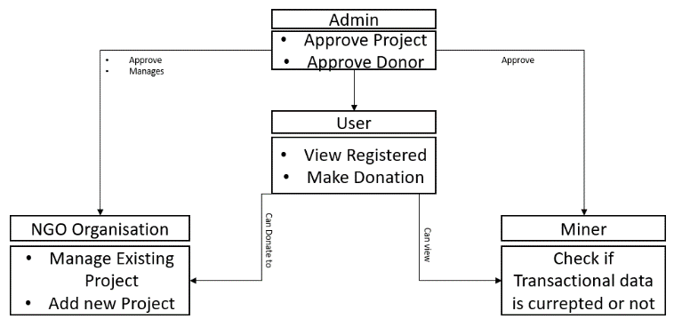Fig.1. Class Diagram
The proposed system is a block-chain based solution which offers a way to eliminate the doubts of users by providing data security, immutability, transparency in the application. For providing the data security, immutability, transparency here we apply SHA-1 algorithm for storage of transactional data in the database. SHA1 is a one-way encryption algorithm, here it takes sha1(cardName, cardNumber, cardcvv, cardExpDate, timestamp) as an input and SHA-1 produces a 160-bit output called a message digest. The message digest can then, for example, be input to a signature algorithm which generates or verifies the signature for the message.
The System is a solution for regaining the trust of public and at the same time connecting the interested people to the such organization which are unable to reach the maximum people due to lack of recent technologies knowledge and facing the problem to collecting funds because of above stated problem, our system providing them platform for add their project to gain the public support.
The system consists users which are playing the major role which classified as donor, NGO organizations, miners, and admin.
1] The donor:
The donor can view the requirements raised by different NGO organizations approve by the admin and choose the NGO of their preference and ability to make donation to them.
2]NGO Organization:
NGO or organizations can use this system to add their project and connect with maximum people without paying the technological requirements, the system provide them free of registration on the application so they can collect the maximum possible donation and help the maximum necessitous people.
3]Admin:
Admin has access to monitor and manage the organization projects and their transaction history.
4]Miners:
The system has miner section in case of user after certain period of time wants to check if his transaction has been manipulated then all three can view for manipulation in data. So, if any user tries to tamper any information outside by system, all three comes to know about it.

4. System Architecture
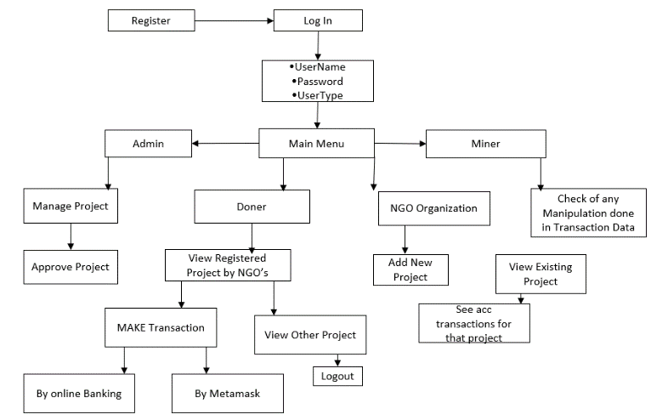
Fig.3. Flow Diagram
The system is in the form of a website where users can register themselves and allowed to perform actions as per their role which can be donor, non-government organization, admin and miners. Each user will have their own username, password and the private key for their account, which will authenticate the user and authorize to access their own dashboard. The dashboard will allow the donor to donate, track transactions, total contribution of the donor. The tracking will allow donor to get the latest state of a transaction. The admin would be allowed to approve the requirements raised by the NGO. They will also be able to track the transactions.
The System Provide two secure method of transaction.
1]Through Online Banking(credit card, debit card)
2]Through Metamask-id(cryptocurrency)
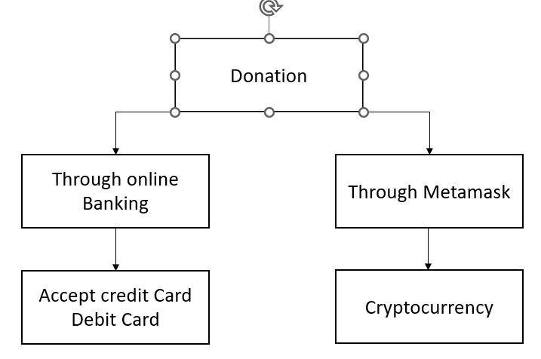
Fig.2. transaction flow chart
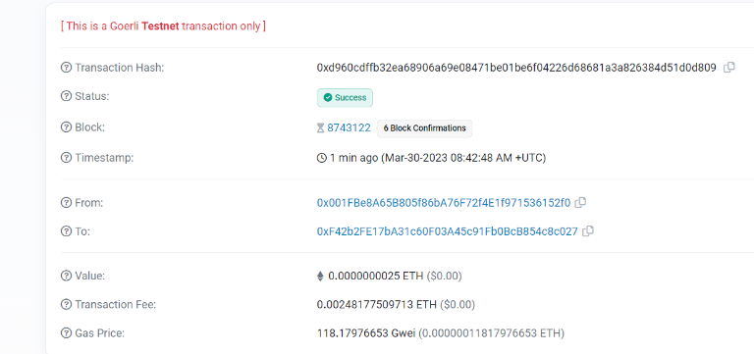Fig.4. Image of format of transactional data storage in system.
Fig.4 shows the transactional data storing format in the database. SHA-1 algorithm create the unique hash for the each transaction which makes it immutable and secure.
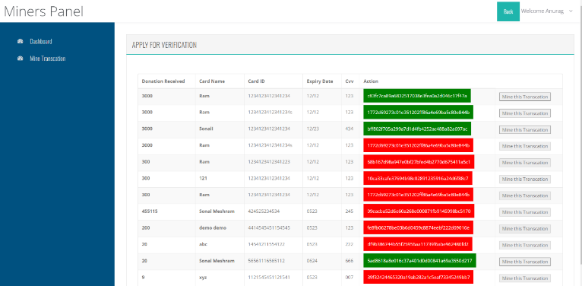
Fig.5. Image of Miners dashboard
Fig.5 is the image of miner dashboard where they can check either data manipulation takes place or not in the system, to ensuring the immutability and transparency of the system.

5. CONCLUSIONS
In this research, a blockchain-based solution was proposed that would increase transparency and trust between NGOs and donor agencies in third-world countries.
Blockchain technology may be the solution to the current problems faced by NGOs worldwide. Damaged reputation and high levels of mistrust are common issues faced by NGOs, ultimately affecting society.
Blockchain brings in more traceability, security, and efficiency in NGOs’ fundraising operations. It is high time that NGOs start taking measures to adopt blockchain-powered systems.

6. ACKNOWLEDGEMENT

It is my utmost duty and desire to express acknowledgement to the various torchbearers, who have rendered valuable guidance during the preparation of my Project. First, I extend my deepest gratitude to respected Principal, Dr. D. T. Ingole without whose support, my Project could not have been transformed into present form.
I am grateful to Dr. V. B. Kute Head, Computer Science and Engineering Department, and my guide Prof. Anuradha Kale for providing immense support and guidance. I am beholden for guiding me at every step in the Project. she has honestly guided me throughout, never leaving me unanswered for any of my doubts. It was her constant persuasion, encouragement, inspiration and able guidance that helped me in completing my Project successfully.

7. REFERENCES

[1] Zheng, Z., Xie, S., Dai, H., Chen, X., & Wang, H. (2017, June). An overview of blockchain technology: Architecture, consensus, and future trends. In 2017 IEEE international congress on big data (BigData congress) (pp. 557-564). IEEE.
[2] Alexopoulos, N., Daubert, J., Mühlhäuser, M., & Habib, S. M. (2017, August). Beyond the hype: On using blockchains in trust management for authentication. In 2017 IEEE Trustcom/BigDataSE/ICESS (pp. 546- 553). IEEE.
[3] Mukhopadhyay, U., Skjellum, A., Hambolu, O., Oakley, J., Yu, L., & Brooks, R. (2016, December). A brief survey of cryptocurrency systems. In 2016 14th annual conference on privacy, security and trust (PST) (pp. 745-752). IEEE.

