Undernourishment Detection in progenies using CNN with MATLAB
V Veerraju[1] K Ankitha[2] N Umasankar[3] K Vandana[4]
K Surendra[5] G Sai Prasad[6]
Asst. Professor, Sir C R Red.dy College of Engineering[1]
UG Scholars, Sir C R Reddy College of Engineering[2,3,4,5,6]

ABSTRACT: In many countries, the deaths of children younger than 5 years are directly or indirectly attributed to undernourishment. To prevent such risks and minimize physical and health complications, identifying malnourished children is crucial. To achieve this, a Convolutional Neural Network (CNN) is proposed as a deep learning algorithm that analyzes input images to distinguish between malnourished and normal children. The training process utilizes the AlexNet architecture and Transfer Learning. By processing an image of a child, the system can classify the child as malnourished or normal, and provide food suggestions. This proposed system is to detect undernourishment in children, which can help healthcare providers and people to address its effects by implementing automation instead of a manual process.
Keywords— Alexnet, Undernourishment, Convolutional Neural Network, Matlab.
INTRODUCTION: The proposed system emphasizes the crucial role of nutrition in a child's life. Adequate nutrition is essential for a child's physical and cognitive development, allowing them to thrive and reach their full potential. Good nutrition also supports a child's immune system, helping them fight off infections and diseases. On the other hand, malnutrition can have severe consequences, including stunted growth, weakened immunity, and increased risk of death. Malnourished children may also struggle with learning and cognitive development, affecting their ability to participate and contribute to society. Therefore, ensuring access to proper nutrition for all children is essential to building healthy and thriving communities.
malnutrition can refer to both undernutrition and overnutrition, which are characterized by inadequate or excessive intake of nutrients. Undernutrition can lead to stunted growth, weakened immune system, and increased risk of infections, while overnutrition can cause obesity, type 2 diabetes, cardiovascular diseases, and other health problems. Malnutrition is indeed a major contributor to child mortality, particularly in low- and middle-income countries, where access to nutritious food is limited and healthcare services are inadequate. According to the World Health Organization, malnutrition contributes to about 45% of all deaths of children under the age of 5 years worldwide..
malnutrition can refer to both undernutrition and overnutrition, which are characterized by inadequate or excessive intake of nutrients. Undernutrition can lead to stunted growth, weakened immune system, and increased risk of infections, while overnutrition can cause obesity, type 2 diabetes, cardiovascular diseases, and other health problems. Malnutrition is indeed a major contributor to child mortality, particularly in low- and middle-income countries, where access to nutritious food is limited and healthcare services are inadequate. According to the World Health Organization, malnutrition contributes to about 45% of all deaths of children under the age of 5 years worldwide.
Certainly! In 2019, there were 47.0 million children under the age of 5 who were affected by wasting, with 14.3 million of them experiencing severe wasting. Additionally, the World Health Organization reported in their 2020 edition that stunting affected 21.3% or 144 million children under 5 globally, while wasting affected or threatened the lives of 6.9% or 47 million children in the same age group. Furthermore, approximately 5.6% or 38.3 million children under 5 were overweight worldwide. Malnutrition can cause physical health and growth issues, and according to UNICEF's The State of the World's Children 2019 report, globally, at least 1 out of 3 children is not growing well due to malnutrition, and 1 out of 2 children is affected by hidden hunger.
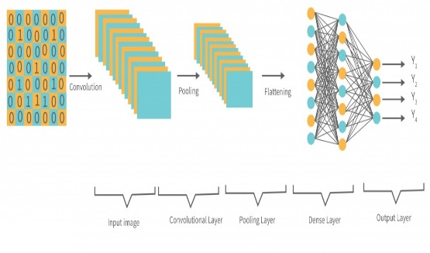
The latest global and regional estimates of child malnutrition from UNICEF, WHO, and the World Bank demonstrate that we have a long way to go before achieving a world without malnutrition. These estimates, released in March 2020, provide information on stunting, wasting, severe wasting, and overweight among children under the age of 5. They also reveal that progress has been inadequate to meet the targets set by the World Health Assembly for 2025 and the Sustainable Development Goals for 2030.
Over the past decade, there has been a slight decline in the number of stunted and underweight children, but the prevalence of wasted children remains alarming. Early detection of malnutrition is crucial in preventing the risk of death and reducing physical and growth issues by taking necessary measures. In 2020, the worldwide rate of undernourishment was 9.9 percent, with Sub-Saharan Africa having the largest share of undernourished people at 24.1 percent. Southern Asia and Sub-Saharan Africa are among the regions with the highest numbers of undernourished people in the world, totaling 257.3 million and 234.7 million, respectively, in 2019. According to the World Hunger Index 2020, the Central African Republic and Chad were among the most affected countries by hunger and malnutrition. Overall, an estimated 687.8 million people suffered from malnutrition worldwide in 2019.
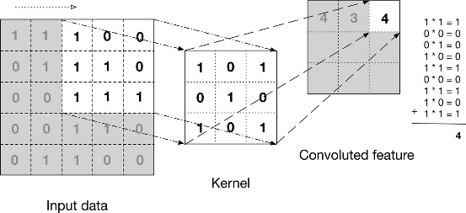
It is important to address the issue of malnutrition as it affects both adults and children. According to the World Health Organization (WHO), there are currently 462 million underweight adults and 1.9 billion adults who are overweight or obese. Among children under the age of 5, 155 million are stunted, 52 million are wasted, 17 million are severely wasted, and 41 million are overweight or obese. Detecting malnutrition in children is crucial in order to take preventive measures and minimize the impact of malnutrition on their health. One approach to detecting malnutrition in children is through the use of convolutional neural networks (CNNs), such as the AlexNet architecture.
II.ARCHITECTURE OF CONVOLUTIONAL NEURAL NETWORK
Convolution Neural Network
CNNs are a type of neural network commonly used for image recognition and classification tasks, and they have been proven to be very effective for detecting patterns in images. AlexNet, in particular, is a popular CNN architecture that has achieved state-of-the-art performance on several challenging image recognition datasets. By using CNNs and AlexNet, we can train a model to classify images of children as either malnourished or normal, which can be a valuable tool in detecting and preventing malnutrition in children.

Fig. Architecture of Convolution Neural Network
CNN is mainly used in image analysis tasks like Image recognition, Object detection & Segmentation. Convolutional Neural Networks specialized for applications in image & video recognition.
There are three types of layers in Convolutional Neural Networks:
Convolutional Layer (CONV)
They are the foundation of CNN, and they are in charge of executing convolution operations. The Kernel/Filter is the component in this layer that performs the convolution operation (matrix). Until the complete image is scanned, the kernel makes horizontal and vertical adjustments dependent on the stride rate. The kernel is less in size than a picture, but it has more depth. This means that if the image has three (RGB) channels, the kernel height and width will be modest spatially, but the depth will span all three.
Fig. Convolution Layer
PoolingLayer (POOL):
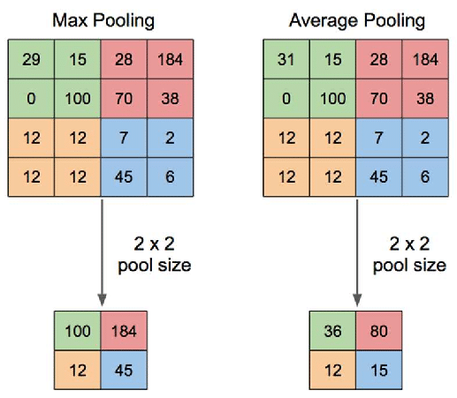
This layer is in charge of reducing dimensionality. It aids in reducing the amount of computing power required to process the data. Pooling can be divided into two types: maximum pooling and average pooling. The maximum value from the area covered by the kernel on the image is returned by max pooling. The average of all the values in the part of the image covered by the kernel is returned by average poolingOther than convolution, there is another important part of convolutional layers, known as the Non-linear activation function. The outputs of the linear operations like convolution are passed through a non-linear activation function. Although smooth nonlinear functions such as the sigmoid or hyperbolic tangent (tanh) function were formerly utilized because they are mathematical representations of biological neuron actions. The rectified linear unit (ReLU) is now the most commonly used non-linear activation function. f(x) = max(0, x)This layer is in charge of reducing dimensionality. It aids in reducing the amount of computing power required to process the data. Pooling can be divided into two types: maximum pooling and average pooling. The maximum value from the area covered by the kernel on the image is returned by max pooling. The average of all the values in the part of the image covered by the kernel is returned by average pooling.
Fig. Pooling Layer(Max and Average)
Fully Connected Layer (FC):
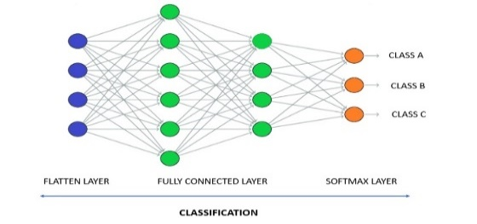
The fully connected layer (FC) works with a flattened input, which means that each input is coupled to every neuron. After that, the flattened vector is sent via a few additional FC layers, where the mathematical functional operations are normally performed. The classification procedure gets started at this point. FC layers are frequently found near the end of CNN architectures if they are present.
Fig. Fully Connected Layer
Along with the above layers, there are some additional terms that are part of a CNN architecture.
Activation Function: The last fully connected layer’s activation function is frequently distinct from the others. Each activity necessitates the selection of an appropriate activation function. The softmax function, which normalizes output real values from the last fully connected layer to target class probabilities, where each value ranges between 0 and 1 and all values total to 1, is an activation function used in the multiclass classification problem.
Dropout Layers: The Dropout layer is a mask that nullifies some neurons’ contributions to the following layer while leaving all others unchanged. A Dropout layer can be applied to the input vector, nullifying some of its properties; however, it can also be applied to a hidden layer, nullifying some hidden neurons. Dropout layers are critical in CNN training because they prevent the training data from overfitting. If they aren’t there, the first batch of training data has a disproportionately large impact on learning. As a result, learning of traits that occur only in later samples or batches would be prevented.
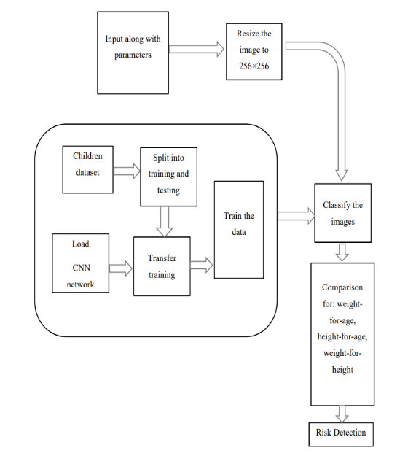
III.BLOCK DIAGRAM AND METHODOLY
Fig. Description of Block Diagram
Parameters like height, weight, age, and gender of the testing progeny are taken. Height in terms of Centimetres, weight in terms of kilograms and age in terms of months are considered.
Training using CNN
Before training with the CNN, the images in the database need to be resized. Although the captured images can vary in size, they need to be resized to 256x256 for training purposes using a resize function. The CNN then trains the entire network to classify the images. To accomplish this, a pre-trained Convolutional Neural Network called AlexNet is utilized. AlexNet was trained on over a million images from the ImageNet database and can classify images into 1000 object categories. The pre-trained AlexNet neural network is loaded, and an appropriate learning rate, epochs, and mini-batch values are assigned to it. Finally, the final layers of the architecture are modified to accommodate the two new categories in the dataset, which are undernutrition and normal.
The learning rate is a hyperparameter that regulates how much the model should be adjusted in response to the estimated error every time the model weights are updated. On the other hand, epochs refer to the number of times a learning algorithm goes through the complete dataset. An epoch is completed when the entire dataset is passed forward and backward through the neural network once.
Training-I
During the first training phase, each image is trained once by taking one iteration for an epoch. Since there are 50 images to train, the total number of epochs is 50, and the iteration limit is also 50. Iterations are the number of batches of data that the algorithm has processed, or simply the number of passes the algorithm has made on the dataset.
Training-II
During the second training phase, nine iterations are taken for each epoch, and a total of 50 epochs are completed. As a result, the maximum number of iterations is 450.
Testing input image
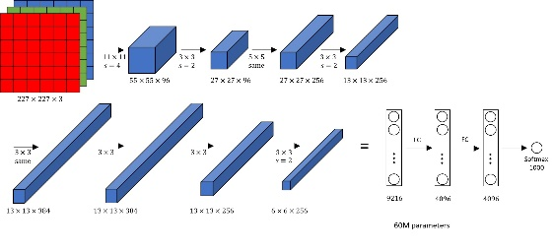
To make it easier for the computer to handle, we divide one epoch, which may be too large, into smaller batches.Regarding the testing input image, the dataset comprises of images of undernutrition and normal progenies, which are stored in different folders labeled as Undernutrition and Normal with no specific filters or size restrictions. The dataset consists of a total of 50 images, out of which 25 images are of undernutrition progenies, and the remaining 25 images are of normal progenies. One image from the dataset is taken as input for testing. The input image can have any dimensions, but it needs to be resized to 256x256 dimensions for proper classification.
classification
This module is responsible for classifying the input image as either Undernutrition or Normal. To achieve this, the module loads the pre-trained Alexnet model, reads the input image, resizes it to 256x256 dimensions, as the pre-trained model requires the image size to match the input size of the network, and then labels the image based on 8the classification result.
Risk Detection
After the classification process is complete, the risk of undernutrition is detected based on the input parameters and the testing input image.
Comparison based on parameters
Such as age, weight, and height, the classifier categorizes progenies into three categories: Undernutrition, Normal, and At risk of undernutrition. WHO has defined the -2 standard deviations (SD) of the WHO Progeny Growth Standards median for z-scores of weight-for-age, height-for-age, and weight-for-height as indicators of undernutrition. By using these standards and user input for age, weight, and height, the classifier determines if the progenies suffer from undernutrition or not.
If both the image and z-scores classifications are predicted as undernutrition, the progeny is considered undernourished. Even if either the image or z-scores classification is predicted as undernutrition, the final results indicate that the progeny is at risk of undernutrition. If both the image and z-scores classifications are predicted as normal, the progeny is considered normal, and there is no risk of undernutrition.
The primary objective of this project is to identify progenies suffering from undernutrition by analyzing their images and inputting simple parameters such as gender, age, weight, and height. To achieve this, a deep learning algorithm is utilized that processes the input, analyzes the images, and differentiates them from one another. The training process involves using the AlexNet architecture, and transfer learning is employed to replace the final layers. The ultimate goal is to accurately classify progenies as either undernourished or not, thereby enabling early detection and intervention to prevent long-term health consequences.
Fig. Alexnet Architecture
IV.RESULTS
The proposed system employs MATLAB 0.9 R2022b software to process images of the offspring. With its abundant libraries for mathematical calculations including Linear Algebra, Statistics, Fourier Analysis, Filtering, Optimization, Numerical Integration, and solving ordinary differential equations, MATLAB is a suitable tool for this purpose. The progeny images undergo multiple steps to prepare them for model training.
The system that was proposed relied on a dataset of 50 progeny images, all of which were under five years of age. Within the dataset, there were 25 images of undernourished progenies and 25 images of healthy/normal progenies. During the model training and testing phase, 90% of the data was allocated to training, and the remaining 10% was used for testing. All images in the dataset, including the input image for classification, had dimensions of 256×256. To ensure that the images were appropriate for the input filter of AlexNet, the images were resized to dimensions of 227×227×3 using the Resizing by Data Augmentation method.
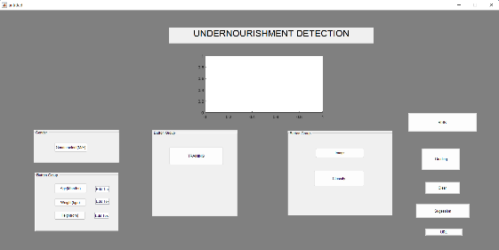
Graphic User Interface (GUI) for the proposed system.
Fig.GUI Interface
The code for executing the algorithm is written in MATLAB. The execution of the code results in a display of GUI as shown in fig. 4.1. Every button is associated with a function. This also includes taking input progenies images, required parameters like age, height, weight and gender and then loading database to train the data.
Selecting Gender
For detection of Undernutrition, gender is also considered as a parameter. When Gender select button is clicked, it pops out a textbox showing Gender. Give ‘M’ for male and ‘F’ for female.
Input-Age
To detect the undernutrition one of the parameters is age. Certain age is given as input in terms of months. Age limitation is from 0 Displaying inputs Fig:10 months to 60 months.
Input-Weight
Weight is another parameter needed for the detection of undernutrition. Here, weight is taken in terms of kilograms. Same as age input, weight input is also given from the keyboard and for confirming the weight input ok button is clicked.
Input-Height
Height is also considered to detect undernutrition. Here, height is taken in terms of centimetres. 40 centimetres is taken as height input.
Training
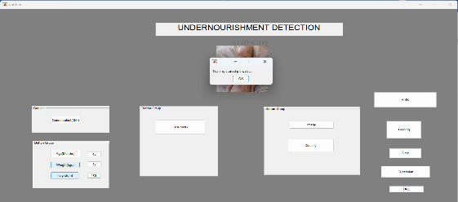
When training button is clicked, training of the CNN starts and a textbox opens saying "testing started pls wait"
Fig:Training
Displaying Training Images
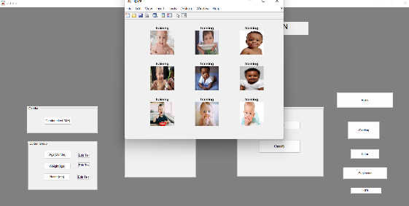
When the textbox "Training started pls wait…" is appeared, if click on 'ok' button then "Figure 1" window will be opened. This window consists some images (12) of undernutrition and normal
Fig:Displaying Training Image
progeny which are used for training.
Training Progress-1
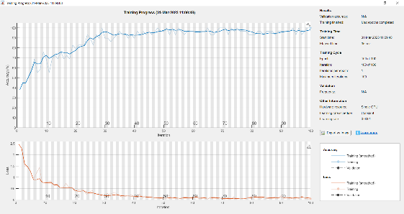
The elapsed time for this training progress is 1 minute 29 seconds Here, elapsed times means the actual time taken from the start of traning progress to the end
Fig:Training Progress-I
Accuracy is defined as percentage of correct predictions for the test data. It can be calculated by dividing the number of correct predictions by number of total predictions.
Loss represents the summation of errors in model. It is calculated by dividing number of errors predicted by total number of predictions. The accuracy graph is plotted as accuracy versus iteration. From the plot it can be observed that as the iterations are increasing the accuracy is increasing.Similarly, the loss graph is plotted between loss as y-axis and iteration as x-axis. As the iterations are increasing, loss is tended to be decreasing.Training Progress-2 After the first training process second training progress window will be opened. In the second training process, 9 iterations per epoch are considered and 50 epochs are taken. So, the maximum number of iterations are 450
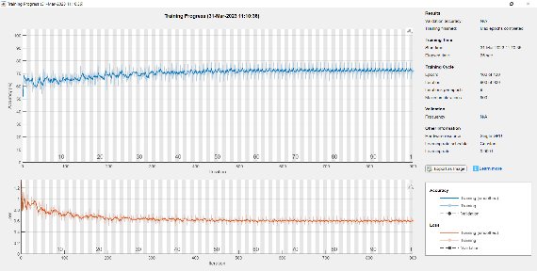
Fig.Training Progress-II
Displaying Testing Image
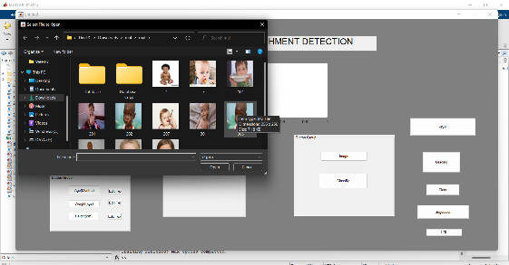
After training is completed when image button is clicked, set of images used for testing will be appeared. Then an image is selected for testing and that image will be appeared in the window named.
Fig:Displaying Testing Images
Image Classification
Now, when "classify" button is clicked the given input image is classified whether progeny is undernutrition or normal. And display that in a textbox as Malnutrition(severe or medium).

Risk Detection
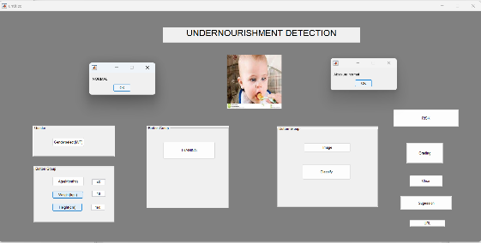
After the classification is done and displayed in a textbox click on "ok". Now, click on "Risk" button then it displays a textbox resulting if there is a risk or no risk. If risk is detected then it displays as "Malnutrition", if no risk is detected then it displays as "No Risk Detected". Then click on "ok" in that textbox.To clear the current image and give another testing image click on the "Clear" button and then click on "Image" button and can give another testing image.
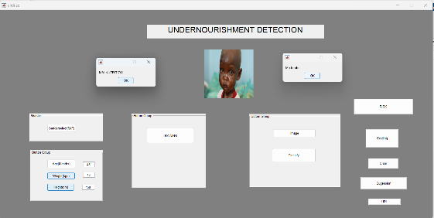
Fig:Normal Condition
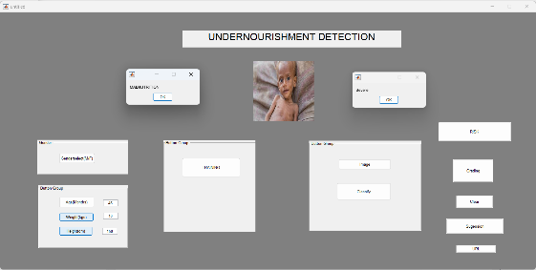
Fig:Moderate Condition
Fig:Severe Condition
NITIALIZING INPUT DATA NORMALIZATION:
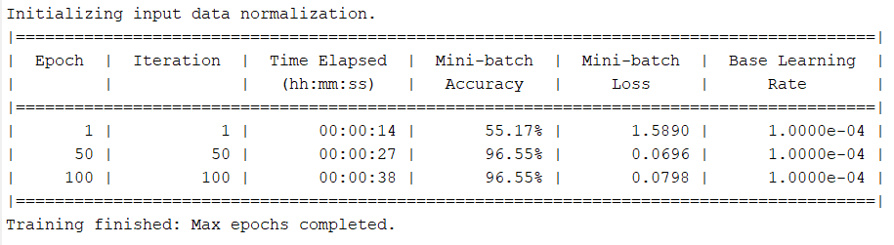
The below table shows the mini batch accuracy and mini-batch loss for the first training process.
Fig:Training Progess-I
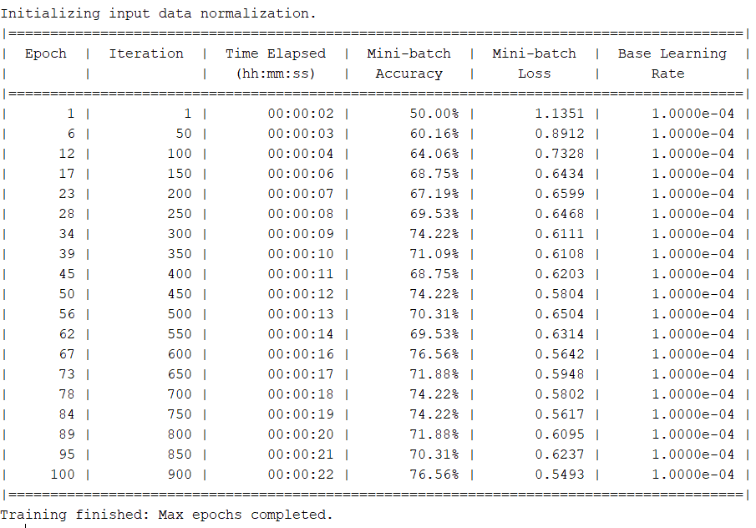
The below table shows the mini-batch accuracy and mini-batch loss for every epoch's iteration
Fig:Training Progress-2
Average accuracy = Sum of all accuracies/Total number of accuracies.
So, average accuracy is 98.2%.
Average loss = Sum of all losses/Total number of losses = 0.0171
So, the average loss is 1.71%
V. Conclusion and Future Scope
So, average accuracy is 98.2%. Average loss = Sum of all losses Total number of losses = 0.0171 So, the average loss is 1.71% Detecting undernutrition in children under the age of 5 is crucial for governments and health services to take preventive measures. One promising approach is using conventional neural networks, such as CNN or ConvNet, which analyze images of children as input. These networks, like AlexNet, can recognize and classify patterns in images to identify signs of undernutrition. Recent testing of such models has shown that they can achieve impressive accuracy rates, such as 98% with a learning rate of 0.001. By utilizing a system that incorporates parametric conditions, AlexNet architecture, and extracted features, it's possible to predict which children are at risk of undernutrition and even classify the type of undernutrition that is affecting them. This is important because treatment for undernutrition varies depending on the specific type. Overall, utilizing CNN algorithms to detect and classify undernutrition in children under 5 can be a beneficial tool for improving public health outcomes.
Reference
- 'Malnutrition Detection using Convolutional Neural Network', by Arun Raj Lakshminarayanan, Pavani B, Rajeswari V, B. S. Abdur Rahman, Saravanan, A.Abdul Azeez Khan, K.Javubar Sathick .
- 'Levels and trends in progeny undernutrition', UNICEF/WHO/World Bank Group –Joint Progeny Undernutrition Estimates 2019 edition.
- The State of the World's Progenies 2019: Progenies, Food and Nutrition, UNICEF.
- Undernutrition is a world health crisis, [2019], WHO.
- Sahu, S. K., Kumar, S. G., Bhat, B. V., Premarajan, K. C., Sarkar, S., Roy, G., & Joseph, N. (2015). Undernutrition among under-five progenies in India and strategies for control. Journal of natural science, biology, and medicine, 6(1), 18.
- Markos, Z., Doyore, F., Yifiru, M., & Haidar, J. (2014). Predicting Under nutrition status of under-five progenies: The Case of 2011 Ethiopian Demographic and Health Survey. J Health Med Inform, 5, 152.
- Markos, Z., Doyore, F., Yifiru, M., & Haidar, J. (2014). Predicting Under nutrition status of under-five progenies: The Case of 2011 Ethiopian Demographic and Health Survey. J Health Med Inform, 5, 152.
- Dezhi, X., & Ganegoda, G. U. (2011). Rule based classification to detect undernutrition in progenies. International Journal on Computer Science and Engineering (IJCSE) Vol, 3.
- Susan Smith, Tracy B. Chamblee, Karie Falder-Saeed, Kelly Haight, Melanie Horbal Shuster, Mary J. Waldo and Hea Lan Yoon, [January 2017], 'UNDERNUTRITION IN HOSPITALIZED ADULT PATIENTS', National Association of Clinical Nurse Specialists (NACN).

