WASTE FOOD MANAGEMENT AND DONATION APP
Prof. DEVACHAND CHAUDHARI[01]
RUTIKA RAHUL KAMBLE[02]
KUNAL SURAJ LALWANI[03]
SAKSHI BHASKAR PAWADE[04]
PURVA SATISH BONDGULWAR[05]
RUTIKA DIPAK TONGE[06]
BE Department of Computer Science Engineering
Government College of Engineering, Chandrapur, Maharashtra, India.

1.INTRODUCTION
As per the knowledge the technology is going advanced and growing day by day. Over main motto is to help needy people. The idea behind over project can be use by many people who wish to donate things to needy organizations Also, many organizations like to ask for various things required by them such as clothes, food grains, books utensils. In this mobile app, we have tried to reduce food wastage by giving waste food to people or organization who need it. The needy will add to a request, in case of any leftover food donor have. This request is sent to the list of donors. The Available Donor then accept the request. We are going to manage the delivery system by appointing delivery person who will collect the food from the donor and distribute among the needy people. Second option for delivery system is that volunteers who wish to help to donate food can join us for distribution in near by areas. For eg: they can distribute food in government school, government hospital, orphanage, old age homes. And the third option is the Food Bank if we receive food in odd times we can give it to food bank where the care of food is taken. Safety and Hygiene are maintained in food banks. So. food wastage or food spoilage cannot occur.
2.LITERATURE SURVEY
Food waste” pertains to the edible and inedible parts of food removed from the food chain, which need to be managed through recycling or disposal (Östergren et al., 2014). Food waste may also be interpreted as the loss of edible food at different stages of the food chain, including harvest, production, processing, distribution and consumption (Ivert et al., 2015; Segrè et al., 2014). Food waste comprises two types based on the kind of waste:Unavoidable food waste: expired or spoiled ingredients, food scraps such as meat scraps (e.g. end pieces of baked ham after slicing, meat pieces after trimming) and vegetable scraps (e.g. tomato ends, outer leaves of lettuce, potato peels, vegetable stems); and Avoidable food waste: meal scraps such as peeling or trimming waste arising from the less proficient handling of food items; overproduction for banquets, events and catering; poor ordering procedures; poor food rotation practices, causing food spoilage; and poor inventory systems, leading to food and plate waste such as unconsumed pasta (Derqui and Fernandez, 2017). Academics categorize food waste based on the stages of waste generation, such as pre- and post-consumer food waste (Prescott et al., 2019b). Pre-consumer waste occurs at the production level, and postconsumption waste occurs at the consumer level. Scholars argue they associate different factors with food waste generation at these stages. Accordingly, various mitigation approaches perhaps can reduce such waste (Papargyropoulou et al., 2016). Furthermore, thorough diagnoses of food waste generated at various stages are crucial for ensuring the effective management of waste (Dhir et al., 2020). Food waste is an important concern because it threatens the environment and sustainability. In fact, it is a serious concern in the hospitality and tourism domain (Okumus et al., 2020). Close to 1.3 billion tonnes of edible food is wasted annually, leading to severe financial, environmental and health outcomes (Gustavsson, 2011). Past research has identified several adverse outcomes of food waste, such as threats to food security (Wang et al., 2018), climate change and greenhouse gas emissions (Kallbekken and Sælen, 2013; Katajajuuri et al., 2014) and monetary loss (Hennchen, 2019). For instance, the annual emissions because of food waste in Finland constitute more than 1% of the country’s yearly greenhouse gas emissions (Katajajuuri et al., 2014). Similarly, scientists found the ecological impact of food waste in hotels, cafés and restaurants nearly twice the size of the arable land in Lhasa (Wang et al., 2018). Notably, sustainability has come under intense focus in the hospitality industry in the wake of the COVID-19 pandemic (Jones and Comfort, 2020). In addition, studies have underscored the nutritional loss associated with food waste. For instance, Blondin et al. (2017) revealed that, in the USA, fluid milk waste results in 27% and 41% losses, respectively, of the vitamin D and calcium required under school breakfast programme meals. Consequently, scholars argue that reducing food waste is critical from financial (e.g. food cost) and non-financial (e.g. sustainability) standpoints (Okumus, 2019). In fact, research reports suggest that, by saving one-fourth of the food being wasted, we can feed 870 million hungry people (Khadka, 2017). Similarly, the sustainable development goals of the United Nations (UN) have also emphasized responsible production and consumption, underscoring the importance of mitigating food waste (Gustavsson, 2011).

3. METHODOLOGY
The system comprises of 3 major modules with their sub-modules as follows:
Admin:
1. Register: User can register using personal details.
2. Login: User can login in his personal account using id and password.

3. Restaurant:
• List restaurant: List all the restaurants available
• Add/Register New Restaurant 4. NGOs:
• View All NGOs
• Add/Register New NGOs Restaurant:
1. Register: User can register using personal details.
2. Login: User can login in his personal account using id and password.
3. Profile: • View Profile/Restaurant details • Change Password
1. History: View Order history, Accepted, Pending Confirm
2. Food : • Add new food items to restaurant
NGOs:
1. Register: User can register using personal details.
2. Login: User can login in his personal account using id and password.
3. Details:
• View Other NGOs Profile
• View restaurant requests
4. Add Request:
• Request food for NGOs from restaurant
• Assign employee for delivery of the food
5. Manage Employee
• Add new employee
• Update employee details
• View employee profile
6. Records:
• View restaurant history
7. Profile:
• View Profile/Restaurant details
• Change Pass
STEP 1 : Start the application
STEP 2 : Register by filling the necessary details.
STEP 3 :Select the Option of donor or volunteer accordingly.
STEP 4 : If you wish to donate go to donation page by clicking on Donor button.
STEP 5: Then click on create donation.
STEP 6: Fill up the necessary details and click Submit.
STEP 7: If you wish to see donation request then click on Request for Food option.
STEP 8 : If you are in need of food then go to request food option which is on volunteer page.
STEP 9: Fill up your requirement and click on Request button.
STEP 10 : If you wish to see available food list by donors click on Available Food Button.
4.WORKING OF APPLICATION
-LANDING PAGE -ADMIN PAGE
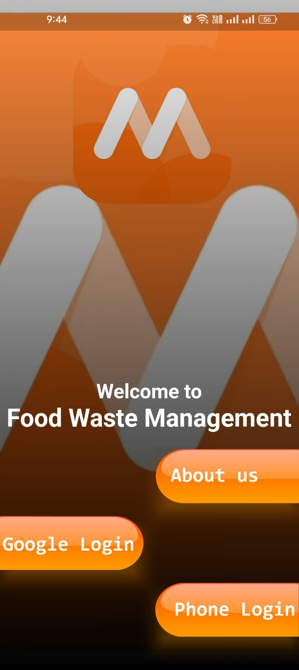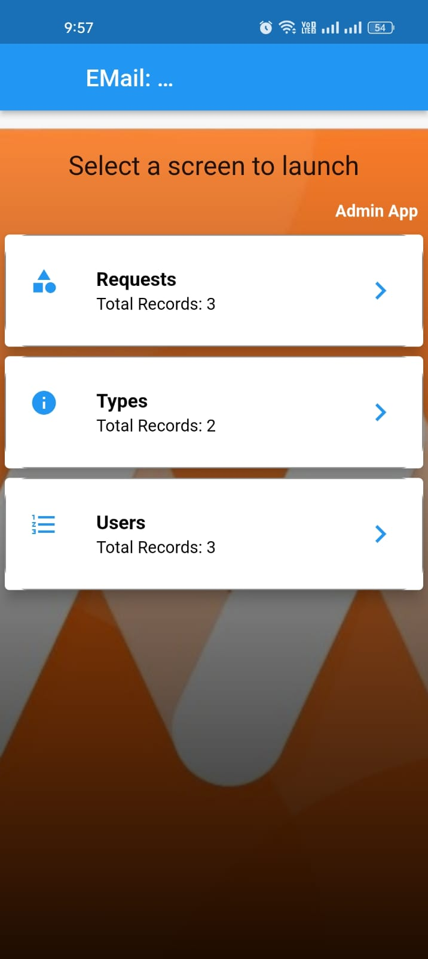
-REQUEST MODULE -TYPE MODULE
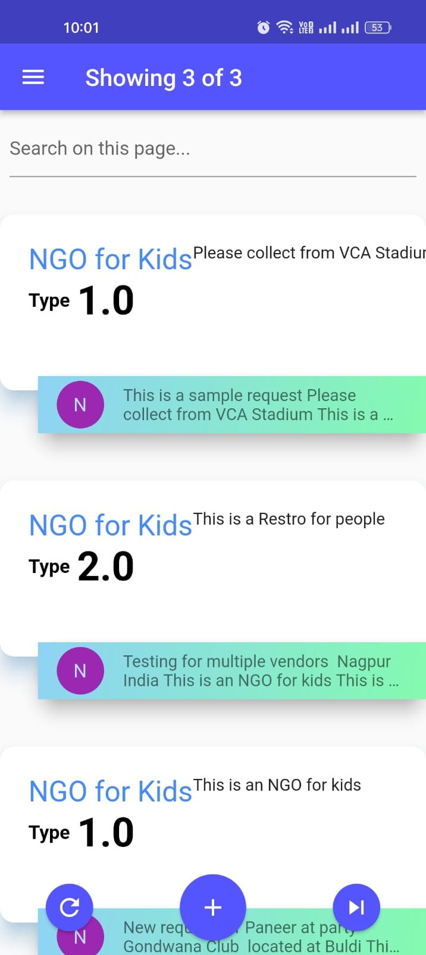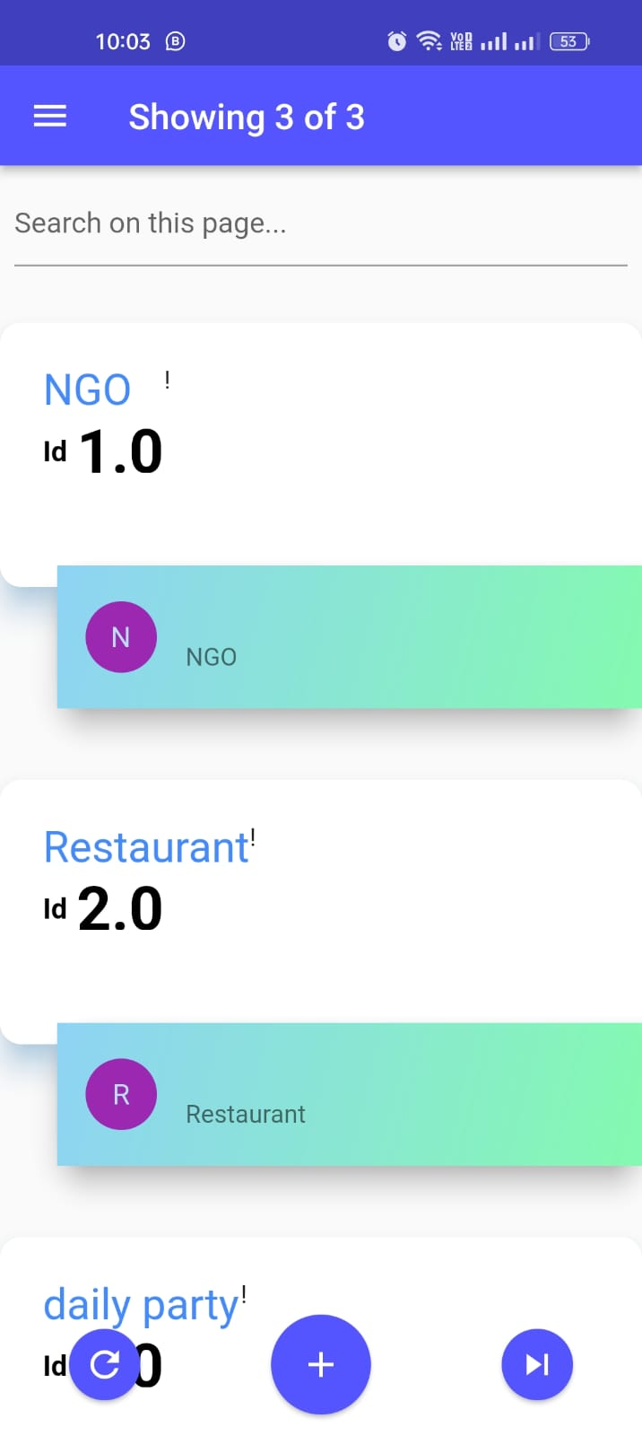

5. Future Scope
The future scope of the project that it is a app which will reduce food wastage . So it can be a medium through which we can stop food wastage little by little. This app is also useful in providing good quality food to needy people and organizations.
6.REFERENCES
[1] Review in Food Wastage Reduction Through Donation Application. June 2020 DOI:10.17148/IJIREEICE.2020.8611. Authors: Sankar Vt K.S.R. College of Arts and Science
[2] A Review of Empirical Applications on Food Waste Prevention & Management;March 2018Project: CoachAI: A Conversational-UI Assisted Ecoaching platform For Health & Wellbeing Authors:Ahmed Fadhil Università degli Studi di Trento, Fondazione Bruno Kessler
[3]Zero Hunger: Smart Food Donation System using IoT Juhi Patil, Gayatri More, Pooja Mahale, Nikita Harale and Vijaylaxmi Bittal Department of Computer Science and Engineering SVKM’s Institute of Technology Dhule, MH, India
[4]https://www.lovelycoding.org/waste-foodmanagement-system/
[5]https://ieeexplore.ieee.org/document/9641624
[6]https://ewastekuldeep.com/?gclid=CjwKCAjwvGUBhAzEiwASUMm4lkhZpzoad2XPCz_16uBETctbIw2nXirfJ VSSEY7UtRcivHfXZfhoCLasQAvD_BwE
[7] Food Waste Loss and Donation U.S. Environmental Protection Agency Office of Resource Conservation and Recovery May 2013

