ONLINE BICYCLE STORE

¹ Mr. Dr. D. SWAMYDOSS, ² Anjugabharathi.S
- Head of the Department, Department Master of Computer Application Engineering, Adhiyamaan College of Engineering (Autonomous), Hosur, Tamil Nadu, India
- Student, Department of Computer Application Engineering., Adhiyamaan College of Engineering (Autonomous), Hosur, Tamil Nadu, India

ABSTRACT
ONLINE BICYCLE STORE is a website which helps the user to enquire about the product which are added by the admin. Admin can add various kinds of bicycle. User can send enquiry about the product, which can be seen by the admin , later admin can call or mail the user and answer the user.
Admin module:
This module allows adding, deleting and modifying of products. Admin can add the category, and on the basis of category admin can add product. Admin can view messages from the user. Admin can change password. Admin can view the enquiry of the user ,and then later can reply either by mail or by calling the user.

Front end:
User can view various products and their details added by the admin. User can send message to the admin. User can also enquire about the product from the admin, later admin can reply by mail or by calling the user.
INTRODUCTION

ONLINE BICYCLE STORE is a website which helps the user to enquire about the product which are added by the admin. Admin can add various kinds of bicycle. User can send enquiry about the product, which can be seen by the admin , later admin can call or mail the user and answer the user.
  - OVERVIEW

ONLINE BICYCLE STORE project is implemented in PHP using HTML, Xamp and CSS and Mysql. Main aim of ONLINE BICYCLE STORE is to keep user updated about the new models of bicycles available in the market, with their price and description.
This application consists of admin module and front end:
Admin module:
This module allows adding, deleting and modifying of products. Admin can add the category, and on the basis of category admin can add product. Admin can view messages from the user. Admin can change password. Admin can view the enquiry of the user ,and then later can reply either by mail or by calling the user.
Front End:
User can view various products and their details added by the admin. User can send message to the admin. User can also enquire about the product from the admin, later admin can reply by mail or by calling the user.
  - OBJECTIVE
The objective to develop this website was to display the information about the latest bicycle product available . The user can get an idea about what products are available in the market and at which price.
PROJECT FEASIBILITY STUDY
2.1 TECHNICAL CONSTRAINTS:
The constraints of this case are the network connectivity which is required and a website located on the internet.
2.1.1 H/W SPECIFICATION
- Processor : Pentium IV
- RAM Capacity : 1GB
- Hard Disk : 160GB

2.1.2 S/W SPECIFICATION

- Technology : PHP
- Web-Technologies : HTML ,JavaScript ,CSS
- Web Server : Apache
- Backend Database : MYSQL
- Text Editor : Notepad ++

MODULE DESCRIPTION

- Admin Panel
This module allows adding, deleting and modifying of products. Admin can add the category, and on the basis of category admin can add product. Admin can view messages from the user. Admin can change password. Admin can view the enquiry of the user ,and then later can reply either by mail or by calling the user.

• Customer End
User can view various products and their details added by the admin. User can send message to the admin. User can also enquire about the product from the admin, later admin can reply by mail or by calling the userPROCESS DESCRIPTION/METHODOLOGY

- User can view products added by admin.
- User can enquire about the product to the admin.
- User can also send message to the admin.
- Admin can add products on the basis of categories. Admin has to add category and then can add product. If the category already exist, then admin can add product directly by choosing category from the dropdown.
- Admin can view messages and enquiries of the user.
- Admin also can change his password if required.

4.1DATA FLOW DIAGRAM (DFD):
A graphical tool used to describe and analyze the moment of data through a system manual or automated including the process, stores of data, and delays in the system. Data Flow Diagrams are the central tool and the basis from which other components are developed. The transformation of data from input to output, through processes, may be described logically and independently of the physical components associated with the system. The DFD is also known as a data flow diagrams or a bubble chart.

4.3 UML DIAGRAMS

UNIFIED MODELING LANGUAGE DIAGRAMS
The unified modeling language allows the software engineer to express an analysis model using the modeling notation that is governed by a set of syntactic semantic and pragmatic rules.
A UML system is represented using five different views that describe the system from distinctly different perspective. Each view is defined by a set of diagram, which is as follows.
TECHNOLOGY OVERVIEW

The technology selected for implementing E-Commerce is PHP/MYSQL. Apache is used as the HTTP server. The development was done in a ‘windows’ environment using adobe dreamweaverCS5/Sublime

PHP
PHP is a general-purpose scripting language that is especially suited to server side web development where PHP generally runs on a web server. PHP code is embedded into the HTML source document.Any PHP code in a requested file is executed by the PHP run time, usually to create dynamic web page content. It can also be used for command-line scripting and client-side GUI applications. PHP can be deployed on many web servers and operating systems, and can be used with many relational database management systems (RDBMS). It is available free of charge, and the PHP Group provides the complete source code for users to build, customize and extend for their own use

MYSQL
MYSQL is a relational database management system (RDBMS) that runs as a server providing multi-user access to a number of databases. MYSQL is a popular choice of database for use in web applications and is an open source product. The process of setting up a MYSQL database varies from host to host, however we will end up with a database name, a user name and a password. Before using our database, we must create a table. A table is a section of the database for storing related information. In a table we will set up the different fields which will be used in that
table. Creating a table in PHP My Admin is simple, we just type the name, select the number of fields and click the ‘go’ button. we will then be taken to a setup screen where you must create the fields for the database. Another way of creating databases and tables in PHP My Admin is by executing simple SQL statements. We have used this method in order to create our database and tables.

APACHE
The Apache HTTP Server is a web server software notable for playing a key role in the initial growth of the World Wide Web. In 2009 it became the first web server software to surpass the 100 million web site milestone. Apache is developed and maintained by an open community of developers under the auspices of the Apache Software Foundation. Since April 1996 Apache has been the most popular HTTP server software in use. As of November 2010 Apache served over 59.36% of all websites and over 66.56% of the first one million busiest websites.
XAMPP
XAMPP is a small and light Apache distribution containing the most common web development technologies in a single package. Its contents, small size, and portability make it the ideal tool for students developing and testing applications in PHP and MYSQL. XAMPP is available as a free download in two specific packages: full and lite. While the full package download provides a wide array of development tools, XAMPP Lite contains the necessary technologies that meet the Ontario Skills Competition standards. The light version is a small package containing Apache HTTP Server, PHP, MYSQL, PHP My Admin, Open SSL, and SQLite.
SCREENSHOTS
Front end:
Home:
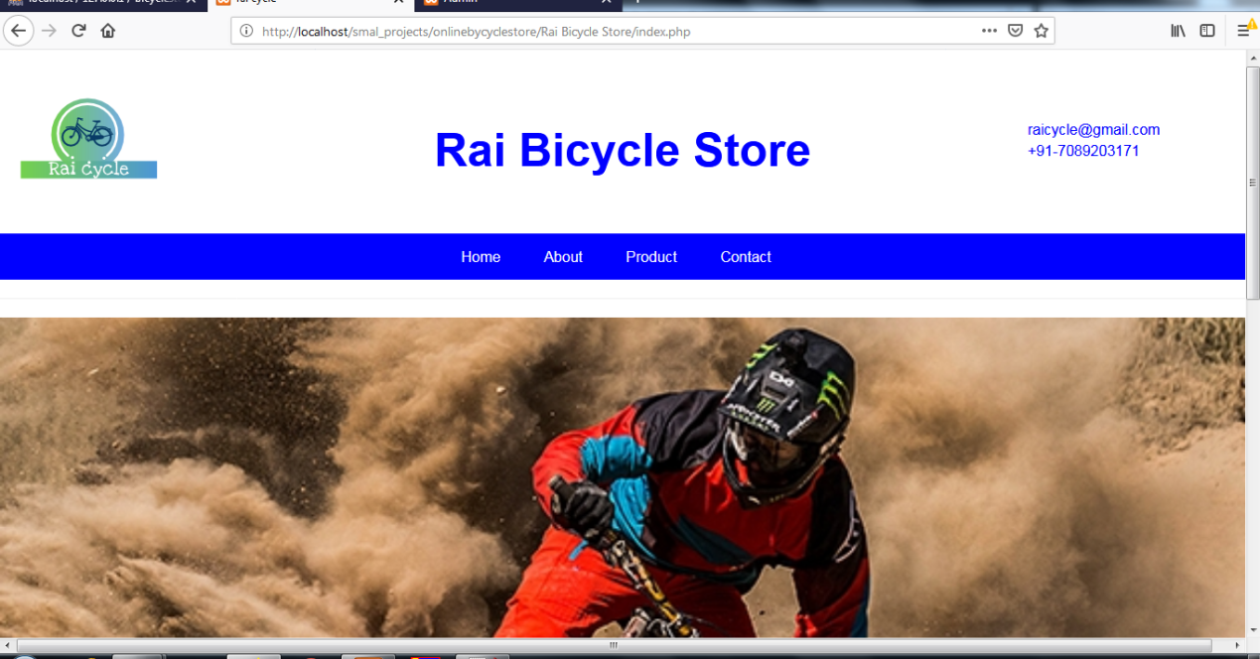

About:
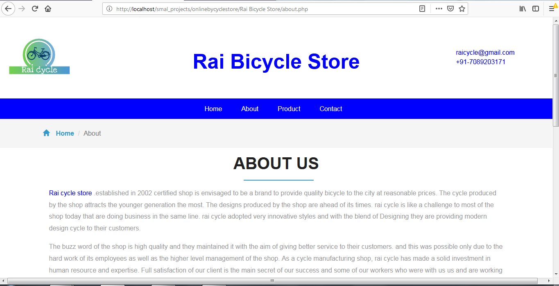

Product:
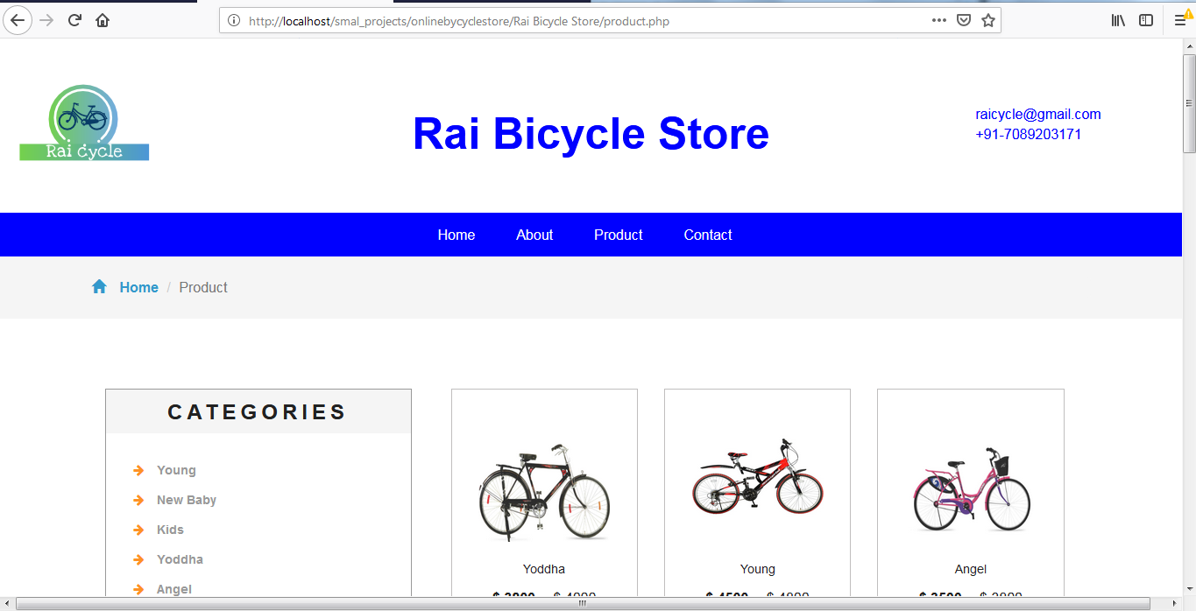

View details:
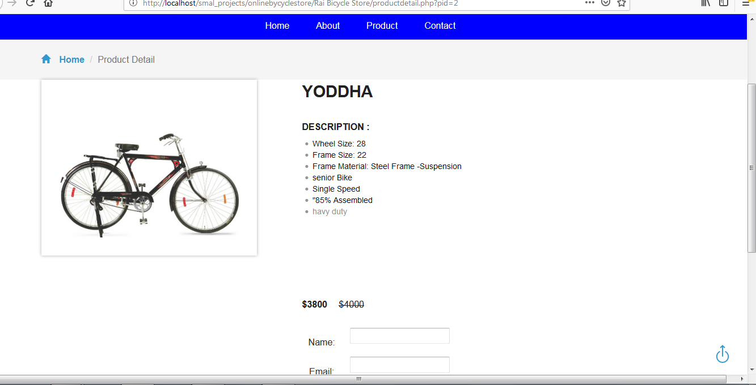

Contact:
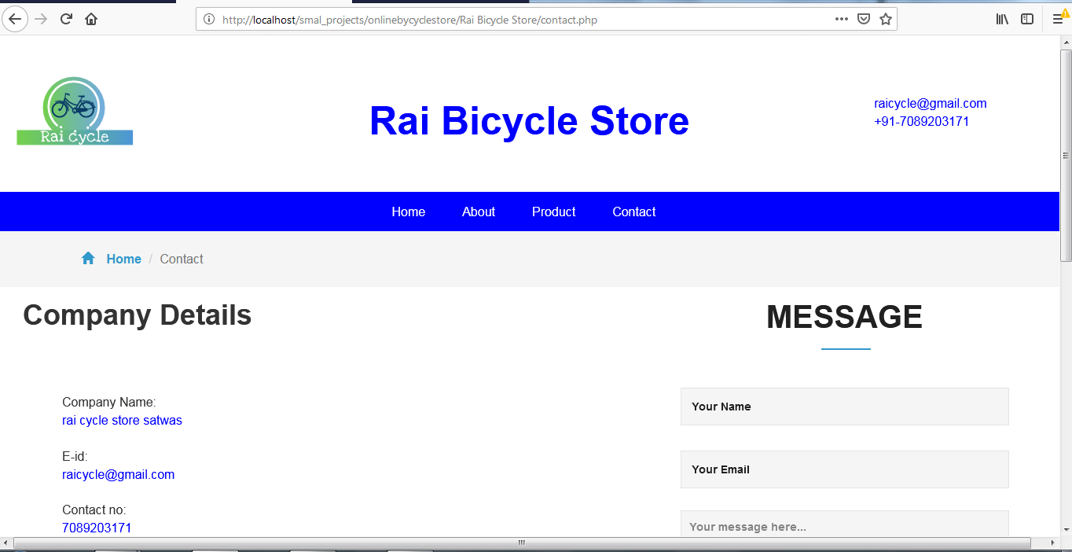
Admin Page:
Login Page:
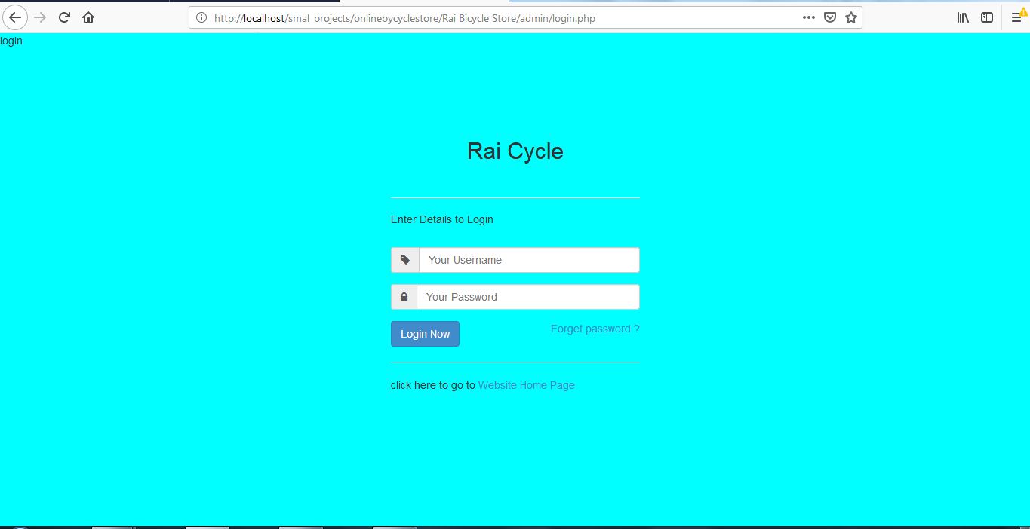

Dashboard:
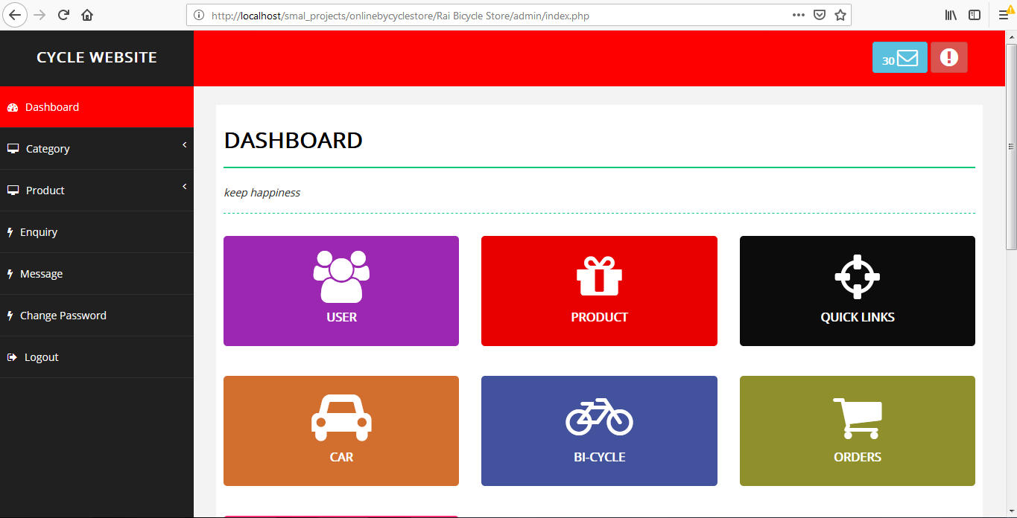
Add Category: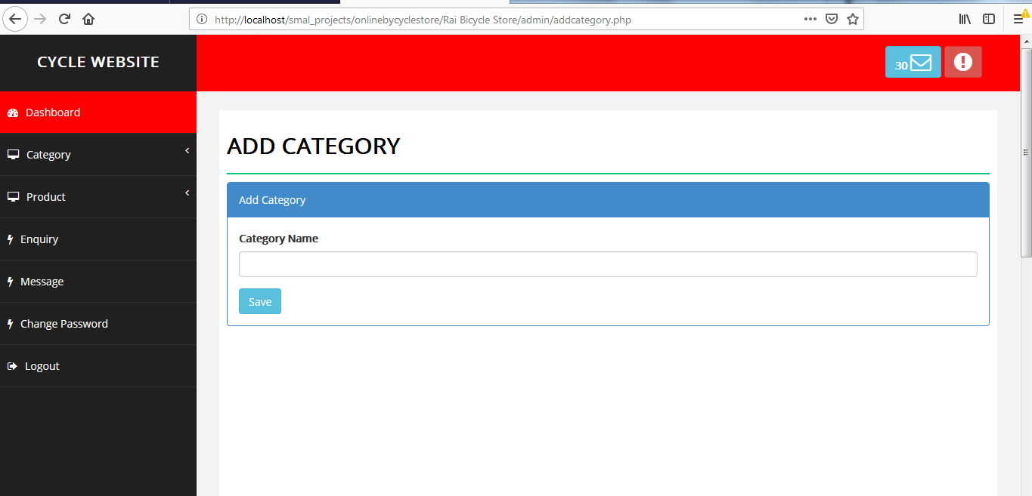

Category List:
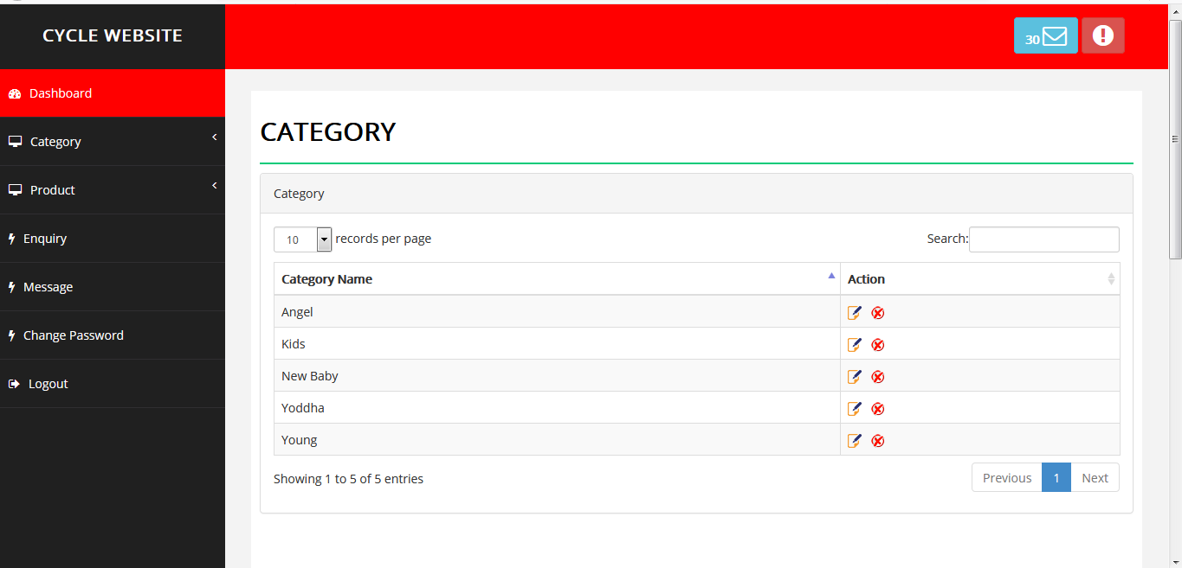

Add Product:
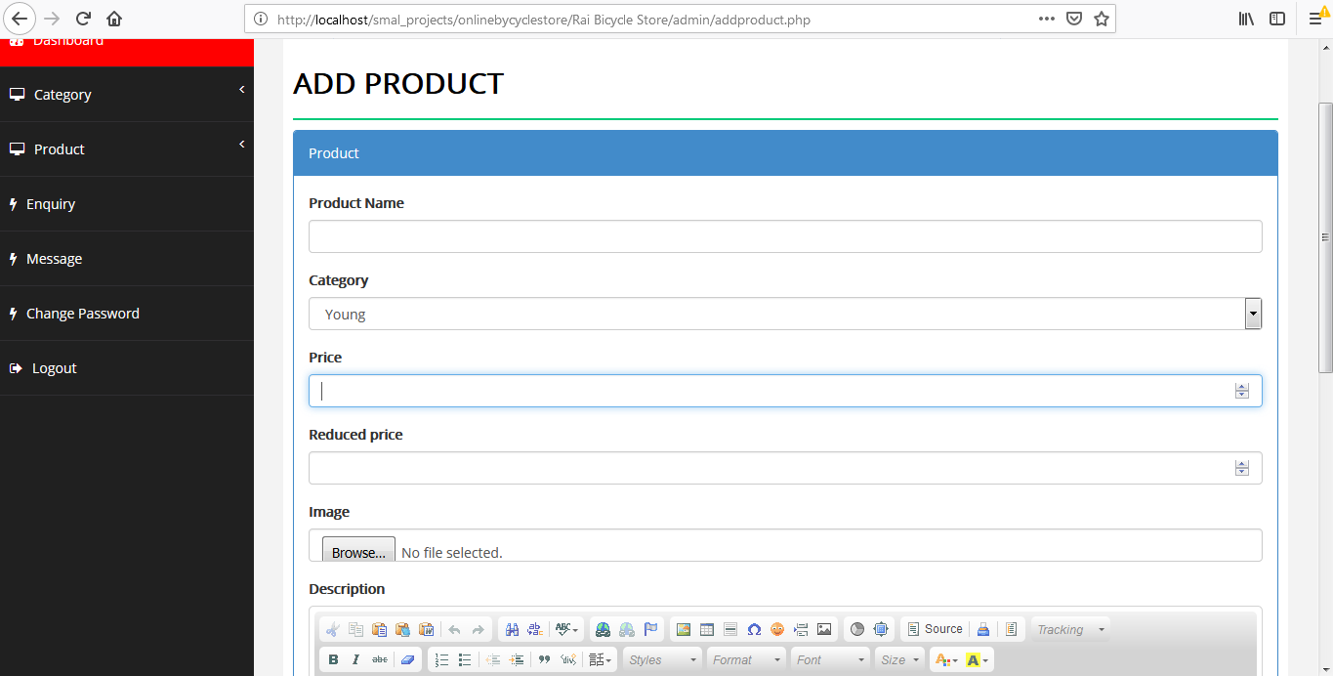

Product List :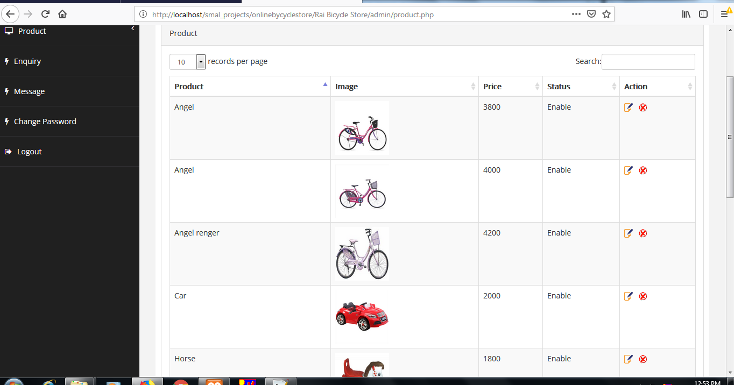

Change Password:
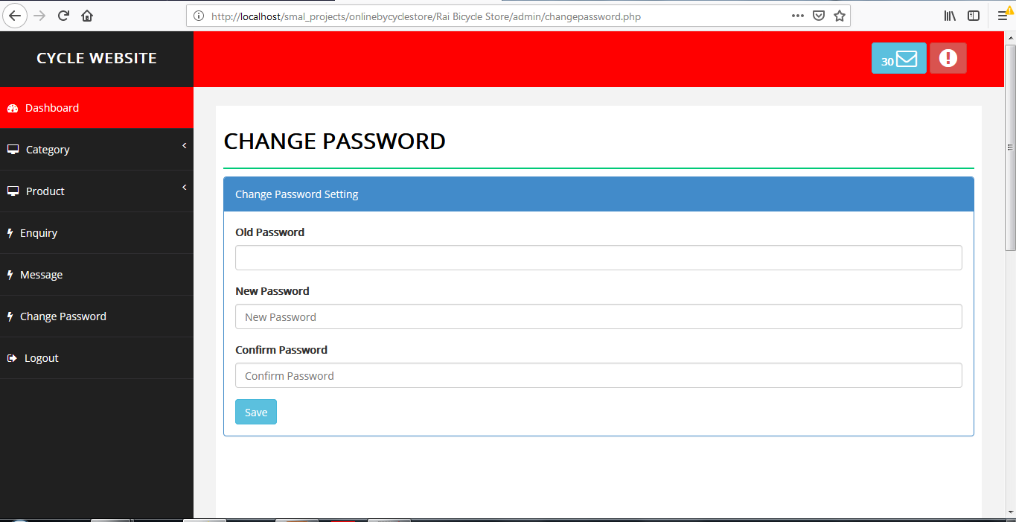

Enquiry:
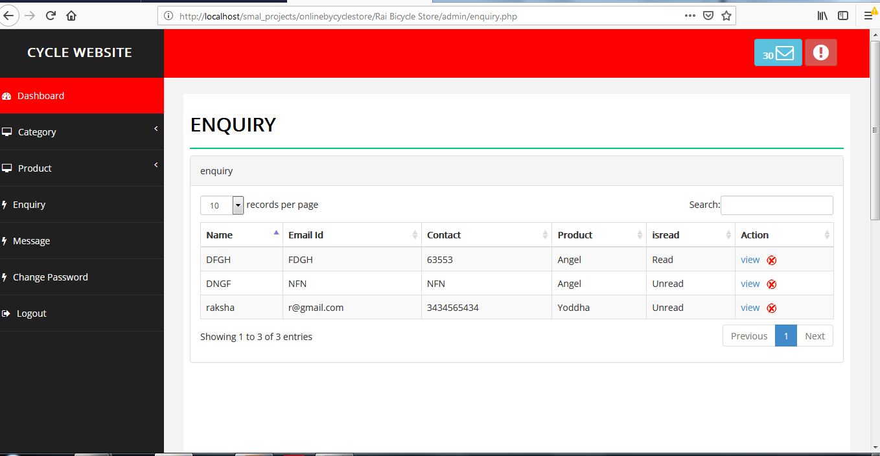

Message:

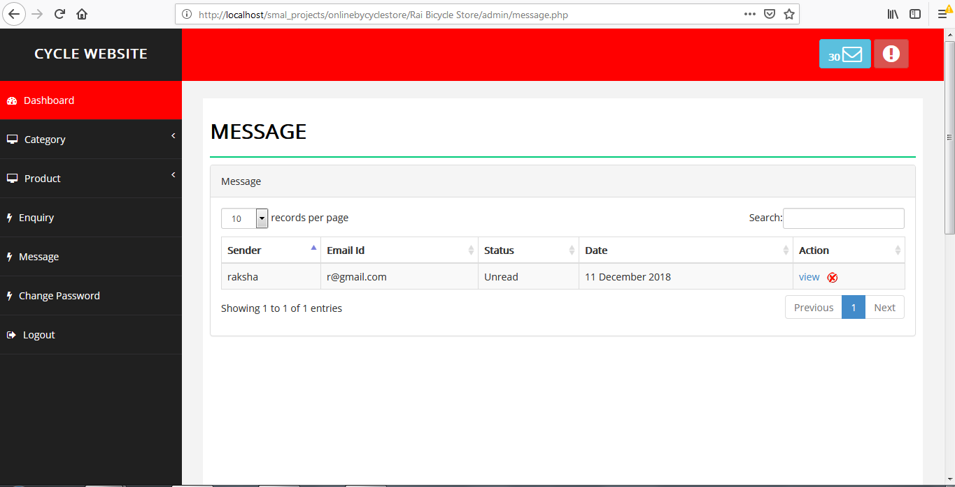

Database Tables:
Database
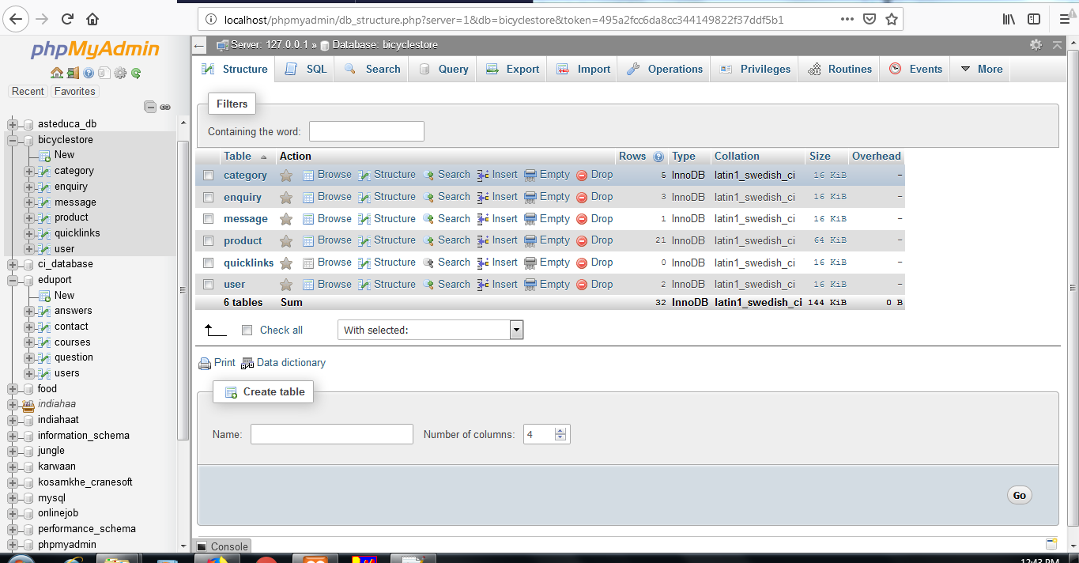

Category
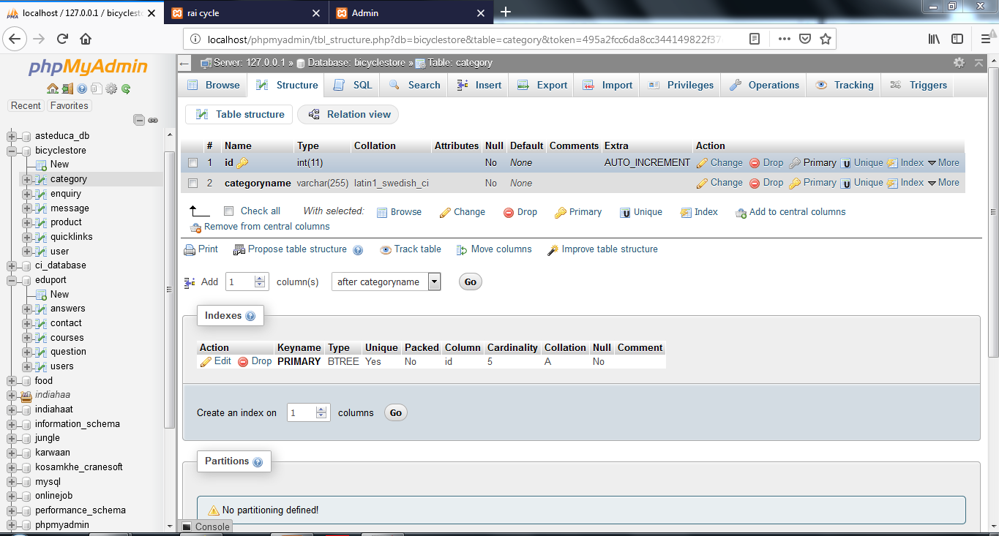

Enquery:
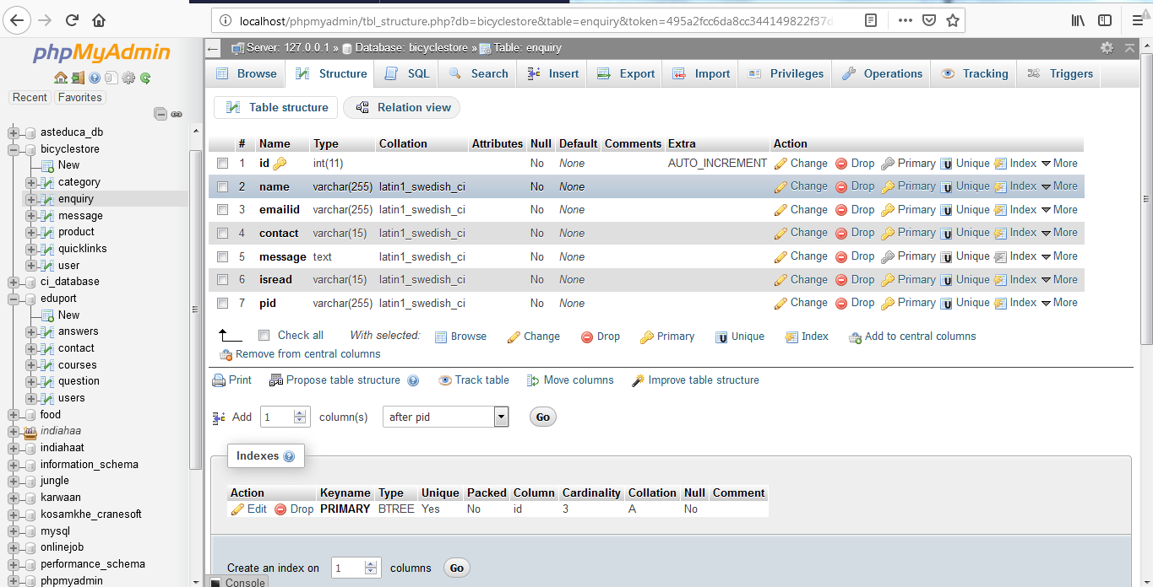

message: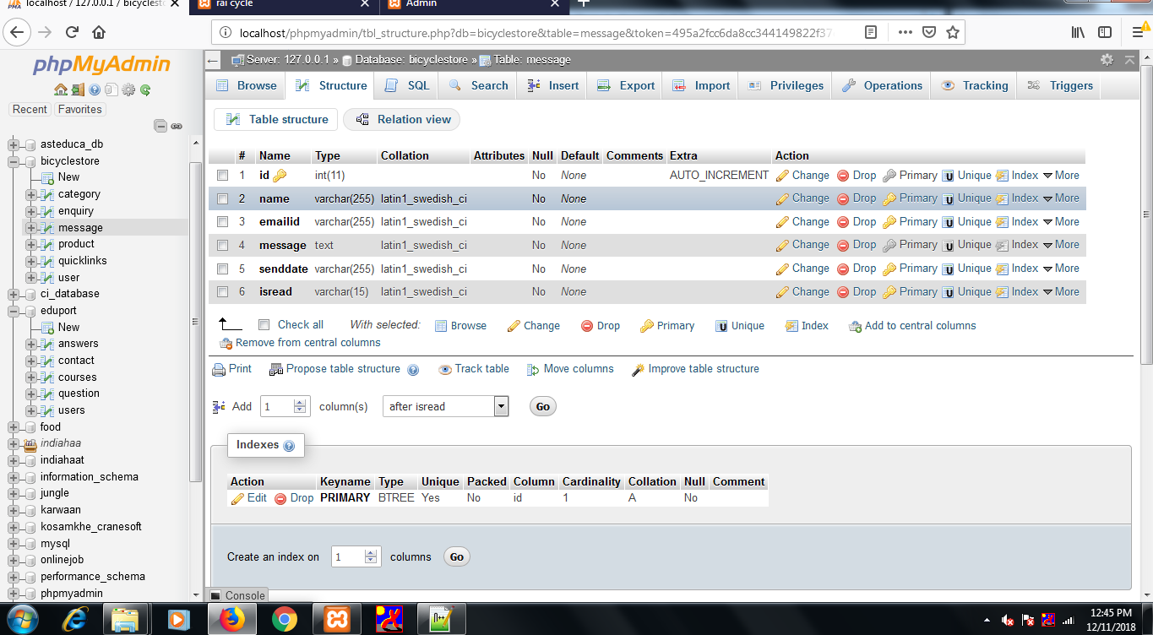

Product:
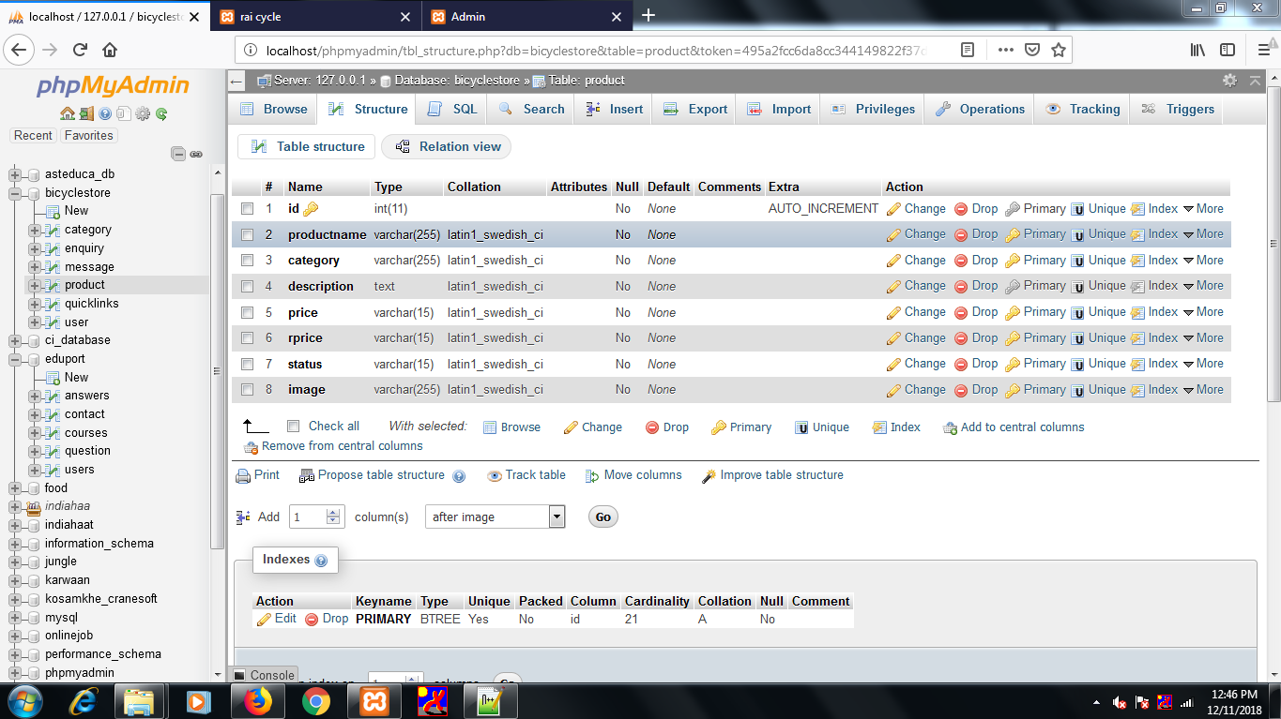
User:

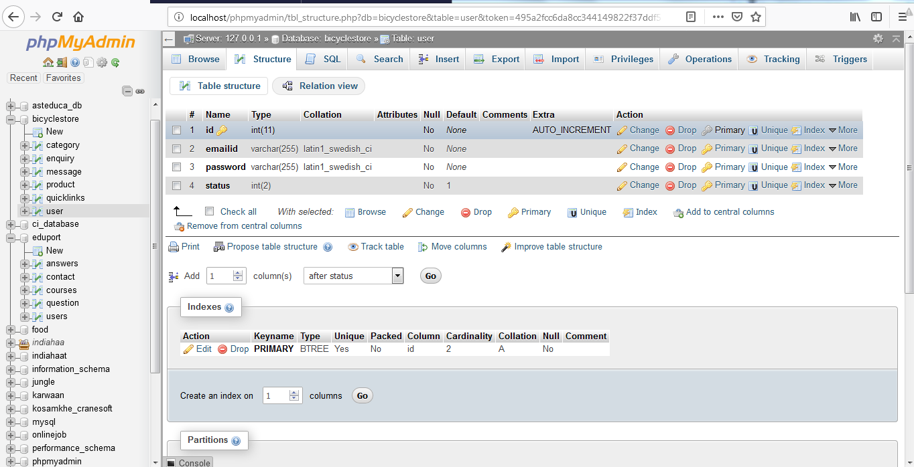
TESTING
Software Testing is the process used to help identify the correctness, completeness, security, and quality of developed computer software. Testing is a process of technical investigation, performed on behalf of stakeholders, that is intended to reveal quality-related information about the product with respect to the context in which it is intended to operate. This includes, but is not limited to, the process of executing a program or application with the intent of finding errors. Quality is not an absolute; it is value to some person. With that in mind, testing can never completely establish the correctness of arbitrary computer software; testing furnishes a criticism or comparison that compares the state and behavior of the product against a specification. An important point is that software testing should be distinguished from the separate discipline of Software Quality Assurance (SQA), which encompasses all business process areas, not just testing. There are many approaches to software testing, but effective testing of complex products is essentially a process of investigation, not merely a matter of creating and following routine procedure. One definition of testing is "the process of questioning a product in order to evaluate it", where the "questions" are operations the tester attempts to execute with the product, and the product answers with its behavior in reaction to the probing of the tester[citation needed]. Although most of the intellectual processes of testing are nearly identical to that of review or inspection, the word testing is connoted to mean the dynamic analysis of the product—putting the product through its paces. Some of the common quality attributes include capability, reliability, efficiency, portability, maintainability,
CONCLUSION
This website displays the latest bicycle products. This helps the user to get the information about what are the latest products available in the market. It provides whole information about the product with its price. If user wants to know more about the product or have any query about the product can send enquiry message to the user.
BIBLIOGRAPHY AND REFERENCES

- http://www.w3schools.com/html/html_intro.asp
- http://www.w3schools.com/css/css_background.asp
- http://www.w3schools.com/js/js_datatypes.asp
- http://www.w3schools.com/sql/sql_insert.asp
- http://www.w3schools.com/sql/sql_update.asp
- http://www.w3schools.com/php/php_forms.asp
- Fundamentals of software engineering by Rajib mall,PHIlearning
- Web development and application development by Ivan Byross BPB publications

