Name:- Priyanka mohan hasurkar

Email - priyankahasurkar2000@gmail.com

Contact no-8623014789

Topic name- Artificial intelligence chatbot using python

College name:- Rizvi college Bandra

ARTIFICIAL INTELLIGENCE CHATBOT USING PYTHON

ABSTRACT:A chatbot is merely a computer program that fundamentally simulates human conversations. A chatbot that functions through AI and machine learning has an artificial neural network inspired by the neural nodes of the human brain. Chatbots are programs that can do talk like human conversations very easily
KEYWORDS: Chatbot, Chatbot architecture, Artificial Intelligence, NLU (Natural language understanding), python main keywords.

I.INTRODUCTION
A chatbot is a computer program that uses artificial intelligence (AI) and natural language processing (NLP) to understand customer questions and automate responses to them, simulating human conversation.
A chatbot (conversational interface, AI agent) is a computer program that can understand human language and converse with a user via a website or a messaging app. Chatbots can handle various tasks online — from answering simple questions and scheduling calls to gathering customer feedback

II.LITERATURE SURVEY

Artificial intelligence is intelligence demonstrated by machines, in contrast to the natural intelligence displayed by humans and other animals. ChatterBot is a Python library that is developed to provide automated responses to user inputs. It makes utilization of a combination of Machine Learning algorithms in order to generate multiple types of responses.Python. AI chatbots leverage a technology called Natural Language Processing (NLP) that deciphers the human language for the chatbot to interpret and give responses. NLP makes it possible for bots to not sound like bots and sound like humans instead.

III.PROGRESS IN CHATBOT
A.A review on Chat system:- This unit is the front end of the system. Chat refers to the process of communicating, interacting and/or exchanging messages over the Internet. It involves two or more individuals that communicate through a chat-enabled service or software. Advertisements. Chat is also known as chatting, online chat or Internet chat.Therefore, it can be said that the chat interface is the face of the system through which the entire communication takes place .
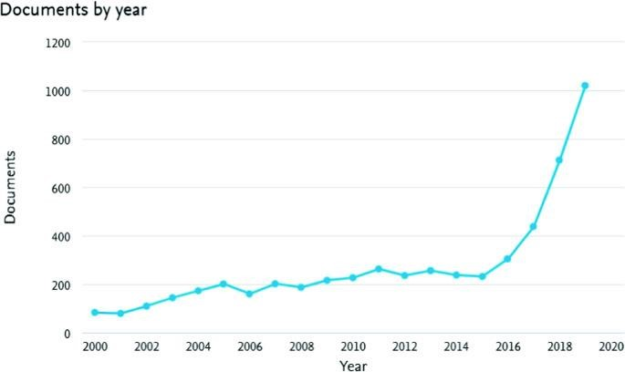

Fig 1: Development of Chabot
B.A review on NLU Engine natural language understanding (NLU) is a data science competency that allows artificial intelligence to understand human communication. Natural language understanding is a branch of artificial intelligence that uses computer software to understand input in the form of sentences using text or speech. NLU enables human-computer interaction.
C.A review on Word Segmentation also referred to as tokenization is the process of splitting text into smaller and meaningful units.Segmenting is a skill that focuses on breaking up words into their individual sounds. For example, when we spell the word dog, we separate it into its three separate sounds: /d/-/o/-/g/. It’s important to note that the length of the word doesn’t matter. What matters are the individual sounds the word produces. The tokenizers split the sentences into words and punctuations marks as independent units.
D.A review on POS Tagging POS Tagging is the process of assigning grammatical annotations to individual words in the sentences. These annotations include the Parts-Of-Speech Tags. They denote the grammatical importance of the word in the sentence based on the dependency of that word with other words in that phrase, clause, sentence, paragraph, etc. The common POS tags are noun, verb, pronoun, etc. There are number of ways which can be used to perform the POS Tagging.
F.A review on Dependency a situation in which you need something or someone and are unable to continue normally without them: Some parents infantilize young adults and keep them in a permanent state of dependency. We need to reduce our dependency on fossil fuels. It is the next step after parsing. A dependency tree or graph is created for every sentence. This tree is called as the parsing tree or the dependency tree. There are a number of ways by which the parsing can be implemented.
E.A review on Synonym and Pattern Recognition For information retrievals, no matter how big our data is, no sentence sent by the user can be perfectly same to any sentence in the database. But there can be sentences with the same intent. After understanding the intent of the user sentence, the database is checked for a sentence with the same intent. The matched sentences have difference of words which are used to express the same content.
G.A review on Decision or ML Engine the act or process of deciding something especially with a group of people. The project will require some difficult decision-making. It is used to make predictions to predict the responses for the user queries and also to update the system from its experiences. It keeps updating the databases as and when it encounters something new from the user.

H.A review on NLG Engine Upon processing statistical data present in spreadsheets, NLG can produce data-rich information unlike Natural Language Processing that only assesses texts to form insights. With Natural Language Generation, data can be assessed, analyzed and communicated with precision, scale and accuracy

IV.PROPOSED SYSTEM

It makes utilization of a combination of Machine Learning algorithms in order to generate multiple types of responses .Chatbots are conversational tools that perform routine tasks efficiently. People like them because they help them get through those tasks quickly so they can focus their attention on high-level, strategic, and engaging activities that require human capabilities that cannot be replicated by machines.

V.SYSTEM ARCHITECTURE
Typical chatbot architecture should consist of the following:

- Chat window/ session/ or frontend application interface.
- The deep learning model for Natural Language Processing [NLP].
- Corpus or training data for training the NLP model Application Database for processing actions to be performed by the chatbot.

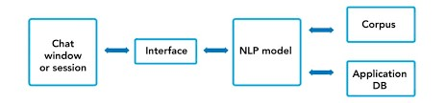

Fig 3: System Architecture
- Corpus or Training Data: Corpus means the data that could be used to train the NLP model to understand the human language as text or speech and reply using the same medium. Corpus is usually huge data with a lot of human interactions.
- Chatbot window: We have designed a function which enables the user to interact with bot using text. The function keeps the chat window alive unless it is asked to break or quit. The name of our text bot is Jason.
- Evaluate or test the chatbot: There could be multiple paths using which we can interact and evaluate the built text bot.

D) Data pre-processing
Text case [upper or lower] handling: Convert all the data coming as an input [corpus or user inputs] to either upper or lower case. This will avoid misrepresentation and misinterpretation of words if spelt under lower or upper cases.
E) Tokenization: Convert a sentence [i.e., a collection of words] into single words.


Fig 4: Tokenization process

F) Stemming: It is a process to find similarities between words with the same root words. This will help us to reduce the bag of words by associating similar words with their corresponding root words.
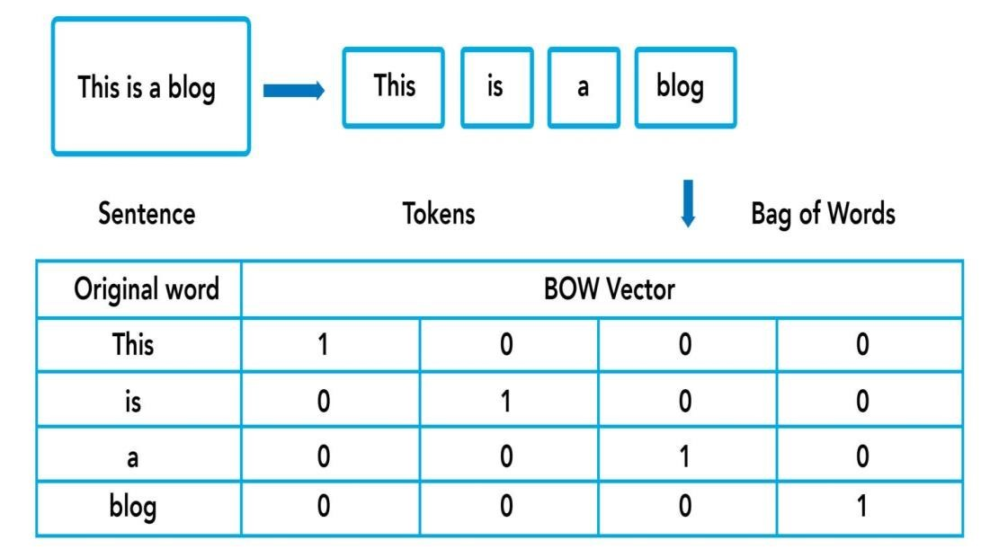

Fig 5: Stemming process

G) Generate BOW [Bag of Words]: Process of converting words into numbers by generating vector embeddings from the tokens generated above. This is given as an input to the neural network model for understanding the written text.

VI.MODULES
It has three python code modules.
- Intents.json:intents classification or recognization it is a type of getting a spoken or written text and then classifying it based on what the user wants to achieve.
- Trainer.py: Defines the Chatbot overall file structure and contains the intent, actions, slots, stories, domain, config and endpoint details. The code will train an NLU and dialogue model to retrieve weather from the Yahoo weather API. Model folder contains the trained models. It will also start the server with actions and also runs the chatbot on the command line. Execute only this code as it will trigger the actions and run.py.
- Run.py: triggered by trainer.py. contains the modules to run the chatbot module in the command line.

VII.IMPLEMENTATION
- Build a command-line chatbot with ChatterBot
- Train the chatbot to customize its responses
- Export your WhatsApp chat history
- Perform data cleaning on the chat export using regular expressions
- Retrain the chatbot with industry-specific data
- Then we follow the steps of following:-
- Step(1):-create a chatbot using python chatterbot
- Step (2):-begin training your chatbot
- Step(3):-export a dialogue chat
- Step(4):-clean your chat export
- Step(5):-train your chatbot on custom data and start chatting also.
- example, the chatbot may respond: “Would you like to tell me as well an example sentence with the word environment?”.

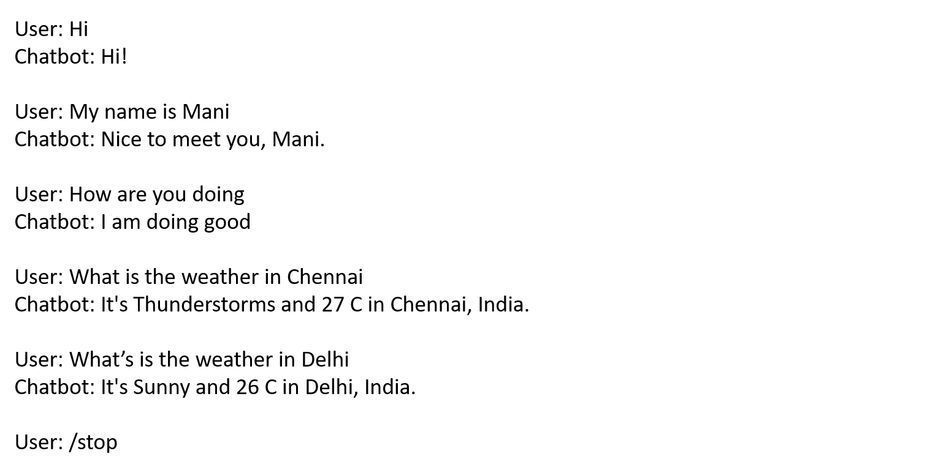
Fig 6: Chatting process

VII.RESULT

It makes utilization of a combination of Machine Learning algorithms in order to generate multiple types of responses. This feature enables developers to construct chatbots using Python that can communicate with humans and provide relevant and appropriate responses.

VIII.CONCLUSION
In this project, we have introduced a chatbot that is able to interact with users. This chatbot can answer queries in the textual user input. For this purpose, AIML with program-o has been used. The chatbot can answer only those questions which he has the answer in its AIML dataset.

FERENCES
- DR.C.K.Gomathy , V.Geetha , S.Madhumitha , S.Sangeetha , R.Vishnupriya Article: A Secure With Efficient Data Transaction In Cloud Service, Published by International Journal of Advanced Research in Computer Engineering & Technology (IJARCET) Volume 5 Issue 4, March 2016, ISSN: 2278 – 1323.
- Dr.C.K.Gomathy,C K Hemalatha, Article: A Study On Employee Safety And Health Management International Research Journal Of Engineering And Technology (Irjet)- Volume: 08 Issue: 04 | Apr 2021

- Dr.C K Gomathy, Article: A Study on the Effect of Digital Literacy and information Management, IAETSD Journal For Advanced Research In Applied Sciences, Volume 7 Issue 3, P.No-51-57, ISSN NO: 2279-543X,Mar/2018

[4] Dr.C K Gomathy, Article: Supply chain-Impact of importance and Technology in Software Release Management, International Journal of Scientific Research in Computer Science Engineering and Information Technology ( IJSRCSEIT ) Volume 3 | Issue 6 | ISSN : 2456-3307, P.No:1-4, July-2018.

[5]C K Gomathy and V Geetha. Article: A Real Time Analysis of Service based using Mobile Phone Controlled Vehicle using DTMF for Accident Prevention. International Journal of Computer
Applications 138(2):11-13, March 2016. Published by Foundation of Computer Science (FCS), NY, USA,ISSN No: 0975-8887

[6]C K Gomathy and V Geetha. Article: Evaluation on Ethernet based Passive Optical Network Service
Enhancement through Splitting of Architecture. International Journal of Computer Applications 138(2):14-
17, March 2016. Published by Foundation of Computer Science (FCS), NY, USA, ISSN No: 0975-8887

[7]C.K.Gomathy and Dr.S.Rajalakshmi.(2014), “A Software Design Pattern for Bank Service Oriented Architecture”, International Journal of Advanced Research in Computer Engineering and Technology(IJARCET), Volume 3,Issue IV, April 2014,P.No:1302-1306, ,ISSN:2278-1323.

[8]C. K. Gomathy and S. Rajalakshmi, “A software quality metric performance of professional management in service oriented architecture,” Second International Conference on Current Trends in Engineering and Technology – ICCTET 2014, 2014, pp. 41-47, doi: 10.1109/ICCTET.2014.6966260.

[9]Dr.C K Gomathy, V Geetha ,T N V Siddartha, M Sandeep , B Srinivasa Srujay Article: Web Service Composition In A Digitalized Health Care Environment For Effective Communications, Published by International Journal of Advanced Research in Computer Engineering & Technology (IJARCET) Volume 5 Issue 4, April 2016, ISSN: 2278 – 132

