Word embedding over linguistic features for fake news detections
Chandana.H.R,Soundarya,Treesa mariam koriam,Mr.Jayakumar B.L
CSE department of sea collage of engineering and technology
----------------------------------------------------------***------------------------------------------------------

Abstract – Social media is a popular medium for the dissemination of real-time news all over the world. Easy and quick information proliferation is one of the reasons for its popularity.An extensive number of users with different age groups, gender, and societal beliefs are engaged in social media websites. Despite these favorable aspects, a significant disadvantage comes in the form of fake news, as people usually read and share information without caring about its genuineness. Therefore, it is imperative to research methods for the authentication of news. To address this issue, this article proposes a two-phase benchmark model named WELFake based on word embedding (WE) over linguistic features for fake news detection using machine learning classification. The first phase preprocesses the data set and validates the veracity of news content by using linguistic features. The second phase merges the linguistic feature sets with WE and applies voting classification. To validate its approach, this article also carefully designs a novel WELFake data set with approximately 72 000 articles, which incorporates different data sets to generate an unbiased classification output.
Key Words: Index Terms—Bidirectional encoder representations from transformer (BERT), convolutional neural network (CNN), fake news, linguistic feature, machine learning (ML), text classification, voting classifier, word embedding (WE).
1.INTRODUCTION
Nowadays people around the world are getting much involved on online social networks regardless of age, community, or sex. Communicating using social networks is simple, fast, and attractive to share and transfer information. Currently, social network sites like Facebook trailed by Twitter are the market pioneers, facilitating over 1.3 billion clients with a dynamic monthly variation of 300 million users in average. Their collaborations generate Terabytes of information every second . Online social networks are attractive because of the simple and convenient way to access and circulate information with other people. However, the fast scattering of data at a high rate with minimal effort enables the widespread of false information, such as fake news, which are harmful to society and people. Fake news are low-quality information with purposefully false data, propagated by individuals or bots that deliberately manipulate message for tattle or political plans. Schudson and Zelizer claimed that the term “fake news” originated in previous centuries together with the mass media itself. Nevertheless, this term attracted increased attention after the U.S. presidential elections of 2016, when the propagation of fake news on social media pulled the attention of a larger number of online users than traditional newsreaders. In the last five months before the elections, approximately 7.5 million tweets contained a link to exceptionally one-sided or false news websites. An interesting and worrying aspect is that false and unsubstantiated news from doubtful sources attracts more audiences than credible information. Relevant work on this topic concluded that fake news spread quicker, penetrate further, and have a deeper impact than true news. There are numerous cases where people accept and spread news without checking their correctness certified by sources. By doing this, they become part of a group that deliberately or unintentionally propagates fake news. The intention behind the proliferation of fake news may be manipulation of public views for financial or political benefit, or simply fun. The negative consequences of this phenomenon are, therefore, undeniable, ranging from wrong decision-making to episodes of bullying and violence. Fig. 1(a) and (b) shows two common examples of fake news over social networks.

Fig 1: Fake news examples. (a) Decontextualized news. (b) False news.
As online social networks are major sources of information that can mislead individuals or communities, there is a serious need for solutions to verify the authenticity of the content. Many researchers consistently try to develop machine learning (ML) models with different sets of features targeted toward automating the fake news detection process using visual or text-based linguistic approaches.
However, the following four questions remain unanswered.
1) Which linguistic features are most significant in classifying the news data into real and fake?
2) Which word embedding (WE) technique with linguistic features predicts fake news better than other ML methods like convolutional neural networks (CNNs) or bidirectional encoder representations from transformers (BERTs)?
3) Which classification method is the most appropriate for fake news detection on available data sets?
4) Does ensemble voting classifier improve the fake news detection results?
To answer these questions, we propose a new method called WELFake exclusively focused on text data in three stages.
1) Fake news prediction using linguistic feature sets (LFS);
2) WE over LFS for improved fake news detection over a WELFake data set.
3) Comparative analysis of the linguistic features based results with state-of-the-art CNN and BERT methods.
The WELFake model does not require additional metadata information related to the user or media [24] for the classification of real and fake news. Instead, it aims for a reformation of the state-of-the-art techniques in the detection of fake news over social media websites by using a combined LFS and WE technique. We highlight three contributions of our WELFake model.

A. WELFake Data Set [25]
We designed a larger WELFake data set to prevent overfitting of classifiers and enable better ML training. For this purpose, we merged four popular news data sets (i.e., Kaggle, McIntire, Reuters, and BuzzFeed Political) and prepared a more generic data set of 72134 news articles with 35028 real and 37106 fake news.

B. WELFake Fake News Detection Model
We proposed a novel WELFake model for fake news detection in two steps.
- collection of various linguistic features from state-ofthe-art methods and identification of a subset that performs well on the larger WELFake data set, and
- ensemble learning on WE features using various ML methods.

C. WELFake Model Generalization and Validation
We applied an adversarial approach to evaluate the model generalization and effectiveness by training and testing on separate data sets.
Experimental results on the WELFake data set revealed that our model achieved a fake news classification accuracy of up to 96.73%, which improves the state of the art by 4.25% over CNN and by 1.31% over BERT methods.
The article has eight sections. Section II gives a background overview on text classification methods. Section III highlights the related work. Section IV describes the proposed methodology and the WELFake model, followed by the resulting algorithm in Section V. Section VI describes the implementation of CNN and BERT state-of-the-art methods for fake news classification used for direct comparison. Section VII provides evaluation results and further related work comparison. Section VIII concludes the article and highlights the future work.
2. TEXT CLASSIFICATION BACKGROUND
This section discusses several ML [26] methods, including CNN and BERT for text classification.

A. ML Classification Methods
We review in this section a few ML methods [26] used for fake news classification in the WELFake model.
- Naive Bayes: This is a supervised learning algorithm based on Bayes’ theorem that gives fast predictions with better accuracy in the domain of sentiment analysis, spam filtration, and text classification?
- Support Vector Machine: This is a supervised learning algorithm that works for both classification and regression problems. The algorithm finds the best line for set separation and predicts the correct set for new data values.
- Decision Tree: This is a supervised learning algorithm that classifies the data for both categorical and continuous dependent variables. This classifier uses tree structures to solve a problem by distributing complete data sets into homogeneous ones. Internal nodes, branches and leaf nodes in this tree structure represent the data set, the decision rules and the outcome. There are two attribute selection measures for the best attribute node: information gain and Gini index.
- Random Forest: This is a supervised learning algorithm based on ensemble learning that ensembles several decision trees (DTs) into a random forest (RF) and calculates the average results. The large number of trees in the RF may increase the model accuracy.
- K-Nearest Neighbor: This is majorly useful for classification problems based on feature similarity. The algorithm can use any integer value for K based on the problem statement and statistics, and employs the Euclidean, Manhattan, or Hamming metric for calculating the distance between data.
- Boosting: This connects all base learners sequentially. Initially, it passes a few records to the first base learner
(BL₁) (of any model) for training, evaluates all the records on BL₁, and passes the incorrectly classified ones to the second learner (BL₂) for training. BL₂ tests all the records and passes the incorrectly classified ones to the next learner BL₃. This process continues until a specified number of base learners.
Bagging: This is known as bootstrap aggregation, this is an ensemble technique that uses multiple base learners and provides different subsets of the original data set to each model for training (bootstrapping). The testing process decides the output based on the majority votes from the different models (aggregation). Apart from different sample sets, one can train the models with different subsets to reduce over-fitting.

3.ALGORITHM USED
This section reviews the state-of-the-art CNN and BERT classification methods used in our experimental evaluation.
- CNN [27]: This is each sentence into words (called tokens) and converts them into vectors using context-based WE methods like GloVe, Word2vec, and FastText. These vectors join together to form a m ×n matrix for a given sentence, where m is the embedding dimension and n is the number of tokens present in the vocabulary. Next, it applies the filters on the 1-D convolution (Conv1D) layer. This convolution kernel works from top to bottom (single directional) because of the same width of filters. The Conv1D later combines its outcomes and applies pooling (maximum, average, and global) that passes the data to the final fully connected layer. This takes care of the output generated by the pool layer and produces the classification decision depending on the loads appointed to each other inside the text.
- BERT [28]: This is a popular pretrained model for text processing developed by Google, which gives a better sense of the language context compared to unidirectional models in two phases.
- Bidirectional training of an input and output transformer representation model, comprising:
  - an encoder reading the text as input, and
  - a decoder generating the output based on the task;and
- Popular attention mechanism with a neural network (NN) implementing important features only [29].
BERT takes input text and preprocesses it using tokenization, lemmatization, stopword removal, and text lowering operations. Second, it passes the preprocessed text to the encoding phase where additional token, segment, and positional embedding processes take place. Third, it converts the input into default 768 long embedding vectors and passes them through the encoder layers. Finally, the more accurate information of each token available at the last encoding layer passes to the dense layer for text categorization
4.IMPLEMENTATION
FAKE NEWS DETECTION DATA SETS

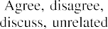
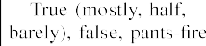

Quantity features explain sentence information such as the number of words and number of sentences.

A.Summary
No single method guarantees the best solution for all data sets. The state-of-the-art approach of Gravanis et al. [37] used 57 linguistic features and embed them with a word-to-vector embedding method on UNBiased data set of less than 4000 articles only. They used all features in a single LFS reasons.

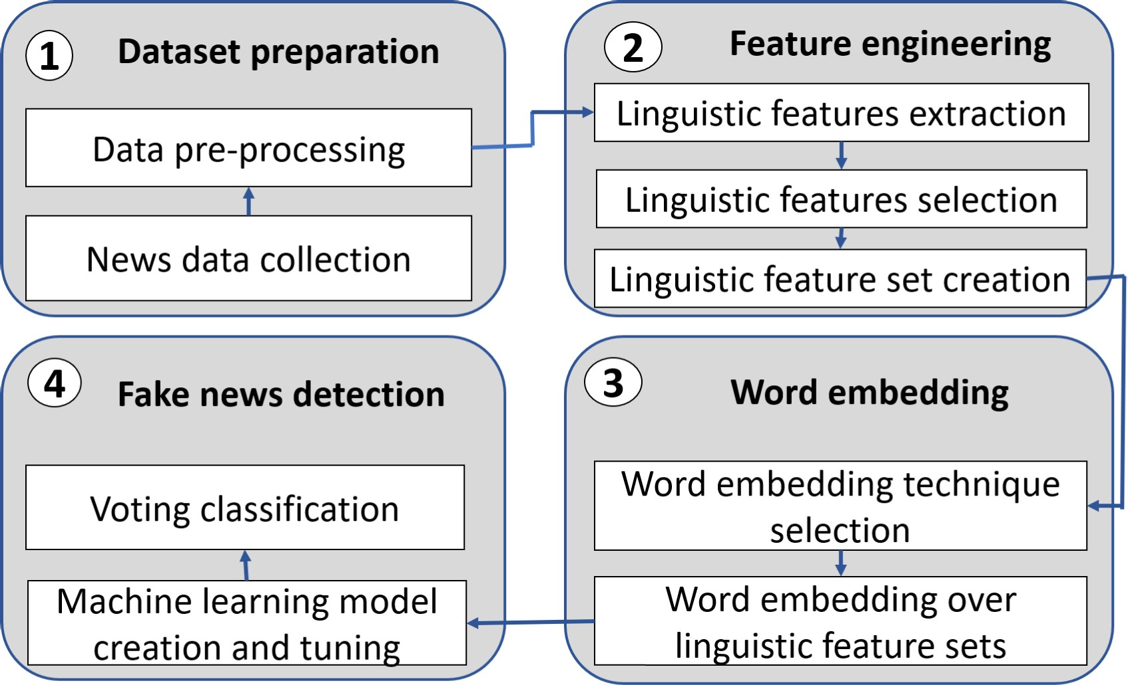

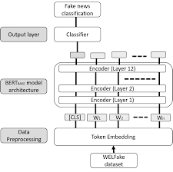

Fig. 2. WELFake Architecture
and achieves up to 95% accuracy. WELFake improves on this method using a novel method based on four stages that:
  - creates a larger data set with improved generalization;
  - identifies the most significant twenty linguistic features and creates three unique LFS based on categories;
  - applies two WE methods to train various ML models; and
  - generates the final prediction using a two-stage voting classification

WELFAKE DATA SET

FAKE VERSUS REAL NEWS DISTRIBUTION IN WELFAKE

and real news distribution in the WELFake data set.

  - multiplication of the term frequency tf(t, d) that computes the occurrence of a term t in a document d and the inverse document frequency idf(t, D) that computes the importance of that term t in a corpus of documents D
TABLE V WELFAKE LFS

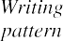
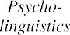
TF-IDF(t, d , D) = tf(t, d) . idf(t, D)

idf(t, D) ln |D|
|{d ∈ D : t ∈ d}|
where f_{d} (t) represents the number of occurrences of the term t in the document d, D is the number of documents in the corpus D, and d D t d is the number of documents containing the term t.
|{ ∈ : ∈ }|
| |
- WE Over LFS: This improves the output prediction, as predefined features do not always accurately predict and need additional training methods. For this purpose, we com- bined the WE with LFS. We applied the TF-IDF and CV WE techniques on the three LFS and found that CV gives better results. We achieved maximum of 95.61% accuracy using SVM on CV, while TF-IDF gave maximum accuracy of 95.12% using bagging. Thus, we selected CV and combined it with LFSs for further accuracy analysis of various models in Section VII-B.
Fake News Detection
  - ML Model Creation and Tuning: This passes the LFS with WE through six ML methods: SVM, NB, KNN, DT, Bagging, and AdaBoost. For this purpose, we experimented with each ML model on random samples of the WELFake data set with four training-testing data combinations: 60%–40%, 70%–30%, 80%–20%, and 90%–10%. To improve the accu- racy, we performed a manual tuning of the six different models using the hyperparameters displayed in Table VI. We sequentially explored different hyperparameter value com- binations from the given possible value ranges and tuned them until we obtained a state-of-the-art accuracy of at least 96%. We evaluated the performance of each ML model on different training and testing data distributions as explained in Section VII-B and found out that a 70%–30% data distribution gives better accuracy for all six ML methods.

  - Voting Classification: This process uses ensemble learn- ing to collect predictive outputs from various models and generates an output that minimizes the error and the over- fitting. There are in general two voting classifier approaches: soft voting based on probability and hard voting based on maximum votes. Since fake news detection is a binary classi- fication problem, we use hard voting that predicts a target variable Y based on the maximum votes mode given by different models M_{i} to a class:
Y = mode{M₁(X), M₂(X), ..., M_{n} (X)}
where X is predictor or input variable.
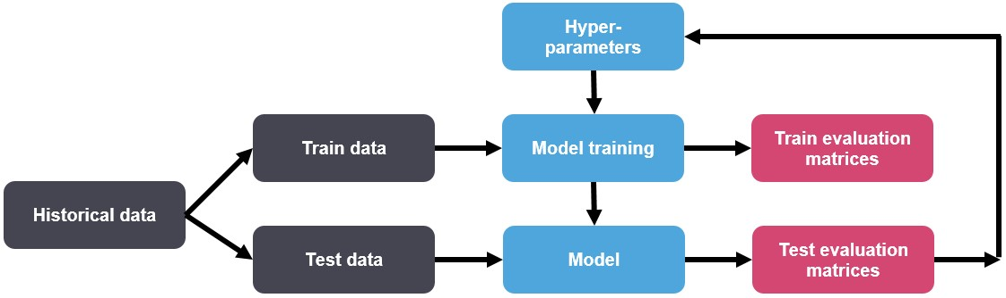

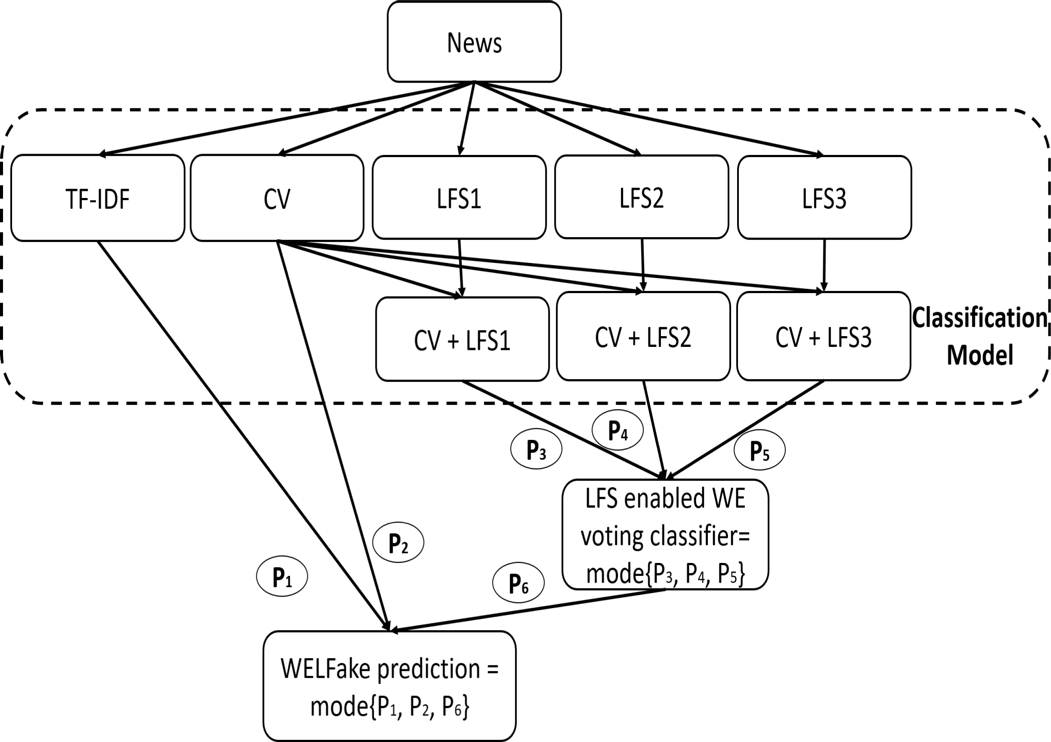

Fig. 3. Sequential Workflow of WELFAKE Model

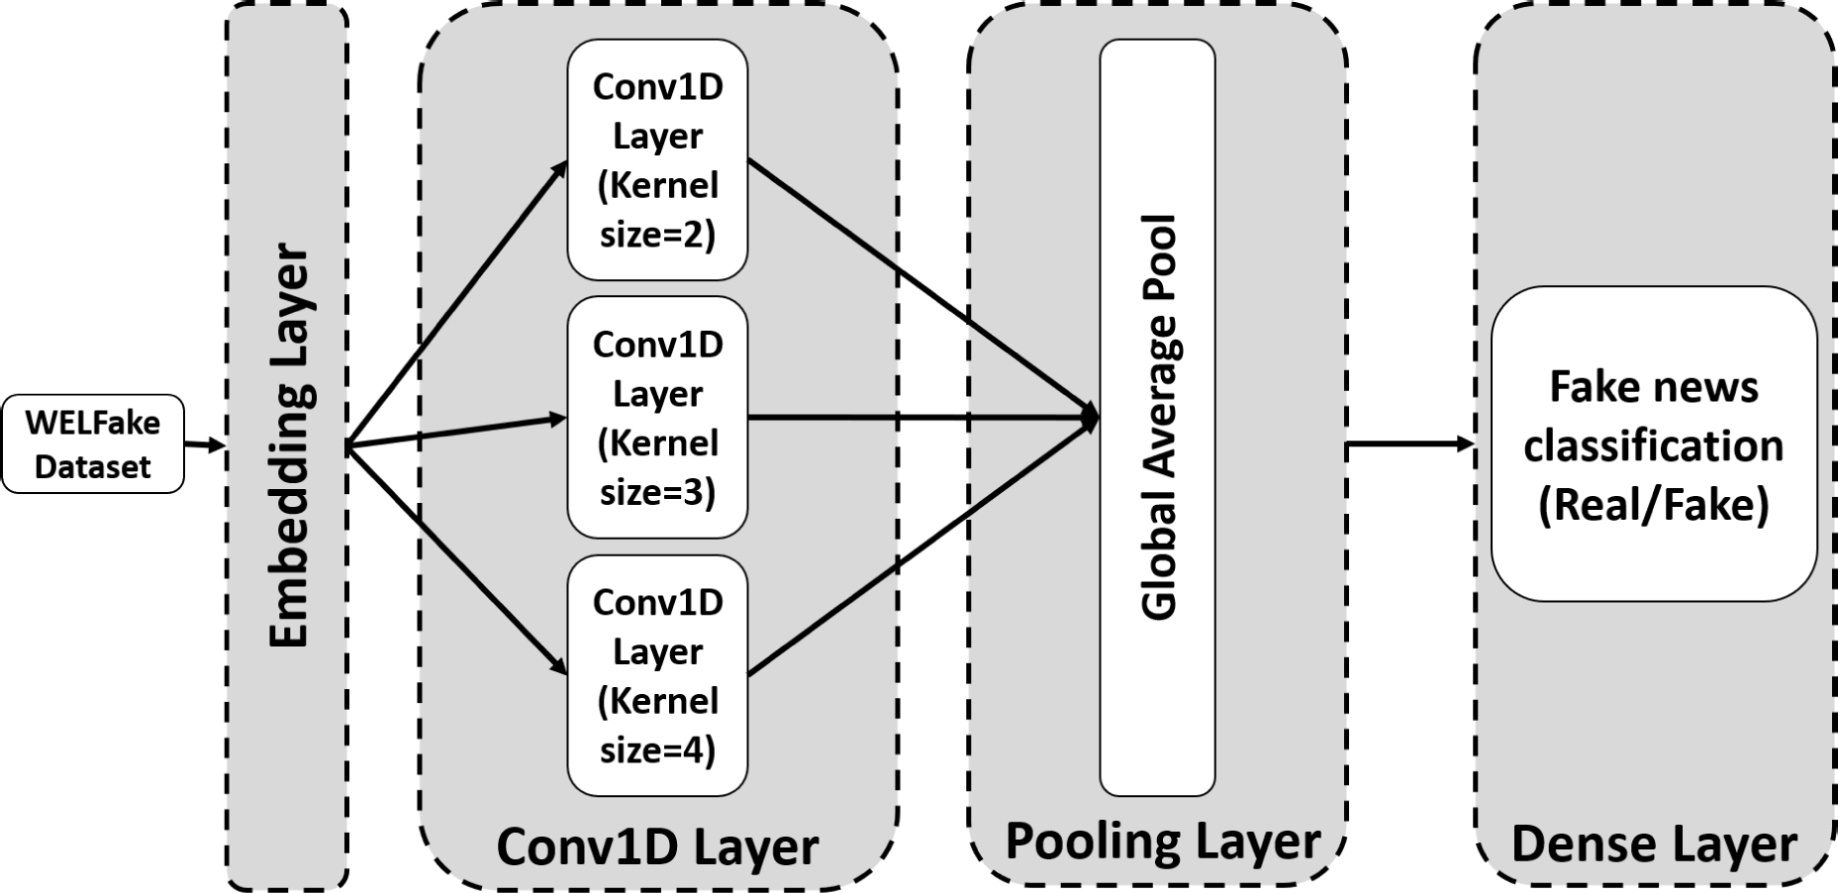
CNN AND BERT IMPLEMENTATIONS ON WELFAKE DATA SET
This section describes the CNN and BERT implementation on the WELFake data set. We performed a hyperparameter tuning to improve their performance, summarized in Table VII.

Algorithm 1: WELFake Fake News Detection Algorithm

Data: Kaggle, McIntire, Reuters, BuzzFeed
Result: WELFake Model for news classification
// Phase 1: data set preparation
1 WELFake_data set collection(Kaggle, McIntire, Reuters, BuzzFeed) // News collection
←
2 WELFake_data set preprocess(WELFake_data set) // Data set pre_processing
←
// Phase 2: feature engineering
3 LF extract(WELFake_data set) // Linguistic feature extraction
←
4 LF selection(LF) // Feature selection using Pearson’s correlation
←
5 LFS split(LF) // Split linguistic features in odd sets
←
// Phase 3: Word embedding
6 CV ← cv(WELFake_data set) // Apply CV technique on data set
7 TF I DF ← tfidf(WELFake_data set) // Apply TFIDF technique on data set
8 Best ← select(CV, TFIDF) // Select best embedding technique with data set
9 foreach LFS_{i} ∈ LFS do
10 CLFS_{i} ← combine(CLFS_{i} , Best)
// Phase 4: ML model tuning and voting classifier
11 Model bestModel(SVM (CLFS), DT (CLFS), NB (CLFS), Bagging (CLFS), AdaBoost (CLFS), KNN (CLFS))
←
// Selection of best model for linguistic feature set
12 vote_hard votingClassifier(Model (CLFS_{i} ));
←
13 return votingClassifier(TFIDF, CV, vote_hard)

6.CONCLUTION AND FUTURE WORK
We presented a new model called WELFake for text fake news detection. For this purpose, we prepared a larger data set called WELFake with over 72 000 news articles combining four open-source data sets (i.e., Kaggle, McIntire, Reuters, and BuzzFeed) to reduce their individual limitation and bias. Afterward, we analyzed over 80 linguistic features from state-ofthe-art works and selected 20 significant ones to minimize the computational complexity and increase the standard classifiers’ accuracy. We applied two WE-based methods (i.e., TF-IDF, CV) over these linguistic features using six ML models (i.e., KNN, SVM, NB, DT, Bagging, and AdaBoost) and found out that CV produces better overall accuracy than TF-IDF with an SVM model. We, therefore, used CV over LFS and classified the 20 features based on four categories: writing pattern, readability index, psycho-linguistics, and quantity. As the number of predictors that participate in the voting classifier needs to be odd, we prepared three LFS by distributing the twenty selected features in a balanced manner across these categories. Afterward, we embedded CV with these LFS and applied all six ML models. We determined the most accurate ML model and took its predicted results from each WE-enabled LFS data set for voting classification. We finally applied the result of this voting classifier to the next level voting classification with the best model results of TF-IDF and CV over LFS and obtained the final classification. Experimental results show that the WELFake model produces a high 96.73% accuracy on the WELFake data set. To further analyze its advantage we compared it with two stateof-theart works and found out that it improves the overall accuracy by 1.31% compared to BERT and 4.25% compared to CNN models. The proposed WELFake model also improved the accuracy by up to 10% on the McIntire and BuzzFeed data sets [37]. We also analyzed the performance of different ML models in terms of accuracy, precision, recall, and F1-score, and found out that SVM produced the most accurate results. Finally, our frequency-based model focused on analyzing writing patterns outperformed predictive-based related works implemented using the Word2vec WE method by up to 1.73%. We plan to extend our work in the future with other factors like knowledge graphs and user credibility for further verification of the output generated by the WELFake model.
7.REFERENCES
[1] Ajeet Ram Pathak, Aditee Mahajan, Keshav Singh, Aishwarya Patil, Anusha Nair: “Analysis of Techniques for Rumor Detection in Social Media”, International Conference on Computational Intelligence and Data Science (ICCIDS), 2019, volume-167, pp.2286-2296,DOI:10.1016/j.procs.2020.03.281. [2]Aswinithota,PriyankaTilak,SimratAhluwalia,NibratLohia:“FakeNewsDetection:ADeepLearningApproach”,S MUDataScienceReview,2018,volume-1,issu e-3,Article-10. [3] Caio V. Meneses Silva, Raphael Silvsa Fontes, Methanias Colaco Junior: “Intelligent Fake News Detection: A Systematic Mapping”, Journal of Applied Security, 2020,nDOI:10.1080/19361610.2020.1761224. [4] Dong-Ho Lee, Yu-Ri Kim, Hyeong-Jun Kim, Seung-Myun Park, Yu-Jun Yang: “Fake NewsDetectionusingDeepLearning”,JournalofInformationProcessingSystems(JIPS),2019,volume15,issue5,pp.1119-1130, DOI: 10.3745/JIPS.04.0142. [5] Fatmeh Torabi Asr, Maite Taboada:“Big Data and quality data for Fake News and misinformation detection”, Big Data & Society, 2019, Article-14, DOI:10.1177/2053951719843310. [6] Harita Reddy, Namratha Raj, Manali Gala, Annappa Basava: “Text-mining-based Fake News Detection Using Ensemble Methods”, International Journal of Automation and Computing,DOI:10.1007/s11633-019-1216- 5. [7] James Bradbury, Stephen Merity, CaimingXiong, Richard Socher: “Quasi-Recurrent Neural Networks”, International Conference of Learning Representations(ICLR),2017. [8] MeichangGuo, ZhiweiXu, Limin Liu, MengjieGuo, and Yujun Zhang: “An Adaptive Deep Transfer Learning Model for Rumor Detection without Sufficient Identified Rumors”, Mathematical Problems in Engineering, 2020, article ID-7562567, DOI:10.1155/2020/7562567. [ 9] PranavBharti,MohakBakshi,R.AnnieUthra:“FakeNewsDetectionUsingLogistic [10] Regression, Sentiment Analysis and Web scrapping”, International Journal of Advanced Science and Technology (IJAST),2020,volume-29,issue-9,pp.115–1167. [11] Pritika Bahad, Preeti Saxena, Raj Kamal: “Fake News Detection using Bi-Directional LSTM-Recurrent Neural Network”, International Conference on Recent Trends in Advanced Computing (ICRTAC), 2019, volume165,pp.74-82,DOI:10.1016/j.procs.2020.01.072. [12] Ray Oshikawa, Jing Qian, William Yang Wang: “A Survey on Natural Language Processing for Fake News Detection”, Language Resources and Evaluation Conference (LREC), 2020,volume-12. Word Embedding Over Linguistic Features for Fake News Detection Dept. of CSE, SEACET 2022-23 Page70 [13] Rohit KumarKaliyar, Anurag Goswami, Pratik Narang: “Deep Fake: Improving fake news detection using tensor decomposition - based deep neural network”, The Journal ofSupercomputing,2020. [14] SachinKumar, Rohan Asthana, Shashwat Upadhyay, Nidhi Upreeti, Mohammad Akbar: “Fake News Detection using Deep Learning models: A Novel Approach”, Transactions on Emerging Telecommunication Technologies, 2019, volume-31, issue-2, DOI:10.1002/ett.3767. [15] Sebastian Kula, Michal Choras, Rafal Kozik, Pawel Ksieniewicz, Michal Woznaik: “Sentiment Analysis for Fake News Detection by Means of Neural Networks”, International Conference on Computational Science (ICCS), 2020, volume-12140, pp.653-666, DOI:10.1007/978-3-030-50423-6_49. [16] Tejaswini Yesugade, Shrikant Kokate, Sarjana Patil, Ritik Varma, Sejal Pawar: “Fake News and Deep Fake Detection”, Journal of Critical Reviews, 2020, volume-7, Issue-19. [17] Xinyi Zhou, Reza Zafarani: “A Survey of Fake News: Fundamental Theories, Detection Methods, and Opportunities”, ACM Computing Surveys, Article-109,DOI:10.1145/3395046

