SMART PEST DETECTION
H Sudhakar[1] M Sindhu[2] N Gowtham[3] M Haripriya[4] M Bhagavan[5] M Sasidhar[6]
Asst. Professor, Sir C R Reddy College Of Engineering[1] UG Scholars, Sir C R Reddy College Of Engineering[2,3,4,5,6]

ABSTRACT: An automatic approach for early pest detection. Agriculture not only provides food for the human existence, it is also a big source for the economy of any country. Millions of dollars are being spent to safeguard the crops annually. Insects and pests damage the crops and, thus, are very dangerous for the overall growth of the crop. One method to protect the crop is early pest detection so that the crop can be protected from pest attack. The best way to know about the health of the crop is the timely examination of the crop. If pests are detected, appropriate measures can be taken to protect the crop from a big production loss at the end. Early detection would be helpful for minimizing the usage of the pesticides and would provide guidance for the selection of the pesticides. It has become a wide area for research now a days and a lot of research has been carried out worldwide for automatic detection of pests. Traditional method of examination of the fields is naked eye examination but it is very difficult to have a detailed examination in large fields. To examine the whole field, many human experts are needed which is very expensive and time consuming. Hence, an automatic system is required which can not only examine the crops to detect pest infestation but also can classify the type of pests on crops by using the neural networks which we had already given in the data sets .finally we attained pest detection with an accuracy of 99%..
KEYWORDS : Matlab, Convolutional neural network (CNN), pests, Classification, Object detection, Segmentation.
- INTRODUCTION: India is been called as “land of agriculture” and agriculture is the backbone of India. 75% of the total population of India depends on agriculture. It’s necessary to get a good quality and quantity of crops. Various modern techniques have been introduced in order to help our farmers to yield a better quality and better quantity of food crops. But still our farmers are facing various problems to yield a better food crop and facing huge economic loss. The various problems which are facing by our farmers are: Irrigation problem, getting good quality of fertilizers and seeds, storage of the harvest, and major problem is pest infestation. There are number
of solutions from the government for the above mentioned agricultural issues, except for pest infestation. There is no proper solution from the government for the pest infestation. Presently we can see various crops have been attacked by pests and farmers face huge loss in getting good quality and good quantity of crops which in turn causes economic loss to them. In order to overcome this problem farmers spray pesticides. To spray pesticides there should be better knowledge about the pests and the pesticides. Farmers face lots of problem without getting suitable information about pests and the pesticides. If a farmer sprays pesticides without proper knowledge he may face number of problems. And even by spraying pesticides manually he may face lots of health disorders like skin diseases, breathing problem, skin cancer and many other diseases. A camera is used to take an image of the sticky trap. These manual techniques not only provide inefficient results, but also prove to be a danger for environment. So as a preventative measure, farmers spray pesticides in bulk which is not only harmful for the crops but also harmful for the environment. Recently different methodologies have been used for pest identification and monitoring, which employ image processing and complex algorithms for detection and classification of pests. Automatic detection is the best way which uses image processing techniques for the detection of pests from the crops and classification algorithms to classify them on the basis of the different properties of the images. the images of leaves from the crop fields were taken and then various 2 processing techniques were applied on them. For pest detection, ‘threshold technique’ was used to separate background from the pests on images of leaves. This technique is very simple and accurate in detection of the pests from the images. Different properties of the images are extracted, which can be used as input for support vector machine (SVM) to classify images with pests and without pests. In this paper, the focus has been to examine white flies as these are very small and difficult to examine by the naked eye and can damage the fields on a large scale. The proposed algorithm counts pests on leaves and then estimates the number of the white flies per leaf. This paper

introduces a method using which white flies are automatically identified from the leaves. This proposed technique has proved to be very helpful for timely taking preventive measures, and saves the environment from harmful effect of massive usage of pesticides.
- LITERATURESURVEY:
Proposed an insect detection model for Mosquitos and Ball worm from digital images. They used the colour of insects and the shape of the insect as a feature attribute. For determining the shape of insect RGB to binary conversion done, but this work was developed for only two insect species.

Table:Previous work on pest detection with detection efficiency and used techniques

Year/Reference | Plants | Techniques used | Applications | Detection Effciency
2006[4] | Citrus leaves | CCM,HIS,SGDM | Reduces the  computational time | 95
2009[5] | Wheat kernals | Near-infrared hyper spectral imaging | To investigate the potential of near-infrared (NIR)  hyperspectral imaging for the detection of insect-damaged wheat kernels with highly reproducible  results.
2009[6] | Rice leaves | SVM, Gray level co- occurrence matrix[GLCM},HSM | Classify rice  disease using shape, color and texture feature | 97.2
2009[7] | Banana leaves | RGB, Colour transformation  ,Thresholding technique | Identify diseases region | -
2011[8] | Corn leaves | YCBCR colour space  , Neural Network | Classification  of various diseases | -
2012[9] | Orchard species | Global feature modal | To develop an image-based automated insect identification and classification for orchard field species  classification | 86.6
2013[10] | Cucumber leaves | Median filtering, gray level co-occurrence matrix ,PCA | Detects downy mildew, powdery mildew and anthracnose  disease | 96
2013[11] | Palm oil leaves | Neural Networks | Detects hawar and anthracnose  leaf disease | 87.75
2013[12] | Jujube tree | Neural  networks,Feed for war | Classify  different disease based | 85.33

on color, morphological and texture
features
2014[13] | Common crop | SVM classifier | Develop an automatic insect identification framework that can identify grasshoppers and butterflies from colored  images | 90
2014[14] | Cotton leaves | Skew Divergence ,SVM, BPN, Fuzzy classifier, EPSO(enhanced PSO), Gentic algorithm, CYMK  colour space | Classifies bacterial blight, fusarium wilt, leaf blight, root rot, micro nutrient disease, verticillium wilt | 94
2015[15] | Common crop | Multifracta -l analysis, Watershed and Efficient Graphbased Image Segmentati on (EGBIS) | In this research, multifractal analysis was  adopted for segmentation of whitefly images based on the local singularity and global image characters with the help of regional minima  selection strategy. | 86.9
2016[16] | Pomegranate leaves | SVM, kmean clustering, Color coherence vector (CCV) | Bacterial blight disease identification through  mobile device | 82
2018[17] | Common crop | Otsu’s method and edge  detection segmentati on | Color-based image segmentation using k- means clustering was used for image  segmentation of various | -

pest infected
crops
2019[18] | Common crop | CNN | A diagnostic system based on transfer learning for pest detection and  recognition | 93.84 and 98.92

There are many methods at present for the detection of grain pests, but these methods are not efficient because of its poor accuracy, less efficiency, difficulty in implementation, and not detecting in proper time, etc…So, convolution neural networks(CNN) is used for classification and with that we achieved an accuracy of 99%. In most of the agriculture we observed the pests like Mosquitos and boll worms Here segmentation technique is used in order to detect the presence of pest. Segmentation plays an important role in order to identify the difference between the pest and other parts of the image. Here entropy based thresholding is proposed and the comparison of results is done with the K-mean method. In agricultural field the detection of pest in paddy field is very much challenging. The effective methods have to be developed for pest infestation by which the use of pesticides can be minimized. Different processing techniques have been proposed in this to detect pest. This proposed system gives an efficient, simple and fast solution in pest detection in paddy fields. The experimental results provides a better technique for detecting pest but in future other image processing techniques can be developed in order to detect and extract pests more accurately and efficiently.

Methodology:
Existing method
- The existing method is c means clustering method, in this method the clusters are chosen randomly without forming in any region, the main disadvantage of this method is which reduces the quality of the image. Proposed method
- The proposed method is k means clustering method, in this method the clusters are chosen according to the property, K decides the value of clusters, this method improves the quality of the image.
- A convolutional neural network (CNN) is a type of artificial neural network used in image recognition and processing that is specifically designed to process pixel data, and to know the stage of the pest.

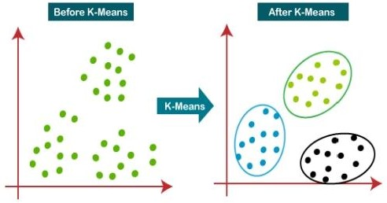
The stages for pest detection on the leaf using image processing are presented in the flowchart given below

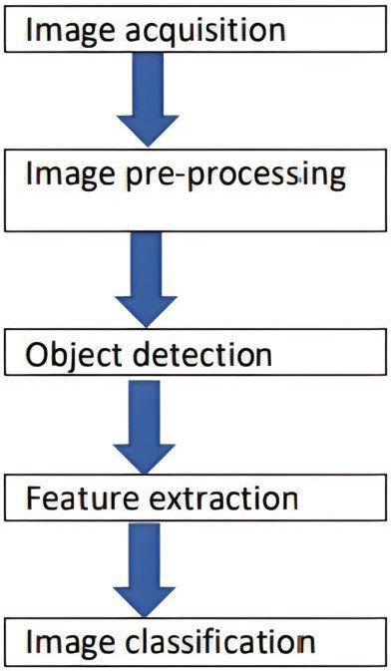

Fully Connected Layer is simply, feed forward neural networks. Fully Connected Layers form the last few layers in the network. The input to the fully connected layer is the output from the final Pooling or Convolutional Layer, which is Fully Connected Layer is simply, feed forward neural networks. Fully Connected Layers form the last flattened and then fed into the fully connected layer.
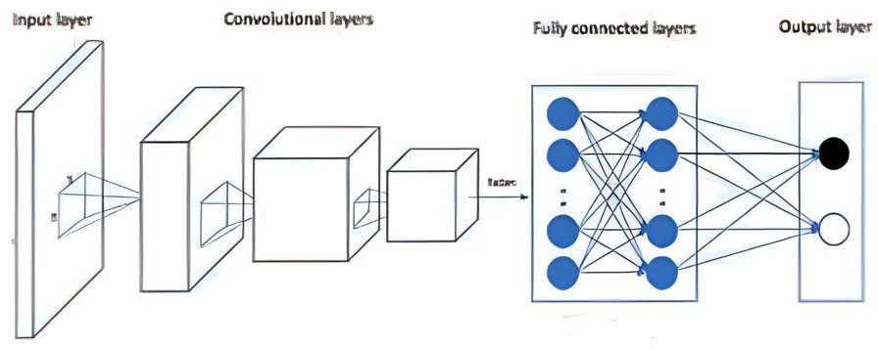

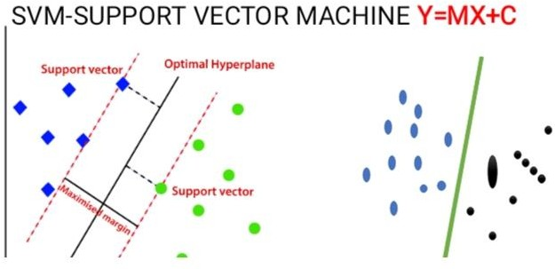
- RESULTS:

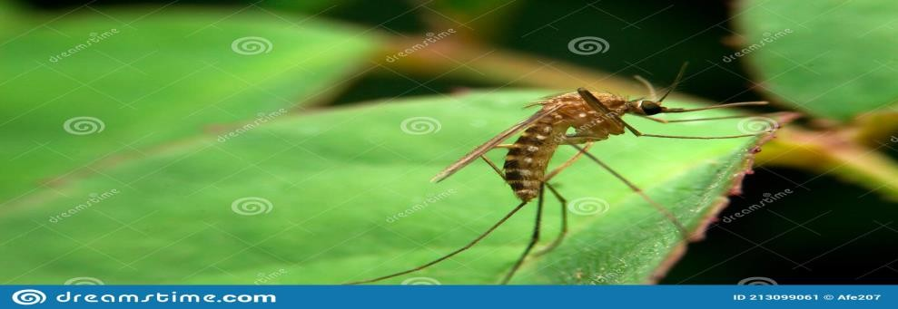

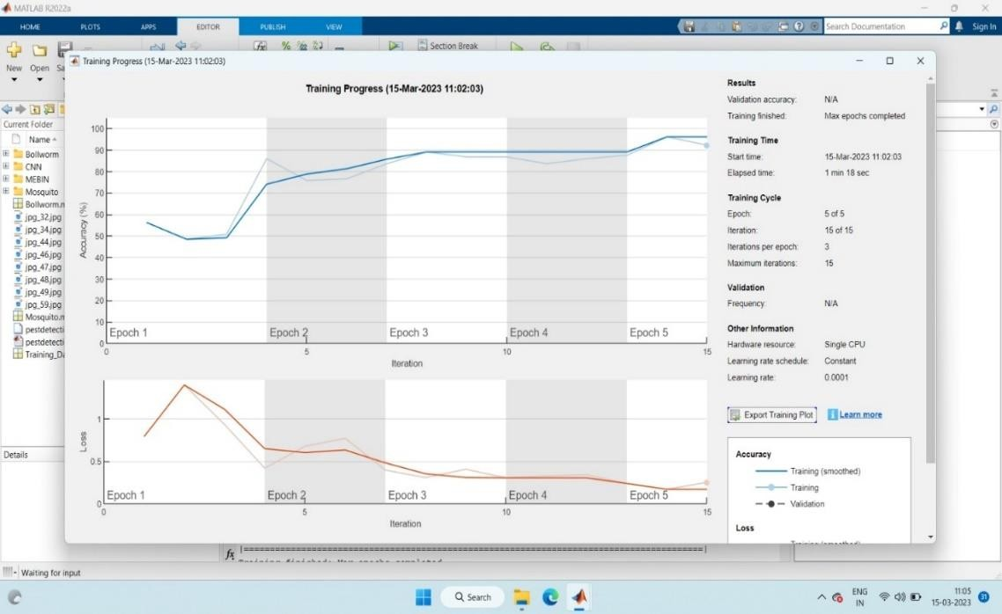

CONCLUSION:
In this paper, an automatic detection and extraction system was presented, different image processing techniques were used to detect and extract the pests in the captured image. The presented system is simple and yet efficient. The authors used background modeling to detect the presence of insect pests in the captured image In the whole agricultural research we conclude that the pests like ballworm and mosquitoes can be detected by the image processing techniques and found by an accuracy with 99 percent and also suggests the remedy for that particular pest so that we can get the maximum crop profit and decrese the loss percentage 6.REFERENCES:

- Proceedings of the International Conference on Intelligent Computing and Control Systems (ICICCS 2020) IEEE Xplore Part
Number:CFP20K74-ART; ISBN: 978-1-7281-
4876-2

A Comprehensive Survey on Pest Detection Techniques using Image Processing
Harshita Nagar(MTech Scholar) Department of Computer Science Engineering
Rajasthan Technical University Kota, India harshita.nagar2810@gmail.com
R.S. Sharma(Associate Professor) Department of Computer Science Engineering
Rajasthan Technical University Kota, India rssharma@rtu.ac.in
- Detection of Plant Leaf Diseases using CNN S.Bharath1, K. Vishal Kumar2, R.Pavithran3 , T.Malathi4
1-4Computer Science and Engineering,
SRM Institute of Science and Technology, Chennai. India.
- Pest Detection on Leaf using Image Processing Harshita Nagar Dept. of Computer Science Engineering
Rajasthan Technical University Kota, India harshita.nagar2810@gmail.com
R.S. Sharma Dept. of Computer Science Engineering
Rajasthan Technical University Kota, India rssharma@rtu.ac.in
[18]K. Y. Huang, “Application of artificial neural network for detecting Phalaenopsis seedling diseases using colour and texture features,” Computers and Electronics in Agriculture, vol. 57, no. 1, pp. 3-11, 2007.
[19]C.B. Singh, D.S. Jayas, J. Paliwal and N.D.G. White, “Detection of insect-damaged wheat kernels using near-infrared hyperspectral imaging,” Journal of Stored Products Research,
vol. 45, pp. 151–158, 2009.
[20]D. Cui, Q. Zhang, M. Li, Y. Zhao, and G. L. Hartman,
“Detection of soybean rust using a multispectral image sensor,” Sensing and Instrumentation for Food Quality and Safety,
vol. 3, no. 1, pp. 49-56, 2009.
[21]A. Camargo, and J. S. Smith,
“An image-processing based algorithm to automatically identify plant disease visual symptoms,” Biosystems Engineering,
vol. 102, no. 1, pp. 9–21, 2009.
[22]S. Kai, L. Zhikun, S. Hang and G. Chunhong, “A research of maize disease image recognition of corn based on BP networks,” In the Proceedings of Third International Conference on Measuring Technology and
Mechatronics Automation, vol. 1, pp.246- 249,2011.
[23]Chenglu Wena and Daniel Guyer,
“Image-based orchard insect automated identification and classification method,” Computers and Electronics in Agriculture,
vol. 89, pp. 110–115, 2012.
[24]D. Pixia, and W. Xiangdong,
“Recognition of greenhouse cucumber disease based on image processing technology,” Open Journal of Applied Sciences,
vol. 3, no. 01, pp. 27-31, 2013.
[25]J. W. Orillo, J. D. Cruz, L. Agapito, and P. J.
S. I. Valenzuela,
“Identification of diseases in rice plant (Oryza Sativa) using back propagation artificial neural network,” 7th IEEE International Conference Humanoid, Nanotechnology, Information Technology Communication and Control, Environment and Management (HNICEM),
pp. 1-6, 2013.
[26]W. Zhang, and G. Teng, C. Wang,
“Identification of jujube trees diseases using neural Network,” International Journal for Light and Electron Optics,
vol. 124, no. 11, pp. 1034-1037, June 2013.
[27]Siti N. A. Hassan, Nadiah S. A. Rahman, Zaw Zaw Htikeand and Shoon Lei Win,
“Automatic Classification of Insects Using Colour- Based and Shape Based Descriptors,” International Journal of Applied Control, Electrical and Electronics Engineering (IJACEEE),
vol. 2, no.2, May 2014.
[28]P. Revathi, and M. Hemalatha,
“Cotton leaf spot diseases detection utilizing feature selection with skew divergence method,” International Journal of Scientific Engineering and Technology,
vol.3,no.1, pp. 22-30, 2014.
[29]P. R. Rothe and R. V. Kshirsagar,
“Adaptive neuro-fuzzy Inference system for recognition of cotton leaf diseases,” International Conference on Innovative Applications of Computational Intelligence on Power, Energy and Controls with their impact on Humanity ,
pp. 12-17,2014.
[30]M. Bhange, and H. A. Hingoliwala,
“Smart farming: pomegranate disease detection using image processing,”
Second International Symposium on Computer Vision and the Internet (VisionNet’15), vol.58,pp. 280-288, 2015.
- Apurva Sriwastwa, Shikha Prakash, Mrinalini, Swati Swarit, Khushboo Kumari and Sitanshu Sekhar Sahu, “Detection of Pests Using Colour Based Image Segmentation,” Proceedings of the 2nd International Conference on Inventive Communication and Computational Technologies (ICICCT 2018), 2018.

- Wang Dawei, Deng Limiao,Ni Jiangong, Gao Jiyue, Zhu Hongfei and Han Zhongzhi, “Recognition Pest by Image-Based Transfer Learning,” Journal of the Science of Food & Agriculture, vol. 99, pp. 4524-4531, 2019.

