ANDHRA LOYOLA INSTITUTE OF ENGINEERING AND TECHNOLOGY, VIJ-8.
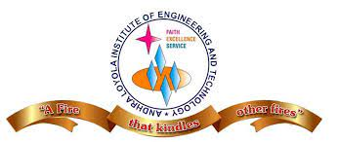
DEPARTMENT OF ELECTRONICS AND COMMUNICATION ENGINEERING
An Abstract Report on Project Titled

Automatic Vehicle Speed Control System
In A Restricted Zone

Signature of the guide Submitted by
Ms. S. Spandana Ch. Bharath Krishna(19HP1A0433)
Assistant professor G. Mahesh Babu(19HP1A0442)
ECE Department P. Sohail Khan(19HP1A0456)
V. Satyanarayana(19HP1A0444)

ABSTRACT

As far as automobiles are concerned, safety is very important to reduce the occurrence of accidents in speed restricted zones. It minimizes the loss of property and life. According to the recent surveys, in the past few years, an accident near the school zones, hospital zones and sharp turnings have increased tremendously, because of their hurry to get the targeted place soon. Therefore, controlling vehicle speed has been a crucial issue to be considered. This paper aims to give a practical, compact and simple design to develop an automatic vehicle speed control system, which has to be quickly get implemented in school, college, hospital, sharp turning zones and Highways to reduce the number of accidents. This automated speed controlling system is built using the microcontroller-based platform of the Arduino Uno board. Here the Arduino is programmed in such a way that, the prescribed speed limit was incorporated in the transmitter unit which transmits the signals, and it was received by the receiver in the vehicle using Zigbee wireless communication technology and the speed of the vehicle was automatically controlled by the input signals by the receiver, with the help of speed encoder sensor. Once this technique was implemented the accidents will be reduced on a larger rate, and also reduce the nuisance by some drivers.

INTRODUCTION

The Indian Law Commission has an advisory to limit the speed at critical zones, to reduce the road accidents and to make a peaceful environment for the people. The existing methodologies can’t able to reduce the accidents still now, Because of the rash driving of some drivers. Hence speed control is in need to be implemented in all the vehicles. Here is the new idea of ours to install an automated speed control system in the vehicles mainly in the restricted areas. Here setup device as a transmitter where the multiple devices are combined to monitor the speed of the vehicle when the vehicle enters above the prescribed speed and controls it by placing a receiver at the vehicles, based on the signals transmitted the speed of the vehicle get reduced by interfacing a microcontroller. The current speed of the vehicle is sensed by the dc motor and the output of it was given to the microcontroller where it compares the speed with the prescribed limit and the speed is controlled automatically. The technology used in this system to communicate between transmitter and receiver is Zigbee technology, which covers up to 10-100m within its range. This is comparatively cheaper than others. Therefore, this system controls and monitors the overall vehicles in its covered area. By implementing this system, the accidents are reduced in this fast-moving world. In the developed and developing countries, people find’s inconvenience with the road accidents, jamming of vehicles because of the drivers who dislike to obey the laws at the restricted zone, where the speed has to be limited as prescribed in that zone by using an automated speed control system to limit the speed automatically using Zigbee technology.
NOVELTY

The working of this system in three different zones where the speed wants to reduce automatically by using Zigbee technology. They are Normal zone, silence zone, speed limit zone. The speed is reduced by reversing the motor rotating direction through the microcontroller 8051. The Zigbee transmitter is placed at that zone for example hospital while the vehicle reached that area the signal is received by the Zigbee receiver in the vehicle. The speed of the vehicle is compared with the determined speed in that area. If speed is higher for that zone the microcontroller takes in action to reduce the speed of the vehicle and if it is silence zone it disables.
The main aim of the system is to control the speed of the vehicle to avoid the accidents in the hospital zone, curve roads and deep cuts due to over speed. This can be done with the ZigBee technology with the microcontroller. The prescribed speeds at that zone are incorporated in the transmitter module and when the receiver in the vehicle senses the signal that microcontroller would check whether the driver reducing the speed for a limited time. After the timer passes the limited time, the microcontroller makes the signal to reduce the speed of the motor, which makes the vehicle decelerate without the action of the driver.

TRANSMITTER BLOCK DIAGRAM

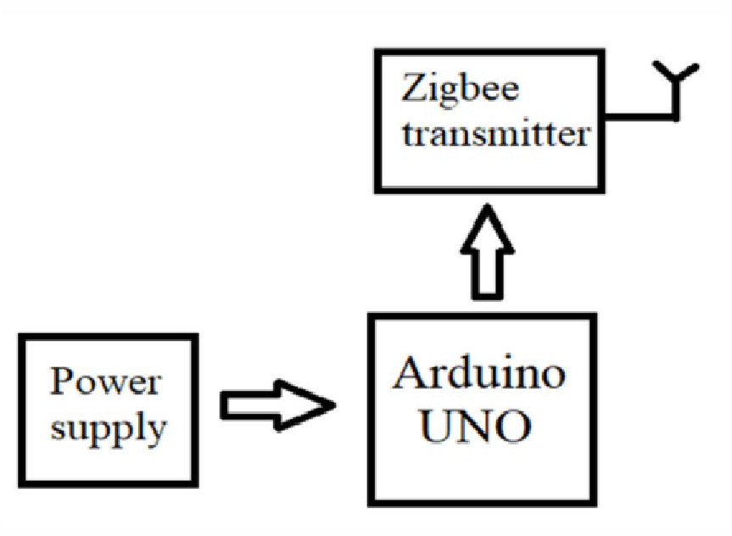

RECEIVER BLOCK DIAGRAM

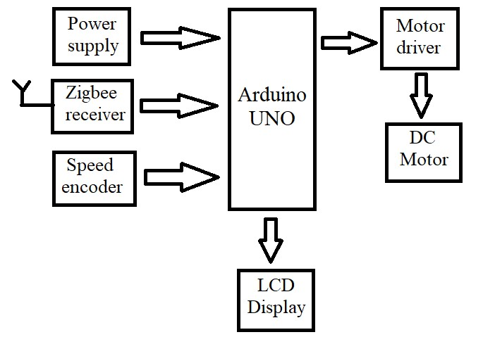
APPLICATIONS
AUTOMATIC SYSTEM TO CONTROL THE SPEED OF VEHICLES, “WHEN VEHICLE ENTERS IN ANY ACCIDENT PRONE AREAS”. SIMPLY REDUCES ACCIDENTS.

ADVANTAGES
• Reliable
• Low cost
• Low power consumption
• Quick response
• Durability
• Easy adaption in vehicles
• Compact process
• Highly secured

FUTURE SCOPE
This system proves to be highly effective in minimizing the over speeding and unwanted accidents in restricted zones. In current systems, there is no autonomous speed restriction in the vehicle to avoid accidents. Hence further research and optimizations of the automatic vehicle speed control system will allow us to implement in vehicles for improved safety for roadside pedestrians, passengers, and other road users.

Findings
The automatic vehicle speed control system is a much more practical and safety feature for the pedestrian and it is economical in implementation. The Zigbee wireless communication is chosen rather than the RF wireless communication due to its secured encryption and multiple connections for communication.

CONCLUSION

This study shows the role of reducing vehicle speed automatically and its contributions to the safety of pedestrians and road users. It is found that the use of the vehicle speed control system contributes a lot in minimizing the accident rate that occurs due to the negligence of the driver to disobeying roadside signboards in special zones. Though the VSC system in a vehicle is effective, they help much in terms of improving safety, keeping both the passenger safety and the pedestrians on the roads. Considering the automatic VSC system is incorporate in school zones or hospital zones which allows the vehicle to act independently to slow down the vehicle when the vehicle comes at a higher speed which minimizes the accidents due to negligence of the driver actively and in a way more effectively. Hence it is concluded from the above study that the uses of Automatic vehicle speed control systems in restricted zones minimize unwanted accidents to a great extent compared to normal behaviour.

ACKNOWLEDGEMENT
We feel privileged to express our deepest sense of gratitude and sincere thanks to our project guide Prof. S. SPANDANA mam for her continuous support and guidance throughout our project work. We would also like to thank our HOD. M. RAMA KRISHNA sir for approving our project. We also wish to thank them for their patience and co-operation, which proved beneficial for us. We owe a significant share of our success to the whole faculty and staff members of Electronics and communication Engineering Department, which provided us the requisite facilities required to complete our project work. We wish to express our sincere appreciation and thanks to our library and all those who have guided and helped us directly or indirectly for accomplishing our goal.

REFERENCES

- Amulya A M, et.al., Intelligent speed control system, Volume 5, Issue 4, April 2018, pp.2537-2540.
- Vaishal B. Niranjane, et.al., Automatic Vehicle Speed Control System Using Zigbee Technology, IJEECS ISSN 2348-117X Volume 6, Issue 3, March 2017.
- Amarnarayan, et.al., Automatic Over speed Controlling of Vehicle, eISSN:2321-225X, pISSN:2321-2241, Volume 5, Issue 5, May2016.
- Gummarekula Sattibabu, et.al., Automatic Vehicle Speed Control with Wireless In-Vehicle Road Sign Delivery System Using ARM 7, Volume 2, Issue 8, pp.32-34.
- Amruta Ramase, et.al., Automatic Speed Control of Vehicle Using RF Communication, pp.419-422.
- A Vengadesh, et.al., Automatic Speed Control of Vehicle in Restricted Areas Using RF and GSM, Volume 02, Issue 09, December 2015, pp.875-877.
- Akash Batra, et.al., Automatic Car Speed Control with Wireless RF Control, ISSN: 2277-9655, et al., 7(4): April 2018, pp.592-597.
- R. Ashok Kumar et.al., A Beacon Based Automatic Vehicle Speed Control System for Restricted Zone, Volume 7, Issue X, October 2018, pp.1152-1159.
- Shankhavi K B, et.al., Vehicle Speed Control using RF Communication, Volume 13, Issue 1, May 2016, ISSN: 2349 – 9303.
- R.Deepa. Design of Vehicle Speed Control System Using Wireless Instrument Cluster, Volume 4, Issue 1, January 2015.
- Sunil R Kewate, et.al., Automatic speed control system by the color sensor for automobiles – An innovative modelbased approach, ISSN 2250-3234, volume 4, number 2 (2014), pp. 223-230.
- Dr.K.S.Tamilselvan, et.al., Android Based Vehicle Speed Control System In Critical Zone Using GPS Technology, volume 7, issue 6, June 2018, pp.639-644.

