Body Monitoring System For Critical Patients

Mr,.Raju Rathod Project guide
JSPM’s Rajarshi Shahu College of Engineering
Pune, India Rathodraju5983@gmail.com
Abhishek Ganesh Wani Dept of Electronics and
Telecommunications Engineering JSPM’s Rajarshi Shahu College of Engineering
Pune, India Abhishekwani213@gmail.com

Vaishnavi Narsingh Tundare
Dept of Electronics and Telecommunications Engineering JSPM’s Rajarshi Shahu College of Engineering
Pune, India Tundarevn78@gmail.com
Neha Rajendra Patil Dept of Electronics and
Telecommunications Engineering JSPM’s Rajarshi Shahu College of Engineering
Pune,India Patil2neha2@gmail.com

Abstract— Detection of changes due to movement in a real- time video is a truly important tool. Case movement & monitoring system is a system that is used to descry movement changes in the case. Those changes may be either abnormal behavior or unusual changes made by the case in the absence of a croaker This paper presents the system of patient movement monitoring system for those cases that are taking medical treatment in both original and foreign hospitals with the help of frames comparison approach. In this design, FLUX sensors are fixed in two hands of the case when there is any movement in hands the sensor sends information to the croakers by wireless communication. GLASS SETUP with EYEBALL sensor is fixed in the case’s eye when any movements in the eye the sensor sense the value and shoot information to the croaker MEMS is used to find the case's leg movement and all the information is wirelessly transferred through IOT module and covered in PC eyeblink and the TEMPERATURE sensors are used to find the heart rate and the temperature of the case.

Introduction

Preface As seen far and wide the quantum of the accident happens truly high, if there is an accident, the cases are admitted in ICU (Intensive Care Unit), In analogous condition, the case may go in a coma state. when a person is unconscious he/she can't be awakened or they fails to respond generally to painful actions light, or sound; lacks a normal sleeping cycle, and does not initiate voluntary conduct. Coma may do for various reasons, analogous as intoxication, a complaint or infection that affects the central nervous system( CNS), a serious injury, and hypoxia, or oxygen

deprivation. Croakers will check the affected person's movements and distastes, response to painful instigations, and pupil size. Croakers will observe breathing patterns to help diagnose the cause of the coma. Checking the signs of any skin infections. To determine the affected person's position of knowledge. Croakers will watch for signs of exhilaration, analogous as oral noises, eyes opening or movement. And also will test reflexive eye movements. These tests can help determine the cause of the coma and the position of brain damage. For covering the case physically it's generally passing in hospitals where two or three sanitorium staff demanded to cover the patient 24 * 7 for watching if there is movement or not, but this is not effective system to get maximum effectiveness. So this design helps to cover the case physically for every moment. The system developed predicated on Flex sensor, Eyeball sensor, MEMS body sensor, eyeblink sensor, Temperature sensor and the Pressure sensor which is used to design a system which monitors the movement of the person at coma stage and cautions automatically by transferring a communication to the concerned person using IOT.

A. LITERATURE SURVEY

SURVEY 1: “Analysis and Monitoring of Coma Cases using Wearable stir Sensor System”.

1. DESCRIPITION

- AUTHORSneha Chowdary Koganti,Dr. H N Suma, AppajiM. Abhishek.

- Publication INTERNATIONAL JOURNAL OF SCIENCE AND RESEARCH(IJSR) ISSN(ONLINE) 2319- 7064, VOLUME 4 ISSUE 9, SEPTEMBER 2015.

- Concept Drowsiness and setbacks of responsiveness
- Concept In this paper, Wearable stir detector system have the eventuality to beget losses in numerous

is used to cover the body movements similar as eye blink movement and hand movement to descry the conscious state of an existent. This system will be helpful in aiding the croaker
about the health condition of the unconscious case and waking the croaker
whenever care is needed. This system will help the croaker
by giving an alarm about the health condition of the case, when the set of vital signals recorded are out of the normal range. These results are displayed on the computer and on the Liquid demitasse display (TV).

- fashion Wearable stir Sensor System.

- downsides occasionally due to the critical condition of the case there will be a delicate in measuring the palpitation at the cutlet.

SURVEY 2: “exigency Fall Incidents Discovery in supported Living surroundings exercising stir, Sound and Visual Perceptual Components”.

1. DESCRIPITION

- AUTHOR CharalamposN.Doukas, IliasMaglogiannis.

- Publication IEEE Deals ON INFORMATION TECHNOLOGY IN BIOMEDICINE, VOL. 15, NO. 2, MARCH 2011.

- Concept The main ideal of this paper utilizes
occupations. One subsystem of a prototype device which aims to descry these setbacks as they do is described. A head- mounted camera measures several features of the eye that are known to relate with doziness. The system was tested with eight combinations of eye colour, ambient lighting, and eye spectacles to pretend typical real- world input conditions. A task was completed for each set of conditions to pretend a range of eye movement — saccades, shadowing, and eye check.

- fashion Image processing. (Omni Vision OV77351 image detector).

- downsides the camera module uses an Omni Vision OV77351 image detector. check

SURVEY 4: “A Model- Driven Methodology for the Design of Autonomic and Cognitive IoT- Grounded Systems operation to Healthcare”.

1. DESCRIPITION

- AUTHOR Emna Mezghani, Ernesto Exposito, and Khalil Drira.

- Publication Deals ON Arising motifs IN COMPUTATIONAL INTELLIGENCE, VOL. 1, NO. 3, JUNE 2017.

- Concept The ultimate thing of these patterns is furnishing general and applicable results for evolving

videotape, audio, and stir data captured from the case’s flexible smart IoT- grounded systems suitable to
body using applicable body detectors and the girding perceive the collected data and give opinions. These
terrain, using outflow cameras and microphone arrays. patterns are articulated within a model driven

Applicable shadowing ways are applied to the visual perceptual element enabling the line shadowing of
methodology a set of patterns for developing a flexible cognitive monitoring system to manage cases’ health

persons, while proper audio data processing and sound grounded on miscellaneous wearable bias. The directionality analysis in confluence to stir information proposed model describes the detectors measures and

and subject’s visual position can corroborate fall and indicate an exigency event.

- fashion stir and Sound Data Acquisition, Human Body Visual Tracking and Sound Processing and Event Detection downsides the body detector networks are
protocols, identifies simple and complex pollutants to process the entered data and detects symptoms to enable the adaption.

d) fashion Model driven methodology.

still considered as invasive technology and bear special e) Drawbacks Insufficient analysis. expenditure

treatment by druggies (e.g., proper body placement, battery relief, etc.)

SURVEY 3: “A wearable device for measuring eye dynamics in real- world conditions”.

1. DESCRIPITION

- AUTHOR Simon Knopp, Philip Bones, Stephen Weddell, Carrie Innes, and Richard Jones.

- Publication35TH Periodic transnational CONFERENCE OF THE IEEE EMBS OSAKA, JAPAN, 3- 7 JULY, 2013.
enforcing prototyping.

Block Diagram

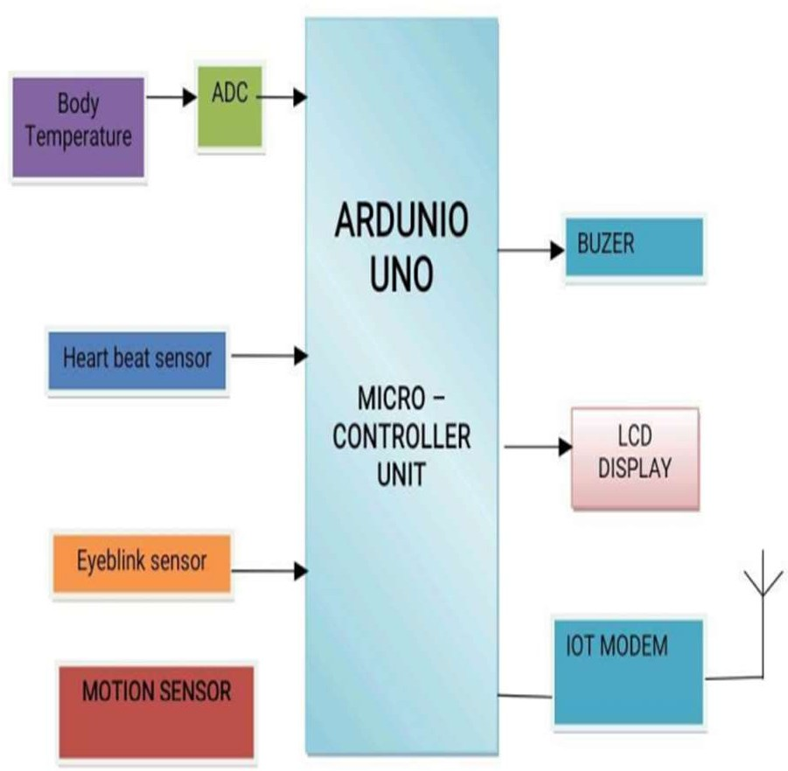

Simplified block diagram of Micro-Controller based Temperature and respiration display system is shown in figure. With this system the parameters of our body can be mentioned and it is viewed by various doctors where ever. The signals form the patients are picked up by the sensors.

Objectives

- To work on Literature Survey.

- To detect eyeblink.

- To measure heartrate.

- To detect body movement.

- To measure body temperature using temperature sensor.

Acknowledgment

We wish to express our sincere thanks to Dr. R.K. Jain, Principal, Rajarshi Shahu College of Engineering, Tathawade, for providing us all the necessary facilities.
We would like to place on record our deep sense of gratitude to Dr. S.C. Wagaj, HOD, Department of Electronics & Telecommunication Engineering, for his stimulating guidance and continuous encouragement.
We also wish to extend our thanks to Mrs. C.V. Rane, Project coordinator for her supervision throughout the course of present work.
We are extremely thankful to Mrs. Lata More for her insightful comments and constructive suggestions to improve the quality of project work.
Lastly we are thankful to Teaching and non-teaching faculty of the Department for their continuous co- operation.

CONCLUSION
To conclude that our project used for monitoring the health related parameters of comatose patient such as eye movement, pulse rate, temperature, hand, and leg movements.The system is designed for unconscious patients who need continuous care.

References

- R. Archana, S. Indira, “Soldier Monitoring and Health Indication System”, International Journal of Science and Research (IJSR) ISSN.

- Ping Wang, Xinfeng BA, “Design of Soldier Status Monitoring and Command and Control System Based on Beidou System”, 2012 2nd International Conference on Computer Science and Network Technology.

- Richard B. Marth, Robert Levi, Dr.I.Newton Durboraw, Kenneth Beam, “The Integrated Navigation Capability for the Force XXI Land Warrior”.

- Shruti Nikam, Supriya Patil, Prajkta Powar, V.S. Bendre, “GPS based soldier tracking and health indication system”.

- Vongsagon Boonsawat,Jurarat Ekchamanonta,Kulwadee Bumrungkhet, and Somsak Kittipiyakul, “XBee Wireless Sensor Networks for Temperature Monitoring”, Sirindhorn International Institute of Technology, Thammasat University, Pathum-Thani,Thailand.

