Smart Image To Text And Text To Speech Recognition Using Machine Learning

Nikita Pakhale
Electronics & Telecommunication
JSPM’S Rajarshi Shahu College of Engineering
Pune, India
niku.pakhale@gmail.com
Mrs.Lata More
Electronics & Telecommunication
JSPM’S Rajarshi Shahu College of Engineering
Pune, India
ismore_51105@gmail.com
Harshada Kamble
Electronics & Telecommunication
JSPM’S Rajarshi Shahu of Enineeing
Pune, India
harshadarupeshkamble@gmail.com
Dr.S.C.Wagaj
Head of Department Electronics & Telecommunication
line 3: JSPM”S Rajarshi Shahu College of Engineering
Pune, India

Abstract—The optical character recognition (OCR) and text-to-speech (TTS) concepts are combined in this project. By successfully establishing a voice interface connection with computers, this type of framework helps persons who are visually handicapped. Image to text and text to speech conversion is a technique that uses the OCR method to read and scan 20+ different languages and numbers in the image and converts them to voices. The voice processing module and the picture processing module are both implemented in this project. Numerous methods have been used in the past, such as the Edged Based Method, Connected Component Method, Texture-Based Method, and Mathematical Morphology Method, however they have significant limitations when measured by exactness, f-score, and review. These picture texts can be found in magazines, photographs, newspapers, banners, and other media. The development of intelligent systems to enhance quality of life is the focus of current technological developments in the fields of natural language processing and image processing. An efficient method for text recognition, extraction from images, and text-to-speech conversion is proposed in this paper. In this work, a successful method for text detection, extraction from photos, and text to speech conversion is suggested. The incoming image is first improved by using grey scale conversion. Then, using the maximum stable external areas feature detector, the text portions of the improved image are located. The following step is to use geometric filtering along with a stroke width transform to effectively gather and filter text sections in a picture. The geometric properties and stroke width transform are used to remove the non-text maximum stable exterior regions. Individual letters and alphabets are then grouped to find text sequences, which are subsequently broken up into words. In order to digitize the words, optical character recognition (OCR) is used. The text is converted to speech in the final phase by feeding it through our text-to-speech synthesizer (TTS). On images from documents to nature settings, the suggested method is tested. The correctness and robustness of the suggested framework have been demonstrated by promising findings, which promote its practical use in real-world applications.
Keywords— Image Processing, Text Recognition and Extraction, Maximally stable extremal regions, OCR(Optical Character-Recognition),SWT(Stroke-Width-Transform) TTS(Text-to-speech synthesizer)

Introduction
Modern performance on tasks requiring knowledge of documents and natural language has been shown for sequence modelling. Due to its practical potential for automatically transforming unstructured text input into structured information to get insight about a document's contents, form-based document understanding is a burgeoning study area. However, due to the variety of layout patterns in form like documents, it can be difficult to correctly serialise tokens in practise. We suggest Form Net, a sequence model that takes structure into account in order to improve the serialisation of forms. First, we create Rich Attention, which makes use of the spatial relationship between tokens in a way that allows for a more accurate calculation of attention score. Second, by embedding representations from their neighbouring tokens through graph convolutions, we create Super-Tokens for each word. As a result, Form Net explicitly restores any possibly lost local syntactic information.

Methodology

AIM:
The conversion of text to audio and text recognition and extraction from images are both effectively addressed.

OBJECTIVES:
For use as a powerful communication tool,recognise and extract text from photos and transform it into a digital form of speech

BLOCK DIAGRAMS:

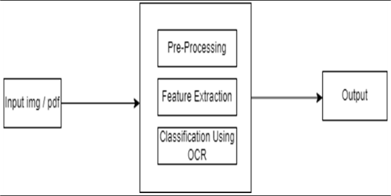

Acknowledgment

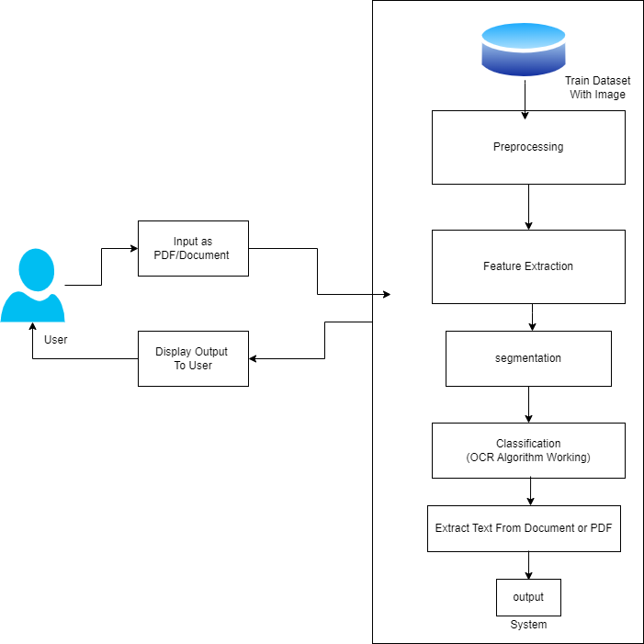

References
[1]. Ranjit Ghosal, Ayan Banerjee,” An Improved Scene Text And Document Image Binarization Scheme”, Recent Advances In Information Technology (RAIT) 2018.

[2]. Muhmmad Jaleed Khan, Naina Said, Aqsa Khan, Naila Rehman,
Khurram Khurshid Automated Latin Text.

[3]. Satish Kumar, Sunil Kumar, Dr. S, Gopinath “Text Extraction
From Images”, International Journal of Advanced Research In Computer
Engineering & Technology, June 2012.

[4]. Nitin Sharma And Nidhi, “Text Extraction and Recognition From
The Normal Image Using MSER Feature Extraction and Text Segmentation
Methods.” Indian Journal of Science and Technology May 2017.

[5]. Amani Jamal, Noora Alhindi, Raghdah Nahhas, Somayh AlAmoudi
“Image Assistant Tools for Extracting, Detecting, Searching Images
And Texts”.2019.

[6]. Saeed Mian Qaisar†, Raviha Khan, Noofa Hammad “Scene to Text Conversion and Pronunciations For Visually Impaired People” 2019.

[7]. B. Gatos, I. Pratikakis, K. Kepene and S.J. Perantonis,” Text Detection in Indoor/Outdoor cene Images” 2005.

[8]. Kamrul Hasan Talukderr, Tania Mallick “Connected Component Based Approach for Text Extraction from Color Image”, International
Conference on Computer and Information Technology (ICCIT) 2014.

Testing:

Integration Testing:
Integration tests are designed to test integrated software
components to determine if they actually run as one program.
Testing is event driven and is more concerned with the
basic outcome of screens or fields. Integration tests demonstrate
that al- though the components were individually satisfaction,
as shown by successfully unit testing, the combination of components
is correct and consistent. Integration testing is specifically aimed
at exposing the problems that arise from the combination of component.
