PRACTICAL KIT ON ELEMENTS OF ELECTRONICS

Abdul Faimeed2, Mohammad Ali 1, Tekale Vedant 3, Shaikh Imran 4, Patil Vivek 5

2Professor, 1,3,4,5 Students, Department Electrical Engineering, Government Polytechnic Nanded, Maharashtra, India

---------------------------------------------------------------------***---------------------------------------------------------------------

Abstract - : The Scope Electronics Kits Is A Device That Functions As A Tool For The Teaching And Learning Process And Also For Testing Electronic Circuits. With This Kits Kit, Research In The Field Of Electronic Engineering Can Be Carried Out Easily And The Cost Of The Study Is Cheaper As These Tools Have A Reasonable Price.
This Kits Is A Combination Of Three Instruments In One Kits Including The DC Power Supply, The Oscilloscope, And The Function Generator. This Study Aimed At Investigating The Perception And Use Of Kits In The Teaching And Learning Process. The Effectiveness Of Using This Kits Kit In Educational
Settings Has Been Evaluated Through A Survey On Students 25 Students That Had Attended Electrical
Technology And Measurement Course And Used This Kits In Their Practical Work In December 2018
Session At The Department Of Electrical Engineering In Politeknik Mukah. Research Analysis Is Using The
Statistic Method To Find Mean Score To Get The Overall Rating Of The Kits Kit And Student’s Perception
And The Response Has Been Positive, With The Total Average Mean Achievement Was 4.80 Of The
Correspondence Has Shown Positive Feedbacks, Indicating The Usefulness Of The Kits Kit. This Kits Kit
Will Give Students A Great Deal Of Practical Work In Laboratories And Also Improve The Teaching And
Learning Sessions In The Classroom.
Key Words: Automated, Filling, DC Geared Motor, DC Pump, Conveyor Belt, Arduino, Water filling etc.

- INTRODUCTION

For Educational Purpose Practical Kit Are Importance To Perform Practical In Physical Manner Due To Absence Of Various Component Or Other Problems Individual Perform Of Practical Is Not Possible Therefore To Available All Practical On One Stage Practical Kit Are Used In This Practical Kit We Perform Ten Different Practical Dc Supply Is Given To All Practical From Six Transformer There Are Three Transformers Of 12-0-12 Volt And Three Transformer Of 9-0-9 Volt To Get Supply To The All The Practical .This Transformer Connected To All Practical Through Buk Converter Control The Dc Voltage From Transformer And Given To Practical Circuit There Are Ten Switches Connected Across Each Practical to On/Off The Practical One Voltmeter And One Ammeter Is Placed On Kit Form Reading And One Voltmeter Is For Regulated Power Supply As We Increase Or Decrease The Dc Voltage This Is Show In Voltmeter To Gives Power To The Voltmeter And Ammeter One Battery Charger Is Used This Battery Charger Gives 5v Constant Dc Supply To The Voltmeter And Ammeter, One Cathode Ray Oscilloscope Is Used For Showing The Waveform On Display, This Is Required For Practical No 4,5,6,7,8, And 10.For Each CRO Practical Two Nobs Are Connected To Output Of Practical Circuit , Two Connecting Wires Are Used To Connect Output Of Circuit To Input Of CRO

- LITERATURE SURVEY:

Many students, And Hobbyists For That Matter, Remember Assembling Kits When They Were Young To Learn The Basics Of Electronics And Have Fun Doing It. Some Kits Used To Be Quite Complex Devices Such Televisions, Oscilloscopes, Audio Amplifiers, And Even Computers. According To Wikipedia, Building Devices From Scratch For Hobbyists

These Days, Electronic Kits Are A Completely Different Animal. One Of The More Popular Kits Is Microchip PIC™ Microcontrollers Like Velleman’s K8076 Which Connects To A PC And Can Program A Wide Range Of IC’s Using Software That Comes With

Limited Variety And Number Of Components. A Kit Often Includes Only A Small Subset Of The Analog/Digital Electronic Component Types. Of Each Included Type (E.G. Capacitor), There Would Be A Limited Number Of Them

COMPONENT SELECTION:
TRANSFORMER:- The transformer is used for connecting this system directly to 500MA AC. It steps down DC 12-0-12V and 9-0-9v dc . A transformer is an electrical device that transfers electrical energy at one voltage from one circuit to other at a different voltage merely by magnetic coupling; the transfer of energy doesn’t involve any kind of motion.

Photodiode: The package of a photodiode allows light (or infrared or ultraviolet radiation, or X-rays) to reach the sensitive part of the device. The package may include lenses or optical filters. Devices designed for use specially as a photodiode use a PIN junction rather than a p–n junction, to increase the speed of response. Photodiodes usually have a slower response time as their surface area increases. A photodiode is designed to operate in reverse bias.[2] A solar cell used to generate electric solar power is a large area photodiode.
BUCK CONVERTER: The buck converter is a ubiquitous DC-DC converter that efficiently converts a high voltage to a low voltage efficiently. Efficient power conversion extends battery life, reduces heat, and allows for smaller gadgets to be built. The buck converter can be used in lots of cool applications. The buck converter is a ubiquitous DC-DC converter that efficiently converts a high voltage to a low voltage efficiently. Efficient power conversion extends battery life, reduces heat, and allows for smaller gadgets to be built.
CAPACITOR: In a way, a capacitor is a little like a battery. Although they work in completely different ways, capacitors and batteries both store electrical energy. If you have read How Batteries Work, then you know that a battery has two terminals.
Zener diode: Zener diode is basically like an ordinary PN junction diode but normally operated in reverse biased condition. But ordinary PN junction diode connected in reverse biased condition is not used as Zener diode practically. A Zener diode is a specially designed, highly doped PN junction diodePlastic box: we used one plastic box for enclosing the all electronic circuit.
Arduino: The main function of Arduino in our project is to receive the data from Ultrasonic sensor which is mounted on water tank ,show the tank water level on LCD display and if the tank level less than 20% then off the conveyor motor and ON the Buzzer/indicator. For this purpose we used one Arduino Uno board.
Connecting wires: Connecting wire is used to connecting one circuit to another circuit. We used different colour wire for different components for easy to identifying the circuit connections

SCHEMATIC DIAGRAM:
There are two parts of our project as follows:

CRO

When the switch is turn on and power supply is given to the circuit OLED display is ON After that Arduino also required power supply that why we will give the dc power supply to Arduino with help of charger or mobile with the help of OTG cable after turn on Arduino CRO is ready for showing the waveform then which practical perform that Nobs are connected to CRO and CRO gives the waveform. Pot is used for changing the voltage level in display.

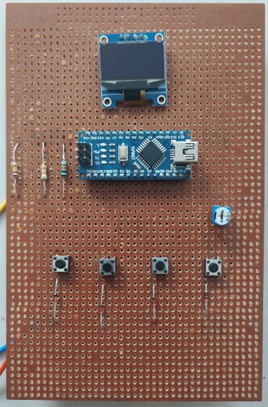
Fig.1 Mini Oscilloscope

PRACTICAL KIT
WORKING
- Give the supply to the practical kit.
- Rotate the nob of the potentiometer to the increase the dc supply to the rated value.
- Because of the main supply all switches are power on
- For Each Practical On The Switch And Note Down The Reading Shown In Voltmeter And Ammeter
- For CRO Using Connect Output Of Circuit To The Input Of CRO And Check The Waveform Shown In The Display
- For Changing Next Practical Switch Off The Previous Practical And Switch On Practical To Be Perform
- After Note Down All The Reading Switch Off The Main Power
Increase the dc regulated power supply to rated value
Switch on the main supply
- Actual Practical Kit

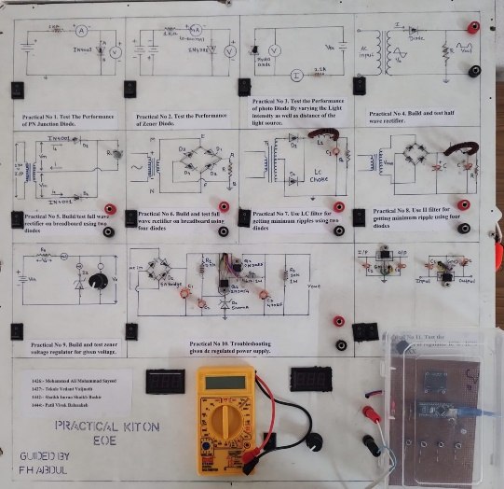

WORKING METHODALOGY:

When the switch is turn on and power supply is given to the circuit OLED display is ON After that Arduino also required power supply that why we will give the dc power supply to Arduino with help of charger or mobile with the help of OTG cable after turn on Arduino CRO is ready for showing the waveform then which practical perform that Nobs are connected to CRO and CRO gives the waveform. Pot is used for changing the voltage level in display.
Procedure:-
1. Give The Supply To The Practical
2. Rotate The Nobs Of Potentiometer To Increase The Dc Supply (Voltage) At Rated Value.
3. Because Of The Main Supply All Switch Are Power On That Why Which Practical Is Try To Perform Only That Switch Is On And Start Performing
4. For Each Practical On The Switch And Note Down The Reading Shown In Voltmeter And Ammeter
5. For Cro Using Connect Output Of Circuit To The Input Of Cro And Check The Waveform Shown In The Display.
6. For Changing Next Practical Switch Off The Previous Practical And Switch On Practical To Be Perform
7. After Note Down All The Reading Switch Off The Main Power Supply

FLOW DIAGRAM:
For Educational Purpose Practical Kit Are Importance To Perform Practical In Physical Manner Due To Absence Of Various Component Or Other Problems Individual Perform Of Practical Is Not Possible Therefore To Available below:

On the switch of the practical to be perform

Connect the connecting wires to input of practical

Noted down the readings

Now decrease the dc regulated power supply

Switch off the main supply

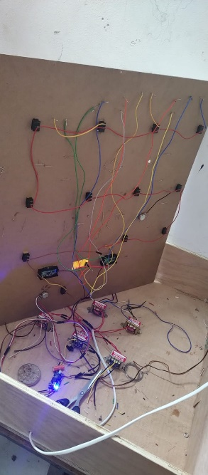
PHOTO OF ACTUAL CIRCUIT CONNECTIONS:

9.1 Advantage of practical kit :

1 .Helps increase creativity

2. help teach students how to be more observant and inquisitive.

3. Make students understand how practical are actually perform.

4. Make them more creative

5. Enhance cognitive skills

6. Grow interests in electronics

7. Helps to develop practical skills

9.2 Disadvantage

1. Increasing experiment cost.

2. The disadvantages for teachers

3. Cost required more for making

4. More time required

5. Connection is more complicated

6. Construction is also more complicated

- RESULT:

Gives students a greater understanding of their skills base.

Students will be able to acquire new ideas and learn a deeper understanding of various concepts.

• Practical education helps one to think critically, analyze problems, and come up with appropriate solutions.

• To give support for students in their learning and to make a link between the domain of real objects and observable facts on one hand and the domain of ideas on the other

• The abilities that students acquire to perform their practical efficiently

CONCLUSION:

This Project Is Successfully Developed And Used In Laboratories Session. These Scope
Electronic Kits Perfectly Suitable For Hands Tests On Experience In Construction And
Testing And Also It Should Be Useful In Supporting Repair And Testing And Also Perfectly
Suitable For Tests To Implement The Basic Knowledge For Many Electronic Professions.

- References

1. Arnel M. Avelino, Gelirose A. Delos Santos, Jonathan T. Danoso, Renz Louise D. Gumapac And
Marcus Miguel V. Vicedo (2015). Design And Testing Of A Mobile Studio Operational Amplifier
Trainer Board. International Journal Of Electrical And Electronics Research ISSN2348-6988
(Online) Vol. 3, Issue 4, And Pp: (223-230), Month: October - December 2015.

2. Dunwill, E. (2016). 4 Changes That Will Shape The Classroom Of The Future: Making Education
Fully Technological. Accessed From Https://Elearningindustry.Com/4-Changes-Will-Shape-
Classroom-Of-The-Future-Making-Education-Fully-Technological.

3. Intan Shafinaz Mohammad, Syafiq Abdul Halim, Ahmad Luqman Jamil, Muhammad Rashidi Abdul
Razak, And Nur Farahiyah Mohammad (2018). Development Of Digital Electronics Book Trainer.
Journal Of Engineering Research And Education Volume 10, [49-56]
4. K. & B. Ajao, (2014) Local Fabrication Of Digital Logic Trainer For Laboratory Demonstration, 2,
1 43–46.

5. Landell, K. (1997). Management By Menu. London: Wiley & Sons Inc.

6. Sahat Siagian (2014). Development Of Basic Electronic Instructional Module And Trainer. European

Journal Of Computer Science And Information Technology. Vol.2, No.3, Pp.36-46. ISSN 2054-0957
(Print), ISSN 2054-0965 (Online).

7. Wan Zah Wan Ali, Hajar Mohd Nor, And Azimi Hamzah And Hayati Alwi (2009). The Conditions
And Level Of ICT Integration In Malaysian Smart Schools. International Journal Of Education And
Development Using ICT Volume 5.

