COMMANDFENCE FOR SECURING SMART HOME SYSTEM
Dr. T. Annalakshmi,M.E¹ , Gokulakrishnan B², Dharun E ³, Syed Farook M ⁴
Professor¹, UG Students^{2,3,4}
Department of ECE, S.A. Engineering College, Thiruverkadu, Chennai, Tamil Nadu, India

Abstract: The smart home system has become increasingly popular due to its convenience and security benefits. The advantages of the smart home system in terms of convenience and security have made it more and more popular. It is, nevertheless, vulnerable to security lapses and cyberattacks.In this article, we suggest a method for protecting a smart home system using PIR sensor, Node MCU, Arduino Uno, LCD screen, buzzer, and Telegram software are all included. The suggested system is made to recognize and react to potential security concerns like infiltration, unauthorized access, and motion detection. The NodeMCU board receives a signal when the PIR sensor detects motion. The ESP32-CAM module and the Node MCU board then communicate in order to take photos, which are subsequently sent to the user's Telegram account for visual confirmation. Additionally, the system has an LCD display and a buzzer to offer

Keywords- IOT (Internet of Things),Arduino,ESP8266, Telegram Bot ,Twillo API

- INTRODUCTION

The Internet of Things (IOT) has evolved as a potent tool for monitoring and managing numerous parts of our daily lives as the globe becomes more linked. The smart home security system is one area where IOT can be especially useful.
Security hardware installed on a building and individual security habits are both parts of home security. Doors, locks, alarms, illumination, motion detectors, and security camera systems are examples of securing hardware.
Personal security measures include routines like making sure all doors are locked, alarms are set, windows are closed, and spare keys are not stashed outdoors.
The terms "home automation" and "smart homes" are used to describe a variety of approaches to controlling, monitoring, and automating household activities. A smart home setup provides automatic internet control of appliances and equipment from any location in the world using a mobile or other networked device. This gives the user the ability to control features like home theatre, lighting, temperature, and home security access.
When you are not at home, home security systems and alarm companies can be helpful
Searching for a security system to protect your house. For a monthly charge, they will install and watch over your house.

Security firms and alarm.
Modern security systems from businesses like ADT, Reliance Protection, and Safe-Tech Alarm Systems can monitor and safeguard your house fast and safely. Advertisements for alarm firms can be found online, in local newspapers, and in the phone book.
Security system installation is a skilled task that, in the hands of qualified personnel, can be made simple and secure. Find a provider that is appropriately qualified to oversee your security system as your first order of business. You should search for a company that has performed the task in the past, as with any alarm firms. You might search for security firms with experience in big houses, small enterprises, or corporate offices depending on your particular requirements. It's important to work with a business that can provide this level of protection because some sites, like a corporate office, may need it to reduce the likelihood of an incident.
In general, home security is quite easy, while large business security may call for specialized knowledge. You'll need to discover someone who can assist you with your office's documentation, constraints, and rules as well as the setup of your security monitoring. For all people to keep their private information private, security is crucial. The mission of TopSecurityCompanies.com is simply submit a request for quote on this website if you need a home security business and need exceptional service. We only work with industry pros.

- LITERATURE SURVEY
The GSM Module is a versatile piece of equipment. It keeps you socially connected. Additionally, two GSM modules may communicate at any moment. Therefore, this device can be useful to keep a watch on the House for security reasons. GSM Module has the ability to send and receive messages to both the system and the owner. Nowadays, virtually everyone has a smartphone, therefore keeping in touch with our homes via a smartphone could be a way to lessen the likelihood that our property will be destroyed in any way. In this essay, we'll examine a few connected papers and talk about them. In [1] A parameter watching system for induction motors supported ZigBee protocol was developed, that was capable to perform such operations as running the motor although RF, stopping it, activity and watching most parameters of the motor like part currents, part voltages, wiring temperature, speed. All of those values may be transferred to the host laptop, displayed on the interface, depicted diagrammatically, transferred into associate surpass file to store them for a old. [2] In this paper the author experimented, the implemented system’s that is connect all the devices with the sensors and the automated home is controlled by the controller. But there is some lacking in the other existing system. The main lacking is in the security portion. The security is a little bit weak in that observed process. In our home automation system, there are huge benefits than the other systems.

- COMPONENTS USED

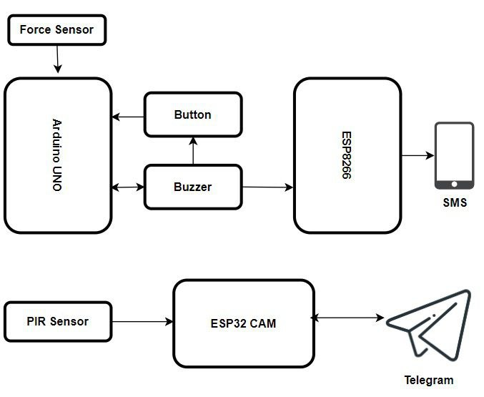
Figure 1: Block Diagram
- Arduino uno: Arduino is an open-source electronics platform based on easy-to-use hardware and software. Arduino boards are able to read inputs - light on a sensor, a finger on a button, or a Twitter message - and turn it into an output - activating a motor, turning on an LED, publishing something online. You can tell your board what to do by sending a set of instructions to the microcontroller on the board. To do so you use the Arduino programming language (based on Wiring), and the Arduino Software (IDE), based on Processing.
- LCD Display: The Liquid Crystal Display shows the display messages generated by the Microcontroller chip, which is depending upon the Zone Code received.
- Force Sensor: A Force Sensor is defined as a transducer that converts an input mechanical load, weight, tension, compression or pressure into an electrical output signal (load cell definition). Force Sensors are also commonly known as Force Transducer.
- PIR: PIR (passive infrared) sensors utilize the detection of infrared that is radiated from all objects that emit heat. This type of emission is not visible to the human eye, but sensors that operate using infrared wavelengths can detect such activity.
E. Embedded c (programming language): Embedded C is generally used to develop microcontroller-based applications. C is a high-level programming language. Embedded C is just the extension variant of the C language. This programming language is hardware independent Embedded C programming plays a key role in performing specific function by the processor. In day-to-day life we used many electronic devices such as mobile phone, washing machine, digital camera, etc. These all device working is based on microcontroller that are programmed by embedded C.
IV. WORKING PRINCIPLE
- The main motive of this paper is to secure home. Our aim is to achieve secured environment inside the home. Here we used ESP32 camera module to capture an image of the trespassers. The camera module came to active when PIR sensor detect the motion of the trespassers and capture an image. In case the camera fails due to some technical fault the force sensor which is placed in floor tiles take the responsibility to secure home. When the trespassers walk over the tiles the sensor take responsibility to acknowledge users. The buzzer which is configured with a force sensor makes a sound to alert a neighbor near the house.
- This phases acknowledge the user(owner) with an telegram software application. This telegram is accessed through TWILIO API. Configure WIFI Module Make sure our Wi-Fi adapter is plugged into the Raspberry Pi. Before the Wi-Fi adapter can be configured it needs to check that the correct drivers are installed. With the help of SSH connection establish Wi-Fi USB dongle provide raspberry pi remote desktop application. This provides a major role because with this remote desktop application we able to connect raspberry pi over the everywhere in word.
- Coding section: Coding section is divided into two parts
  - Write code: In this we write the code in embedded c language according to the application and save it with extension .ino
  - Run Code: To run the code firstly open the Arduino IDE
Connect your evive to your computer using a USB cable. click
Upload button to load the program to the Arduino.
- 3) Now open the Arduino IDE Serial Monitor Window to see
- the sketch run and print the text message. The text that the
- program shows should be visible in the serial monitor window.
  - IMPLEMENTATION
The ESP32 camera module is the primary component that is used to implement this project. Without the assistance of additional gear, this component is easily accessible over Wi-Fi. The PIR sensor that unlocks the ESP32 camera module is mounted to the edges of the floor. When intruders enter a home, a PIR sensor detects the movement. At this point, the ESP32 Camera module takes a picture of the intruders and recognizes the user using the reliable native mobile app telegram bot. To access the native mobile application, a hardware component called the Node MCU is utilized. On the floor tiles are force sensors. The force sensor detected the trespassers' force when the camera's functionality failed.
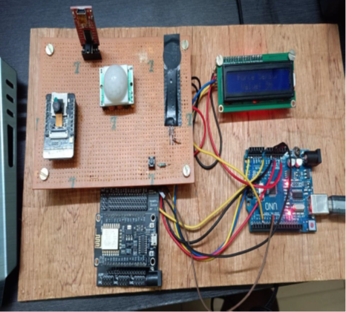
Figure 1: Working Model of our model
VI. APPLICATIONS
The project is utilized to secure homes and prevent theft.
Used in home.
Can be used in Bank.
Can be used in museum
VII. ADVANTAGES
Energy efficiency improvement.
Real Time Alerts.
Alert can be generated through SMS even in the case of motion detected and camera failure.
Fire and Life Safety.
VII. CONCLUSION AND FUTURE SCOPE
Home Automation is getter popular day by day making it the basic requirement for future homes which will be smart enough to provide the best possible comfort to people. This technology has a lot of scope in feature, here are some of them Smart devices are so common and popular devices that are becoming integral parts of our lives. Devices like smart Homes (goggle home, Amazon Echo, Apple homepod) and smart assistants make it easy to control smart devices installed at homes connected via IOT. Also, there are a lot of smart devices and integration available to the users to perform daily house tasks like switching lights, and other devices, changing light colors, checking for home security like using cameras, door speakers and mic, and door locks that can be controlled using smartphones. And there are many more technologies that are under development to make our homes smarter.
A home automation system will monitor and/or control
Attributes such as lighting, climate, entertainment systems,
And appliances. It may also include home security such as
Access control and alarm systems.

REFERENCES
[1]. Gaikwad, P.P., J.P. Gabhane, and S.S. Golait. A survey based on Smart Homes system using Internetof-Things. in Computation of Power, Energy Information and Commuincation (ICCPEIC), 2015 International Conference on. 2015.
[2]. Lin, H.; Bergmann, N.W. IoT Privacy and Security Challenges for Smart Home Environments. Information 2016, 7, 44
[3]. R. K. Kodali, V. Jain, S. Bose and L. Boppana, "IoT based smart security and home automation system," 2016 International Conference on Computing, Communication and Automation (ICCCA), Noida, 2016, pp. 1286-1289. Dorri, S. S. Kanhere, R. Jurdak and P. Gauravaram, "Blockchain for IoT security and privacy: The case study of a smart home," 2017 IEEE International Conference on Pervasive Computing and Communications Workshops (PerCom Workshops), Kona, HI, 2017, pp. 618-623
[4]. D. Geneiatakis, I. Kounelis, R. Neisse, I. Nai-Fovino, G. Steri and G. Baldini, "Security and privacy issues for an IoT based smart home," 2017 40th International Convention on Information and Communication Technology, Electronics and Microelectronics (MIPO),2017,pp 1292-1297,doi:10.23919/MIPRO.2017.7973622.
[5]. Allafi I and Iqbal T. Design and implementation of a low cost web server using ESP32 for real-time photovoltaic system monitoring. 2017 IEEE Electrical Power and Energy Conference, EPEC 2017. DOI: 10.1109/EPEC.2017.828618

