An Effective and Reliable Method for Detecting Brain Tumors in Magnetic Resonance Images

Nallani Sravan kumar Kamireddi Vamsi Pusala Bala Sai Venkat
Department of computer Department of computer Department of computer
Science and Engineering Science and Engineering Science and Engineering
Lovely Professional University Lovely Professional University Lovely Professional University
Phagwara, Punjab Phagwara, Punjab Phagwara, Punjab
chowdarysravan08@gmail.com vamsikamireddi852001@gmail.com saivenkat8757@gmail.com

Gudimetla Sai Keerthi Reddy Lingaladinei Manoj Narayanadas kamsali Susritha
Department of computer Department of computer Department of computer
Science and Engineering Science and Engineering Science and Engineering
Lovely Professional University Lovely Professional University Lovely Professional University
Phagwara, Punjab Phagwara, Punjab Phagwara, Punjab
gkeerthireddy113@gmail.com l.manojreddy123@gmail.com susrithanarayandas193@gmail.com

Abstract: An abnormal development of brain cells results in a condition known as a brain tumor. It is difficult to determine a patient's survival rate because tumors are uncommon and come in a variety of shapes. Magnetic Resonance Imaging (MRI) images, which are essential for locating the tumor, can be used to diagnose these tumors; nonetheless, manual recognizable proof is a tedious and troublesome technique that could bring about certain errors in discoveries. Addressing these limitations necessitates the use of computer-assisted techniques. As artificial intelligence advances, clinical imaging is using deep learning (DL) models to distinguish mind tumors utilizing MR pictures. By modifying the EfficientNet-B0 base model of a major convolutional neural network (CNN) with the assistance of our proposed layers, we successfully recognize and differentiate images of frontal cortical developments in this study. Picture update methodologies are used to chip away at the idea of photos by applying different channels. To make more information tests accessible for preparing our recommended model, information increase procedures are utilized. With a general arrangement and discovery exactness of 98.87 percent, the suggested calibrated cutting-edge EfficientNet-B0 surpasses existing CNN models in order precision, accuracy, review, and region under bend values. Correlation is achieved through the use of DL calculations for VGG16, InceptionV3, Xception, ResNet50, and InceptionResNetV2.
Index Terms: MRI, deep learning, convolution neural networks (CNN), transfer learning, and detection are all related to the brain tumor.
- INTRODUCTION
A brain tumour is a condition wherein strange synapses or tissues develop [1]. Each new cell replaces the past one in an anticipated example as cells duplicate and bite the dust. In any case, a few cells foster irregularities and keep on developing, bringing about critical mischief to mind capability and, in certain occasions, demise. There are no less than 120 particular kinds of diseases of the mind and the central nervous system (CNS). In 2021, mind and central nervous system (CNS) tumors will bring about the passings of 18,600 individuals and 3,460 youngsters younger than 15. The 5-year endurance rate for cerebrum growth patients was 36%, and the 10-year endurance rate was 31% [2]. Likewise, 86,010 instances of different mind disease and CNS malignancies were distinguished in the US in 2019, as per the National Cancer Institute. In the United States, approximately 0.7 million people are thought to be affected by brain tumors. There were 0.86 million cases found, with 26,170 patients having malignant tumors and 60,800 having benign tumors [3]. In 2018, 9.6 million people worldwide were diagnosed with cancer, according to the World Health Organization [4]. Early detection of cerebrum tumors is one of the most important factors in preserving a patient's life. While deciding a patient's wellbeing, legitimate assessment of cerebrum growth photographs is fundamental. In the regular technique for recognizing mind malignant growths, a clinician or radiologist looks at magnetic resonance (MR) examines for irregularities and decides. In any case, it vigorously relies upon a specialist's clinical mastery; contrasts in experience levels and pictures demolish diagnosing with uncovered normal eyes [5]. A specialist would struggle with dissecting these photographs in a short measure of time because of the presence of various irregularities or boisterous information. As how much data increments, it turns out to be progressively difficult to assess a lot of data. As an outcome of this, a computer-aided diagnostic (CAD) framework that can help doctors and radiologists in making an early finding of these lethal growths is expected to save significant living souls.
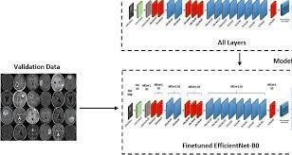
Fig 1 Example Figure
A subfield of computer science known as artificial intelligence (AI) aims to give computers the intelligence of humans by giving them the ability to learn, comprehend, and solve problems when confronted with a variety of data. The discovery and diagnosis of brain cancers rely heavily on AI. Brain tumour medical procedure is an incredible contender for expanded AI mix because of its complicated methodology. A method that is both highly accurate and dependable for classifying brain tumors has been the subject of numerous efforts. On the other hand, addressing the wide range of form, texture, and contrast variations that exist between and among people remains a difficult issue. Neurosurgery procedures have recently been altered by AI subsets such as deep learning (DL) and machine learning (ML). Among them are data preparation, feature selection, feature reduction, and classification. Due to AI, neurosurgeons may be able to diagnose their patients' brain tumors with greater certainty than ever before, according to research [6,]. While promising outcomes are found, the field of deep learning, and neural networks specifically, ascends to noticeable quality. CNNs, or convolutional neural networks, succeed at learning highlights and proposition exactness that is almost boundless. Examples of deep learning applications include design recognisable proof, object localization, speech recognition, and other dynamic tasks [7, 8]. Support vector machines (SVMs), k-nearest neighbor (k-NN), decision trees, and Naive Bayes were used in previous studies to help the medical community diagnose such dangerous diseases. DL calculations like custom CNNs, VGGNets, GoogleNets, and ResNets were also used. Experts have attempted to use MRI scans to distinguish between benign and malignant growths, but a number of flaws remain, such as poor accuracy, large and sluggish models, and high processing costs. In addition, larger data sets are always a barrier in the healthcare industry due to concerns about patient privacy that prevent researchers from freely discussing medical information. Also, past strategies have lower levels of exactness and review, making them wasteful and demanding greater investment to order pictures, which could defer the patient's treatment [12].
2. LITERATURE SURVEY
Deep learning approach for brain tumor detection and segmentation:
On the off chance that not treated immediately, a brain tumour is a serious ailment that can bring about death. Therefore, in order to schedule therapy as soon as possible, it is essential to identify the tumor in its early stages. In this study, we suggested using a CNN model to find brain tumors. Brain MRI scans are used as a starting point to get enough data for deep learning. After that, the photos are pre-processed to lessen the amount of noise and get ready for the next steps. Pre-processed MRI brain images serve as training for the proposed system, which then uses those characteristics to classify newly input images as tumorous or normal. During preparing, back engendering is used to diminish mistake and produce more exact outcomes. The tumor area is segmented using the unsupervised learning method K-Means, and images are created using autoencoders to remove any extraneous characteristics.
Near real-time intraoperative brain tumor diagnosis using stimulated Raman histology and deep neural networks:
Intraoperative investigation is basic for conveying viable and safe treatment to malignant growth patients1. The ongoing intraoperative indication of handled tissue with hematoxylin and eosin staining necessitates a significant investment of time, money, and effort2,3. Additionally, a dispersed and shrinking pathology workforce makes it difficult to comprehend intraoperative histologic images4. To predict a near-constant conclusion at the bedside, we present a comparable strategy that combines SRH, a nameless optical imaging technique, with deep convolutional neural networks (CNNs). In contrast to conventional methods, which can take 20-30 minutes, our CNNs, which have been trained on more than 2.5 million SRH images, are able to estimate the location of a mind growth in the laboratory in less than 150 seconds. 2. We demonstrated that CNN-based interpretation of SRH images was not inferior to pathologist-based comprehension of standard histologic images in a multicenter urgent clinical assessment (n = 278) (general precision, 94.6% vs. 93.9%). The most well-known histopathologic types of cerebrum growths were grouped using a progressive system of notable portrayals of histologic highlights created by our CNNs. Also, we recognized cancer penetrated demonstrative regions in SRH pictures utilizing semantic division. The development of a supplementary tissue diagnostic route that is independent of a typical pathology laboratory, as demonstrated by our findings, has the potential to speed up the detection of cancer during an operation.
Convolutional neural network based early fire detection:
Since man-made disasters, particularly fires, result in significant property damage and loss of life, detection is critical. A well-known area of study in fire detection research is the application of video-based approaches and wireless sensor networks. However, in order for the WSN-based recognition method to function, there must be fire, a lot of smoke, and fires.
Additionally, video-based models encounter difficulties due to the identification requirements of include vectors and high rule-based models. A method for recognizing fire that makes use of sophisticated deep learning and machine learning calculations was presented in this review. To prevent fires, we utilized picture and sensor data. The model we propose is based on three important brain networks: a cross breed model composed of various MLP brain organizations, an Adaboost-LBP model, and a convolutional brain organization. To anticipate the fire, we made use of the Adaboost-MLP model. The Adaboost-LBP model and a convolutional brain network for fire localization based on security camera images were unveiled as anticipated. At the point when a crisis happens, the Adaboost-LBP model is used to create returns for money invested from pictures. With an accuracy of about 99%, the results of our suggested model are excellent. With additional training, the false alarm rate can be reduced even further.
Machine learning based approach for multimedia surveillance during fire emergencies:
Video monitoring of man-made disasters like fire has become a popular field of study, and it is helping to develop smart environments. Fires cause significant damage to society and the economy. By catching the fire early, we can avoid these damages. Utilizing vision-based Convolutional Neural Networks (CNNs) for observation, it is currently conceivable to recognize fires thanks to ongoing progressions in implanted handling. Subsequently, we proposed an answer for Sight and sound Observation utilizing AI approaches during fire circumstances. Two models of deep neural networks are included in the approach we propose. To start, we utilized a half and half model involved Adaboost and a few multi-facet perceptron (MLP) brain organizations. The objective of the creamer Adaboost-MLP model is to precisely anticipate fire. The gas, intensity, and smoke sensors are some of the sources of the preparation data for this model. We suggested using a CNN model to anticipate the fire and quickly find it. According to these findings, our trained model can detect fires with an accuracy of around 91 percent.
Very deep convolutional networks for large-scale image recognition:
In this paper, we investigate how a convolutional association's precision overall scale picture affirmation is influenced by its significance. Our inside-out examination of organizations of expanding profundity demonstrates that increasing the profundity to 16-19 weight layers fundamentally outperforms previous workmanship arrangements by employing an engineering with minuscule (3x3) convolution channels. Based on these revelations, our ImageNet Challenge 2014 proposal won first and second places in the limitation and characterization classes, respectively. In addition, we demonstrate that our portrayals produce cutting-edge results when applied to a wide range of datasets. In order to encourage more research into the use of deep visual representations in computer vision, we have made our two most successful ConvNet models accessible to the general public.

3. METHODOLOGY
Assessments have previously utilized regular ML estimations like support vector machines (SVMs), knearest neighbor (k-NN), decision trees, and Naive Bayes, in addition to DL computations like custom CNNs, VGGNets, GoogleNet, and ResNets, in order to assist the clinical consideration community in diagnosing poisonous diseases. Despite numerous attempts by analysts to identify cancers using MRI images, many flaws remain, including low precision, large and slow models, and expensive processing costs. In addition, larger data sets are always a barrier in the healthcare industry due to concerns about patient privacy that prevent researchers from freely discussing medical information. Additionally, current methods lack accuracy and recall, making them inefficient and requiring more time to categorize images, which delays the patient's treatment.
Past exploration techniques had lower exactness and review levels, which brought about unfortunate proficiency and demanded greater investment for picture classification, subsequently deferring the patient's treatment.t.
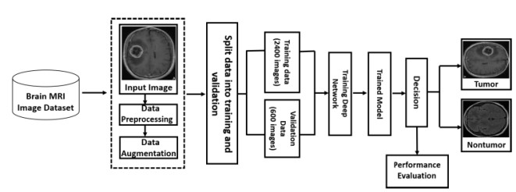
Fig 2 Proposed Architecture
In ongoing examinations, deep learning has been utilized to work on the precision of PC supported clinical diagnostics used to look at cerebrum disease. They are huge instruments in different basic circumstances, for example, the recognition of mind sicknesses and the examination of skin disease pictures, and they assume a significant part in the medical services industry. For the request for mind developments, DL approaches considering move learning and adjusting are inclined in the direction of and routinely used. Through transfer learning, adjusting, and deep convolutional neural networks, this project aims to robotize mind growth grouping and recognition.
The benefits of the proposed framework Extending the number of information tests that can be used to prepare our proposed model is made possible by using information expansion strategies. With a general order and discovery exactness of 98.87%, the outcomes show that the proposed adjusted cutting edge EfficientNet-B0 beats other CNN models concerning characterization precision, accuracy, recall, and area under curve values.
4. IMPLEMENTATION
Mobilenet: Mobilenet is a model that channels pictures in an unexpected way in comparison to CNN utilizing a similar convolution approach. It uses the thoughts of profundity convolution and point convolution, rather than standard CNN convolution.
Googlenet: GoogLeNet is a deep convolutional brain network with 22 layers. The organization can be stacked as a pretrained variant that was prepared on ImageNet [1] or Places365 [2] or [3]. Photographs of consoles, mice, pencils, and a wide assortment of creatures are sorted into 1,000 thing classes by the ImageNet-prepared network.
Resnet50: A deep learning model called as Residual Network (ResNet) is used in computer vision applications. It is a Convolutional Neural Network (CNN) engineering project that aims to assist hundreds or thousands of convolutional layers.
InceptionResnetV2: The Inception ResNet-v2 convolutional brain network was ready on more than a million photos from the ImageNet variety. The 164layer network is equipped for ordering photographs into 1,000 distinct thing classifications, like the console, mouse, pencil, and different creatures.
VGG16: With an exactness of 92.7 percent, the item ID and order calculation VGG16 can classify 1000 photographs into 1000 novel classifications. It is direct to use with move learning and is one of the most widely utilized picture arrangement procedures.
Xception: Xception is a significant convolutional neural network with 71 layers. A pretrained version of the organization that was trained on more than one million images from the ImageNet data set can be stacked [1]. The pretrained network can group images of consoles, mice, pencils, and other animals into one of 1,000 distinct thing categories.
InceptionV3: The Inception V3 deep learning model for image categorization is built on CNN as its foundation. The first model, Beginning V1, which was released in 2014 under the name GoogLeNet, has been enhanced into the Starting V3. As the name suggests, a Google group built it.
Fine tuned efficientnetB5: The article EfficientNet: Describes the EfficientNet B5 Model Architecture Rethinking Convolutional Neural Network Model Scaling. Parameters: weights (optional, EfficientNet B5 Weights) - The weights that were trained before being used. See EfficientNet B5 Weights for additional details and potential values.
Ensemble model- Inception + Mobilenet: Utilizing an assortment of demonstrating strategies or an assortment of preparing informational collections, troupe displaying is a cycle where various particular models are created to foresee an outcome. The figures from each base model are then consolidated by the gathering model, bringing about a solitary last expectation for the obscure information.
5. EXPERIMENTAL RESULTS

Fig 3 Home Page Fig 4 Registration Page
 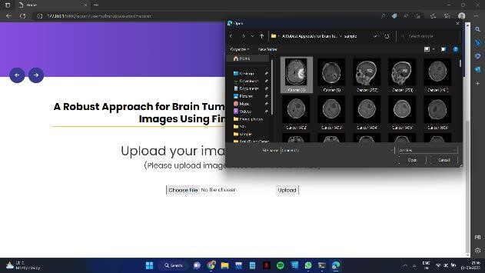 Fig 5 Login and Sign in Page Fig 6 Upload Input image
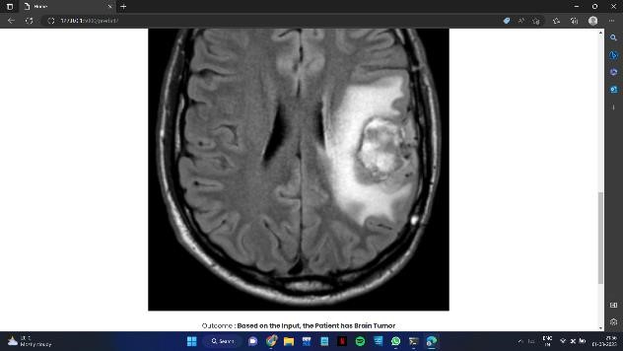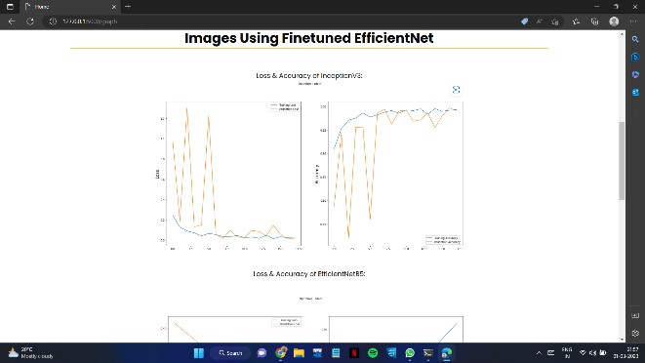
Fig 7 Prediction Result Fig 8 Loss and Accuracy Graph for Efficient Net B5

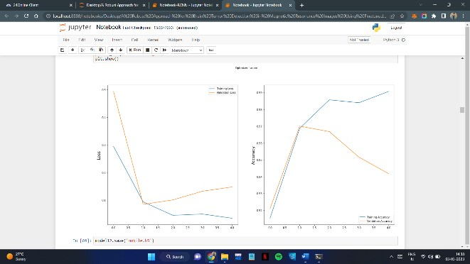
Fig 9 Loss and Accuracy for Ensembel Model
6. CONCLUSION
Due to the developing requirement for a commonsense and dependable evaluation of immense volumes of clinical information, MR imaging for the conclusion of cerebrum cancers has filled in notoriety. Cerebrum cancers are a perilous condition that should be physically recognized, which takes time and requires the skill of doctors. A robotized demonstrative framework will be expected to find issues in MRI pictures. To find mind growths in MRI information, our group fostered a proficient and refined EfficientNetB0-based move learning engineering. As far as recognizing mind growths, the recommended technique played out the best, with approval exactness of 98.87 percent. Despite the fact that this study zeroed in on five extra convolutional models and move learning plans for clinical imaging mind growths, more examination is required. We will look at more profound CNN models for mind cancer order that are more huge and have a more noteworthy effect from now on, and we will perform division with less time intricacy. To make the proposed model more precise, we will likewise add more X-ray outputs to the dataset we use for this review. Additionally, we will apply the suggested method to a variety of clinical imaging techniques, including ultrasound, computed tomography (CT), and x-ray, which could serve as a foundation for additional tests.
7.REFERENCES

- D. Y. Lee, ‘‘Roles of mTOR signaling in brain development,’’ Experim. Neurobiol., vol. 24, no. 3, pp. 177–185, Sep. 2015.
- F. Islami, C. E. Guerra, A. Minihan, K. R. Yabroff, S. A. Fedewa, K. Sloan, T. L. Wiedt, B. Thomson, R. L. Siegel, N. Nargis, R. A. Winn, L.
Lacasse, L. Makaroff, E. C. Daniels, A. V. Patel, W.
G. Cance, and A. Jemal, ‘‘American Cancer
Society’s report on the status of cancer disparities in the United States, 2021,’’ CA, Cancer J. Clinicians, vol. 72, no. 2, pp. 112–143, Mar. 2022.
- Q. T. Ostrom, G. Cioffi, H. Gittleman, N. Patil, K. Waite, C. Kruchko, and J. S. Barnholtz-Sloan,
‘‘CBTRUS statistical report: Primary brain and other central nervous system tumors diagnosed in the
United States in 2012–2016,’’ Neuro-Oncol., vol. 21, no. 5, pp. v1–v100, Nov. 2019.
- World Health Organisation. (2021). Cancer. Accessed: Jan. 23, 2022. [Online]. Available:
https://www.who.int
- G. Raut, A. Raut, J. Bhagade, J. Bhagade, and S.
Gavhane, ‘‘Deep learning approach for brain tumor detection and segmentation,’’ in Proc. Int. Conf. Converg. Digit. World Quo Vadis (ICCDW), Feb. 2020, pp. 1–5.
- T. C. Hollon, B. Pandian, A. R. Adapa, E. Urias, A. V. Save, S. S. S. Khalsa, D. G. Eichberg, R. S.
D’Amico, Z. U. Farooq, S. Lewis, and P. D. Petridis, ‘‘Near real-time intraoperative brain tumor diagnosis using stimulated Raman histology and deep neural networks,’’ Nature Med., vol. 26, no. 1, pp. 52–58, Jan. 2020.
- F. Saeed, A. Paul, P. Karthigaikumar, and A.
Nayyar, ‘‘Convolutional neural network based early fire detection,’’ Multimedia Tools Appl., vol. 79, nos. 13–14, pp. 9083–9099, Apr. 2020.
- F. Saeed, A. Paul, W. H. Hong, and H. Seo,
‘‘Machine learning based approach for multimedia surveillance during fire emergencies,’’ Multimedia Tools Appl., vol. 79, nos. 23–24, pp. 16201–16217, Jun. 2020.
- K. Simonyan and A. Zisserman, ‘‘Very deep convolutional networks for large-scale image recognition,’’ 2014, arXiv:1409.1556.

[10] C. Szegedy, W. Liu, Y. Jia, P. Sermanet, S.Reed, D. Anguelov, D. Erhan, V. Vanhoucke, and A. Rabinovich, ‘‘Going deeper with convolutions,’’ in Proc. IEEE Conf. Comput. Vis. Pattern Recognit.

[11] K. He, X. Zhang, S. Ren, and J. Sun, ‘‘Deep residual learning for image recognition,’’ in Proc. IEEE Conf. Comput. Vis. Pattern Recognit. (CVPR), Jun. 2016, pp. 770–778.

[12] K. Muhammad, S. Khan, J. D. Ser, and V. H. C. D. Albuquerque, ‘‘Deep learning for multigrade brain tumor classification in smart healthcare systems: A prospective survey,’’ IEEE Trans. Neural Netw. Learn. Syst., vol. 32, no. 2, pp. 507–522, Feb. 2021
[13] M. K. Abd-Ellah, A. I. Awad, A. A. M. Khalaf, and H. F. A. Hamed, ‘‘Two-phase multi-model automatic brain tumour diagnosis system from magnetic resonance images using convolutional neural networks,’’ Eurasip J. Image Video Process., vol. 2018, p. 97, Dec. 2018.

[14] Z. Hu, J. Tang, Z. Wang, K. Zhang, L. Zhang, and Q. Sun, ‘‘Deep learning for image-based cancer detection and diagnosis a survey,’’ Pattern Recognit., vol. 83, pp. 134–149, 2018.

[15] M. K. Abd-Ellah, A. I. Awad, A. A. M. Khalaf, and H. F. A. Hamed, ‘‘A review on brain tumor diagnosis from MRI images: Practical implications, key achievements, and lessons learned,’’ Magn. Reson. Imag., vol. 61, pp. 300–318, Sep. 201.

